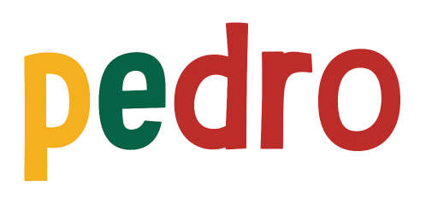

STEM Lesson n°5

Radio Mode

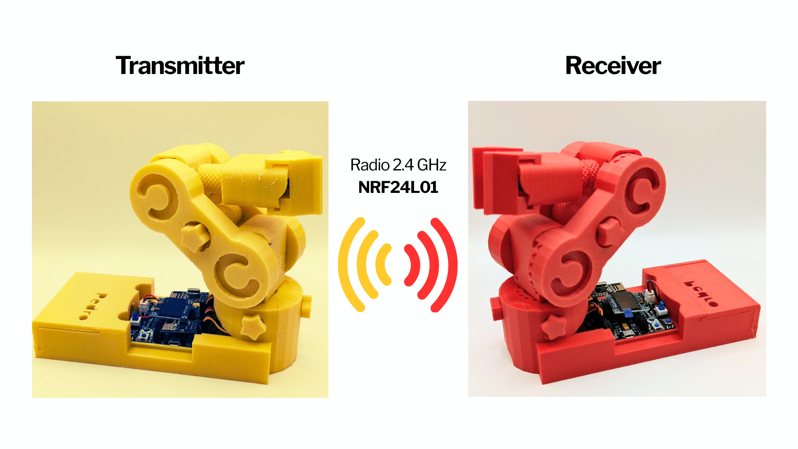
v1.0.0
PDF Tricks
(To make sure the PDF file that opens in your browser shows the most up-to-date version,
add a version query to the URL, like this:
https://almtzr.github.io/PedroSTEM/stem_lessons//Pedro_Lesson_5.pdf?v=2)

🎯 Learning Objective
In this lesson, students will discover how robots can communicate wirelessly using radio signals.
By the end of the lesson, students will be able to:
• Understand how two robots exchange information
• Configure a transmitter and a receiver
• Control one robot remotely using another

👨‍🏫 Instructor Notes
- Recommended age: 12+
- Difficulty Level: Beginner → Intermediate
- Prerequisites: Lesson 1, 2, 3
- Duration: 90 – 120 minutes
💡 Tip: Encourage students to predict what will happen before testing

🧰 Required Materials
Per student or team:
- 2 x Pedro robots Assembled
- 2 x NRF24L01 modules
- USB cable
- Computer with Arduino IDE installed

Table of Contents
🎯 Learning Objective 2
👨‍🏫 Instructor Notes 2
🧰 Required Materials 2
1. Install the Pedro Program (Skip this step if already completed in Lesson n°3) 4
2. Control Modes Overview 5
3. Radio Mode 6
4. Radio Mode Configuration Overview 7
🎯 Activity 1 — First Connection 7
Mission 7
Student Actions 7
Observation 7
🎯 Activity 2 — Mirror Movement 7
Mission 7
Student Actions 8
Observation 8
🎯 Activity 3 — Measuring Radio Communication Range 8
Mission 8
Experiment 8
🎯 Activity 3 — Break the Connection 9
Mission 9
Experiment 9
🧠 Reflection Questions 9
3. Quiz (20 Questions) 10

1. Install the Pedro Program
(Skip this step if already completed in Lesson n°3)

The Pedro Program is the core software that powers and controls the robot. It acts as the robot’s “brain,” managing all behaviors and interactions.
Through this single program, students can access and explore multiple control modes, allowing them to understand how a robot receives instructions, processes them, and translates them into physical actions.
- Download and install the latest version of the Arduino IDE.
- Install the required libraries from the Library Manager:
  - PedroRobot: Tools → Manage Libraries → search PedroRobot → Install
  - U8glib: Tools → Manage Libraries → search U8glib → Install
  - RF24: Tools → Manage Libraries → search RF24 → Install
- Insert the Oled Screen into the Pedro board and Connect the board to your computer via USB.
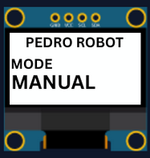
- Select the correct port:
  - Tools → Select the port that appear when you connect Pedro robot
- Select the board type:
  - Tools → Board → Arduino Micro
- Open the example sketch:
  - File → Examples → PedroRobot → Pedro
- Compile and upload the sketch to your Pedro board.
✅ If everything is correct, Pedro’s OLED screen will display “MANUAL MODE”.
- Press the button A0 and observe what happen.
The LED corresponding to the selected servo light on. That button allows you to control each part of the robot. Here is the mapping between the LED ID and the servo ID
  - LED D13 → servo D5 (Base)
  - LED D11 → servo D6 (Shoulder)
  - LED D8 → servo D9 (Elbow)
  - LED D7 → servo D10 (Gripper)
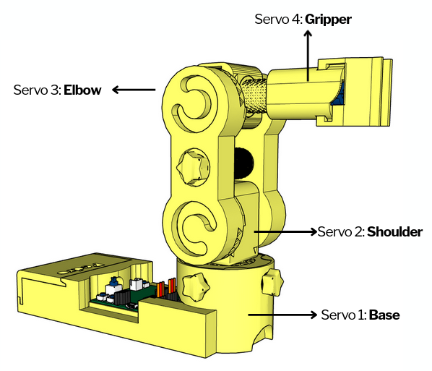

2. Control Modes Overview
Using the 128x64 OLED display, users can easily navigate through the menu to select and configure different modes of operation. The available control modes are:
- Manual Mode – direct control using onboard buttons
- Record & Replay Mode – record and replay movements
- Bluetooth Mode – control Pedro via smartphone or PC
- Radio Mode – remote communication between robots
- USB Serial Mode – control Pedro directly from a computer
Through this firmware, students discover how software can define robotic behavior and how multiple communication interfaces can coexist within one system. The picture below described how to navigate through the multiple control modes.
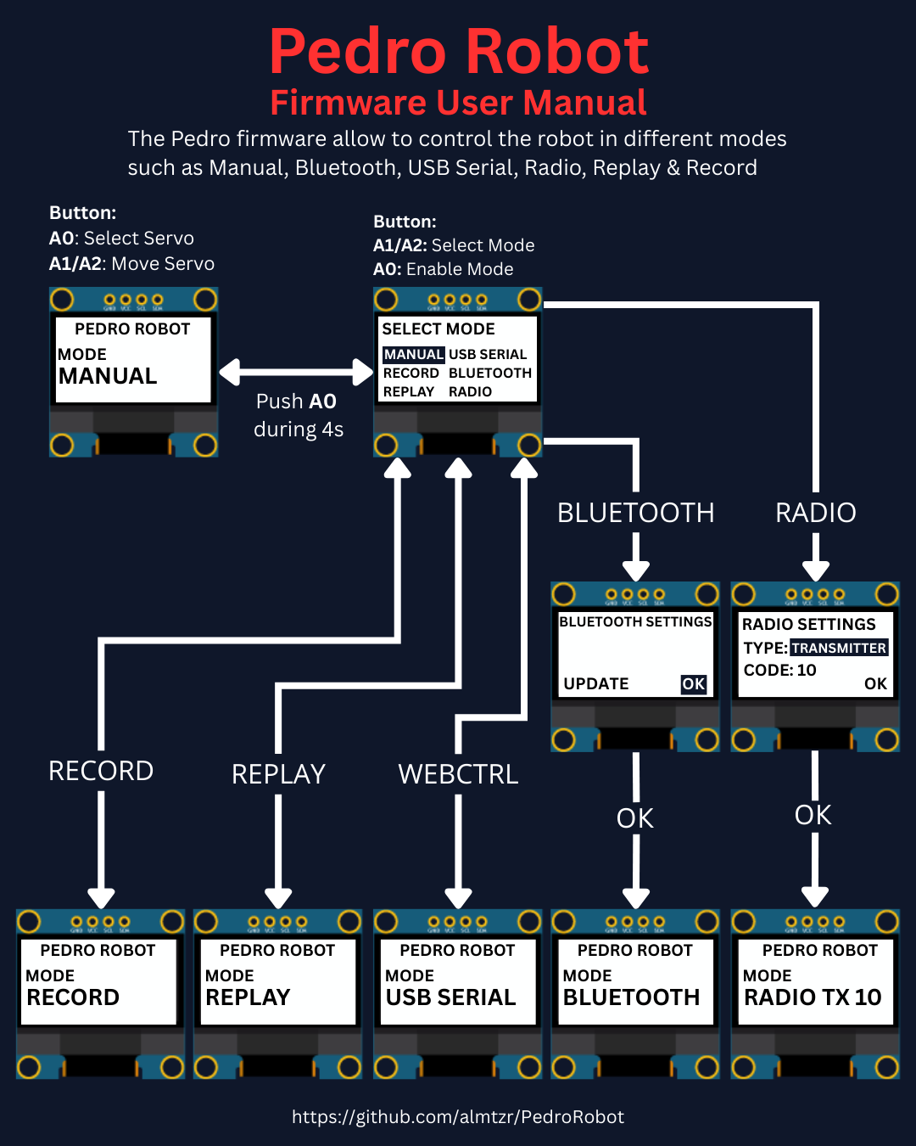

3. Radio Mode
Radio Mode allows two Pedro robots to communicate using the NRF24L01 module :
👉 One robot sends commands (Transmitter)
👉 The other receives and executes them (Receiver)

💡 This is exactly how drones, remote-controlled cars or industrial robots are controlled in real life.

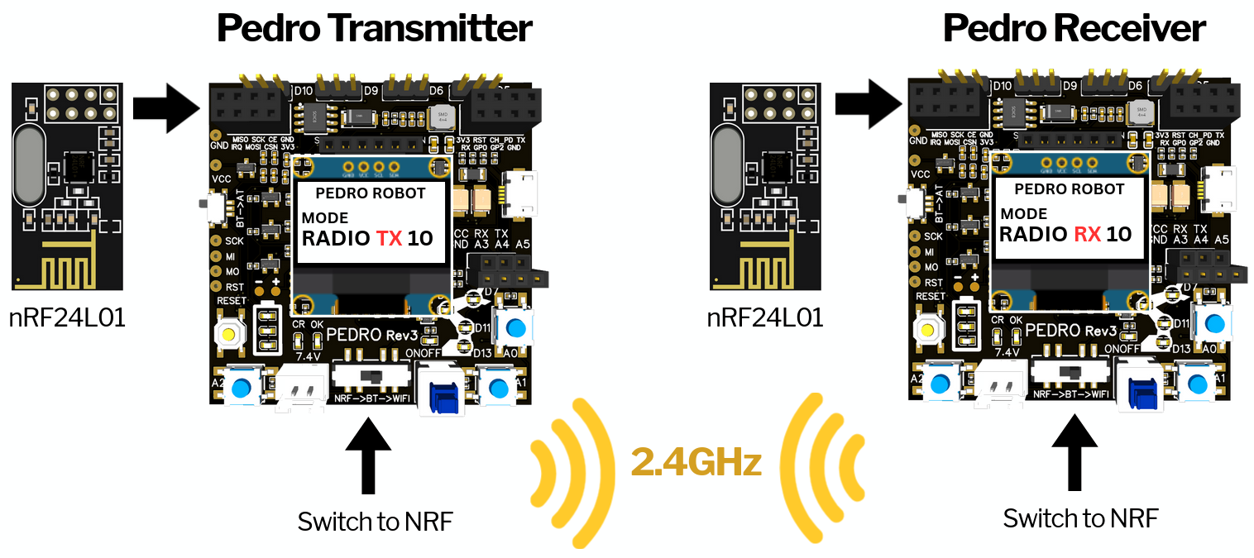
How to use:
- Insert the NRF24L01 modules into both robots
- Set Pedro’s switch NRF → BT → WiFi to NRF
- Restart both robots
- Enter the Select Mode menu (hold A0 for 4 seconds).
- Select Radio mode from the menu and press A0 to confirm.
- Define the robot’s role (type): press A1 to select TRANSMITTER or RECEIVER.
- Press A0 to confirm the role.
- Set a communication Code Key:
  - Press A1 to increase (increment)
  - Press A2 to decrease (decrement)
  - Values range from 1 to 99
💡Note: Both the transmitter and receiver must use the same Code Key to establish communication.
👉 Think of it like a password for communication
- Press A0 to confirm the Code Key.
- Press A0 again to validate (OK).

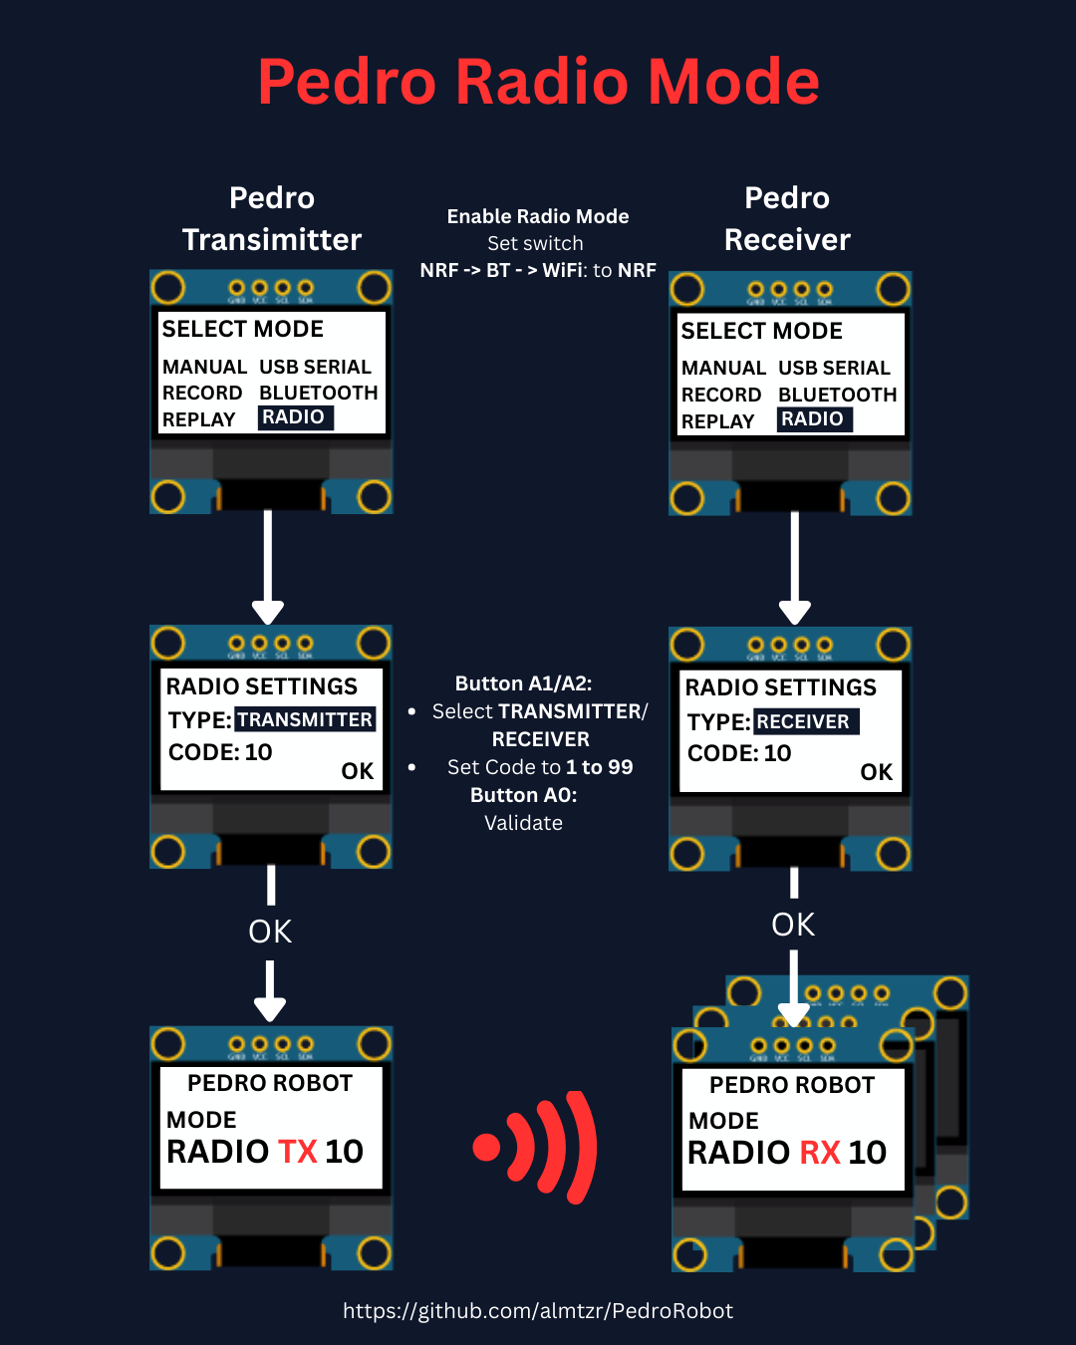Radio Mode Configuration Overview

4. Activities

🎯 Activity 1 — First Connection

Mission
Make both robots connect.

Student Actions
Once the two Pedro robot are configured as transmitter and receiver. Press A0 on trasmitter

Observation
👉 Do LEDs light up on both robots? The LED corresponding to the selected servo light on simultaneously on the Pedro transmitter and the receiver. That indicates that the radio communication between both is established.

🎯 Activity 2 — Mirror Movement

Mission
Control one robot using the other.

Student Actions
• Press A1 /or A2 on transmitter
• Observe receiver

Observation: Do both robots move at the same time?

🎯 Activity 3 — Measuring Radio Communication Range

Mission
Students will measure the maximum communication distance between two Pedro in an open space.
They will compare Real-world performance vs theoretical specifications
According to the manufacturer:
👉 NRF24L01: typical range: 30 to 50 meters (indoor), up to 100 meters (open space)
💡 Note: Real performance depends on environment, obstacles, and power supply.

Experiment
Step 1: Move Away
• One student stays with the RECEIVER
• One student walks away with the TRANSMITTER
Step 2: Every few meters (5m 10m 20m 50m 100m 150m etc)
• Press A1 or A2
• Observe the RECEIVER
👉 Does it still respond?
Step 3: Find the Limit
Continue until: ❌ The receiver no longer responds
Step 4: Measure Distance
• Measure or estimate the distance
• Record the result
📋 Data Collection Table
Distance (m) | Signal Working? | Notes
5 | Yes
10 | Yes
20 | Yes
... | ...
Max | No | Lost signal

🎯 Activity 4 — Break the Connection

Mission
Understand what breaks communication.

Experiment
• Change Code Key on one robot
• Test again
👉 What happens?
💡 Expected: No communication

🧠 Reflection Questions
• Why is wireless communication useful?
• What happens if signals are interrupted?
• Where do we use this in real life?

3. Quiz (20 Questions)

1. Radio Mode enables communication between _________ robots.
A) Two
B) One
C) Three
D) Four
✅ Answer:
2. The NRF24L01 module is used for:
A) Power
B) Display
C) Wireless communication
D) Sound
✅ Answer:
3. A transmitter:
A) Receives data
B) Sends data
C) Stores data
D) Deletes data
✅ Answer:
4. A receiver:
A) Sends data
B) Receives data
C) Prints data
D) Ignores data
✅ Answer:
5. The Code Key is:
A) Voltage
B) Password for communication
C) Speed
D) Memory
✅ Answer:
6. If Code Keys are different:
A) Works faster
B) No communication
C) LED brighter
D) Nothing changes
✅ Answer:
7. The Code Key range is:
A) 0-9
B) 1-99
C) 100-999
D) 0-255
✅ Answer:
8. LED sync indicates:
A) Error
B) No battery
C) Connection established
D) Shutdown
✅ Answer:
9. Robots moving together is called:
A) Isolation
B) Synchronization
C) Rotation
D) Compilation
✅ Answer:
10. « No tools required » means the kit is ___________.
A) Pre-assembled
B) Tool-free assembly
C) Only screws
D) Requires soldering
✅ Answer:
5. The primary learning domain for these modes is ___________.
A) History
B) STEM
C) Art
D) Geography
✅ Answer:
6. « Hands-on STEM learning » promotes ___________.
A) Watching videos
B) Building and experimenting
C) Reading books only
D) Using simulators
✅ Answer:
7. Open-source hardware allows students to ___________.
A) Disassemble parts only
B) View, modify and share designs
C) Keep designs proprietary
D) Use closed software
✅ Answer:

8. Which mode is best for directly recording manual movements?
A) Manual Mode
B) Record & Replay Mode
C) Bluetooth Mode
D) USB Serial Mode
✅ Answer:
9. Pedro’s 3D missing parts can be found on _________.
A) Facebook
B) GitHub
C) Instagram
D) Pinterest
✅ Answer:
10. The educational value of Multiple Modes is to show _________.
A) Only one type of control
B) Diverse control interfaces
C) Just electronics
D) Only mechanics
✅ Answer:
11. In Radio Mode, both robots must use the same _________.
A) Battery level
B) Serial port
C) Code Key
D) USB cable
✅ Answer:

Work in progress...

END
Pedro STEM Lesson n°5

