

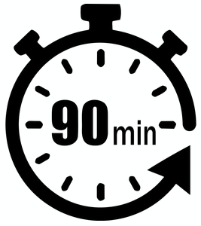
ADVANCED
STEM Program
Lesson #7: Replay Mode
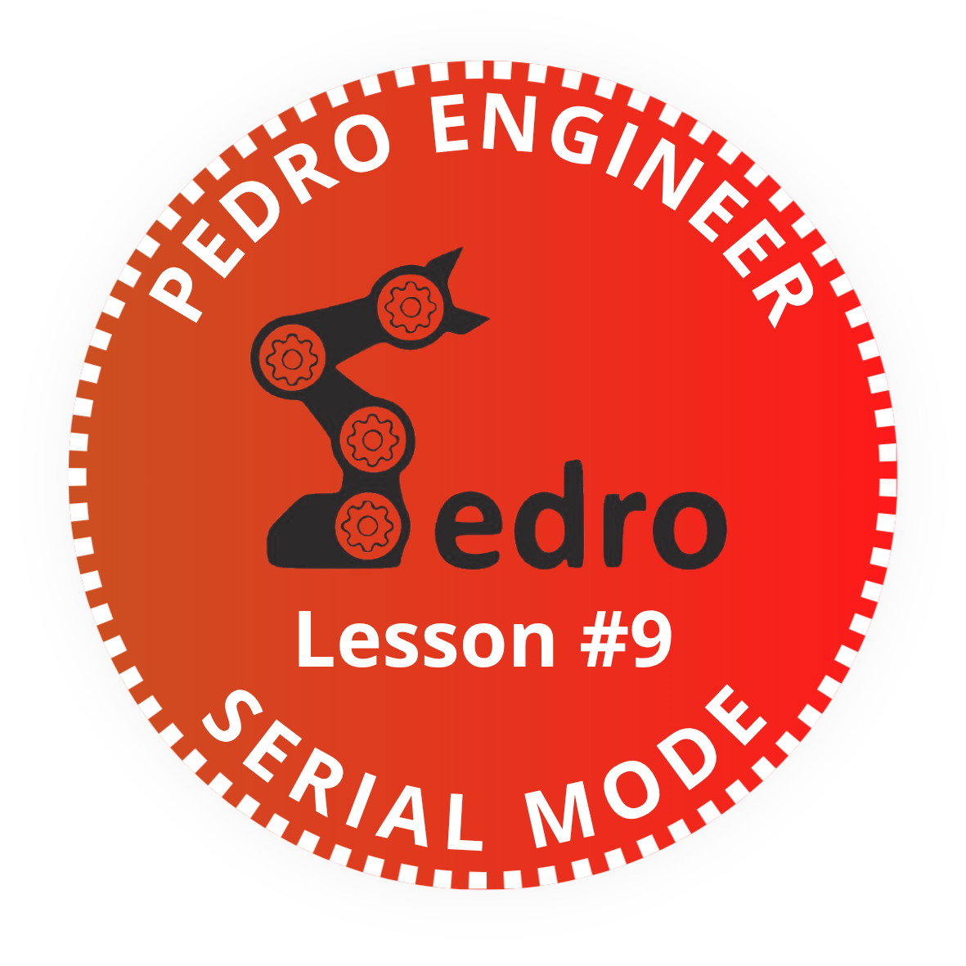
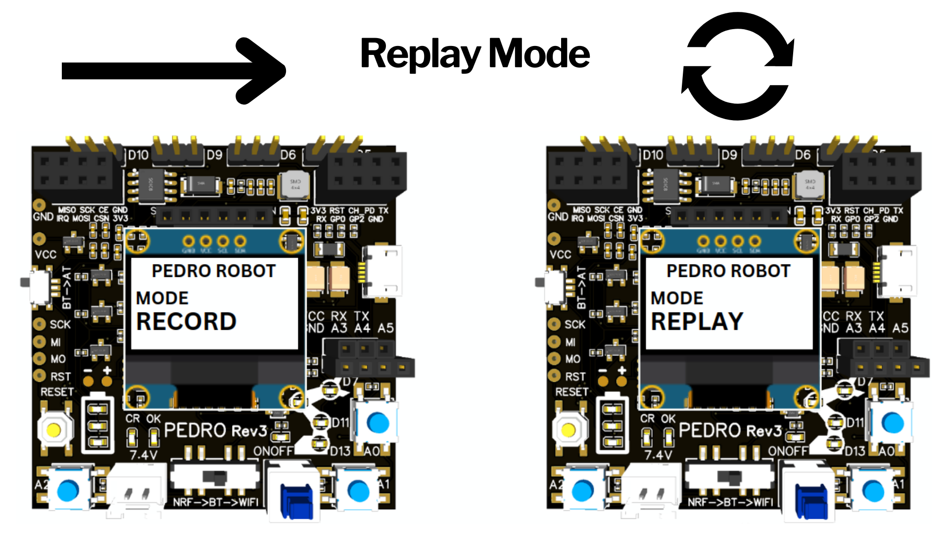

Add it to your Pedro Passport to track your STEM journey!
Complete this lesson to earn your Pedro Badge.

YOUR MISSION: ….

STEM Lesson n°7



v1.0.0

🎯 Learning Objective
In this lesson, students discover one of the most exciting features of robotics:
👉 Teaching a robot by demonstration
Instead of writing code line by line, students physically move the robot, record its movements, and replay them automatically. This lesson introduces important robotics concepts such as:
- memory
- automation
- motion sequences
- data recording
- repeatability
Pedro’s Record & Replay Mode makes these advanced concepts accessible in a simple and interactive way.
By the end of this lesson, students will be able to:
- Understand how robots record movements
- Explain the difference between Record Mode and Replay Mode
- Create a movement sequence manually
- Replay robotic actions automatically
- Understand how motion data is stored in memory
- Explore the foundations of robotic automation

👨‍🏫 Instructor Notes
Recommended age: 12+
Difficulty Level: Beginner → Intermediate
Prerequisites: Previous Lessons
Duration: 90 – 120 minutes
💡 Tip: Encourage students to predict what will happen before testing

🧰 Required Materials
Per student or team:
- One Pedro robots Assembled
- USB cable
- Computer with Arduino IDE installed

Table of Contents
🎯 Learning Objective 2
👨‍🏫 Instructor Notes 2
🧰 Required Materials 2
1. Install the Pedro Program 4
2. Control Modes Overview 5
3. Understanding Record & Replay Mode 6
4. How the System Works 6
4.1 Entering Record Mode 7
4.2 Recording a Sequence 7
4.3 Replay the Sequence 7
5. Student Activities 🧪 8
6. STEM Reflection Questions 💡 10
📝 Quiz — Record & Replay Mode (10 Questions) 10

1. Install the Pedro Program
(Skip this step if already completed in Lesson n°3)

The Pedro Program is the core software that powers and controls the robot. It acts as the robot’s “brain,” managing all behaviors and interactions.
Through this single program, students can access and explore multiple control modes, allowing them to understand how a robot receives instructions, processes them, and translates them into physical actions.
- Download and install the latest version of the Arduino IDE.
- Install the required libraries from the Library Manager:
  - PedroRobot: Tools → Manage Libraries → search PedroRobot → Install
  - U8glib: Tools → Manage Libraries → search U8glib → Install
  - RF24: Tools → Manage Libraries → search RF24 → Install
- Insert the Oled Screen into the Pedro board and Connect the board to your computer via USB.
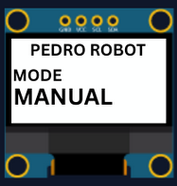
- Select the correct port:
  - Tools → Select the port that appear when you connect Pedro robot
- Select the board type:
  - Tools → Board → Arduino Micro
- Open the example sketch:
  - File → Examples → PedroRobot → Pedro
- Compile and upload the sketch to your Pedro board.
✅ If everything is correct, Pedro’s OLED screen will display “MANUAL MODE”.
- Press the button A0 and observe what happen.
The LED corresponding to the selected servo light on. That button allows you to control each part of the robot. Here is the mapping between the LED ID and the servo ID
  - LED D13 → servo D5 (Base)
  - LED D11 → servo D6 (Shoulder)
  - LED D8 → servo D9 (Elbow)
  - LED D7 → servo D10 (Gripper)
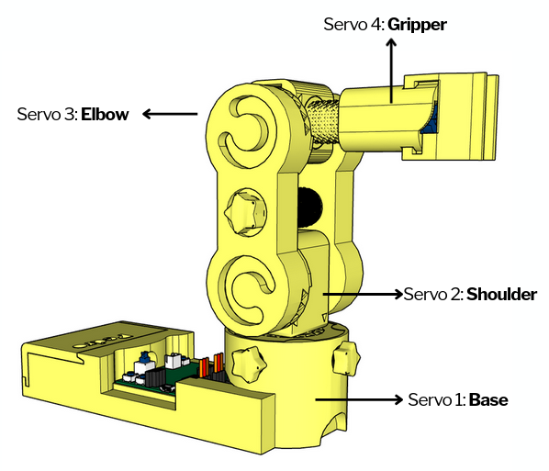

2. Control Modes Overview
Using the 128x64 OLED display, users can easily navigate through the menu to select and configure different modes of operation. The available control modes are:
Manual Mode – direct control using onboard buttons
Record & Replay Mode – record and replay movements
Bluetooth Mode – control Pedro via smartphone or PC
Radio Mode – remote communication between robots
USB Serial Mode – control Pedro directly from a computer
Through this firmware, students discover how software can define robotic behavior and how multiple communication interfaces can coexist within one system. The picture below described how to navigate through the multiple control modes.
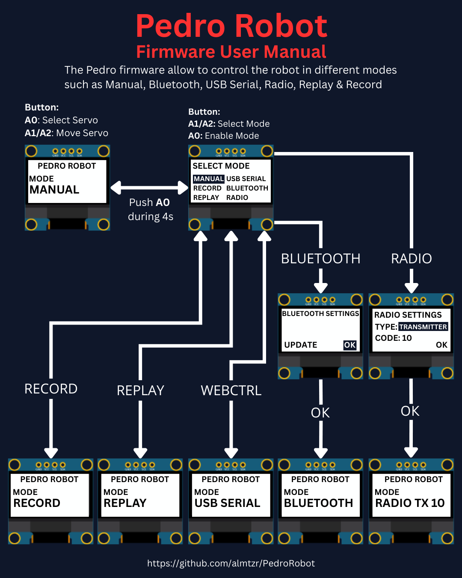

3. Understanding Record & Replay Mode
Pedro doesn’t use inverse kinematics because it’s powered by 360° continuous rotation servos (MG90S) not classic positional servos. That means Pedro doesn’t « go to » a position it just spins forward or backward, depending on the PWM signal.
To perform a Repeat sequence instead of recording positions, Pedro records three specifics data:
- the time
- the direction
- the speed
The result? Pedro can replay movements like a macro recorder just by following the same timing and motion patterns. Each movement becomes part of a motion sequence.
For example:

Step | Action
1 | Move arm up
2 | Open gripper
3 | Move arm down
4 | Close gripper

Replay Mode allows Pedro to reproduce the recorded sequence automatically. The robot repeats the exact same movements without human control. This creates an automated robotic behavior.
Students discover that:
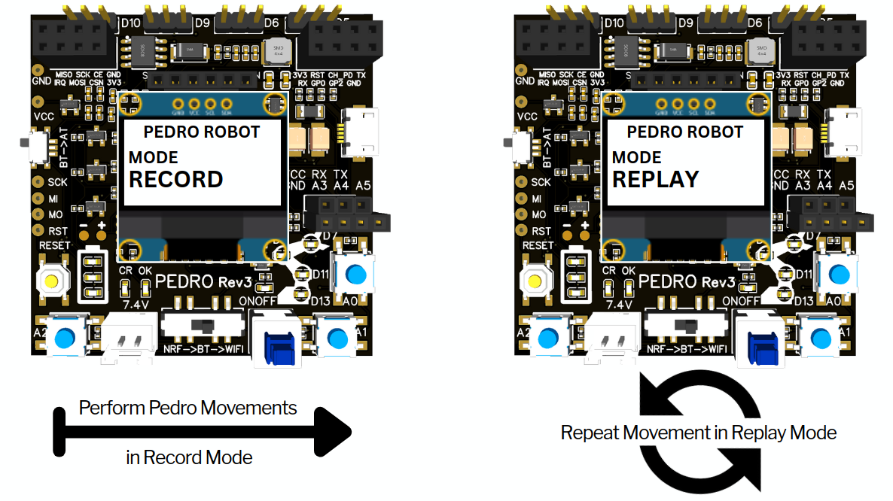
👉 Robots can repeat tasks consistently. This is one of the main advantages of robotics in industry.

4. How the System Works

Pedro uses a simple logic system in three steps:
- Entering Record Mode
- Recording a Sequence
- Entering Replay Mode

4.1 Entering Record Mode
- Power ON the robot
- Enter the Select Mode menu (hold A0 for 4 seconds)
- Select RECORD mode from the menu and press A0 to confirm
- The OLED screen displays :
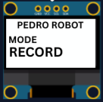
💡Note: Pedro is now ready to memorize movements.

4.2 Recording a Sequence
Students now create their first robotic routine.
Example sequence:
- Rotate base
- Lift arm
- Open gripper
- Lower arm
- Close gripper
Each movement is stored inside Pedro’s memory.

4.3 Replay the Sequence
Replay the Sequence:
- Enter the Select Mode menu (hold A0 for 4 seconds)
- Select REPLAY mode from the menu and press A0 to confirm
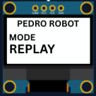
- The OLED screen displays :
- Pedro automatically executes the sequence

💡Note: Pedro now repeats the recorded actions continuously.
To stop the replaying sequence press A0 until the Select mode menu display

5. Student Activities 🧪
These activities help students understand how robotic automation works through experimentation and teamwork.
Activity 1 — First Recording
Objective
Record and replay a simple robotic movement.
Instructions
- Enter RECORD mode
- Move the robot slowly:
  - rotate the base
  - lift the arm
  - open the gripper
- Enter REPLAY mode
- Observe the replayed sequence
Discussion Questions
- Did Pedro repeat the exact same movement?
- Was the replay smooth?
- Which movement was the most difficult to reproduce?
Activity 2 — Precision Challenge
Objective
Improve movement repeatability.
Instructions
Students must:
- Record the shortest possible movement sequence
- Replay it 3 times
- Compare the precision of each replay
Engineering Focus
Students discover:
- timing accuracy
- movement consistency
- robotic repeatability
Activity 3 — Pick and Place Mission 🧩
Objective
Simulate an industrial robotic task.
Mission
Pedro must:
- Pick up an object
- Move it to another position
- Release it
Rules
- Students may only use Record & Replay mode
- No direct control during replay
- Teams have 10 minutes
Scoring
Task | Points
Successful pickup | +2
Smooth movement | +2
Accurate placement | +2
Team collaboration | +1
🏆 Winning team earns the title:
Pedro Automation Engineers
Activity 4 — Human vs Robot
Objective
Compare human control and robotic automation.
Instructions
- One student performs the movement manually
- Pedro performs the replayed movement
- Students compare both performances
Questions
- Which was more precise?
- Which was faster?
- Which made fewer mistakes?
Students discover one of the main advantages of robotics:
👉 repeatable automated behavior
Activity 5 — Create a Robotic Dance 🎵
Objective
Create a fun movement routine. Students record:
- arm rotations
- synchronized gripper movement
- repeated patterns
Replay the sequence continuously. This activity introduces:
- motion programming
- timing synchronization
- creative robotics

6. STEM Reflection Questions 💡
After the activities, discuss with students:
- Why is repeatability important in robotics?
- Why do factories use automated robots?
- What happens if incorrect data is recorded?
- How does Pedro “remember” movements?
- Can robots learn by observing humans?

📝 Quiz — Record & Replay Mode (10 Questions)

Question 1
What is the purpose of Record Mode?
A) Charge the battery
B) Store robot movements
C) Connect to WiFi
D) Control LEDs
✅ Correct answer:
Question 2
What does Replay Mode do?
A) Deletes movements
B) Replays stored actions automatically
C) Turns OFF the robot
D) Resets the program
✅ Correct answer:
Question 3
Which type of servos does Pedro use?
A) Stepper motors
B) Classic positional servos
C) Continuous rotation servos
D) Hydraulic motors
✅ Correct answer:
Question 4
Which data are recorded during Record Mode?
A) Servo positions only
B) Time, direction, and speed
C) Battery voltage
D) OLED brightness
✅ Correct answer:
Question 5
Why doesn’t Pedro use inverse kinematics?
A) The battery is too small
B) Pedro uses continuous rotation servos
C) The OLED screen is too small
D) Bluetooth is disabled
✅ Correct answer:

Question 6
What happens when Pedro enters Replay Mode?
A) It records new movements
B) It repeats stored movements automatically
C) It turns OFF the servos
D) It resets the memory
✅ Correct answer:
Question 7
What is one major advantage of robotics in industry?
A) Robots can sleep
B) Robots can repeat tasks consistently
C) Robots can print documents
D) Robots can create batteries
✅ Correct answer:
Question 8
Which button is used to access the Select Mode menu?
A) A1
B) A2
C) A0
D) RESET
✅ Correct answer:
Question 9
What engineering concept is tested when replaying movements multiple times?
A) Battery charging
B) Repeatability
C) Bluetooth pairing
D) Screen resolution
✅ Correct answer:
Question 10
What is the main purpose of robotic automation?
A) Make robots colorful
B) Allow robots to perform tasks automatically
C) Increase screen brightness
D) Charge batteries faster
✅ Correct answer:
END
Pedro STEM Lesson n°7

