



ADVANCED
STEM Program
Lesson #8: Replay Mode
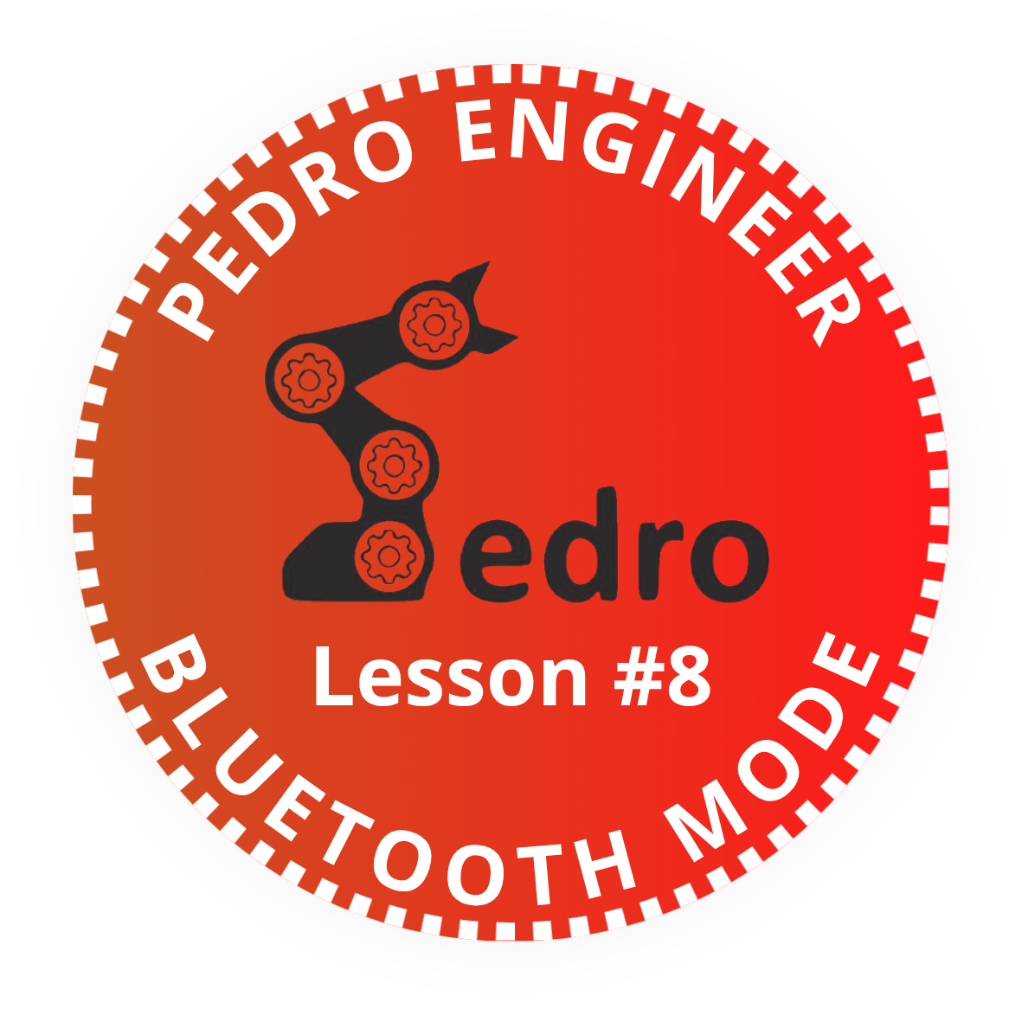
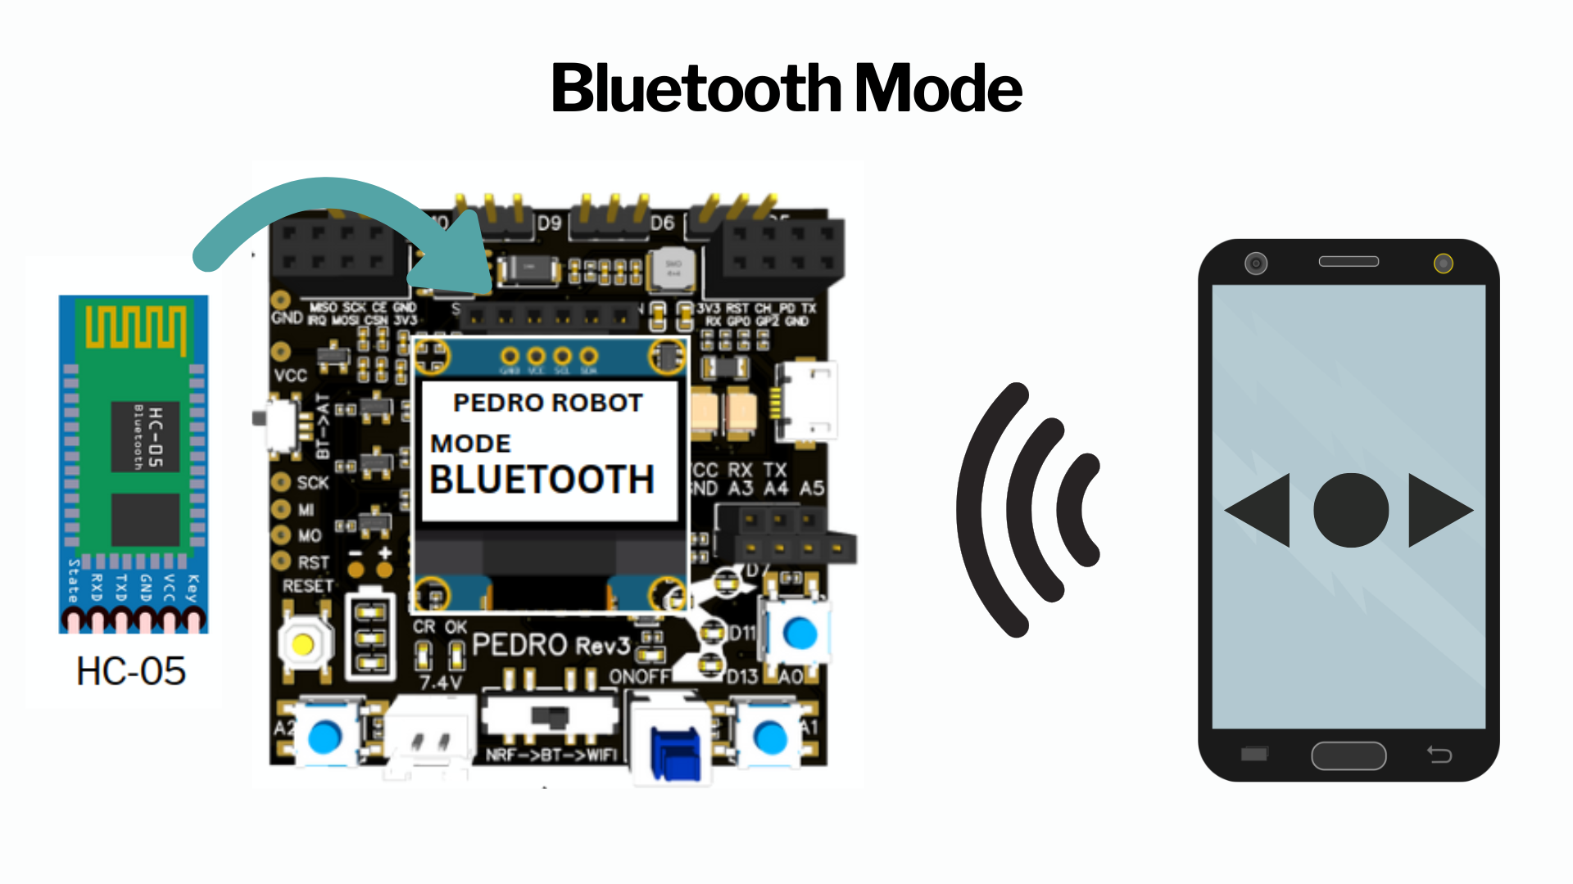

Add it to your Pedro Passport to track your STEM journey!
Complete this lesson to earn your Pedro Badge.

YOUR MISSION: ....

STEM Lesson n°8



v1.0.0

🎯 Learning Objective
In this lesson, students will discover how to control Pedro wirelessly using Bluetooth technology.
Using the integrated HC-05 Bluetooth module, students connect Pedro to a smartphone or tablet and send commands remotely.
By the end of this lesson, students will be able to:
- Understand Bluetooth communication
- Explain how smartphones communicate with robots
- Connect Pedro to a mobile device
- Send wireless commands to Pedro
- Understand serial communication principles

👨‍🏫 Instructor Notes
Recommended age: 12+
Difficulty Level: Beginner → Intermediate
Prerequisites: Previous Lessons
Duration: 90 – 120 minutes
💡 Tip: Encourage students to predict what will happen before testing

🧰 Required Materials
Per student or team:
- Pedro robot Assembled with HC-05 module
- Smartphone with Serial Bluetooth (available on iOS or Android)
- USB cable
- Computer with Arduino IDE installed

Table of Contents
🎯 Learning Objective 2
👨‍🏫 Instructor Notes 2
🧰 Required Materials 2
1. Install the Pedro Program 4
2. Control Modes Overview 5
3. STEM Context 6
4. Understanding Bluetooth Communication 6
5. The HC-05 Bluetooth Module 6
6. Entering Bluetooth Mode 7
7. Installing the Smartphone App 9
7.1 Configuring the Bluetooth Controller 9
7.2 Creating the Servo Control Buttons 9
7.3 Creating the Motion Control Buttons 9
7.4 How the Communication Works 9
📝 Quiz — Bluetooth Mode (10 Questions) 11
🎯 Bonus Challenge Question 12

1. Install the Pedro Program
(Skip this step if already completed in Lesson n°3)

The Pedro Program is the core software that powers and controls the robot. It acts as the robot’s “brain,” managing all behaviors and interactions.
Through this single program, students can access and explore multiple control modes, allowing them to understand how a robot receives instructions, processes them, and translates them into physical actions.
- Download and install the latest version of the Arduino IDE.
- Install the required libraries from the Library Manager:
  - PedroRobot: Tools → Manage Libraries → search PedroRobot → Install
  - U8glib: Tools → Manage Libraries → search U8glib → Install
  - RF24: Tools → Manage Libraries → search RF24 → Install
- Insert the Oled Screen into the Pedro board and Connect the board to your computer via USB.
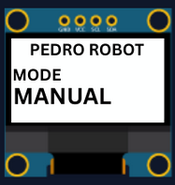
- Select the correct port:
  - Tools → Select the port that appear when you connect Pedro robot
- Select the board type:
  - Tools → Board → Arduino Micro
- Open the example sketch:
  - File → Examples → PedroRobot → Pedro
- Compile and upload the sketch to your Pedro board.
✅ If everything is correct, Pedro’s OLED screen will display “MANUAL MODE”.
- Press the button A0 and observe what happen.
The LED corresponding to the selected servo light on. That button allows you to control each part of the robot. Here is the mapping between the LED ID and the servo ID
  - LED D13 → servo D5 (Base)
  - LED D11 → servo D6 (Shoulder)
  - LED D8 → servo D9 (Elbow)
  - LED D7 → servo D10 (Gripper)
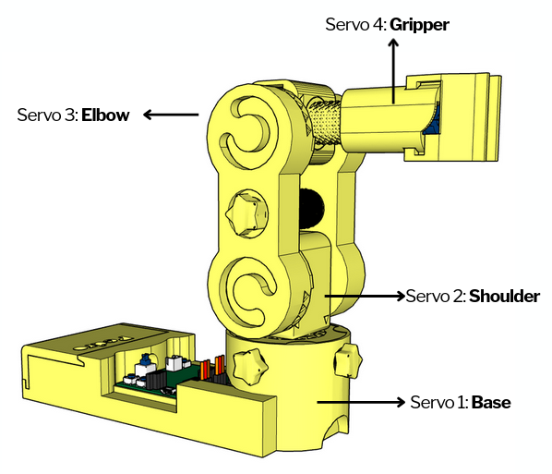

2. Control Modes Overview
Using the 128x64 OLED display, users can easily navigate through the menu to select and configure different modes of operation. The available control modes are:
Manual Mode – direct control using onboard buttons
Record & Replay Mode – record and replay movements
Bluetooth Mode – control Pedro via smartphone or PC
Radio Mode – remote communication between robots
USB Serial Mode – control Pedro directly from a computer
Through this firmware, students discover how software can define robotic behavior and how multiple communication interfaces can coexist within one system. The picture below described how to navigate through the multiple control modes.
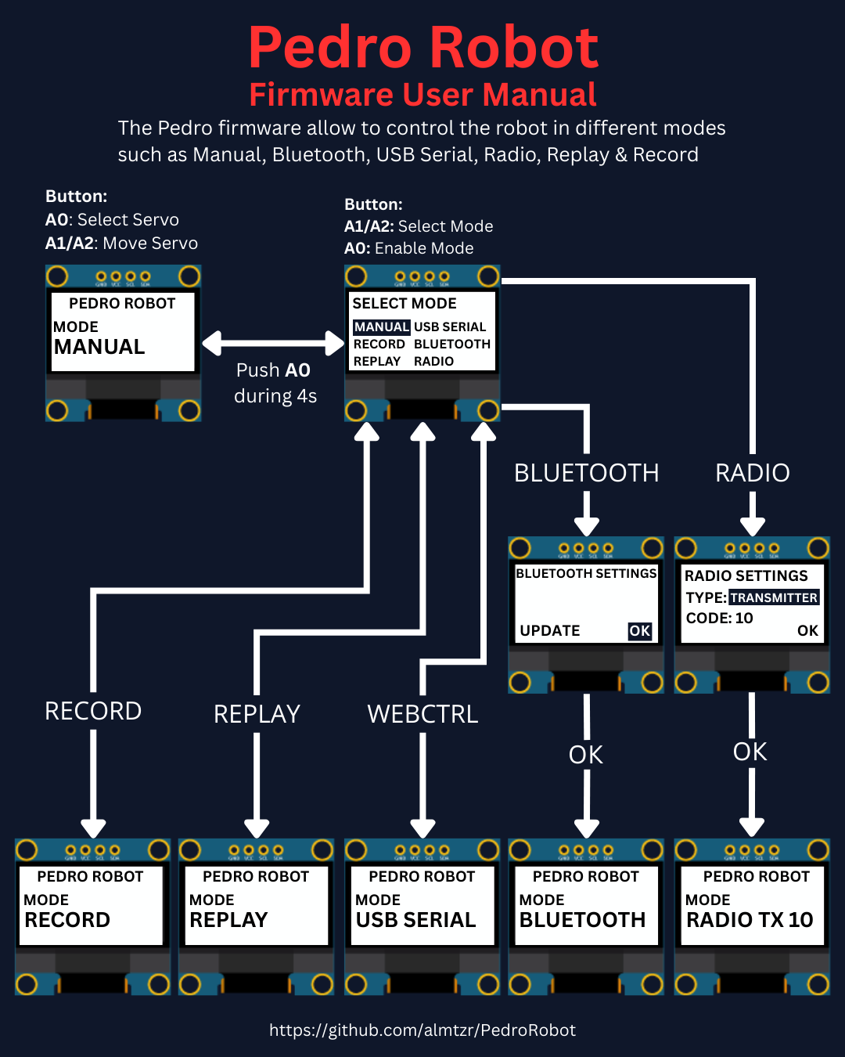

3. STEM Context
Why Bluetooth Matters in Robotics ?
Bluetooth is one of the most common wireless communication technologies.
It allows devices to exchange data over short distances without cables.
Bluetooth is used in:
- wireless headphones
- smartwatches
- drones
- robots
- home automation systems
Pedro uses the HC-05 Bluetooth module to create a wireless communication link with a smartphone.

4. Understanding Bluetooth Communication

Bluetooth communication works like a wireless conversation. The smartphone sends digital commands. Pedro receives the commands and converts them into robot movements.
The communication chain is:

Smartphone → Bluetooth Signal → HC-05 Module → Microcontroller → Servomotors → Robot Movement

5. The HC-05 Bluetooth Module

Pedro uses an HC-05 Bluetooth module connected to the ATmega32U4 microcontroller through serial communication pins (RX/TX).
The HC-05 module:
- receives wireless data
- converts Bluetooth signals into serial data
- sends commands to Pedro’s program
The HC-05 can operate in two modes:
Mode | Function
Normal Mode | Standard Bluetooth communication
AT Mode | Configuration and settings

6. Entering Bluetooth Mode
To activate Bluetooth Mode:
- Power OFF Pedro
- Set switch NRF → BT → WiFi to BT
- Power ON Pedro (💡Note: maintain AT Button to start on AT mode for settings options)
- Enter the Select Mode menu (hold A0 for 4 seconds)
- Select BLUETOOTH mode from the menu and press A0 to confirm
- The OLED screen displays:
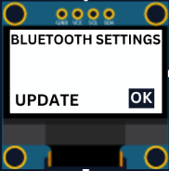
Two Setting Options
UPDATE (AT mode required) | OK
- When you choose UPDATE and press A0  - The OLED screen displays:  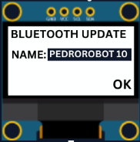  - That screen allows to update the name of Pedro for Bluetooth connexion  - Set the Pedro Bluetooth name by using the button A1/A2 PEDROROBOT1 to 99  - And click on A0 to validate  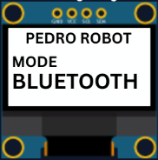  - The OLED screen displays: | - When you choose OK and press A0  - The OLED screen displays:    - 💡Note: Pedro is now ready to communicate by Bluetooth.
💡 Note: You can now detect the Pedro robot using your smartphone’s Bluetooth search.
Pedro may appear with the default Bluetooth name HC-05 or with a custom name such as PEDROROBOTn.
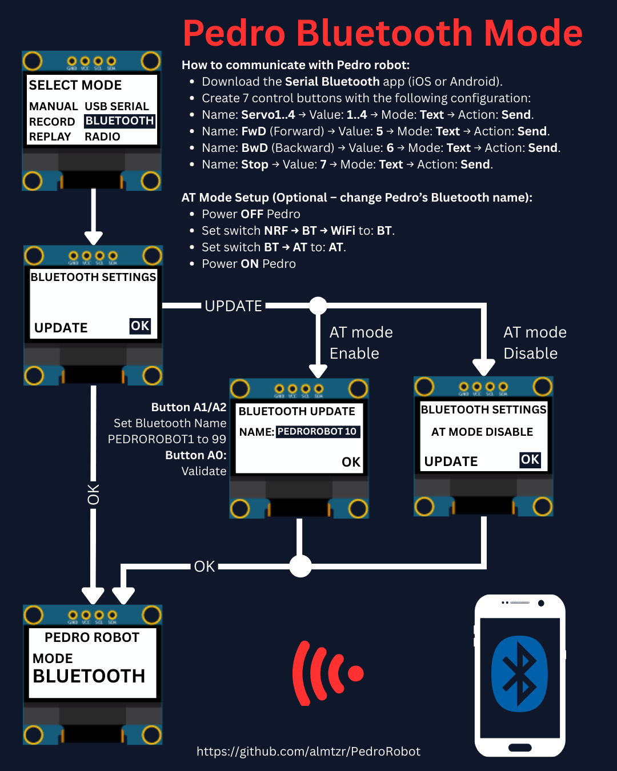

Bluetooth Mode Configuration Overview

7. Installing the Smartphone App
To communicate wirelessly with Pedro, students must install a Serial Bluetooth application on their smartphone or tablet. These applications allow the phone to send commands directly to the robot through the HC-05 Bluetooth module.
Recommended Applications
Android
- Serial Bluetooth Terminal
- Bluetooth Electronics
iOS
- Bluetooth Serial Controller

7.1 Configuring the Bluetooth Controller
After installing the application, students will create a simple control interface to operate Pedro remotely. The interface uses buttons that send text commands to the robot.

7.2 Creating the Servo Control Buttons
Create four buttons with the following configuration:
Button Name | Value Sent | Mode | Action
Servo1 | 1 | Text | Send
Servo2 | 2 | Text | Send
Servo3 | 3 | Text | Send
Servo4 | 4 | Text | Send

These buttons select which servo motor will be controlled.

7.3 Creating the Motion Control Buttons
Create three additional buttons:
Button Name | Value Sent | Mode | Action
FwD (Forward) | 5 | Text | Send
BwD (Backward) | 6 | Text | Send
Stop | 7 | Text | Send

These commands control the movement direction of the selected servo.

7.4 How the Communication Works
When a student presses a button on the smartphone:
- The app sends a text command via Bluetooth
- The HC-05 module receives the command
- Pedro’s program interprets the instruction
- The selected servo motor moves
Example:
- Phone Button → "Servo 1" (Bluetooth command → « 1 »: the LED D13 light ON)
- Phone Button → "FwD" (Bluetooth command → « 5 »: the Servo 1 Move Forward)
- Bluetooth → HC-05
- Program reads "5"
- Servo rotates forward

📝 Quiz — Bluetooth Mode (10 Questions)
Question 1
What module allows Pedro to communicate via Bluetooth?
A) ESP8266
B) NRF24L01
C) HC-05
D) GPS module
✅ Correct answer:
Question 2
What type of communication does Bluetooth use?
A) Wired communication
B) Wireless communication
C) Optical communication
D) Mechanical communication
✅ Correct answer:
Question 3
What device is commonly used to control Pedro in Bluetooth Mode?
A) Printer
B) Smartphone or tablet
C) Keyboard only
D) Camera
✅ Correct answer:
Question 4
What is the role of the HC-05 module?
A) Charge the battery
B) Receive Bluetooth commands
C) Rotate servos directly
D) Print 3D parts
✅ Correct answer:
Question 5
Which communication protocol is used between the HC-05 and the microcontroller?
A) HDMI
B) Ethernet
C) UART Serial
D) VGA
✅ Correct answer:
Question 6
What happens when the "FwD" button is pressed in the smartphone app?
A) The robot turns OFF
B) A Bluetooth command is sent to move the servo forward
C) The OLED screen resets
D) The battery charges
✅ Correct answer:
Question 7
Which button is used to enter the Select Mode menu?
A) RESET
B) A2
C) A0
D) POWER
✅ Correct answer:
Question 8
What is the purpose of AT Mode on the HC-05 module?
A) Move the servos
B) Configure Bluetooth settings
C) Charge the robot
D) Record movements
✅ Correct answer:
Question 9
What can students modify in AT Mode?
A) Battery voltage
B) OLED size
C) Bluetooth device name
D) Servo dimensions
✅ Correct answer:
Question 10
Why is wireless communication important in robotics?
A) It makes robots heavier
B) It allows robots to communicate without cables
C) It changes the robot color
D) It increases battery size
✅ Correct answer:

🎯 Bonus Challenge Question
How does a smartphone command become robot movement?
✅ Expected Answer:
Smartphone → Bluetooth signal → HC-05 module → Microcontroller → Servo motor → Robot movement

END
Pedro STEM Lesson n°8

