

ADVANCED
STEM Program
Lesson #9: USB Serial Communication
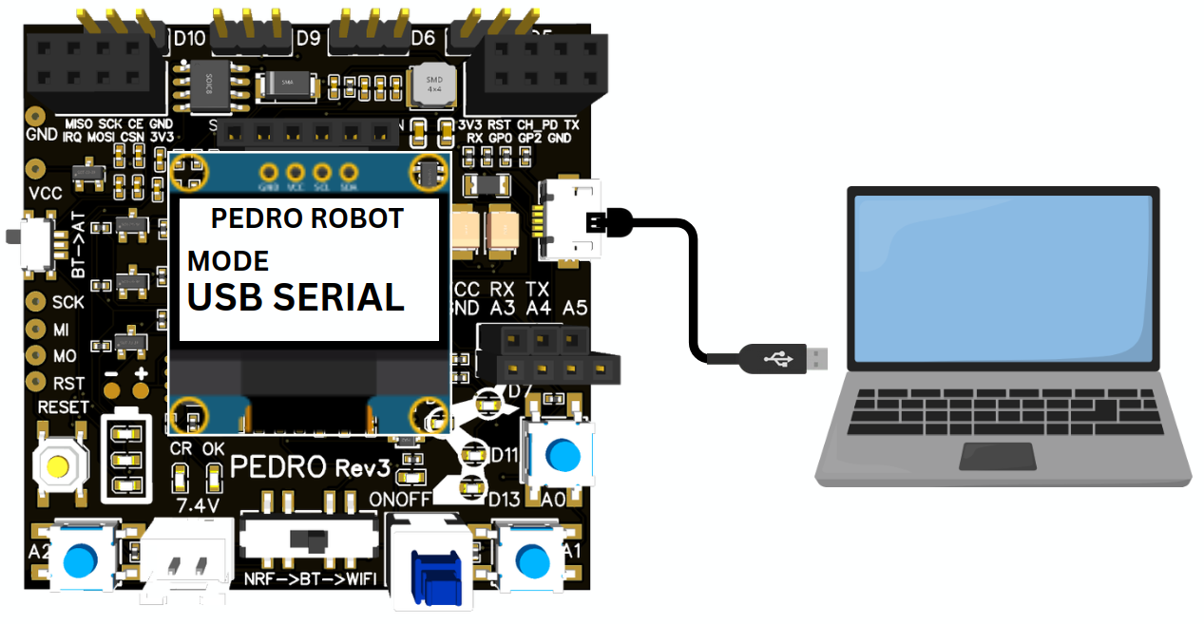
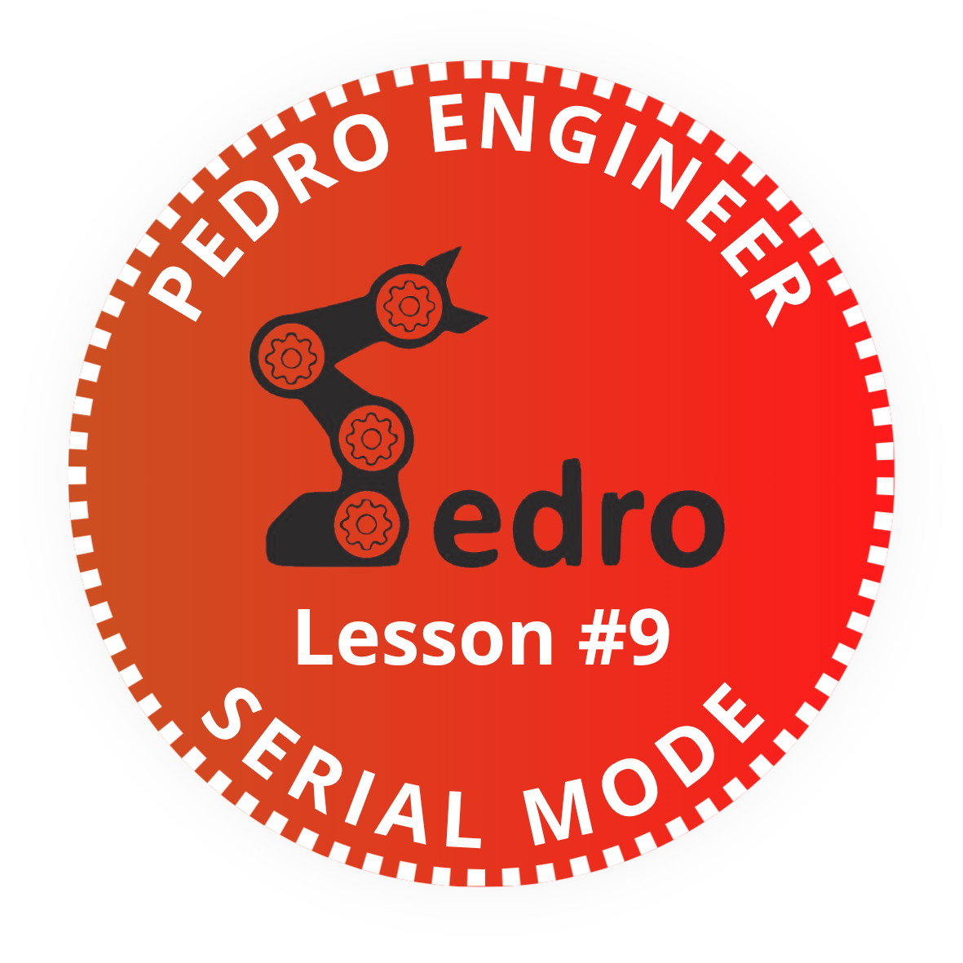

Add it to your Pedro Passport to track your STEM journey!
Complete this lesson to earn your Pedro Badge.

YOUR MISSION: Learn how robots exchange data with
computers using USB Serial communication.

🚀 Pedro Mission
In this lesson, students discover how to control Pedro directly from a computer using USB Serial communication. Students will learn how a computer exchanges data with a robot through a USB cable and how digital commands are translated into robotic movement.

🎯 Learning Objective
By the end of this lesson, students will be able to:
- Understand USB Serial communication
- Explain how computers communicate with robots
- Connect Pedro to a computer
- Control servomotors from a web application
- Understand serial data transmission
- Explore human–computer–robot interaction systems

🎓 Instructor Notes
Recommended age: 8+
Difficulty Level: Beginner → Intermediate
Prerequisites: Previous lessons
Duration: 90 – 120 minutes

💡 Tip: Encourage students to predict what will happen before testing

🧰 Required Materials
Per student or team:
- Pedro robot Assembled
- USB Data Cable and USB Charging-Only Cable
- Computer with:
  - Arduino IDE installed
  - Compatible browser : Google Chrome, Microsoft Edge or Brave Browser

⚙️ Install the Pedro Program
The Pedro Program is the core software that powers and controls the robot. It acts as the robot’s « brain », managing all behaviors and interactions. Through this single program, students can access and explore multiple control modes (radio mode, bluetooth mode, USB serial mode, record & replay mode) allowing them to understand how a robot receives instructions, processes them, and translates them into physical actions.
- Download and install the latest version of the Arduino IDE.
- Install the required libraries from the Library Manager:
PedroRobot: Tools → Manage Libraries → search PedroRobot → Install
U8glib: Tools → Manage Libraries → search U8glib → Install
RF24: Tools → Manage Libraries → search RF24 → Install
- Insert the Oled Screen into the Pedro board
- Connect the board to your computer via USB
- Select the correct port:
Tools → Port (port that appear when you connect Pedro robot)
- Select the board type:
Tools → Board → Arduino Micro
- Open the Pedro sketch:
File → Examples → PedroRobot → Pedro
- Compile and upload the sketch to your Pedro board.
✅ Pedro is now ready and the OLED screen displays «MANUAL MODE».
- Press the button A0 and observe what happen.
The LED corresponding to the selected servo light on. That button allows you to control each part of the robot. Here is the mapping between the LED ID and the servo ID
- LED D13 → servo D5 (Base)
- LED D11 → servo D6 (Shoulder)
- LED D8 → servo D9 (Elbow)
- LED D7 → servo D10 (Gripper)

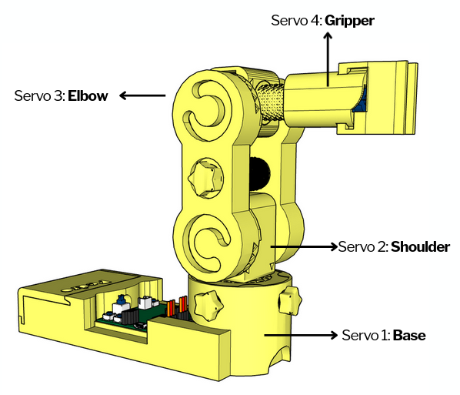
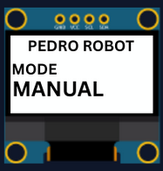

Table of Contents
🎯 Learning Objective 2
👨‍🏫 Instructor Notes 2
🧰 Required Materials 2
1. STEM Context 4
2. Understanding USB Serial Communication 4
3. What Is Serial Communication? 4
4. Install the Pedro Program 5
5. Control Modes Overview 6
6. Entering USB Serial Mode 7
🎯 Activity — Investigating USB Cables 8
Test the Charging-Only USB Cable 8
STEM Investigation 🔬 9
Why Does the Charging Cable Not Work? 9
Classroom Discussion 💡 9
Question 1 9
Question 2 9
Question 3 9
Question 4 10
Engineering Challenge 🏆 10
Expected Answer 10
Key Takeaway 10
📝 Quiz - USB Serial Mode (10 Questions) 10
Question 1 10
Question 2 11
Question 3 11
Question 4 11
Question 5 11
Question 6 11
Question 7 12
Question 8 12
Question 9 12
Question 10 12

1. STEM Context
Why USB Serial Communication Matters
Before wireless communication existed, robots were commonly controlled through wired serial communication.
Even today, USB Serial communication is still essential in:
- robotics
- industrial automation
- electronics debugging
- spacecraft systems
- embedded engineering
USB Serial communication allows a computer to:
- send commands
- receive data
- monitor sensors
- control robotic systems
Pedro uses this same engineering principle.

2. Understanding USB Serial Communication
USB Serial communication works like a digital conversation between the computer and the robot.
The communication chain is:
Computer → USB cable → Atmega32u4 → Pedro Program → Servo Motors → Robot Movement

The computer sends digital commands through the USB cable.
Pedro receives the commands and executes actions.

3. What Is Serial Communication?
Serial communication means sending data:
👉 one bit at a time
👉 in a sequence
Instead of sending all data simultaneously, information travels step-by-step very quickly.
Example:
Computer sends: "5"
Pedro receives:
Move selected servo forward

4. Control Modes Overview
Using the 128x64 OLED display, users can easily navigate through the menu to select and configure different modes of operation. The available control modes are:
- Manual Mode – direct control using onboard buttons
- Record & Replay Mode – record and replay movements
- Bluetooth Mode – control Pedro via smartphone or PC
- Radio Mode – remote communication between robots
- USB Serial Mode – control Pedro directly from a computer
Through this firmware, students discover how software can define robotic behavior and how multiple communication interfaces can coexist within one system. The picture below described how to navigate through the multiple control modes.
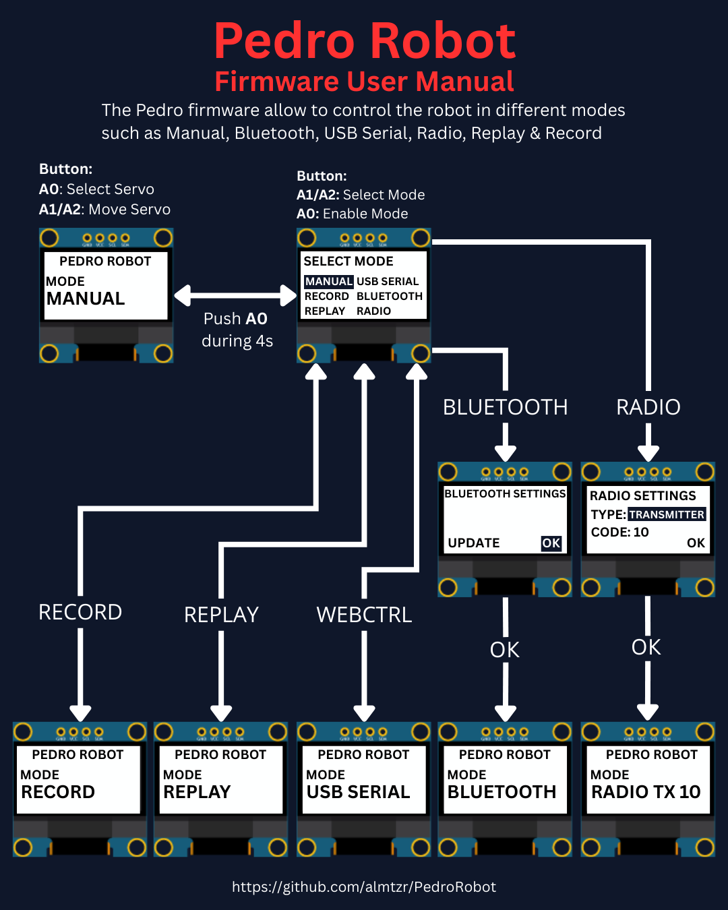

5. Entering USB Serial Mode
STEP 1:
To activate USB Serial Mode:
- Power ON Pedro
- Enter the Select Mode menu (hold A0 for 4 seconds)
- Select USB SERIAL MODE mode
- Press A0 to confirm
- The OLED screen displays:
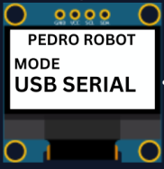
💡Pedro is now ready to communicate with the computer.
STEP 2:
Students connect Pedro using a USB cable:
The USB connection provides:
- communication
- data transfer
- optional power supply
💡 Note: Some USB cables only provide charging and cannot transfer data.

- Connect Pedro via USB cable
- Launch the web controller (https://www.pedrobot.com/webcontroller.html) app
- In the web controller click, the « Connect Pedro » button
- Select the corresponding Pedro serial port
- Click « Servo N » button to select a servo
(the LED corresponding to the selected servo lights up)
- Use the « Left » button to move servo to the left
- Use the « Right » button to move servo to the right
- Use the « Stop » button to stop the movement
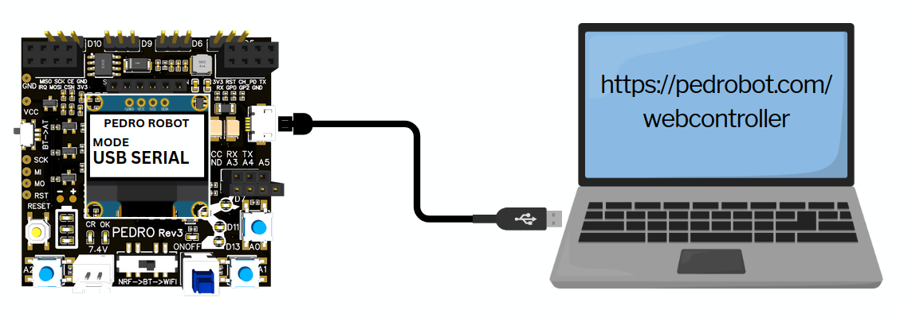

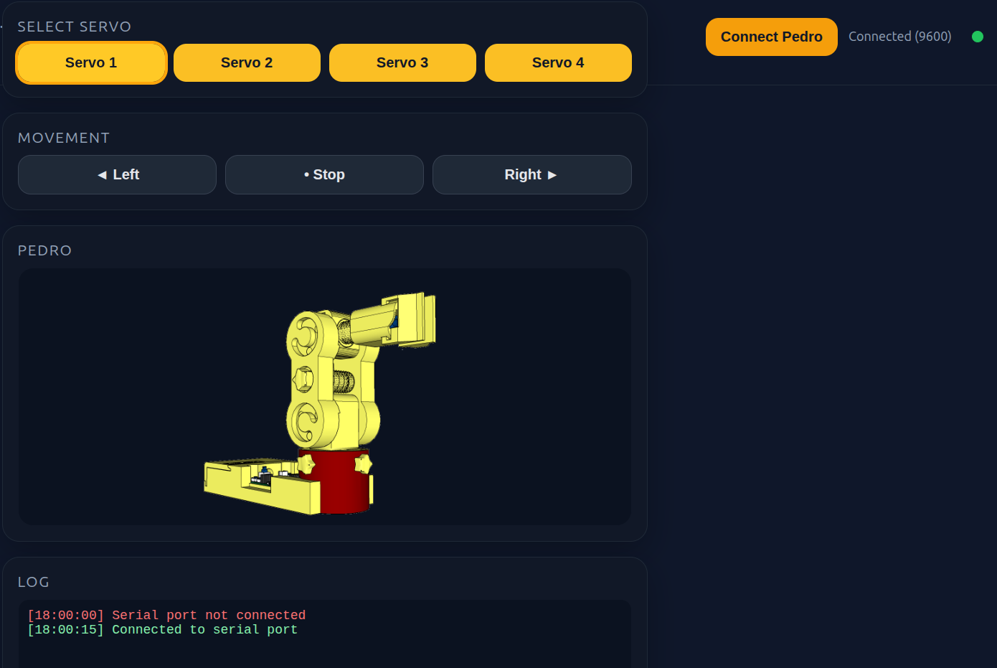

🎯 Activity — Investigating USB Cables
Objective
Discover why some USB cables allow communication with Pedro while others only provide power.
Students will learn that a USB connection can be used for:
- Power transmission
- Data communication
and that not all USB cables support both functions.

Test the Charging-Only USB Cable
- Disconnect the data cable.
- Connect Pedro using the charging-only cable.
- Open the Pedro Web Controller.
- Click Connect Pedro.
Observation
Students should observe:
✅ Pedro powers ON
❌ Pedro does not appear in the serial port list
❌ Communication cannot be established
❌ Commands cannot be sent
Students complete the following table:
Feature | Data Cable | Charging Cable
Powers Pedro | Yes | Yes
Appears as USB Device | Yes | No
Allows Communication | Yes | No
Controls Servos | Yes | No

STEM Investigation 🔬

Why Does the Charging Cable Not Work?
Inside a standard USB cable there are usually four wires:
Wire | Function
VCC | Power (+5V)
GND | Ground
D+ | Data
D− | Data
A charging-only cable often contains only:
- VCC
- GND
The data wires are missing.
Without the D+ and D− wires:
❌ The computer cannot exchange information with Pedro.
❌ The browser cannot detect the robot.
❌ No serial communication is possible.

Classroom Discussion 💡
Ask students:

Question 1
Why does Pedro turn ON when using the charging cable?
Expected Answer:
Because electrical power is still transmitted through the cable.

Question 2
Why can't the computer detect Pedro?
Expected Answer:
Because the cable does not contain the data wires required for communication.

Question 3
What is missing inside a charging-only cable?
Expected Answer:
The D+ and D− data wires.

Question 4
Why do engineers need to understand cable specifications?
Expected Answer:
Because devices may receive power but still fail to communicate if the correct cable is not used.

Engineering Challenge 🏆
A student says:
"Pedro is broken because the Web Controller cannot connect."
As an engineer, what should you check first?

Expected Answer
- Is Pedro powered ON?
- Is the correct serial port selected?
- Is the USB cable a data cable?
- Does the computer detect the robot?
This teaches students an important engineering principle:
👉 Always verify the communication path before assuming a system is defective.

Key Takeaway
A USB cable can look identical on the outside while behaving very differently on the inside.
To control Pedro through USB Serial Mode, students must use a USB data cable that supports both:
✅ Power transmission
✅ Data communication
This activity introduces students to real-world troubleshooting techniques used by engineers and robotics technicians every day.

📝 Quiz - USB Serial Mode (10 Questions)

Question 1
What type of communication is used in USB Serial Mode?
A) Hydraulic communication
B) Wireless communication
C) Serial communication
D) Optical communication
✅ Correct answer:

Question 2
What is used to connect Pedro to the computer?
A) HDMI cable
B) Ethernet cable
C) USB cable
D) Audio cable
✅ Correct answer:

Question 3
What does the web controller allow students to do?
A) Charge the battery
B) Control Pedro from the computer
C) Print 3D parts
D) Edit videos
✅ Correct answer:

Question 4
Which browsers are compatible with Pedro’s web controller?
A) Chrome, Edge, Brave
B) Safari only
C) Firefox only
D Internet Explorer
✅ Correct answer:

Question 5
What happens when the “Left” button is clicked?
A) The battery charges
B) The OLED turns OFF
C) A serial command moves the servo left
D) The robot resets
✅ Correct answer:

Question 6
What does Serial.read() do in Arduino?
A) Charges the battery
B) Reads incoming serial data
C) Rotates the servo directly
D) Prints text on the OLED
✅ Correct answer:

Question 7
Why is serial communication useful?
A) It changes robot colors
B) It allows reliable data transfer
C) It increases battery size
D) It prints documents
✅ Correct answer:

Question 8
What must students select before clicking “Connect Pedro”?
A) WiFi password
B) Camera input
C) Correct serial port
D) OLED brightness
✅ Correct answer: C

Question 9
Which component receives USB commands inside Pedro?
A) Servo motor
B) OLED display
C) ATmega32U4 microcontroller
D) Battery
✅ Correct answer:

Question 10
What engineering concept does USB Serial Mode demonstrate?
A) Human–computer–robot interaction
B) Solar energy conversion
C) Mechanical printing
D) Wireless charging
✅ Correct answer:

END
Pedro STEM Lesson n°9

