Pedro Lesson n°1
Assemble Pedro
v1.0
🎯 Learning Objective
Discover the Pedro robot, understand its basic operation, and explore its different control modes.
Students will learn:
- Basic concepts of robotics (programming, embedded systems, planetary gear systems)
- How a 3D printer works
- How to identify the components of a robot
- How to assemble a robot
🛠 Required Materials
✅ All Pedro robot parts printed in 3D
✅ 2 ball bearings
✅ 4 continuous rotation (360°) servomotors
✅ 1 micro USB cable
✅ 7.4V battery
✅ Pedro Rev3 Electronic Board
✅ PC (Windows, Linux, or OS X) with Arduino IDE installed

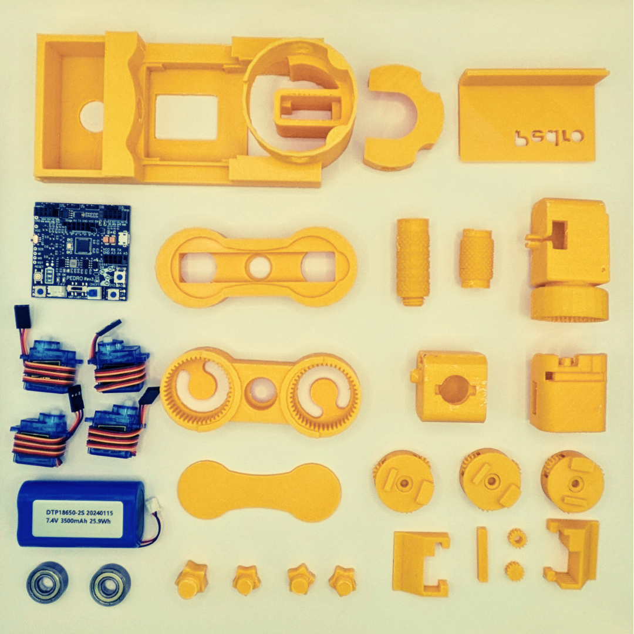

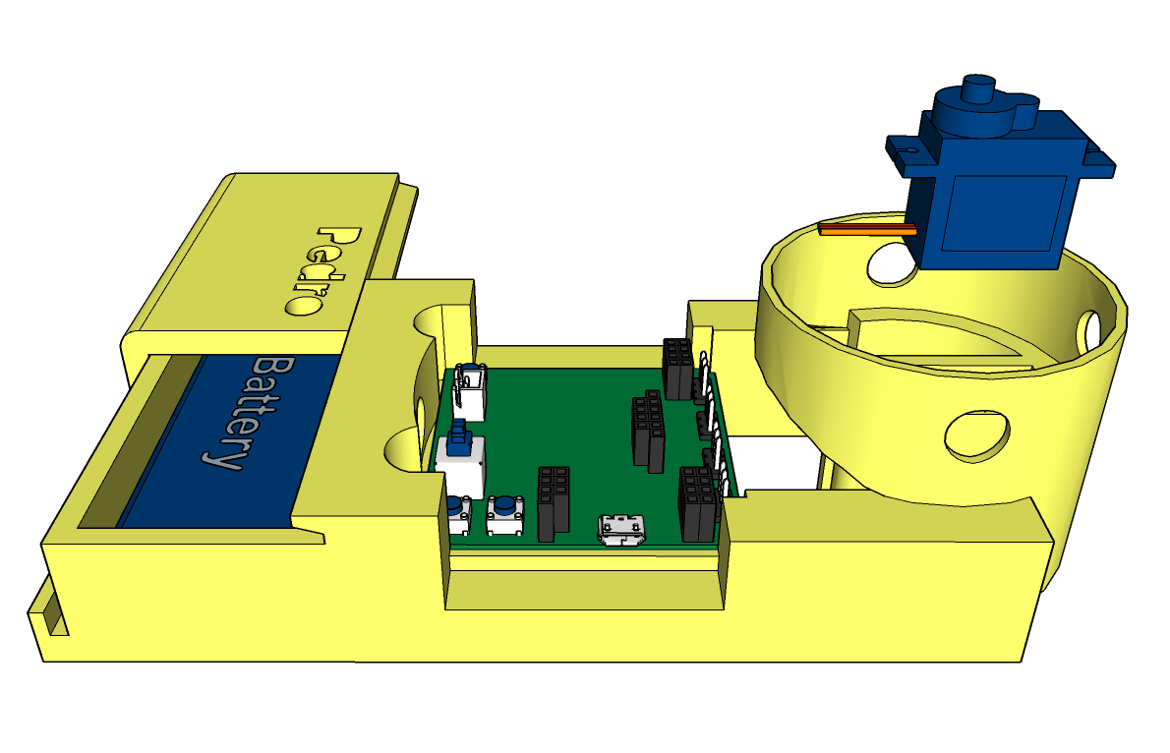
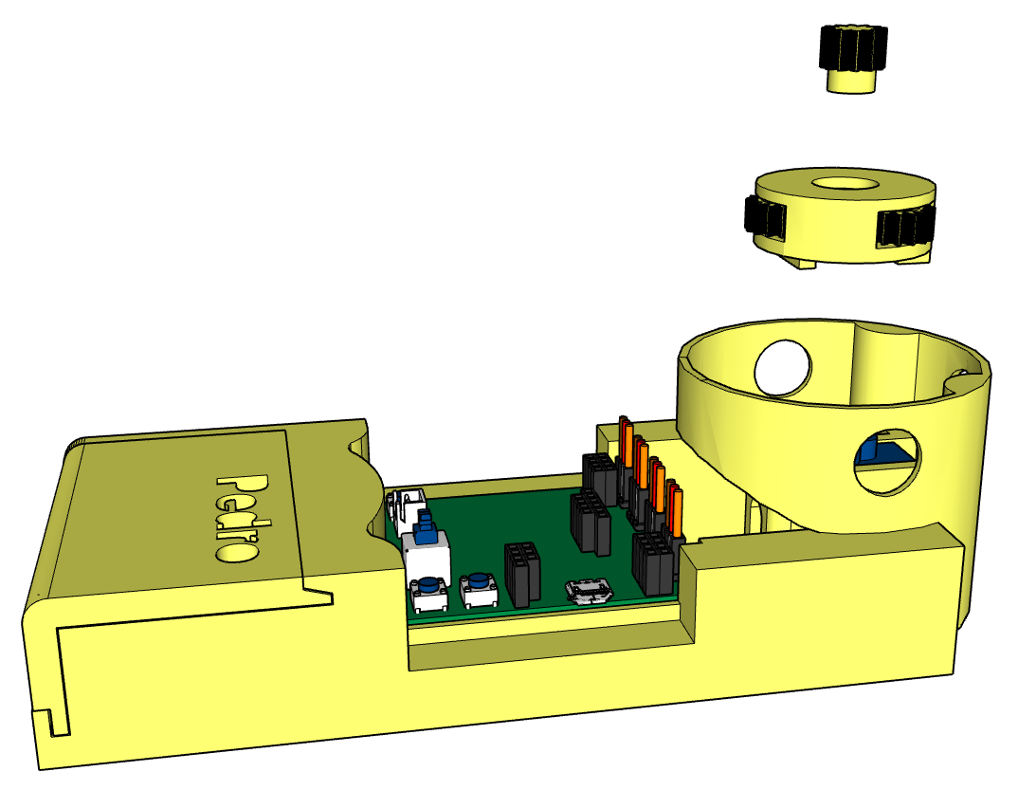
1
2

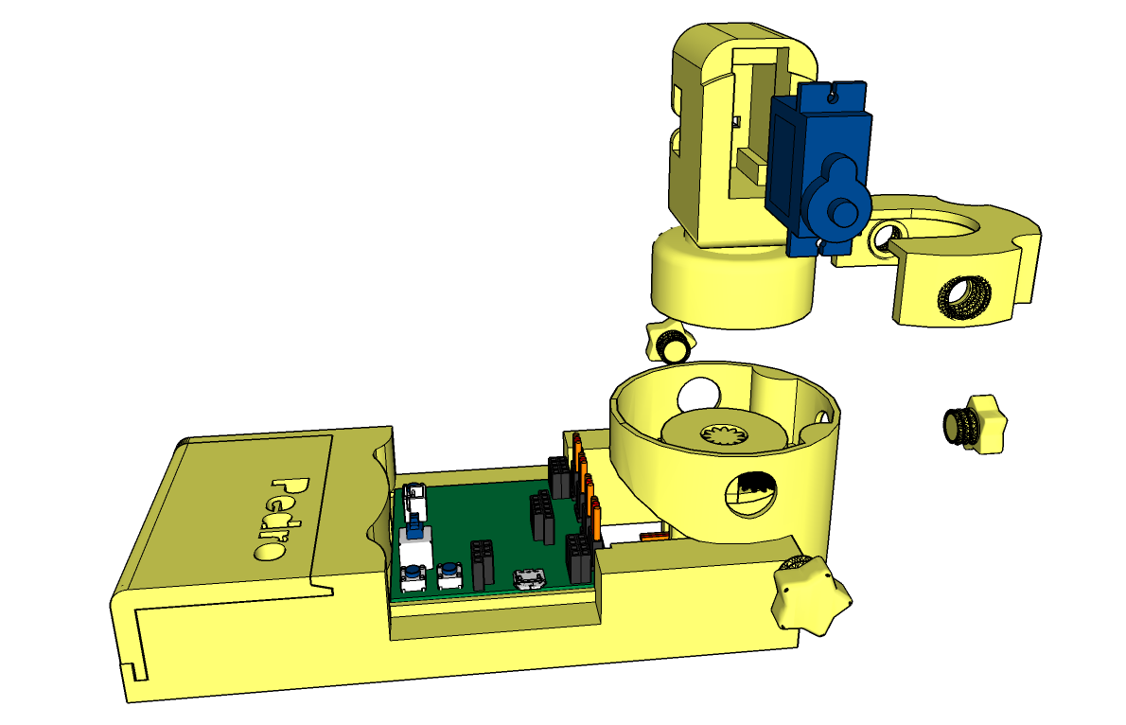
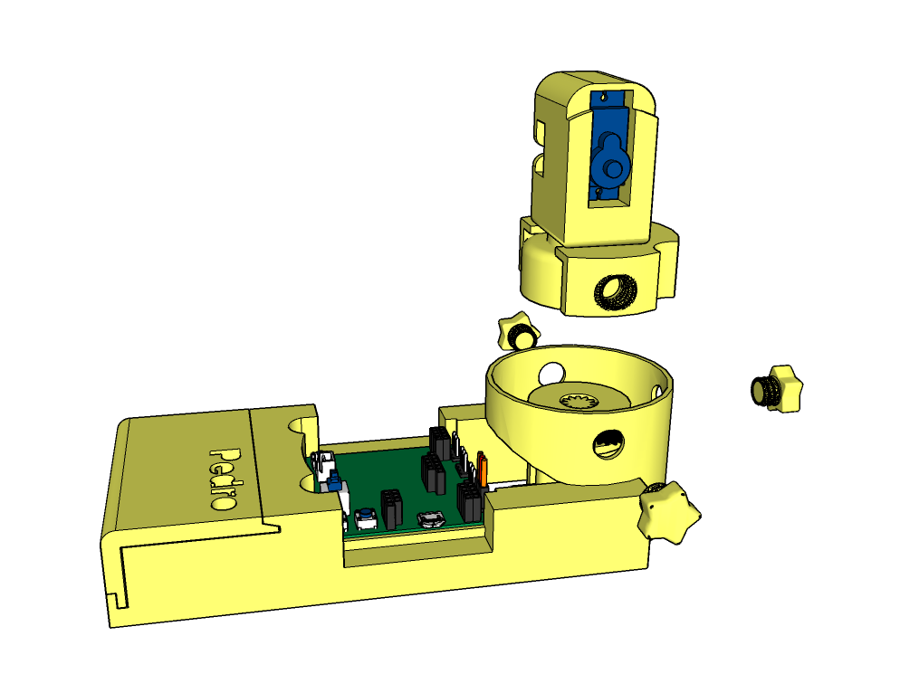
3
4

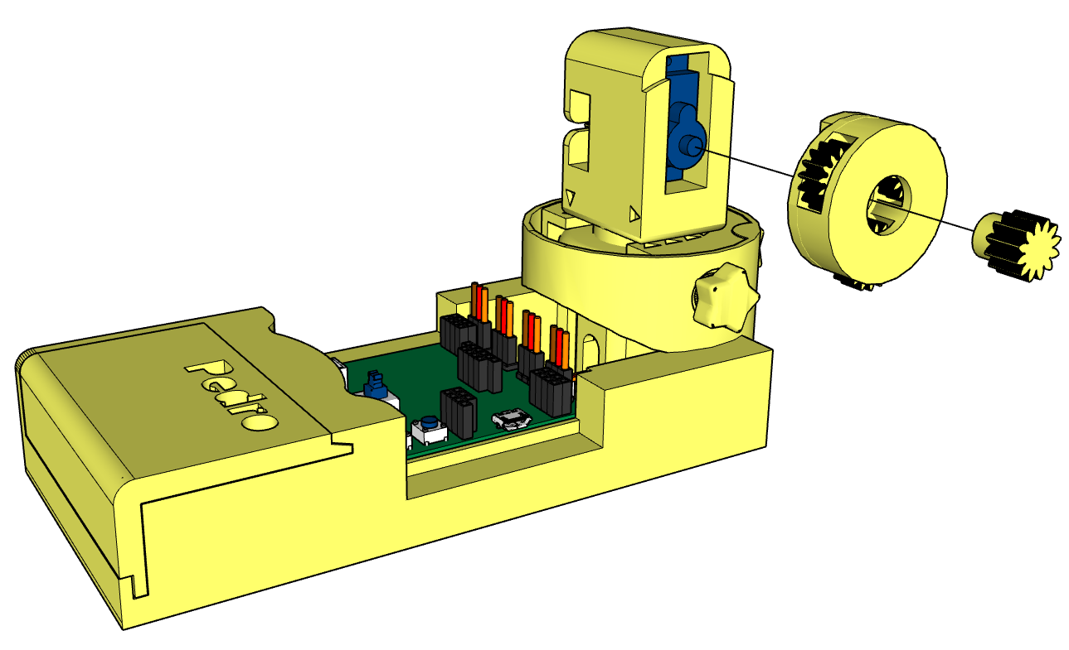
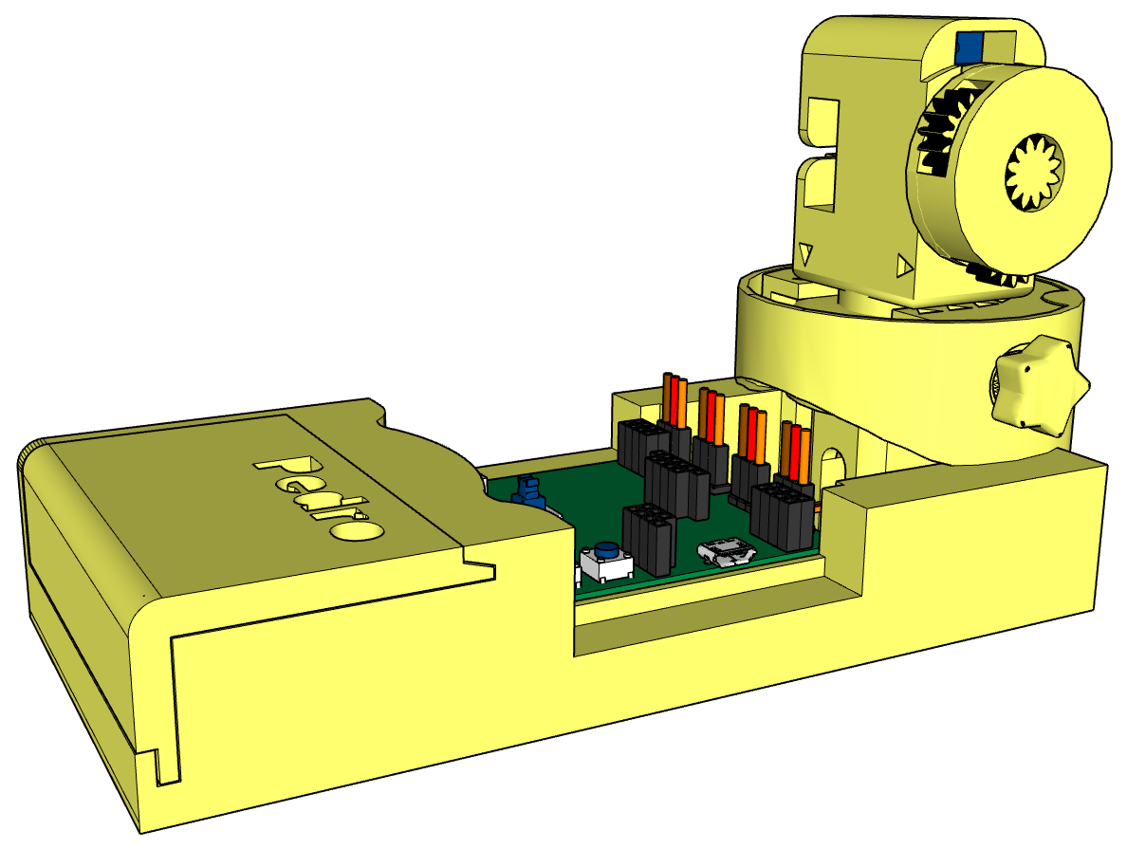
5
6

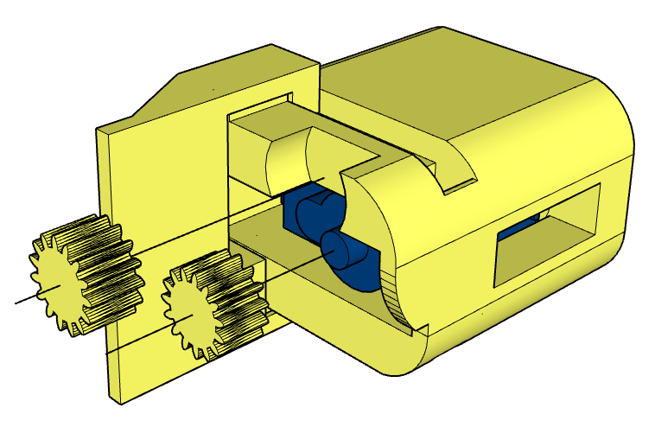
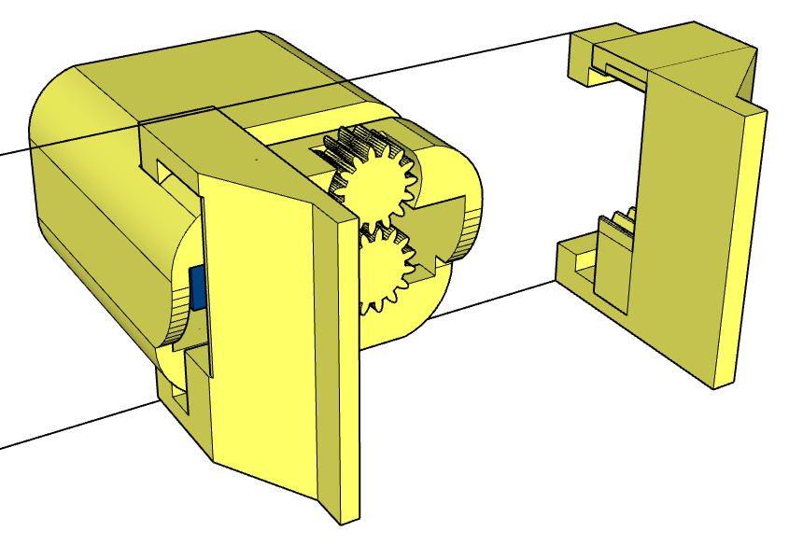
7
8

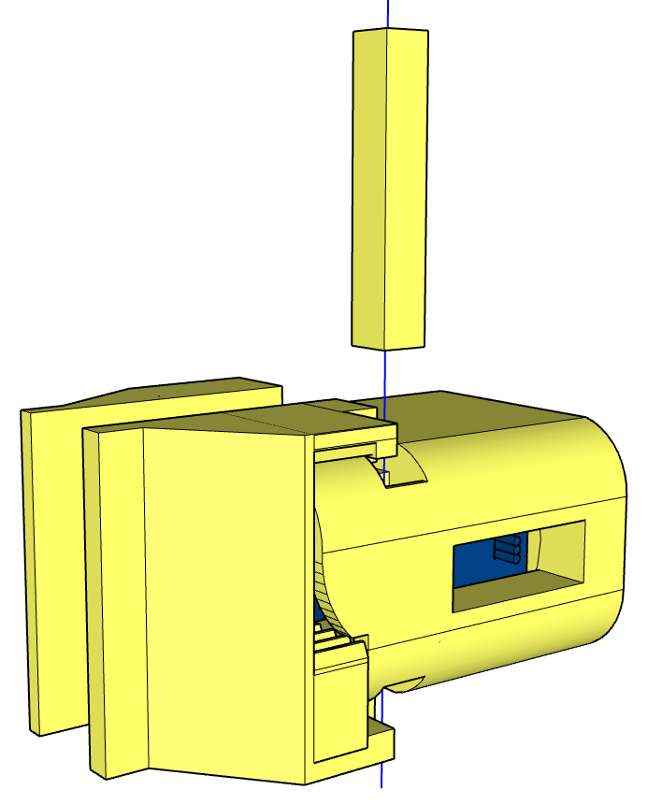
9
10
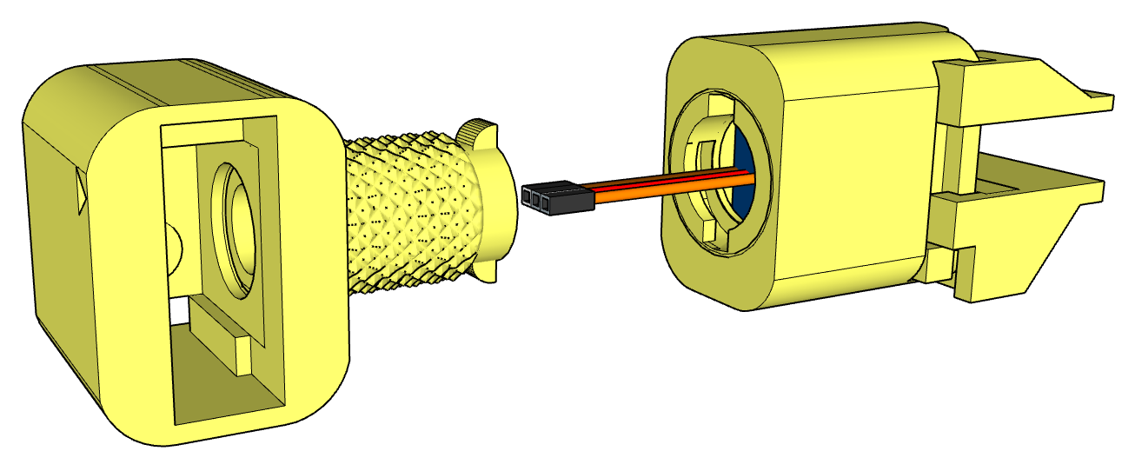

11
12

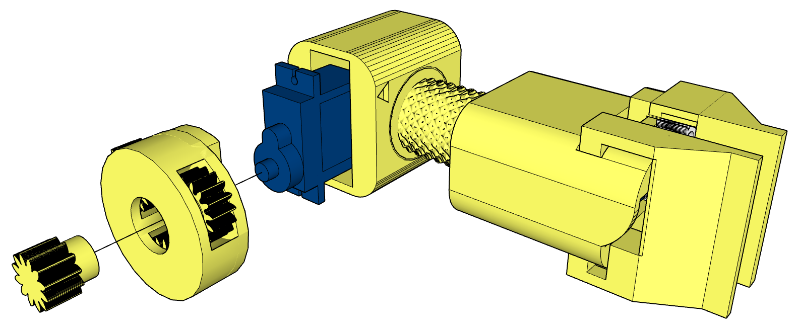
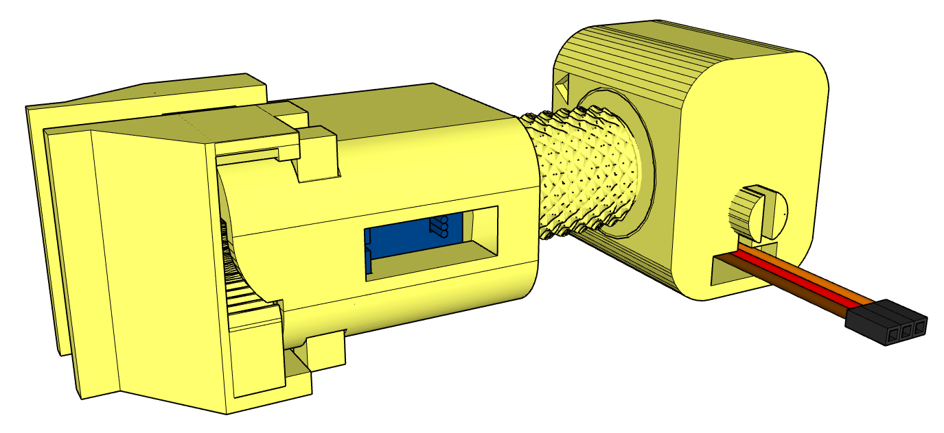
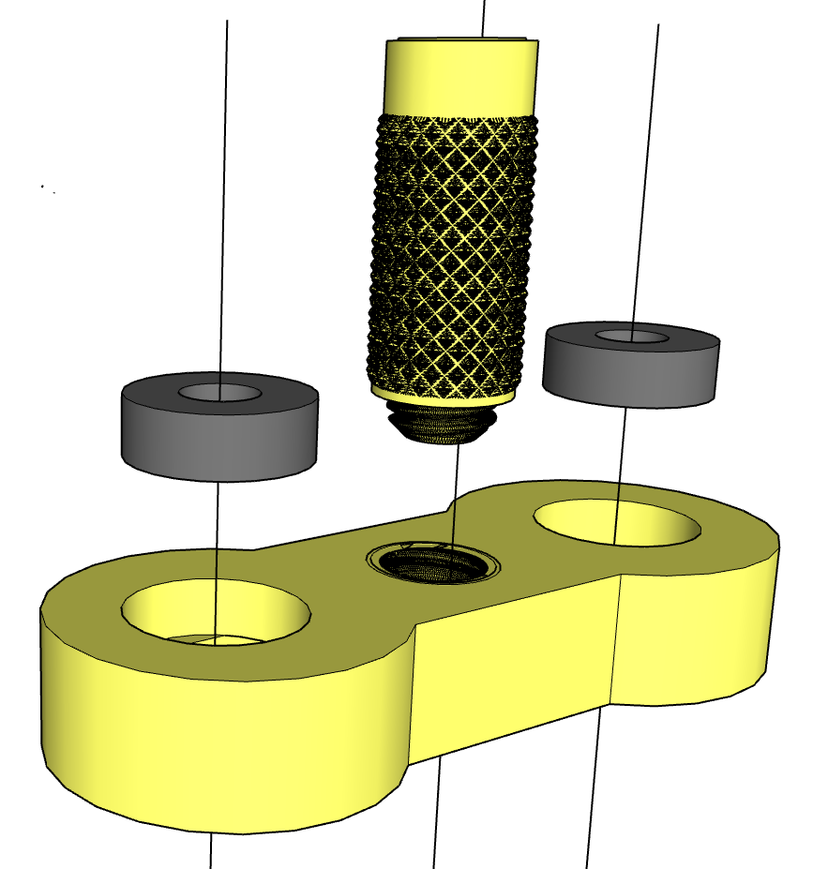

14
13
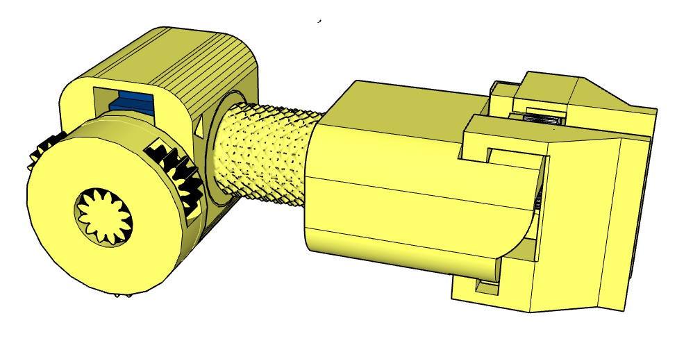

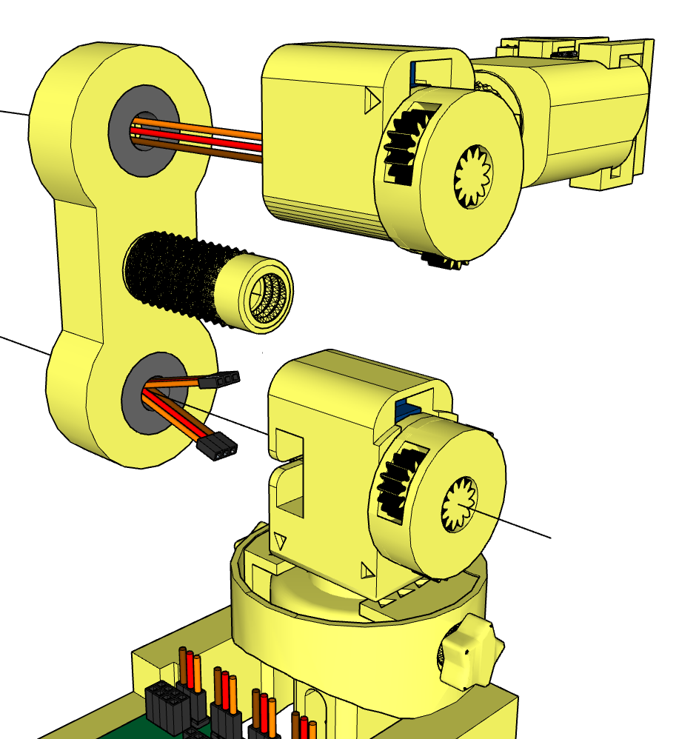
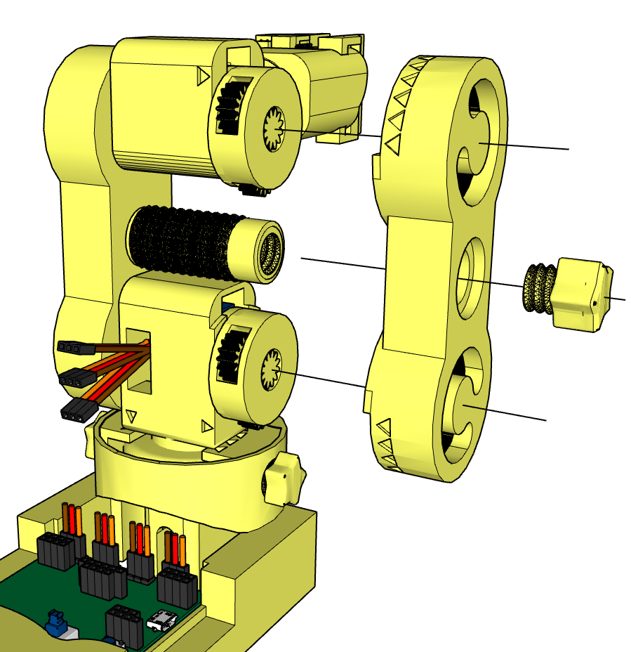

15

16

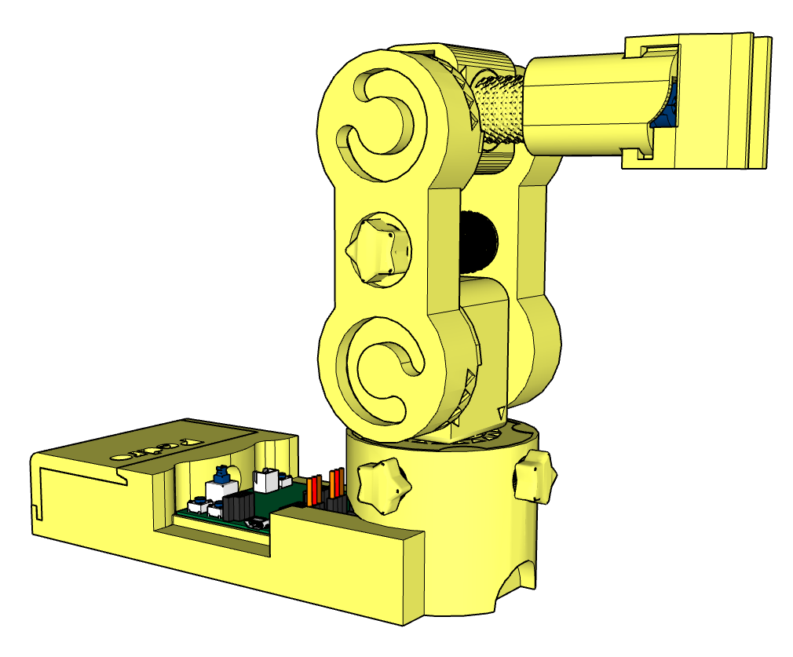

17

