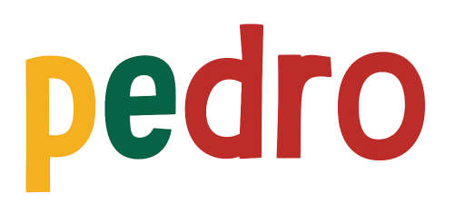

STEM Lesson n°6

Multiple Radio Mode

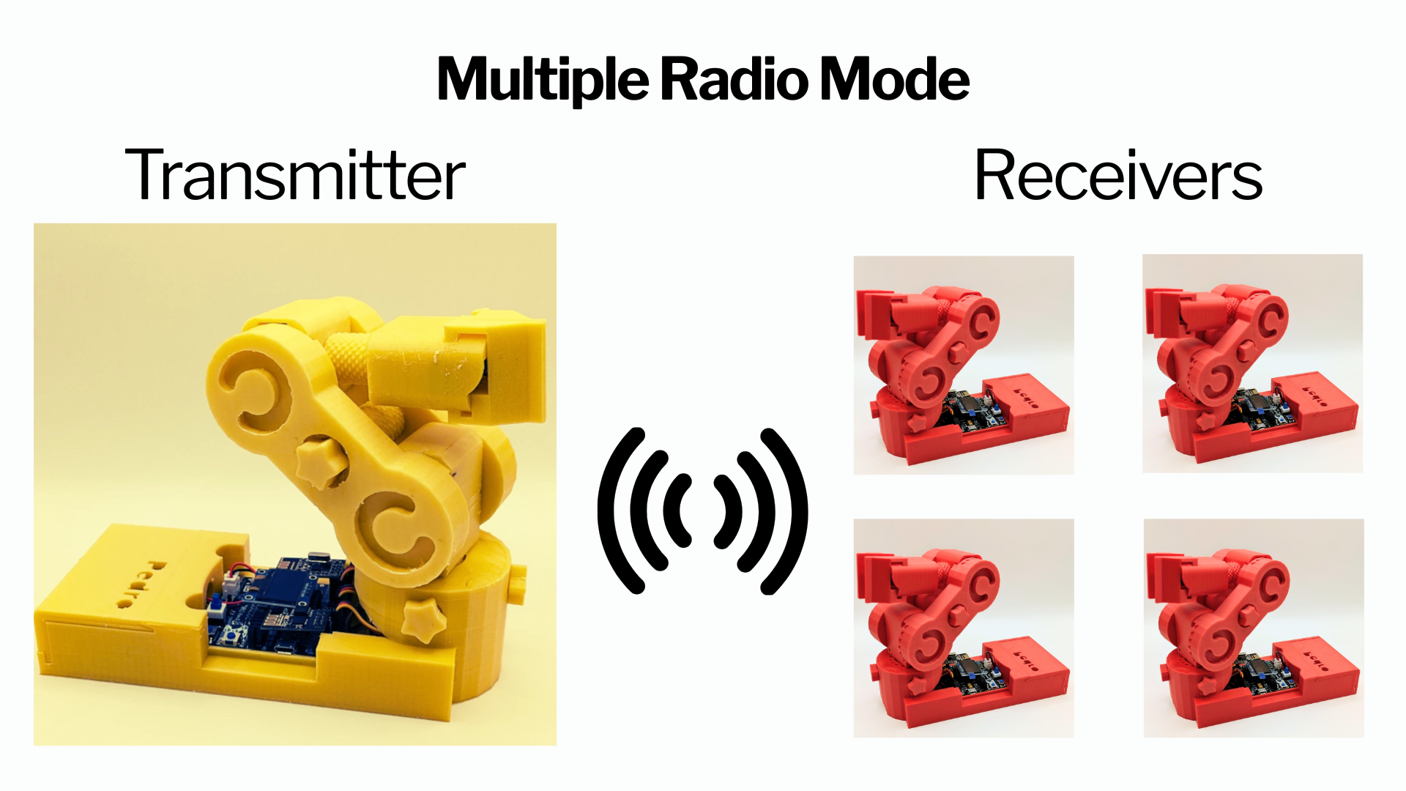

v1.0.0

🎯 Learning Objective
In this lesson, students will discover how multiple robots can communicate wirelessly using radio signals.
By the end of the lesson, students will be able to:
• Understand how two robots exchange information
• Configure a transmitter and a receiver
• Control one robot remotely using another

👨‍🏫 Instructor Notes
Recommended age: 12+
Difficulty Level: Beginner → Intermediate
Prerequisites: Previous Lesssons 1 to 5
Duration: 90 – 120 minutes
💡 Tip: Encourage students to predict what will happen before testing

🧰 Required Materials
Per student or team:
- 3 or 4 Pedro robots Assembled with NRF24L01 modules
- USB cable
- Computer with Arduino IDE installed

Table of Contents
🎯 Learning Objective 2
👨‍🏫 Instructor Notes 2
🧰 Required Materials 2
1. Install the Pedro Program 4
2. Control Modes Overview 5
3. Radio Mode 6
3.1 Setup 6
3.2 Radio Mode Configuration Overview 7
4. Activities 8
🎯 Activity 1 — First Connection 8
🎯 Activity 2 — Mirror Movement 8
🎯 Activity 3 — Measuring Radio Communication Range 8
🎯 Activity 4 — Break the Connection 9
🧠 Reflection Questions 9
📝 Quiz — Check Your Understanding 10

1. Install the Pedro Program
(Skip this step if already completed in Lesson n°3)

The Pedro Program is the core software that powers and controls the robot. It acts as the robot’s “brain,” managing all behaviors and interactions.
Through this single program, students can access and explore multiple control modes, allowing them to understand how a robot receives instructions, processes them, and translates them into physical actions.
- Download and install the latest version of the Arduino IDE.
- Install the required libraries from the Library Manager:
  - PedroRobot: Tools → Manage Libraries → search PedroRobot → Install
  - U8glib: Tools → Manage Libraries → search U8glib → Install
  - RF24: Tools → Manage Libraries → search RF24 → Install
- Insert the Oled Screen into the Pedro board and Connect the board to your computer via USB.
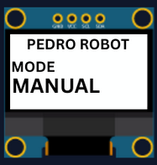
- Select the correct port:
  - Tools → Select the port that appear when you connect Pedro robot
- Select the board type:
  - Tools → Board → Arduino Micro
- Open the example sketch:
  - File → Examples → PedroRobot → Pedro
- Compile and upload the sketch to your Pedro board.
✅ If everything is correct, Pedro’s OLED screen will display “MANUAL MODE”.
- Press the button A0 and observe what happen.
The LED corresponding to the selected servo light on. That button allows you to control each part of the robot. Here is the mapping between the LED ID and the servo ID
  - LED D13 → servo D5 (Base)
  - LED D11 → servo D6 (Shoulder)
  - LED D8 → servo D9 (Elbow)
  - LED D7 → servo D10 (Gripper)
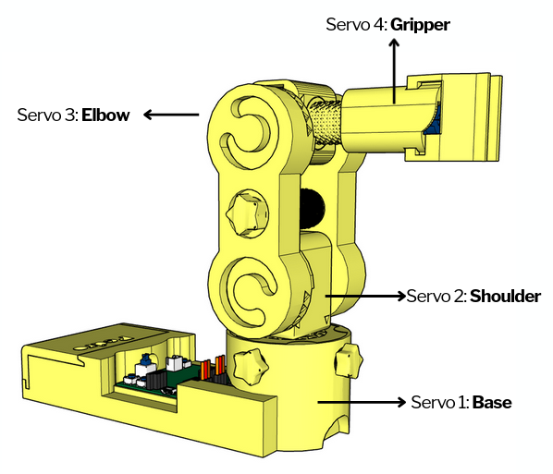

2. Control Modes Overview
Using the 128x64 OLED display, users can easily navigate through the menu to select and configure different modes of operation. The available control modes are:
Manual Mode – direct control using onboard buttons
Record & Replay Mode – record and replay movements
Bluetooth Mode – control Pedro via smartphone or PC
Radio Mode – remote communication between robots
USB Serial Mode – control Pedro directly from a computer
Through this firmware, students discover how software can define robotic behavior and how multiple communication interfaces can coexist within one system. The picture below described how to navigate through the multiple control modes.
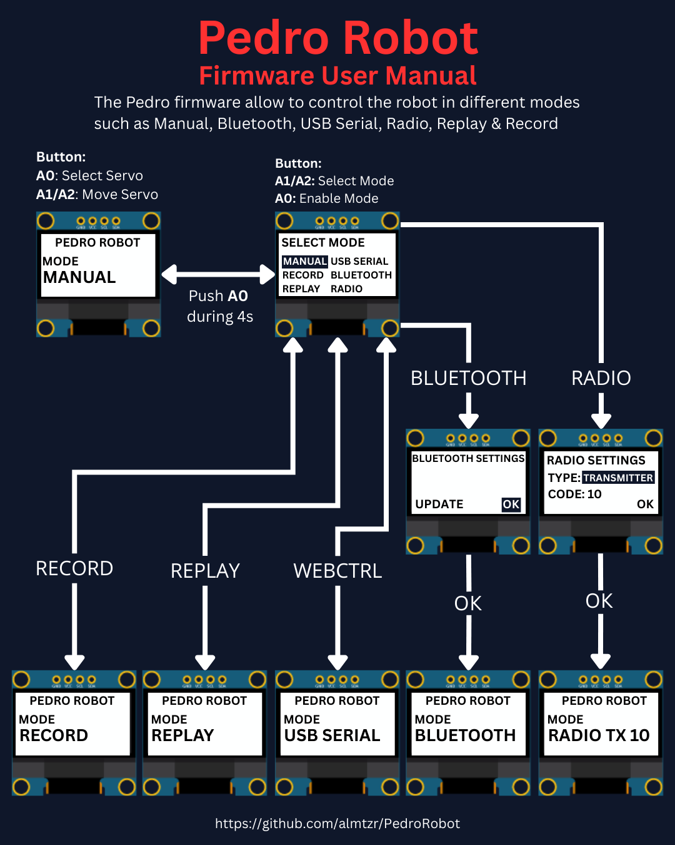

3. Entering Radio Mode
Radio Mode allows two Pedro robots to communicate using the NRF24L01 module :
👉 One robot sends commands (Transmitter)
👉 The others receive and execute them (All Receivers)
💡 This is exactly how drones, remote-controlled cars or industrial robots are controlled in real life.

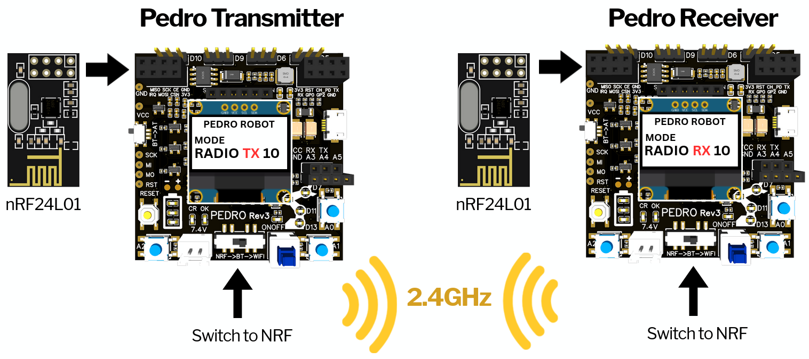

3.1 Setup transmitter and receivers

The Pedro Transmitter | All The Pedro Receivers (2 or more)
- Insert the NRF24L01 modules  - Set Pedro’s switch NRF → BT → WiFi to NRF  - Restart the robot  - Enter the Select Mode menu (hold A0 for 4 seconds).  - Select Radio mode from the menu and press A0 to confirm.  - Define the robot’s type: press A1 to select TRANSMITTER.  - Press A0 to confirm the role.  - Set a communication Code Key:  - Press A1 to increase the value  - Press A2 to decrease the value  - Values range from 1 to 99  - Press A0 to confirm the Code Key.  - Press A0 again to validate (OK).  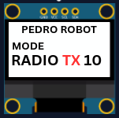  - The Oled Pedro transmitter TX screen displays :  (code key 10 for this exemple) | - Insert the NRF24L01 modules into all the receiver robots  - Set Pedro’s switch NRF → BT → WiFi to NRF  - Restart all robots  - Enter the Select Mode menu (hold A0 for 4 seconds).  - Select Radio mode from the menu and press A0 to confirm.  - Define the robot’s type: press A1 to select RECEIVER.  - Press A0 to confirm the role.  - Set a communication Code Key:  - Press A1 to increase the value  - Press A2 to decrease the value  - Values range from 1 to 99  - Press A0 to confirm the Code Key.  - Press A0 again to validate (OK).  - The Oled Pedro transmitter RX screen displays :  (code key 10 for this exemple)  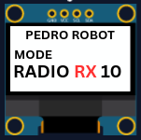
💡Note: The transmitter and all the receivers must use the same Code Key to establish communication.
👉 Think of it like a password for communication.

3.2 Radio Mode Configuration Overview

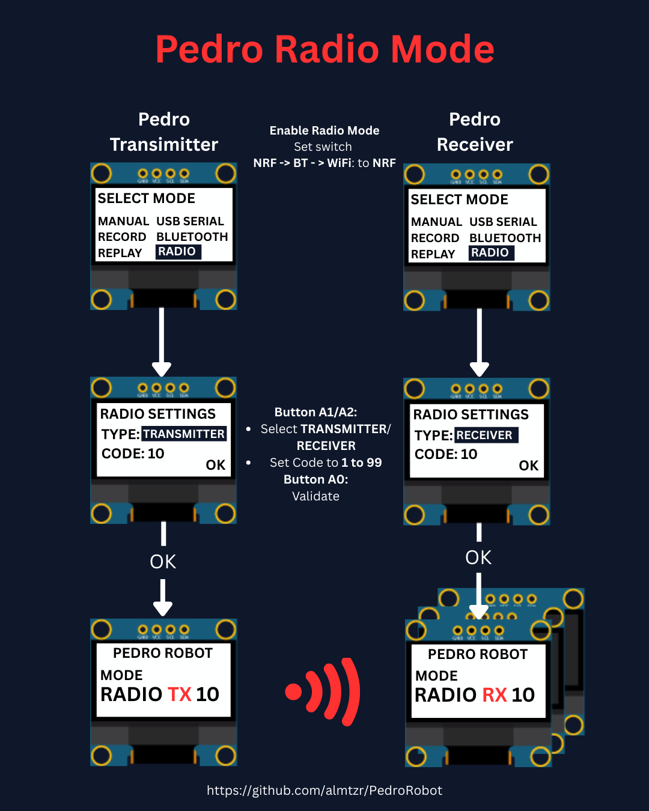

4. Activities

🎯 Activity 1 — First Connection
Mission
Make all robots connect.
Student Actions
Once all the Pedro robots are configured as transmitter and receiver. Press A0 on the trasmitter
Observation
👉 Do LEDs light up on all robots?
The LED corresponding to the selected servo light on simultaneously on the Pedro transmitter and all the receivers. That indicates that the radio communication between all the robots is established.

🎯 Activity 2 — Mirror Movement
Mission
Control all the robots using the transmitter.
Student Actions
• Press A1 /or A2 on transmitter
• Observe all the receivers
Observation: Do all robots move at the same time?

🎯 Activity 3 — Measuring Radio Communication Range
Mission
Students will measure the maximum communication distance between all the Pedro robot in an open space.
They will compare Real-world performance vs theoretical specifications
According to the manufacturer:
👉 NRF24L01: typical range: 30 to 50 meters (indoor), up to 100 meters (open space)
💡 Note: Real performance depends on environment, obstacles, and power supply.
Experiment
Step 1: Move Away
• One student stays with one of the RECEIVERS
• One student walks away with the TRANSMITTER
Step 2: Every few meters (5m 10m 20m 50m 100m 150m etc)
Press A1 or A2 and observe the RECEIVER: does it still respond?
Step 3: Find the Limit
Continue until: ❌ The receiver no longer responds
Step 4: Measure Distance
• Measure or estimate the distance
• Record the result
📋 Data Collection Table
Distance (m) | Signal Working? | Notes
5 | yes or no
10 | yes or no
20 | yes or no
... | ...
Max | No | Lost signal

🎯 Activity 4 — Break the Connection
Mission
Understand what breaks communication.
Experiment
• Change Code Key on one robot
• Test again
👉 What happens?
💡 Expected: No communication

🧠 Reflection Questions
• Why is wireless communication useful?
• What happens if signals are interrupted?
• Where do we use this in real life?

📝 Quiz — Check Your Understanding

1. Radio Mode enables communication between _________ robots.
A) Two
B) One
C) Three
D) Multiple
✅ Answer:
2. The NRF24L01 module is used for:
A) Power
B) Display
C) Wireless communication
D) Sound
✅ Answer:
3. A transmitter:
A) Receives data
B) Sends data
C) Stores data
D) Deletes data
✅ Answer:
4. A receiver:
A) Sends data
B) Receives data
C) Prints data
D) Ignores data
✅ Answer:
5. The Code Key is:
A) Voltage
B) Password for communication
C) Speed
D) Memory
✅ Answer:
6. If Code Keys are different:
A) Works faster
B) No communication
C) LED brighter
D) Nothing changes
✅ Answer:
7. The Code Key range is:
A) 0-9
B) 1-99
C) 100-999
D) 0-255
✅ Answer:
8. LED sync indicates:
A) Error
B) No battery
C) Connection established
D) Shutdown
✅ Answer:
9. Robots moving together is called:
A) Isolation
B) Synchronization
C) Rotation
D) Compilation
✅ Answer:
10. In Radio Mode, all the robots must use the same:
A) Battery level
B) Serial port
C) Code Key
D) USB cable
✅ Answer:

END
Pedro STEM Lesson n°6

