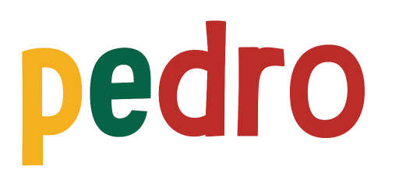

STEM Lesson n°7

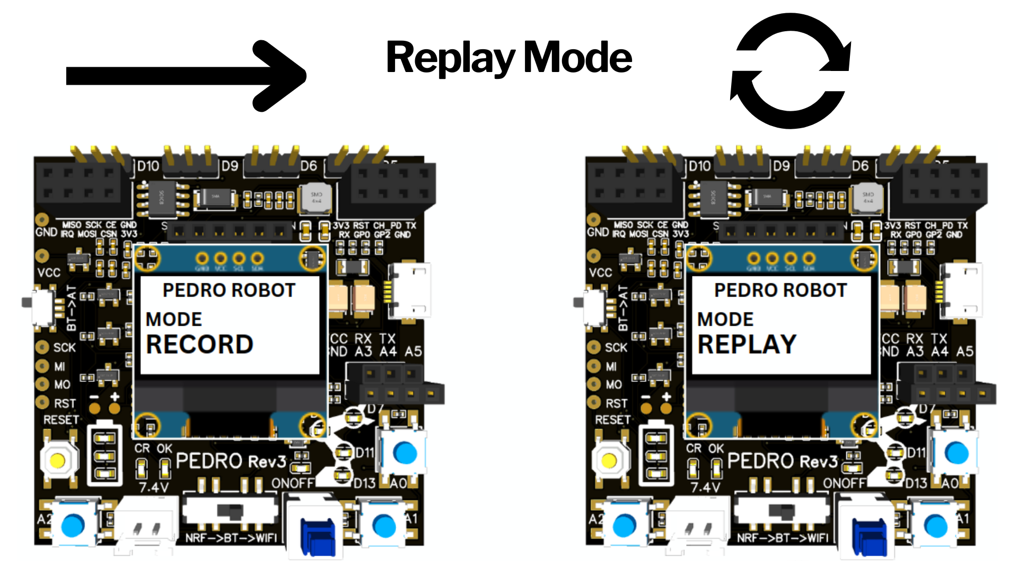

v1.0.0

🎯 Learning Objective
In this lesson, students discover one of the most exciting features of robotics:
👉 Teaching a robot by demonstration
Instead of writing code line by line, students physically move the robot, record its movements, and replay them automatically. This lesson introduces important robotics concepts such as:
- memory
- automation
- motion sequences
- data recording
- repeatability
Pedro’s Record & Replay Mode makes these advanced concepts accessible in a simple and interactive way.
By the end of this lesson, students will be able to:
- Understand how robots record movements
- Explain the difference between Record Mode and Replay Mode
- Create a movement sequence manually
- Replay robotic actions automatically
- Understand how motion data is stored in memory
- Explore the foundations of robotic automation

👨‍🏫 Instructor Notes
Recommended age: 12+
Difficulty Level: Beginner → Intermediate
Prerequisites: Previous Lesssons 1 to 6
Duration: 90 – 120 minutes
💡 Tip: Encourage students to predict what will happen before testing

🧰 Required Materials
Per student or team:
- One Pedro robots Assembled
- USB cable
- Computer with Arduino IDE installed

Table of Contents
🎯 Learning Objective 2
👨‍🏫 Instructor Notes 2
🧰 Required Materials 2
1. Install the Pedro Program 4
2. Control Modes Overview 5
3. Radio Mode 6
3.1 Setup 6
3.2 Radio Mode Configuration Overview 7
4. Activities 8
🎯 Activity 1 — First Connection 8
🎯 Activity 2 — Mirror Movement 8
🎯 Activity 3 — Measuring Radio Communication Range 8
🎯 Activity 4 — Break the Connection 9
🧠 Reflection Questions 9
📝 Quiz — Check Your Understanding 10

1. Install the Pedro Program
(Skip this step if already completed in Lesson n°3)

The Pedro Program is the core software that powers and controls the robot. It acts as the robot’s “brain,” managing all behaviors and interactions.
Through this single program, students can access and explore multiple control modes, allowing them to understand how a robot receives instructions, processes them, and translates them into physical actions.
- Download and install the latest version of the Arduino IDE.
- Install the required libraries from the Library Manager:
  - PedroRobot: Tools → Manage Libraries → search PedroRobot → Install
  - U8glib: Tools → Manage Libraries → search U8glib → Install
  - RF24: Tools → Manage Libraries → search RF24 → Install
- Insert the Oled Screen into the Pedro board and Connect the board to your computer via USB.
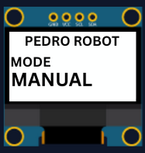
- Select the correct port:
  - Tools → Select the port that appear when you connect Pedro robot
- Select the board type:
  - Tools → Board → Arduino Micro
- Open the example sketch:
  - File → Examples → PedroRobot → Pedro
- Compile and upload the sketch to your Pedro board.
✅ If everything is correct, Pedro’s OLED screen will display “MANUAL MODE”.
- Press the button A0 and observe what happen.
The LED corresponding to the selected servo light on. That button allows you to control each part of the robot. Here is the mapping between the LED ID and the servo ID
  - LED D13 → servo D5 (Base)
  - LED D11 → servo D6 (Shoulder)
  - LED D8 → servo D9 (Elbow)
  - LED D7 → servo D10 (Gripper)
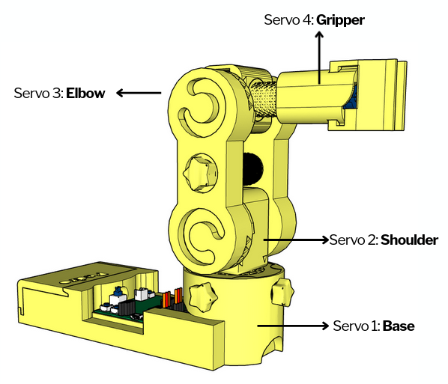

2. Control Modes Overview
Using the 128x64 OLED display, users can easily navigate through the menu to select and configure different modes of operation. The available control modes are:
Manual Mode – direct control using onboard buttons
Record & Replay Mode – record and replay movements
Bluetooth Mode – control Pedro via smartphone or PC
Radio Mode – remote communication between robots
USB Serial Mode – control Pedro directly from a computer
Through this firmware, students discover how software can define robotic behavior and how multiple communication interfaces can coexist within one system. The picture below described how to navigate through the multiple control modes.
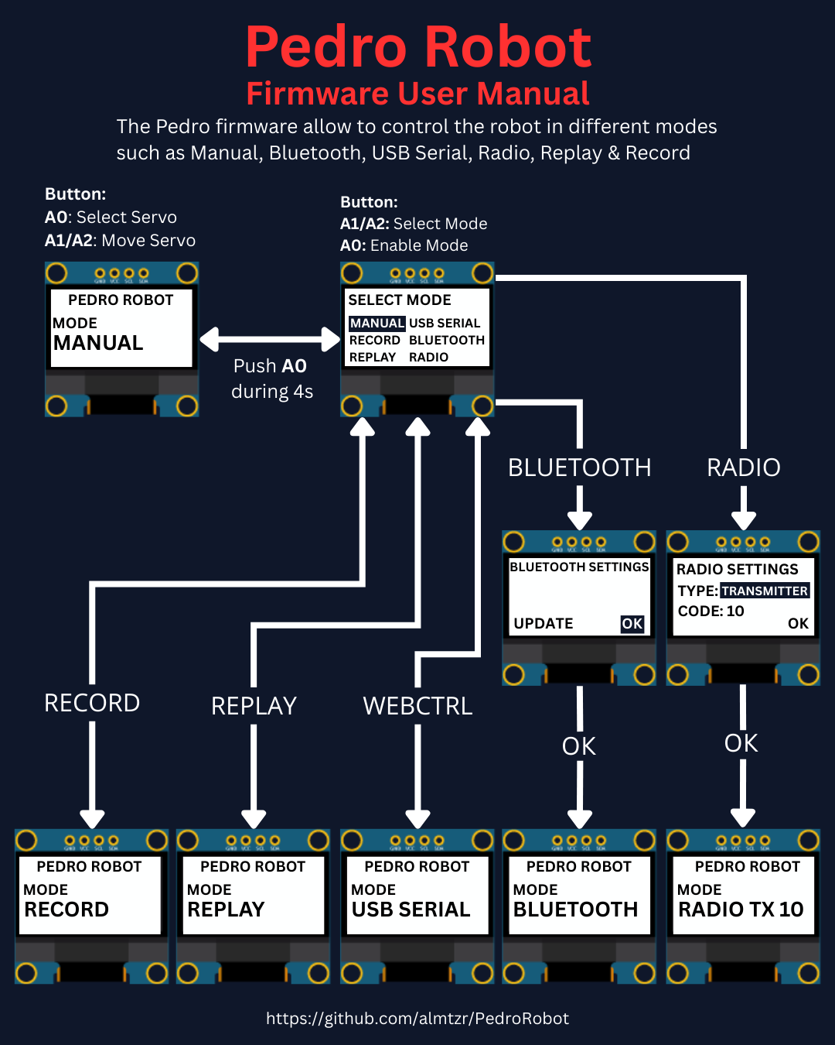

3. Understanding Record & Replay Mode
Pedro doesn’t use inverse kinematics because it’s powered by 360° continuous rotation servos (MG90S) not classic positional servos. That means Pedro doesn’t « go to » a position it just spins forward or backward, depending on the PWM signal.
To perform a Repeat sequence instead of recording positions, Pedro records three specific data:
- the time
- the direction
- the speed
The result? Pedro can replay movements like a macro recorder just by following the same timing and motion patterns. Each movement becomes part of a motion sequence.
For example:

Step | Action
1 | Move arm up
2 | Open gripper
3 | Move arm down
4 | Close gripper

Replay Mode allows Pedro to reproduce the recorded sequence automatically. The robot repeats the exact same movements without human control. This creates an automated robotic behavior.
Students discover that:
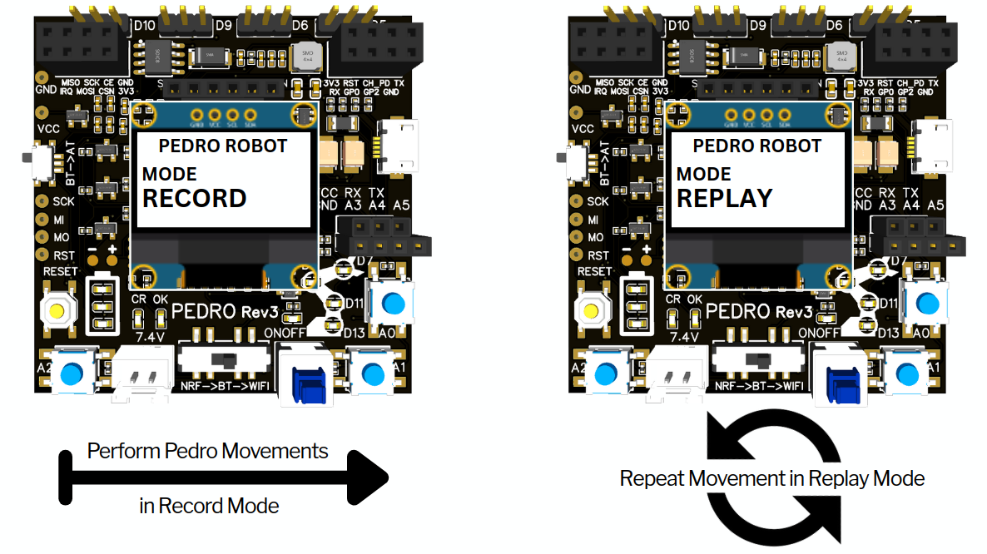
👉 Robots can repeat tasks consistently. This is one of the main advantages of robotics in industry.

4. How the System Works

Pedro uses a simple logic system in three steps:
- Entering Record Mode
- Recording a Sequence
- Entering Replay Mode

4.1 Entering Record Mode
- Start the robot
- Enter the Select Mode menu (hold A0 for 4 seconds)
- Select RECORD mode from the menu and press A0 to confirm
- The OLED screen displays :
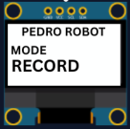
💡Note: Pedro is now ready to memorize movements.

4.2 Recording a Sequence
Students now create their first robotic routine.
Example sequence:
- Rotate base
- Lift arm
- Open gripper
- Lower arm
- Close gripper
Each movement is stored inside Pedro’s memory.

4.3 Entering Replay Mode
Replay the Sequence:
- Enter the Select Mode menu (hold A0 for 4 seconds)
- Select REPLAY mode from the menu and press A0 to confirm
- The OLED screen displays :
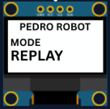
💡Note: Pedro now repeats the recorded actions continuously.
To stop the replaying sequence press A0 until the Select mode menu display

4. Activities

🎯 Activity 1 — First Connection
Mission
Make both robots connect.
Student Actions
Once all the Pedro robots are configured as transmitter and receiver. Press A0 on the trasmitter
Observation
👉 Do LEDs light up on both robots?
The LED corresponding to the selected servo light on simultaneously on the Pedro transmitter and all the receivers. That indicates that the radio communication between all the robots is established.

🎯 Activity 2 — Mirror Movement
Mission
Control all the robots using the transmitter.
Student Actions
• Press A1 /or A2 on transmitter
• Observe all the receivers
Observation: Do all robots move at the same time?

🎯 Activity 3 — Measuring Radio Communication Range
Mission
Students will measure the maximum communication distance between all the Pedro robot in an open space.
They will compare Real-world performance vs theoretical specifications
According to the manufacturer:
👉 NRF24L01: typical range: 30 to 50 meters (indoor), up to 100 meters (open space)
💡 Note: Real performance depends on environment, obstacles, and power supply.
Experiment
Step 1: Move Away
• One student stays with one of the RECEIVERS
• One student walks away with the TRANSMITTER
Step 2: Every few meters (5m 10m 20m 50m 100m 150m etc)
Press A1 or A2 and observe the RECEIVER: does it still respond?
Step 3: Find the Limit
Continue until: ❌ The receiver no longer responds
Step 4: Measure Distance
• Measure or estimate the distance
• Record the result
📋 Data Collection Table
Distance (m) | Signal Working? | Notes
5 | yes or no
10 | yes or no
20 | yes or no
... | ...
Max | No | Lost signal

🎯 Activity 4 — Break the Connection
Mission
Understand what breaks communication.
Experiment
• Change Code Key on one robot
• Test again
👉 What happens?
💡 Expected: No communication

🧠 Reflection Questions
• Why is wireless communication useful?
• What happens if signals are interrupted?
• Where do we use this in real life?

📝 Quiz — Check Your Understanding

1. Radio Mode enables communication between _________ robots.
A) Two
B) One
C) Three
D) Multiple
✅ Answer:
2. The NRF24L01 module is used for:
A) Power
B) Display
C) Wireless communication
D) Sound
✅ Answer:
3. A transmitter:
A) Receives data
B) Sends data
C) Stores data
D) Deletes data
✅ Answer:
4. A receiver:
A) Sends data
B) Receives data
C) Prints data
D) Ignores data
✅ Answer:
5. The Code Key is:
A) Voltage
B) Password for communication
C) Speed
D) Memory
✅ Answer:
6. If Code Keys are different:
A) Works faster
B) No communication
C) LED brighter
D) Nothing changes
✅ Answer:
7. The Code Key range is:
A) 0-9
B) 1-99
C) 100-999
D) 0-255
✅ Answer:
8. LED sync indicates:
A) Error
B) No battery
C) Connection established
D) Shutdown
✅ Answer:
9. Robots moving together is called:
A) Isolation
B) Synchronization
C) Rotation
D) Compilation
✅ Answer:
10. In Radio Mode, all the robots must use the same:
A) Battery level
B) Serial port
C) Code Key
D) USB cable
✅ Answer:

END
Pedro STEM Lesson n°6

