**TEACHING SHEET PEDRO – N°1“Assembling the Pedro Robot”**(Duration: 2h – Difficulty: ★)

**🎯 Learning Objective**  
Discover the Pedro robot, understand its basic operation, and explore its different control modes.

Students will learn:

* Basic concepts of robotics (programming, embedded systems, planetary gear systems)
* How a 3D printer works
* How to identify the components of a robot
* How to assemble a robot

**🛠 Required Materials**

* All Pedro robot parts printed in 3D
* 2 ball bearings
* 4 continuous rotation (360°) servomotors
* 1 micro USB cable
* 7.4V battery
* Pedro Rev3 Electronic Board
* PC (Windows, Linux, or OS X) with Arduino IDE installed

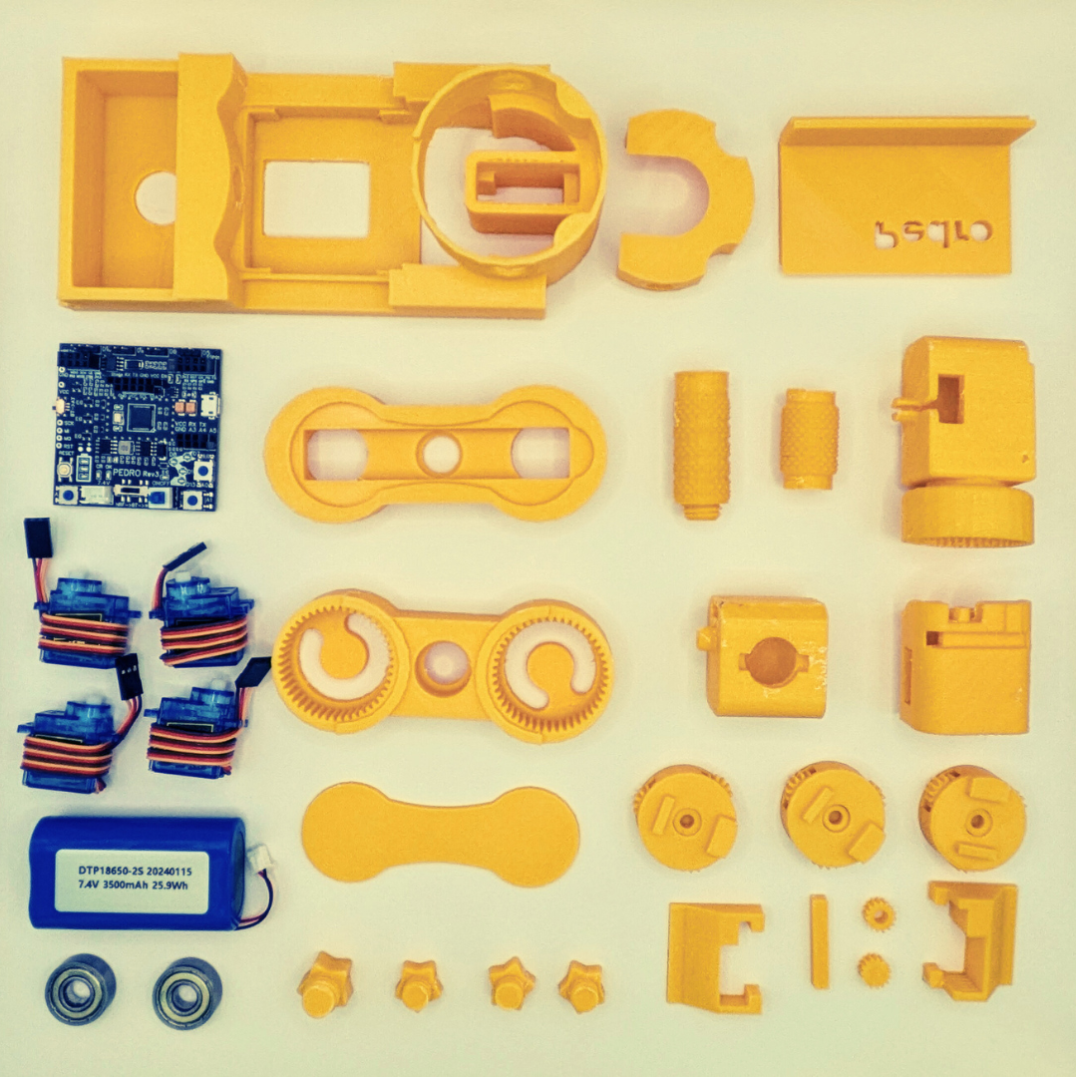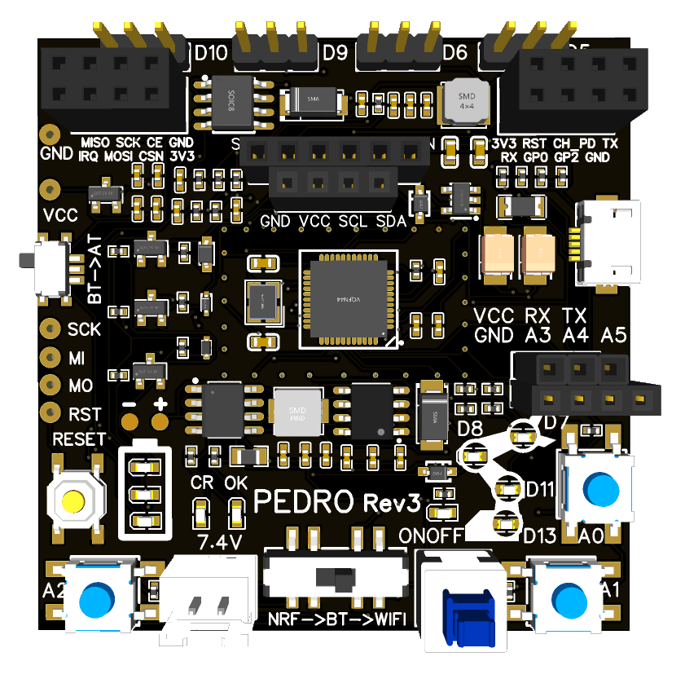

### ****Step 1 – Base****

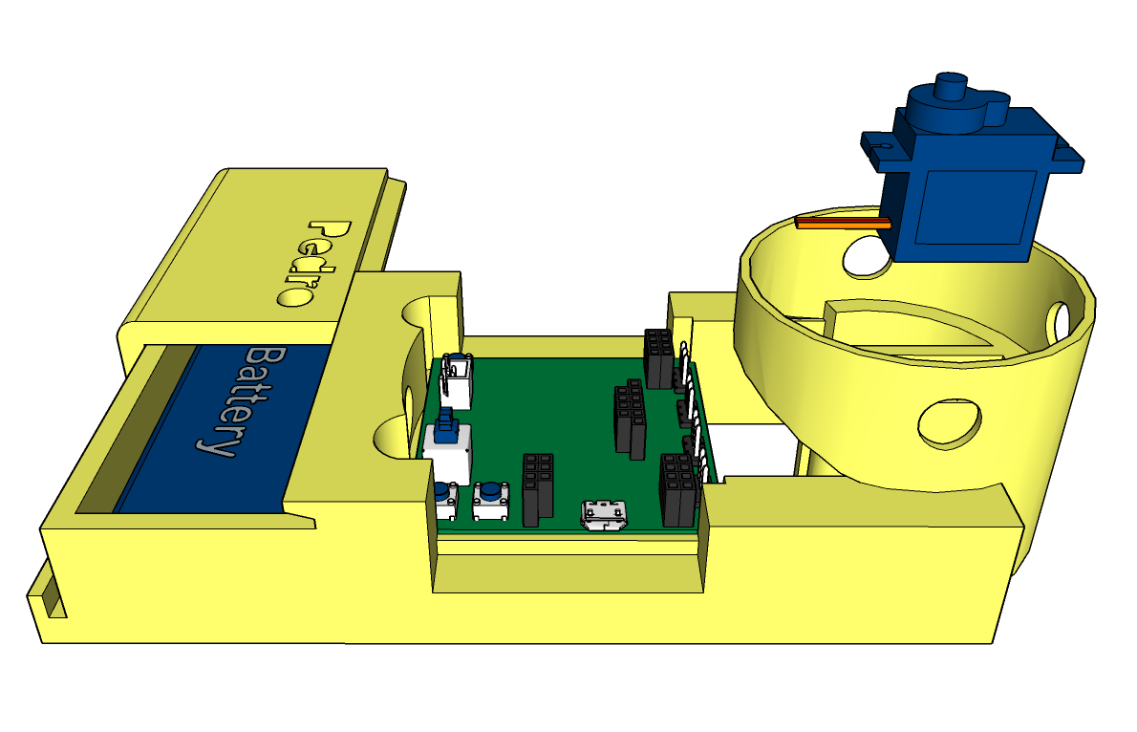

|  |  |
| --- | --- |
| * Place the battery in the base and close the cover * Place the electronic board in the middle of the base * Connect the battery to the board * Position the first servomotor in its slot (the cable should be oriented toward the board) | * Connect the servomotor to the board pins (Pin D5) * Place the first planetary gear system on top of the servo * Then place the gear in the center and press lightly so it attaches to the servo head * Turn on the board (On/Off button), the gear system should rotate in both directions |

### ****Step 2 – Shoulder****

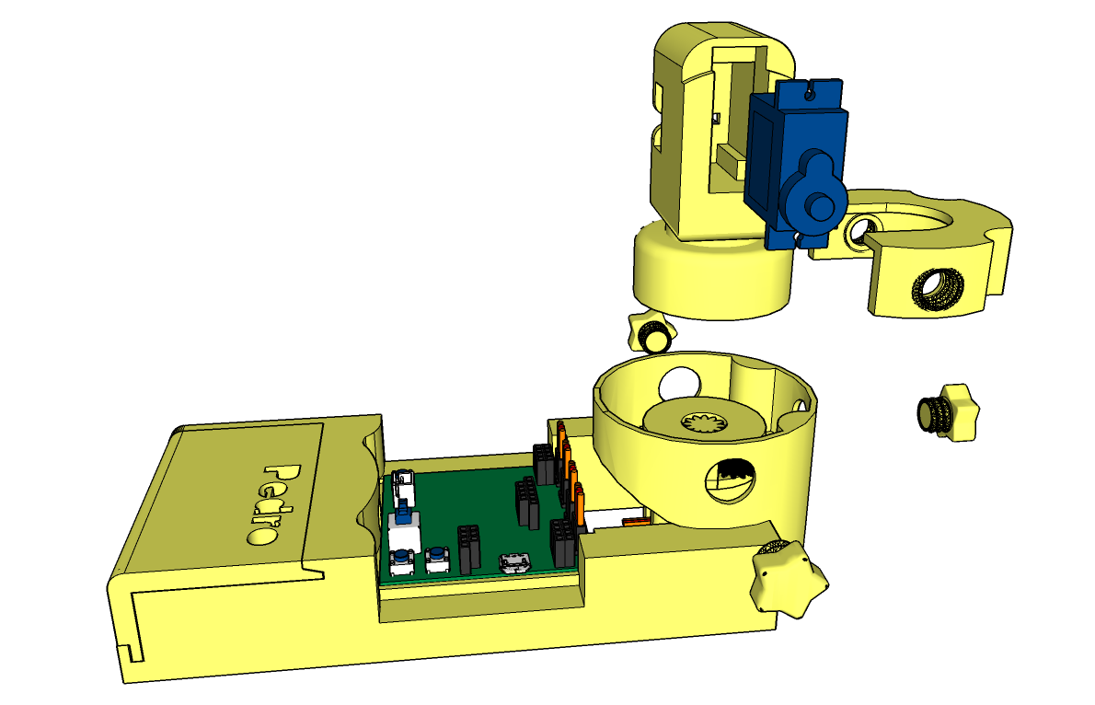

|  |  |
| --- | --- |
| * Insert the second servomotor into the robot’s shoulder * The servomotor should be oriented with the cable facing downward * Connect the shoulder support to the shoulder * Place the entire shoulder assembly on top of the planetary gear system | * Press until the shoulder is secured onto the planetary gear system * Gently rotate the shoulder left and right to check the planetary gear rotation * Screw the base with the 3 screws |

