Physics – unit 2 : Motion

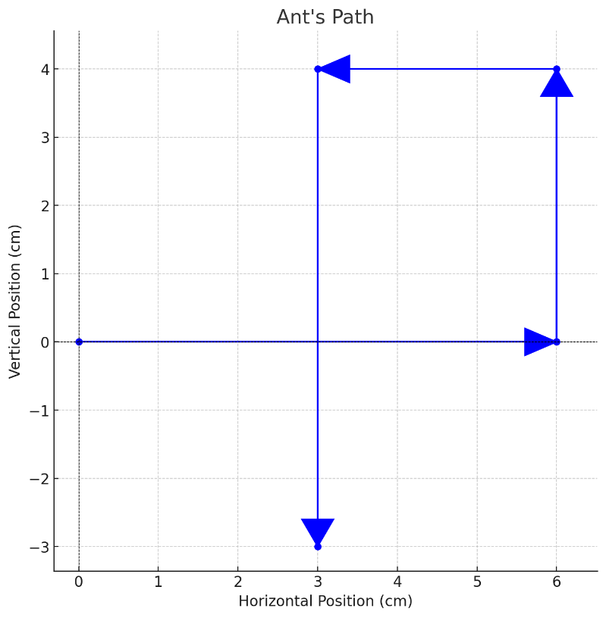
Distance and Displacement
Imagine an ant is trying to reach a drop of honey. It doesn't walk in a straight line. It walks around pebbles, over twigs, and maybe even takes a detour to avoid a spider!

- how many total segments does the ant's path have?
- In which directions does the ant move during its journey?
- What is the total distance traveled by the ant?
- What is the starting point of the ant? What is the ending point?
- Compare the total distance the ant traveled with the straight-line displacement. Which is larger? Why?
- If the ant walks in a square and returns to its starting point
  - what would its displacement be?
  - What would its total distance be?
- Can displacement ever be greater than distance? Why or why not ?
Remember:
- When talking about distance we only state the numerical value (for example: 14 cm and not 14 centimeters northeast or anything like that). This means we have only one value, the magnitude. This type of values is called a scalar.
- When talking about displacement, we also add the direction (for example: 7 centimeters northeast of its starting point). So, we have two values: the magnitude and the direction. This type of values is called a vector.

Below is a movement of cat in meters. The cat starts at some position (initial) and moves to another position (final).
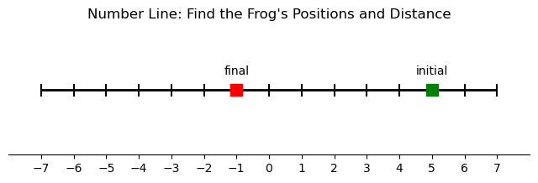
a) What is the initial position of the cat?
b) What is the final position of the cat?
c) If the cat travelled in a straight line from the initial to the final position, what distance did it travel?

Speed and velocity
Remember:
(1) Speed: How Fast You're Going
The Cheetah's Chase: Imagine a cheetah chasing a gazelle. Let's say the cheetah runs 100 meters in 4 seconds.
Speed = Distance / Time = 100 meters / 4 seconds = 25 meters per second (m/s).
Speed tells us how fast something is moving. It's the rate at which distance is covered over time.
Speed is a scalar quantity – it only has magnitude (25 m/s in this case) and no direction. We don't say the cheetah's speed is 25 m/s towards the gazelle.
(2) Velocity: Speed with a Direction
The Airplane's Flight: Now, consider an airplane flying. Let's say it's traveling at 600 kilometers per hour (km/h).
"Is this enough information to fully describe the airplane's motion?"
- knowing only the speed isn't enough.
- We also need to know the direction. Is it flying north, south, east, or west?

Velocity combines speed with direction. It's the rate at which displacement changes over time. So, we might say the airplane's velocity is 600 km/h east.

Velocity is a vector quantity – it has both magnitude (600 km/h) and direction (east). It's often represented by an arrow, where the arrow's length represents the speed and the arrow's direction represents the direction of motion.

A car travels at a constant speed of 60 km/h for 2 hours heading north, then turns east and travels at the same speed for another hour.
(a) What is the car's speed for the entire trip?
(b) What is the car's velocity for the first 2 hours?
(c) What is the car's total displacement? (draw a diagram to visualize the displacement).
(d) What is the car's average velocity for the entire trip?

