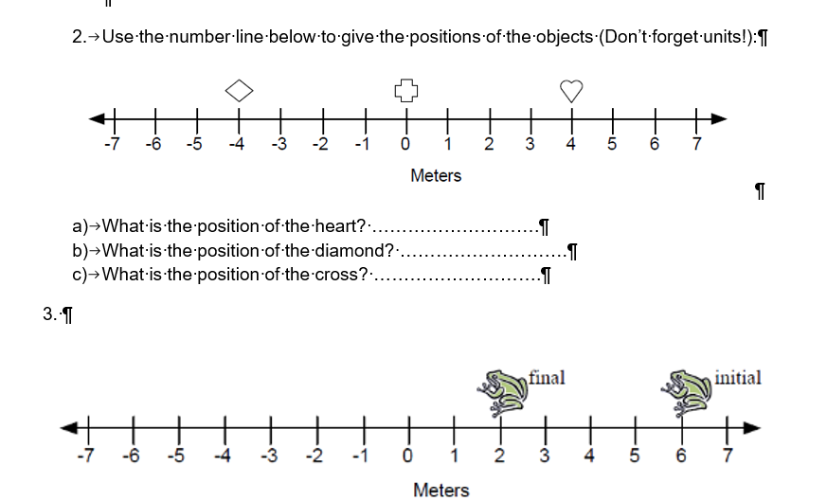

Below is a detailed, step-by-step explanation of how to find the positions of objects on a number line, as well as how to determine the initial and final positions of an object (like the frog) and the distance it traveled.

Understanding the Number Line
A number line is a straight horizontal line marked with numbers placed at intervals. Negative numbers are typically to the left of zero, and positive numbers are to the right of zero. The position of any object on the line can be read off by looking vertically down (or up) to see which number it aligns with.
Key points:
- If the object is to the right of zero, its position is a positive number.
- If the object is to the left of zero, its position is a negative number.
- The position should include units (for example, meters) if the number line is marked with units.

Part 2: Finding the Positions of the Heart, Diamond, and Cross
Step-by-Step Approach:
- Identify the symbols on the number line:
You have three objects: a heart (♥), a diamond (♦), and a cross (+).
- Find the scale and the markings on the number line:
Look at the number line. There should be a zero (0) marked at the center, and to the left, negative numbers like -1, -2, -3, etc., and to the right, positive numbers like 1, 2, 3, etc. Each mark on the line corresponds to a certain number of meters.
- Locate each object exactly above or below a number:
  - The heart (♥): Look at where the heart symbol is placed. Trace straight down from the symbol to the number line to find out what number it is above.
  - The diamond (♦): Do the same for the diamond symbol.
  - The cross (+): Again, follow the symbol down (or up) to the number line to read off its position.
- Write down the positions including the units (meters):
Suppose the heart is above the number +5 on the number line. That means its position is +5 meters.
If the diamond is located above -3, its position is -3 meters.
If the cross is at +1, its position is +1 meter.
Example (based on the image you provided):
- Heart: about at +5 m
- Diamond: about at -3 m
- Cross: about at +1 m

Part 3: Finding the Initial and Final Positions of the Frog and Distance Traveled
Now consider a scenario where we have a frog that was initially at one position on the number line and then moved to another position.
Step-by-Step Approach:
- Identify the initial position of the frog:
Look at the number line and find where the frog is labeled "initial". Let’s say the frog’s initial position is at +6 meters.
- Identify the final position of the frog:
Look for where the frog ended up, labeled “final.” Suppose the frog’s final position is at +2 meters.
- Record these two positions:
  - Initial position = +6 m
  - Final position = +2 m
- Find the distance the frog traveled:
Distance traveled = |final position - initial position|
Here, the difference is: +2 m (final) - +6 m (initial) = -4 m
The absolute value (just the number, ignoring the sign) of -4 m is 4 m.
Why take the absolute value? Because distance is always positive. Even if the frog moved backwards (from right to left on the number line), the distance it covered is still a positive number.
Example (based on the image you provided):
- Initial position of the frog: +6 m
- Final position of the frog: +2 m
- Distance traveled: |2 - 6| = |-4| = 4 m

Putting It All Together
For the objects:
- Look at the number line, read the value beneath the symbol, and include units (meters).
- Heart is at +5 m (example from the given image)
- Diamond is at -3 m
- Cross is at +1 m
For the frog:
- Identify initial and final positions by reading directly below where it’s labeled.
- Calculate the distance by finding the difference and taking the absolute value.

In summary:
- To find positions of objects on a number line, simply read off the number line at the point where the object is placed.
- To find the distance traveled from one point to another, subtract the final position from the initial position and take the absolute value of the result.
This step-by-step reasoning ensures that no matter where the objects or the frog are placed, you can determine their positions and distances traveled correctly.

