Directions:

1. Create a length conversion Calculator
2. The unit that the user will be inputting is Millimeter.
3. Millimeter can be converted into:
   1. *Centimeters*
   2. *Meter*
   3. *Kilometers*
4. Use JavaScript Events, Functions, and Output.
5. Save the HTML file with the filename: ***CAMPUS***_***ICTGr&Sec_Project_Lastname.html***
6. Upload to GitHub Pages.
7. Submit the repository and website link in the submission bin.

Sample Website View:

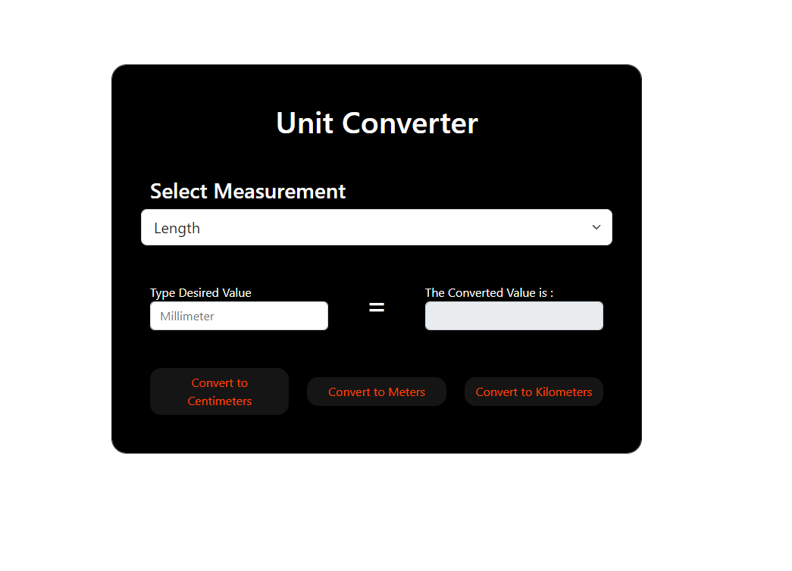Source: https://raymartrosali.github.io/SampleProjectQ4/

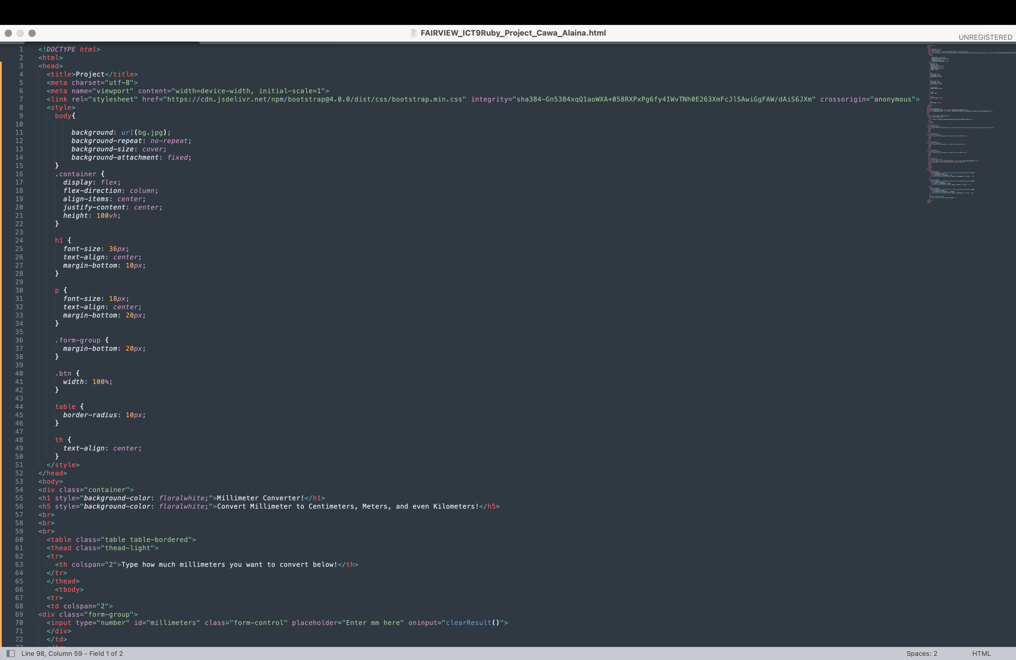

**RUBRICS**

|  |  |  |  |  |
| --- | --- | --- | --- | --- |
| **CRITERIA** | **E** | **AS** | **S** | **NI** |
| **Execution of Instructions and time of submission** | The activity was completed before the allotted time elapsed and the instructions were properly executed. | Followed most of the instructions. One instruction is skipped; The activity was completed within the given time, | Minimal errors can be seen in the project and it was not completed within the given time. | The activity is full of technical errors due to misinterpretation of all instructions and it is not completed within the given time frame. |
| **Format and Layout** | All the contents are organized and presented in a uniform format with distinctions between major contents and supporting details. | Most contents are organized and well presented. Formatting where necessary is applied. However, one formatting requirement is missing. | The activity contains formatting; however, four to five formatting requirements are missing. | The activity was laid out poorly. Contents are not placed in proper order. All formatting requirements are missing. |
| **Website Functionality** | All the functionality of the website is working properly. | Some of the buttons web pages doesn’t show prompts but the website is still working. | Some buttons don't lead to anything and some of the prompts are not working on webpages. | All of the buttons and prompts are not working properly |
| **TOTAL** | **20** | **15** | **10** | **5** |