Tigo CCA
Power Supply
Author: Alan Hunt, Date: 2025-10-11, License: CERN OHL v2 Permissive

This is a simple project to power a Tigo CCA, which is a device that manages solar panel optimisation and claims to have boosted output by 11%.
With grid loss, solar powered inverters automatically shutdown their grid output for safety of those working on the grid. My Anker inverter has a 5kWh battery and an EPS (Emergency Power System) output that is connected to the oil heating system and most of the downstairs mains.
Initially, the CCA was on the grid circuit and when it lost power the solar panels would shutdown instead of maintaining the backup supply. The first goal was to replace the CCA power supply with one on the backup mains, so the system could feed itself. The second goal was to provide an auxiliary battery input that could kick-start the system, if the grid was still down and the inverter’s backup battery had completely depleted.
This project describes the replacement power supply and shares all the source files. Some tools and techniques in stripboarding, labelling and LED powering are noted too.

Contents
This file provides a summary of the:
- Pre-conversion Details
- Design and Validation
- Circuit Diagram, produced in KiCad.
- Circuit Board, using stripboard and designed in VeroRoute.
- Box and Labels, produced in LibreOffice Draw.
- Photos

Pre-conversion Details
The CCA’s power supply specification is 12V to 24V and the installed system met the criteria for using a 12V supply. The CCA specification states a 1A supply although the power consumption is quoted as 3W to 10W, dependent on configuration.
The Tigo CCA was powered from a switch mode power supply mounted inside a mains distribution panel, the efficiency and mains power drain of this is not known, but the output was set to 24.21V.
With the CCA supply at 24.21V the average current drain was 83mA, so 2.01W. With a 12.0V volt supply the system worked seamlessly and power dropped to 1.57W (131mA), so a lower voltage replacement was preferred.

Design and Validation

Dual Power Supply
The project links two low-voltage power supplies to a single output for the CCA. There’s a main input from a SMPS (Switched Mode Power Supply) and a battery input to kickstart a dead, off-grid system. These connections link via diodes to prevent one power supply back feeding the other.

Grid Power
The main power supply is an off-the-shelf SMPS (Switched Mode Power Supply) connected to the EPS circuit. The CCA consumed less power at lower supply voltages, so a 15VDC 1A PSU was chosen. Any PSU of 15V to 24V and at least 1A would do though.
Choosing 15V provided so some headroom for circuit losses and voltage drops on the supply cable. The CCA is about 5 metres metres from the power supply, so the 24 AWG cable would drop about 0.94V, with 0.47V on each wire (5 metres * 1A * 0.094Ω/metre = 0.47V). In normal operation the CCA draws less than 150mA current, so the measured drop was only 0.13V (14.40V – 14.27V).
For personal convenience, the SMPS was chosen to have the popular 5.5/2.1mm power jack, instead of fairly common 5.5/2.5mm size.
The SMPS had low very power consumption when idle, with the test showing as 0.0W. When the SMPS was connected to the CCA via a 1N4004 diode, its output of 15.22V dropped by 0.78V, so supply to the CCA was 14.44V. The average load was about 120mA (1.83W) and the SMPS was drawing 2.6W from the mains, so it was roughly 70% efficient.
The main input has an internal quick blow fuse to match the CCA specification and SMPS output of 1A.

Battery Backup Power
For flexibility, the battery input accepts a range of voltages that are boosted, if necessary, to a slightly lower voltage than the main SMPS. Setting the DC booster to a slightly lower voltage is intended to reduce battery drain if the main SMPS regains power. The battery input uses a 5.5/2.1mm jack socket on the project box too and this follows the convention of centre pin positive.
The 2A DC Boost Converter is based on the MT3608 chip. This board has a 2A maximum input in the range of 2V to 24V and a boosted output of 4V to 28V, which is set by a multi-turn potentiometer. The DC Boost Converter was set to output 14.48V and fixed with medium strength Loctite. An inline 1n4004 diode dropped 0.78V to give a final output of 13.7V. At this voltage the CCA load was about 125mA (1.81W).

Boost Limitations
The DC Boost Board is rated everywhere as 2A output, which is wrong and may even be intended to mislead people. AI propagates this hokum from both suppliers and users and it took 2 further questions for AI to agree the error, while adding that many people have over heating issues. Although the M3608 is rated as 4A and the SS34 diode is 3A, the inline inductor is usually only 2A. When boosting, the input current is a multiplication of the output, based on circuit efficiency and the voltage ratios, therefore the 2A rating should apply to the board’s input, not the output.
To meet the CCA’s specification of 1A supply the boost input needs to be above 9V, in which case the input current is 1.97A or lower. The normal operating current of the CCA is much lower though, so lower voltage batteries can be used. With a 5V and 1.9A input the maximum output at 14.48V was 470mA, and with a 4V and 1.9A input the maximum output was 330mA. Below these input voltages the booster became unstable and little too close to CCA power fluctuations.
The battery input has an internal quick blow fuse to match the DC Boost Converter limit of 2A. If the battery input fuse blows it may indicate a higher voltage battery is required.

Battery Choice
The most likely battery choices are a 5V USB battery bank or car battery. A 9V PP3 couldn’t tolerate the load and would have insufficient capacity. The battery should have a voltage under load of between 4V and 24V. Ideally it should be below 15V so it cuts out when then main input is present. The battery should be able to supply 15W, for the DC booster to output 1A to the CCA, although in my case the nominal battery load was only 2W.

Using a USB Battery Bank
It’s possible to obtain off-the-shelf adaptor cables from USB to a 5.5/2.1mm DC jack.
Some battery banks have PD capability to provide a 9V, 12V, 15V, or 20V supply instead of the usual 5V, in which case 9V or 12V settings are recommended.
For a basic battery bank with 5V output the measured input to the DC Booster was 4.94V and 397mA, so that’s 1.96W with 92% efficiency. For indicative purposes, a 10,000mAh battery bank with a nominal Li-Ion 3.6V battery has 36Wh. Assuming it has 80% efficiency, and a new and fully charged battery, the supply would last about 15 hours.
It’s worth noting that battery banks could limit current to 0.5A or some arbitrary value. For example, an old 10Ah battery bank had a 1A limit, whereas USB standards should require pull-down currents on CC1 and CC2 pin connections to raise older 0.5A USB limits to 3A.

Power Supply Monitoring
A 3mm green LED provides an indication that adequate voltage is output from the power supply. The LED brightness is controlled by limiting its current to a maximum of only 120uA, which makes it clearly visible in daylight. This level was set to prevent dazzling and to be frugal with wasted power. The entire LED circuity was estimated to cost 0.7p (£0.007) per year
To prevent the LED conducting at low voltage its cathode is connected to two 5.1V Zener diodes in series and then down to 0V. The diodes are a little under biased to about 10.0V, so with the LED forward voltage of 2.3V there is some gradual turn-on from 12.3V.
LED current limiting is performed by a LM334 current source. The maximum current is set by R2 and with this setup the LED reaches its maximum brightness at 12.9V. Higher output voltages can be supported, up to the power supply’s maximum permissible voltage of 24V, without burning out the LED or increasing its brightness and wasting power.

Circuit Diagram
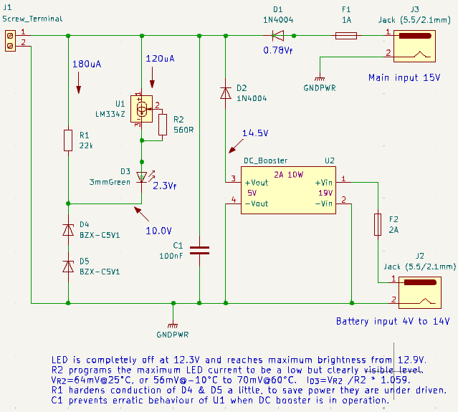

Circuit Board
The layout was hand produced in VeroRoute v2.39. Ergonomics of accessing connectors and fuses in the small box were a key consideration.
The layout image was transferred to the top of the stripboard to aid component positioning (gone are the days of soldering a batch of components just 1 hole out). To help hole cutting of the copper tracks and to visualise the circuit from above, black squares are used. These are text boxes with the “Black Large Square” (Alt-11035) character at 16pt.
To make the image, toner transfer paper was used with a LaserJet printer set to glossy paper. The image was first mirrored in VeroRoute with “Flip-Horizontal”, then pasted to LibreOffice Text and scaled. The image was held onto the board with heat resistant tape and this was passed through an A4 laminator 4 times to make sure the top of the board was warm enough to accept the toner transfer. If the laminator can accept the stripboard thickness, the rubber rollers are ideal to apply the essential pressure during the heat transfer process.

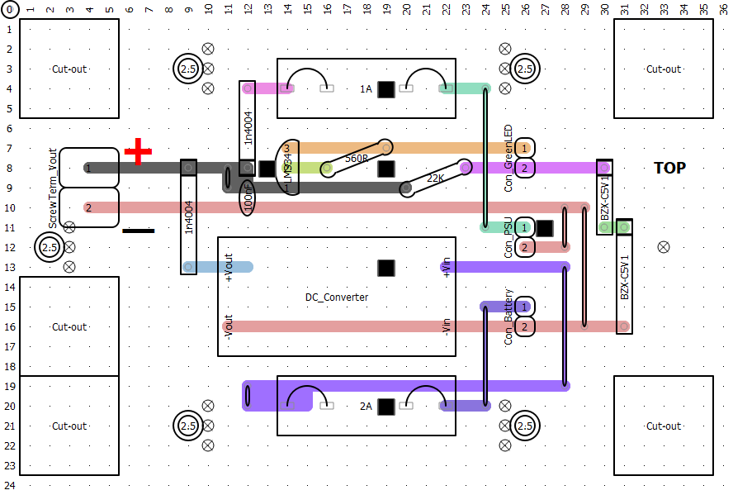
Box and Labels
The project was housed in a black IP65 ABS box measuring 100×68×50mm.
Some good looking labels were produced for the outside of the box that are fairly tough and water resistant too. They were made with adhesive white glossy vinyl paper and a LaserJet printer set to glossy paper (otherwise the toner would not fix properly). To achieve a white font for labels, the background was set to black and the font set to white, this worked quite well on the black ABS box.
The drawing package was LibreOffice Draw, which helped in visualising the box layout, planning hole cut-outs and sizing the labels.
Box Layout | Labels
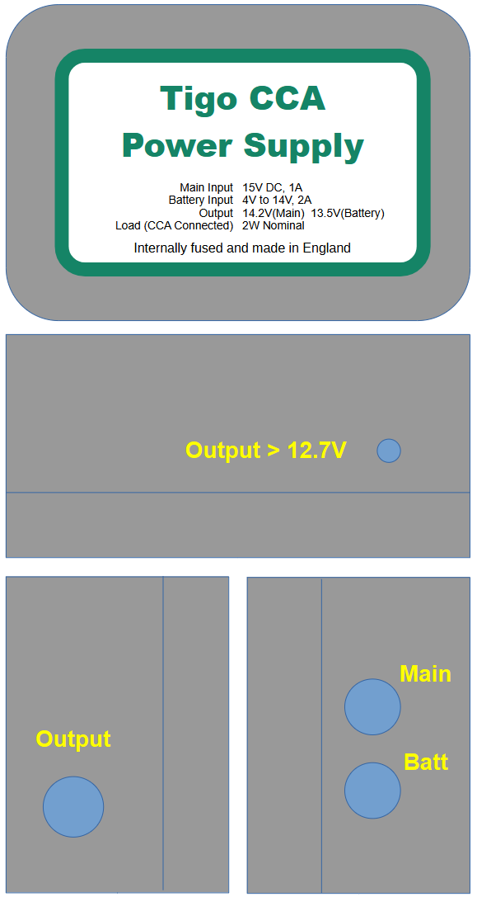 | Tigo CCA  Power Supply  Internally fused and made in England  Main Input  Battery Input  Output  Load (CCA Connected)  15V DC, 1A  4V to 14V, 2A  14.2V(Main) 13.5V(Battery)  2W Nominal  Output > 12.3V    Main  Batt

Photos
Stripboard Pin Holes Lined Up | Image Taped Down
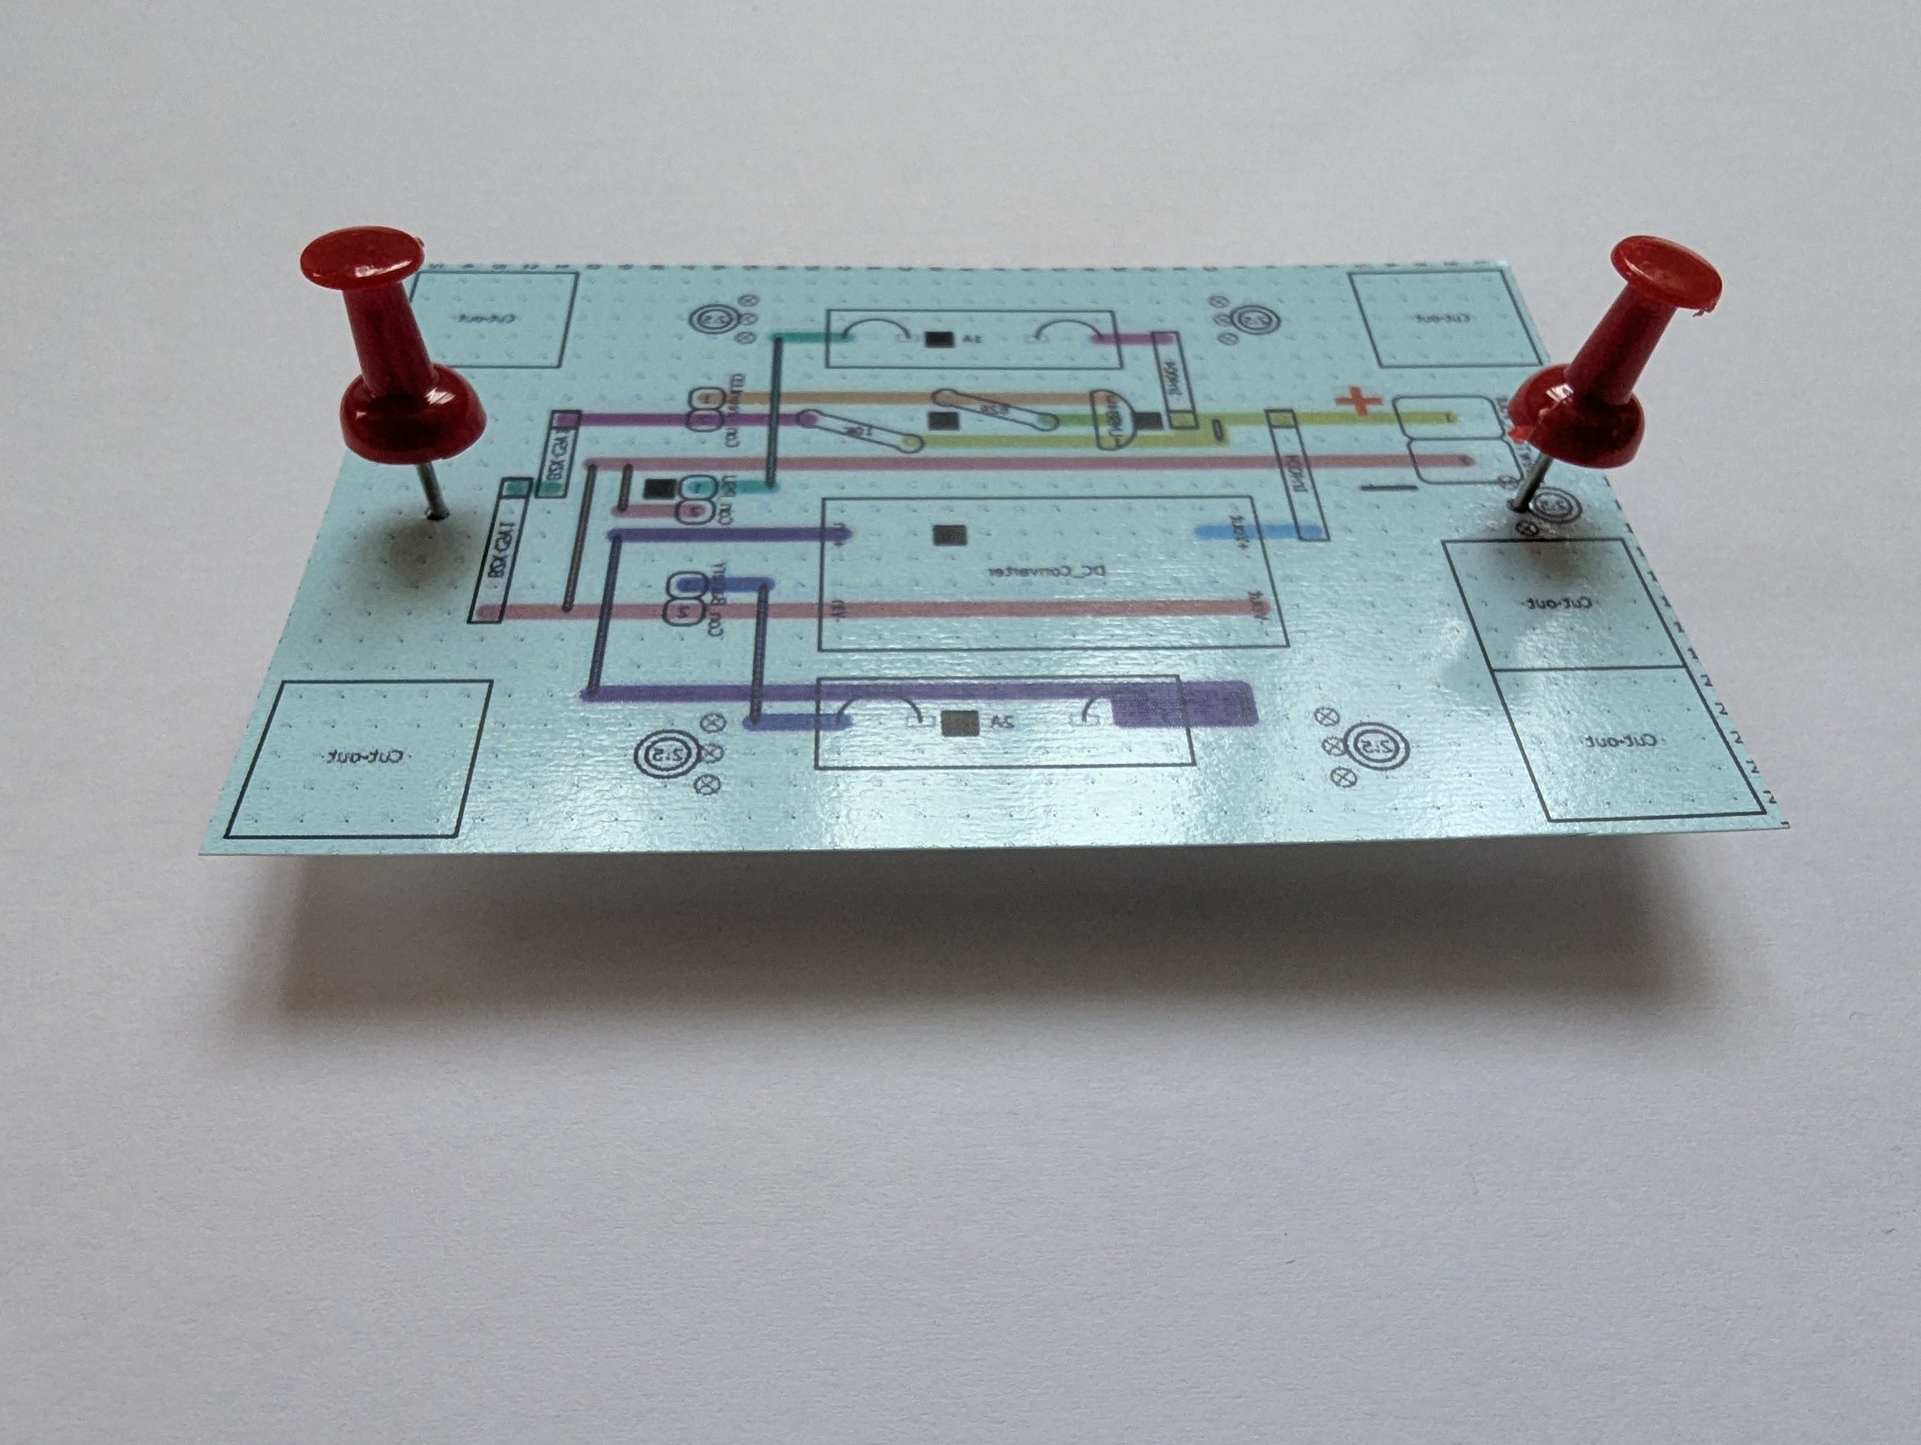 | 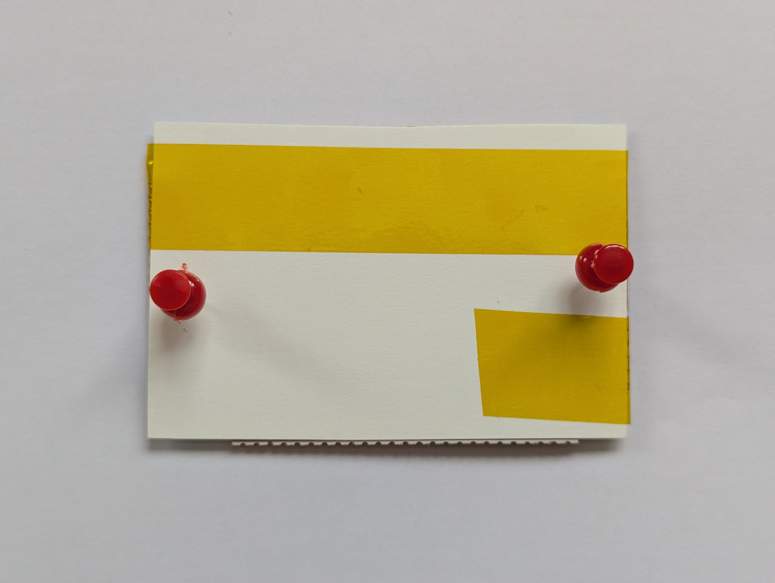
Ready for Laminator | Layout Image for Ease of Soldering
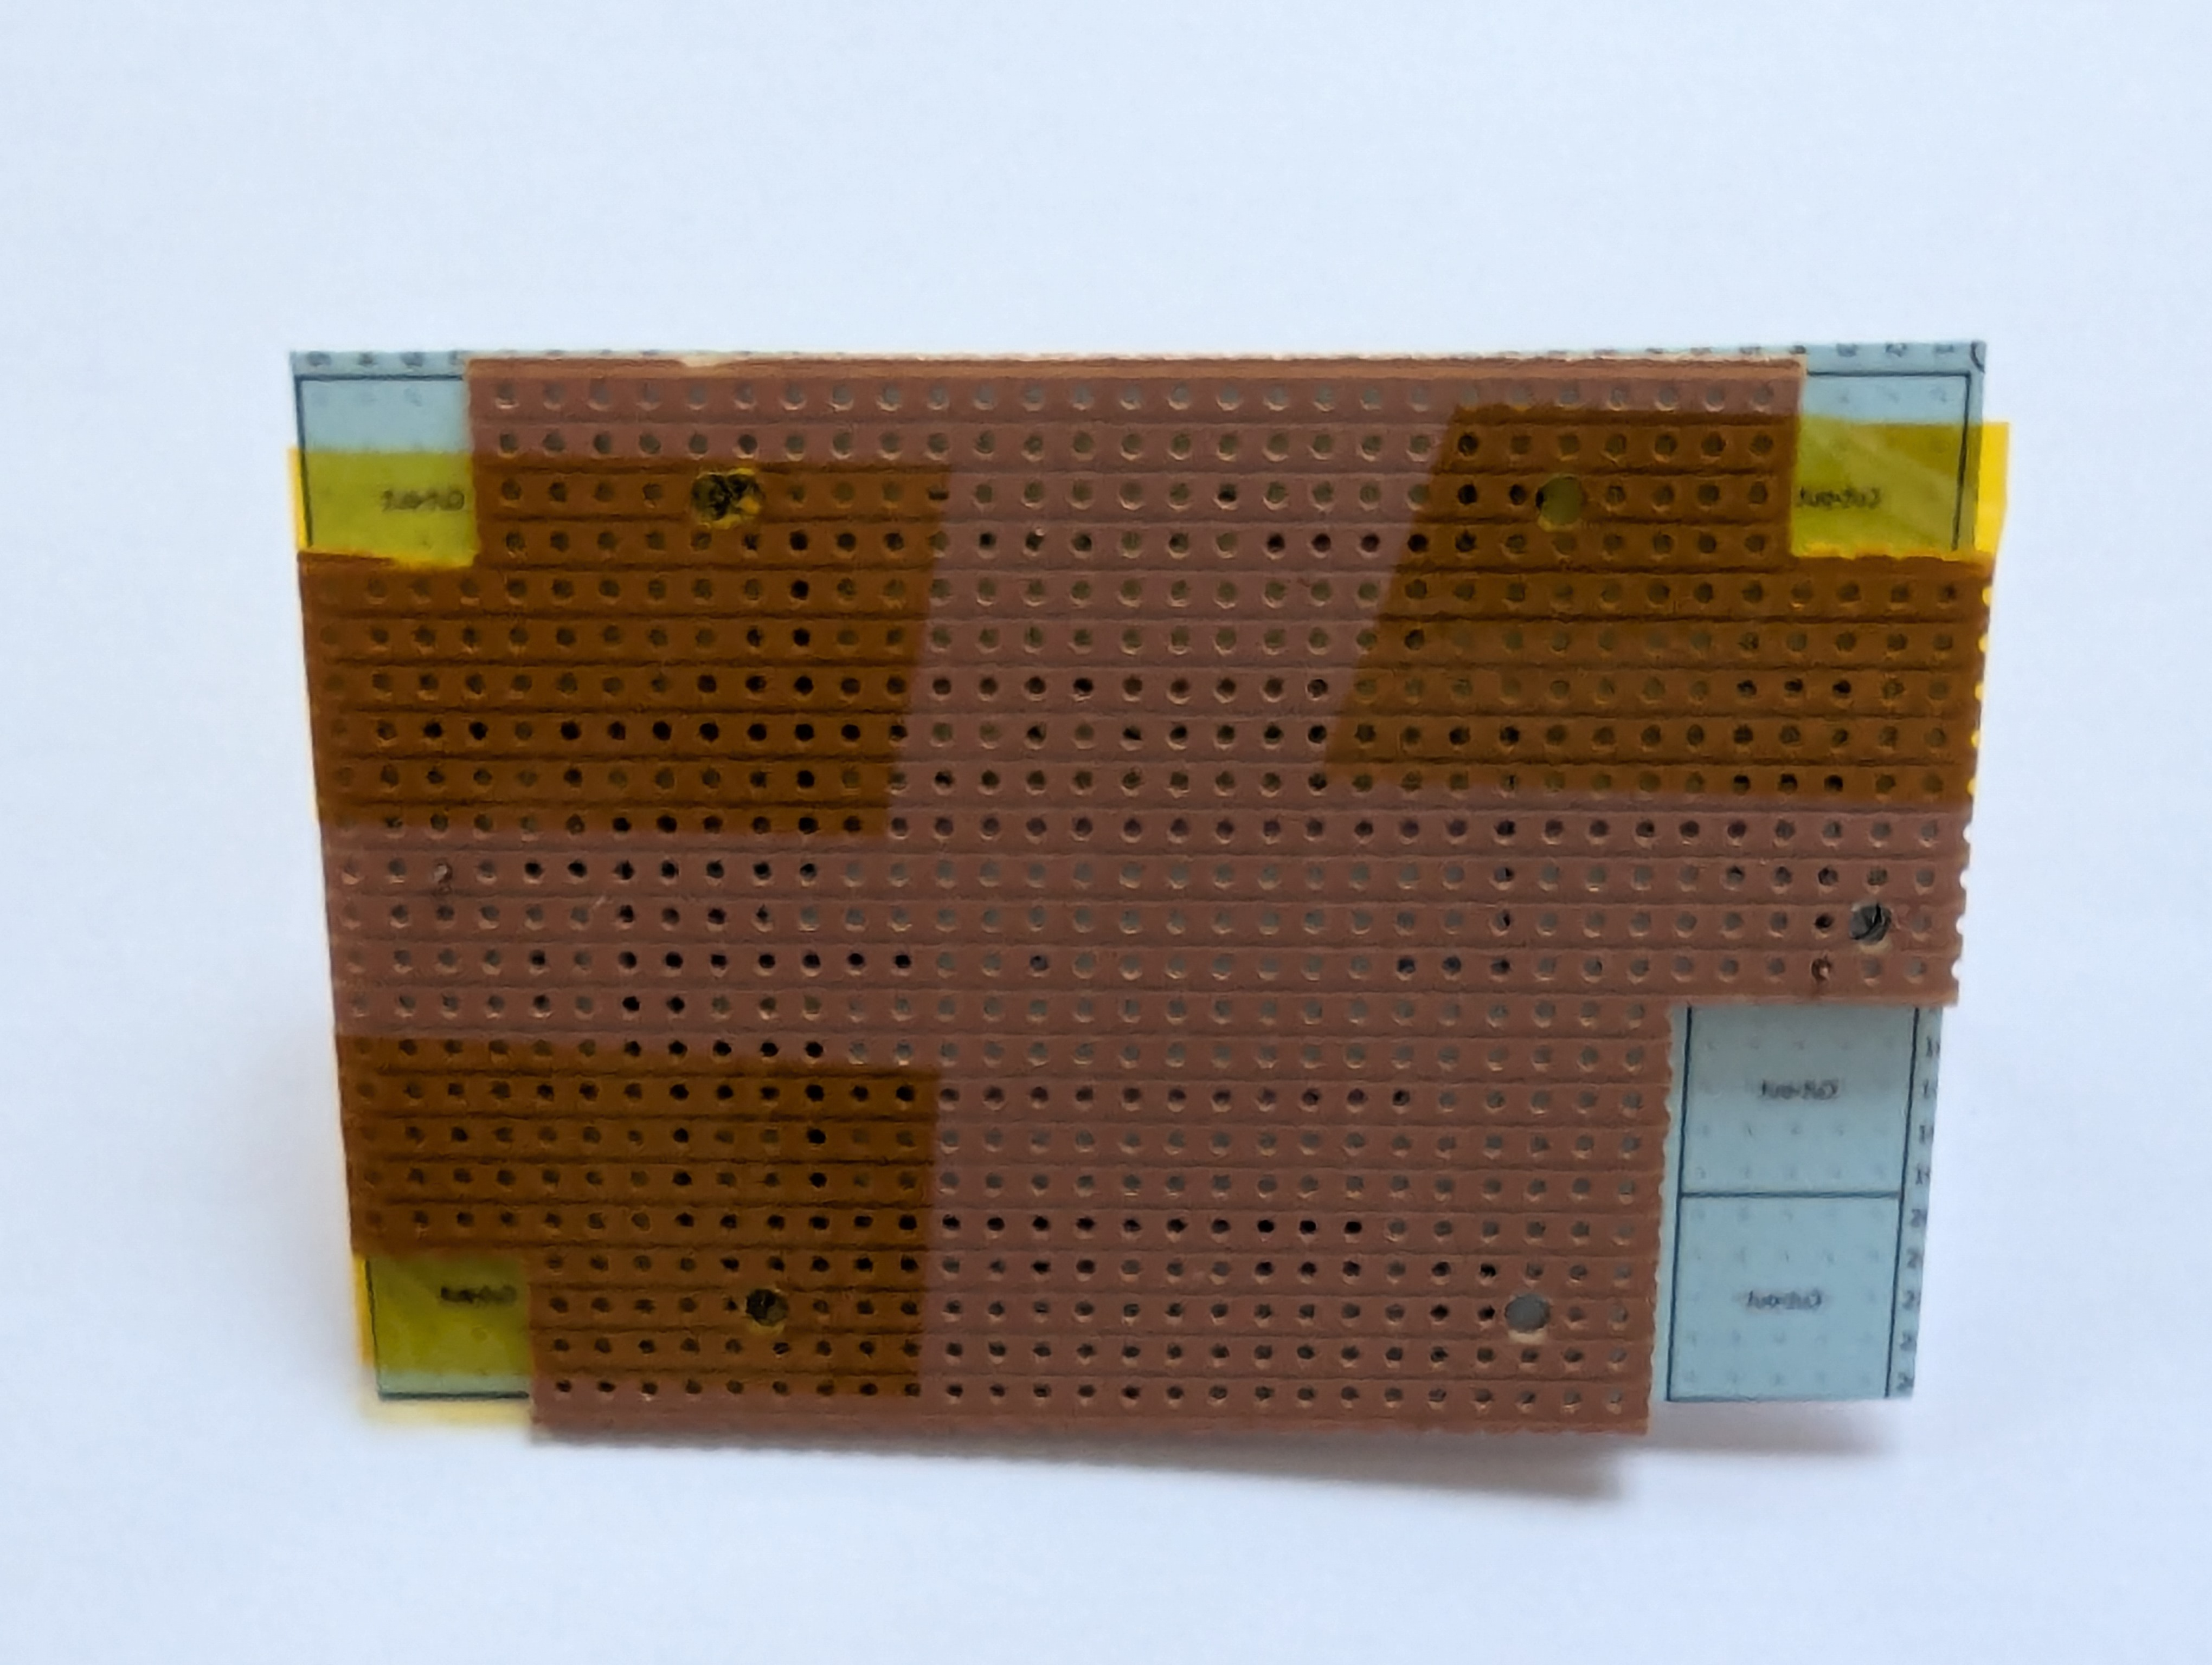 | 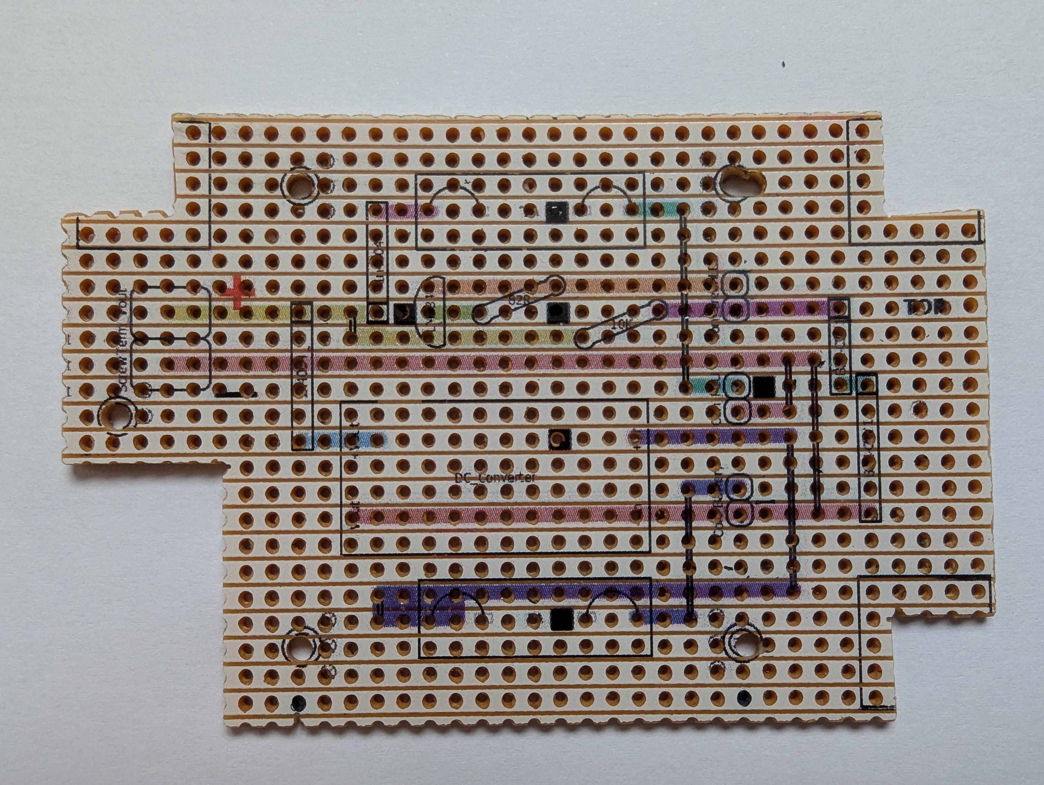
Components Soldered | Box is Ready
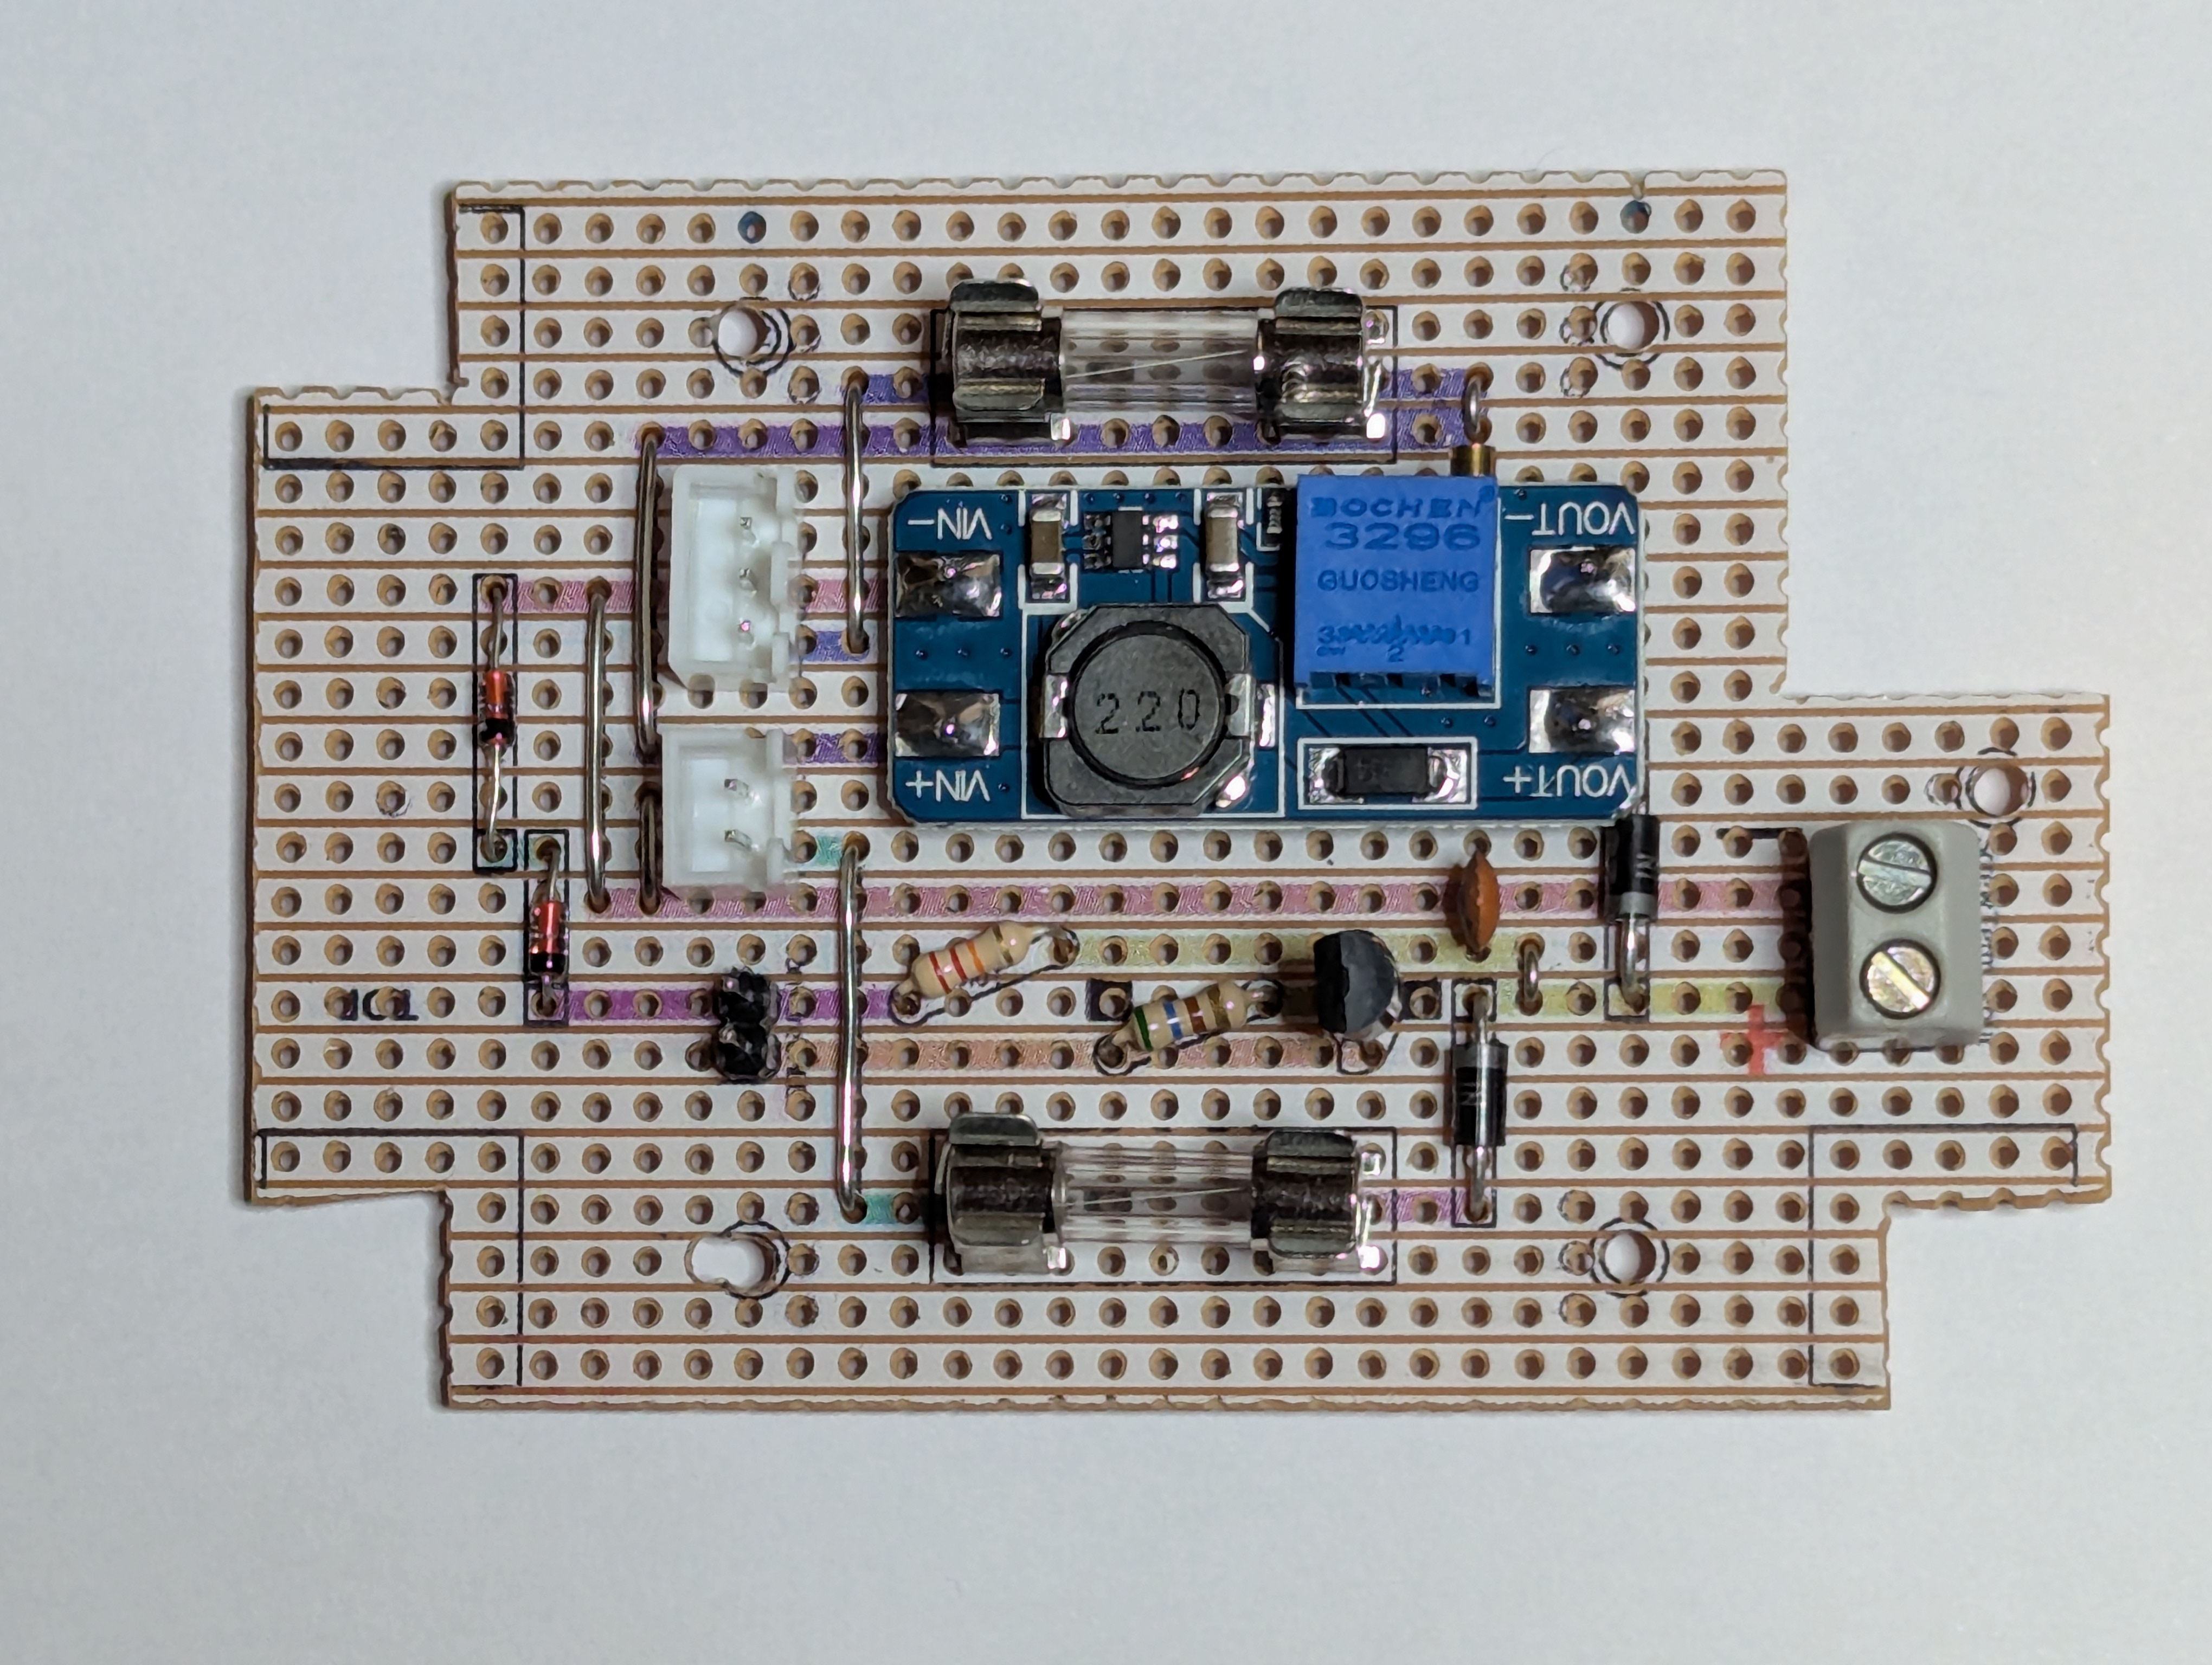 | 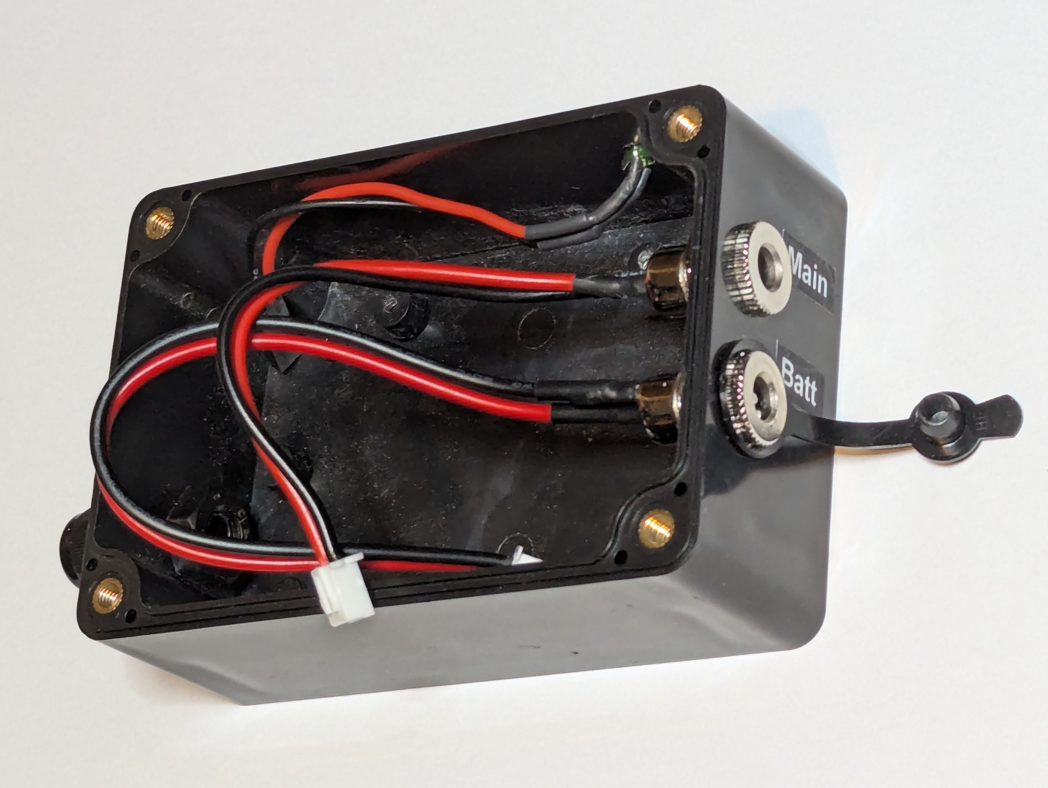
Ready to Seal Up | Finished
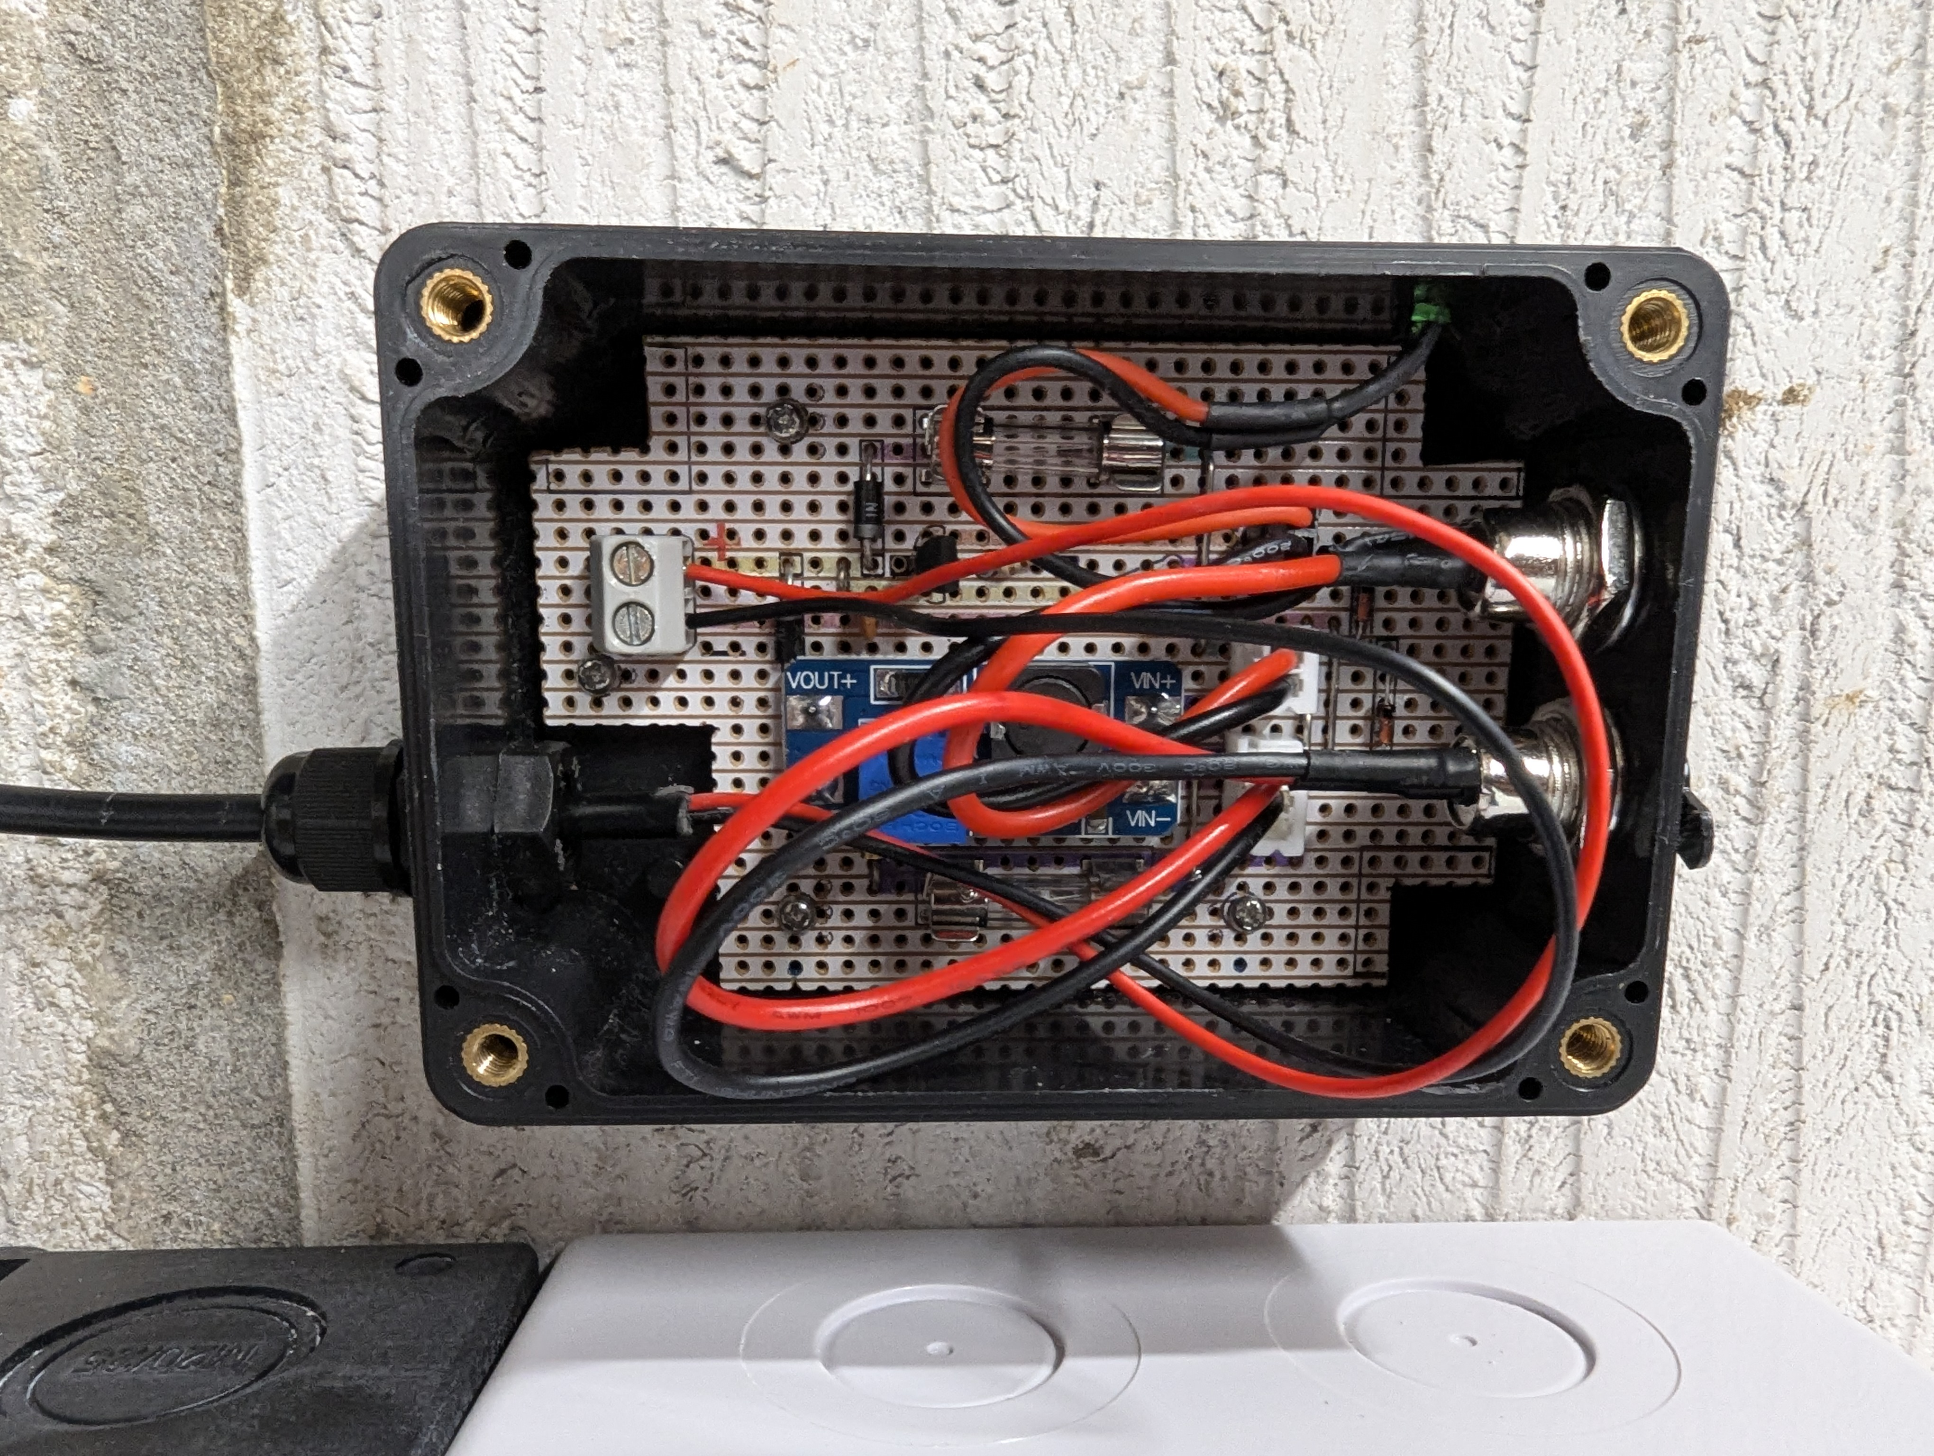 | 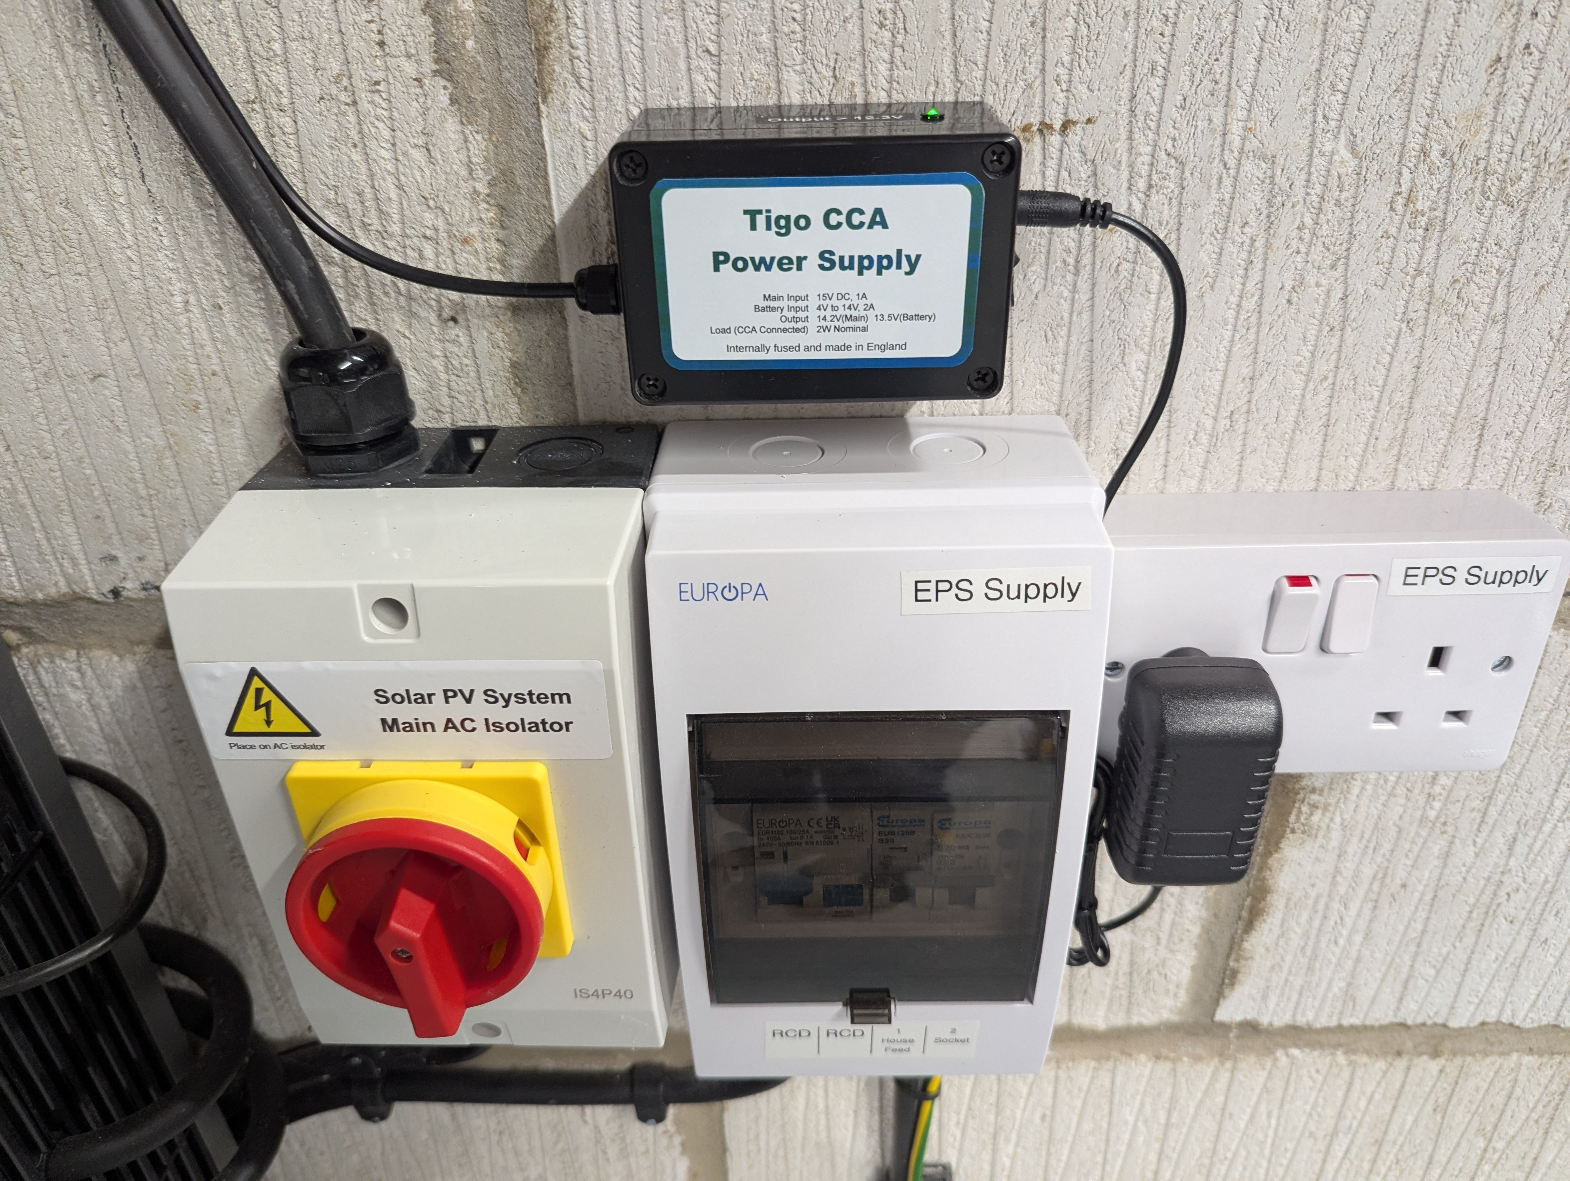

<End of Document>

