How to create a Dark Theme for PICAXE Editor 6.2

While the PICAXE Editor is not running, make a backup copy of the settings files that are held in this folder:
C:\Users\{YourUsername}\AppData\Roaming\Revolution Education\PICAXE Editor\Settings

Then copy “PICAXE_Editor_General_Settings.xml”, “ColourScheme-Dark.xml” and “TerminalColourScheme.xml” to the folder, overwriting any of the files that existed before.

If you’re running Linux Mint that’s it you’re done! If your running windows, edit each of the xml files and replace the font entries for Liberation Mono with Cascadia Code.

Run the PICAXE Editor and choose File→Options→Colours/Fonts and you should see this setup:

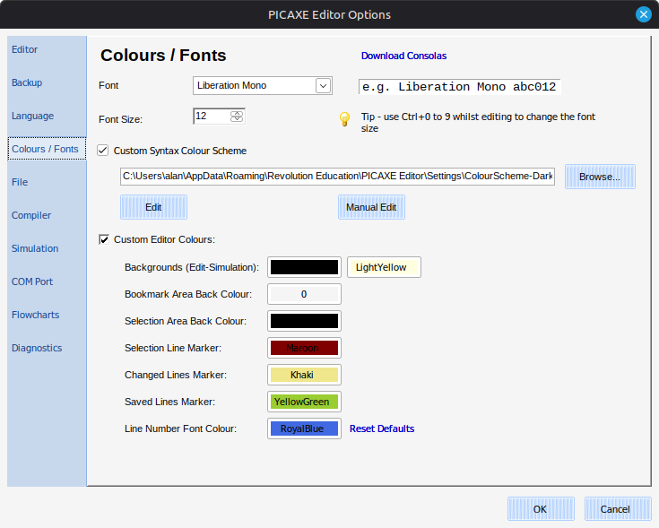

As shown above, you should have the checkbox ticked for "Custom Syntax Colour Scheme" and “ColourScheme-Dark.xml” should be selected. Also, the “Custom Editor Colours" should be ticked with the selections shown.

To have the text both display and print clearly I use the system colour Chocolate, which looks orange. Strings are toned down a bit from Red to FireBrick; Keywords to DodgerBlue; Numbers and Operators to a light turquoise without Bold etc. Also, text highlighting was improved by editing PICAXE_Editor_General_Settings.xml so that Blue is replaced with White or LightYellow in this line: <ColorCurrentLineHighlight>Blue</ColorCurrentLineHighlight>
NB: In the xml files I’ve stripped out duplications for font type and size to try and make the default work more freely. Unless the files are edited directly, PE seemed to keep allocating Text to Courier New, 10pt when editing the colour scheme any field type when using File→Options→Colours/Fonts→CustomSyntaxColourScheme→Edit.

