Please read,
or take a peek

Buzz Wire Game Description

Scan here to read later:


Buzz Wire Game

Quick Overview
You get a timed lap of the Snetterton Racetrack with this game! The game will speak your player number and lap time, and you may get on the leaderboard or make a new lap record.
When the game first powers up it checks the battery capacity and tells you to place the car at the left or right start point, if it’s not already there.
The game then says it’s initialised and suggests you press the yellow Help Button, which speaks some instructions. To start racing, you press the green Race Button, wait for the green light, lift the car clear of the start point and place it at the other end of the track.
The race is bidirectional, so leave the car at the end and this becomes the start point for the next player. During the game you’ll be told if you’re going too fast or too slow based on your crashes and time. At the end of the game your lap time is spoken and you may get some advice if you crashed too often or went too slow! If you get on the leaderboard of top 20 places, you’ll get some praise and if you get the lap record you’ll get a fanfare too.
If you start the race too soon, you’ll get a 10 second time penalty. You’ll also get a 3 second time penalty if you skid off course by touching the buzz wire. Correct your course quickly because the crash penalty is added every 0.5 seconds. “When” you crash you’ll hear a buzz tone and some car crashing sounds too. If your crash penalties add up to more than your driving time you’ll also get an extra 1 minute penalty for “stock car racing”.
If you’re not crashing too often during a race, you’ll hear some background music or sound effects played. During idle times different sounds are played, mostly with a car theme, which are interspersed with adverts every 90 seconds to encourage game play.
If you want a practice, just lift the handle and return it to an endpoint when finished. Unless you press the Race Button you won’t get a player number or lap time though.
Pressing the Leaderboard Button will speak out the top 4 player numbers and their lap times. The leaderboard records were cleared for today and the results are not lost when the game is switched off. The fastest lap of the day will receive the Piston Cup Trophy.
The battery lasts about 10 hours when the volume is high, or about a day if the volume is low.

Technical Summary
The game uses an MCU (Microcontroller Unit), which is a low power computer chip as used in something like a washing machine. It has 4 Kbytes of program memory, 56 bytes of RAM for general purpose variables and 256 bytes of permanent storage where the leaderboard is placed. The game almost filled of all these memory locations. The program is about 1,000 lines of code and is written in BASIC because it’s simple, fun and I’m old. The MCU is a PICAXE 20X2.
An audio module stores sound on an SD card, consisting of songs, effects and downloaded AI generated words or phrases. These sounds are strung together and controlled by a communication link to the microcontroller. The microcontroller has a timer and the electrical input and output pins for the buttons, buzz wire connections, buzz sound, LEDs (Light Emitting Diodes). The inputs use transient voltage suppression to protect the electronics against static electricity, up to 30 kV.

Photos
Working Prototype | The Workbench
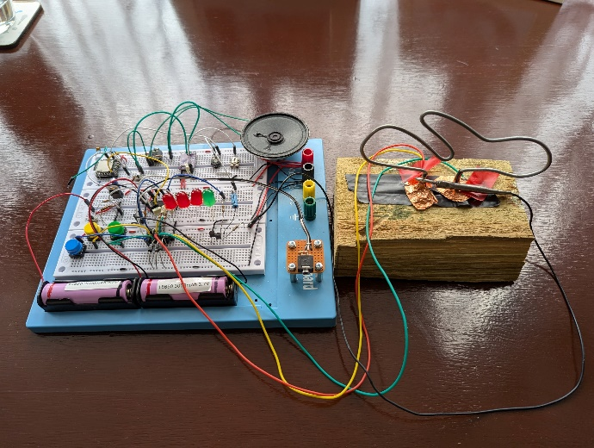 | 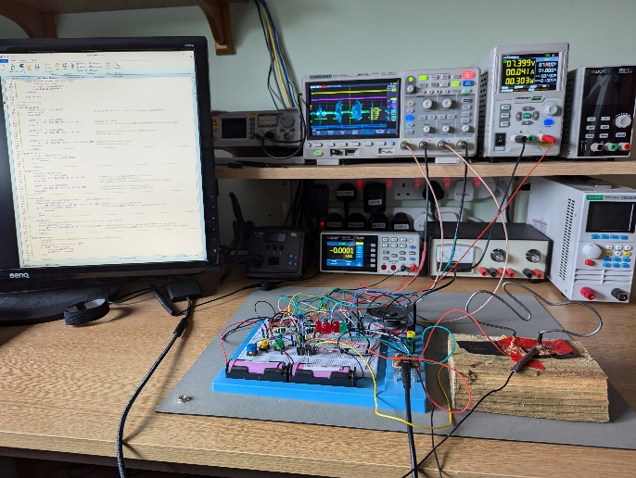
Handle V1 (Final was brazed) | 1st Semblance
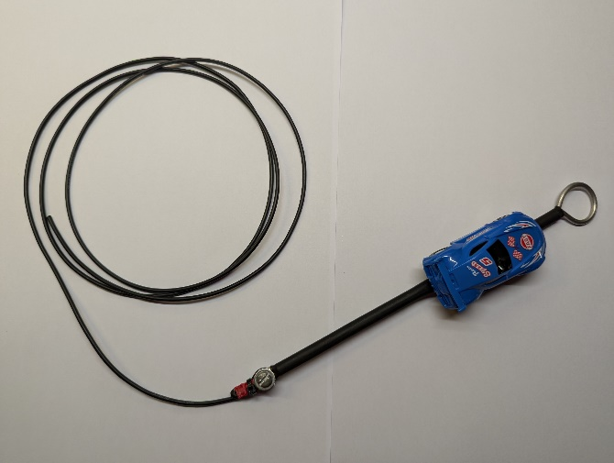 | 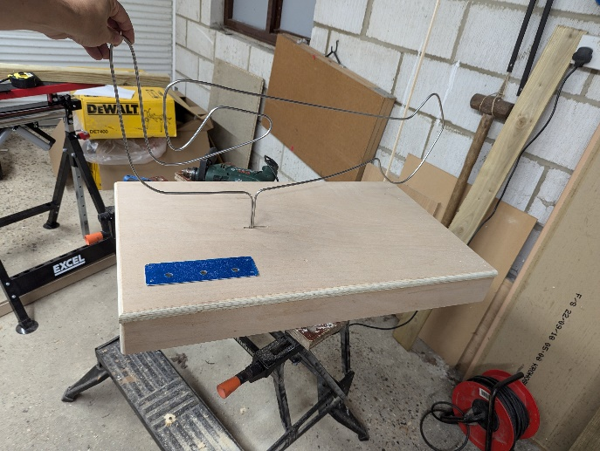
Some 30 Year Old Varnish | The Underneath
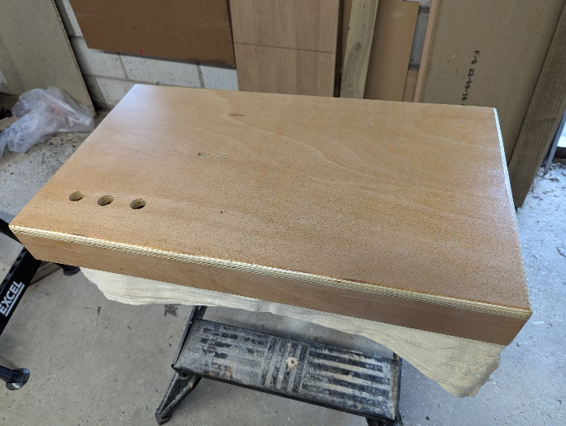 | 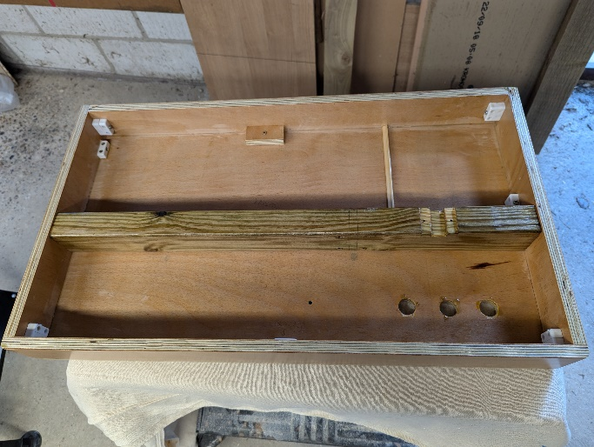

Button Panel | Assembled Components
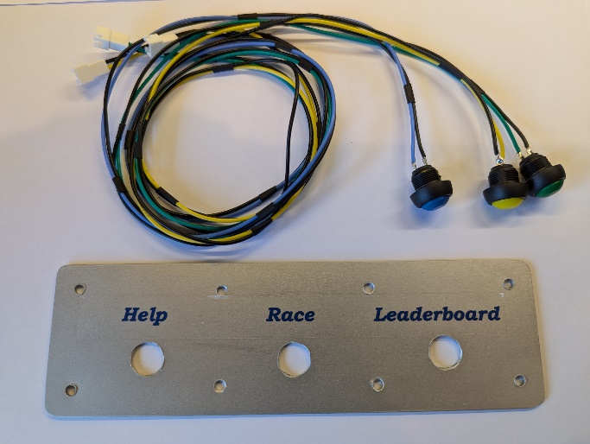 | 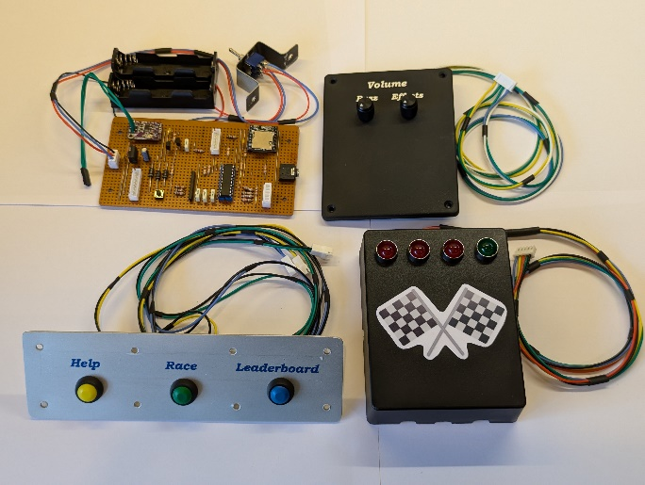
Testing Australian Style | The Piston Cup Trophy
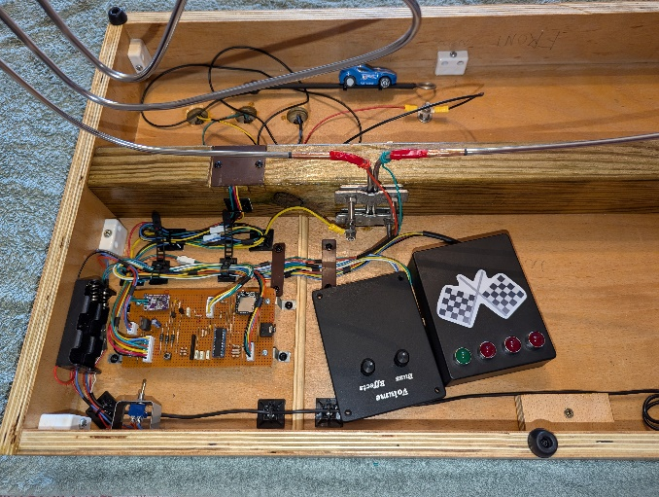 | 
A Look From The Top | A Look Underneath
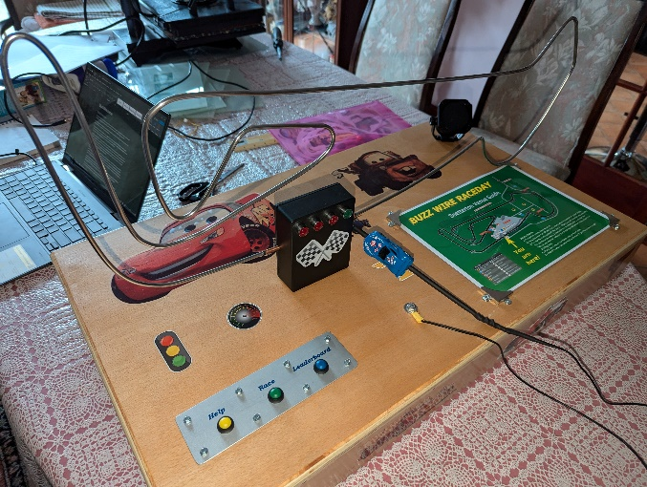 | 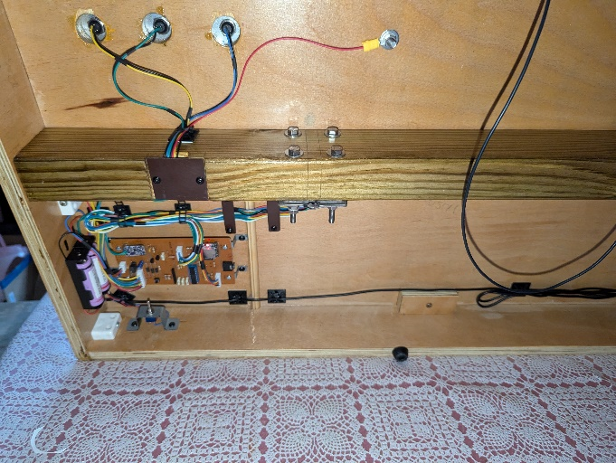

It’s Finished!
(Until another 22 tracks were added!)
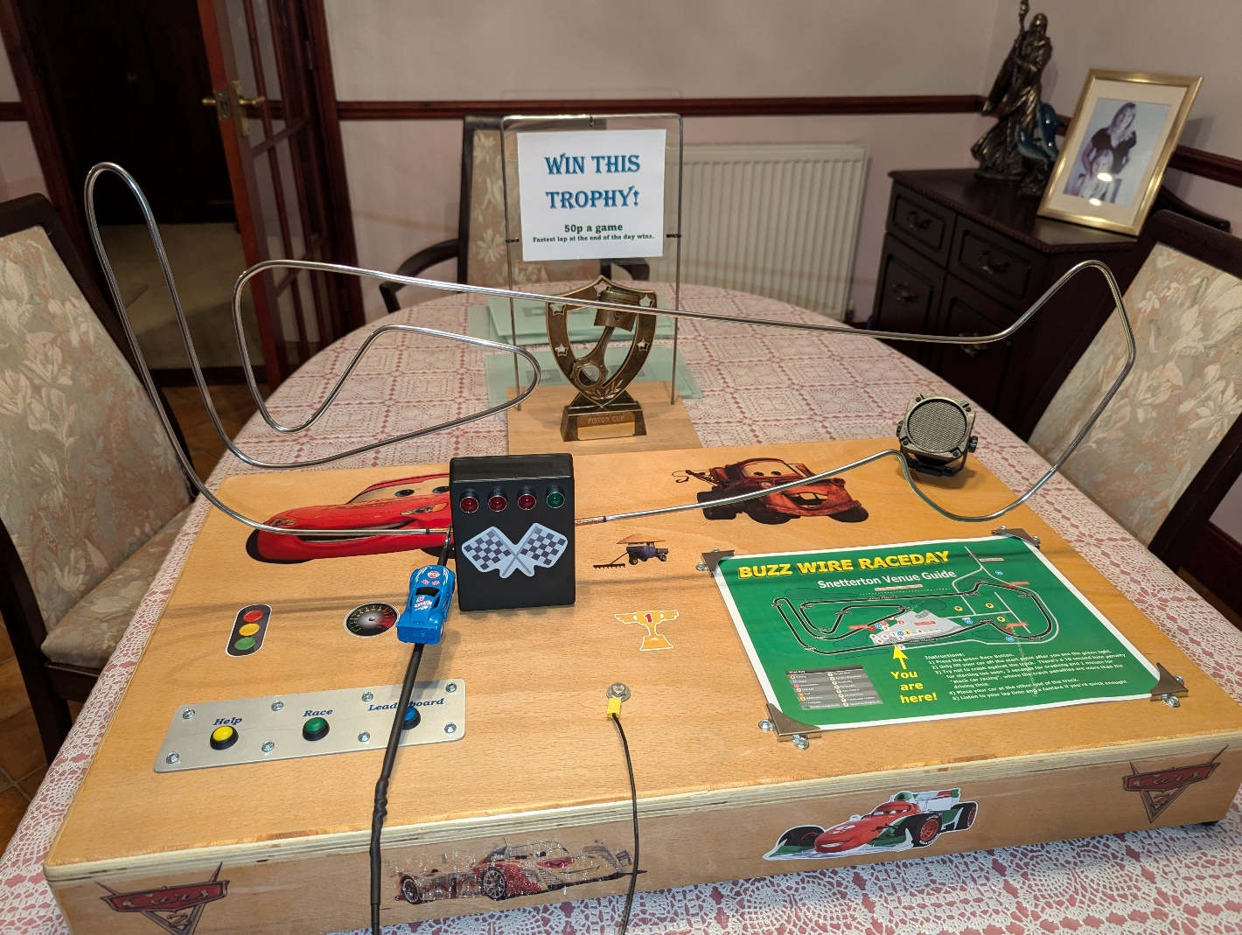

The Circuit Diagram
The Electronics Schematic was produced in KiCad and the connectivity of all components was exported as a “netlist”, so that the circuit board design could be produced in VeroRoute.
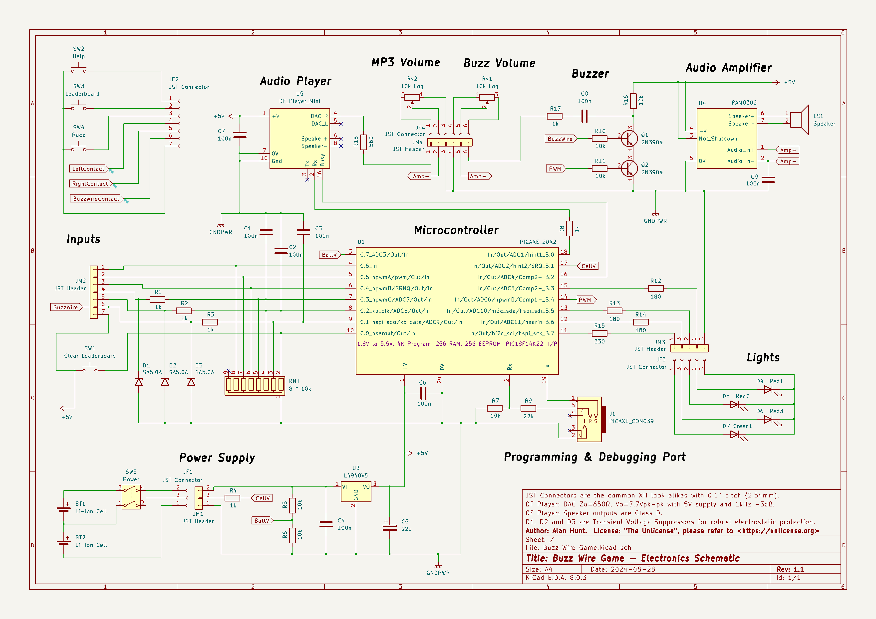

Circuit Board
The game uses a type of circuit board, which is referred to as “Stripboard” these days. It has holes 0.1” apart, which early electronic chips used and this size spacing is still common today. The board has copper strips, which are easy to visualise and connect components together. Components are passed through the holes and soldered to the copper strips. Where you want to isolate components a hole is cut in the copper strip.
Some of the components I used are over 40 years old, from when I first played with electronics. These days it’s increasingly hard to use this type of layout because components are miniaturised to tiny sizes and then surface mounted on printed circuit boards.
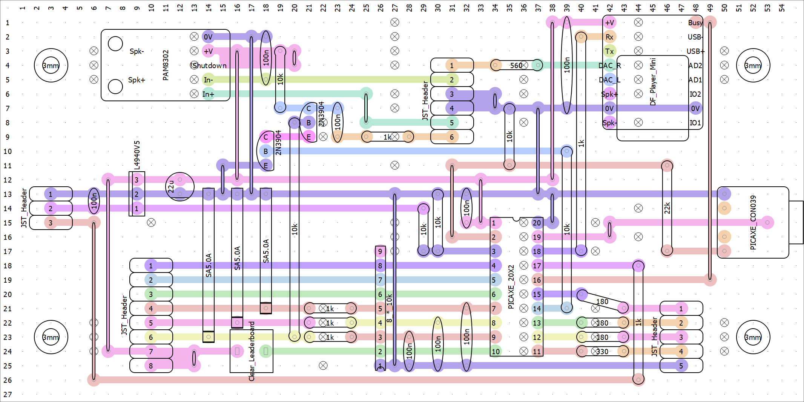

Detailed Features
The game was going to be used in a charity event with a prize attached. So, for the first time ever, I created a list of detailed features for testing. This helped to perform a final code review in addition to identifying test cases. It’s challenging to test all the program states of the microcontroller, so both steps proved worthwhile. As a bonus the list helps to describe the game’s features too:
- Initialisation, Battery Checks and Program Updates:
  - The game tells you when it’s powered on or restarted.
  - The battery voltage is checked at restart and between idle tracks.
  - If either of the 2 battery cells are nearly exhausted (below 3,000mV) a warning will be spoken and the game will shut down into a low power state to prevent over discharge. If either cell is low (below 3,300mV) then a warning will be spoken between sound tracks when the game is idle, or directly after a game has finished, then the game continues as normal.
  - The Reset Button only works during a restart and it clears the games stats.
  - Program updates do not clear the game stats.
  - After a restart the previous number of games is spoken and if games have been played the lap record is spoken.
  - After a restart the handle must be placed at a starting position, if not it will speak a warning every 3 seconds before proceeding.
- When the game is waiting to be played:
  - Background music with a driving or fun theme is always played. There are several soundtracks played in a loop.
  - Every 90 seconds an advert is played to encourage game play. These adverts play in a loop:
    - “Roll-up, roll-up! It's only 50p a game. Have some fun and a chance to win the coveted Piston Cup Trophy!”
    - “Most racing car legends start their careers with BUZZ WIRE RACING! It's not too late to start now, so give it a try!”
    - “Here is an important announcement: It's championship race day here at Snetterton. Get the fastest lap of the day and get that darn tooting trophy!”
    - “Please, please, PLEASE have a game. I'm processing 4 million lines of code a second, so I'm kind of getting bored over here! “
    - “Hey you! Yes you! Do you want some fun? It's a mere 50p for a chance to become a racing car legend!”
    - “Come on, have a game! I promise you won't EVEN kill yourself if you crash.”
    - “This game has a special 2 for 1 offer! You have some FUN! And your money will go to restoring the Village Sign TOO!”
    - “Is there no one else! Is there no one else!”, a Brad Pitt extract from Troy.
- Starting a practise:
  - If the handle is raised from either start point without pressing the Race Button first, then a practise session is assumed. “Having a practise hey! There's no lap time for you.” is spoken, but other sound effects of a real game are still played.
  - When the handle is returned to either endpoint, “Practise over and ready to race! Press the green button next time!” is played.
- Starting a race:
  - Pressing the Race Button only functions when the game is in idle mode, or while the help information is being spoken.
  - The game is bidirectional and can be started at either start point, even if there’s been a practise and the previous race endpoint is changed.
  - After pressing the Race Button a coin drop effect is played, then the player number is incremented and spoken, then starting beeps and the LED sequence (Red 1, Red 1 and 2, Red 1, 2 and 3, and then Green only) are synced to run in parallel.
  - To allow for an accidental wiggle of the handle, the handle can lose contact with the start point for up to 100mS before a premature start is determined.
  - If the player starts before the green light a 10 second penalty is created and a message “Time penalty! Started too soon!” is played.
- During a race:
  - Race themed background music starts with the game. There are several soundtracks in a loop and the next track is played if a game is started, or if a track finishes during a game.
  - The player gets some feedback:
    - The audio clip “Taking it slow huh. I can respect that” is played after 10 seconds if crash count is zero, or after 30 seconds if crash count is less than 2.
    - The audio clip “Slow down!” is played after 10 seconds if crash count is more than 2, or after 30 seconds if crash count is more than 5.
    - “You've been playing a while now, if there's someone waiting let them have a go to” is spoken after 90 seconds.
  - Whenever the handle touches the buzz wire:
    - There’s a buzz tone.
    - The background sound is interrupted with a crash sound effect, the sound effect changes each time and ultimately loops.
    - There’s a 3 second penalty, which is repeated in 0.5 seconds unless the handle is free from the buzz wire.
- Cancelling the race:
  - If the handle is returned to the start point during a race, then the race is cancelled and the next race will use the same player number. To debounce any handle wobbles during the race start phase, this event won’t be acknowledged until at least 2 seconds after the normal race start, or a premature race start.
  - Then “Going back huh. I would have done the same” and “Press the Race Button to start again!” are spoken.
- Finishing the race:
  - If the handle touches the finish point:
    - The green race light goes out and the log of player numbers is incremented and stored permanently.
    - “You’ve finished!” is spoken.
    - If the total crash penalty time is higher than the driving time an audio clip “Slow down stop the insanity!” is played and a cartoon voice states “You spent more time crashing than racing!” and a normal voice states “A 1-minute penalty is added for stock car racing!”.
    - If the player’s adjusted lap time is not quick enough for a leaderboard entry then “Aarh you just missed out on the leaderboard! Have another try!” is spoken.
    - If the player’s adjusted lap time achieves a leaderboard ranking their player number and lap time is inserted in the permanent memory of the leaderboard. All lower positions are shuffled downwards and eventually out of the leaderboard, which is limited to 20 places.
    - If the player is ranked 1st the audio clip “A new record!” is played. If this isn’t the 1st player, then 1 of 4 random victory audio clips is played.
    - If the player achieves a leaderboard ranking that is less than half the number of games played, the announcement “Here's a musical tribute just for you!” is spoken. A short fanfare is then played from a loop of tracks. Then a voice states their position on the leaderboard.
    - If the crash count is zero then “No crashes. That's amazing for this crowd!” is spoken. If it’s not a lap record the audio clip “Wow all I can say is wow!” is played.
    - If the crash count is greater than 9 “Unfortunately the car is a right off” is spoken.
    - If there were any crashes, a voice states the number of crashes and how much time each crash cost.
    - Then the lap time is spoken in seconds to 1 decimal place.
    - Then “Waiting for next player!” is spoken and the game returns to idle/waiting mode.
- Help Button:
  - The help button only functions when the game is in idle mode, waiting to be played.
  - This soundtrack is spoken: “This is a souped-up buzz wire game! The idea of this game is to get your race car around a lap of the racetrack as quickly as possible. If the car touches the metal tube you'll hear the car crashing, your parents worrying about the repair bill and most importantly time will be added to your lap of the race! To start a race, press the green button and wait for the green light. All you have to do is lift your car up and place it down at the other end of the track. The game will tell you your lap time and whether you've set a record for the day. Take it in turns to play. Have fun and Good luck!”.
  - As an admin function, if the Help Button is held down and the Leaderboard Button pressed then the battery cell voltages will be spoken.
- Speaking the Leaderboard:
  - The Leaderboard Button only functions when the game is in idle mode, or while the help information is being spoken.
  - If any games have been played an announcement starts with “The top N positions are”, where N is the number of games played up to the maximum of 4.
  - Then from 1st to 4th place: the place, player number and lap time in tenths of a second are spoken.
  - If the number of games is more than 4 the number of games played is spoken.
  - Then “Press the green race button to beat them!” is played.

The Program
Written in PICAXE BASIC, the program occupies 4,072 bytes of the 4,096 available on the 20X2 microcontroller. As more functionality, like the Leaderboard, was added some memory had to be saved by reducing the debug logging.
The program is organized into the following regions to improve quality:
- Program Notes
- Compiler Directives
- Resources
  - Pins
  - Variables
  - Constants
  - Utilities
- Initialisation
- Main:
- Interrupt:
- Subroutines

Four software modules were written for the game, these are intended to be re-useable utilities for future projects:
- "Debug_Terminal.basinc" helps to easily display status information to a computer screen while the program is running.
- "Timing.basinc" sets the processor clock rate and provides timing functions regardless of the clock rate.
- "DF_Player_Mini.basinc" provides functions to easily control sound output from a DF Player Mini audio module mounted on the circuit board.
- "Voltage.basinc" calculates the chip supply voltage and the input voltage levels of the battery cells.

Program Listing – “Buzz_Wire_Race.bas”

#Region "Program Notes"
#REM

File: "Buzz_Wire_Race.bas"
License: MIT (See end of file)
Change History: 2024/10/27 by Alan Hunt - 1st issue.

Microcontroller Pin Usage
==========================

Pin Usage PICAXE 20X2 Pinout & Functions Pin Usage
-------------------------------------------------------------------
+5V Supply |1 Vdd Gnd 20| 0V Supply
Programming Input |2 Serial In Serial out 19| Debugging Output
BATTERY (ADC3 VoltageBatt) |3 C.7(ADC3/Out/In) B.0(In/Out/ADC1/hint1) 18| AUDIO_TX (to DF Player @T9600)
HelpButton |4 C.6(In) B.1(In/Out/ADC2/hint1/SRQ) 17| CELL (ADC2 for Cell 1 voltage)
LeaderboardButton |5 C.5(hpwmA/pvmC.5/Out/In) B.2(In/Out/ADC4/Comp2+) 16| AUDIO_STATUS (DF Player active low)
RaceButton |6 C.4(hwpmB/SRNQ/Out/In) B.3(In/Out/ADC5/Comp2-) 15| LED_RED1 (1st "Get Ready")
InputPosL (Left Start Point) |7 C.3(hwpmC/ADC7/Out/In) B.4(In/Out/ADC6/hpwmD/Comp1-) 14| PWM_BUZZ (Tone for Buzz Wire)
InputPosR (Right Start Point) |8 C.2(kbclk/ADC8/Out/In) B.5(In/Out/ADC10/hi2csda/hspisdi) 13| LED_RED2 (2nd "Get Ready")
InputBuzz (Buzz Wire) |9 C.1(hspisdo/kbdata/ADC9/Out/In) B.6(In/Out/ADC11/hserin) 12| LED_RED3 (3rd "Get Ready")
RESET_BUTTON |10 C.0(hserout/Out/In) B.7(In/Out/hi2cscl/hspisck) 11| LED_Green(Race "Go" light)
-------------------------------------------------------------------

PICAXE 20X2 Notes
=================
* Chip hardware is the Microchip PIC18F14K22 MCU:
- Power supply 1.8V to 5.5V. Default clock 8MHz.
- Pullup and pulldown input currents measured respectively as 1.5nA and 300pA on B.1 when set as a digital input.
- When an ADC channel is enabled it draws approximately 280 uA and the recommended source impedance is 10 kOhm.
- Input over/under voltage protection has a maximum clamp current of 20mA.

Program Notes
=============
* The game has 7 digital inputs monitored on Port C. Five of the inputs are monitored by software interrupts with "setint" (Only c.1 to c.5 permitted for 20M2 and 20X2). The symbol "getInputs" (pinsC) is used to read PortC simultaneously and place it in the symbol "GameInputs" (variable b3). Then bits of b3 are used to check specific inputs, like InputBuzz(bit25).
* Clock rate was set to 16MHz but it's not necessary. It probably helps to speed up inputs, particularly as I left debugging on for show.
* Timer3 word value is set to increment every 131 mS (Prescale8:1 * 65536 * 4 / Clock), so very roughly divide 8 to get seconds.

#EndREM
#EndRegion

#Region "Main Compiler Directives"
'Compiler Directives
#picaxe 20X2
#no_data
#no_table
#no_debug
#define Debugger_On 'Comment out this line to disable Debugging.

#Endregion

#Region "Resources"
'Pins
symbol AUDIO_TX = B.0 '@DF_Player_Mini.basinc: Serial Tx to audio module via 1K resistor.
symbol CELL1 = pinB.1 '@Voltage.basinc: Cell 1 voltage monitoring is ADC2(B.1).
symbol AUDIO_STATUS = pinB.2 '@DF_Player_Mini.basinc: Busy is active low after time lag (AUDIO_IDLE and AUDIO_BUSY).
symbol LED_RED1 = B.3 '1st track light.
symbol PWM_BUZZ = B.4 'Tone for Buzz Wire.
symbol LED_RED2 = B.5 '2nd track light.
symbol LED_RED3 = B.6 '3rd track light.
symbol LED_GREEN = B.7 '4th "go" and running track light.
symbol RESET_BUTTON = pinC.0 'Circuit board button to clear game stats if pressed during initialisation.
symbol HELP_BUTTON = pinC.6 'Button to explain game.
symbol BATTERY = pinC.7 '@Voltage.basinc: Battery voltage monitoring is ADC3(C.7).

'Variables
symbol GameTime = timer 'Alias for the system "timer", measures elapsed game/idle time time in tenths of a second.
symbol UpTime = timer3 'Alias for "timer3", used for random number generation and uptime in 8th's of a second.

symbol _Debugger = b0 '"Debugger.basinc" module is limited to using b0 for Byte to ASCII bitstream conversion.

symbol InterruptSetting = b1 'Interrupt setting for input pins.
symbol IntSetBuzz = bit9
symbol IntSetPosR = bit10
symbol IntSetPosL = bit11
symbol IntSetRace = bit12
symbol IntSetLeaderboard = bit13

symbol InterruptMask = b2 'Interrupt mask for input pins.
symbol IntMaskBuzz = bit17
symbol IntMaskPosR = bit18
symbol IntMaskPosL = bit19
symbol IntMaskRace = bit20
symbol IntMaskLeaderBoard = bit21

symbol GameInputs = b3 'Game inputs on PortC with quick byte getter "getInputs" and bit checkers in b3.
symbol getInputs = pinsC
symbol InputBuzz = bit25
symbol InputPosR = bit26
symbol InputPosL = bit27
symbol RaceButton = bit28
symbol LeaderboardButton = bit29
symbol HelpButton = bit30

symbol GameStatus = b4 'Game Status has enumerated state constants
symbol GameDirection = b5

symbol SoundLoopIdle = b6 'Pointer for a list of tracks played when no game is running.
symbol SoundLoopBackground = b7 'Pointer for a list of tracks played as background music during the game.
symbol SoundLoopCrash = b8 'Pointer for a list of crash sounds that interupt the background music.
symbol SoundLoopFanfare = b9 'Pointer for a list of tracks played at the end of a game.
symbol SoundLoopAdvert = b10 'Pointer for a list of adverts played when the game is idle for too long.

symbol CrashCount = b11
symbol LapTime = w6 'Time in tenths of a second.
symbol PenaltyTime = w7 'Time added, in tenths, for a premature race start.

symbol LapRecord = w8
symbol PlayerNumber = w9
symbol PlayerRanking = b20

symbol GameTimerLog = b21
symbol GameTimer1 = w11
symbol GameTimer2 = w12
symbol GameTimer3 = w13

symbol VoltsCell2 = w14
symbol VoltsCell1 = w15
symbol BatteryCapacity = b32

'Internal variables for gosubs (Try and keep these unique due to ease Interrupt handling)
symbol _LeaderBoard_ResultPTR = b33 'For Gosub PlayerRank only.
symbol _LeaderBoard_TimePTR = b34 'For Gosubs PlayerRank and SayLeaderboard.
symbol _LeaderBoard_PlayerPTR = b35 'For Gosubs PlayerRank and SayLeaderboard.
symbol _GameEndW = w18 'For Gosub GameEnd only.
symbol _LeaderBoardW = w19 'For Gosubs PlayerRank and SayLeaderboard.
symbol _LeaderBoardB = b40 'For Gosubs PlayerRank and SayLeaderboard.

'@DF_Player_Mini.basinc Variables
symbol _Timing = w21 'Assign symbol to any spare Word.

'@DF_Player_Mini.basinc Variables
symbol _Audio_Digit = b41 'Assign symbol to any spare Byte.
symbol _Audio_Integer = w22 'Assign symbol to any spare Word.
symbol _Audio_Fraction = w23 'Assign symbol to any spare Word.
symbol _Audio_Track = b48 'Assign symbol to any spare Byte.
symbol _Audio_Byte = b49 'Assign symbol to any spare Byte.

'@Voltage.basinc Variables
symbol Voltage_Vdd = w25 'Assign symbol to any spare Word. Stores PICAXE supply voltage as mV.
symbol _VoltageADCval = w26 'Assign symbol to any spare Word.
symbol _VoltageModulus = w27 'Assign symbol to any spare Word.

'Constants
'For interrupts
symbol VAL_DEFAULT = %00000000 'Interrupt value default
symbol MASK_DEFAULT = %00111110 'Interrupt mask default
symbol NOT_MASK_DEFAULT = %11000001
symbol CONTACT = 1 'Logic level for contact with buzz wire or end points.
symbol NO_CONTACT = 0
symbol PRESSED = 1 'Logic level for button press.
symbol NOT_PRESSED = 0

'For GameStatus variable
symbol GAME_NOT_SET = 0 'Not at a valid start point.
symbol GAME_WAITING = 1 'At a valid start point and waiting for Race or practise.
symbol GAME_BEGINNING = 2 'Race button pressed.
symbol GAME_NOT_STARTED = 3 'Race Go signal was given but not moved off yet.
symbol GAME_PLAYING = 4
symbol GAME_ENDING = 5 'Reached end point and stating performance.
symbol GAME_PRACTISE = 6 'Moved off without pressing Race button.

'For GameDirection variable
symbol R_TO_L = 1
symbol L_TO_R = 2

'For Penalty time (tenths of a second)
symbol PENALTY_PREMATURE_START = 100
symbol PENALTY_CRASH = 30

'Initialise Variables
symbol SOUND_IDLE_START = 177 'MP3 177 to 215 play backgound music when no game is running.
symbol SOUND_IDLE_END = 215
symbol SOUND_BACKGROUND_START = 218 'MP3 218 to 238 play background music during the game.
symbol SOUND_BACKGROUND_END = 238
symbol SOUND_FANFARE_START = 250 'MP3 250 to 254 play different game endings for leaderboard entries.
symbol SOUND_FANFARE_END = 254
symbol SOUND_CRASH_START = 1 'ADVERT 1 to 8 play crash sounds that interupt the background music.
symbol SOUND_CRASH_END = 8
symbol SOUND_ADVERT_START = 15 'ADVERT 15 to 22 interuppt idle music to encourage game playing.
symbol SOUND_ADVERT_END = 22

'Timer Values (tenths of a second)
symbol GAME_TIME1 = 100 'Some encouragement after 10S, or quit a failed race start.
symbol GAME_TIME2 = 300 'Some encouragement after 30S.
symbol GAME_TIME3 = 900 'Suggest you let someone else play after 90S.
symbol IDLE_TIMER = 900 'Play an advert to encourage playing every 90S.

'For EEPROM storage locations
symbol aGAME_COUNT = 2
symbol LEADERBOARD_SIZE = 20 'Limited to 20 to make speaking nth's easier.
symbol aLEADERBOARD_PLAYER = 30 'The Leaderboard player numbers occupy EEPROM addresses from here.
symbol aLEADERBOARD_PLAYER_END = 68 'Player numbers are stored as words, the last byte used is this plus 1.
symbol aLEADERBOARD_TIME = 70 'Laptimes are stored as words from here.
symbol aLEADERBOARD_TIME_END = 108 'The last byte is this +1.
symbol LEADERBOARD_SPOKEN_SIZE = 4 'Number of entries spoken after LEADERBOARD_BUTTON pressed (limited to 4 by track 120).

'For Battery Monitoring (Voltage in mV)
symbol VOLTS_CELL_GOOD = 3400 'A li-ion Samsung INR18650-30Q with constant 200mA load was tested to be about 18% at 3400 mV.
symbol VOLTS_CELL_EXHAUSTED = 3100 'The battery spec is 2.5V cut-off but tested down to 2.8V, this gave about 6% at 3100 mV.
'Caution: Figures change drastically for 3.0V cut-off cells, or high current loads.

'@Timing.basinc Constants
'CLOCK_SET_KHZ options: 31,250,500,1000,2000,4000,8000,16000,32000,or 64000 (Dependenton chip). No equals sign and nothing after number.
#define CLOCK_SET_KHZ 16000
#define TIMER_IN_HUNDRETHS 10

'@DF_Player_Mini.basinc Constants
symbol AUDIO_VOLUME = 31 '0 to 31(Maximum).
symbol AUDIO_BAUD = T9600_16 'Tx is idle high (T) and 9600 bps, the last characters you adjust to your clock speed.
symbol AUDIO_ACTIVE = 0 'The AUDIO_STATUS pin is active low, indicating audio playing.
symbol AUDIO_IDLE = 1 'AUDIO_STATUS high indicates the module is idle, or seeking to play a track on the disk.

'@Voltage_X2.basinc Constant
symbol VoltageDividend = 10595 'Adjust value for FVR inaccuracy, see "Voltage_X2.basinc" Calibration.

'Modules
#include "Debugger.basinc"
#include "Timing.basinc"
#include "DF_Player_Mini.basinc"
#include "Voltage_X2.basinc"
#Endregion

#Region "Programme Initialisation"
Init:
if PenaltyTime = PENALTY_PREMATURE_START then goto Main 'A premature start causes a Run 0

Pause1S 'Allows PICAXE Editor time to open the terminal window.
DebugLine(ppp_filename) 'Displays the programming filename in PICAXE Editor Terminal if "Debugger_On" is defined.
DebugLine(ppp_datetime) 'Displays the programming date and time.

'Setup Pins
dirsB = %11111001 'Set port B7 to B0 pins (1=output).
dirsC = %00000000 'Ensure all C pins are inputs.
adcsetup = %0000000000000110 'Use ADC3(Pin 3, C.7) and ADC2 (Pin 17, B.1), this disables digital interface circuitry.
hpwm PWMDIV16, 0, 0, %1000, 255, 511 'Use PWM to produce lowest tone possible for a potential buzz wire contact sound.

'Setup Timers
tmr3setup %10110001 'Enables timer3 to generate randomness and for approx timing (8 per Sec, see notes).

'Initialise Variables
SoundLoopIdle = SOUND_IDLE_START 'MP3 150 to 172 play background music when no game is running.
SoundLoopBackground = SOUND_BACKGROUND_START 'MP3 200 to 212 play background music during the game.
SoundLoopCrash = SOUND_CRASH_START 'ADVERT 1 to 9 play crash sounds that interupt the background music.
SoundLoopFanfare = SOUND_FANFARE_START 'MP3 250 to 254 play different game endings.
SoundLoopAdvert = SOUND_ADVERT_START 'ADVERT 15 to 21 to encourage play when idle too long.

GameTimer1 = GAME_TIME1 'Some encouragement after 10S, or quit a failed race start.
GameTimer2 = GAME_TIME2 'Some encouragement after 30S.
GameTimer3 = GAME_TIME3 'Suggest you let someone else play after 90S.

'Initialise Audio Module and check battery
gosub AudioInitialise
PlayMP3(063,"Restarted") 'Play "The system has restarted"
gosub CheckBattery

'Reset game records during startup if necessary
if RESET_BUTTON = PRESSED then
DebugLine("@Reset Stats")
PlayerNumber = 0
write aGAME_COUNT, WORD PlayerNumber
LapRecord = 0
for PlayerRanking = aLEADERBOARD_Player to aLEADERBOARD_TIME_END step 2
write PlayerRanking, WORD PlayerNumber
next PlayerRanking
PlayMP3(0145,"game stats reset")
gosub AudioWaitForIdle
endif

'Speak the game stats
gosub SayGamesPlayed
gosub SayLapRecord

'Ensure the car is at one end of the track and prepare interrupt settings
gosub GameGetReady
InterruptSetting = VAL_DEFAULT
InterruptMask = MASK_DEFAULT

'Confirm Initialisation
PlayMP3(0151," Hello the game is ready")
PlayMP3(0133," Press Help or start now")
DebugLine("@Initialised")
debug 'Display values in PICAXE Editor unless "no_debug" is defined.

#Endregion

#Region "Main"
Main:
'Contiunally loop around Main to see if music has ended or GameTimers have expired.
setint NOT InterruptSetting, InterruptMask 'Set interupts for low state on C1 to C5 (BuzzWire, PosR, PosL, Race and Leaderboard)

'Check if the audio has finished playing.
if AUDIO_STATUS = AUDIO_IDLE then
DebugLine("@Main Without Audio")
gosub DebugGameStatus
select case GameStatus
case GAME_NOT_SET
PlayNow(0134," Place car at 1 end of the track")
Pause10S
case GAME_WAITING
gosub CheckBattery
gosub AudioWaitForIdle
DebugOut("Play Idle ",#SoundLoopIdle,cr,lf)
PlayNow(SoundLoopIdle," IdleTrack") 'Play the next rotating idle track
inc SoundLoopIdle
if SoundLoopIdle > SOUND_IDLE_END then
SoundLoopIdle = SOUND_IDLE_START
endif
case GAME_NOT_STARTED, GAME_PLAYING, GAME_PRACTISE
DebugOut("Play Background ",#SoundLoopBackground,cr,lf)
PlayNow(SoundLoopBackground," GameTrack") 'Play the next rotating game track
inc SoundLoopBackground
if SoundLoopBackground > SOUND_BACKGROUND_END then
SoundLoopBackground = SOUND_BACKGROUND_START
end if
else
'Other values GAME_BEGINNING and GAME_ENDING are temporary and should not occur.
endselect
endif

'Check if timers have expired.
select case GameStatus
case GAME_WAITING
if GameTime > IDLE_TIMER then
PlayAdvert(SoundLoopAdvert,"Roll-up etc")
Gametime = 0
inc SoundLoopAdvert
if SoundLoopAdvert > SOUND_ADVERT_END then
SoundLoopAdvert = SOUND_ADVERT_START
endif
endif
if HELP_BUTTON = PRESSED then
DebugLine("Help Pressed")
GameTime = 0 'Reset the timer for encouragement adverts
PlayNow(0132," GameIntro")
gosub AudioWaitForIdle
endif
case GAME_BEGINNING
gosub GameBegin
case GAME_NOT_STARTED
'DebugOut("GameTime: ",#GameTime,cr,lf)
'DebugOut(", GameTimer1: ",#GameTimer1,cr,lf)
if GameTime > GameTimer1 then
DebugLine("Not started after 10S")
gosub GameQuit
PlayNow(0153, "Oh no it's nap time")
PlayMP3(0152, "Press the race button to start again")
gosub AudioWaitForIdle
endif
case GAME_PLAYING
select case GameTime
case > GameTimer1
if CrashCount = 0 then
PlayAdvert(11,"Too slow")
elseif CrashCount > 2 then
PlayAdvert(14, "Slow down")
endif
GameTimer1 = 65535
case > GameTimer2
if CrashCount < 2 then
PlayAdvert(11,"Too slow")
elseif CrashCount > 5 then
PlayAdvert(14, "Slow down")
endif
GameTimer2 = 65535
case > GameTimer3
PlayNow(0135, "You've been playing a while, let someone else too")
GameTimer3 = 65535
endselect
endselect

Pause10mS
goto Main

#Endregion

#Region "Interrupts"
Interrupt:
GameInputs = getInputs
DebugLine("@Interupt")
gosub DebugGameStatus
gosub DebugGameInputs

select case GameStatus
case GAME_NOT_SET
if InputPosL = CONTACT OR InputPosR = CONTACT then 'Car now placed correctly at one end of the track.
GameStatus = GAME_WAITING
if InputPosL = CONTACT then
GameDirection = L_TO_R
else
GameDirection = R_TO_L
endif
PlayNow(062," Thank you")
endif

case GAME_WAITING
if InputPosL = NO_CONTACT AND InputPosR = NO_CONTACT then 'Car moving without Race button, so it's a practise.
GameStatus = GAME_PRACTISE
SoundLoopCrash = SOUND_CRASH_START
CrashCount = 0
PlayNow(0147,"having a practise hey. There's no laptime for you")
endif
if LeaderboardButton = PRESSED then
if HelpButton = PRESSED then
gosub AudioClear
gosub CheckBattery 'If both pressed then state battery cell voltages
PlayNow(0070, "The cell voltages are")
AudioSpeakNumber(VoltsCell1)
PlayMP3(0130, "millivolts")
PlayMP3(0060, "and")
AudioSpeakNumber(VoltsCell2)
PlayMP3(0130, "millivolts")
else
gosub SayLeaderboard
endif
GameTime = 0 'Reset the timer for encouragement adverts
endif
if RaceButton = PRESSED then
GameStatus = GAME_BEGINNING
endif

case GAME_BEGINNING
if InputPosL = NO_CONTACT AND InputPosR = NO_CONTACT then 'Car moved too early while game still begining (before green light).
Pause100ms 'Pause a while to debounce a player wiggling the handle.
GameInputs = getInputs
if InputPosL = NO_CONTACT AND InputPosR = NO_CONTACT then 'Car is really moving too early, so start the game and log the penalty.
GameStatus = GAME_PLAYING
'DebugLine("Started too Soon")
PlayNow(0148,"Time penalty. Started too soon.")
low LED_RED1, LED_RED2, LED_RED3
high LED_GREEN
GameStatus = GAME_PLAYING
GameTimer1 = GAME_TIME1
GameTimer2 = GAME_TIME2
GameTimer3 = GAME_TIME3
SoundLoopCrash = SOUND_CRASH_START
CrashCount = 0
PenaltyTime = PENALTY_PREMATURE_START
GameTime = 0
IntSetPosL = InputPosL
IntSetPosR = InputPosR
IntSetBuzz = InputBuzz
run 0
endif
endif

case GAME_NOT_STARTED
if InputPosL = NO_CONTACT AND InputPosR = NO_CONTACT then 'Car moving correctly after given the green light.
DebugLine("Started OK")
GameStatus = GAME_PLAYING
endif

case GAME_PLAYING
if InputPosL = CONTACT then 'Car touching left end of the track.
if GameDirection = R_TO_L then
gosub GameEnd
else
if GameTime > 20 then 'debounce a return to start
PlayNow(0144," Going back huh")
PlayMP3(0152," Press the race button to start again")
gosub AudioWaitForIdle
gosub GameQuit
endif
endif
endif
if InputPosR = CONTACT then 'Car touching right end of the track.
if GameDirection = L_TO_R then
gosub GameEnd
else
if GameTime > 20 then 'debounce a return to start
PlayNow(0144," Going back huh")
PlayMP3(0152," Press the race button to start again")
gosub AudioWaitForIdle
gosub GameQuit
endif
endif
endif
if InputBuzz = CONTACT then 'Buzz wire contact
gosub GameCrash
endif

case GAME_PRACTISE
if InputPosL = CONTACT or InputPosR = CONTACT then 'Car finished practising on the track.
GameStatus = GAME_WAITING
if InputPosL = CONTACT then
GameDirection = L_TO_R
else
GameDirection = R_TO_L
endif
PlayNow(0150," Practise over, press green button")
endif
if InputBuzz = CONTACT then 'Buzz wire contact
gosub GameCrash
endif

endselect

IntSetPosL = InputPosL
IntSetPosR = InputPosR

gosub DebugGameStatus
DebugLine("@Interupt End")
setint NOT InterruptSetting, InterruptMask

return
#Endregion

#Region "Subroutine GameGetReady"
GameGetReady:
DebugLine("@GameGetReady")
GameInputs = getInputs
gosub DebugGameInputs

if InputPosL = NO_CONTACT and InputPosR = NO_CONTACT then
do until InputPosL = CONTACT or InputPosR = CONTACT 'Ensure car is at 1 end of the track
PlayMP3(0134,"Place car at 1 end of the track")
Pause3S
GameInputs = getInputs
loop

PlayNow(062," Thank you")
endif

if InputPosL = CONTACT then
GameDirection = L_TO_R
else
GameDirection = R_TO_L
end if

IntSetPosL = InputPosL
IntSetPosR = InputPosR

GameStatus = GAME_WAITING

return
#Endregion

#Region "Subroutine GameBegin"
GameBegin:
DebugLine("@GameBegin")
GameStatus = GAME_BEGINNING
read aGAME_COUNT, WORD PlayerNumber
inc PlayerNumber 'Don't flash the PlayerNumber increase until a successful end.

PlayNow(173," Arcade token")
PlayMP3(157," Player")
AudioSpeakNumber(PlayerNumber)
PlayMP3(174," Wait for the green light")
PlayMP3(175," Mario Kart beeps")

high LED_RED1
Pause1S
high LED_RED2
Pause1S
high LED_RED3
Pause1S
low LED_RED1, LED_RED2, LED_RED3
high LED_GREEN

GameStatus = GAME_NOT_STARTED
GameTimer1 = GAME_TIME1
GameTimer2 = GAME_TIME2
GameTimer3 = GAME_TIME3
SoundLoopCrash = SOUND_CRASH_START
CrashCount = 0
PenaltyTime = 0
GameTime = 0

return
#Endregion

#Region "Subroutine GameCrash"
GameCrash:
DebugLine("@GameCrash")
PlayAdvert(SoundLoopCrash, "Crash") 'There is a timed delay in PlayAdvert, which helps as a crash rate limiter.
if CrashCount < 255 then
inc CrashCount
inc SoundLoopCrash
if SoundLoopCrash > SOUND_CRASH_END then
SoundLoopCrash = SOUND_CRASH_START
endif
endif
DebugOut("CrashCount=",#CrashCount,cr,lf)
return
#Endregion

#Region "Subroutine GameQuit"
GameQuit:
DebugLine("@GameQuit")
low LED_RED1, LED_RED2, LED_RED3, LED_GREEN
gosub GameGetReady
GameTime = 0
return
#Endregion

#Region "Subroutine GameEnd"
GameEnd:
DebugLine("@GameEnd")

'Record Game and notify of GameEnd
GameStatus = GAME_ENDING
LapTime = GameTime
low LED_GREEN
gosub AudioClear
write aGAME_COUNT, WORD PlayerNumber
PlayNow(0136," You finished!")

'Add 1 minute penalty if crash time is greater than laptime.
_GameEndW = PENALTY_CRASH * CrashCount
if _GameEndW > Laptime then
PenaltyTime = PenaltyTime + 600
PlayMP3(246," Slow down stop the insanity!")
PlayMP3(155," 1 minute penalty because crashtime > laptime")
endif

'Calculate laptime and penalty time (measured in tenths of a second)
DebugOut("GameTime=", #Laptime)
DebugOut(", CrashTime=", #_GameEndW)
PenaltyTime = _GameEndW + PenaltyTime
LapTime = LapTime + PenaltyTime
DebugOut(", Adjusted=",#LapTime,cr,lf)

'Leaderboard ranking and associated messages.
gosub PlayerRank
select case PlayerRanking
case 0
PlayMP3(0170," Ah you just missed out on the leaderboard, have another try!")
case 1
LapRecord = LapTime
PlayMP3(0149," New lap record")
_GameEndW = UpTime % 4
_GameEndW = _GameEndW + 240
PlayMP3(_GameEndW," Winners track")
gosub PlayFanfare
else
gosub PlayFanfare
endselect

'Speak about crashes
if CrashCount = 0 then
PlayMP3(0142," No crashes!")
if LapTime <> LapRecord then
PlayMP3(0247," Wow all I can say is wow!")
endif
PlayMP3(0137," Your time was")
else
if CrashCount > 9 then
PlayMP3(0143," The car is a right off.")
endif

PlayMP3(0140," You crashed")
AudioSpeakNumber(CrashCount)
PlayMP3(0141," times & each cost")'
AudioSpeakNumber(PENALTY_CRASH/10)
PlayMP3(0083," seconds")
PlayMP3(154," Your adjusted time was")
endif

'Speak the laptime seconds
AudioSpeakTenths(LapTime)
PlayMP3(0083," seconds")

If PlayerRanking <> 1 then gosub SayLapRecord

gosub GameQuit
PlayMP3(0156," Waiting for next player!")

return
#Endregion

#Region "Subroutine SayGamesPlayed"
SayGamesPlayed:
read aGAME_COUNT, WORD PlayerNumber
DebugOut("@SayGamesPlayed: ",#PlayerNumber,cr,lf)
PlayMP3(0138," There have been")
AudioSpeakNumber(PlayerNumber)
PlayMP3(0139," games")
return
#Endregion

#Region "Subroutine SayLeaderboard"
SayLeaderBoard:
read aGAME_COUNT, WORD PlayerNumber
DebugLine("@SayLeaderBoard")
if PlayerNumber = 0 then
'@No games yet
gosub AudioClear
gosub sayGamesPlayed
else
'@Speak Leaderboard
PlayNow(0158, "The top")
If PlayerNumber > LEADERBOARD_SPOKEN_SIZE then
PlayMP3(LEADERBOARD_SPOKEN_SIZE, "{n}")
else
PlayMP3(PlayerNumber, "{n}")
endif
PlayMP3(0159," leaderboard positions are:")
_LeaderBoard_PlayerPTR = aLEADERBOARD_PLAYER
_LeaderBoard_TimePTR = aLEADERBOARD_TIME
_LeaderBoard_ResultPTR = 0
do
read _LeaderBoard_PlayerPTR, WORD _LeaderBoardW
if _LeaderBoardW = 0 then exit 'Quit leaderboard if the entry isn't filled yet.

_LeaderBoardB = 160 + _LeaderBoard_ResultPTR 'Track 0160 to 0163 is "1st place" to "4th place".
PlayMP3(_LeaderBoardB," {nth} place is")
PlayMP3(0157," Player")
AudioSpeakNumber(_LeaderBoardW)

read _LeaderBoard_TimePTR, WORD _LeaderBoardW
PlayMP3(0164," with laptime")
AudioSpeakTenths(_LeaderBoardW)
PlayMP3(0083," seconds")

inc _LeaderBoard_ResultPTR
_LeaderBoard_PlayerPTR = _LeaderBoard_PlayerPTR + 2
_LeaderBoard_TimePTR = _LeaderBoard_TimePTR + 2

loop until _LeaderBoard_ResultPTR = LEADERBOARD_SPOKEN_SIZE 'Only speak the first n entries.

if PlayerNumber > LEADERBOARD_SPOKEN_SIZE then gosub sayGamesPlayed 'Speak game count if more records.
PlayMP3(0165, "Press green button to beat them")
endif
GameTime = 0
return
#Endregion

#Region "Subroutine SayLapRecord"
SayLapRecord:
read aLEADERBOARD_TIME, WORD LapRecord
DebugOut("@SayLapRecord: ",#LapRecord,cr,lf)
if LapRecord > 0 then
PlayMP3(0146," The lap record is")
AudioSpeakTenths(LapRecord)
PlayMP3(0083," seconds")
endif
return
#Endregion

#Region "Subroutine PlayFanfare"
PlayFanfare:
PlayMP3(0166, "Congratulations you are")
_GameEndW = 32 + PlayerRanking
PlayMP3(_GameEndW, "nth")
PlayMP3(0167, "on the leaderboard")
_GameEndW = PlayerNumber / 2
if PlayerRanking <= _GameEndW then
PlayMP3(168," Musical tribute just for you.")
PlayMP3(SoundLoopFanfare," Fanfare")
inc SoundLoopFanfare
if SoundLoopFanfare > SOUND_FANFARE_END then
SoundLoopFanfare = SOUND_FANFARE_START
endif
endif
return
#Endregion

#Region "Subroutine PlayerRank"
PlayerRank:
'DebugLine("@PlayerRank")

'@Work down the leaderboard to determine ranking from the 1st beaten or blank time entry.
_LeaderBoard_ResultPTR = aLEADERBOARD_TIME
do
read _LeaderBoard_ResultPTR, WORD _LeaderBoardW
if _LeaderBoardW = 0 OR LapTime < _LeaderBoardW then exit
inc _LeaderBoard_ResultPTR
inc _LeaderBoard_ResultPTR
loop until _LeaderBoard_ResultPTR > aLEADERBOARD_TIME_END

'@Chose action based on ranking.
select case _LeaderBoard_ResultPTR
case = aLEADERBOARD_TIME_END
'@Last entry on the leaderboard.
PlayerRanking = aLEADERBOARD_TIME_END - aLEADERBOARD_TIME / 2 + 1
write aLEADERBOARD_PLAYER_END, WORD PlayerNumber
write aLEADERBOARD_TIME_END, WORD LapTime
'DebugOut("RankLast=",#PlayerRanking,cr,lf)
case > aLEADERBOARD_TIME_END
'@Not on the leaderboard.
PlayerRanking = 0
'DebugLine("Rank=None")
return
else
'@Other placing on the leaderboard.
PlayerRanking = _LeaderBoard_ResultPTR - aLEADERBOARD_TIME / 2 + 1
'DebugOut("RankElse=",#PlayerRanking,cr,lf)

'@Work up the leaderboard to shuffle slower entries down.
_LeaderBoard_PlayerPTR = aLEADERBOARD_PLAYER_END - 2
_LeaderBoard_TimePTR = aLEADERBOARD_TIME_END - 2
do
'Move time entry down
read _LeaderBoard_TimePTR, WORD _LeaderBoardW
_LeaderBoard_TimePTR = _LeaderBoard_TimePTR + 2
write _LeaderBoard_TimePTR, WORD _LeaderBoardW
_LeaderBoard_TimePTR = _LeaderBoard_TimePTR - 4

'Move player entry down
read _LeaderBoard_PlayerPTR, WORD _LeaderBoardW
_LeaderBoard_PlayerPTR = _LeaderBoard_PlayerPTR + 2
write _LeaderBoard_PlayerPTR, WORD _LeaderBoardW
_LeaderBoard_PlayerPTR = _LeaderBoard_PlayerPTR - 4

loop until _LeaderBoard_TimePTR < _LeaderBoard_ResultPTR

'@Insert new leaderboard entry
_LeaderBoard_PlayerPTR = _LeaderBoard_PlayerPTR + 2
write _LeaderBoard_PlayerPTR, WORD PlayerNumber
_LeaderBoard_TimePTR = _LeaderBoard_TimePTR + 2
write _LeaderBoard_TimePTR, WORD LapTime
endselect
'DebugOut("Rank=",#PlayerRanking,cr,lf)
#rem'For Debug output only:
for _LeaderBoard_PlayerPTR = aLEADERBOARD_PLAYER_END to aLEADERBOARD_PLAYER STEP -2
'DebugOut("PlayerRankPTR=",#_LeaderBoard_PlayerPTR)
read _LeaderBoard_PlayerPTR, WORD _LeaderBoardW
DebugOut("Player=",#_LeaderBoardW)
_LeaderBoard_TimePTR = _LeaderBoard_PlayerPTR + aLEADERBOARD_TIME - aLEADERBOARD_PLAYER
read _LeaderBoard_TimePTR, WORD _LeaderBoardW
DebugOut(", Time=",#_LeaderBoardW,cr,lf)
next _LeaderBoard_PlayerPTR
#endrem
return
#EndRegion

#Region "Subroutine CheckBattery"
CheckBattery:
GetVdd
VoltsByVdd(VoltsCell2,3) 'Get half battery voltage on ADC3 and store in VoltsCell2 as mV.
VoltsByVdd(VoltsCell1,2) 'Get cell voltage on ADC2 and store in VoltsCell1 as mV.
VoltsCell2 = VoltsCell2 * 2 - VoltsCell1 'Convert ADC3 input to Cell2 voltage.
'DebugOut("Vdd: ",#Voltage_Vdd,"mV",cr,lf)
'DebugOut("Cell 2: ",#VoltsCell2,"mV",cr,lf)
'DebugOut("Cell 1: ",#VoltsCell1,"mV",cr,lf)

if VoltsCell2 > VOLTS_CELL_GOOD AND VoltsCell1 > VOLTS_CELL_GOOD then
'DebugLine("Battery cells good")
else
if VoltsCell2 < VOLTS_CELL_EXHAUSTED OR VoltsCell1 < VOLTS_CELL_EXHAUSTED then
'DebugLine("Battery cells exhausted")
PlayMP3(0069,"System shutting down due to low battery")
sleep 0 'Enter low power state, essentially off.
else
'DebugLine("Battery cells low")
PlayMP3(0068,"Warning, battery is below 20%")
endif
endif
return
#Endregion

#Region "Subroutine DebugGameStatus"
#ifndef Debugger_On
DebugGameStatus:
Return
#else
DebugGameStatus:
DebugOut("GameStatus: ")
select case GameStatus
case GAME_NOT_SET
DebugOut("NotSet")
case GAME_WAITING
DebugOut("Waiting")
case GAME_BEGINNING
DebugOut("Beginning")
case GAME_NOT_STARTED
DebugOut("NotStarted")
case GAME_PLAYING
DebugOut("Playing")
case GAME_ENDING
DebugOut("Ending")
case GAME_PRACTISE
DebugOut("Practising")
endselect

DebugOut(", Direction: ")
select case GameDirection
case L_TO_R
DebugLine("Left to Right")
case R_TO_L
DebugLine("Right to Left")
else
DebugLine("Not Set")
endselect
return
#endif
#Endregion

#Region "Subroutine DebugGameInputs"
#ifndef Debugger_On
DebugGameInputs:
Return
#else
DebugGameInputs:
DebugOut("GameInputs: ", #GameInputs, " ")
if GameInputs = 128 then
DebugLine("Nothing")
else
if InputBuzz = CONTACT then
DebugOut("BuzzWire ")
endif
if InputPosR = CONTACT then
DebugOut("Right ")
endif
if InputPosL = CONTACT then
DebugOut("Left ")
endif
if RaceButton = PRESSED then
DebugOut("Race ")
endif
if HelpButton = PRESSED then
DebugOut("Help")
endif
DebugOut(cr,lf)
endif
return
#endif
#Endregion

#Region "License"
#Rem

MIT License

Copyright (c) 2024 Alan Hunt

Permission is hereby granted, free of charge, to any person obtaining a copy
of this software and associated documentation files (the "Software"), to deal
in the Software without restriction, including without limitation the rights
to use, copy, modify, merge, publish, distribute, sublicense, and/or sell
copies of the Software, and to permit persons to whom the Software is
furnished to do so, subject to the following conditions:

The above copyright notice and this permission notice shall be included in all
copies or substantial portions of the Software.

THE SOFTWARE IS PROVIDED "AS IS", WITHOUT WARRANTY OF ANY KIND, EXPRESS OR
IMPLIED, INCLUDING BUT NOT LIMITED TO THE WARRANTIES OF MERCHANTABILITY,
FITNESS FOR A PARTICULAR PURPOSE AND NONINFRINGEMENT. IN NO EVENT SHALL THE
AUTHORS OR COPYRIGHT HOLDERS BE LIABLE FOR ANY CLAIM, DAMAGES OR OTHER
LIABILITY, WHETHER IN AN ACTION OF CONTRACT, TORT OR OTHERWISE, ARISING FROM,
OUT OF OR IN CONNECTION WITH THE SOFTWARE OR THE USE OR OTHER DEALINGS IN THE
SOFTWARE.

#EndRem
#EndRegion

Program Listing – “Debugger.basinc”

#Region "Read Me"
#REM

File: "Debugger.basinc"
License: MIT (See end of file)
Change History: 2024/10/1 by Alan Hunt - Improved help text.
2024/9/30 by Alan Hunt - 1st issue.

Description
===========
This simple module provides:

* A debugging feature that can easily be turned on or off using a single compiler directive.
* Improved program readability in addition to debugging.
* An efficient and visually easy way to represent a byte (or port) as individual bit values.
* The option of having 2 debug levels.

It can be useful to easily turn off debugging because this avoids serial transmissions delays that could affect program performance. These transmissions also temporarily disable software interrupts too.

The statements in this module start with "Debug", which I find it easier on the eye than sertxd. In fact the sertxd command is being used, so any information about program execution points or particular program state can be sent. Hopefully, you will find a key benefit of using brief text is that the debug messages help static reviews of the program too, such as ``DebugLine("Not started after 10S")``.

Taking this further, it's nice to see macros with text explanations highlighted by the PICAXE Editor, rather than over use of comments in your program. For example, it would be awful to remember or lookup the contents of audio track 112, but this line makes it very clear ``PlayNow(0112, "The cell voltages are")``. In the PlayNow macro you can use the text with debugging statements and comment out these lines when things are working, or turn all the debugging off in one go. Whatever you choose the PICAXE Editor keeps on displaying the bright red text as part of your program.

The DebugBinary(val) statement can be used when a byte is holding important information in individual bits. For readability the byte is written as two nibbles separated by a space. For example, to view logic level inputs on port C it's just ``DebugBinary(pinsC)``, which would show "0010 0001" if C.0 and C.5 were high.

The Debugger's sertxd output is the usual way to perform PICAXE debugging because it sends text or data to the PICAXE Editor Terminal window with the same connection as the programming interface. Most of the functionality in this module is achieved by creating a unique alias for sertxd. When debugging is turned off this alias becomes comment lines instead off sertxd. Any sertxd commands in your program remain intact, so these can provide always-on basic information in addition to turning on or off detailed debugging. However, in normal situations, just using the Debugger statements is recommended.

In comparison to the Debugger/sertxd output, the PICAXE debug command only performs a large snapshot of variable values. For an X2 chip with default clock rate the debugger/sertxd output will send 10 bytes in 15mS, compared to the debug output which takes 180mS, without any indication of the execution points. For M2 chips at 4800bps the times will double. The PICAXE Editor will also try to disable its Terminal when debug is active, rendering sertxd useless. Debugging output would then need to be directed to another pin using serout/hserout and to a different com port and Terminal on the PC.

Programming Guide
==================
The following statements are defined in this module:

DebugOut This is an alias for sertxd, so use in the same way, e.g. ``DebugOut("Player ",#player," Wins",cr,lf)``.
DebugBinary(val) This is a 2 line macro that displays a byte value as two nibbles, e.g. ``DebugBinary(18)`` displays "0001 0010".
NB: It's very useful to display the status of 8 bit input/output ports, e.g. ``DebugBinary(pinsC)``.
DebugLine(msg) This is a 1 line macro that takes text and adds a CR and LF to it, e.g. ``DebugLine("@Initialising")``.

This module uses just a few lines of pre-processor directives, with no program memory space unless the debug statements are used and debugging is turned on.

The debugging information can be descriptive text, such as status or program position, and/or variables and constants. For example, ``Debugger("@Interrupt")`` would indicate the passing of a significant program execution point. To output a value as text use the "#" sign, such as ``Debugger("Battery = ",#BattVoltage," mV",cr,lf)``. The cr and lf provide a carriage return and line feed to move the cursor down to the start of the next line.

The Debugger statements are turned off in your main program with the compiler directive ``#define no_debugger`` and turned on by just commenting out that line. The compiler directive must be defined before the include statement for this file.

Variable b0 is used by this module to provide the byte to binary string conversion. To remind yourself, it's recommended that you add the line ``symbol _Debugger = b0`` in your program.

The PICAXE Editor will take some time to open its Terminal window for the debug output, so a two second pause is recommended in your program initialisation before its first use.

The problem with keeping both sertxd commands and debug statements in your program is that debugging can't be fully turned off. The recommended approach is to rely only on the Debugger statements, just create them and then comment out one's that were used for detailed debugging.

Debugging quickly consumes program memory space, so text should be kept as short as possible and debugging that is no longer necessary should be commented out.

Below is a sample configuration, assuming the following program structure:

1) Program Notes
2) Compiler Directives
3) Resources
3a) Pins
3b) Variables
3c) Constants
3d) Modules
4) Initialisation
5) Main:
6) Interrupt:
7) Subroutines

Sample Configuration
====================
'Compiler Directives
#picaxe 20X2
#no_data
#no_table
#no_debug
#terminal 9600
'#define no_debugger 'Comment out this line to enable Debugging.

'Variables
symbol _Debugger = b0 '"Debugger.basinc" module is limited to using b0 for Byte to ASCII bitstream conversion.

'Modules
#include "Debugger.basinc"

'Initialisation
pause 2000 'Wait for the PICAXE Editor Terminal window to come online.

#EndRem
#EndRegion

#Region "Program"
'If ``#define no_debugger`` is present the pre-processor comments out the Debugger statements.
#ifndef no_debugger
#define DebugOut sertxd
#define DebugBinary(val) b0=val : sertxd(#bit7,#bit6,#bit5,#bit4," ",#bit3,#bit2,#bit1,#bit0)
#define DebugLine(msg) sertxd(msg,cr,lf)
#else
#define DebugOut 'Replaced with comment.
#define DebugBinary(val) 'Replaced with comment.
#define DebugLine(msg) 'Replaced with comment.
#endif

#Endregion

#Region "License"
#Rem
License
=======
MIT License

Copyright (c) 2024 Alan Hunt

Permission is hereby granted, free of charge, to any person obtaining a copy
of this software and associated documentation files (the "Software"), to deal
in the Software without restriction, including without limitation the rights
to use, copy, modify, merge, publish, distribute, sublicense, and/or sell
copies of the Software, and to permit persons to whom the Software is
furnished to do so, subject to the following conditions:

The above copyright notice and this permission notice shall be included in all
copies or substantial portions of the Software.

THE SOFTWARE IS PROVIDED "AS IS", WITHOUT WARRANTY OF ANY KIND, EXPRESS OR
IMPLIED, INCLUDING BUT NOT LIMITED TO THE WARRANTIES OF MERCHANTABILITY,
FITNESS FOR A PARTICULAR PURPOSE AND NONINFRINGEMENT. IN NO EVENT SHALL THE
AUTHORS OR COPYRIGHT HOLDERS BE LIABLE FOR ANY CLAIM, DAMAGES OR OTHER
LIABILITY, WHETHER IN AN ACTION OF CONTRACT, TORT OR OTHERWISE, ARISING FROM,
OUT OF OR IN CONNECTION WITH THE SOFTWARE OR THE USE OR OTHER DEALINGS IN THE
SOFTWARE.

#EndRem
#EndRegion

Program Listing – “Timing.basinc”

#Region "Read Me"
#REM

File: "Timing.basinc"
License: MIT (See end of file)
Change History: 2024/10/4 by Alan Hunt - Added the error handling of #terminal if it is already defined in the main program.
2024/10/4 by Alan Hunt - 1st issue.

Description
===========
This software was originally used for a game where the clock rate hadn't been finalised and the audio interface required consistent timings to be near minimum levels. Modifying more than a few pause commands by hand is unwieldy and error prone, particularly because arithmetic like "Pause 1 * ClockMultiplier" is not allowed with the pause commands. Ultimately, a short list of logarithmic timings was easy to remember and they provided all the accuracy needed on most projects. It became a bit of fun to delve deeper into PICAXE timing and record some timing on an oscilloscope and this module emerged. This module's list of pause statements doesn't consume any extra program memory, and the module has these features:

* A list of pause statements that provide timing delays regardless of the PICAXE clock rate: Pause1mS, Pause3mS, Pause10mS, Pause30mS, Pause100mS, Pause300mS, Pause1S, Pause3S and Pause10S.
* The macro ``Pause_mSec(t)`` allows you to specify specific pause times regardless PICAXE clock rate.
* The PICAXE clock rate is set using a kHz value: 31, 250, 500, 1000, 2000, 4000, 8000, 16000, 32000, or 64000 (Dependent on chip).
* The debug terminal baud rate is automatically set to the appropriate value for the PICAXE clock rate.
* For X2 chips, the "timer" variable is set to increment at a configured rate if ``TIMER_IN_HUNDRETHS`` is defined in your program and given a value. This proved useful to measure lap time in a game.
* A reference list of actual pause timings is shown in the Programming Guide notes below, these are valid if you use this module, or just use regular pause commands and do integer math based on the ratio of actual clock rate to default clock. From this some subjective recommendations are made for minimum clock rates with certain durations. Just don't expect a 1mS delay to be added when you use ``pause 1`` :)

Limitations
===========

Processing Delays
-----------------
There are processing delays around a pause statement, just to process each line of a program. For example, an output toggling test with ``high b.1`` immediatley followed by ``low b.1`` created a 267uS pulse width with a 20X2 or 419uS with a 20M2 when using their default clock rates. Please note, if you just wanted an accurate or short time pulse output then you would use the ``pulsout pinName, timeWord``, it supports 10us increments based on either an M2 or X2 running at 4MHz.

Continuing with the testing and processing delays, the processing time is approximately doubled when inserting a ``pause 1 `` between the high and low sequence. The test pulse then became 1.50mS with a 20X2 and 2.1mS with an 20M2, instead of the idealistic 1.00mS. The 2 lines of processing delay grow significantly at low clock rates. For an 20X2 with a 31kHz clock the ClockDivider is 256, so ``pause 1`` and ``pause 2`` should cause a 256mS and 512mS pulse, but the results were 371mS and 633mSm respectively. They were roughly 256mS apart but with an added 115mS. Even with a minimum ``pauseus 1``, this added 54mS to the output toggling test. Changing to an X2 running at 64MHz the ClockMultiplier is 8, so 125us and 250us expected, but 185uS and 316us totals were seen, so the gap is still about right and the processing delays have come down to 60us.

So it's worth keeping in mind that: incrementing pause values gives quite accurate results; the pause command introduces a procesing delay in addition to its timed delay; the processing delays are a large factor for small pause times or slow clock rates; and high clock rates will make pauses more accurate, albeit at the cost of power and heat.

It would be possible to compensate for processing delays in most situations, but it should not be necessary. A pause statement may be only one of many statements each causing their own processing delay. If more accurate delays are needed, you can take a measurement and make a delta change if the clock rate is fixed. Just remember to check timings again if you modify any of your program between the events you're trying to pause.

Available Clock Rates
---------------------
Parameters for CLOCK_SET_KHZ have chipset limitations as defined in PICAXE documentation, see Manual 2, setfreq. Only the common internal clock rates are included in this module: K31, K250, K500, M1, M2, M4, M8, M16, M32 and M64, where K=kHz and M=MHz.

Other Factors
-------------
When using clock rates below the chips default, the accuracy of integer division needs to be considered. This module compensates for most of this by scaling up to use ``pauseus``. Short delays are realy not be possible anyway due to the processing time mentioned earlier. Another key consideration is the granularity of the Pause_mS(t) macro at lowered clock rates. Its simplistic implementation means the macro will only affect changes if the value of t increases by the modulus of the clock divisor amount, so if an X2 is clocked at 1MHz instead of the default 8MHz, the actual pause value increments at 8, 16, 24 etc.

Unfortunately, when using a clock rate of 31kHz it's impossible to use the sertxd command with the PE (PICAXE Editor) Terminal. The data is still being sent at 37.5bps, so it takes a very long time, but the minimum baud rate for the PE Terminal is 110 bps.

Programming Guide & Timing Tests
================================
Below is a list of statements defined in this module, these can be used just like any other PICAXE command if this module is included. The statements are equivalent to using ``pause t * ClockRatio`` when using integer maths and converting some statements to ``pauseus t * ClockRatio * 100`` to help with scaling of low clock rates. The timings shown are based on the test described in the Processing Delays section above. The recommended minimum clock rates are subjective, based on needs:

Pause1mS Minimum recommended clock rate is 8MHz, the X2 default:
- 20X2@8MHz(Default) ``Pause 1`` and ``Pause1mS``=1.50mS, @64MHz=1.07mS.
- 20M2@4MHz(Default)=2.11mS, @8MHz=1.55mS, @32MHz=1.15mS
Pause3mS Minimum recommended clock rate is 4MHz, the M2 default:
- 20X2@4MHz=3.98mS, @8MHz=3.56mS, @64MHz=3.08mS.
- 20M2@4MHz=4.23mS, @8MHz=3.66mS, @32MHz=3.15mS
Pause10mS Minimum recommended clock rate is 1MHz:
- 20X2@1MHz=14.1mS, @8MHz=10.6mS, @64MHz=10.1mS.
- 20M2@1MHz=14.4mS, @4MHz=11.4mS, @8MHz=10.6mS, @32MHz=10.2mS
Pause30mS Minimum recommended clock rate is 500kHz.
- 20X2@500KHz=38.3mS, @8MHz=30.6mS.
- 20M2@500kHz=40.1mS
Pause100mS Minimum recommended clock rate is 250kHz.
- 20X2@250kHz=118.6mS, @8MHz=100.7mS.
- 20M2@250kHz=120.1mS
Pause300mS Use any clock rate.
- 20X2@31kHz=418.4mS, @250kHz=318.7mS.
- 20M2@31kHz=477.8mS, @250kHz=320.2mS.
Pause1S Use any clock rate.
Pause3S Use any clock rate.
Pause10S Maximum clock rate is 32MHz due to word variable overflow at 64MHz.

This macro is available for use from this module:

Pause_mSec(t) This macro takes a variable or constant "t" and conveniently creates the pause according to the clock rate.
A good use of this macro is where you need to increment a pause fairly accurately, for example ``Pause_mSec(1)``=2.15ms, whereas values above 1 add precisely 1.024mS per step. The macro also provides a quick and dirty solution when playing with clock timing, but other than that this macro should be avoided. The issue is that it consumes program memory and speed/accuracy in addition to requiring "_Timing" to be defined to a spare word variable, for example "#define _Timing w21". For fixed pause times that are not already included in this file, you can create your own based on the definitions of the standard delays shown in this file. They are calculated in pre-compilation, which avoids memory usage and calculation delays.

This module requires the type of PICAXE chip to be declared in your program, which is normal practise, e.g. #picaxe 20X2.

If you have ``#terminal`` defined in your main program you should delete or comment out this line. The #terminal directive is defined within this module with the optimal baud rate for your clock rate. If the terminal is not open it should open after a program download, but the PE will not change the Terminal baud rate if the Terminal is already open. So if you download a new clock rate, either close the Terminal beforehand or change the baud rate manually.

As shown in the sample configuration below, your program needs to "#define" pre-processor directives before the inclusion of this file:

Sample Configuration
====================
#Region "Resources"

'Variables
'Timing.basinc Variables
#define _Timing w21 'Assign symbol to any spare Word.

'Constants
'@Timing.basinc Constants
'CLOCK_SET_KHZ options: 31,250,500,1000,2000,4000,8000,16000,32000,or 64000 (Dependent on chip). No equals sign and nothing after number.
#define CLOCK_SET_KHZ 16000
'The defintion below is optional, if present settimer is used to set the major tick rate. The example below makes the Timer variable increment every tenth of a second.
#define TIMER_IN_HUNDRETHS 10

'Modules
#include "Timing.basinc"

#Endregion

#EndREM
#EndRegion

#Region "Program"

'Determine the Default Clock Rate in kHz
'=======================================
'Your program should specify the chip that it's aligned to, for example ``#picaxe 20X2`` will define "_20X2".
#ifdef _20X2
#define CLOCK_DEFAULT_KHZ 8000
#elseifdef _28X2
#define CLOCK_DEFAULT_KHZ 8000
#elseifdef _40X2
#define CLOCK_DEFAULT_KHZ 8000
#else
'The chip is assumed to have a 4MHz default clock if the preceding if commands are false.
#define CLOCK_DEFAULT_KHZ 4000
#endif

'Determine and Set key parameters
'================================
'NB: TerminalRate is the bit rate for the Serial Out pin, as used for debugging with the sertxd command.
#ifndef CLOCK_SET_KHZ
#define CLOCK_SET_KHZ CLOCK_DEFAULT_KHZ
#endif

#if CLOCK_DEFAULT_KHZ = 8000
#if CLOCK_SET_KHZ = 31
#define ClockDivider 256
setfreq K31
'NB: PE Terminal will not operate at 37.5 bps but PICAXE still sends.
#elseif CLOCK_SET_KHZ = 250
#define ClockDivider 32
setfreq K250
#terminal 300
#elseif CLOCK_SET_KHZ = 500
#define ClockDivider 16
setfreq K500
#terminal 600
#elseif CLOCK_SET_KHZ = 1000
#define ClockDivider 8
setfreq M1
#terminal 1200
#elseif CLOCK_SET_KHZ = 2000
#define ClockDivider 4
setfreq M2
#terminal 2400
#elseif CLOCK_SET_KHZ = 4000
#define ClockDivider 2
setfreq M4
#terminal 4800
#elseif CLOCK_SET_KHZ = 8000
#define ClockMultiplier 1
setfreq M8
#terminal 9600
#elseif CLOCK_SET_KHZ = 16000
#define ClockMultiplier 2
setfreq M16
#terminal 19200
#elseif CLOCK_SET_KHZ = 32000
#define ClockMultiplier 4
setfreq M32
#terminal 38400
#elseif CLOCK_SET_KHZ = 64000
#define ClockMultiplier 8
setfreq M64
#terminal 76800
#endif
#else
#if CLOCK_SET_KHZ = 31
#define ClockDivider 128
setfreq K31
'NB: PE Terminal will not operate at 37.5 bps but PICAXE still sends.
#elseif CLOCK_SET_KHZ = 250
#define ClockDivider 16
setfreq K250
#terminal 300
#elseif CLOCK_SET_KHZ = 500
#define ClockDivider 8
setfreq K500
#terminal 600
#elseif CLOCK_SET_KHZ = 1000
#define ClockDivider 4
setfreq M1
#terminal 1200
#elseif CLOCK_SET_KHZ = 2000
#define ClockDivider 2
setfreq M2
#terminal 2400
#elseif CLOCK_SET_KHZ = 4000
#define ClockMultiplier 1
setfreq M4
#terminal 4800
#elseif CLOCK_SET_KHZ = 8000
#define ClockMultiplier 2
setfreq M8
#terminal 9600
#elseif CLOCK_SET_KHZ = 16000
#define ClockMultiplier 4
setfreq M16
#terminal 19200
#elseif CLOCK_SET_KHZ = 32000
#define ClockMultiplier 8
setfreq M32
#terminal 38400
#elseif CLOCK_SET_KHZ = 64000
#error "An M2 chip cannot clock at 64MHz"
#endif
#endif

'Determine ClockRatio and Tick Rate and define Pause_mSec(t) macro
'=================================================================
'NB: ClockRatio is a pre-processor symbol that is used as a multiplier or divisor in timing symbols to generate pause statements.
'NB: For X2 chips, TickRate is the incrementing rate for the system "timer" variable.
#ifdef ClockMultiplier
symbol MinorTickuS = 32 / ClockMultiplier 'Minor ticks = 256/Clock (Default=32uS, x2=16uS, x4=8uS, x8=4uS).
#define ClockRatio * ClockMultiplier
#ifdef _Timing then
#define Pause_mSec(t) _Timing = t * ClockMultiplier: pause _Timing
#endif
#else
symbol minorTickuS = 32 * ClockDivider 'Minor ticks = 256/Clock (/2=64uS, /4=128uS, /8=256uS, /16=512uS, /32=1024uS, /256=8096uS).
#define ClockRatio / ClockDivider
#ifdef _Timing then
#define Pause_mSec(t) _Timing = t / ClockDivider: pause _Timing
#endif
#endif

'If an X2 chip then set the timer rate
'=====================================
#if CLOCK_DEFAULT_KHZ = 8000
#ifdef TIMER_IN_HUNDRETHS then
symbol MinorTicksIn_10mS = 10000 / MinorTickuS
symbol TicksRequired = TIMER_IN_HUNDRETHS * MinorTicksIn_10mS
symbol TickToSet = 65536 - TicksRequired
settimer TickToSet 'Sets incrementing rate for the system "timer" word variable.
'For example, at 16MHz the "timer" word value increments every 0.1S with a setting of 59,286 (65,536-(100,000/minorTickuS).
#endif
#endif

'Pre-Processor definitions for standard pause statements
'=======================================================
'NB: These pause deifintions work regardless of clockrate, just enter a statement like "Pause10mS" in your program:
'A "pauseus" has 10uS units at default clock rate. It's used here to provide better accuracy and low range.
symbol ustime1mS = 100 ClockRatio
#define Pause1mS pauseus ustime1mS
symbol ustime3mS = 300 ClockRatio
#define Pause3mS pauseus ustime3mS
symbol ustime10mS = 1000 ClockRatio
#define Pause10mS pauseus ustime10mS
symbol ustime30mS = 3000 ClockRatio
#define Pause30mS pauseus ustime30mS

'This prevents a word overflow when the chip is clocked at 8 times its default.
#ifdef ClockMultiplier
symbol time100mS = 100 ClockRatio
#define Pause100mS pause time100mS
#else
symbol ustime100mS = 10000 ClockRatio
#define Pause100mS pauseus ustime100mS
#endif

'This extends the use of pauseus for low clock rates.
#ifdef ClockDivider
symbol ustime300mS = 30000 ClockRatio
#define Pause300mS pauseus ustime300mS
#else
symbol time300mS = 300 ClockRatio
#define Pause300mS pause time300mS
#endif

'A "pause" has 1mS units at default clock rate. Using pause here instead of pauseus gives top range.
symbol time1S = 1000 ClockRatio
#define Pause1S pause time1S
symbol time3S = 3000 ClockRatio
#define Pause3S pause time3S
symbol time10S = 10000 ClockRatio
#define Pause10S pause time10S

#Endregion

#Region "License"
#Rem

MIT License

Copyright (c) 2024 Alan Hunt

Permission is hereby granted, free of charge, to any person obtaining a copy
of this software and associated documentation files (the "Software"), to deal
in the Software without restriction, including without limitation the rights
to use, copy, modify, merge, publish, distribute, sublicense, and/or sell
copies of the Software, and to permit persons to whom the Software is
furnished to do so, subject to the following conditions:

The above copyright notice and this permission notice shall be included in all
copies or substantial portions of the Software.

THE SOFTWARE IS PROVIDED "AS IS", WITHOUT WARRANTY OF ANY KIND, EXPRESS OR
IMPLIED, INCLUDING BUT NOT LIMITED TO THE WARRANTIES OF MERCHANTABILITY,
FITNESS FOR A PARTICULAR PURPOSE AND NONINFRINGEMENT. IN NO EVENT SHALL THE
AUTHORS OR COPYRIGHT HOLDERS BE LIABLE FOR ANY CLAIM, DAMAGES OR OTHER
LIABILITY, WHETHER IN AN ACTION OF CONTRACT, TORT OR OTHERWISE, ARISING FROM,
OUT OF OR IN CONNECTION WITH THE SOFTWARE OR THE USE OR OTHER DEALINGS IN THE
SOFTWARE.

#EndRem
#EndRegion

Program Listing – “DF_Player_Mini.basinc”

#Region "Read Me"
#REM

File: "DF_Player_Mini.basinc"
License: MIT (See end of file)
Change History: 2024/10/16 by Alan Hunt - 1st issue.

Description
===========
Designed for the DF Player Mini audio board, this module provides macros and subroutines to speak numbers and play audio tracks to emulate speech and play music and sound effects.

The DF Player module does not behave entirely as expected, so this module eases its use. The busy pin takes time to become active and effectively reports audio output without file seek time delays. Testing also found the minimum pause times between different instructions, so this module takes care of that too and shares the info with inline comments. Using the module should mean that individual words can be sequenced to be as quick and reliable as practical.

The list of macros include:
PlayMP3(Track, Title) Plays the Track after the previous track is finished. Title is for debugging/information.
PlayNow(Track, Title) Stops anything currently played or queued and plays the selected Track.
PlayAdvert(Track, Title) Plays the Advert and temporarily suspends anything currently playing.
AudioSpeakNumber(Val) Speaks the number Val, which is a Word value from 0 to 65,535.
AudioSpeakTenths(Val) Speaks the number Val divided by 10
AudioSpeakHundreths(Val) Speaks the number Val divided by 100
AudioSpeakThousandths(Val) Speaks the number Val divided by 1000

The list of subroutines include:
AudioInitialise To be included in program initialisation.
AudioWaitForIdle Wait for sound to stop.
AudioClear Stop sound.
_AudioPlayMP3 Internal routine to play the track defined by _Audio_MP3Track.
_AudioPlayAdvert Internal routine to play the advert defined by _Audio_AdvertTrack.
_AudioSpeakInteger Internal routine to speak the number defined by _Audio_Integer.
_AudioSpeakDecimalPlaces Internal routine to speak a number as individual digits, as spoken after a decimal place.

Limitations
-----------
The DF Player Mini comms is 9,600bps, so the minimum clock speed for a PICAXE chip is 8MHz, this is the X2 default whereas an M2 needs setting to run faster than default.

The DF Player Mini can support several folders and thousands of files but this module is limited to using the default MP3 and ADVERT folders, so a maximum of 256 files in each.

Even with trimming silences, chaining tracks with individual words is a little staccato. For personal use it's quick and very clear but not smooth, or so impressive for others. To get the best results use joined phrases, such as "The total solar power is" {n} "kilo watt hours over the last week". Otherwise, you need solutions to replace the DF Player, such as online interfaces or a far more powerful speech synthesis device.

Dependencies
------------
Certain pause statements and symbols must be defined for timing, pin usage and variable usage, see the Programming Guide section.

About the DF Player Mini
========================

Sourcing the hardware
---------------------
The DF Player Mini can be obtained from many sources and in many variants. Some of these are unreliable or appeared faulty. Here's a summary of types I compared:

1) Good: The PICAXE SPE035, labelled "DF Player Mini", with processor "YX5200-24SS, OE64 1607" provided good results and this utility is based on its timings. Like other units, completion of a track is reported twice from its serial output and the track number appears to be a random number, which is perhaps the file position in the SD card FAT.
2) Good: The "DF Player Mini, VO5.1, HW-247A" with processor "TD5580A". Initially I thought only 1 of 3 modules worked but this was due to timing differences from (1). The differences I noted were that: Boot-up delays were more than 100mS, so the subroutine AudioIniailise now pauses for 1 second; the Busy signal went active earlier but stayed on later, typically 160mS after the modules track completion message; and there's a 10ms gap in the double reporting of track completion.
3) Bad: A batch labelled "MP-TF-16P-V3.0" with processor "MH2024K-24SS, 240113" were not usable. They were very slow, only reported track completion occasionally and did not reliably accept track requests.
4) Based on the findings above I'd buy from an electronics store unless I had time on my hands to check cheap packs from eBay, Amazon, AliExpress etc.

Some Reference Notes
--------------------
The DF Player Mini is loaded with an SD card containing .mp3 or .wav tracks in the root MP3 folder, these are then easily selected for playback. The filename simply must begin with a number, I use 0000 to 0255 followed by a space and a short description. Likewise, numbered Advert tracks can also be played and these temporarily suspend the main playing track. The Adverts have uses such as playing a crash sound during a game and they are placed in the root ADVERTS folder. Adverts are a really cool feature!

* The "DF Player Mini" supply is 3.2V to 5.0V. TTL is 3.3v level so a 1kOhm series must be placed between its Rx pin and 5V signals.
* At startup the module may need up to 4 seconds to boot and load a very long file list.
* The Busy signal only indicates audio output. After requesting a track to be played there's a delay before it goes active.
* Various commands take time to respond or need short wait periods before another command is supplied. This module takes care of it and includes comments on them.
* The serial comms is True(Idle high), 9600 bps. This module needs the baud rate parameter adjusting when PICAXE clock speed changes from 8MHz.
* The command packet format is: $7E(Start), $FF(Version), $06(Length), $xx(Command), $00(No feedback), $xx(Param1), $xx(Param2), {Optional 2 byte checksum},$EF(End)
- Normally the optional checksums are not used, the packet length stays as $06 regardless.
- If required, the checksum is easily calculated as zero minus each of the byte values in the message.
* Manuals are widely available on the Internet, including https://picaxe.com/docs/spe033.pdf.
* A simple starter kit is shown here: https://picaxe.com/docs/spe035.pdf.
* A nice little weatherproof speaker is the Eagle B185.
* The speaker volume is software controllable, and the maximum is very loud indoors. Outdoors it won't carry far in a noisy environment.
* Playing an Advert when an advert is already running seems to either clear the underlying track or cause longer delays on the Busy signal (I haven't investigated this).

Programming Guide
==================
The main 3 macros PlayMP3, PlayNow and PlayAdvert include a Title parameter, which allows short descriptive text to be passed. The Title can greatly improve readability of your program, and it consumes no program memory if debugging remains commented out, e.g. if track 29 is configured to say "thousand" the program statement to use it is PlayMP3(29,"thousand"). The Title output can be helpful when debugging is enabled, but program memory will diminish very quickly, so the text should be short.

This module requires the following pause statements to be defined Pause3mS, Pause30mS, Pause100mS, Pause300mS and Pause1S. These can be defined in your main program with pre-processor directives like '#define Pause3mS pause 3'; or instead, you can '#include "Timing.basinc"' before this file, which will provide these statements and give consistent timing across different clock rates.

When changing PICAXE clock rates be sure to change the AUDIO_BAUD constant too, valid settings are T9600_8, T9600_16, T9600_32 and, if using X2 chips, T9600_64.

Using phrases instead words for most tracks will greatly reduce program memory space. It will also make speech smoother and the code more readable with fewer lines.

When reading voltage levels it's tempting to use millivolts but this adds extra words like "thousand", "and" and "hundred". If you have a variable representing millivolts, try using AudioSpeakThousandths(Val) because "12325" would be spoken as separate digits like twelve-point-three-two-five, which is quicker and seems natural with a little staccato.

Your program can and probably should work asynchronously with the DF Player. In the sample config below, you can see the DF Player Busy Pin is connected to the PICAXE B.2 input, which is symbolised by AUDIO_STATUS; and the Busy Pin idle state of 1 is symbolised by AUDIO_IDLE. So for example, in a main program loop you can test to see if a music track is finished and play the next track with "if AUDIO_STATUS = AUDIO_IDLE then {.....} endif". Taking this a stage further you could probably trigger interrupts on the pin represented by AUDIO_STATUS but take care of time delays in this going active and inactive.

You should be careful that your program isn't blocked unintentionally by the PlayMP3(Track, Title) macro. This macro waits for any existing track to complete before it sends its track request to the DF Player. PlayNow is an alternative macro, but this simply stops anything being played and plays what it wants.

My preferred program structure is:

1) Program Notes
2) Compiler Directives
3) Resources
3a) Pins
3b) Variables
3c) Constants
3d) Modules
4) Initialisation
5) Main:
6) Interrupt:
7) Subroutines

Based on the program structure above, here is an example configuration for this module:

#Region "Resources"
'Pins
symbol AUDIO_TX = B.0 '@DF_Player_Mini.basinc: PICAXE Serial Tx to DF Player via 1K resistor.
symbol AUDIO_STATUS = pinB.2 '@DF_Player_Mini.basinc: Busy indication from DF Player is active low after about 230mS.

'Variables
'@DF_Player_Mini.basinc Variables
symbol _Audio_Digit = b43 'Assign symbol to any spare Byte.
symbol _Audio_Integer = w22 'Assign symbol to any spare Word.
symbol _Audio_Fraction = w23 'Assign symbol to any spare Word.
symbol _Audio_Track = b48 'Assign symbol to any spare Byte.
symbol _Audio_Byte = b49 'Assign symbol to any spare Byte.

'Constants
'@DF_Player_Mini.basinc Constants
symbol AUDIO_VOLUME = 15 '0 to 31(Maximum). You can assign this symbol to a variable if you don't want fixed volume.
symbol AUDIO_BAUD = T9600_8 'Tx logic is idle high (T) and 9600 bps, adjust the last character(s) to your clock speed in MHz.
symbol AUDIO_ACTIVE = 0 'The AUDIO_STATUS pin is active low, indicating audio playing.
symbol AUDIO_IDLE = 1 'AUDIO_STATUS high indicates the module is idle OR seeking a track to play on the disk.

'Modules
#include "Timing.basinc"
#include "DF_Player_Mini.basinc"

'Initialisation
gosub AudioInitialise 'Prepares PICAXE output pin, Resets the DF Player, selects SD input and sets volume.

#Endregion

#EndREM
#EndRegion

#Region "Program"

goto DF_Player_End 'This module only contains macro and subroutine definitions.

'Debugging
'=========
'Caution, debugging provides some nice info but causes serial transmission delays and consumes program space.
'#define DebugAudio_On 'Comment out this line to turn debugging off.
#ifdef DebugAudio_On
#define DebugAudio sertxd
#else
#define DebugAudio 'Do nothing
#endif

'Audio Macros
'============
#macro PlayMP3(Track, Title)
'DebugAudio("@PlayMP3 ",#Track,Title,cr,lf) 'Enabling this line consumes program space extremely quickly with track title info.
_Audio_Track = Track
gosub AudioWaitForIdle
gosub _AudioPlayMP3
#endmacro
#macro PlayNow(Track, Title)
'DebugAudio("@PlayNow ",#Track,Title,cr,lf) 'Enabling this line consumes program space extremely quickly with track title info.
_Audio_Track = Track
gosub AudioClear
gosub _AudioPlayMP3
#endmacro
#macro PlayAdvert(Track, Title)
'DebugAudio("@PlayAdvert ",#Track,Title,cr,lf) 'Enabling this line consumes program space extremely quickly with track title info.
_Audio_Track = Track
gosub _AudioPlayAdvert
#endmacro
#macro AudioSpeakNumber(Val)
_Audio_Integer = Val
gosub _AudioSpeakInteger
#endmacro
#macro AudioSpeakTenths(Val)
_Audio_Integer = Val / 10
_Audio_Fraction = Val % 10
gosub _AudioSpeakInteger
PlayMP3(031,"point")
_Audio_Byte = 1
gosub _AudioSpeakDecimalPlaces
#endmacro
#macro AudioSpeakHundreths(Val)
_Audio_Integer = Val / 100
_Audio_Fraction = Val % 100
gosub _AudioSpeakInteger
PlayMP3(031,"point")
_Audio_Byte = 2
gosub _AudioSpeakDecimalPlaces
#endmacro
#macro AudioSpeakThousandths(Val)
_Audio_Integer = Val / 1000
_Audio_Fraction = Val % 1000
gosub _AudioSpeakInteger
PlayMP3(031,"point")
_Audio_Byte = 3
gosub _AudioSpeakDecimalPlaces
#endmacro

'Audio Subroutines
'=================
AudioInitialise:
DebugAudio("@AudioInitialise",cr,lf)
high AUDIO_TX 'Output pins are default low, so this prepares communication.
Pause1S 'Some types of DF Player need more than 100mS boot time.

serOut AUDIO_TX, AUDIO_BAUD, _
($7E, $FF, $06, $0C, $0, $0, $0, $EF) 'Command $0C (Reset)
Pause1S 'AUDIO_ACTIVE after 220mS and module messages going to sleep at 900mS.

serOut AUDIO_TX, AUDIO_BAUD, _
($7E, $FF, $06, $09, $0, $0, $2, $EF) 'Command $09 (Playback source), Arg $0002 (SD card)
Pause1S 'Pause to read SD card

serOut AUDIO_TX, AUDIO_BAUD, _
($7E, $FF, $06, $06, $0, $0, AUDIO_VOLUME, $EF) 'Command $06 (Set Audio volume)
Pause100mS 'Pause to ensure volume set
return

AudioWaitForIdle:
DebugAudio("@AudioWaitForIdle",cr,lf)
do while AUDIO_STATUS = AUDIO_ACTIVE
Pause3mS
loop
return

AudioClear:
DebugAudio("@AudioClear",cr,lf)
serOut AUDIO_TX, AUDIO_BAUD, _
($7E, $FF, $06, $15, $0, $0, $0, $EF) 'Command $15. Stop Advert(Crash), if playing.
Pause100mS '75mS required for settling time.
'NB: Contrary to manual, command $16 did not stop everything.
serOut AUDIO_TX, AUDIO_BAUD, _
($7E, $FF, $06, $16, $0, $0, $0, $EF) 'Command $16. Stop main track, if playing
Pause30mS '14mS required before requesting the new track
return

_AudioPlayMP3:
DebugAudio("@_AudioPlayMP3 - ",#_Audio_Track,cr,lf)
serOut AUDIO_TX, AUDIO_BAUD, _
($7E, $FF, $06, $12, $0, $0, _Audio_Track, $EF) 'Command $12. Play from MP3 folder.
do while AUDIO_STATUS = AUDIO_IDLE 'Ensures AUDIO_STATUS caught up (seen delays up to 290mS)
Pause3mS
loop
return

_AudioPlayAdvert:
'Known issue:
' - This applies to the PICAXE SPE035 hardware, but not the DF Player Mini, VO5.1, HW-247A.
' - When an advert tries to play over the top of another advert the underlying MP3 track is lost.
' - Finally, a bug I liked because it kept my Buzz Wire Game more active and interesting by shifting to the next track :)
DebugAudio("@_AudioPlayAdvert - ",#_Audio_Track,cr,lf)
serOut AUDIO_TX, AUDIO_BAUD, _
($7E, $FF, $06, $13, $0, $0, _Audio_Track, $EF) 'Command $13. Play ADVERT (suspends current track while playing).
Pause300mS '170mS required because AUDIO_STATUS goes Idle before main track resumed.
return

_AudioSpeakInteger:
DebugAudio("@_AudioSpeakInteger - ",#_Audio_Integer,cr,lf)
'Thousands
_Audio_Byte = _Audio_Integer / 1000
if _Audio_Byte > 0 then
gosub _AudioSpeak1to99
PlayMP3(29,"thousand")
endif

'Hundreds
_Audio_Digit = _Audio_Integer dig 2
if _Audio_Digit > 0 then
PlayMP3(_Audio_Digit,"aDigit[0to9]")
PlayMP3(28,"hundred")
endif

'Units
_Audio_Byte = _Audio_Integer % 100
if _Audio_Integer > 99 AND _Audio_Byte > 0 then
PlayMP3(0030,"and")
endif
gosub _AudioSpeak1to99
if _Audio_Integer = 0 then
PlayMP3(0,"zero")
endif

return

_AudioSpeakDecimalPlaces:
DebugAudio("@_AudioSpeakDecimalPlaces - ",#_Audio_Byte," places for ",#_Audio_Fraction,cr,lf)
dec _Audio_Byte
for _Audio_Digit = _Audio_Byte to 0 step -1
_Audio_Track = _Audio_Fraction dig _Audio_Digit
PlayMP3(_Audio_Track,"aDigit[0to9]")
next _Audio_Digit
return

_AudioSpeak1to99:
'Speak numbers 1 to 99 (zero is not sounded here). NB: "dig" operator needs to be the first or only argument.
_Audio_Digit = _Audio_Byte dig 1
if _Audio_Digit >= 2 then
_Audio_Track = _Audio_Digit + 18
PlayMP3(_Audio_Track,"aDecade[20to90]") 'Twenty=20, Thirty=21 etc
_Audio_Track = _Audio_Byte dig 0
if _Audio_Track > 0 then
PlayMP3(_Audio_Track,"[0to9]")
endif
else
if _Audio_Digit = 1 then
_Audio_Track = _Audio_Byte dig 0 + 10
PlayMP3(_Audio_Track,"[10to19]")
else
_Audio_Track = _Audio_Byte dig 0
if _Audio_Track <> 0 then
PlayMP3(_Audio_Track,"[0to9]")
endif
endif
endif
return

DF_Player_End:
#Endregion

#Region "License"
#Rem

MIT License

Copyright (c) 2024 Alan Hunt

Permission is hereby granted, free of charge, to any person obtaining a copy
of this software and associated documentation files (the "Software"), to deal
in the Software without restriction, including without limitation the rights
to use, copy, modify, merge, publish, distribute, sublicense, and/or sell
copies of the Software, and to permit persons to whom the Software is
furnished to do so, subject to the following conditions:

The above copyright notice and this permission notice shall be included in all
copies or substantial portions of the Software.

THE SOFTWARE IS PROVIDED "AS IS", WITHOUT WARRANTY OF ANY KIND, EXPRESS OR
IMPLIED, INCLUDING BUT NOT LIMITED TO THE WARRANTIES OF MERCHANTABILITY,
FITNESS FOR A PARTICULAR PURPOSE AND NONINFRINGEMENT. IN NO EVENT SHALL THE
AUTHORS OR COPYRIGHT HOLDERS BE LIABLE FOR ANY CLAIM, DAMAGES OR OTHER
LIABILITY, WHETHER IN AN ACTION OF CONTRACT, TORT OR OTHERWISE, ARISING FROM,
OUT OF OR IN CONNECTION WITH THE SOFTWARE OR THE USE OR OTHER DEALINGS IN THE
SOFTWARE.

#EndRem
#EndRegion

Program Listing – “Voltage_X2.basinc”

#Region "Read Me"
#REM

File: "Voltage_X2.basinc"
License: MIT (See end of file)
Change History: 2024/10/23 by Alan Hunt - Corrected typos of Denominator to Dividend.
2024/10/22 by Alan Hunt - 1st issue.

Description
===========
This module provides some macros that calculate the power supply voltage and ADC input voltages with the 10bit ADC channels on an PICAXE X2 chip. This is achieved with good accuracy and minimal program space and there's advice for a calibration method included in the notes too.

Hopefully the macros are easy to use and understand, but sorry M2 chips are not supported.

The list of macros included:
GetVdd A word variable symbolised by Voltage_Vdd is updated with the power supply voltage in mV.
SetVdd(Val_mV) If the power supply is accurately known and stable, Voltage_Vdd can be set manually.
VoltsByVdd(Var, Channel) Updates a word variable, Var, with the voltage in mV from the specified Channel number.

Limitations
-----------
M2 chips do not have the X2 operator "*/" that is used here for simplification. It keeps the code simple and short by obtaining the middle word of a word multiplication, which goes most of the way towards making a division of 1024 while achieving good accuracy on the maths.

In the PICAXE Forum there are several solutions to calculate Vdd and ADC input voltages with some accuracy. There are methods to average ADC readings, or using large dividends and divisors to make the integer math easier, or a neat method of using the DAC to obtain higher value ADC readings for more accuracy etc. Sadly, there's no DAC on my 20X2 and I was extremely short on program space too, even after swapping out a 20M2.

The key problem in calculating Vdd seems to be the accuracy of the PICAXE 1.024V FVR (Fixed Voltage Reference). In my case it was 1.1% high, which is expected as per Microchip application note AN1072 and datasheet PIC18(L)F1XK22. If the power supply is known and stable it's preferable to use a fixed constant for Vdd to calculate ADC input voltages, which is what the SetVdd macro does. If the supply voltage varies, perhaps being connected directly to a battery, another option to improve accuracy is to calibrate, as shown in a section below.

Using the FVR to calculate Vdd presents another issue with the range of voltage uncertainty for each ADC step. For example, each step is 5mV with a 5V supply and there's perhaps 1 bit error making 10mV, then because the calculated Vdd is roughly 5 times larger this value could be 50mV out. A possible approach could be to reduce supply voltage making smaller ADC steps and less multiplication of uncertainty too. In terms of percentage accuracy it's also worth noting that you need lots of steps, so you can't measure small voltages with 1% accuracy and you'd probably want a minimum ADC input of 1V when using a 5V supply.

The good news is that the ADC does seem to be reasonably accurate and linear. Measured with two 20X2 chips, if anything the readings start a little early perhaps by 1mV and finish early too by about 3mV. At these voltage levels it's difficult to be accurate and noise will be a factor, but the readings were taken with an OWON XDM1041 bench multimeter and verified with a handheld digital multimeter. With 5.000V measured on the 20X2 PICAXE supply pins and using SetVdd(5000), the ADC was expected to read 1 between 2.4mV and 7.3mV but this reading started from a 1mV input. Also, an ADC reading of 1023 was expected after 4997mV but the reading started to be seen at 4993mV and was consistent at 4994mV. The table of the results is below:

ADC mV | ADC Val | VoltsByVdd mV Value
--------------------------------------
5000 1023 4995
4994 1023 4995
4993 1022 4990 (occasional 1023, 4995mV)
4000 819 3999
3000 614 2998
2000 410 2001 (some 409, 1997mV)
1000 205 1000
0200 41 200
0100 21 102
0050 10 48
0027 6 29
0021 5 24
0016 4 19
0012 3 14
0007 2 9
0006 1 4 (occasional 2, 9mV)
0002 1 4
0001 0 0 (occasional 1, 4mV)
0000 0 0

Dithering around ADC step changes is a commonly reported issue. I found capacitance on the ADC input didn't help much when there's only 2 obvious ADC values at play. If the readings are fluctuating more than this it probably points to the dynamics of your setup, like varying supply loads and ADC inputs, or noise.

How it Works
------------
The maximum ADC value is 1023 and in basic configuration this approximately represents the PICAXE supply voltage, Vdd. Actually, the specification states this should be a half value, so 1023 represents a voltage over 2047/2048 of Vdd, whereas a value of 1 should represent 1/2048 to 3/2048 of Vdd. In testing the tipping point to 1023, it was found to be just under 1023/1024 of Vdd, which is a good approximation.

To measure Vdd this module simply takes an ADC reading for the internal FVR of 1.024V and scales that up. The math is Vdd=1023*1.024/Val_ADC, but the ADC value is quite large divisor for integer maths. Dependent on the chip and its supply voltage range of perhaps 1.8V to 5.2V, the ADC reading will be between 581 (1023*1.024V/1.8V) and 201 (1023*1.024V/5.2V). The dividend is therefore scaled up to 10476, which is a rounding of 1023*1.024*10. The remainder of this division is then scaled up by 100 for the final part of the division. The integer result is then 1,000 times bigger and accurate to the last digit, meaning the answer for Vdd is given in millivolts.

To calculate an ADC input voltage, the ADC reading is just scaled according to Vdd with ADC_Volts=Vdd*ADC_Val/1024. This formula gives the lowest possible voltage at the input. The math is performed with the X2 operator "*/", which returns the middle word of a multiplication. This effectively divides the result by 256 and this is then divided by 4 to get the overall division of 1024.

Calibration
-----------
The fixed voltage reference of 1.024V can vary by several percent between chips and it's also dependent on supply voltage and temperature. To halve the supply voltage errors across the possible range, Microchip AN1072 recommends calibrating at 4V. Coincidently, 4V calibration is good when monitoring charge voltages on Li-ion cells too.

To calibrate, set the supply voltage to 4000mV as monitored on the PICAXE supply pins. Uncomment the line "'#define VoltageDebug_On", which will output information to the PICAXE Editor Terminal, then repeatedly call GetVdd from your program with 1 second pauses. Note the ADC Value and adjust the supply up and down so you find voltages where the ADC value occasionally reads 1 higher and 1 lower. The midpoint between these voltages is used to calculate a constant named VoltageDividend, using the formula VoltageDividend=Midpoint*ADC_Value*10. If your FVR is accurate the reading should be 10476. In my case, two 20X2 chips gave an ADC reading of 265, the edge voltages were 3991mV and 4004mV, the chosen midpoint was 3998mV, so VoltageDividend was 10595. The FVR spec for the 20X2 chip is -8% to +6% and the error seen was +1.1%.

Programming Guide
=================
You should use the ADCSETUP command to disable digital circuitry on the ADC Channels that you plan to use, see Manual 2.

You must use the GetVdd or SetVdd macro before using the VoltsByVdd macro. If you are using a stable regulated power supply, then it's only necessary to do this once. The SetVdd macro is preferred if you have an accurate and stable supply to the PICAXE, the macro can be also be used for testing too. If the PICAXE is connected to a battery where the supply voltage will change over time, then the GetVDD macro should be used immediately before every VoltsByVdd reading.

To debug values to the PICAXE Editor Terminal window just uncomment this line in the module "'#define VoltageDebug_On".

When monitoring battery voltages be careful not to Phantom Power your circuit through voltage protection diodes on ADC channels. Ideally, batteries should be fully disconnected when your circuit is off to prevent battery drain, otherwise connect the ADC channel via a 1K to 10K resistor to protect the PICAXE chip. Microchip recommends a minimum source impedance of 10K for ADC inputs.

An example configuration is shown below and these statements should appear in your program before the macros are used:

#Region "Resources"
'Variables
'@Voltage_X2.basinc Variables
symbol Voltage_Vdd = w25 'Assign this symbol to any spare Word, it stores PICAXE supply voltage as mV.
symbol _VoltageADCval = w26 'Assign this symbol to any spare Word, it's an internal variable for maths.
symbol _VoltageModulus = w27 'Assign this symbol to any spare Word, it's an internal variable for maths.

#Constants
'@Voltage_X2.basinc Constant
symbol VoltageDividend = 10595 'Adjust value for FVR inaccuracy, see "Voltage_X2.basinc" Calibration.

'Modules
#include "Voltage_X2.basinc"
#EndRegion

#EndREM
#EndRegion

#Region "Program"

goto VoltageEnd 'There is no code to execute, just macro definitions for the compiler.

'Debugging
'=========
'Caution, debugging provides some nice info but causes serial transmission delays and consumes program space.
'#define VoltageDebug_On 'Uncomment this line to turn debugging on.
#ifdef VoltageDebug_On
#define _VoltageDebug sertxd
#else
#define _VoltageDebug 'Do nothing
#endif

'Macros
'======
#macro GetVdd
_VoltageDebug("@GetVdd")
calibadc10 _VoltageADCval 'Read reference 1.024V (Value = 1023 * 1.024V / Vdd)
Voltage_Vdd = VoltageDividend / _VoltageADCval * 100 'Obtain first 2 digits, nnxx. Max=5200(5211), Min=1800(1803)
_VoltageModulus = VoltageDividend // _VoltageADCval 'Find remainder. Max=580, Min=0
Voltage_Vdd = 100 * _VoltageModulus / _VoltageADCval + Voltage_Vdd 'Obtain last 2 digits, xxnn. Max=99(=100*580/581), Min=0
_VoltageDebug(" (Ref_1.024V=",#_VoltageADCval,", Vdd=",#Voltage_Vdd," mV)",cr,lf)
#endmacro

#macro SetVdd(VoltsW)
_VoltageDebug("@SetVdd (Val=",#VoltsW,")",cr,lf)
Voltage_Vdd = VoltsW
#endmacro

#macro VoltsByVdd(VoltsW, Channel)
'The measured voltage is Vdd(1800 mV to 5200 mV) * ADC_Reading(0 to 1023) / 1024(ADC_Range). NB: ADC range is approximately 1024
_VoltageDebug("@VoltsByVdd")
readadc10 Channel, _VoltageADCval 'Read ADC Channel, the range is 0 to 1023 from Gnd to Vdd.
VoltsW = Voltage_Vdd */ _VoltageADCval 'Get the middle word of Vdd * ADC10, so the result is divided by 256.
VoltsW = VoltsW / 4 'Then divide by 4, now we have Vdd * ADC_Reading / 1024.
_VoltageDebug(" (ADC",#Channel,"=",#_VoltageADCval,", Voltage=",#VoltsW," mV)",cr,lf)
#endmacro

VoltageEnd:
#Endregion

#Region "License"
#Rem

MIT License

Copyright (c) 2024 Alan Hunt

Permission is hereby granted, free of charge, to any person obtaining a copy
of this software and associated documentation files (the "Software"), to deal
in the Software without restriction, including without limitation the rights
to use, copy, modify, merge, publish, distribute, sublicense, and/or sell
copies of the Software, and to permit persons to whom the Software is
furnished to do so, subject to the following conditions:

The above copyright notice and this permission notice shall be included in all
copies or substantial portions of the Software.

THE SOFTWARE IS PROVIDED "AS IS", WITHOUT WARRANTY OF ANY KIND, EXPRESS OR
IMPLIED, INCLUDING BUT NOT LIMITED TO THE WARRANTIES OF MERCHANTABILITY,
FITNESS FOR A PARTICULAR PURPOSE AND NONINFRINGEMENT. IN NO EVENT SHALL THE
AUTHORS OR COPYRIGHT HOLDERS BE LIABLE FOR ANY CLAIM, DAMAGES OR OTHER
LIABILITY, WHETHER IN AN ACTION OF CONTRACT, TORT OR OTHERWISE, ARISING FROM,
OUT OF OR IN CONNECTION WITH THE SOFTWARE OR THE USE OR OTHER DEALINGS IN THE
SOFTWARE.

#EndRem
#EndRegion

PICAXE Forum Post: 30/9/2024

Improved Debugging
In a recent project I made a module called [ICODE]Debugger.basinc[/ICODE]. I found it quite useful so it’s here to share!

It’s very simple and doesn’t consume any extra memory or delays compared to using sertxd for debugging. You can also turn it on and off with a compiler directive.

The main benefit to me was program readability. It was nice to read code without needing extra comments, particularly when text was used in macros. Inside the macro you could debug out the text, using a lot of program space; or disable the debugging either by commenting out a line or turning the whole debugging off. Whatever you choose the PICAXE Editor keeps on displaying the bright red text as part of your program.

I couldn’t find anything similar on the forum, so I hope someone finds it useful.

There’s a lot help information in the file, just rename the extension from .bas to .basinc, or download it from here [URL] https://github.com/alnhnt/PICAXE/blob/main/Library/Debugger.basinc[/URL].

PICAXE Forum Post: 4/10/2024

Delving into and supporting Timing with Clock Rates (module/library)
The attached module was originally used for a game where the clock rate hadn't been finalised and the audio interface required consistent timings to be near minimum levels. Modifying more than a few pause commands by hand is unwieldy and error prone, particularly because arithmetic like "Pause 1 * ClockMultiplier" is not allowed with the pause commands. Ultimately, a short list of logarithmic timings was easy to remember and they provided all the accuracy needed on most projects. It became a bit of fun to delve deeper into PICAXE timing and record some timing on an oscilloscope and this module emerged. This module's list of pause statements doesn't consume any extra program memory, and the module has these features:

[LIST]
[*] A list of pause statements that provide timing delays regardless of the PICAXE clock rate: Pause1mS, Pause3mS, Pause10mS, Pause30mS, Pause100mS, Pause300mS, Pause1S, Pause3S and Pause10S.
[*] The macro ``Pause_mSec(t)`` allows you to specify specific pause times regardless PICAXE clock rate.
[*] The PICAXE clock rate is set using a kHz value: 31, 250, 500, 1000, 2000, 4000, 8000, 16000, 32000, or 64000 (Dependent on chip).
[*] The debug terminal baud rate is automatically set to the appropriate value for the PICAXE clock rate.
[*] For X2 chips, the "timer" variable is set to increment at a configured rate if ``TIMER_IN_HUNDRETHS`` is defined in your program and given a value. This proved useful to measure lap time in a game.
[*] A reference list of actual pause timings is shown in the Programming Guide notes below, these are valid if you use this module, or just use regular pause commands and do integer math based on the ratio of actual clock rate to default clock. From this some subjective recommendations are made for minimum clock rates with certain durations. Just don't expect a 1mS delay to be added when you use ``pause 1`` :)
[/LIST]

The attached file should be renamed to [ICODE]Timing.basinc[/ICODE] with the basinc extension. There’s a lot of help information in the file and you can also download the master file with the basinc extension from GitHub [URL=https://github.com/alnhnt/PICAXE/blob/main/Library/Timing.basinc] here [/URL].

PICAXE Forum Post: 16/10/2024

Speech, Effects and Music with DF Player Mini (module/library)
Back in the 80’s the most exciting outputs I could muster usually involved LEDs and 7 segment displays. Returning to electronics I’m finding that generating audio is now easy and can be far more informative and fun. The attached module provides the ability for your PICAXE program to speak numbers and sentences by stringing together words or phrases, it can also play music, sound effects and adverts. The adverts I found useful in interrupting idle music to encourage game play of my Buzz Wire Race Game at the village fete, also they provided crash sound effects during background music when the game was played.

With websites like www.ttsmp3.com it’s easy to create and download MP3 tracks for words or entire paragraphs. I’ve put together a foundation set of tracks for some projects in addition to the one’s used in my game. Together with this “DF Player_Mini.basinc” module, the audio tracks make it easy to:

[LIST]
[*] Speak numbers up to 65,535 using the macro AudioSpeakNumber(val).
[*] Speak decimals assuming a word value represents 10’s, 100’s, or 1000’s, such as AudioSpeakThousandths(4023), which speaks four-point-zero-two-three.
[*] Speak numbers with ordinal suffixes like 18th, which has its own audio track; or 28th which would be formed by joining the tracks for twenty and eighth.
[*] Speak modifiable sentences by stringing together a sequence of words, phrases and numbers.
[*] Recite speech, or play any sound, effects or music, by just pre-recording MP3s that a PICAXE either starts immediately using PlayNow(136, “You finished!”); or starts when the preceding track is finished using PlayMP3(137, “Your time was”).
[/LIST]

With the foundation tracks you make spoken reports like the demo program below:

[CODE]
'Compiler Directives
#picaxe 20X2
#no_data
#no_table
'@Timing.basinc directive
#define CLOCK_SET_KHZ 8000

'Pins
symbol AUDIO_TX = B.0 '@DF_Player_Mini.basinc: PICAXE Serial Tx to DF Player via 1K resistor.
symbol AUDIO_STATUS = pinB.2 '@DF_Player_Mini.basinc: Busy indication from DF Player is active low after about 230mS.

'Variables
'@DF_Player_Mini.basinc Variables
symbol _Audio_Digit = b43 'Assign symbol to any spare Byte.
symbol _Audio_Integer = w22 'Assign symbol to any spare Word.
symbol _Audio_Fraction = w23 'Assign symbol to any spare Word.
symbol _Audio_Track = b48 'Assign symbol to any spare Byte.
symbol _Audio_Byte = b49 'Assign symbol to any spare Byte.

'Constants
'@DF_Player_Mini.basinc Constants
symbol AUDIO_VOLUME = 15 '0 to 31(Maximum). You can assign this symbol to a variable if you don't want fixed volume.
symbol AUDIO_BAUD = T9600_8 'Tx logic is idle high (T) and 9600 bps, the last characters you adjust to your clock speed.
symbol AUDIO_ACTIVE = 0 'The AUDIO_STATUS pin is active low, indicating audio playing.
symbol AUDIO_IDLE = 1 'AUDIO_STATUS high indicates the module is idle or seeking a track to play on the disk.

'Modules
#include "Timing.basinc"
#include "DF_Player_Mini.basinc"

'Initialisation
gosub AudioInitialise 'Prepares PICAXE output pin, Resets the DF Player, selects SD input and sets volume.

Main:
PlayNow(0063, "The system has restarted.")
PlayMP3(0070, "The cell voltage levels are")
AudioSpeakThousandths(3423) 'This speaks "three-point-four-two-three".
PlayMP3(0112, "volts")
PlayMP3(0030, "and")
AudioSpeakNumber(3375) 'This speaks "three-thousand-three-hundred-and-seventy-five".
PlayMP3(0111, "millivolts.")
PlayMP3(0068, "Warning, the battery is below 20%.")
PlayMP3(0103, "Internal")
PlayMP3(0121, "temperature")
PlayMP3(0105, "is")
AudioSpeakTenths(354) 'This speaks "thirty-five-point-four".
PlayMP3(0122, "degrees C.")
PlayMP3(0104, "External")
PlayMP3(0121, "temperature")
PlayMP3(0105, "is")
AudioSpeakTenths(176)
PlayMP3(0122, "degrees C.")
PlayMP3(0106, "Total")
PlayMP3(0101, "solar")
PlayMP3(0116, "power")
PlayMP3(0105, "is")
AudioSpeakHundreths(1263) 'This speaks "Twelve-point-six-three".
PlayMP3(0093, "kilo")
PlayMP3(0117, "watt")
PlayMP3(0087, "hours")
PlayMP3(0108, "over the last")
AudioSpeakNumber(7)
PlayMP3(0089, "days.")

Pause3S
goto Main
[/CODE]

The attached zip file contains a recording that lets you hear what the demo was like. The staccato of individual words is fine and clear for personal use but to save program space and greatly improve presentation it’s best to join phrases rather than individual words. For my game I also edited tracks to speed up the pace a little and occasionally added a cartoon effect and changed pitch.

The DF Player Mini is referred to as a PICAXE SPE033, which isn’t in the shop; or as a SPE035 Project Board which includes a tiny yet powerful speaker, just note the speaker’s pins are too chunky for breadboard. The DF Player Mini is also widely and cheaply available, just make sure you’re obtaining from a quality source. The PICAXE only needs to monitor the DF Player Busy Signal and send serial data to play or stop MP3 or WAV tracks.

The attached “DF_PLAYER_MINI” file contains lots of useful information and it should be renamed with a “.BASINC” extension, the master file is [URL=https://github.com/alnhnt/PICAXE/blob/main/Library/DF_Player_Mini.basinc] here [/URL].

Please note the audio tracks are not for commercial use, although the majority are from ttsmp3.com using the AI “Alloy” voice and their website claims they don’t have any restrictions. NCH WavePad was used to touch-up the tracks, mainly this was normalising based on peak loudness (RMS) and trimming the start and end to remove small amounts of quiet time.
The audio files and a list of all the tracks can be found [URL=https://github.com/alnhnt/PICAXE/tree/main/Buzzz_Wire_Race_Game/Audio] here [/URL].

My future projects are likely to bias more towards speech feedback in future, particularly with external projects because waterproofing and visibility becomes less of an issue. I’m glad to help if you have any issues. Please also let me know if there’s any potential improvements.

Forum Post: 22/10/2024

Voltage monitoring and calibration for X2 chips (module/library)
This module is fairly simple, but maybe of use to someone. It’s my penultimate write-up of a project.

The X2 operator “*/” is used to gain an accurate ADC to voltage conversion with a small amount of program code and memory. There are some test results in the notes showing that the ADC is reasonably linear and accurate but the internal FVR (Fixed Voltage Reference) is not so great as a basis to calculate the PICAXE supply voltage. To compensate for this there’s an FVR calibration method included in the notes too.

There are just 3 macros:

[LIST]
[*] GetVdd updates a word variable with the power supply voltage in mV.
[*] SetVdd(Val_mV) can be used instead of GetVdd for testing purposes, or if the power supply is accurately known and stable.
[*] VoltsByVdd(Var, Channel) updates a word variable, Var, with the voltage in mV from the specified ADC Channel number.
[/LIST]

The attached “Voltage_X2” file contains its own documentation and it should be renamed with a “.BASINC” extension when used, the master file is [URL=https://github.com/alnhnt/PICAXE/blob/main/Library/Voltage_X2.basinc] here [/URL].

I’m glad to help if you have any issues. Please also let me know if there’s any potential improvements.

PICAXE Forum Post: 27/10/2024

Buzz Wire Race Game
A Buzz Wire game started as a fund-raising idea for our village fete. I offered to make something based on a racetrack with timed laps, and the committee jumped at that. To make it more fun I added music, sound effects and speech with a DF Player Mini, as per a previous post. The game was engaging and fun with the audio never stopping and some of the speech speeded up for results etc.

There were advert tracks to encourage game play and to give different crash sound effects during the game. At the race start a beep-beep-beep-beeeeeep was timed to work in parallel to a led sequence. There were timers for feedback during the race. At the end of a race there was more feedback and possible fanfares along with a spoken lap time in tenths of a second. Player times were ranked against a leaderboard and the top 4 positions were spoken if required. There were independent volume controls for audio from the DF Player and for the buzz tone that was created by PWM. The volume was fairly unbearable at maximum.

Soon I ran out of program space on a 20M2, mainly because I liked to see and show the debug output. I swapped out to a 20X2 and kept having to trim back the debug as the program grew. Eventually it was 459 bytes of the 4077 used.

Unfortunately, under twelves performed far worse than expected and a couple were dejected by their lap time, which was sad to see. The adults were so competitive though! The game is a little addictive and frequently people thought they could get the fastest lap by crashing 1 less time. I think the least number of crashes all day was 2, but you must be fairly quick too.

Probably the worst decision was boldly stating I would base the layout on our local racetrack, Snetterton. I already felt committed, then I checked the look of the layout and probably expressed a few expletives based around “oh dear”! I’ve promised a different track for next year.

I’ve always hand drawn circuits and stripboard layouts in the past, knocked up programs quickly and then wondered what it all meant if I return to it later. This year I wanted to go better and probably took on a bit too many firsts for me:

[LIST]
[*] KiCad for electronics schematic and exports of a netlist and bill of materials.
[*] VeroRoute for stripboard layout after importing the netlist.
[*] InkScape for vector graphics of the laminated sheet.
[*] Wavepad for audio editing.
[*] DecalProFx for silk screening panels, which has always been a bug bare. Sadly, they’re now out of business. The decal didn’t peel away properly on the bare metal panel but worked perfectly for the plastic mounted volume controls.
[*] Brazing to connect the handle and wire, although a nut and bolt seemed almost as good.
[*] Getting to know GitHub, Markdown Language (with StackEdit), and Licensing for uploads.
[*] Choosing and learning how to use a table saw after cutting my last wonky bit of wood!
[*] Trying to make a full documentation set.
[/LIST]

It was fun to do and some audio tracks were amusing too. I’ve placed a few in the ZIP file, including the one about a PICAXE being upgraded and taking over the world!

Excluding any copyright music, I’ve made a full upload of remaining files to GitHub including maker details and a presentation folder [URL= https://github.com/alnhnt/PICAXE/tree/main/Buzz_Wire_Race#readme] here [/URL].

