**Navigate category: Incorrect sampling from navigation by category Cellphones brand Apple**

**Project:** https://aliexpress.ru/

**STR:**

1. Open main page.
2. Navigate category “phone and accessories” and click “Apple”

**Result:** On the page displayed offers of phones of other brands.

**Expected result:** On the page displayed offers of phones only brand Apple.

**Severity:** Minor

**Priority:** Low

**Environment**

Windows 10 Pro x64 Version 10.0.19044 Build 19044

Google Chrome v.98.0.4758.102 x64

**Reporter**

Alex Petrukhin

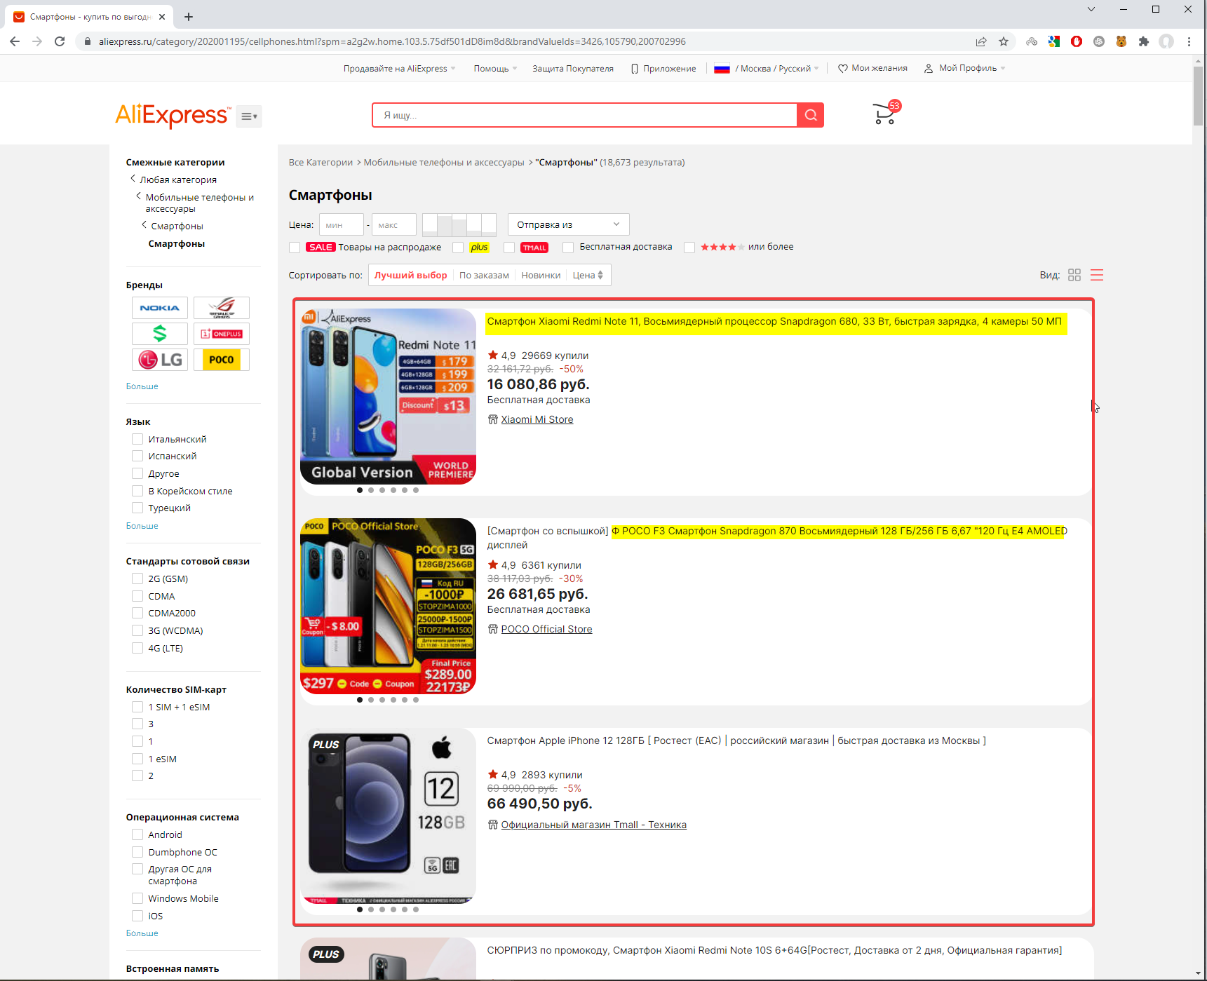

**Сheckout page: The button "Survey" is displaced on the "safe info" hook after window width is changed**

**STR:**

1. Open chechout page
2. Navigate to the "Survey" button
3. Open Development tools
4. Change window width to 1260p

**Result:** The button "Survey" is displaced on the "safe info" hook after window width is changed to 1260p

**Expected Result:** The button "Survey" is located on the page according to mockups

**Severity:** Trivial

**Priority**

Lowest

**Environment**

Windows 10 Pro x64 Version 10.0.19044 Build 19044

Google Chrome v.98.0.4758.102 x64

**Attachments**

<https://drive.google.com/file/d/1Ut8g9dXZKqC1-YFdQfjrCJpRz74U9b0v/view?usp=sharing>

**Reporter**

Alex Petrukhin

**COVID-19 page: The blank page is opened from link "Promotion" in the footer**

**Project:** https://aliexpress.ru/

**STR:**

1. Open main page.
2. Go to footer.
3. In “Browse by Category” follow the link COVID-19
4. Go to footer COVID-19 page.
5. In “Browse by Category” follow the link "Promotion"

**Result:** The Вlank page is opened.

**Expected result:** The page of products with special offers is opened.

**Severity:** Blocker

**Priority:** Medium

**Environment**

Windows 10 Pro x64 Version 10.0.19044 Build 19044

Google Chrome v.98.0.4758.102 x64

**Reporter**

Alex Petrukhin

