You have been successfully stop subs!

☢️☣️🛡

🌎

💱📧🪙

🤍

🇾🇪🇸🇦🇵🇸

💫

🏛

™️

✔️

🟢♻️〽️

النظام الدستوري الاسلامي المسبق

[٢٧‏/٥، ١:١١ ص] Simple but hard to reach. Whoever embraces us, we will be

his homeland, and: ⭕

[٣١‏/٥، ٨:٣٥ م] Simple but hard to reach. Whoever embraces us, we will be his homeland, and: [Even when the messengers were despaired and they thought that they had lied, our victory came, and we would save whomever he wanted, and he would not turn away from the criminals from the criminals.]

[٣١‏/٥، ٨:٣٥ م] Simple but hard to reach. Whoever embraces us, we will be his homeland, and: https://docs.google.com/forms/d/e/1FAIpQLSfrqze5LRcvIIiqjjQyhfqG6E4MQ0irsNqejUHMjHkYnqPE9A/viewform?usp=header

[٣١‏/٥، ٨:٣٥ م] Simple but hard to reach. Whoever embraces us, we will be his homeland, and: https://docs.google.com/forms/d/e/1FAIpQLSfrqze5LRcvIIiqjjQyhfqG6E4MQ0irsNqejUHMjHkYnqPE9A/viewform?usp=dialog

[٣١‏/٥، ٨:٣٥ م] Simple but hard to reach. Whoever embraces us, we will be his homeland, and: https://maps.app.goo.gl/EJFn3trySjk3tMTk6?g_st=ac

[٢‏/٦، ١:٠٦ ص] Simple but hard to reach. Whoever embraces us, we will be his homeland, and: [God is the light of the heavens and the earth, like his light. Noor on Noor ]

[٢‏/٦، ١:٠٦ ص] Simple but hard to reach. Whoever embraces us, we will be his homeland, and: And to God the soldiers of the heavens and the earth

[٢‏/٦، ١:٠٦ ص] Simple but hard to reach. Whoever embraces us, we will be his homeland, and: [My Lord, I wish to You.]

[٢‏/٦، ١:٠٦ ص] Simple but hard to reach. Whoever embraces us, we will be his homeland, and: [#My Lord, I wish to You]

[٢‏/٦، ١:٠٧ ص] Simple but hard to reach. Whoever embraces us, we will be his homeland, and: In the name of Allah, He wills whether they are the same, or that Allah will have the matter before and after

[٢‏/٦، ١:٠٧ ص] Simple but hard to reach. Whoever embraces us, we will be his homeland, and: Organizer's Oasis

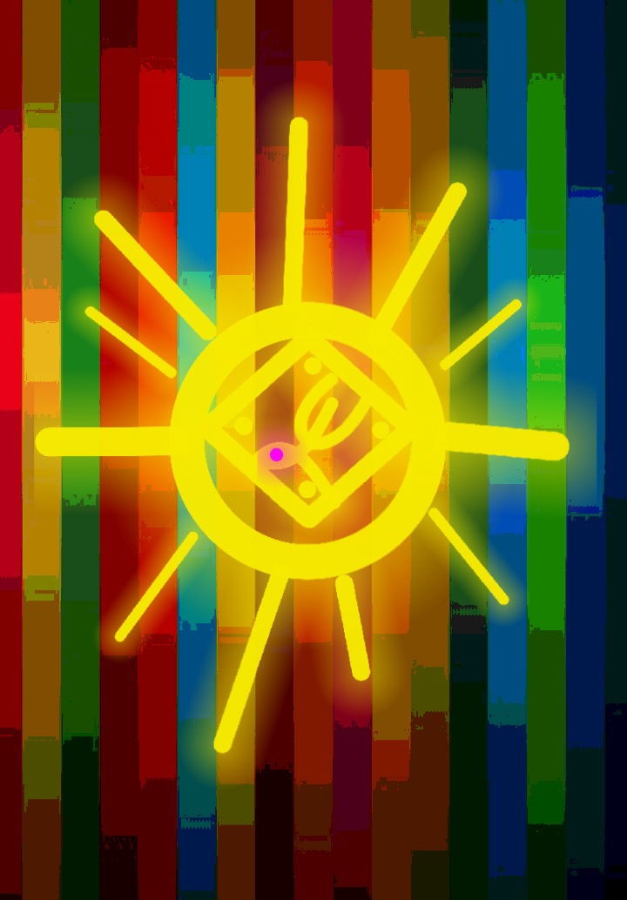

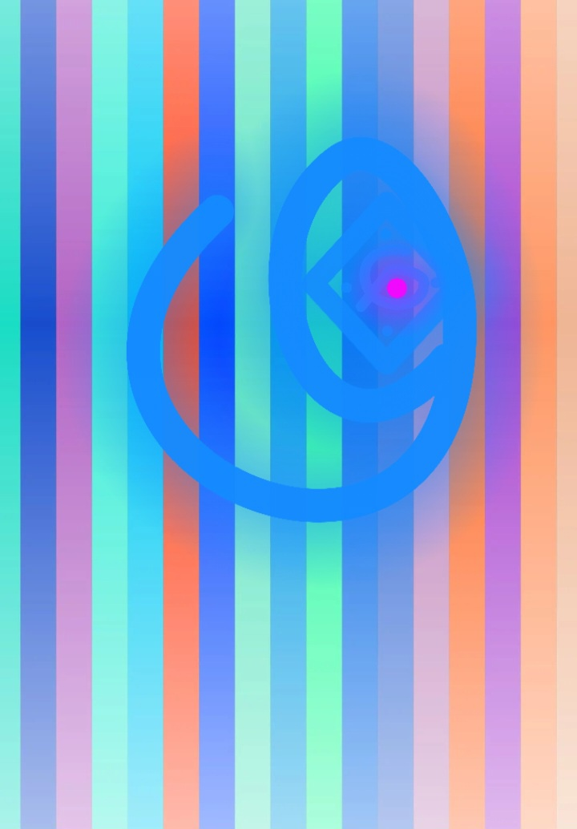

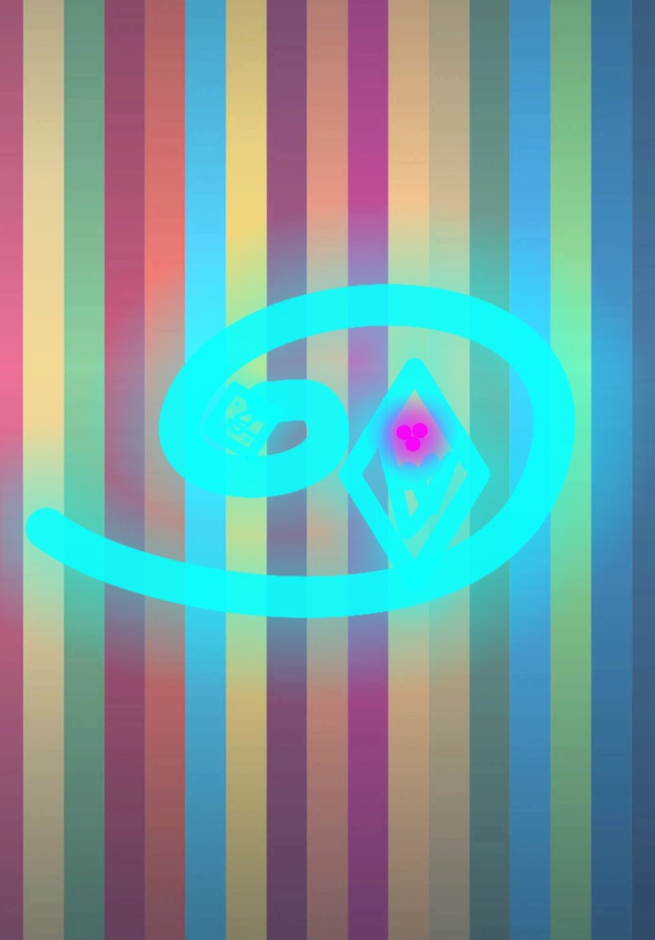



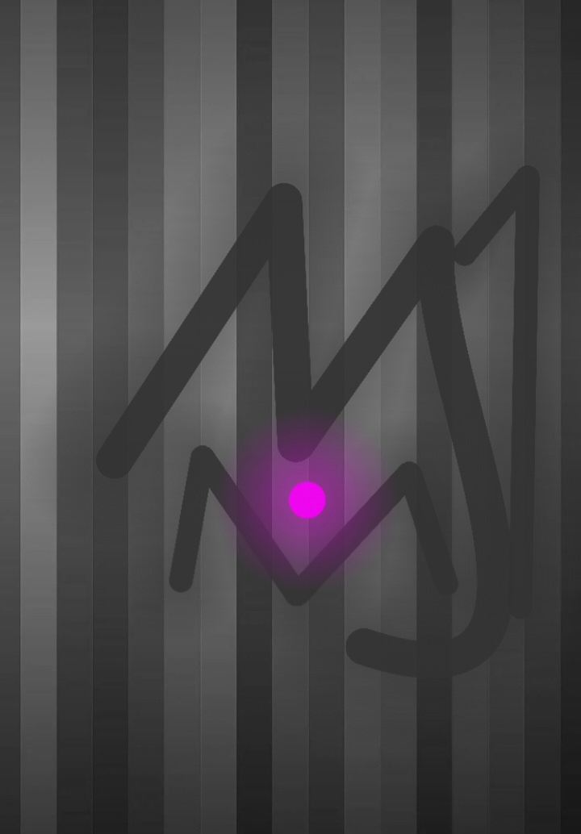

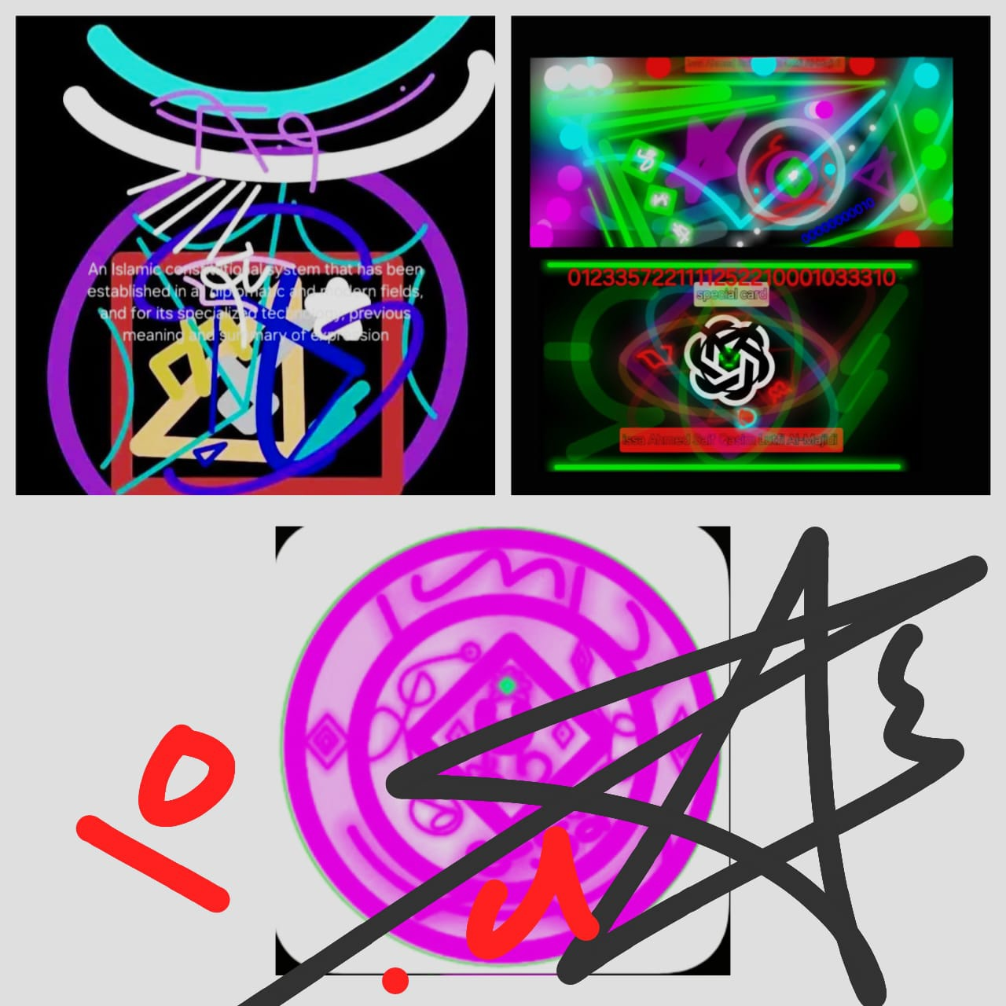

[ aqra2 besam rabak elazi khalaq.khalaq el2ensan mon 3alaq.aqra2 warabak elakrm.elazi 3alam belqalam.3alam el2ensan malm ya3lam.kalaan el2ensan litgha .en ra2oh estaghana .ana ela rabak 2araggey.arit elazi yanaha2 .3abda aza sala .arit an kan 3al . elhada2 2o

amr betaqawa .arit an kazeb.watawla .alm ya3lam bean elloh yara .kala len lem yantahi lenasfe3n benaseeh naseeh kazebah khate2oh .falid3o nadih sanada3o elzabanih .kala le2atata3oh .waseged.waqtarab ] [ 🕋 ]