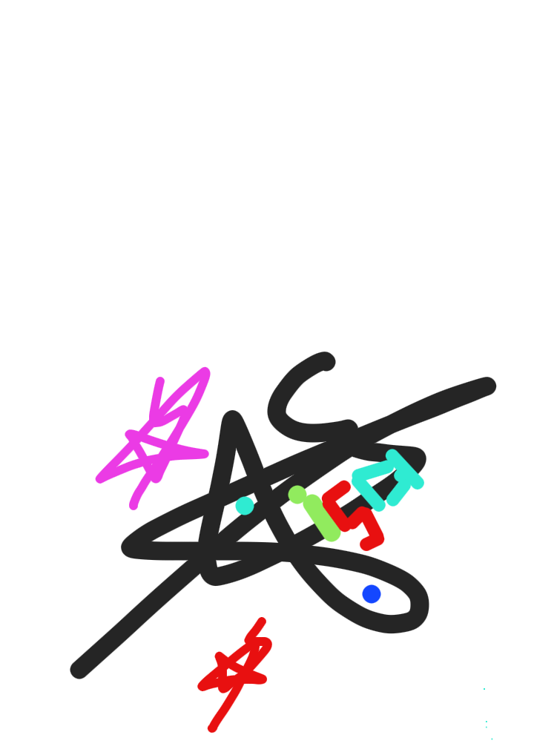

?? تم تعيين المرحلة! 🏟️ el escenario de hoy! 📍 ملعب هارد روك👀 The stage is set!

🏟️ ¡El escenario de hoy!

📍 Hard Rock Stadium

<DMH data panel>

[N.D.A]

[💫]

HMD

☯️✴️✅️

🇾🇪🇸🇦🇵🇸

nashtasha3r benor elazi le2emken le2alta7adahi ela benor monk wama a3zam eladrak walkhayal elik el7amadoma7meda da2ema wabda .🔟🔷️💠⚛️

[We feel the light that cannot be filled with light from you, and what is the greatest awareness and imagination, praise be to you, praise be to you, always and forever.]◇[aza kana khayr haza el2amah fagama3 lena el2emkan wan kan ekhar yakon khayr lelameh .fanakon beganboh fahdona elih wabarkatoh]◇Let us first be your opinion◇He is God, there is no god but God, the Living, the Eternal He wants to save to[◇]💠[⚛️]◇<System race with the latest artificial intelligence

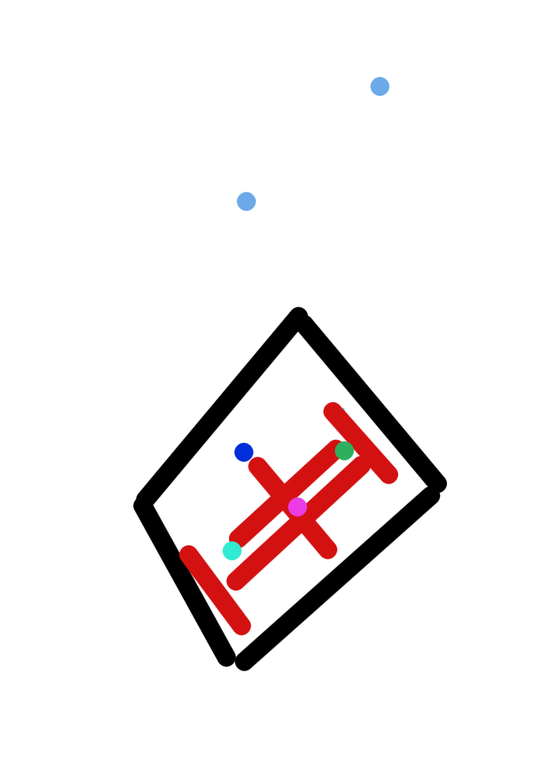

technology>[Automatic]◇He is God, there is no god but God, the Living, the Eternal He wants to save to[◇]💠[⚛️]◇Our Lord, give us what you promise us against your messengers and soldiers, and do not shame us on the Day of Resurrection, nor the Day of ReactionAs our sincerity, we took the impossible, and we are on our way until the day we meet you and cherish your meeting. And it is my soul, eager to meet you, as if it attributed your castration, with precision and appreciation, we understand your rituals, so he made our poetry the rest of the dreadful, and we saw your opinion, and we changed your love, closeness and victory [God is great, praise be to God][◇][○]>🌏There is no power or strength but Allah|◇TM10

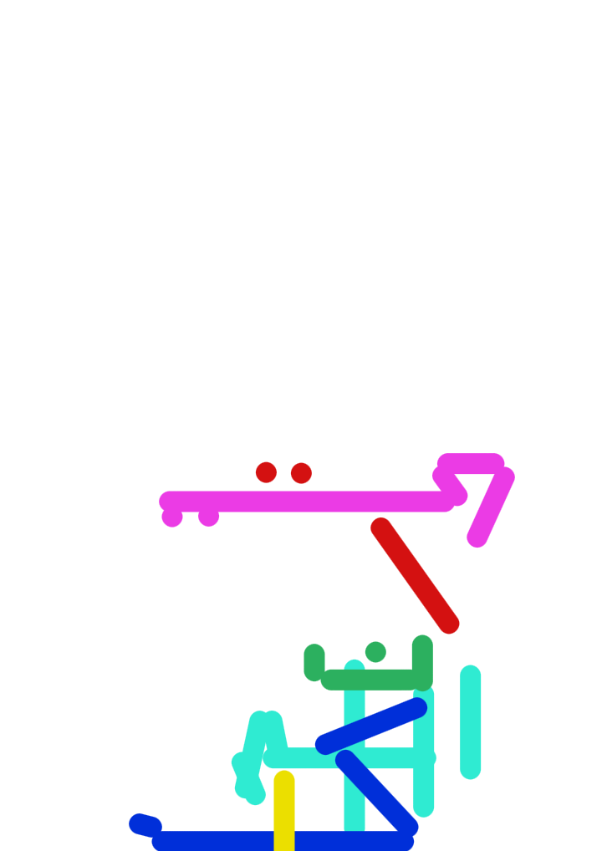

System office, source of acceptance and product in all fieldsPeople have gathered for you, so do not fear them, and fear me

Issa Ahmed Saif Qassem Lutf Al Majidi

The modern Arab world

Autonomous vision in the source of the universe by law

القدس شريف الله

Jerusalem is God's honor

His Eminence Sheikh d. Abdul Mohsen Al-Qasim: The pages of the nights are folded and the hours of life are over, and how quickly the passage of days and years has passed. On the servants.

🤍🪙⛰️

🛡





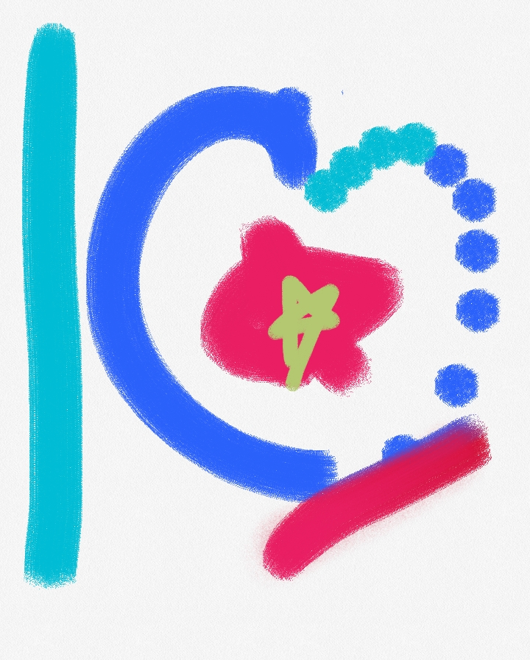

◇◇◇◇◇◇◇◇◇◇◆◇◇◇◇◇◇◇◇◇◇◇◆◇◇◇◇◇◇◇◇◆◆◇◇◇◇◇◇◇◆◇◇

[$$$$$$$$$$$$$$$$$$$$$$$$$$$>1<

♡♥︎♡♥︎♥︎♡♡♡♡▪︎

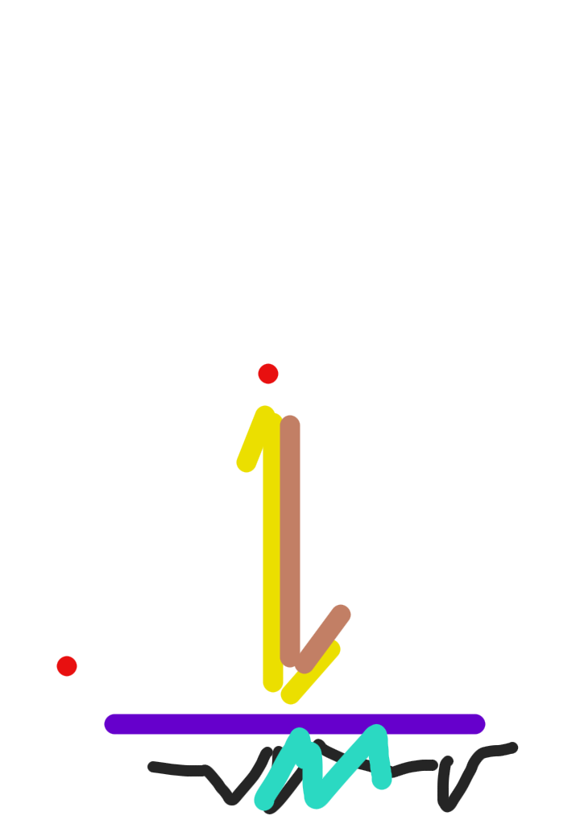

J225+GV4، ، تعز، اليَمَن

🇾🇪 Yemeni

&&&&&&&&&&

●

The current pre-constitutional system(Our embrace is like a homeland, and for everyone who embraces us, we are a home, and for those who are hostile to us, we herald destruction.)

https://maps.app.goo.gl/Gi8ts4SyduDKmj9F9

⚡️☄️🌬🕙

🕋💴💳

OOO

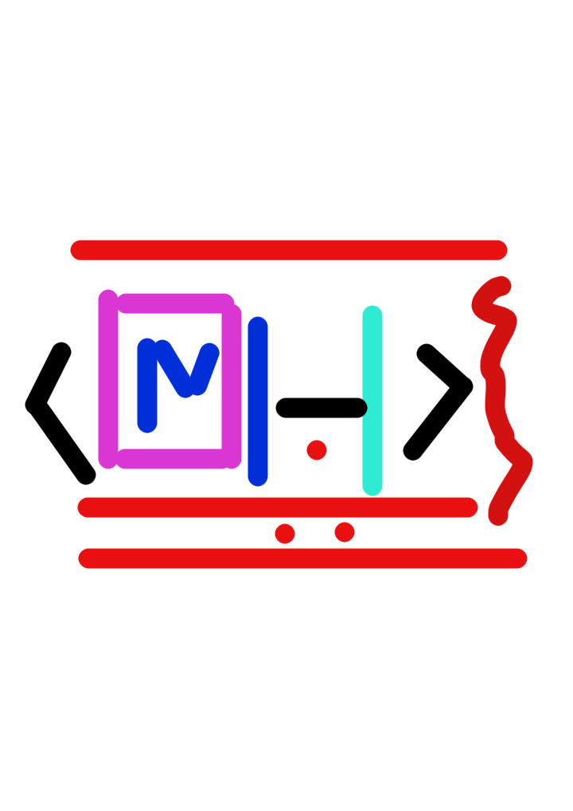







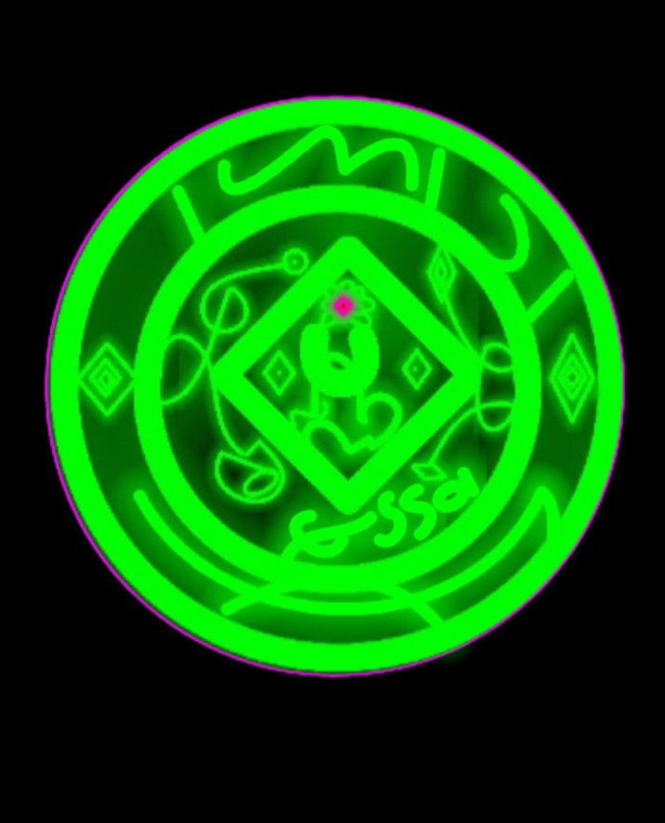



عيسى المجيدي.

الله هو الرحمن الرحيم الملك القدوس السلام المومن المهيمن العزيز الجبار المتكبر الخالق اا الرزق السميع البصير الحاكم العدل نظامي الخبير الحليم العظيم الغفور الشكور العلي الكبير الحفيظ الموقيت

الله اكبر

خ 1 لا معبود بحق الاالله

ع ٢ لاحوله ولاقوة الابالله

س ٣ حسبنا الله ونعم الوكيل

J225+GV4، ، تعز، اليَمَن

https://maps.app.goo.gl/Gi8ts4SyduDKmj9F9