**A Simple Peer-to-Peer File Sharing System**

Output File

Allen VanNoppen Jr.

A20415658

**Step 1: Start Index Server**

**IndexServer RMI is created in folder src1.**

>rmiregistry <port#> &



>rmic IndexServer

Used to create the server stub (disregard warning)

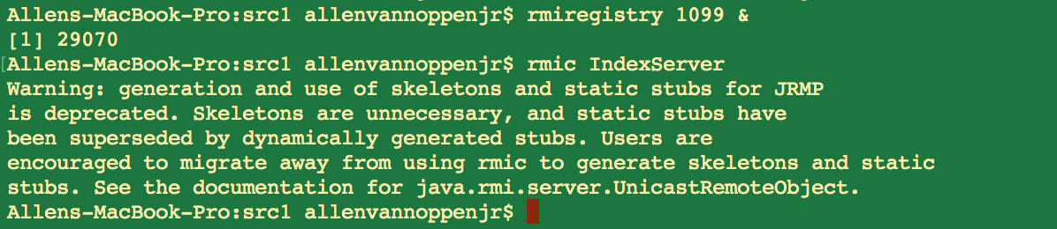

>java StartIndexServer <port#>

runs the IndexServer program. Returns the message “Index Server is Ready! Peers may register”

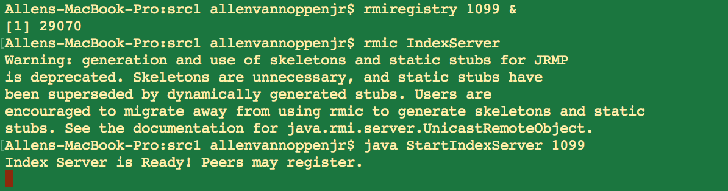

**Step 2: Connect Peers to Index Server:**

>rmiregistry <port #> &

Note: peer port number needs to be different from indexserver.

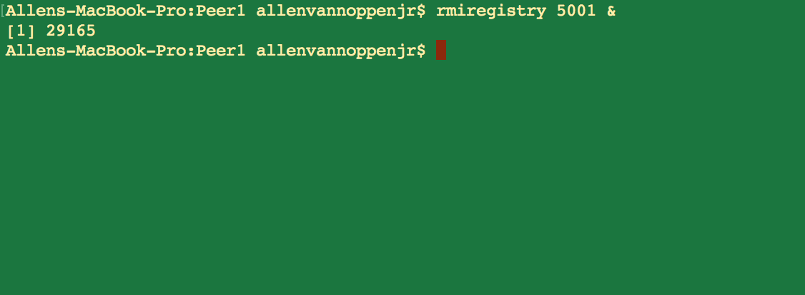

>rmic PeerClient

Generates the PeerClient Stub

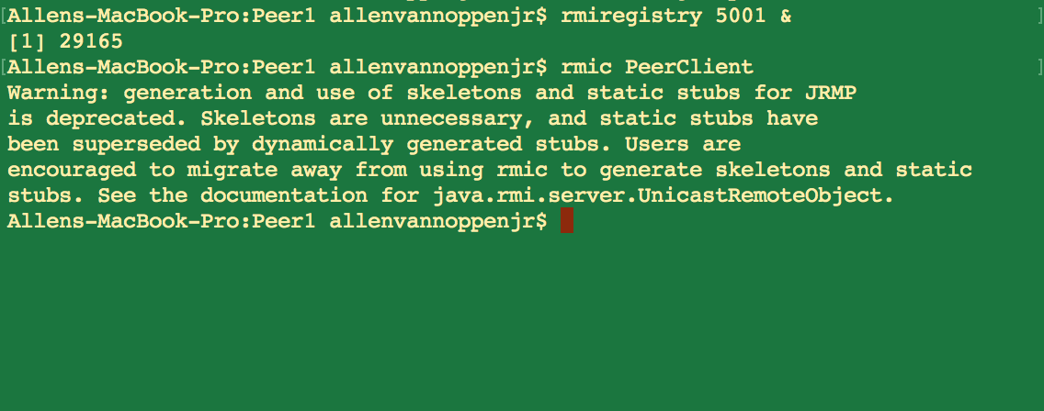

>java StartPeerClient <server port #> <peer port #> <Peer directory name>

The line below the command “null:” should display the Peer name but I have had trouble getting that simple function to work. Following the name comes the list of files in the Peers directory. The prompt at the bottom asks the user to search for a file name.

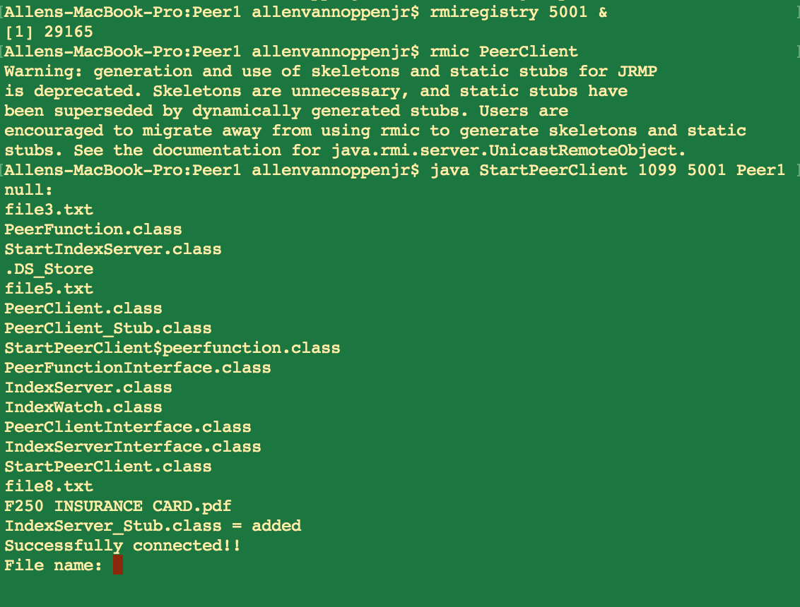

The below output is the result of the registration of a new peer. Again the name shouldn’t be null. Indexed Files are displayed.

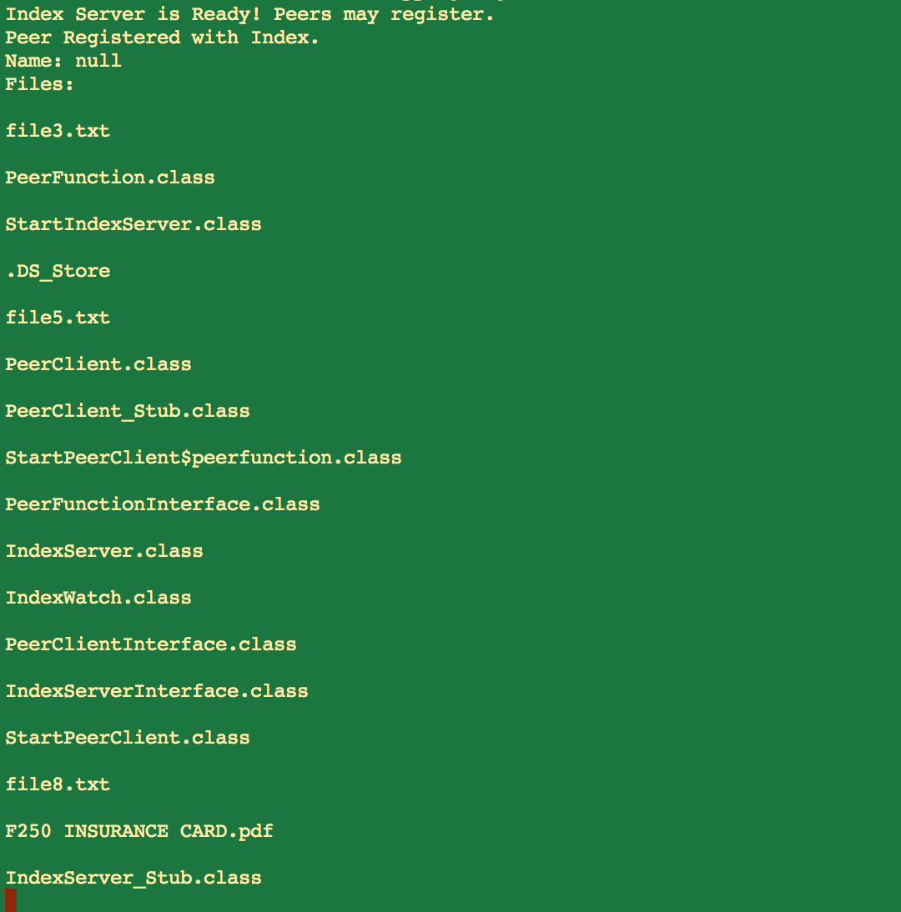

The other two Peers follow the same registration process as above.

**Peer 2:**

>rmiregistry <port #> &

Note: peer port number needs to be different from index server and other peers.

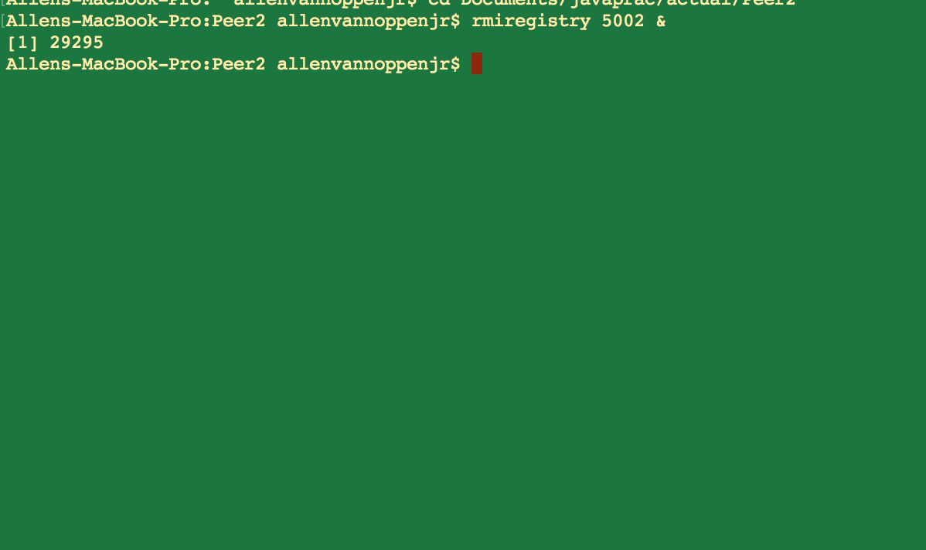

>rmic PeerClient

Generates the PeerClient Stub

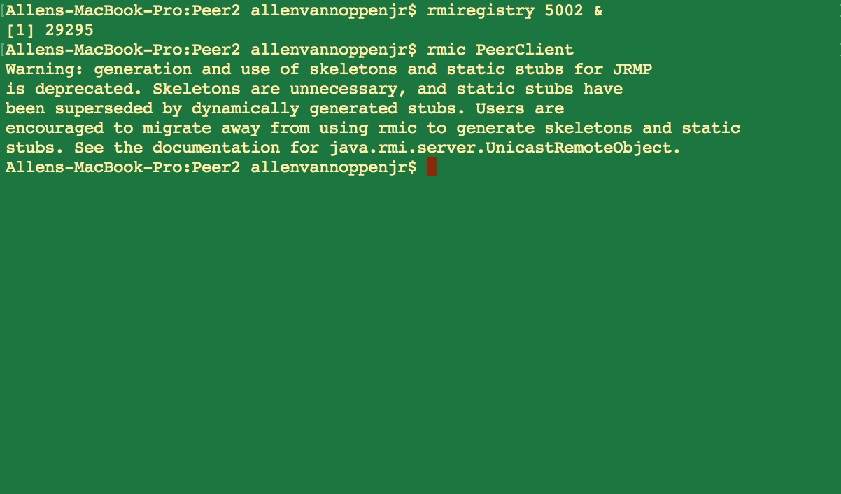

>java StartPeerClient <server port #> <peer port #> <Peer directory name>

The line below the command “null:” should display the Peer name but I have had trouble getting that simple function to work. Following the name comes the list of files in the Peers directory. The prompt at the bottom asks the user to search for a file name.

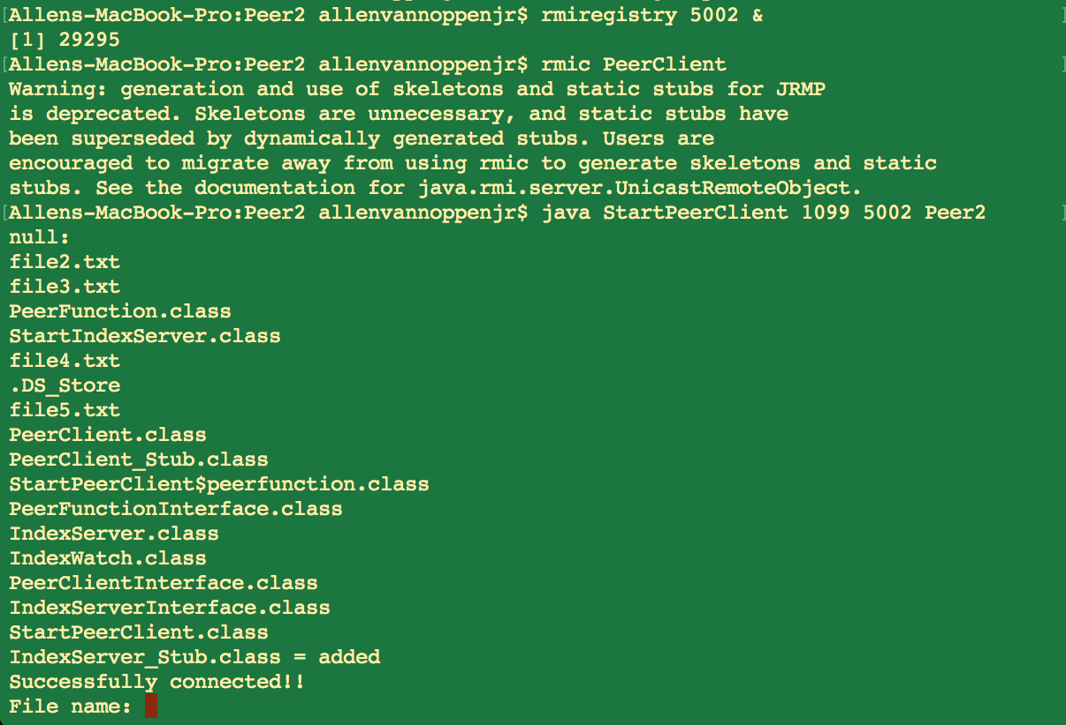

**Peer 3:**

>rmiregistry <port #> &

Note: peer port number needs to be different from index server and other peers.

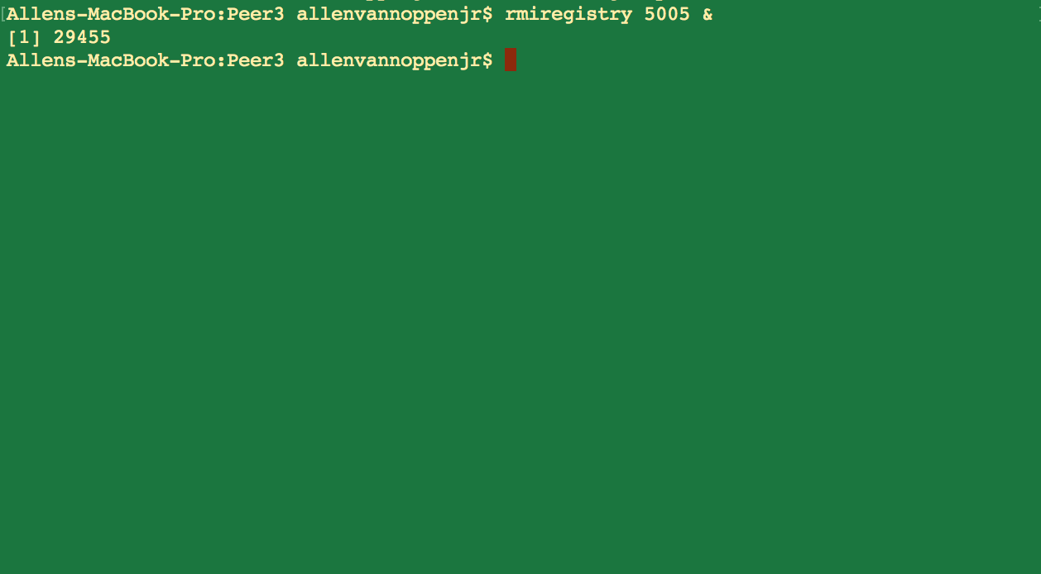

>rmic PeerClient

Generates the PeerClient Stub

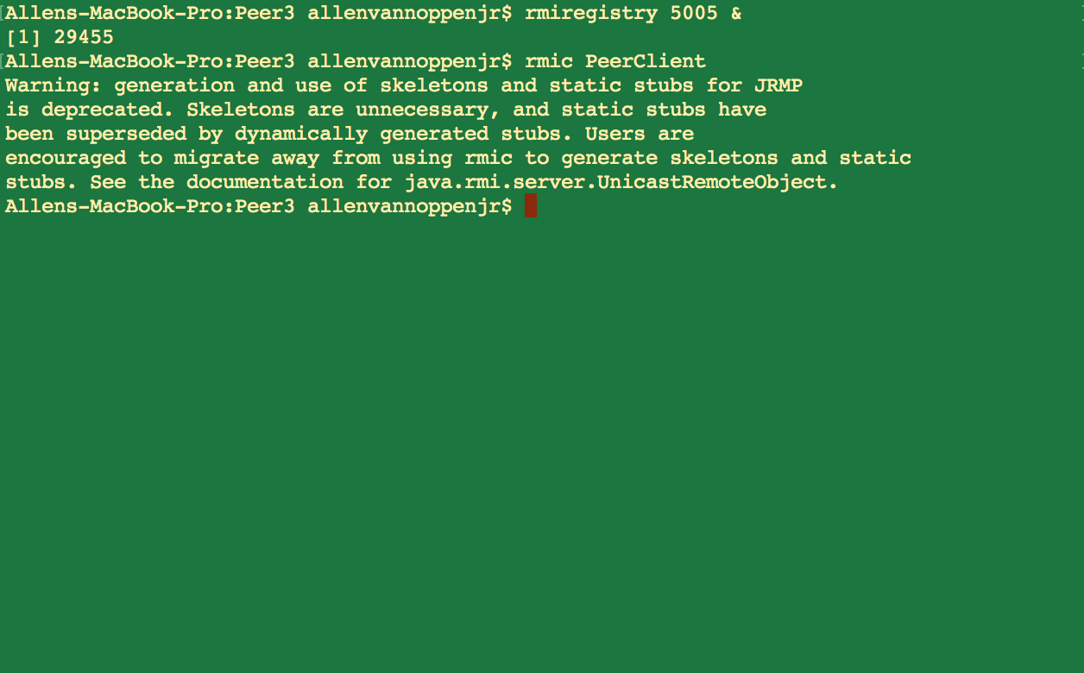

>java StartPeerClient <server port #> <peer port #> <Peer directory name>

The line below the command “null:” should display the Peer name but I have had trouble getting that simple function to work. Following the name comes the list of files in the Peers directory. The prompt at the bottom asks the user to search for a file name.

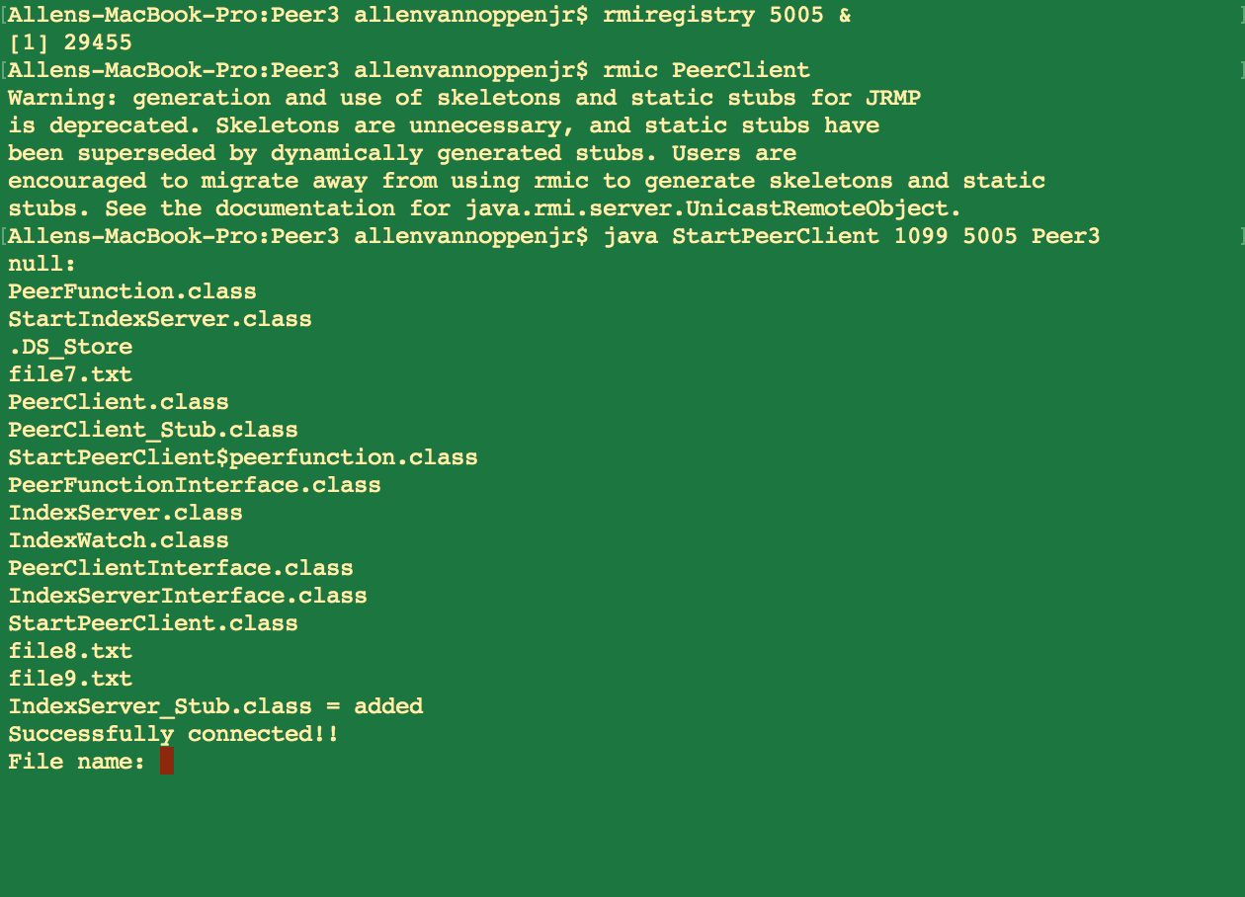

**Step 3: Request/Download File**

In peer 1, a search was performed for file8.txt. Two matches are found. Again, the names should have returned but there is a bug in the code.

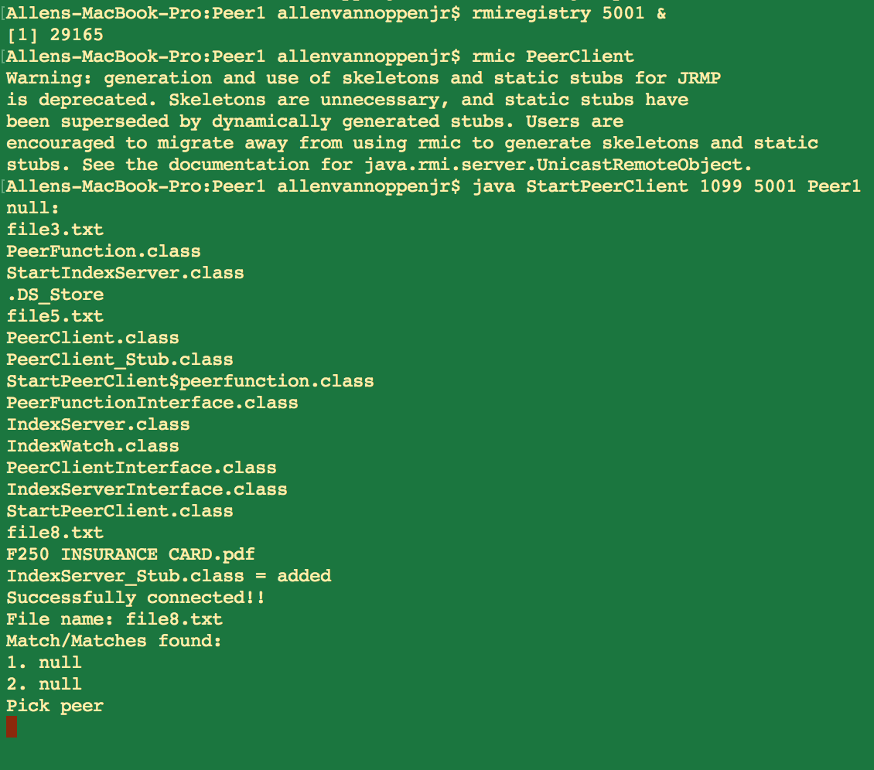

User selects peer 1 and the file is downloaded and in Peer1 directory.

