**A Simple Peer-to-Peer File Sharing System**

User Manual

Allen VanNoppen Jr.

A20415658

**Step 1: Download and Prep**

1. Move the folder to the desired folder and unzip if necessary.
2. Open up terminal (mac) or command prompt (windows)
3. Type in: “cd” followed by the path to where you placed the program.
   1. Ex “cd Documents/”IIT Graduate Program”/CS550/Program/src1

**Step 2: Start Index Server**

1. Type in “ls” and you should see the program files listed.
2. For mac type “rmiregistry 1099 &” or windows “start rmiregistry 1099”



1. type “rmic IndexServer” (disregard the warning)

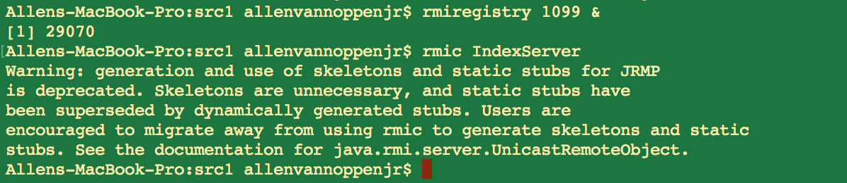

1. type “java StartIndexServer 1099” into the command prompt. You should see the below message. “index server is ready!”

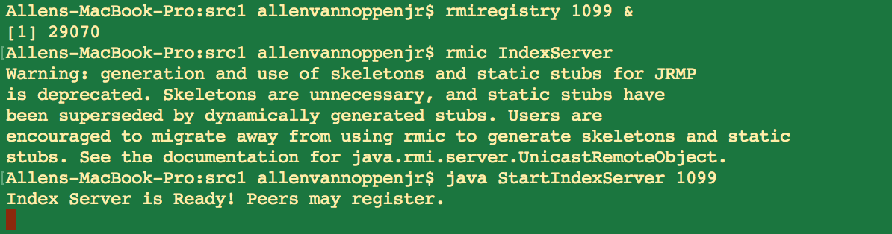

**Step 3: Connect Peer1 to IndexServer:**

1. Open another window in terminal or the command prompt.
2. Again using the “cd” command navigate to the program files and “/Peer1”
3. Type “rmiregistry 5001 &”

Note: peer port number needs to be different from indexserver.

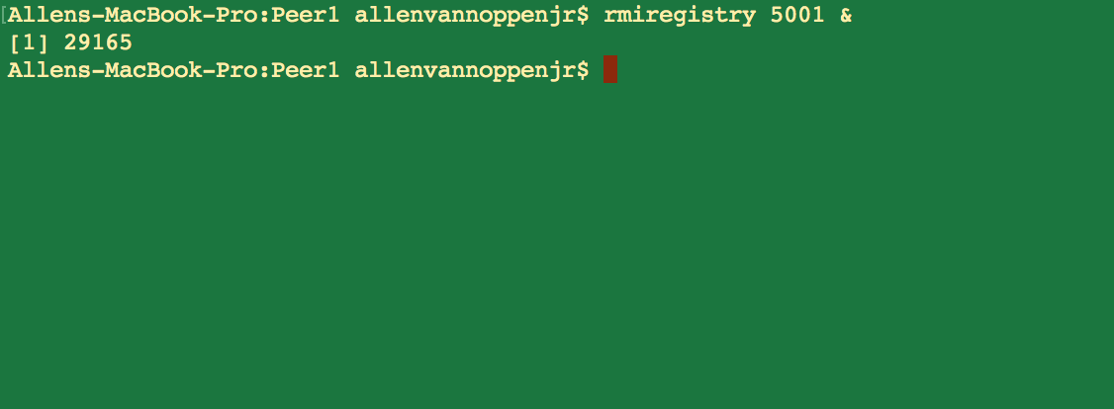

1. type “rmic PeerClient"

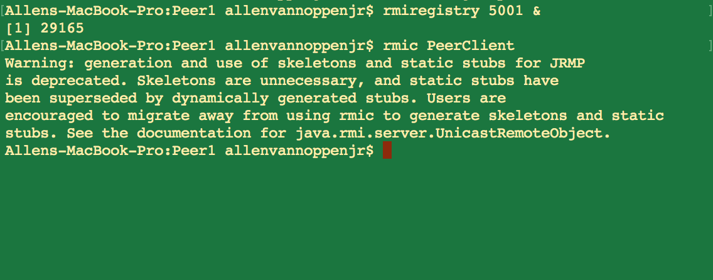

1. type “java StartPeerClient 1099 5001 Peer1

This should connect you to the server and show the files in your directory. The machine now has the Index Server and a Peer running on it. If you so choose you can download the program onto a separate machine and follow the same steps in Step 3 to set up another peer.

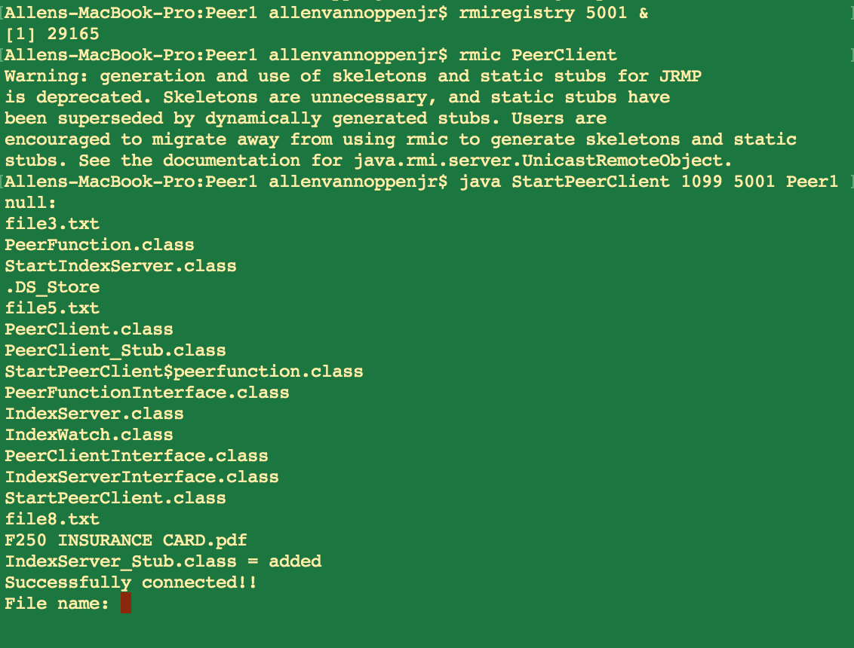

**Step 4: Register Peer 2**

Not much fun to send files to yourself so navigate to Peer 2 directory and follow the similar steps below.

1. type “rmiregistry 5001 &”

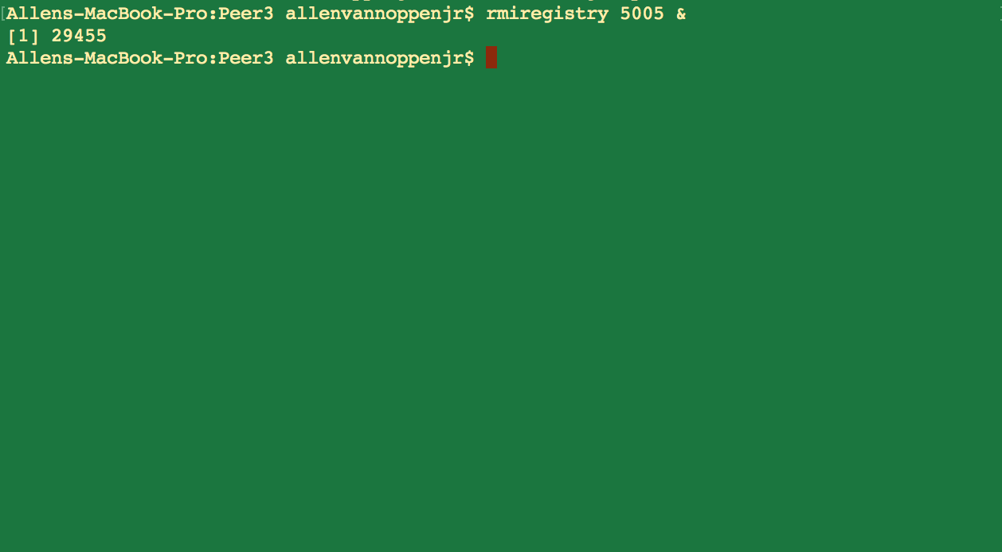

1. type “rmic PeerClient”

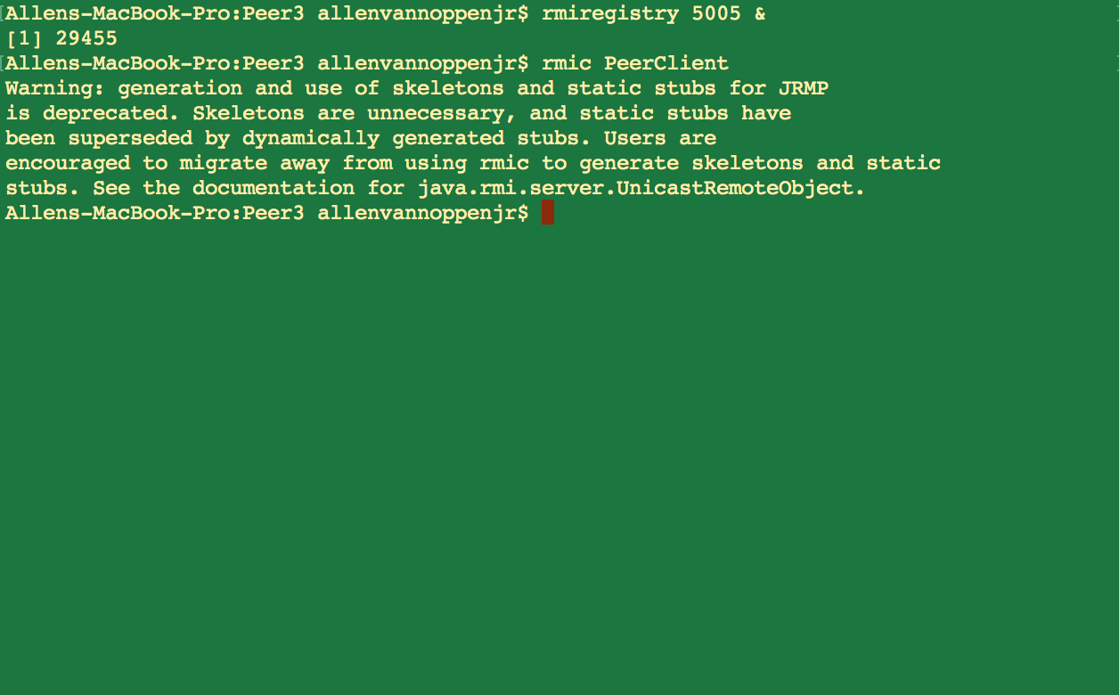

3. type “java StartPeerClient 1099 5005 Peer2”

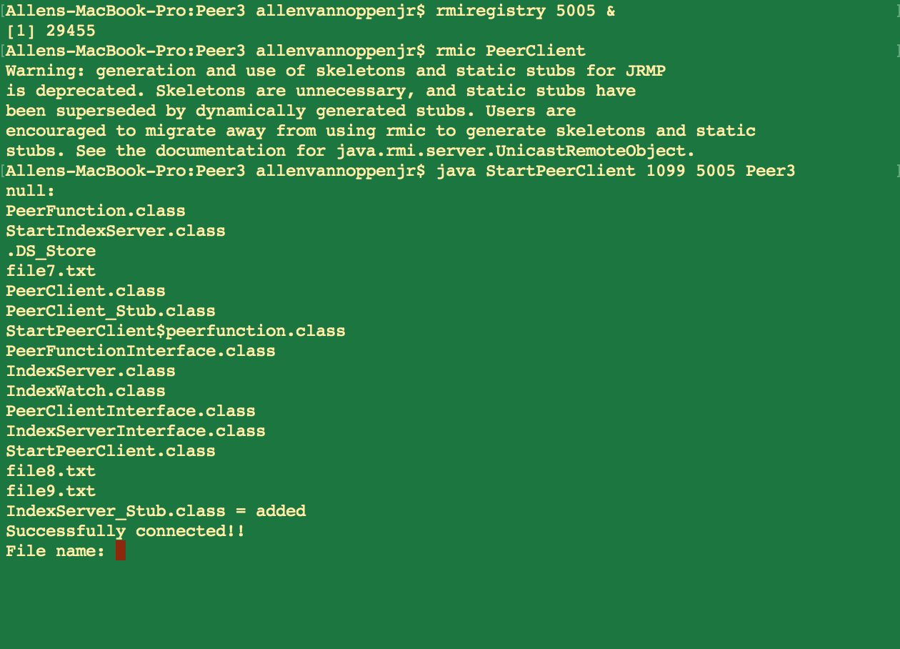

You can now send files back and forth!