

CREDIT CARD DEFAULT



**PREDICTION**



**Architecture**

Author : Alansha M

**MARCH 23, 2024**

INEURON

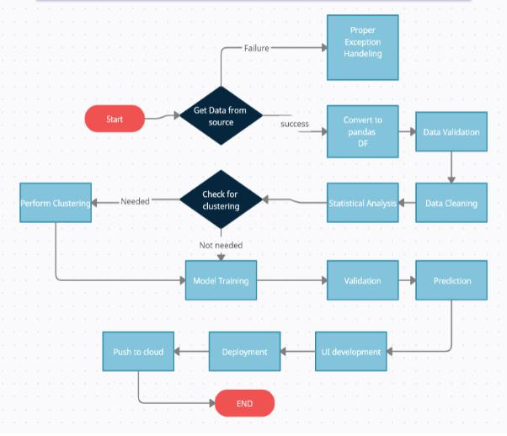

**Model Training and validation workflow**

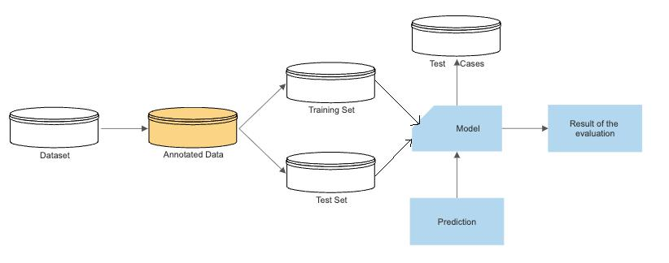

**Model Training and evaluation workflow**

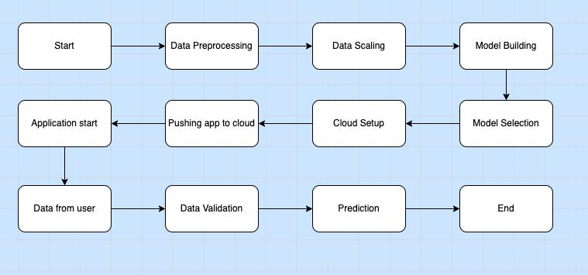

**Architecture**