**Cause**

This is caused by a regression introduced with a fix for [libnl3 bug #1511735](https://bugs.launchpad.net/ubuntu/+source/libnl3/+bug/1511735).  
Resulting network-manager crash has been reported in [network-manager bug #1539513](https://bugs.launchpad.net/ubuntu/+source/network-manager/+bug/1539513) or [network-manager bug #1539634](https://bugs.launchpad.net/ubuntu/+source/network-manager/+bug/1539634)

**Solution**

Downgrade libnl packages and wait for an upgrade of network-manager package

**Step 1**

Try to downgrade libnl with apt-get as in @Max answer:

sudo apt-get install libnl-3-200=3.2.21-1 libnl-route-3-200=3.2.21-1 libnl-genl-3-200=3.2.21-1

**Step 2**

If Step 1 fails,  
because the packages aren't anymore in your cache and obviously cannot be downloaded by package manager, you need to downgrade libnl packages manually (download + install):

* Download and copy them to your system  
  [ from booting a live distrib/rescue cd or from another computer + usb stick ]  
  Download links **for amd64**: [libnl](http://archive.ubuntu.com/ubuntu/pool/main/libn/libnl3/libnl-3-200_3.2.21-1_amd64.deb) [libnl-genl](http://archive.ubuntu.com/ubuntu/pool/main/libn/libnl3/libnl-genl-3-200_3.2.21-1_amd64.deb) [libnl-route](http://archive.ubuntu.com/ubuntu/pool/main/libn/libnl3/libnl-route-3-200_3.2.21-1_amd64.deb)  
  Download links **for i386**: [libnl](http://archive.ubuntu.com/ubuntu/pool/main/libn/libnl3/libnl-3-200_3.2.21-1_i386.deb) [libnl-genl](http://archive.ubuntu.com/ubuntu/pool/main/libn/libnl3/libnl-genl-3-200_3.2.21-1_i386.deb) [libnl-route](http://archive.ubuntu.com/ubuntu/pool/main/libn/libnl3/libnl-route-3-200_3.2.21-1_i386.deb)
* Back to your system, where you saved these .deb files, install them with dpkg:
* sudo dpkg -i libnl-3-200_3.2.21-1_amd64.deb
* sudo dpkg -i libnl-genl-3-200_3.2.21-1_amd64.deb
* sudo dpkg -i libnl-route-3-200_3.2.21-1_amd64.deb
* sudo dpkg -i libnl-*.deb

**Step 3**

Now you should be able to (re)start NetworkManager and bring back networking:

sudo service network-manager restart

**Notice**

These bugs hits **ubuntu trusty 14.04 with Pre-released updates** : trusty-proposed 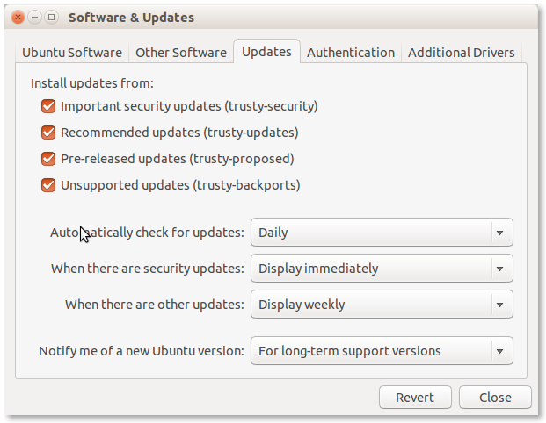

Where last update of libnl packages from version 3.2.21-1 to 3.2.21-1ubuntu1 introduced a regression causing network-manager to crash

**There isn't yet any upgrade on network-manager in**   
**An update of network-manager is now available in trusty-proposed**  
Updated version: 0.9.8.8-0ubuntu7.3  
[**please test proposed package (#1539634 comment n°11)**](https://bugs.launchpad.net/ubuntu/+source/network-manager/+bug/1539634/comments/11)

Thus until an upgrade for it triggers on your package manager you should apply a "hold" - as mentioned in [libnl3 bug #1511735 comment n°29](https://bugs.launchpad.net/ubuntu/+source/libnl3/+bug/1511735/comments/29):

sudo apt-mark hold libnl-3-200 libnl-genl-3-200 libnl-route-3-200

Once the future upgrade from trusty-proposed is installed you can remove that hold with:

sudo apt-mark unhold libnl-3-200 libnl-genl-3-200 libnl-route-3-200

Which then will allow you to upgrade again libnl