
MINISTRY OF EDUCATION AND RESEARCH OF THE REPUBLIC OF MOLDOVA
Technical University of Moldova
Faculty of Computers, Informatics and Microelectronics
Department of Software Engineering and Automation
Adrian Mutu
Group: FAF-242
Report
Laboratory Work No. 3
Operating Systems
Topic: The Command Line — Shell, Pipes and Text Filters
Checked by:
Patricia Reitman
FCIM, UTM
Chișinău – 2026

Purpose of the work
The purpose of this laboratory work is to become fluent at the Linux command line: to predict how bash transforms a command line before executing it (globbing, quoting, expansions), to redirect standard output and standard error wherever they are needed, to chain commands with pipes and with the ;, && and || operators, to manage background jobs, and to answer real questions about a data set using one-line pipelines of small text filters (grep, cut, sort, uniq, wc, head, tail, tr). Finally, the best one-liners are turned into a reusable bash script with argument checking and correct error reporting.
All commands were executed on an Ubuntu 26.04 (aarch64) virtual machine, user adrian, in the directory ~/os-lab3.

Before you start — generating the data set
The artificial web access log for Part 4 was generated with the loop from the lab sheet; each of the 500 lines has the form date time user result page. The check command printed 500 access.log, so the data set is correct.
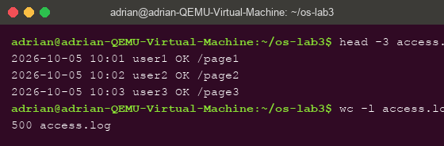
Figure 0.1 – Generating access.log and checking that it has 500 lines

Part 1. Move fast, find help
Tab completion. Typing ls /usr/sh and pressing Tab completed the path to /usr/share/ — it is the only entry in /usr that starts with “sh”, so bash completed it at once; pressing Tab twice afterwards listed the possible next completions (the contents of /usr/share). Typing cd /et and pressing Tab once completed directly to cd /etc/ for the same reason: a unique match is completed immediately, while an ambiguous prefix needs a second Tab to list the candidates.
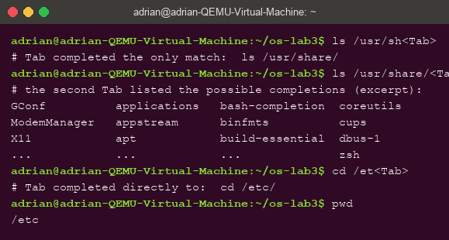
Figure 1.1 – Tab completion: a unique prefix is completed at once, a second Tab lists candidates
History search (Ctrl+R). After running three commands (date +%A, whoami, echo hello lab3), pressing Ctrl+R opened the (reverse-i-search) prompt; typing just “dat” found date +%A in the history, and Enter re-executed it without retyping.
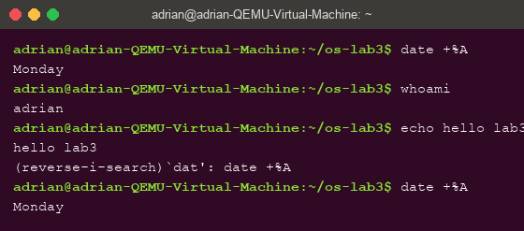
Figure 1.2 – Ctrl+R incremental history search finds and re-runs a previous command
Built-in or external, and where the shell looks.
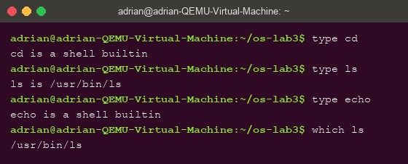
Figure 1.3 – Output of type and which: cd and echo are built-ins, ls is external
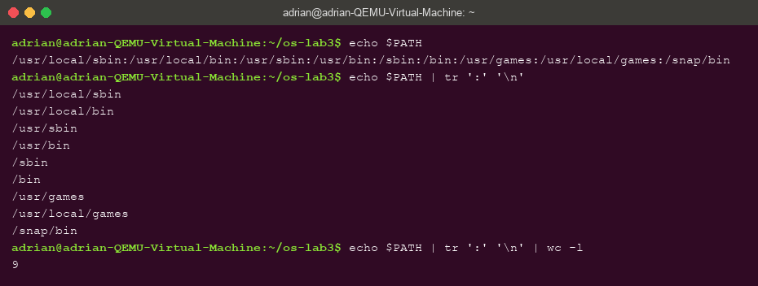
Figure 1.4 – The 9 directories of PATH, one per line via tr
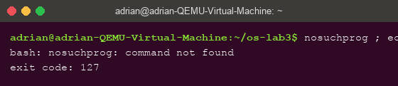
Figure 1.5 – Exit code 127 of a command that is not found
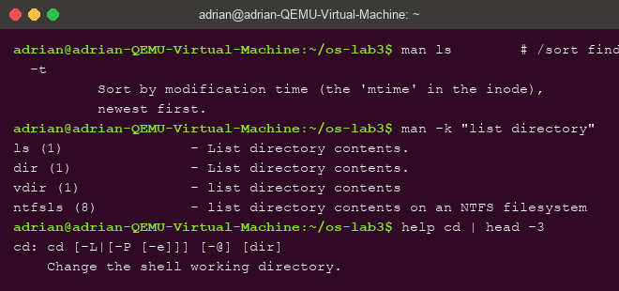
Figure 1.6 – Finding help offline: man ls (the -t option), man -k, help cd

Observe — answers (Part 1)
- Which of cd, ls, echo are built-ins, and why MUST cd be one? type shows that cd and echo are shell built-ins, while ls is an external program (/usr/bin/ls). cd must be a built-in because an external command runs in a child process, and a child can only change its own working directory — the change would vanish when it exits. Only the shell itself can change the shell's current directory. (echo is a built-in purely for speed; /usr/bin/echo also exists.)
- How many directories are in PATH, and in which one is ls? PATH contains 9 directories (Figure 1.4); which ls finds ls in /usr/bin.
- What exit code does a command that is not found return? 127 — the shell-reserved code for “command not found” (Figure 1.5).
- Which option of ls sorts by modification time? -t (from man ls: “Sort by modification time, newest first”); commonly combined as ls -lt.

Part 2. What the shell does to your line
The test directory ~/os-lab3/play was created with the six files from the lab sheet, including a file whose name contains a space (alfa beta.txt).
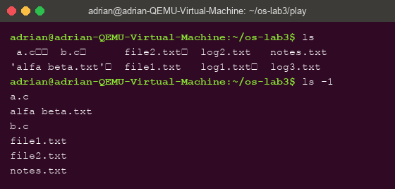
Figure 2.1 – Files created in the play directory (interactive ls quotes the name with a space)
Predictions vs. reality:
Command | My prediction | Real output | Explanation (if different)
echo *.c | a.c b.c | a.c b.c | —
echo file?.txt | file1.txt file2.txt | file1.txt file2.txt | —
echo [a-b]* | a.c b.c | a.c alfa beta.txt b.c | I forgot that [a-b] constrains only the FIRST character: “alfa beta.txt” also starts with a.
echo *.xyz | (nothing / error) | *.xyz | A glob that matches nothing is not an error: bash passes the pattern on literally.
ls alfa beta.txt | error | ls: cannot access 'alfa': No such file or directory (and the same for 'beta.txt') | The shell split the name into two arguments before ls ever ran.
ls "alfa beta.txt" | alfa beta.txt | alfa beta.txt | —
echo '$HOME' "$HOME" \$HOME | $HOME /home/adrian $HOME | $HOME /home/adrian $HOME | —
echo {1..5} ; echo $((7 * 6)) | 1 2 3 4 5 then 42 | 1 2 3 4 5 then 42 | —
echo "today is $(date +%A), I am $(whoami)" | today is Monday, I am adrian | today is Monday, I am adrian | —
touch log{1..3}.txt && ls log* | log1.txt log2.txt log3.txt | log1.txt log2.txt log3.txt | —

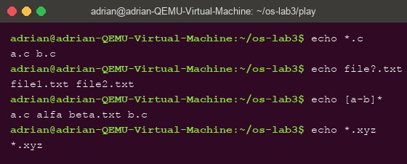
Figure 2.2 – Globbing results: *.c, file?.txt, [a-b]*, and an unmatched pattern
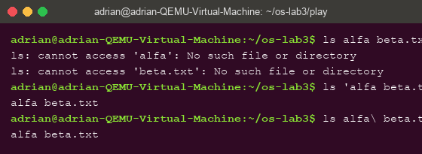
Figure 2.3 – The ls error on a name with a space, and the two fixes (quotes, backslash)
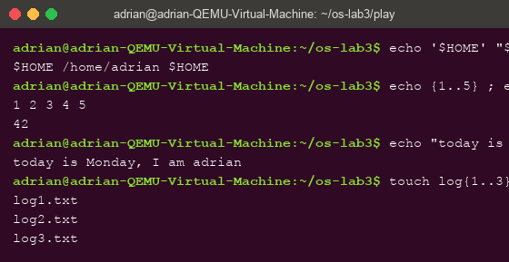
Figure 2.4 – Single quotes, double quotes, backslash, brace expansion, arithmetic and command substitution

Observe — answers (Part 2)
- Prediction table: see above. The two mismatches were echo [a-b]* (the character class constrains only the first character) and echo *.xyz (an unmatched glob is passed through literally, not reported as an error).
- Who produced the file names for echo *.c? The shell (bash). Globbing is performed by the shell during word expansion, before the command is started: echo never sees *.c, it receives the already-expanded arguments a.c b.c.
- Why did ls alfa beta.txt fail, and two fixes. The shell performs word splitting on unquoted spaces, so ls received two separate arguments, alfa and beta.txt, neither of which exists. Fixes: quote the name (ls 'alfa beta.txt' or ls "alfa beta.txt") or escape the space (ls alfa\ beta.txt). Tab completion escapes it automatically.
- Single vs. double quotes. Single quotes suppress ALL expansions — '$HOME' prints literally. Double quotes keep variable and command substitution ("$HOME" prints /home/adrian) but still protect spaces and disable globbing. \$ escapes a single character outside quotes.
Note: interactive ls shows the file as 'alfa beta.txt' (Figure 2.1): when writing to a terminal, ls quotes names containing special characters so the listing is unambiguous and can be copy-pasted back into the shell as valid arguments. When output goes to a pipe or a file, it prints the plain name.

Part 3. Redirection, chaining and jobs
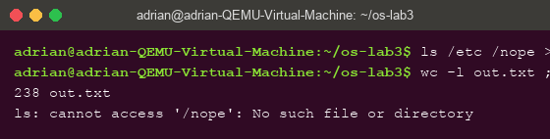
Figure 3.1 – stdout and stderr captured in separate files (out.txt / err.txt)
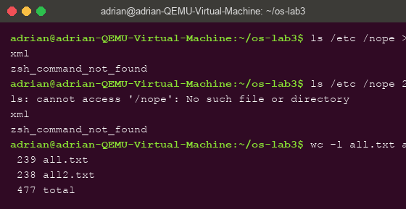
Figure 3.2 – Comparing the order of redirections: > all.txt 2>&1 vs 2>&1 > all.txt
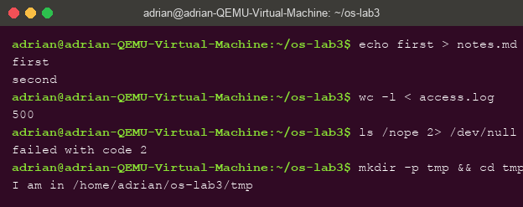
Figure 3.3 – Appending with >>, stdin redirection, and the ; && || operators
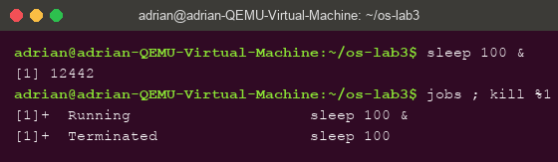
Figure 3.4 – Running a background job with & and stopping it with kill %1

Observe — answers (Part 3)
- Which file got the error and which the listing? out.txt received the listing of /etc (238 lines of stdout); err.txt received the error message ls: cannot access '/nope': No such file or directory (stderr).
- > all.txt 2>&1 vs 2>&1 > all.txt. Redirections are applied left to right. In > all.txt 2>&1, stdout is first sent to the file, then 2>&1 makes stderr a copy of the CURRENT stdout — the file — so both streams land in all.txt (239 lines). In 2>&1 > all.txt, stderr is first duplicated onto the current stdout — still the terminal — and only then is stdout redirected to the file: the error appears on screen and the file holds only the listing (238 lines), as Figure 3.2 shows.
- wc -l < access.log vs wc -l access.log. With <, the shell opens the file and connects it to wc's stdin; wc receives no file-name argument, so it only prints the number. Given the name as an argument, wc itself opens the file and prints the name next to the count.
- The operators. ; runs the next command unconditionally, in sequence. && runs the next command only if the previous one succeeded (exit code 0). || runs the next command only if the previous one failed (non-zero exit code).

Part 4. Answer questions with one-liners
All answers are single pipelines saved in oneliners.sh (one per question, the question as a comment above it); the file runs with bash oneliners.sh inside ~/os-lab3.
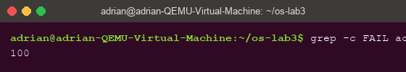
Figure 4.1 – Q1: number of failed requests — 100
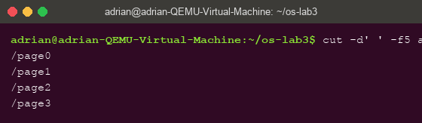
Figure 4.2 – Q2: 4 different pages were requested: /page0 … /page3
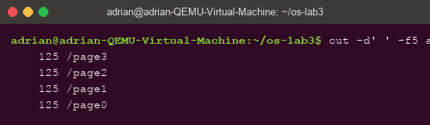
Figure 4.3 – Q3: requests per page — 125 each (sum 500)
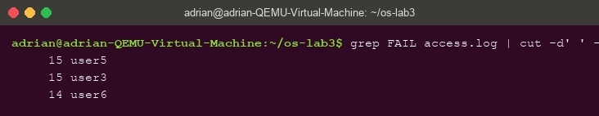
Figure 4.4 – Q4: user5 and user3 lead with 15 failures each
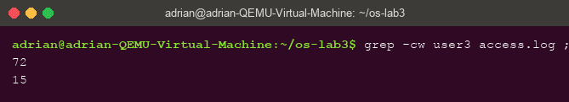
Figure 4.5 – Q5: user3 made 72 requests, 15 of them failed
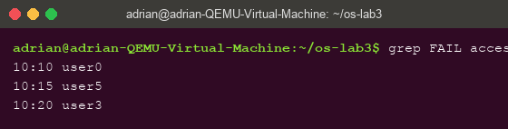
Figure 4.6 – Q6: time and user of the last 3 failed requests
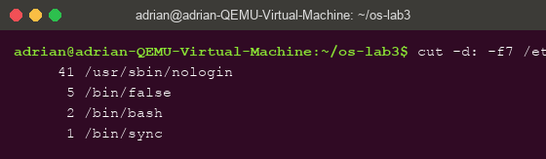
Figure 4.7 – Q7: login shells in /etc/passwd and accounts per shell
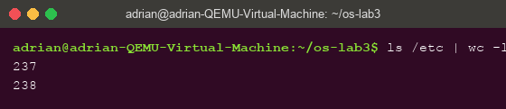
Figure 4.8 – Q8: ls /etc | wc -l vs ls -l /etc | wc -l (237 vs 238)
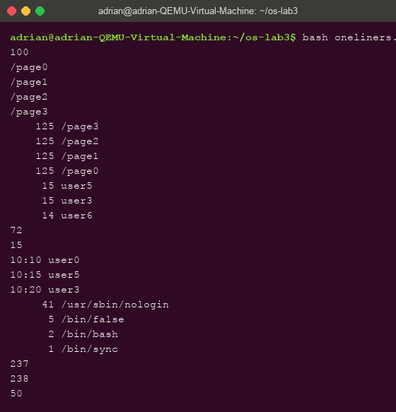
Figure 4.9 – Full run of oneliners.sh
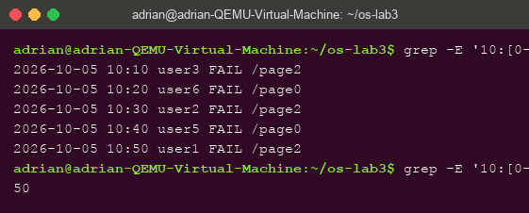
Figure 4.10 – Bonus: failed requests whose minute ends in 0 — 50 lines
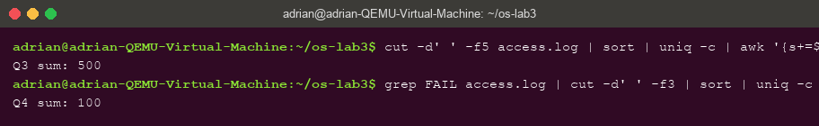
Figure 4.11 – Self-check: Q3 counts sum to 500 and per-user failures sum to Q1 (100)

Answers (Part 4)
- Q1. grep -c FAIL access.log → 100 failed requests.
- Q2. cut -d' ' -f5 access.log | sort -u → 4 different pages: /page0, /page1, /page2, /page3.
- Q3. cut -d' ' -f5 access.log | sort | uniq -c | sort -rn → each page got exactly 125 requests (125 × 4 = 500 ✓).
- Q4. grep FAIL access.log | cut -d' ' -f3 | sort | uniq -c | sort -rn | head -3 → user5 and user3, with 15 failures each (all seven users sum to 100 ✓).
- Q5. grep -cw user3 access.log ; grep -w user3 access.log | grep -c FAIL → user3 made 72 requests, of which 15 failed.
- Q6. grep FAIL access.log | tail -3 | cut -d' ' -f2,3 → 10:10 user0, 10:15 user5, 10:20 user3.
- Q7. cut -d: -f7 /etc/passwd | sort | uniq -c | sort -rn → /usr/sbin/nologin (41 accounts), /bin/false (5), /bin/bash (2), /bin/sync (1).
- Q8. Prediction: they differ because ls -l prints an extra header. Explanation: confirmed — ls -l adds exactly one line, total N (the number of disk blocks used), before the listing, so 237 becomes 238. The number of listed entries is identical.
Bonus: grep -E '10:[0-5]0 user[0-9] FAIL' access.log | wc -l → 50 failed requests whose minute ends in 0. (A failure happens when i is a multiple of 5 and the minute is i mod 60, so “minute ends in 0 AND FAIL” means i is a multiple of 10 — 50 of the 500 lines.)

Part 5. Your first script
report.sh checks its argument, counts total and failed requests, then loops over user0 … user6 printing the failures of each (the completed TODO uses for i in {0..6} with grep -w "user$i" | grep -c FAIL).
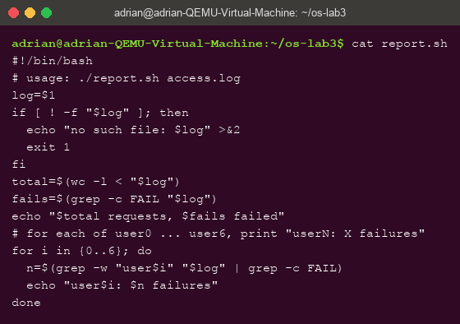
Figure 5.1 – Contents of report.sh with the completed TODO loop
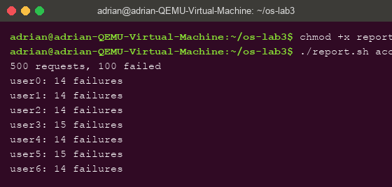
Figure 5.2 – Running the script on access.log
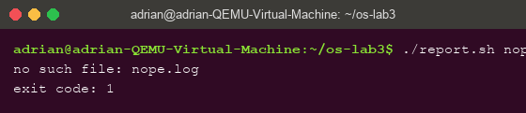
Figure 5.3 – Error handling for a missing file: message on stderr, exit code 1

Observe — answers (Part 5)
- What does #!/bin/bash do, and what happens without chmod +x? The shebang tells the kernel which interpreter must execute the file, so ./report.sh runs under bash no matter which shell launched it. Before chmod +x the kernel refuses to execute it: bash: ./report.sh: Permission denied (it can still be run as bash report.sh, because then bash, not the script, is the executable).
- Why ./report.sh and not report.sh? For security the current directory is not in PATH, and the shell only searches PATH for bare command names. ./report.sh gives an explicit path, so no PATH lookup is needed.
- Why >&2 and exit 1? >&2 sends the message to stderr, so it is not mixed into stdout and survives redirections of normal output (e.g. ./report.sh nope.log > result.txt still shows the error on screen). exit 1 returns a non-zero status so callers — &&, ||, other scripts, cron — can detect the failure programmatically.
Bonus — cron: the line * * * * * /home/adrian/os-lab3/report.sh /home/adrian/os-lab3/access.log >> /home/adrian/os-lab3/report.log 2>&1 was installed with crontab -e; after two minutes report.log contained two full reports (Figure 5.4), after which the crontab was removed with crontab -r.
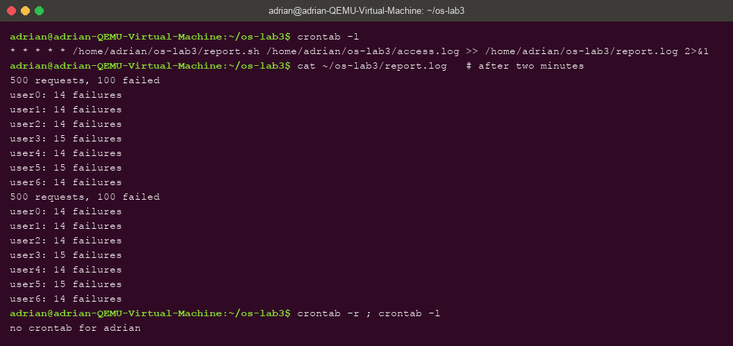
Figure 5.4 – The crontab line, the log after two minutes (two runs), and the removed crontab

Conclusions
In this laboratory work I learned to work fluently in bash and, more importantly, to predict what the shell does to a command line before pressing Enter. The key insight is that the shell transforms the line first — globbing, brace and arithmetic expansion, variable and command substitution, word splitting, quote removal — and only then starts the program, which explains why echo *.c prints file names (bash expanded them) and why an unquoted name with a space breaks into two arguments. The two prediction mismatches ([a-b]* also matching “alfa beta.txt”, and an unmatched glob being passed through literally) were exactly the places where this model of the shell got corrected.
I used redirections to separate stdout from stderr, saw that the order of redirections matters because they are applied left to right, and used ;, && and || to chain commands by exit status — the same status (127 for a missing command, 1 from report.sh) that makes scripts composable. With pipes and the small filters grep, cut, sort, uniq, wc, head and tail I answered every question about a 500-line log in a single line each, and the self-checks (counts summing to 500 and to 100) confirmed the pipelines filter the right thing. Finally, I packaged the one-liners into report.sh with argument checking, errors on stderr and a meaningful exit code, and verified it can run unattended from cron — the step from interactive commands to automation.

