
MINISTRY OF EDUCATION AND RESEARCH OF THE REPUBLIC OF MOLDOVA
Technical University of Moldova
Faculty of Computers, Informatics and Microelectronics
Department of Software Engineering and Automation
Adrian Mutu
Group: FAF-242
Report
Laboratory Works No. 7 & 8
Operating Systems
Topic: Processes, Redirection and Pipes — on Linux and Inside xv6
Checked by:
Patricia Reitman
FCIM, UTM
Chișinău – 2026

Contents
1 Purpose of the Work
2 Lab 7 – Part 1: fork + exec + wait
2.1 Commands executed and relevant output
2.2 Observations
3 Lab 7 – Part 2: A Zombie, on Purpose
3.1 Commands executed and relevant output
3.2 Observations
4 Lab 7 – Part 3: Redirection
4.1 Commands executed and relevant output
4.2 Observations
5 Lab 7 – Part 4: A Pipe
5.1 Commands executed and relevant output
5.2 Observations
6 Lab 8 – Part 1: run, Inside xv6
6.1 Commands executed and relevant output
6.2 Observations
7 Lab 8 – Part 2: pingpong
7.1 The program and its output
7.2 Observations
8 Lab 8 – Optional: primes
8.1 Output
9 Conclusions

1 Purpose of the Work
This report combines Laboratory Works 7 and 8, which answer the lecture's three questions — how a process is born, where printf writes, and how ls | wc -l works — first on Linux and then inside xv6. Lab 7 builds four small C programs: run.c (fork + exec + wait, the three steps of the shell), zombie.c (a child that ended but was not waited for), redirect.c (redirection by closing descriptor 1 before open) and pipeline.c (a pipe with two forks), plus the optional three-stage pipeline3.c. Lab 8 then runs the same three calls inside xv6 (user/run.c) and makes two processes talk through a pair of pipes (user/pingpong.c), plus the optional prime-sieve process chain (user/primes.c).
Lab 7 was done in ~/os-lab7 on the Ubuntu 26.04 (aarch64) virtual machine with gcc 15.2; Lab 8 in the ~/xv6-riscv tree, booted in QEMU with make qemu.

2 Lab 7 – Part 1: fork + exec + wait

2.1 Commands executed and relevant output
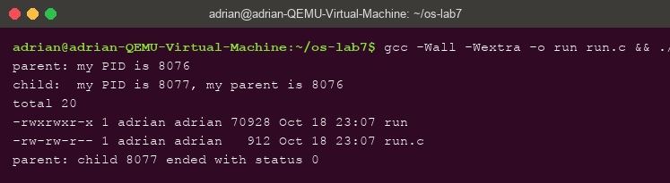
Figure 2.1 – run.c: parent forks, child becomes ls -l, parent waits — status 0
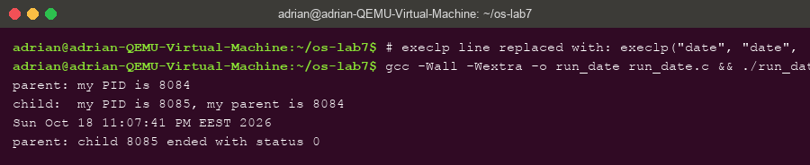
Figure 2.2 – The child changed to exec date: same three steps, different program
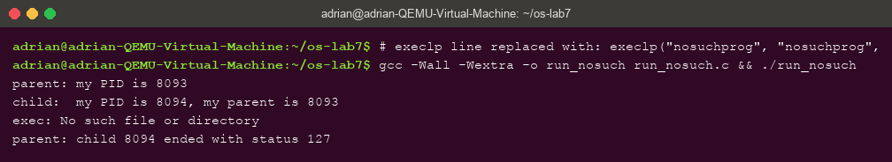
Figure 2.3 – exec of a program that does not exist: perror fires and the status is 127

2.2 Observations
- Why perror("exec") prints only with nosuchprog: a successful execlp REPLACES the child's program — the code after it no longer exists in the process, so the line can only run when exec fails and returns. With nosuchprog exec fails with ENOENT, so exec: No such file or directory appears and the child reaches exit(127).
- The number the child prints as “my parent”: 8076 — exactly the PID the parent printed for itself: getppid() in the child returns the parent's PID, confirming fork created a genuine parent–child pair.
- Status with ls vs nosuchprog: 0 with ls (ls succeeded) and 127 with nosuchprog — the value passed to exit(127) after the failed exec, the shell's conventional “command not found” code.

3 Lab 7 – Part 2: A Zombie, on Purpose

3.1 Commands executed and relevant output
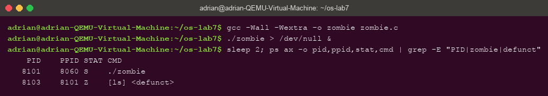
Figure 3.1 – While the parent sleeps: the child shows STAT Z, [ls] <defunct>
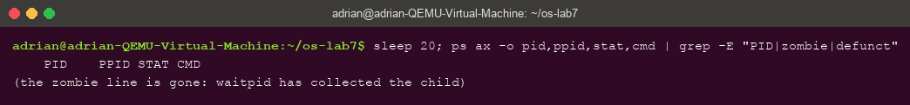
Figure 3.2 – After 20 seconds: waitpid ran and the zombie is gone

3.2 Observations
- The letter in STAT is Z (zombie): the child has already exited, but its exit status is still stored in the process table waiting for someone to collect it — it is dead, yet still occupies an entry, shown as [ls] <defunct>.
- After 20 seconds the defunct line is gone. The line that removed it is waitpid(pid, &status, 0); — when the parent finally calls wait, the kernel delivers the status and frees the table entry. A zombie is not a running process; it is an uncollected exit status.

4 Lab 7 – Part 3: Redirection

4.1 Commands executed and relevant output
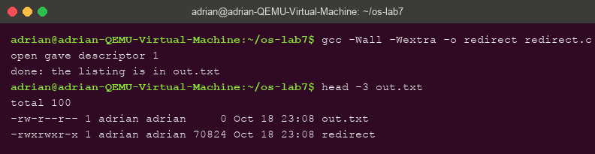
Figure 4.1 – redirect.c: open returns descriptor 1, and the listing of ls lands in out.txt

4.2 Observations
- open gave descriptor 1 — because descriptors are allocated as the SMALLEST free number, and the child had just closed 1. The message itself proves it (printed on stderr, descriptor 2, which stayed on the screen).
- Why ls's listing does not appear on screen: ls was not changed and still writes to descriptor 1 — but in this child, number 1 now refers to out.txt. Redirection is a property of the descriptor table the program inherits, not of the program.
- For 2> err.txt you would close descriptor 2 before the open, so the file takes number 2 and everything the program writes to stderr goes to the file.

5 Lab 7 – Part 4: A Pipe

5.1 Commands executed and relevant output
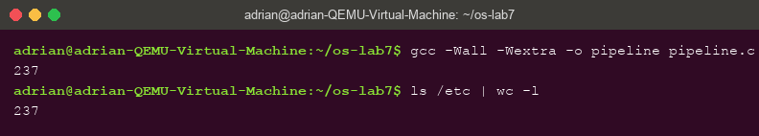
Figure 5.1 – pipeline.c prints 237 — the same number as the real ls /etc | wc -l
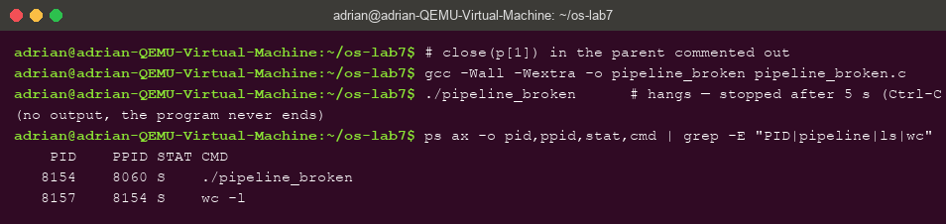
Figure 5.2 – With close(p[1]) commented out in the parent, the program hangs: wc is still alive
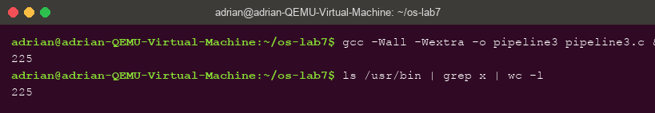
Figure 5.3 – Optional pipeline3.c (ls /usr/bin | grep x | wc -l): 225, equal to the shell

5.2 Observations
- Same number: yes — ./pipeline printed 237 and ls /etc | wc -l printed 237.
- Which child never ends: wc. The ps listing in Figure 5.2 shows wc -l still in state S while ls has long finished.
- What wc is waiting for: end-of-file on the pipe — EOF arrives only when ALL write ends are closed, and the parent still holds p[1] open, so wc keeps waiting for more input forever.
- Optional pipeline3.c: two pipes, three children (ls → grep x → wc -l), every process closing all four pipe ends it does not use — it prints 225, identical to the shell.

6 Lab 8 – Part 1: run, Inside xv6

6.1 Commands executed and relevant output
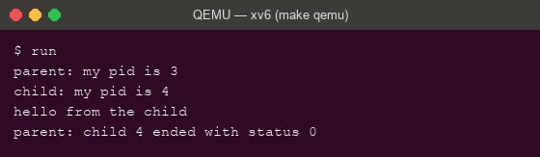
Figure 6.1 – user/run.c in xv6: fork, exec("echo"), wait — the same three steps
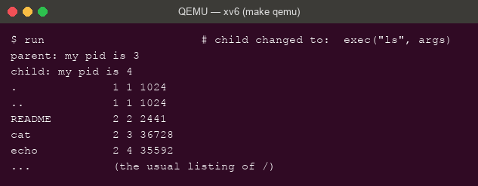
Figure 6.2 – The child changed to exec("ls"): the xv6 listing, then back to the parent
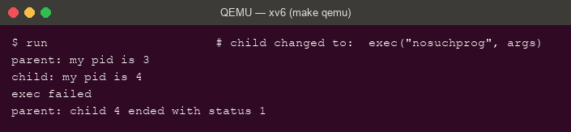
Figure 6.3 – exec of nosuchprog in xv6: "exec failed" and status 1

6.2 Observations
- The three calls are the same calls: on Linux fork(), execlp(), waitpid(); in xv6 fork(), exec(), wait(). Only the library wrappers differ (execlp searches PATH and builds argv from the C varargs; xv6's raw exec takes the path and the argv array directly) — the kernel operations are identical.
- Who prints “hello from the child”: echo. After a successful exec, the code of run no longer exists in the child — the words are echo's argv, printed by echo's own main.
- Why status 1 here and 127 on Linux: the status is simply whatever the program passes to exit after the failed exec — xv6's run.c calls exit(1), the Linux version calls exit(127). The kernel attaches no meaning to the number; 127 is only a shell convention.

7 Lab 8 – Part 2: pingpong

7.1 The program and its output
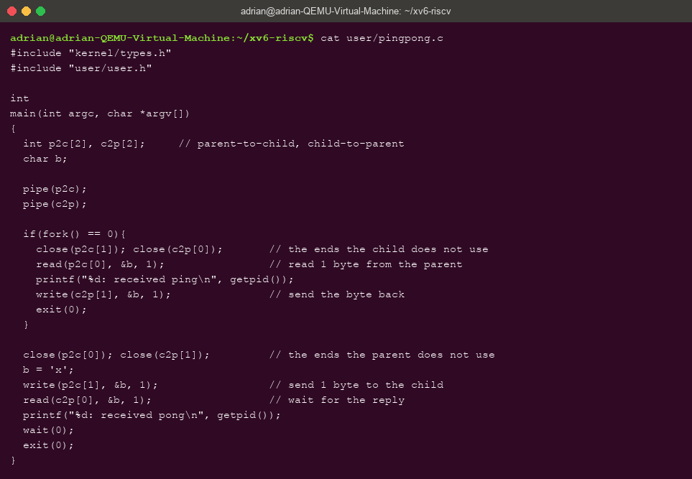
Figure 7.1 – user/pingpong.c with the four TODO lines completed
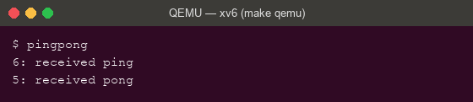
Figure 7.2 – pingpong: ping printed first by the child (pid 6), pong by the parent (pid 5)
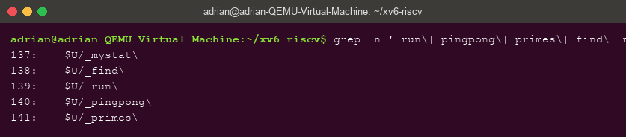
Figure 7.3 – The UPROGS lines for run, pingpong and primes in the Makefile

7.2 Observations
- Why TWO pipes: a pipe is one-directional — one read end, one write end. With a single pipe for both directions a process could read back its OWN byte before the other side ever saw it; two pipes (p2c and c2p) give each direction its own channel.
- Which call makes the parent wait: the read(c2p[0], &b, 1) — read on an empty pipe BLOCKS until data arrives, so the parent cannot print “received pong” before the child has written its reply. (The final wait(0) only collects the child afterwards.)

8 Lab 8 – Optional: primes

8.1 Output
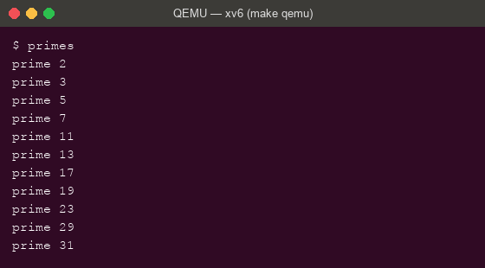
Figure 8.1 – The process-chain sieve: every prime from 2 to 35
Each stage reads its first number p — necessarily prime — prints it, then forwards to a child stage only the numbers not divisible by p; closing every unused pipe end is what lets each stage see EOF and the chain terminate. Eleven processes print the eleven primes up to 35.

9 Conclusions
The two labs demonstrate, with running code, that a shell is a thin layer over three kernel calls. fork duplicates a process (the child printed its parent's PID), exec replaces its program (which is why perror after a successful exec never runs, and why echo — not run — prints the child's words), and wait collects the exit status (whose value, 127 or 1, is pure convention chosen by the program, not by the kernel). The zombie experiment made the bookkeeping visible: a Z process is nothing but an uncollected status, created by delaying wait and destroyed by calling it.
Redirection and pipes turned out to be descriptor-table manipulation, not program features: ls never changed, yet wrote to a file because number 1 happened to name out.txt in its child — the smallest-free-number rule doing all the work for both open and dup. The pipeline matched the real shell exactly (237 and 225), and breaking it taught the one subtle rule of pipes: EOF exists only when every write end is closed, so one forgotten close(p[1]) in the parent leaves wc waiting forever. Running the same program inside xv6 closed the argument: the calls, the blocking read that sequences pingpong, and the close-everything discipline that lets the primes chain terminate are the same ideas in a kernel we compile ourselves — the Unix process model is small, and we have now used all of it from both sides.

