
MINISTRY OF EDUCATION AND RESEARCH OF THE REPUBLIC OF MOLDOVA
Technical University of Moldova
Faculty of Computers, Informatics and Microelectronics
Department of Software Engineering and Automation
Adrian Mutu
Group: FAF-242
Report
Laboratory Works No. 5 & 6
Operating Systems
Topic: The File System — With Your Own Hands (Linux) and Inside xv6
Checked by:
Patricia Reitman
FCIM, UTM
Chișinău – 2026

Contents
1 Purpose of the Work
2 Lab 5 – Part 1: The Tree and the File Types
2.1 Commands executed and relevant output
2.2 Observations
3 Lab 5 – Part 2: Inodes and Links
3.1 Commands executed and relevant output
3.2 Observations
4 Lab 5 – Part 3: Permissions
4.1 Commands executed and relevant output
4.2 Observations
5 Lab 5 – Part 4: Disks and the Kernel as Files
5.1 Commands executed and relevant output
5.2 Observations
6 Lab 5 – Stretch: Magic Numbers and Deleted Open Files
6.1 (a) Magic numbers
6.2 (c) Deleting a file that is still open
7 Lab 6 – Part 1: Reading What xv6 Shows
7.1 Commands executed and relevant output
7.2 Observations
8 Lab 6 – Part 2: mystat and Hard Links at Work
8.1 The program and its output
8.2 Observations
9 Lab 6 – Part 3: Measuring the Limits
9.1 Commands executed and relevant output
9.2 Observations
10 Lab 6 – Part 4: find — Walking the Tree Recursively
10.1 The program and its output
10.2 Observations
11 Conclusions

1 Purpose of the Work
This report combines Laboratory Works 5 and 6, which examine the same subject — the file system — from two sides. Lab 5 verifies the lecture's concepts by experiment on Linux: the directory tree and file types, the inodes behind the names, hard and symbolic links, size versus occupied space, the permission model with its special bits, and the disks and kernel interfaces exposed as files. Lab 6 then opens the hood on the same ideas inside the xv6 teaching system: reading inode numbers and directory sizes at the xv6 prompt, writing a mystat program over the stat() system call to watch hard links at work, measuring the limits written in kernel/fs.h, and writing the recursive find utility.
Lab 5 commands were executed as the normal user adrian (not root, so that permission checks are real) in ~/os-lab5 on the Ubuntu 26.04 (aarch64) virtual machine; Lab 6 work was done in the ~/xv6-riscv tree, with xv6 booted in QEMU via make qemu.

2 Lab 5 – Part 1: The Tree and the File Types

2.1 Commands executed and relevant output
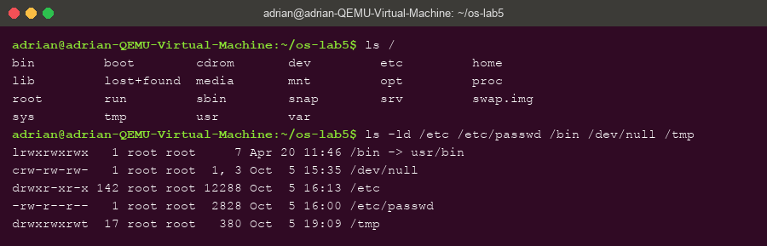
Figure 2.1 – The root of the tree and the types of five well-known paths
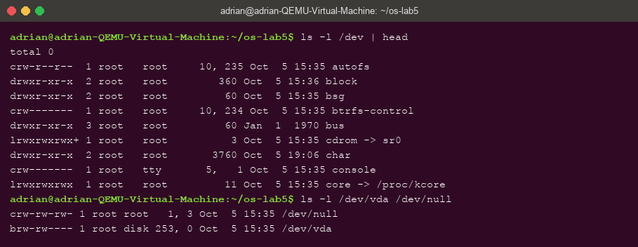
Figure 2.2 – /dev: character devices, and a block device (vda) next to /dev/null
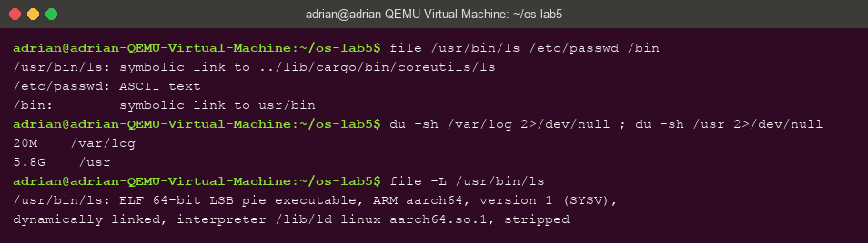
Figure 2.3 – file on three paths, and the sizes of /var/log and /usr

2.2 Observations
- Types from the first letter of ls -ld: /etc — d (directory); /etc/passwd — - (regular file); /bin — l (symbolic link); /dev/null — c (character device); /tmp — d (directory, with the sticky bit: drwxrwxrwt).
- /bin on this system is not a real directory but a symbolic link to usr/bin — the “merged /usr” layout of modern Ubuntu, kept as a link so old paths like /bin/sh still work.
- One character and one block device: /dev/null is a character device (crw-rw-rw-, major,minor 1,3) and /dev/vda — the virtual disk — is a block device (brw-rw----, 253,0). Character devices move byte streams; block devices move addressable blocks and can hold file systems.
- /var/log vs /usr: /usr is far bigger — 5.8 GiB versus 20 MiB for /var/log, roughly 300 times larger. (A detail worth noting: file /usr/bin/ls first reports a symbolic link — Ubuntu 26.04 ships the Rust coreutils — and following it with file -L shows the real type, an ELF 64-bit ARM executable.)

3 Lab 5 – Part 2: Inodes and Links

3.1 Commands executed and relevant output
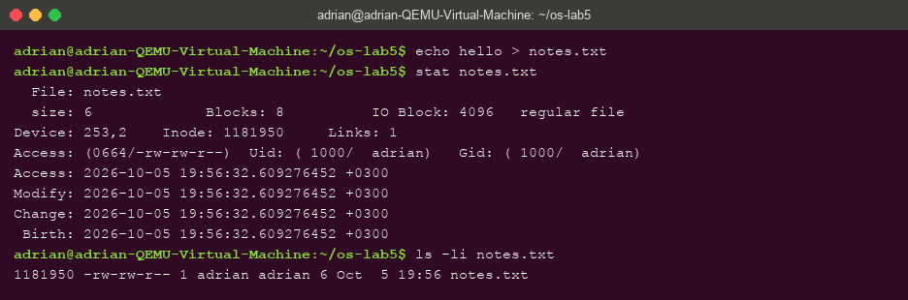
Figure 3.1 – stat and ls -li: the inode number (1181950) and the link count of notes.txt
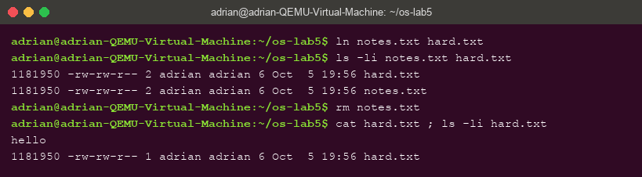
Figure 3.2 – A hard link shares the inode; after rm notes.txt the data is still there
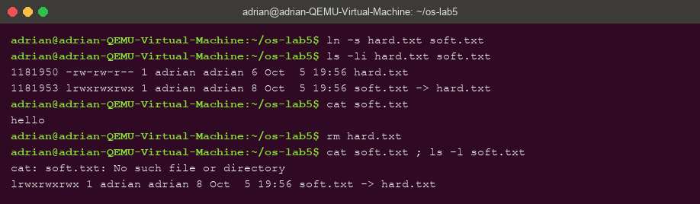
Figure 3.3 – A symbolic link has its own inode; it dangles after its target is removed
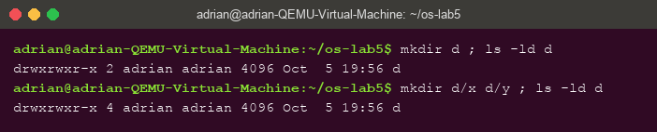
Figure 3.4 – Directory link counts: 2 when empty, 4 after two subdirectories
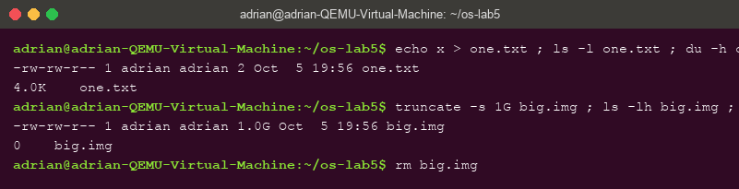
Figure 3.5 – Size is not space: 2 bytes occupy 4.0K, a sparse 1 GB file occupies 0

3.2 Observations
- In stat, Inode: 1181950 is the inode number and Links: 1 is how many names (directory entries) point to it; in ls -li they are the first number and the number after the permissions.
- Why hard.txt survived rm notes.txt: both names pointed to the same inode (identical in Figure 3.2), so the data had two names. rm removes a NAME and decrements the link count; the inode and its data are freed only when the count reaches zero and no process holds the file open.
- Why cat soft.txt failed although soft.txt exists: a symbolic link is a separate small file (own inode 1181953) whose content is just the PATH hard.txt. Opening it makes the kernel follow that path — which no longer exists. Its size is 8 bytes — exactly the length of the string “hard.txt”.
- Directory link counts 2 → 4: a new directory d is named by the entry d in its parent and by its own . entry; every subdirectory adds one more name via its .. entry — 2 + 2 = 4.
- 4.0K for 2 bytes, 0 for 1 GB: space is allocated in whole 4 KiB blocks, so a 2-byte file occupies one block, while truncate creates a SPARSE file — the size field says 1 GiB but no blocks were written, so du reports 0. Size is metadata; space is blocks.

4 Lab 5 – Part 3: Permissions

4.1 Commands executed and relevant output
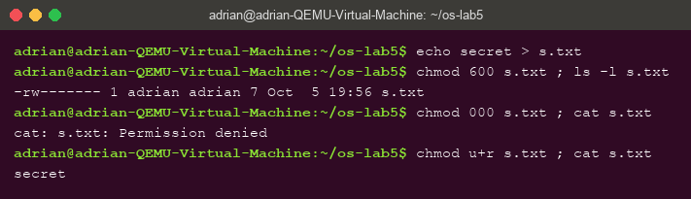
Figure 4.1 – chmod 600 / 000 / u+r on s.txt: even the owner needs the r bit
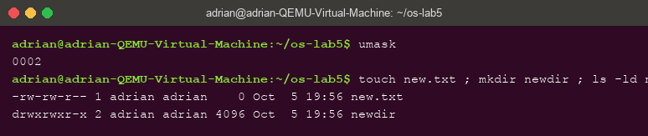
Figure 4.2 – The umask (0002) and the resulting permissions of new.txt and newdir
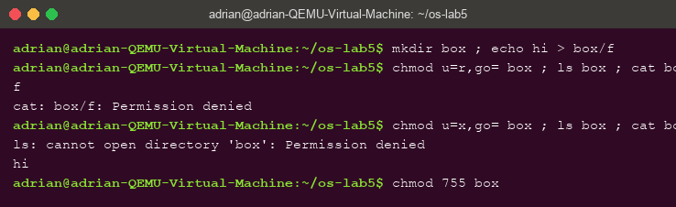
Figure 4.3 – The box experiment: r lists names only, x allows access but no listing
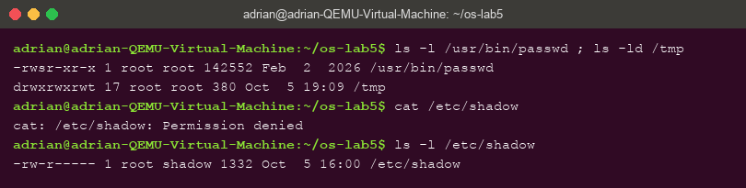
Figure 4.4 – The setuid bit on passwd, the sticky bit on /tmp, and /etc/shadow refusing a normal user

4.2 Observations
- As rwx strings: 600 = rw------- (private file, e.g. an SSH private key); 644 = rw-r--r-- (world-readable config); 755 = rwxr-xr-x (program or directory everyone may use); 700 = rwx------ (private directory such as ~/.ssh).
- Why ownership does not help with 000: the kernel checks the permission BITS, not the identity, on every open(). Owning a file grants the right to change its permissions, not an implicit right to read it — only root bypasses the checks.
- umask 0002: files are created as 666 minus the mask → 664 (new.txt), directories as 777 minus the mask → 775 (newdir).
- The box experiment: on a directory, r means “read the list of names” and x means “traverse”. With u=r only, ls listed f but cat box/f was denied; with u=x only, ls was denied but cat box/f worked.
- s and t: the s on /usr/bin/passwd is the setuid bit — the program runs as its owner (root). passwd needs it because changing a password means writing /etc/shadow, which a normal user may not even read (Figure 4.4). The t on /tmp is the sticky bit: anyone may create files there, but only a file's owner may delete them.

5 Lab 5 – Part 4: Disks and the Kernel as Files

5.1 Commands executed and relevant output
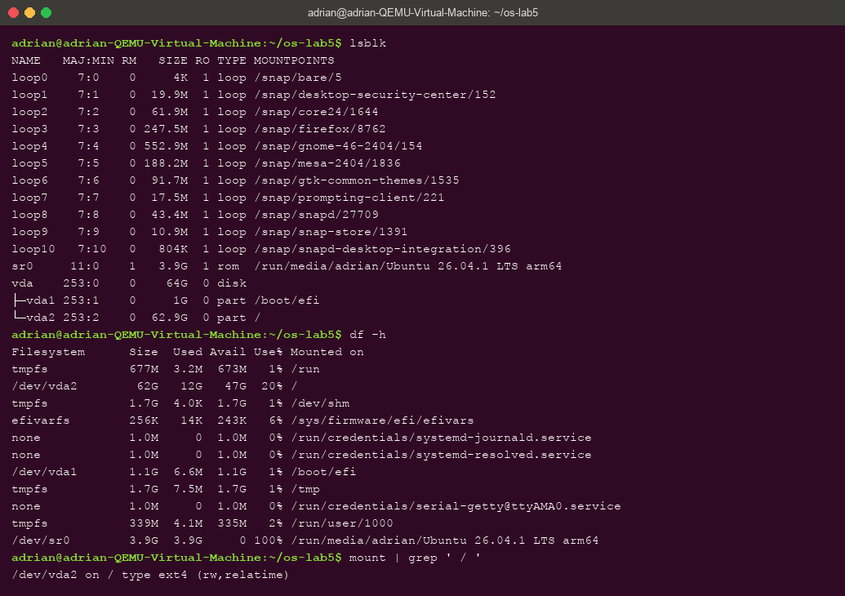
Figure 5.1 – lsblk, df -h and the mount line of the root file system
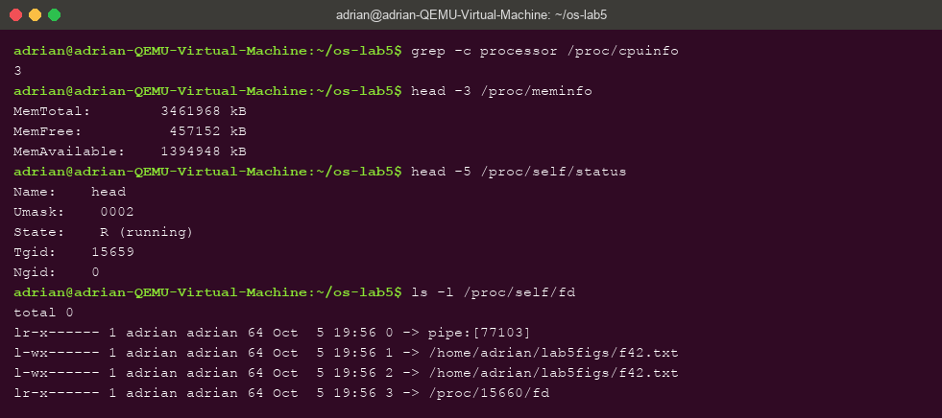
Figure 5.2 – /proc: CPU count, memory, /proc/self/status and /proc/self/fd

5.2 Observations
- The disk: vda (VirtIO, 64 GB) with vda1 (1 GB, /boot/efi) and vda2 (62.9 GB) mounted at / with ext4 (/dev/vda2 on / type ext4 (rw,relatime)).
- Root file system usage: 12 GiB used of 62 GiB — 20% full.
- CPUs and RAM according to /proc: 3 processors and MemTotal: 3461968 kB ≈ 3.3 GiB.
- The name in /proc/self/status was head — /proc/self always refers to the process that OPENS it, and in the pipeline that was head itself.

6 Lab 5 – Stretch: Magic Numbers and Deleted Open Files

6.1 (a) Magic numbers
Figure 6.1 – file identifies gzip data regardless of the .txt name; the magic bytes are 1f 8b
After gzip -c /etc/passwd > notes.txt, file reports “gzip compressed data” although the name ends in .txt — it reads the first bytes of the content. The bytes 1f 8b in the xxd dump are the gzip magic number. Types on Unix live in the content, not in the name.

6.2 (c) Deleting a file that is still open
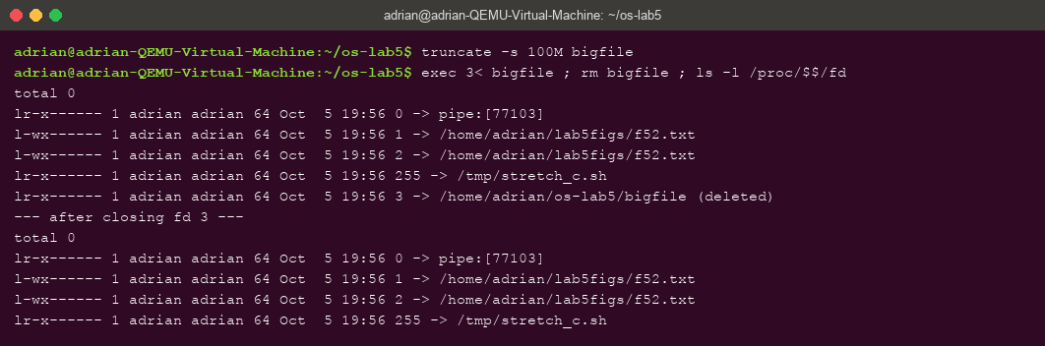
Figure 6.2 – An open, deleted file: fd 3 shows “(deleted)”; the entry disappears after exec 3<&-
With bigfile held open on descriptor 3, rm removed the name but /proc/$$/fd still shows bigfile (deleted) — the open descriptor keeps the inode alive; the space is freed only when the last descriptor closes (exec 3<&-).

7 Lab 6 – Part 1: Reading What xv6 Shows

7.1 Commands executed and relevant output
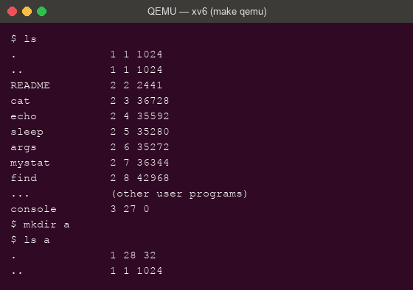
Figure 7.1 – xv6 ls: name, type, inode number, size; an empty directory has size 32
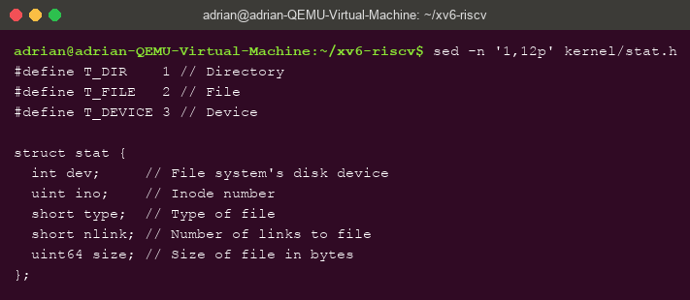
Figure 7.2 – kernel/stat.h: the three file types and struct stat

7.2 Observations
- The types in kernel/stat.h: 1 = T_DIR (directory), 2 = T_FILE (regular file), 3 = T_DEVICE (device — in the listing, console has type 3).
- The root directory has inode 1 (. 1 1 1024). . and .. are the same there because the root is its own parent — the tree has nowhere further up to go, so both entries point to inode 1.
- Directory entry size: an empty directory contains exactly its two obligatory entries, . and .., and has size 32 — so one entry is 16 bytes: a 2-byte inode number plus a 14-byte name (struct dirent with DIRSIZ 14).

8 Lab 6 – Part 2: mystat and Hard Links at Work

8.1 The program and its output
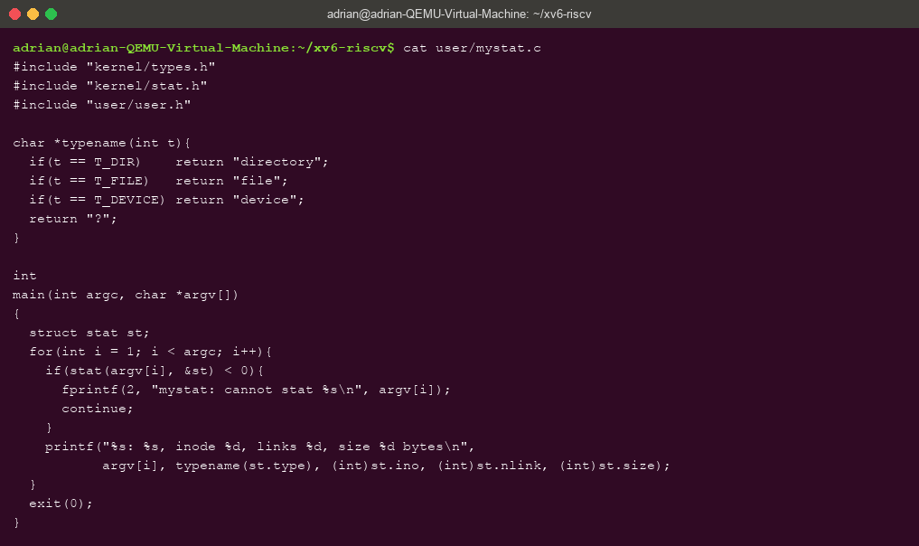
Figure 8.1 – user/mystat.c: typename() and the stat() loop completed
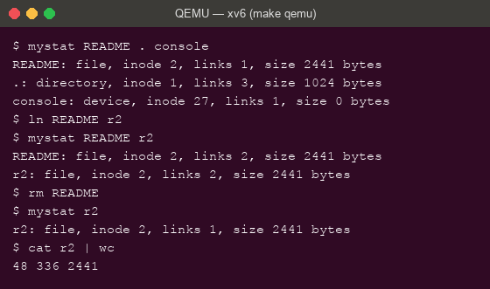
Figure 8.2 – mystat watching a hard link: ln shares inode 2, rm only decrements the link count
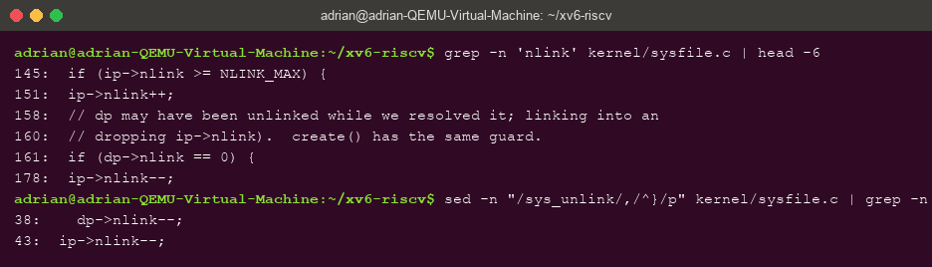
Figure 8.3 – sys_unlink in kernel/sysfile.c: the ip->nlink-- that rm triggers
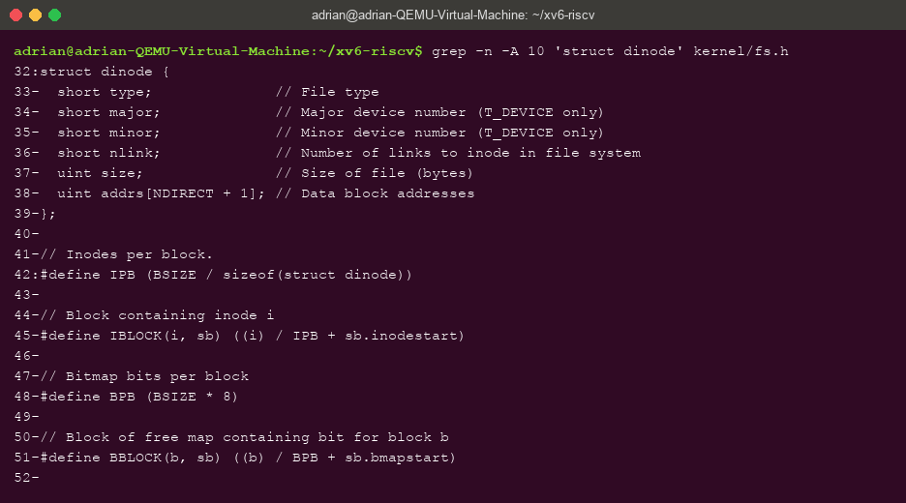
Figure 8.4 – struct dinode in kernel/fs.h: everything an xv6 inode stores

8.2 Observations
- After ln and after rm: after ln README r2 both names report inode 2, links 2 — the identical inode, one more name. After rm README, r2 still reports inode 2 with links 1, and cat r2 | wc still reads all 2441 bytes (48 336 2441). The name changed; the inode, type and size did not.
- The decrement in sys_unlink: inside sys_unlink the line ip->nlink-- (line 178 of kernel/sysfile.c) removes one name from the count. The data blocks are freed later, in iput(), and only when BOTH the link count is zero and no process still has the inode open — the same rule Lab 5 demonstrated from the outside with the (deleted) descriptor.
- What an xv6 inode holds (struct dinode): type, major/minor (device numbers), nlink, size, and addrs[NDIRECT+1] — the data block addresses. Compared with Linux there is no owner, no permission bits and no symlink support: xv6 keeps only the structural core of an inode.

9 Lab 6 – Part 3: Measuring the Limits

9.1 Commands executed and relevant output
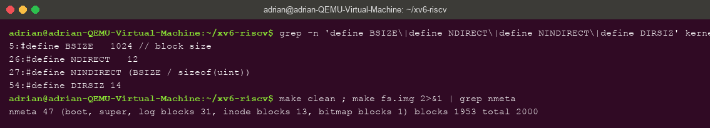
Figure 9.1 – The constants in kernel/fs.h and the disk layout printed by mkfs (nmeta line)
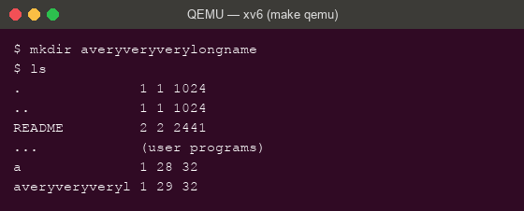
Figure 9.2 – A 21-character directory name silently truncated to 14 characters (DIRSIZ)

9.2 Observations
- The long name: ls shows averyveryveryl — exactly 14 characters. The constant DIRSIZ 14 is the fixed name field of a directory entry; longer names are silently truncated.
- Largest file: 12 direct blocks + one indirect block. The indirect block is one 1024-byte block holding 4-byte block numbers → NINDIRECT = 1024/4 = 256. Maximum file size = (12 + 256) × 1024 = 268 × 1024 = 274 432 bytes = 268 KiB.
- The disk layout from the nmeta line: 2000 blocks in total, of which 47 are metadata — 1 boot, 1 superblock, 31 log blocks (the journal), 13 inode blocks and 1 bitmap block — leaving 1953 data blocks.

10 Lab 6 – Part 4: find — Walking the Tree Recursively

10.1 The program and its output
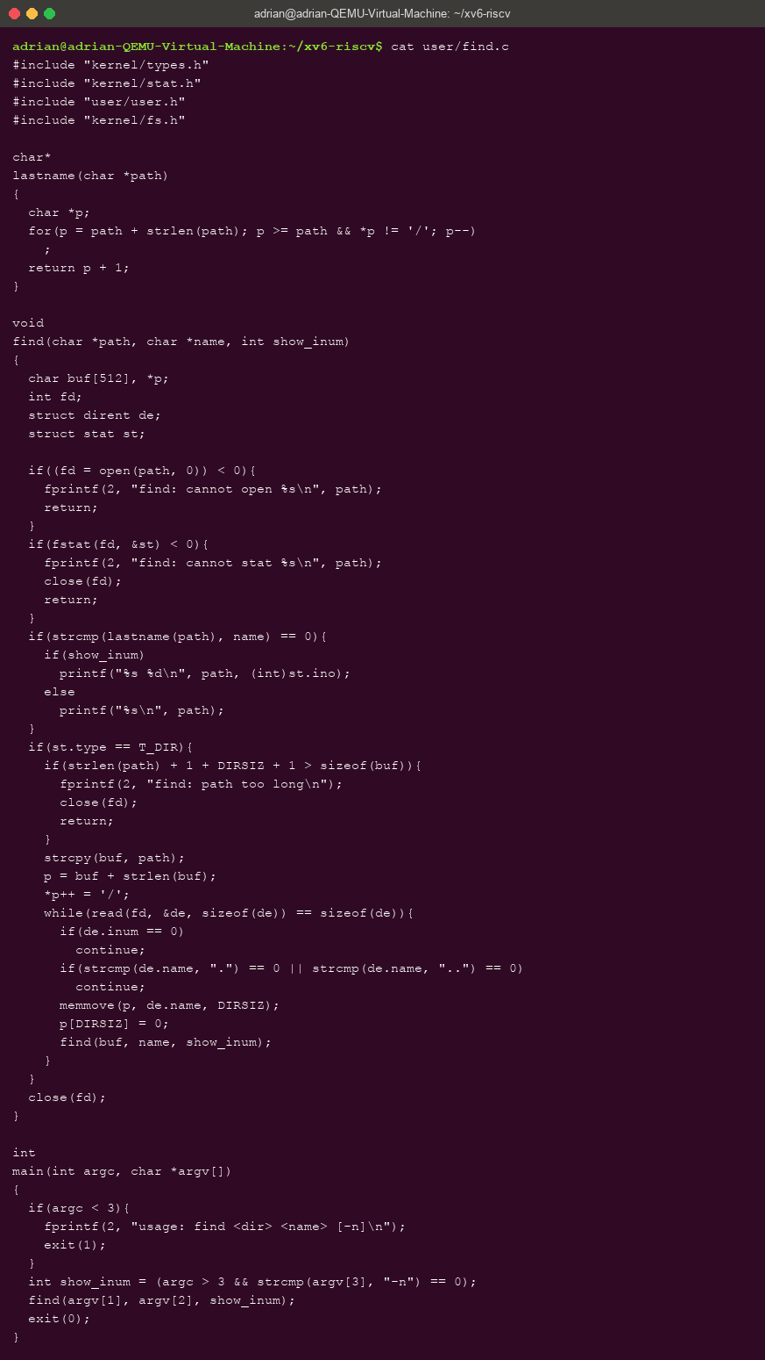
Figure 10.1 – user/find.c: recursive descent, skipping ".", ".." and free slots, closing every fd
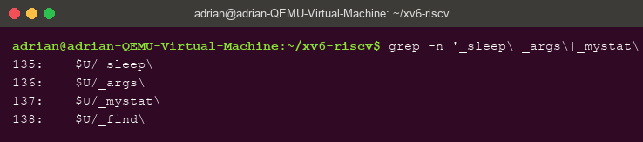
Figure 10.2 – The UPROGS lines for the Lab 6 programs in the Makefile
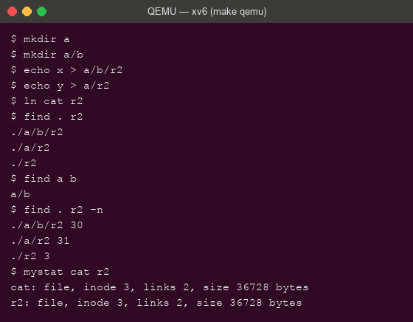
Figure 10.3 – find on a fresh disk, the -n stretch, and the proof that ./r2 is cat

10.2 Observations
- On the fresh disk, find . r2 prints exactly the expected three paths (./a/b/r2, ./a/r2, ./r2) and find a b prints a/b. The program starts from user/ls.c's pattern: open the directory, read struct dirent entries, skip inum == 0 and ./.., build the child path in a buffer, stat it and recurse into subdirectories — closing every descriptor, since a process has only 16.
- Stretch (-n): with the third argument, find prints each path's inode number: ./a/b/r2 30, ./a/r2 31, ./r2 3. So ./r2 is the SAME file as cat — ln cat r2 made it a second name for inode 3, which mystat cat r2 confirms: both show inode 3, links 2, size 36728. The other two r2 files are unrelated inodes that merely share the name.

11 Conclusions
Seen together, the two labs tell one story about file systems at two scales. On Linux, the experiments established the vocabulary with real consequences: names are directory entries pointing at inodes, hard links are extra names and rm merely removes one, a symbolic link is a tiny file containing a path, a file's size is metadata independent of its allocated blocks, and the permission bits — not ownership — are what the kernel checks, with setuid and the sticky bit covering the cases the basic model cannot.
Inside xv6 the same ideas stopped being abstractions and became readable code and measurable numbers: type 1/2/3 in stat.h, the root as inode 1 being its own parent, 16-byte directory entries explaining why an empty directory has size 32 and why names stop at 14 characters, ip->nlink-- in sys_unlink being exactly what rm triggers, and the on-disk layout — 2000 blocks, 47 of them metadata including a 31-block journal — printed by mkfs at build time. Writing mystat and find closed the loop from user space: stat() exposes the inode the kernel maintains, and a dozen lines of recursion over struct dirent are enough to walk the whole tree. The maximum file size, 268 KiB, follows from arithmetic anyone can redo: (12 + 256) blocks of 1024 bytes. A file system, at any scale, is inodes plus names plus blocks — and now each of those words points at something we have measured, broken and rebuilt ourselves.

