
MINISTRY OF EDUCATION AND RESEARCH OF THE REPUBLIC OF MOLDOVA
Technical University of Moldova
Faculty of Computers, Informatics and Microelectronics
Department of Software Engineering and Automation
Adrian Mutu
Group: FAF-242
Report
Laboratory Work No. 4
Operating Systems
Topic: The xv6 Shell from the Outside
Checked by:
Patricia Reitman
FCIM, UTM
Chișinău – 2026

Contents
1 Purpose of the Work
2 Part 1: Fixing sleep for the Current xv6
2.1 Commands executed and relevant output
2.2 Observations (Part 1)
3 Part 2: bash versus the xv6 Shell
3.1 The comparison table
3.2 Observations (Part 2)
4 Part 3: Who Expands *? A Program that Prints its argv
4.1 The two programs and their outputs
4.2 Observations (Part 3)
5 Part 4: Reading the Shell (user/sh.c)
5.1 Commands executed and relevant output
5.2 Observations (Part 4)
6 Conclusions

1 Purpose of the Work
The purpose of this laboratory work is to understand what a shell fundamentally is by comparing the minimal xv6 shell (user/sh.c, 499 lines) with bash, side by side. The work has four parts: making the sleep utility from Lab 2 build on the current xv6 tree (where the sleep() system call was renamed to pause() in August 2025); running the same ten command lines in bash and in the xv6 shell and explaining the differences; writing a small program that prints its argv, which reveals exactly who expands wildcards and removes quotes; and reading the source code of the xv6 shell to connect the observed behaviour with its implementation.
All host-side commands were executed on the Ubuntu 26.04 (aarch64) virtual machine in ~/xv6-riscv and ~/shtest; the xv6 commands were executed at the $ prompt of xv6 booted with make qemu.

2 Part 1: Fixing sleep for the Current xv6

2.1 Commands executed and relevant output
First I checked which name the tree uses — grep shows that user/user.h declares int pause(int); on line 25 and no sleep system call, so the tree is the post-August-2025 one and the program must call pause(). My user/sleep.c from Lab 2 already uses pause(atoi(argv[1])), and $U/_sleep\ is present in UPROGS (Makefile line 135), so the program builds unchanged.
Figure 1.1 – The grep result in user.h: the system call is pause(), line 25
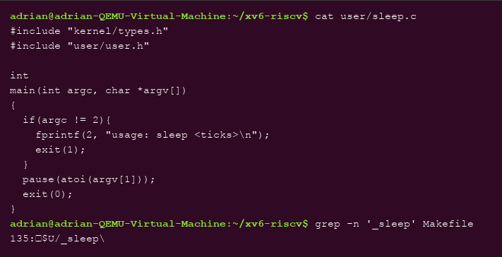
Figure 1.2 – The sleep.c source calling pause(), and its UPROGS line in the Makefile
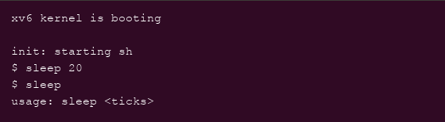
Figure 1.3 – sleep running in xv6: with an argument it pauses, without one it prints the usage error

2.2 Observations (Part 1)
- sleep 20 suspended the shell for 20 clock ticks (about two seconds) and returned to the prompt with no output — exactly the Unix convention that success is silent.
- Invoking sleep with no argument triggered the usage: sleep <ticks> message (written to file descriptor 2, stderr) and exit code 1.
- The rename from sleep() to pause() affects only the system-call name: the user-visible program is still called sleep, which is precisely why the authors freed the name.

3 Part 2: bash versus the xv6 Shell

3.1 The comparison table
Every command was run twice: in bash inside ~/shtest (containing only README), and at the xv6 $ prompt.
Command | Tests | bash | xv6 | Why
echo hello > f ; cat < f | redirection | hello | hello | Both support < and > redirection.
ls | grep READ | pipe | README | README 2 2 2441 | Both support pipes; xv6 ls prints name, type/inode/size.
(echo a; echo b) | wc | grouping, list | 2 2 4 | 2 2 4 | Both support ( ) grouping piped into a command.
echo one ; echo two | sequence | one, two | one, two | Both run ;-separated commands in order.
echo bg & | background | bg | bg | Both support & (xv6: BACK node, parent does not wait).
ls * | globbing | README f | ls: cannot open * | Only bash expands *; xv6 passes the literal * to ls.
echo $HOME | variables | /home/adrian | $HOME | Only bash has variables; xv6 echoes the literal string.
echo "a b" | quotes | a b | "a b" | Only bash processes quotes; xv6 passes them through.
mkdir d ; cd d ; ls .. | PATH / cd | README d f | exec cd failed + listing of / | In xv6, cd works only at the start of a line; in a ; list it is exec'd and fails, so the cwd never changed.
arrow up, Tab, Ctrl+R | history, completion | all work | nothing (raw input) | bash has readline; xv6 reads raw characters with gets().

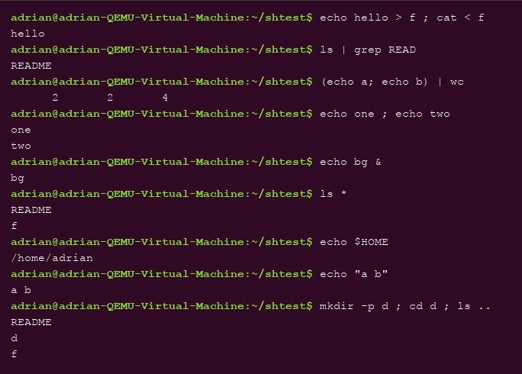
Figure 2.1 – The commands run in bash
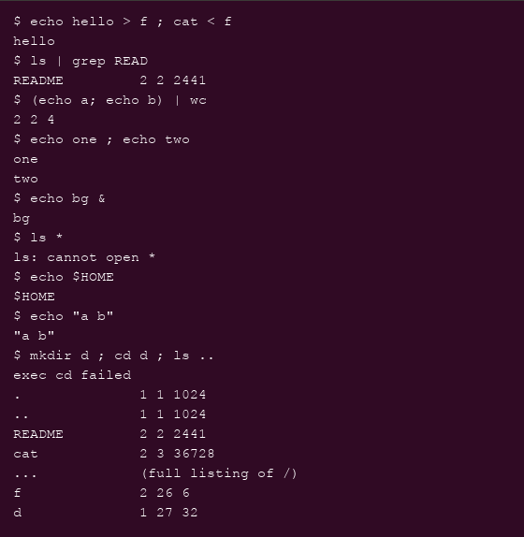
Figure 2.2 – The same commands run in xv6
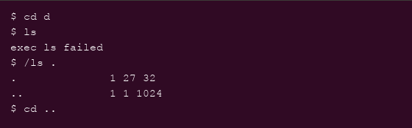
Figure 2.3 – ls failing after cd d (no PATH in xv6), and the working alternative /ls
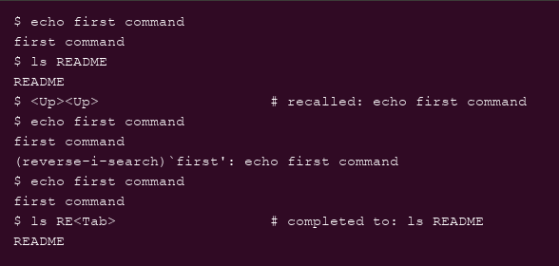
Figure 2.4 – History recall (arrow up), Ctrl+R search and Tab completion in bash

3.2 Observations (Part 2)
- Features both shells have: I/O redirection (<, >), pipes, command grouping with parentheses, ; lists and & background execution. Only bash has: globbing, variables, quote processing, a PATH search for programs, a built-in cd that works anywhere on the line, command history, Tab completion, incremental search, aliases and scripting constructs.
- Why ls stops working after cd d: xv6 has no PATH variable — the shell passes ls directly to exec(), which resolves it relative to the current directory. All xv6 binaries live in the root directory /, so from inside d the file ls does not exist and exec fails. The workaround is an absolute path: /ls . (Figure 2.3). An extra subtlety found while testing: in the line mkdir d ; cd d ; ls .., the cd printed exec cd failed — the xv6 shell special-cases cd only when it is the first word of the whole line, so inside a ; list it is forked and exec'd like a normal program, fails, and the working directory never changes.
- Most missed / easiest to add: in daily work I would most miss history and Tab completion — retyping full commands at the xv6 prompt is painful. The easiest feature to add would be the PATH search: a small loop in the shell (or in exec) that, when exec(argv[0]) fails, retries with "/" prepended — a few lines of code, unlike quoting or globbing which need a real tokenizer.

4 Part 3: Who Expands *? A Program that Prints its argv

4.1 The two programs and their outputs
user/args.c (xv6) and args_linux.c (Linux, compiled with gcc -o args args_linux.c) are the same five-line program: print argc, then every argv[i] between brackets. The xv6 version was added to UPROGS as $U/_args\ (Makefile line 136). The same four command lines were then run in both shells — in bash from ~/shtest, which contains the .c file args_linux.c.
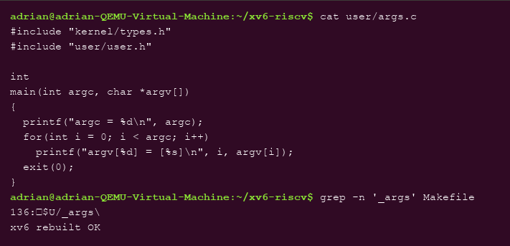
Figure 3.1 – args.c and its UPROGS line in the Makefile
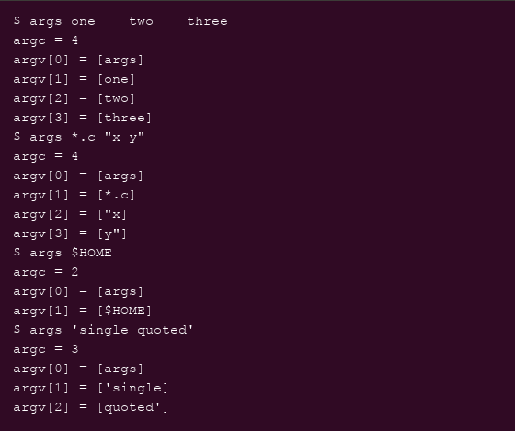
Figure 3.2 – args output in xv6: patterns, quotes and $HOME arrive literally
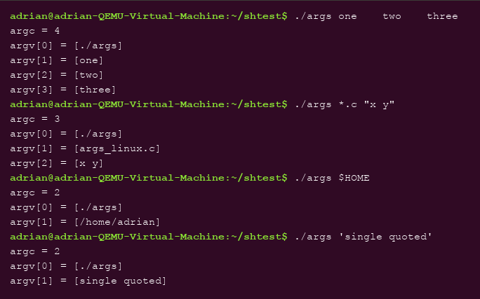
Figure 3.3 – args_linux output in bash: glob expanded, quotes removed, variable substituted

4.2 Observations (Part 3)
- args *.c "x y": in bash the program received argc = 3 — [./args] [args_linux.c] [x y]: the pattern was replaced by the matching file name and the quoted string arrived as ONE argument without quotes. In xv6 it received argc = 4 — [args] [*.c] ["x] [y"]: the pattern stayed literal and the quoted string was split into two arguments with the quote characters still attached.
- Who does the work: the shell. The program is identical in both cases and the kernel's exec() passes argument arrays through unchanged — so the only difference is what the shell did to the line before calling exec(). bash expands *.c, removes quotes and substitutes $HOME; the xv6 shell only splits on whitespace.
- The extra spaces in one two three: they disappeared in both shells — argc = 4 in both. Splitting the command line on runs of whitespace is the one transformation even the minimal xv6 shell performs; the program never sees how many spaces separated the words.

5 Part 4: Reading the Shell (user/sh.c)

5.1 Commands executed and relevant output
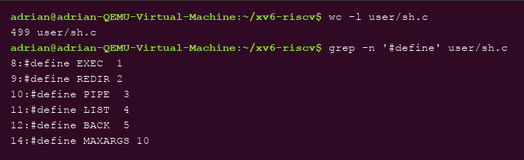
Figure 4.1 – sh.c is 499 lines; the five command kinds defined at its top
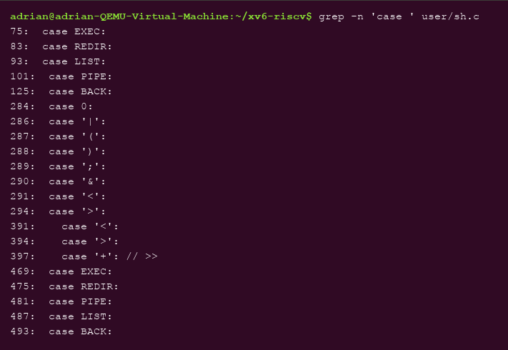
Figure 4.2 – The case labels: where each command kind is executed (runcmd) and parsed
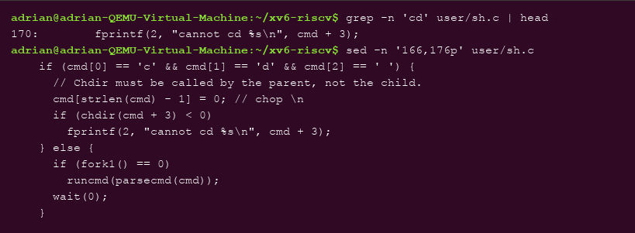
Figure 4.3 – The code that handles cd, inside main(), before any fork

5.2 Observations (Part 4)
- The five kinds of command (defined in lines 8–12) and the character that produces each: EXEC — a plain command word; REDIR — < or >; PIPE — |; LIST — ;; BACK — &. runcmd() dispatches on them in the case labels at lines 75–125.
- Where cd is handled and why: in main() (lines 166–171), before any fork — the comment in the source says it directly: “Chdir must be called by the parent, not the child.” A separate program could only change its own working directory and the change would be lost when it exits; the shell must call chdir() itself. This is also why cd works only as the first word of a line (the test is literally cmd[0]=='c' && cmd[1]=='d' && cmd[2]==' '), which explains the exec cd failed seen in Part 2.
- Code for * or $: there is none — no globbing and no variable code exists anywhere in sh.c (parsecmd() only recognizes the symbols | ( ) ; & < >). That is exactly why Part 2 printed ls: cannot open * and the literal $HOME: the characters reach the program untouched because the shell has no code to treat them specially.

6 Conclusions
In this laboratory work I compared a 499-line teaching shell with bash and learned to separate what a shell must do from what a shell may add. The xv6 shell implements exactly the structural core — splitting the line into words, redirection, pipes, lists, grouping and background execution — and runcmd() shows that this core is nothing more than fork(), exec(), open()/close()/dup() on file descriptors and wait(). Everything else that I use daily in bash — globbing, variables, quoting, PATH lookup, history and completion — is pure user-space convenience layered on top of the same five node types.
The args experiment made the division of labour concrete: the same program received argc = 3 in bash and argc = 4 in xv6 for the same command line, proving that wildcards, quotes and variables are expanded by the shell, not by the kernel and not by the program. Reading sh.c closed the loop: the behaviours observed from the outside map one-to-one to code that is present (the five #define kinds, cd handled by the parent in main) or deliberately absent (no code for * or $). After this lab, a shell is no longer a black box: it is a parser in front of fork and exec.

