
MINISTRY OF EDUCATION AND RESEARCH OF THE REPUBLIC OF MOLDOVA
Technical University of Moldova
Faculty of Computers, Informatics and Microelectronics
Department of Software Engineering and Automation
Adrian Mutu
Group: FAF-242
Report
Laboratory Work No. 7
Operating Systems
Topic: Three Small Programs: Processes, Redirection, a Pipe
Checked by:
Patricia Reitman
FCIM, UTM
Chișinău – 2026

Contents
1 Purpose of the Work
2 Part 1: fork + exec + wait
2.1 Commands executed and relevant output
2.2 Observations
3 Part 2: A Zombie, on Purpose
3.1 Commands executed and relevant output
3.2 Observations
4 Part 3: Redirection
4.1 Commands executed and relevant output
4.2 Observations
5 Part 4: A Pipe
5.1 Commands executed and relevant output
5.2 Observations
6 Conclusions

1 Purpose of the Work
To answer the lecture's three questions — how a process is born, where printf writes, and how ls | wc -l works — by building and running four small C programs on Linux: run.c (fork + exec + wait, the three steps of the shell), zombie.c (a child that ended but was not waited for), redirect.c (redirection by closing descriptor 1 before open) and pipeline.c (a pipe with two forks), plus the optional three-stage pipeline3.c.
All work was done in ~/os-lab7 on the Ubuntu 26.04 (aarch64) virtual machine, compiled with gcc 15.2 and -Wall -Wextra (no warnings).

2 Part 1: fork + exec + wait

2.1 Commands executed and relevant output
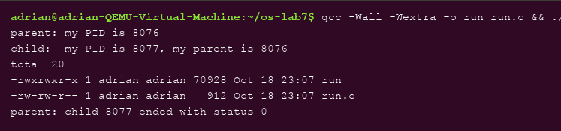
Figure 2.1 – run.c: parent forks, child becomes ls -l, parent waits — status 0
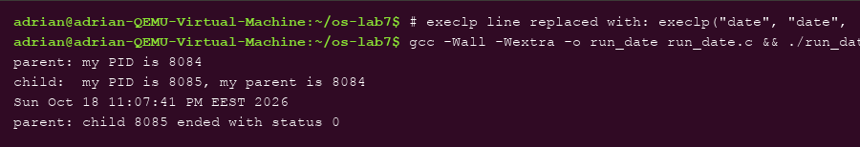
Figure 2.2 – The child changed to exec date: same three steps, different program
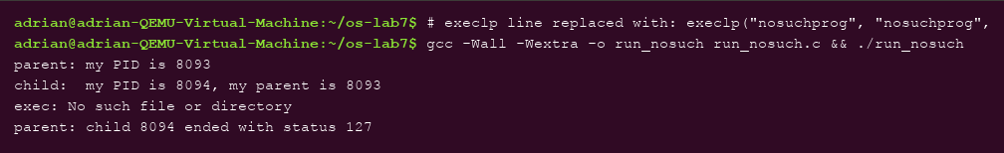
Figure 2.3 – exec of a program that does not exist: perror fires and the status is 127

2.2 Observations
- Why perror("exec") prints only with nosuchprog: a successful execlp REPLACES the child's program — the code after it no longer exists in the process, so the line can only run when exec fails and returns. With nosuchprog exec fails with ENOENT, so exec: No such file or directory appears and the child reaches exit(127).
- The number the child prints as “my parent”: 8076 — exactly the PID the parent printed for itself: getppid() in the child returns the parent's PID, confirming fork created a genuine parent–child pair.
- Status with ls vs nosuchprog: 0 with ls (ls succeeded) and 127 with nosuchprog — the value passed to exit(127) after the failed exec, the shell's conventional “command not found” code.

3 Part 2: A Zombie, on Purpose

3.1 Commands executed and relevant output
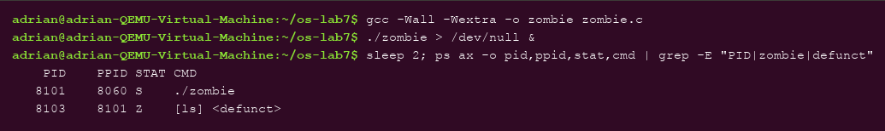
Figure 3.1 – While the parent sleeps: the child shows STAT Z, [ls] <defunct>
Figure 3.2 – After 20 seconds: waitpid ran and the zombie is gone

3.2 Observations
- The letter in STAT is Z (zombie): the child has already exited, but its exit status is still stored in the process table waiting for someone to collect it — it is dead, yet still occupies an entry, shown as [ls] <defunct>.
- After 20 seconds the defunct line is gone. The line that removed it is waitpid(pid, &status, 0); — when the parent finally calls wait, the kernel delivers the status and frees the table entry. A zombie is not a running process; it is an uncollected exit status.

4 Part 3: Redirection

4.1 Commands executed and relevant output
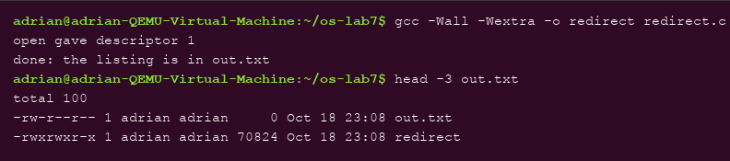
Figure 4.1 – redirect.c: open returns descriptor 1, and the listing of ls lands in out.txt

4.2 Observations
- open gave descriptor 1 — because descriptors are allocated as the SMALLEST free number, and the child had just closed 1. The message itself proves it (printed on stderr, descriptor 2, which stayed on the screen).
- Why ls's listing does not appear on screen: ls was not changed and still writes to descriptor 1 — but in this child, number 1 now refers to out.txt. Redirection is a property of the descriptor table the program inherits, not of the program.
- For 2> err.txt you would close descriptor 2 before the open, so the file takes number 2 and everything the program writes to stderr goes to the file.

5 Part 4: A Pipe

5.1 Commands executed and relevant output
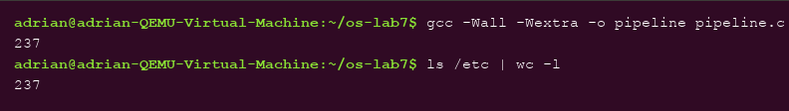
Figure 5.1 – pipeline.c prints 237 — the same number as the real ls /etc | wc -l
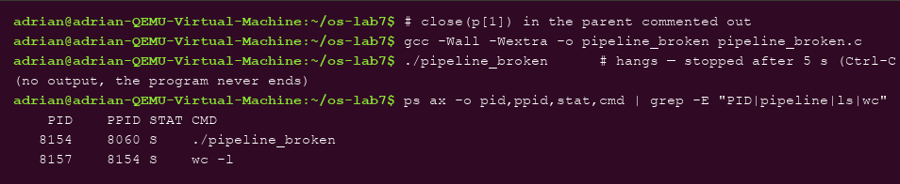
Figure 5.2 – With close(p[1]) commented out in the parent, the program hangs: wc is still alive
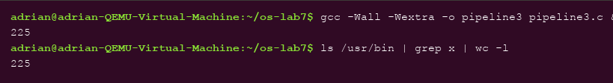
Figure 5.3 – Optional pipeline3.c (ls /usr/bin | grep x | wc -l): 225, equal to the shell

5.2 Observations
- Same number: yes — ./pipeline printed 237 and ls /etc | wc -l printed 237.
- Which child never ends: wc. The ps listing in Figure 5.2 shows wc -l still in state S while ls has long finished.
- What wc is waiting for: end-of-file on the pipe — EOF arrives only when ALL write ends are closed, and the parent still holds p[1] open, so wc keeps waiting for more input forever. (The committed pipeline.c is the working version; the experiment was done on a copy.)
- Optional pipeline3.c: two pipes, three children (ls → grep x → wc -l), every process closing all four pipe ends it does not use — it prints 225, identical to the shell.

6 Conclusions
This laboratory work demonstrated, with running code, that a shell is a thin layer over three kernel calls. fork duplicates a process (the child printed its parent's PID), exec replaces its program (which is why perror after a successful exec never runs), and wait collects the exit status (whose value, 0 or 127, is a convention chosen by the program, not by the kernel). The zombie experiment made the bookkeeping visible: a Z process is nothing but an uncollected status, created by delaying wait and destroyed by calling it.
Redirection and pipes turned out to be descriptor-table manipulation, not program features: ls never changed, yet wrote to a file because number 1 happened to name out.txt in its child — the smallest-free-number rule doing all the work for both open and dup. The pipeline matched the real shell exactly (237, and 225 for the three-stage version), and breaking it on purpose taught the one subtle rule of pipes: EOF exists only when every write end is closed, so one forgotten close(p[1]) in the parent leaves wc waiting forever.

