
MINISTRY OF EDUCATION AND RESEARCH OF THE REPUBLIC OF MOLDOVA
Technical University of Moldova
Faculty of Computers, Informatics and Microelectronics
Department of Software Engineering and Automation
Adrian Mutu
Group: FAF-242
Report
Laboratory Work No. 5
Operating Systems
Topic: The File System with Your Own Hands
Checked by:
Patricia Reitman
FCIM, UTM
Chișinău – 2026

Contents
1 Purpose of the Work
2 Part 1: The Tree and the File Types
2.1 Commands executed and relevant output
2.2 Observations
3 Part 2: Inodes and Links
3.1 Commands executed and relevant output
3.2 Observations
4 Part 3: Permissions
4.1 Commands executed and relevant output
4.2 Observations
5 Part 4: Disks and the Kernel as Files
5.1 Commands executed and relevant output
5.2 Observations
6 Stretch: Magic Numbers and Deleted Open Files
6.1 (a) Magic numbers
6.2 (c) Deleting a file that is still open
7 Conclusions

1 Purpose of the Work
To verify, by direct experiment on Linux, the file-system concepts from the lecture: the directory tree and the file types, the inodes behind the names, hard and symbolic links, the difference between a file's size and the space it occupies, the permission model (including the special bits and the umask), and the disks and kernel interfaces exposed as files. No programming is involved — only commands, careful observation and short explanations.
All commands were executed as the normal user adrian (not root, so that permission checks are real) in ~/os-lab5 on the Ubuntu 26.04 (aarch64) virtual machine.

2 Part 1: The Tree and the File Types

2.1 Commands executed and relevant output
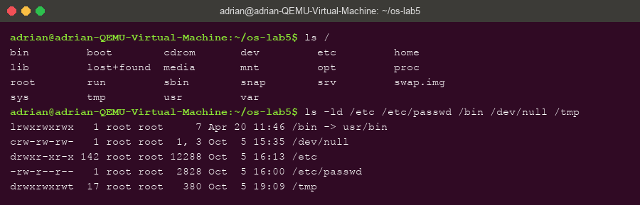
Figure 1.1 – The root of the tree and the types of five well-known paths
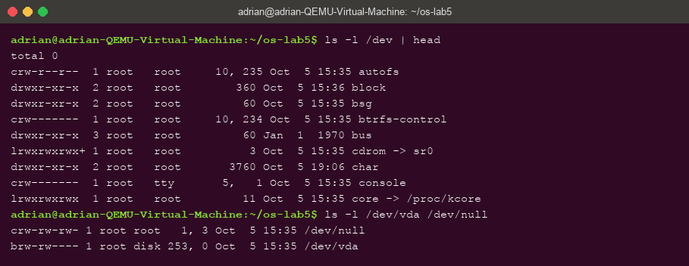
Figure 1.2 – /dev: character devices, and a block device (vda) next to /dev/null
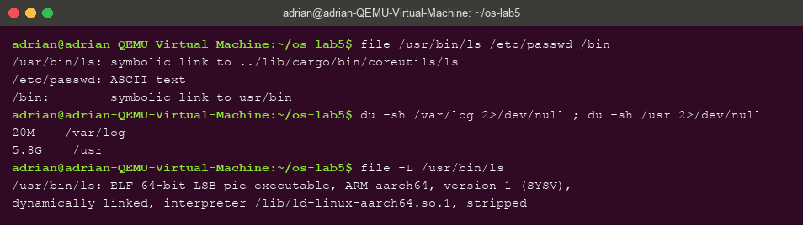
Figure 1.3 – file on three paths, and the sizes of /var/log and /usr

2.2 Observations
- Types from the first letter of ls -ld: /etc — d (directory); /etc/passwd — - (regular file); /bin — l (symbolic link); /dev/null — c (character device); /tmp — d (directory, with the sticky bit: drwxrwxrwt).
- /bin is not a real directory but a symbolic link to usr/bin — the “merged /usr” layout of modern Ubuntu, kept as a link so old paths like /bin/sh still work.
- One character and one block device: /dev/null is a character device (crw-rw-rw-, major,minor 1,3) and /dev/vda — the virtual disk — is a block device (brw-rw----, 253,0). Character devices move byte streams; block devices move addressable blocks and can hold file systems.
- /var/log vs /usr: /usr is far bigger — 5.8 GiB versus 20 MiB for /var/log, roughly 300 times larger. (A detail worth noting: file /usr/bin/ls first reports a symbolic link — Ubuntu 26.04 ships the Rust coreutils — and following it with file -L shows the real type, an ELF 64-bit ARM executable.)

3 Part 2: Inodes and Links

3.1 Commands executed and relevant output
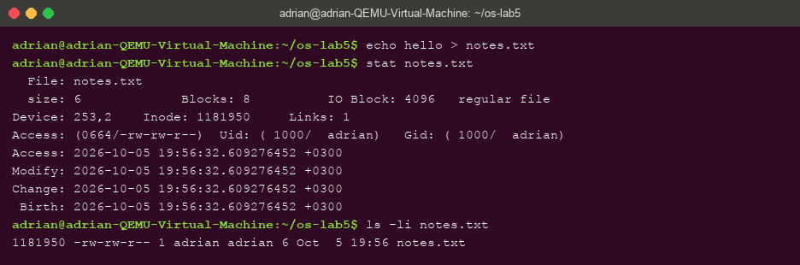
Figure 2.1 – stat and ls -li: the inode number (1181950) and the link count of notes.txt
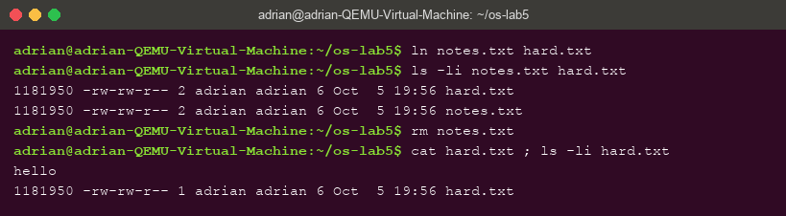
Figure 2.2 – A hard link shares the inode; after rm notes.txt the data is still there
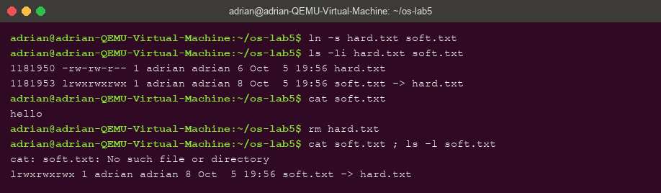
Figure 2.3 – A symbolic link has its own inode; it dangles after its target is removed
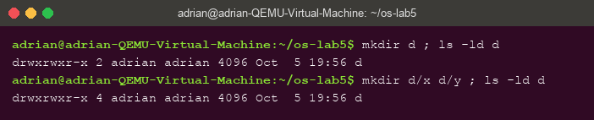
Figure 2.4 – Directory link counts: 2 when empty, 4 after two subdirectories
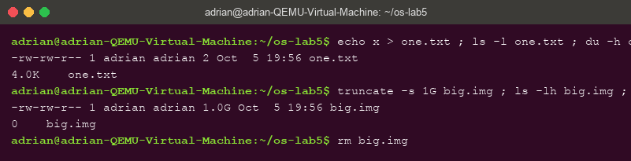
Figure 2.5 – Size is not space: 2 bytes occupy 4.0K, a sparse 1 GB file occupies 0

3.2 Observations
- In stat, Inode: 1181950 is the inode number and Links: 1 is how many names (directory entries) point to it; in ls -li they are the first number and the number after the permissions.
- Why hard.txt survived rm notes.txt: both names pointed to the same inode (identical in Figure 2.2), so the data had two names. rm removes a NAME and decrements the link count; the inode and its data are freed only when the count reaches zero and no process holds the file open.
- Why cat soft.txt failed although soft.txt exists: a symbolic link is a separate small file (own inode 1181953) whose content is just the PATH hard.txt. Opening it makes the kernel follow that path — which no longer exists. Its size is 8 bytes — exactly the length of the string “hard.txt”.
- Directory link counts 2 → 4: a new directory d is named by the entry d in its parent and by its own . entry; every subdirectory adds one more name via its .. entry — 2 + 2 = 4.
- 4.0K for 2 bytes, 0 for 1 GB: space is allocated in whole 4 KiB blocks, so a 2-byte file occupies one block, while truncate creates a SPARSE file — the size field says 1 GiB but no blocks were written, so du reports 0. Size is metadata; space is blocks.

4 Part 3: Permissions

4.1 Commands executed and relevant output
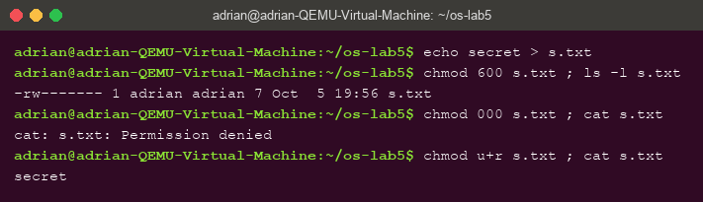
Figure 3.1 – chmod 600 / 000 / u+r on s.txt: even the owner needs the r bit
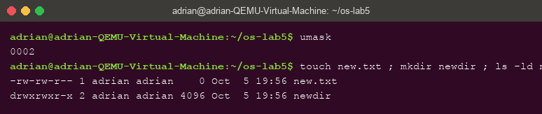
Figure 3.2 – The umask (0002) and the resulting permissions of new.txt and newdir
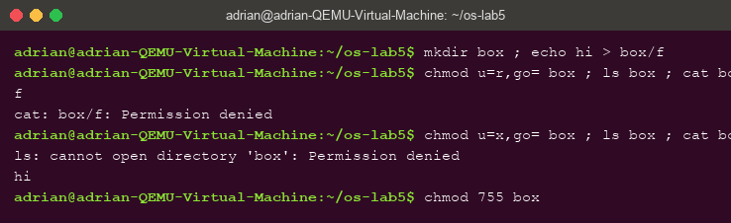
Figure 3.3 – The box experiment: r lists names only, x allows access but no listing
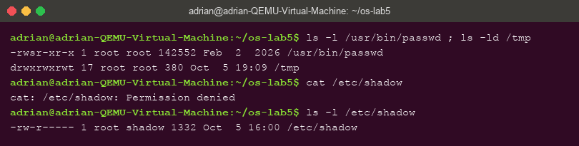
Figure 3.4 – The setuid bit on passwd, the sticky bit on /tmp, and /etc/shadow refusing a normal user

4.2 Observations
- As rwx strings: 600 = rw------- (private file, e.g. an SSH private key); 644 = rw-r--r-- (world-readable config); 755 = rwxr-xr-x (program or directory everyone may use); 700 = rwx------ (private directory such as ~/.ssh).
- Why ownership does not help with 000: the kernel checks the permission BITS, not the identity, on every open(). Owning a file grants the right to change its permissions, not an implicit right to read it — only root bypasses the checks.
- umask 0002: files are created as 666 minus the mask → 664 (new.txt), directories as 777 minus the mask → 775 (newdir).
- The box experiment: on a directory, r means “read the list of names” and x means “traverse”. With u=r only, ls listed f but cat box/f was denied; with u=x only, ls was denied but cat box/f worked.
- s and t: the s on /usr/bin/passwd is the setuid bit — the program runs as its owner (root). passwd needs it because changing a password means writing /etc/shadow, which a normal user may not even read (Figure 3.4). The t on /tmp is the sticky bit: anyone may create files there, but only a file's owner may delete them.

5 Part 4: Disks and the Kernel as Files

5.1 Commands executed and relevant output
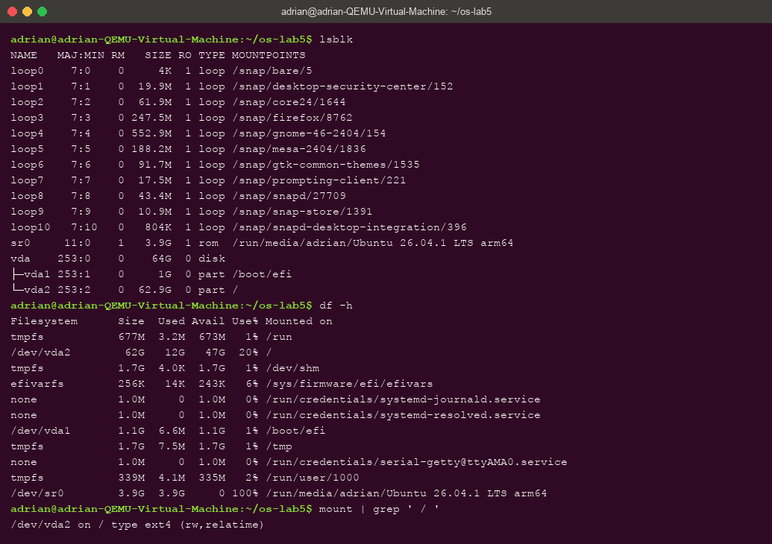
Figure 4.1 – lsblk, df -h and the mount line of the root file system
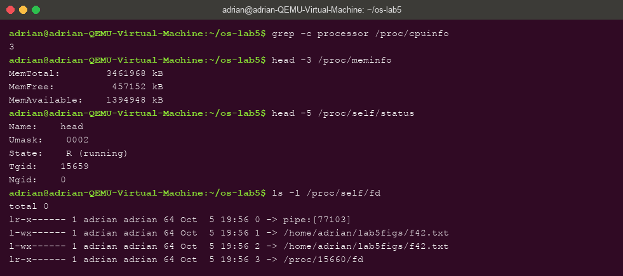
Figure 4.2 – /proc: CPU count, memory, /proc/self/status and /proc/self/fd

5.2 Observations
- The disk: vda (VirtIO, 64 GB) with vda1 (1 GB, /boot/efi) and vda2 (62.9 GB) mounted at / with ext4 (/dev/vda2 on / type ext4 (rw,relatime)).
- Root file system usage: 12 GiB used of 62 GiB — 20% full.
- CPUs and RAM according to /proc: 3 processors and MemTotal: 3461968 kB ≈ 3.3 GiB.
- The name in /proc/self/status was head — /proc/self always refers to the process that OPENS it, and in the pipeline that was head itself.

6 Stretch: Magic Numbers and Deleted Open Files

6.1 (a) Magic numbers
Figure 6.1 – file identifies gzip data regardless of the .txt name; the magic bytes are 1f 8b
After gzip -c /etc/passwd > notes.txt, file reports “gzip compressed data” although the name ends in .txt — it reads the first bytes of the content. The bytes 1f 8b in the xxd dump are the gzip magic number. Types on Unix live in the content, not in the name.

6.2 (c) Deleting a file that is still open
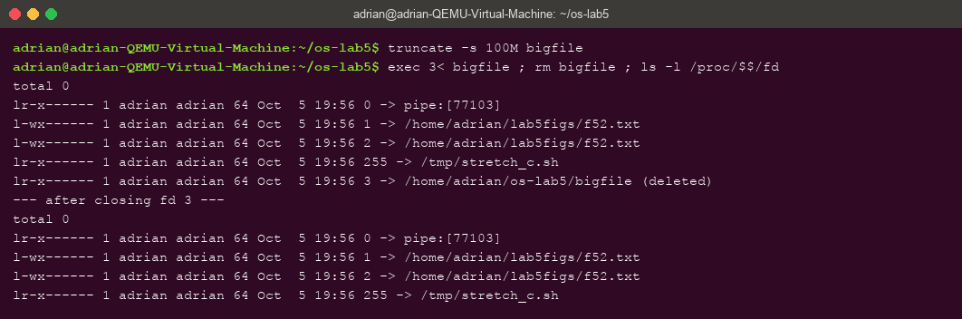
Figure 6.2 – An open, deleted file: fd 3 shows “(deleted)”; the entry disappears after exec 3<&-
With bigfile held open on descriptor 3, rm removed the name but /proc/$$/fd still shows bigfile (deleted) — the open descriptor keeps the inode alive; the space is freed only when the last descriptor closes (exec 3<&-).

7 Conclusions
This laboratory work turned the lecture's file-system concepts into things I have now seen with my own commands. The central idea is the separation between names and inodes: a file is the inode with its data blocks, while directory entries are merely names pointing at it. That one idea explained everything in Part 2 — hard links are extra names for the same inode, rm only removes names, a symbolic link is a little file containing a path (8 bytes for “hard.txt”), directory link counts follow from . and .. entries, and a file's size (inode metadata) is independent of the blocks actually allocated, as the 0-block sparse gigabyte showed.
The permission experiments showed that the kernel checks bits, not ownership — with mode 000 even the owner is refused — and gave precise meaning to r and x on directories, to the umask arithmetic, and to the special bits: setuid is what lets passwd write a shadow file its caller cannot even read, and the sticky bit is what makes the world-writable /tmp safe. Part 4 and the stretch experiments closed the picture: the disk is a block device carrying ext4 partitions, /proc exposes the kernel's view of the machine and of the asking process itself, file types are decided by magic bytes rather than names, and an open file survives its own deletion until the last descriptor closes.

