
MINISTRY OF EDUCATION AND RESEARCH OF THE REPUBLIC OF MOLDOVA
Technical University of Moldova
Faculty of Computers, Informatics and Microelectronics
Department of Software Engineering and Automation
Adrian Mutu
Group: FAF-242
Report
Laboratory Work No. 6
Operating Systems
Topic: Inside the xv6 File System
Checked by:
Patricia Reitman
FCIM, UTM
Chișinău – 2026

Contents
1 Purpose of the Work
2 Part 1: Reading What xv6 Shows
2.1 Commands executed and relevant output
2.2 Observations
3 Part 2: mystat and Hard Links at Work
3.1 The program and its output
3.2 Observations
4 Part 3: Measuring the Limits
4.1 Commands executed and relevant output
4.2 Observations
5 Part 4: find — Walking the Tree Recursively
5.1 The program and its output
5.2 Observations
6 Conclusions

1 Purpose of the Work
To study the same file-system ideas as in Lab 5 — inodes, directories as tables, hard links, a journal — inside the xv6 teaching system, where they fit in a few hundred readable lines: reading inode numbers and directory sizes at the xv6 prompt, writing a mystat program over the stat() system call to watch hard links at work, measuring the limits written in kernel/fs.h, and writing the recursive find utility (with the inode-printing -n stretch).
The work was done in the ~/xv6-riscv tree on the Ubuntu 26.04 (aarch64) virtual machine, with xv6 booted in QEMU via make qemu; new programs are user/NAME.c files plus $U/_NAME\ lines in the Makefile's UPROGS list.

2 Part 1: Reading What xv6 Shows

2.1 Commands executed and relevant output
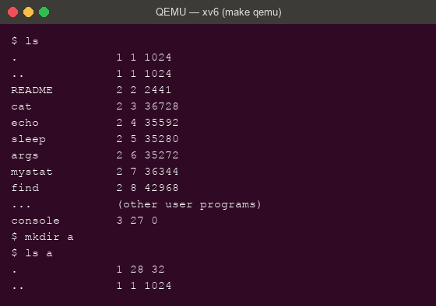
Figure 2.1 – xv6 ls: name, type, inode number, size; an empty directory has size 32
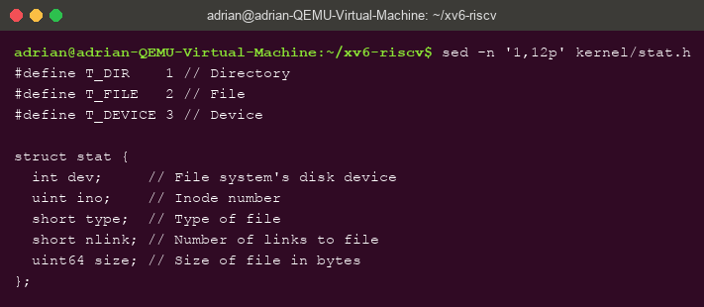
Figure 2.2 – kernel/stat.h: the three file types and struct stat

2.2 Observations
- The types in kernel/stat.h: 1 = T_DIR (directory), 2 = T_FILE (regular file), 3 = T_DEVICE (device — in the listing, console has type 3).
- The root directory has inode 1 (. 1 1 1024). . and .. are the same there because the root is its own parent — the tree has nowhere further up to go, so both entries point to inode 1.
- Directory entry size: an empty directory contains exactly its two obligatory entries, . and .., and has size 32 — so one entry is 16 bytes: a 2-byte inode number plus a 14-byte name (struct dirent with DIRSIZ 14).

3 Part 2: mystat and Hard Links at Work

3.1 The program and its output
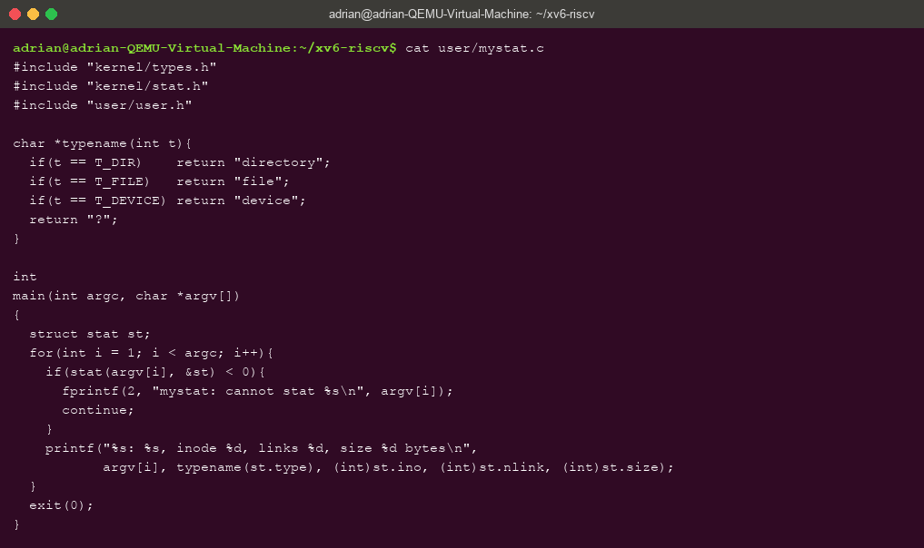
Figure 3.1 – user/mystat.c: typename() and the stat() loop completed
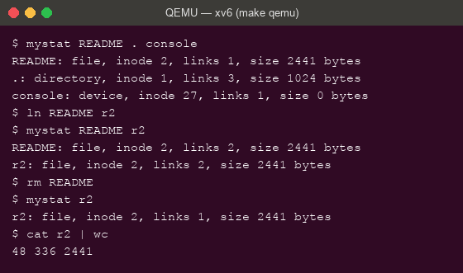
Figure 3.2 – mystat watching a hard link: ln shares inode 2, rm only decrements the link count
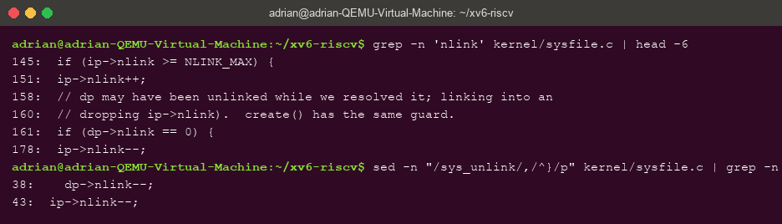
Figure 3.3 – sys_unlink in kernel/sysfile.c: the ip->nlink-- that rm triggers
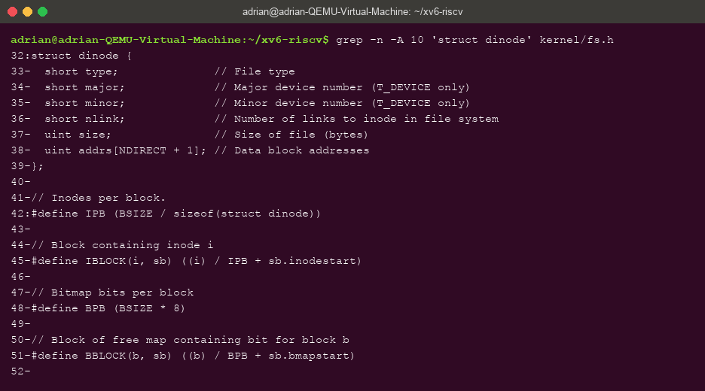
Figure 3.4 – struct dinode in kernel/fs.h: everything an xv6 inode stores

3.2 Observations
- After ln and after rm: after ln README r2 both names report inode 2, links 2 — the identical inode, one more name. After rm README, r2 still reports inode 2 with links 1, and cat r2 | wc still reads all 2441 bytes (48 336 2441). The name changed; the inode, type and size did not.
- The decrement in sys_unlink: inside sys_unlink the line ip->nlink-- (line 178 of kernel/sysfile.c) removes one name from the count. The data blocks are freed later, in iput(), and only when BOTH the link count is zero and no process still has the inode open.
- What an xv6 inode holds (struct dinode): type, major/minor (device numbers), nlink, size, and addrs[NDIRECT+1] — the data block addresses. Compared with Linux there is no owner, no permission bits and no symlink support: xv6 keeps only the structural core of an inode.

4 Part 3: Measuring the Limits

4.1 Commands executed and relevant output
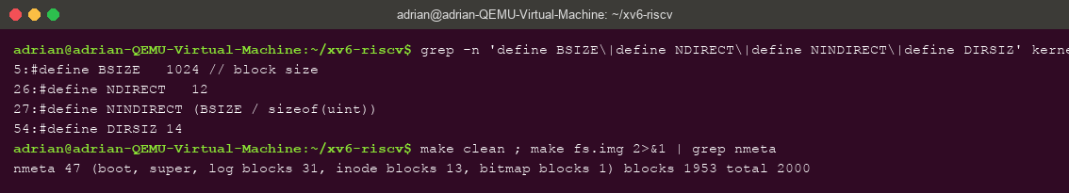
Figure 4.1 – The constants in kernel/fs.h and the disk layout printed by mkfs (nmeta line)
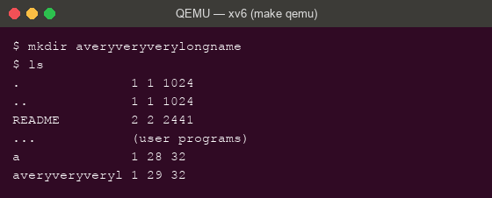
Figure 4.2 – A 21-character directory name silently truncated to 14 characters (DIRSIZ)

4.2 Observations
- The long name: ls shows averyveryveryl — exactly 14 characters. The constant DIRSIZ 14 is the fixed name field of a directory entry; longer names are silently truncated.
- Largest file: 12 direct blocks + one indirect block. The indirect block is one 1024-byte block holding 4-byte block numbers → NINDIRECT = 1024/4 = 256. Maximum file size = (12 + 256) × 1024 = 268 × 1024 = 274 432 bytes = 268 KiB.
- The disk layout from the nmeta line: 2000 blocks in total, of which 47 are metadata — 1 boot, 1 superblock, 31 log blocks (the journal), 13 inode blocks and 1 bitmap block — leaving 1953 data blocks.

5 Part 4: find — Walking the Tree Recursively

5.1 The program and its output
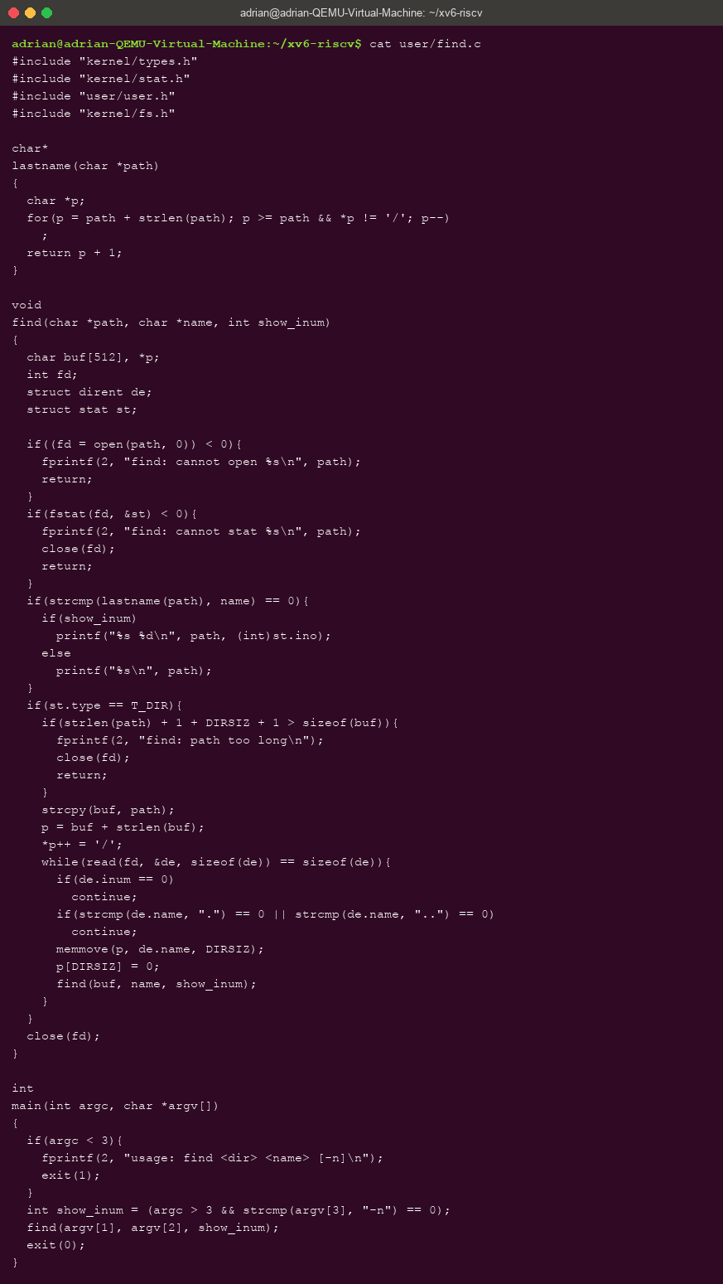
Figure 5.1 – user/find.c: recursive descent, skipping ".", ".." and free slots, closing every fd
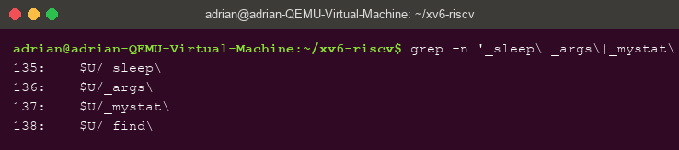
Figure 5.2 – The UPROGS lines for the new programs in the Makefile
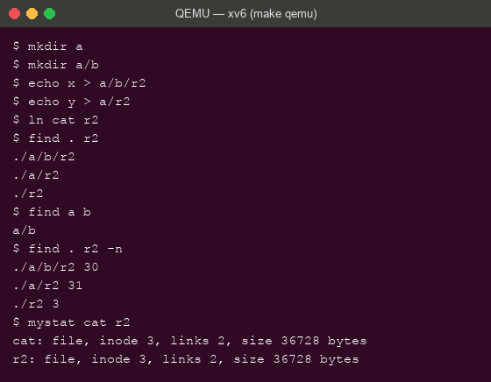
Figure 5.3 – find on a fresh disk, the -n stretch, and the proof that ./r2 is cat

5.2 Observations
- On the fresh disk, find . r2 prints exactly the expected three paths (./a/b/r2, ./a/r2, ./r2) and find a b prints a/b. The program follows user/ls.c's pattern: open the directory, read struct dirent entries, skip inum == 0 and ./.., build the child path in a buffer, stat it and recurse — closing every descriptor, since a process has only 16.
- Stretch (-n): with the third argument, find prints each path's inode number: ./a/b/r2 30, ./a/r2 31, ./r2 3. So ./r2 is the SAME file as cat — ln cat r2 made it a second name for inode 3, which mystat cat r2 confirms: both show inode 3, links 2, size 36728.

6 Conclusions
Inside xv6 the file-system ideas of the lecture stopped being abstractions and became readable code and measurable numbers: type 1/2/3 in stat.h, the root as inode 1 being its own parent, 16-byte directory entries explaining why an empty directory has size 32 and why names stop at 14 characters, ip->nlink-- in sys_unlink being exactly what rm triggers, and the on-disk layout — 2000 blocks, 47 of them metadata including a 31-block journal — printed by mkfs at build time.
Writing mystat and find closed the loop from user space: stat() exposes the inode the kernel maintains, and a dozen lines of recursion over struct dirent are enough to walk the whole tree. The maximum file size, 268 KiB, follows from arithmetic anyone can redo: (12 + 256) blocks of 1024 bytes. A file system is inodes plus names plus blocks — and the ln cat r2 experiment showed a “file name” is truly just a label on an inode: the same inode 3 answers to both cat and r2.

