
MINISTRY OF EDUCATION AND RESEARCH OF THE REPUBLIC OF MOLDOVA
Technical University of Moldova
Faculty of Computers, Informatics and Microelectronics
Department of Software Engineering and Automation
Adrian Mutu
Group: FAF-242
Report
Laboratory Work No. 8
Operating Systems
Topic: The Same Calls, Inside Your Own OS (xv6)
Checked by:
Patricia Reitman
FCIM, UTM
Chișinău – 2026

Contents
1 Purpose of the Work
2 Part 1: run, Inside xv6
2.1 Commands executed and relevant output
2.2 Observations
3 Part 2: pingpong
3.1 The program and its output
3.2 Observations
4 Optional: primes
4.1 Output
5 Conclusions

1 Purpose of the Work
To run the same three system calls as in Lab 7 — fork, exec, wait — inside xv6, the small OS built this semester, and to make two processes talk through pipes: user/run.c repeats the three steps of the shell with the kernel we compiled ourselves, and user/pingpong.c exchanges one byte between parent and child through a pair of pipes. The optional user/primes.c builds a chain of processes that sieves the primes up to 35.
The work was done in the ~/xv6-riscv tree, booted in QEMU with make qemu; each program is a user/NAME.c file plus a $U/_NAME\ line in UPROGS.

2 Part 1: run, Inside xv6

2.1 Commands executed and relevant output
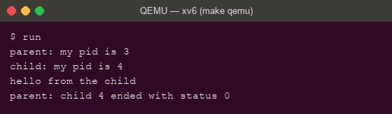
Figure 2.1 – user/run.c in xv6: fork, exec("echo"), wait — the same three steps
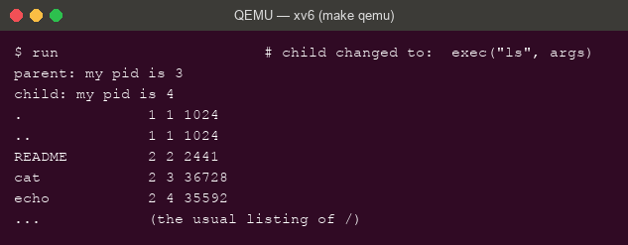
Figure 2.2 – The child changed to exec("ls"): the xv6 listing, then back to the parent
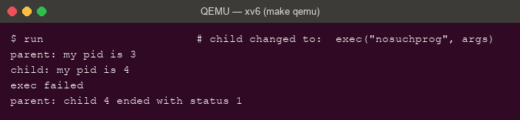
Figure 2.3 – exec of nosuchprog in xv6: "exec failed" and status 1

2.2 Observations
- The three calls are the same calls: on Linux fork(), execlp(), waitpid(); in xv6 fork(), exec(), wait(). Only the library wrappers differ (execlp searches PATH and builds argv from the C varargs; xv6's raw exec takes the path and the argv array directly) — the kernel operations are identical.
- Who prints “hello from the child”: echo. After a successful exec, the code of run no longer exists in the child — the words are echo's argv, printed by echo's own main.
- Why status 1 here and 127 on Linux: the status is simply whatever the program passes to exit after the failed exec — xv6's run.c calls exit(1), the Linux version calls exit(127). The kernel attaches no meaning to the number; 127 is only a shell convention. (The committed run.c is the original echo version.)

3 Part 2: pingpong

3.1 The program and its output
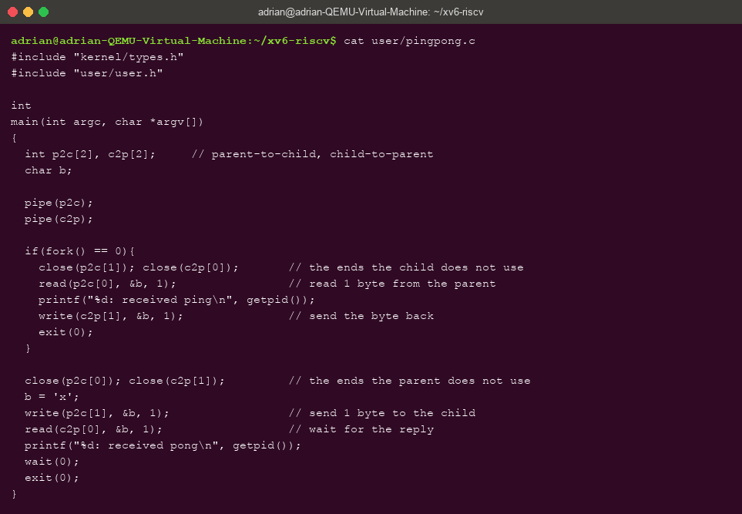
Figure 3.1 – user/pingpong.c with the four TODO lines completed
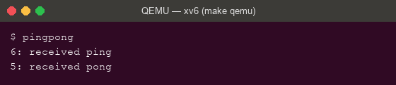
Figure 3.2 – pingpong: ping printed first by the child (pid 6), pong by the parent (pid 5)
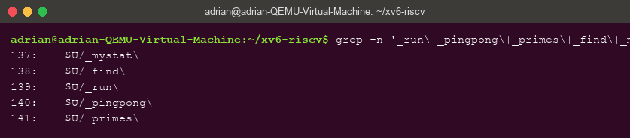
Figure 3.3 – The UPROGS lines for run, pingpong and primes in the Makefile

3.2 Observations
- Why TWO pipes: a pipe is one-directional — one read end, one write end. With a single pipe for both directions a process could read back its OWN byte before the other side ever saw it; two pipes (p2c and c2p) give each direction its own channel.
- Which call makes the parent wait: the read(c2p[0], &b, 1) — read on an empty pipe BLOCKS until data arrives, so the parent cannot print “received pong” before the child has written its reply. (The final wait(0) only collects the child afterwards.)

4 Optional: primes

4.1 Output
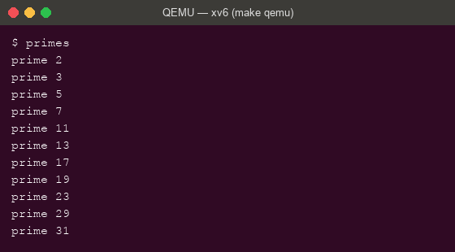
Figure 4.1 – The process-chain sieve: every prime from 2 to 35
Each stage reads its first number p — necessarily prime — prints it, then forwards to a child stage only the numbers not divisible by p; closing every unused pipe end is what lets each stage see EOF and the chain terminate. Eleven processes print the eleven primes up to 35.

5 Conclusions
Running the Lab 7 program inside xv6 closed the argument that the Unix process model is small and universal: fork, exec and wait behave identically in a kernel we compile ourselves, echo — not run — prints the child's words because exec replaces the program, and the exit status after a failed exec is whatever number the program chose (1 here, 127 on Linux), not something the kernel decides.
pingpong showed that pipes carry both data and synchronization: nothing in the code says “wait for the reply”, yet the blocking read orders ping strictly before pong. The optional primes chain scaled the same idea to eleven cooperating processes, and it terminates only because every stage closes every pipe end it does not use — the same EOF rule that explained the hanging wc in Lab 7, now doing productive work.

