EASTERN INTERNATIONAL UNIVERSITY

SCHOOL OF COMPUTING AND INFORMATION TECHNOLOGY

**DEPARTMENT OF SOFTWARE ENGINEERING**



**PROJECT B**

**ELA ENGLISH LANGUAGE CENTER MANAGEMENT**

**Students**

Nguyen Gia Bao - 1831200023

**Supervisor**

Tat Quang Phat, M.Sc.

**Binh Duong,** **13th June 2022**

# **ABSTRACT**

ELA English Language Center Management exists mainly for the purpose of supporting English Center's staffs and students with paperwork, simplifying the process of accessing students' information. It was made under the intention of catching up to the current technologically developing trend, which has proven to be quite useful and convenient for various situations. Upon using this app, the center's student body will have access to distinctive, functional features such as homework, schedules for upcoming tests, previous tests' scores and their class's information. For staff, the app serves as an effective management tool, as it allows them to easily find specific students' personal information, therefore speeding up their work process.

# **ACKNOWLEDGEMENT**

The success and outcome of this project required a lot of guidance and assistance from many and I am extremely privileged to have got this all along with the completion of our project. All that I have done is only due to such supervision and assistance.

I would like to express our deepest appreciation to our teacher, Mr.Tat Quang Phat, whose contribution to stimulating suggestions and encouragement, helped us to coordinate my project and complete it duly. I am extremely thankful to him for providing nice support and guidance, although he had a busy schedule.

Besides, I would also like to thank our greatest university which supports me with office and equipment to implement our project. It is a source of extremely valuable assistance.

**ABSTRACT** 1

**ACKNOWLEDGEMENT** 2

**CHAPTER I: INTRODUCTION** 5

Motivation 5

Objectives 5

Project Overview 5

**CHAPTER II: TECHNOLOGIES** 6

Android studio 6

Firebase 6

Java 6

**CHAPTER III: SUBJECT ANALYSIS** 8

Topic Analyzation 8

Database Design 8

Connect firebase and Realtime database with android 8

Features 12

Login interface 12

**CHAPTER IV: CONCLUSION AND FUTURE WORKS** 23

Result 23

Drawback 23

Future works 23

**REFERENCES** 24

**List of Figures**

Figure 1. Connect firebase and Realtime database with android

Figure 2. Realtime database of question

Figure 3. Login interface

Figure 4. Create account interface

Figure 5. Forgot password interface

Figure 6. Main interface

Figure 7. Search interface - no input

Figure 8. Decimal - Search interface - with input

Figure 9. Add new student interface

Figure 10. Add new student interface - missing/wrong input

Figure 11. Create new class interface

Figure 12. Search for class interface - no input

Figure 13. Search for class interface - with input

Figure 14. Student profile interface

Figure 15. Class information interface

**List of Tables**

Table 1. Database of students

Table 2. Database of accounts

Table 3. Database of classes

# **CHAPTER I: INTRODUCTION**

## **Motivation**

In modern day, English has become the international language. Learning English is the most common activity that not only students but also adults take part in frequently. In Viet Nam, the number of English centers has grown rapidly over the last 10 years. However, the digitization of the management process of language centers is yet to be applied widely.

## **Objectives**

With this project - ELA English Language Center Management app, I wish to help to simplify the management of these centers and create a way of interaction between students and English centers outside of study time. This will also help to reduce the use of papers and reach out to potential students since mobile applications are very popular.

## **Project Overview**

ELA English Language Center Management is an android application written with Android Studio. This app uses Firebase realtime database to manage databases. The app will provide a way for staff members to register new students and create new classes, manage their information, upload assignments and send notifications to users. For normal users, the app offers methods for viewing classes' information and their courses’ results, do assignments and view learning materials provided by the center. All of these are done online via the app.

# **CHAPTER II: TECHNOLOGIES**

## **Android studio**

Android Studio is the official IDE for Android application development, based on IntelliJ IDEA. On top of the capabilities you expect from IntelliJ, Android Studio offers:

* Flexible Gradle-based build system
* Build variants and multiple apk file generation
* Code templates to help you build common app features
* Rich layout editor with support for drag and drop theme editing
* Lint tools to catch performance, usability, version compatibility, and other problems
* ProGuard and app-signing capabilities
* Built-in support for Google Cloud Platform, making it easy to integrate Google Cloud Messaging and App Engine

## **Firebase**

Firebase is a toolset to “build, improve, and grow your app”, and the tools it gives you cover a large portion of the services that developers would normally have to build themselves, but don’t really want to build, because they’d rather be focusing on the app experience itself. This includes things like analytics, authentication, databases, configuration, file storage, push messaging, and the list goes on. The services are hosted in the cloud, and scale with little to no effort on the part of the developer.[1]

## **Java**

Java is a programming language and a platform. Java is a high level, robust, object-oriented, and secure programming language.

Java was developed by Sun Microsystems (which is now the subsidiary of Oracle) in the year 1995. James Gosling is known as the father of Java. Before Java, its name was Oak.

Platform: Any hardware or software environment in which a program runs, is known as a platform. Since Java has a runtime environment (JRE) and API, it is called a platform.[2]

# CHAPTER III: SUBJECT ANALYSIS

## **Topic Analyzation**

ELA Language Center Management app:

* Users need to log in with their accounts
* Build on the following purposes:
  + Create and manage accounts
  + Register students and manage students
  + Create and manage classes
  + Upload and manage assignment
  + Save account, student, assignment and class to database

## **Database Design**

### **Connect firebase and Realtime database with android**

**Connect firebase**: Open android studio -> Tools -> Firebase -> Realtime database -> Get started with Realtime Database -> Connect to Firebase.

**Connect Realtime database:** Open android studio -> Tools -> Firebase -> Realtime database

-> Get started with Realtime Database -> Add the Real Time Database SDK to your app.

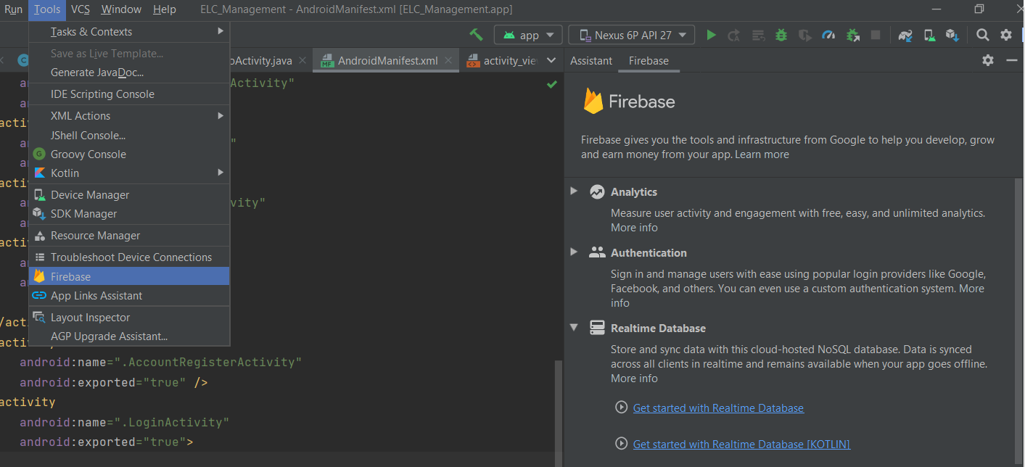

Figure 1. Connect firebase and Realtime database with android

* + 1. **Realtime database**

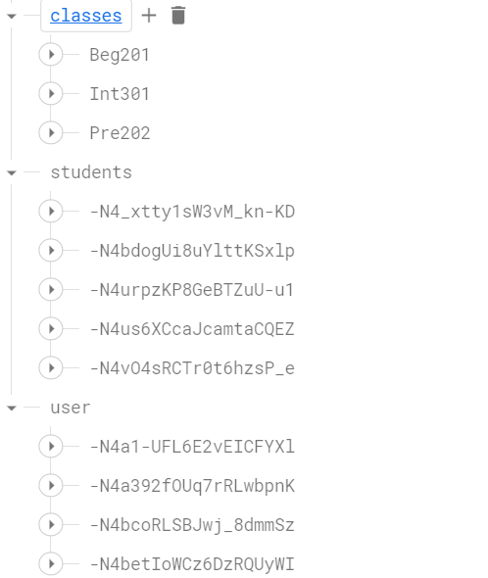

Figure 2. Realtime database of question

* + 1. **Detailed database tables**

|  |  |  |
| --- | --- | --- |
| **Data Name** | **Data Type** | **Description** |
| cId | STRING | The id of the class |
| schedule | STRING | The start/end date of the class |
| time | STRING | The time when the class takes place |
| status | STRING | The class is ongoing or finished |
| quantity | INT | The number of students in the class |

Table 1. Database of class

|  |  |  |
| --- | --- | --- |
| **Data Name** | **Data Type** | **Description** |
| sId | STRING | Student’s id |
| name | STRING | Student’s name |
| gender | STRING | Student’s gender |
| sClass | STRING | Student’s class |
| phoneNumber | STRING | Student’s registered phone number |
| email | STRING | Student’s email |

Table 2. Database of student

|  |  |  |
| --- | --- | --- |
| **Data Name** | **Data Type** | **Description** |
| aId | STRING | Account’s id |
| aUsername | STRING | Account’s username |
| aPassword | STRING | Account’s password |
| aPhoneNumber | STRING | Account’s registered phone number (must be the same as the student’s registered phone number) |
| aEmail | STRING | Account’s registered email |
| aNickname | STRING | Account’s nickname |

Table 3. Database of account

## **Features**

### **Login interface**

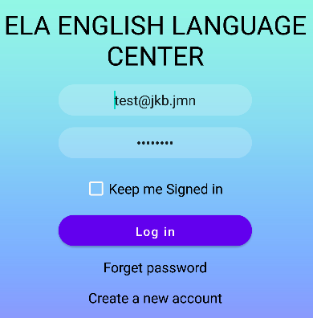

Figure 3. Login interface

When user clicks "Create a new account", the app will switch to "Create account interface"

**3.3.2 Create account interface.**

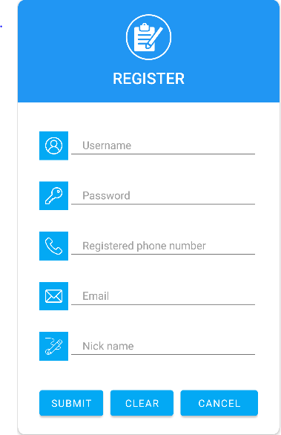

Figure 4. Create account interface

When the user clicks on the submit button, the app will validate the inputs. If all conditions are met, the account will be created and saved to the database.

**3.3.3 Forgot password interface**

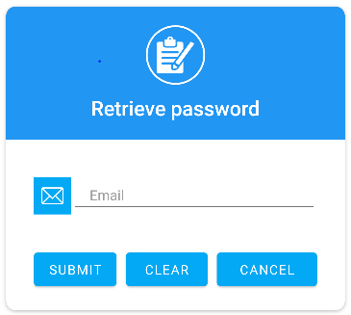

Figure 5. Forgot password interface

Enter registered email address and an email containing reset password link will be sent to the provided email address.

**3.3.3 Main interface**

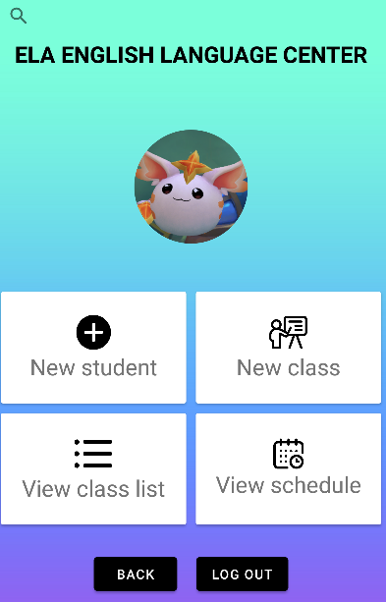

Figure 6. Main interface

From here users can access and use other functions of the app such as: add new student, create new class, view class lists, view schedules and search for specific students/classes.

When users have not entered anything to the search bar, the interface shows all the students.

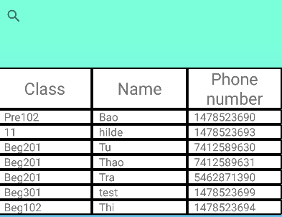

Figure 7. Search interface - no input

If users enter input the interface shows only the results which match the conditions. Currently, the conditions are based on matching a student's name and/or classes.

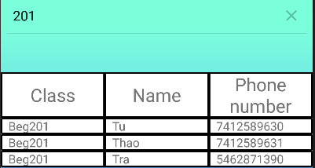

Figure 8. Decimal - Search interface - with input

**3.3.4 Add new student interface**

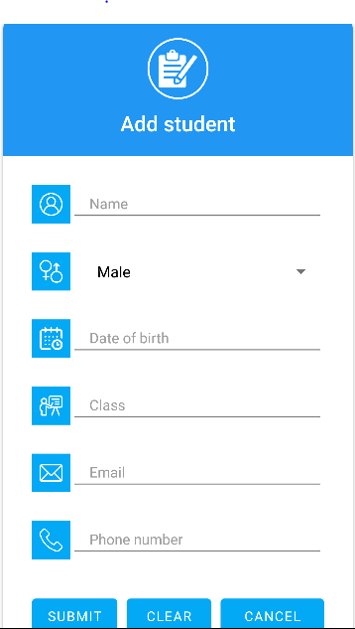

Figure 9. Add new student interface

Users must provide all the above information in order to create and add a student to the database.

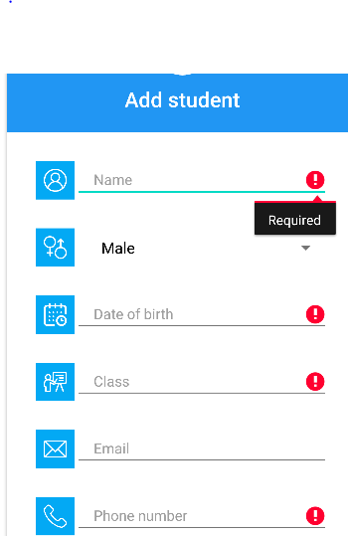

Figure 10. Add new student interface - missing/wrong input

If users leave a field blank or fill in wrong input according to the conditions, the app will notify with the red warning and show the type of errors. Currently, the conditions are:

* All field are required
* Name contains only letters
* Phone number must be at least 10 numbers

**3.3.5 Create new class interface**

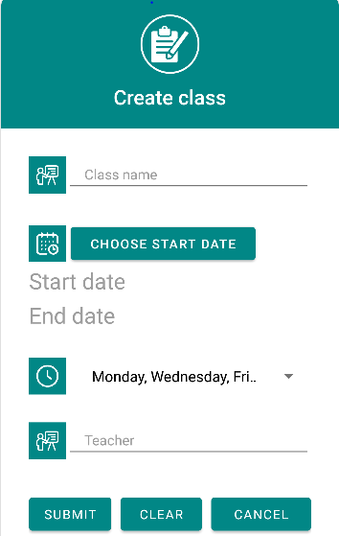

Figure 11. Create new class interface

In this, users must provide all the information except for the teacher field (can be assigned later) to create a new class. A class’s duration is 3-month long by default.

**3.3.6 Search for class interface**

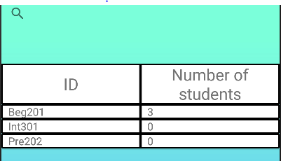

Figure 12. Search for class interface - no input

When the user clicks on “View class list” from the main interface, the app will direct the user to this interface. With no input, the interface will show all the existing classes.

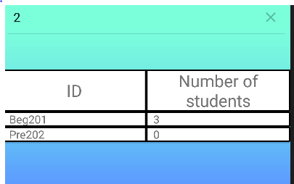

Figure 13. Search for class interface - with input

When the user provides a key word, the interface will look up and show the appropriate results. Currently, the search condition is based on matching class’s ID characters.

**3.3.7 Student profile interface**

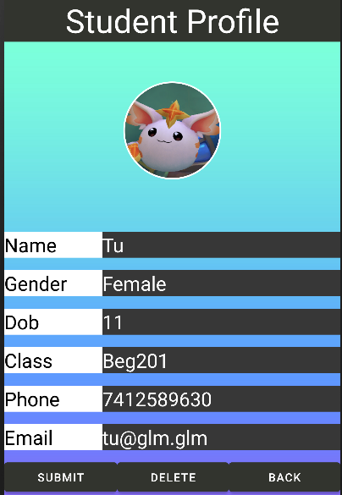

Figure 14. Student profile interface

When the user clicks on a student from the student list, the app will show the student profile interface, which contains the corresponding student profile such as: name, gender, date of birth, class, phone number, email.

Users can click on a field and edit it to change the student information and click on the “submit” button to commit the change.

Users can also delete a student by clicking on the “delete” button to remove a student from the database.

**3.3.8 Class information interface**

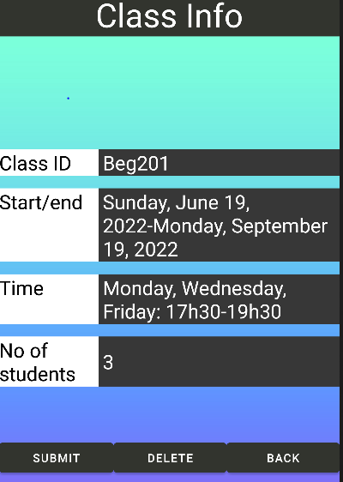

Figure 15. Class information interface

When users click on a class from the “View class list” interface, the program shows the class information interface, which contains information about the class such as: class id, start/end date, class occupied time and the number of students in the class.

Same for student profiles, users can edit the class information (except for number of students) by clicking on the fields and clicking the submit button to commit the change.

Users can also delete a class in the same way as deleting a student from the database.

# **CHAPTER IV: CONCLUSION AND FUTURE WORKS**

## **Result**

After the implementation process, ELA English Language Center has applied the following technologies:

* Firebase: Database management system.
* Realtime database: Real-time tuning database system

The application helps users manage the students and classes online, simplifying the process of manual labor.

## **Drawback**

The project is still not finished: some main functions are not yet finished, contains some bugs, and is facing a synchronization problem between the database and encryption. Furthermore, the project does not fully apply any main design pattern to make the code cleaner and easier to maintain. Besides, the UI of the app is still too simple, along with the lack of notification interfaces.

## **Future works**

In the future, I will develop ELA English Language Center Management with more functions to meet the needs and improve the quality of user service, specifically I will focus on:

* Complete database.
* Add sound to the app.
* Add more notification interfaces.
* Develop function to upload assignments.
* Application user interface improvements.
* Security.
* Developed interfaces for non-staff users.
* Fully apply authentication and authorization.
* Fully apply appropriate design patterns.

# **REFERENCES**

1. Firebase helps you build and run successful apps: <https://firebase.google.com/>
2. JavaTpoint, “Java”: <https://www.javatpoint.com/java-tutorial/>
3. Android studio documentation: <https://developer.android.com/docs>
4. Public platform to find and contribute answers to technical challenges: <https://stackoverflow.com/>
5. Java Programming for Android Developers For Dummies, 2nd Edition [For Dummies] - Barry Burd