My proposal for my first capstone project is to make a website that allows users to create and share color palettes for websites. With the [Colormind API](http://colormind.io/) users can generate random color palettes from scratch, or based off of a few pre-selected colors. Users could then save and share their palettes, and see what other users have created and add them to their favorites. Palettes will also have tags to assist with searching. All the tags would be created by me and users would choose from the list. The target demographic for this website is web developers who do not have much experience in design.

The bulk of the website would be centered around making the palettes. The top half of the page would consist of the color generator and picker. This would show the five generated colors, and allow users to also preset colors. When a palette is generated, each color will be assigned to one of five roles: Main Color, Light Color, Light Accent, Dark Color, and Dark Accent. If they want to, users can select which color goes into which role. The bottom half of the page would be a demo website that would update in real time to show the palette and any changes made. Users would be able to save and share palettes they created. A community page would show the most recent palettes made, and allow users to see and favorite them. There may also be a search feature that allows users to search for palettes by name, colors, or tags, but that would be a stretch goal.

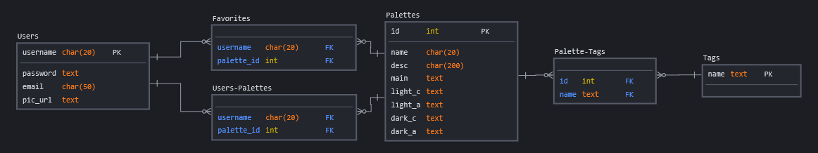The database schema would be very simple for this. There would be three main tables: Users, Palettes, and Tags. There would then be three many-to-many relationship tables: Users-Palettes (relating Users and the Palettes they created), Favorites, and Palette-Tags.

Users would set a unique username and email. The passwords will be encrypted with Bcrypt and stored on the database. They can also set an optional url as their profile picture. Palettes will have a mandatory name and an optional description. There are then five attributes for each of the colors. Users will be able to create, read, update, and delete their own palettes. Users will be able to see other User’s palettes and favorite them. There will be basic authentication to ensure that users can only update/delete their own palettes.

The routing tree would be as follows. **Bold** routes would only be accessible to people logged in as the correct users or require some authentication.

* /users
  + /register (GET/POST) – Create a new user account
  + /login (GET/**POST**) – Log a user in
  + /logout (GET) – Log a user out
  + /<string:username> (GET) – View a user’s account
  + **/<string:username>/edit (GET/POST) – Edit their own profile**
  + **/<string:username>/delete (POST) – Delete the user’s profile**
* /palettes
  + **/new (GET/POST) – Create and save a new palettes**
  + /<int:pal_id> (GET) – View a palette
  + **/<int:pal_id>/edit (GET/POST) – Edit a palette**
  + **/<int:pal_id>/delete (GET/POST) – Delete a palette**
  + /search (GET/POST) – Search for palettes based on name/tag/user