Global Carbon Dioxide CO₂-EMISSIONS
Downloaded 2022-07-24 from “"https://github.com/owid/co2-data"

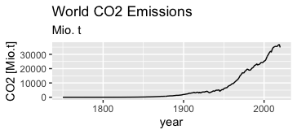
Change of Global Emissions 1750 to 2020:

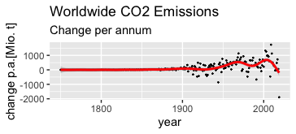

Global Carbon Dioxide CO₂ Monitoring in the atmosphere (CO2-immission):
browseURL(“https://gml.noaa.gov/ccgg/about/co2_measurements.html”)
browseURL(“https://gml.noaa.gov/publications/showpub.php?pubid=2828”)
Method: How we measure background CO2 levels on Mauna Loa.
by Pieter Tans and Kirk Thoning, NOAA Global Monitoring Laboratory,
D.Keeling:wanted on the slopes of Mauna Loa to measure CO2 in air masses that would be representative of much of the Northern Hemisphere,
from above diurnal cycle near ground: „ At sunset, when photosynthesis shuts down, the CO2 mole fraction shoots up, especially at the lowest levels, because plants and soils keep respiring during day and night, releasing CO2.“
The respired CO2 from plants is trapped in the stable boundary layer near the ground, which may have a thickness of only tens of meters
Thoning, K. W.;Tans P. P. ;W.D. Komhyr:Trends identified by fast Fourier transform and low-pass filters
additional assumption: high altitude measurements average over wide areas

NOAA Base line stations:

Site | Latitude | Altitude | CO2 _Mean
Mauna Loa (MLO) | 19,5 | 3399 m | 370 ppm
Barro (BRW) | 71,3 | 27 m | 369 ppm
American Samoa (SMO) | -14,2 | 52 m | 368 ppm
South Pole (SPO) | -90 | 2810 m | 367 ppm

Long term linear trend at NOAA base line stations: Mauna Loa, Hawai (MLO), Barrow, Alaska (BRW), Tutuilla, American Samoa(SMO), South Pole(SPO):
Note: The longterm increase (slope) is identical at the 4 sites. The mean value is lowest at the south pole 367 ppm in dry air, increases at latitudes close to the equator (American Samoa) by 1ppm, the mean at Mauna Loa (Hawai) is 1 ppm higher at 20° north and the biggest mean value at Barrow (arctic site). There is a lag of CO2 mean value increase of roughly 4 years until immission at antarctic sites reach the level of arctic sites.

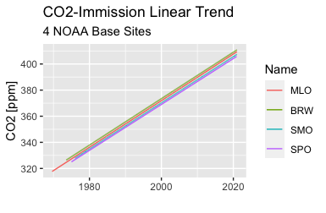
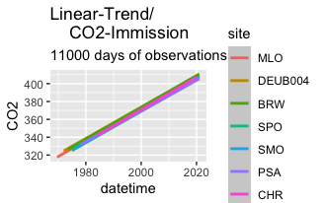
Longterm trends of recorded immission 4 NOAA baseline sites + German recordings at Schauinsland (DEUB004)+ Palmer Station, Antarctica (PSA) +Christmas Island (CHR):
The increase measured as the slope of linear regression is virtually not different at the sites with continuous recordings of more than 11000 days.
Enlarging the plot for more details, shows a time lag of about 2 ½ years, between the two sites northern latitudes (BRW and DEUB004) and the observations at the South-Pole (SPO).
The increase per year(a) is within calculation accuracy identical:

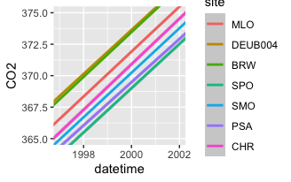
This means that the atmospheric fluctuations (horizontal and vertical) result in CO2-concentrations which increase uniformly independent of the location of the observations of the time series, with a lag of about 2 ½ years between stations at northern latitudes and the southern hemisphere.

Restricting the time span from 2001-01-01 to 2020-12-31with the same sites the slope of the regression lines is 22% bigger but again nearly equal for sites located in arctic and antarctic regions as well as at locations with medium latitudes ore close to the equator. The time lag until immission
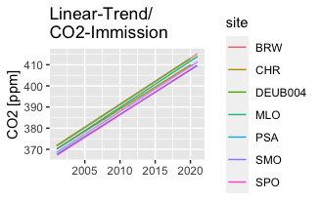
at antarctic locations reaches arctic values is still around 2 ½ years.

Linear trend of CO2 immission recorded at various sites by NOAA and German UBA. The trend depends on the selected time span but not on latitude of the location.

Deviation from linear regression (residuals)

Evaluating the deviations from the linear regression lines ( this are the residuals) one notes that the immission increased less than linear with a minimum around the year 2000:
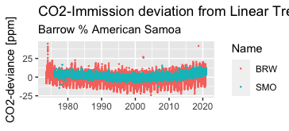

Two NOAA baseline stations Barrow and American do show signifiant deviation (residuals from linear fit):

Samples at the two other baseline sites Mauna Loa and South Pole are both at High altitude and far off vegetational influence:

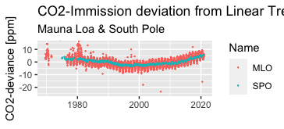
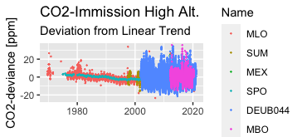

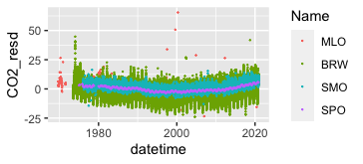
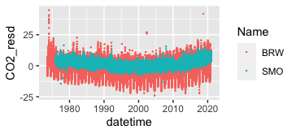

Vegetation reduces the CO2-immission during the vegetation period. This causes annual very strong variations in the order of 25 ppm at MBO and BRW(green). The effect is smaller at high altitudes as MLO or MEX. A little less at SMO American Samoa (blue). Very small but still observable at high altitude observations South Pole(purple).

Two German sites with continuous CO2 measurements DEUB004 Schauinsland (Black Forest), DEUB044 Zugspitze measurements at an elevation of 1284m and 2656m . Both at top of the mountain. Schauinsland Black Forest site within the woods, Zugspitze well above vegetation. The annual variations in the order of 40 ppm may be understood if one takes into consideration that both sites are surrounded by woods, which reduce CO2 during day hours because of photosynthesis and increase immission at night. In addition the vertical exchange during the day night cycle has an influence observed concentrations.

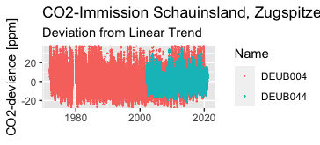
The standard deviation SD of the recorded values does depend on more than altitude as seen with the table:

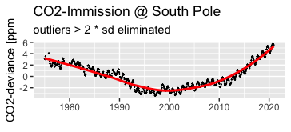

Note that there is a negative deviation from the linear trend visible with the residuals. While the global emissions increased nearly all the times with a rate greater …... p.a. And immissions increasing at average with 2 ppm per year which corresponds 0.5 % p.a. (Taking MLO observations as representative)
CO2 Deviation from Linear Trend at 20 Sites (NOAA+UBA Data)
- Station sites Code:
  - „MLO" "ZEP" "SUM" "PSA" "MHD" "MEX" "ICE" "HPB" "CPT" "CHR" "BHD" "BRW" "SMO" "ABP" "SPO" "CRV" "DEUB004" "LMP" "DEUB044" "TAC"
- Program Code (github.com repo: Global_Temp)
  - CO2_trend_lin:gam.R
  - CO2_site_grouped.R
- Plot of deviation 20 obs sites:
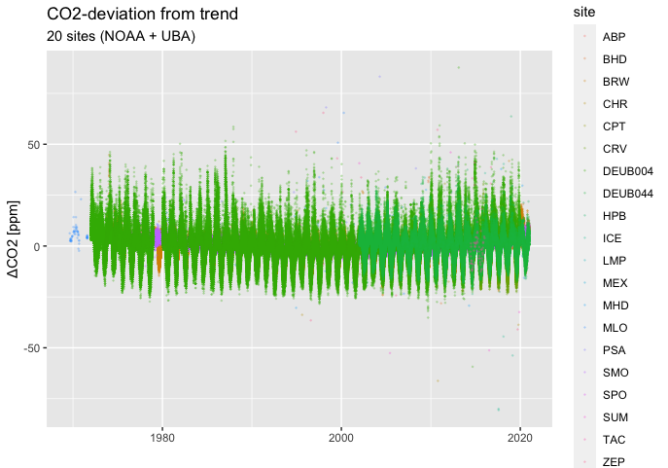
- Arctic sites selected latitude > 65°:
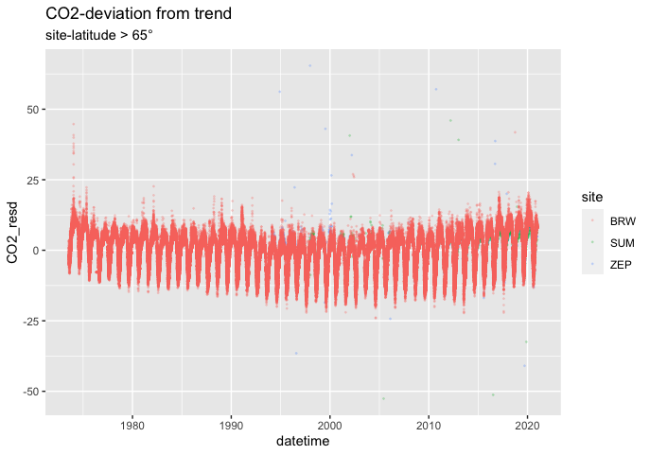

- Antarctic Sites (Latitude < -65°) South Pole
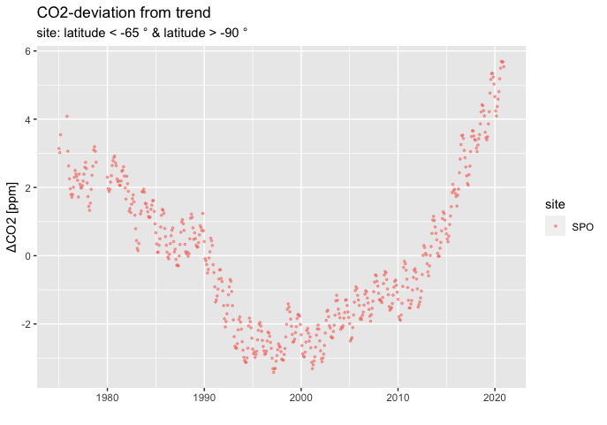
Deviation from linear trend has minimum around 1995 to 2002

  - Northern sites (Latitude > 23.43 ° and < 66.5° )

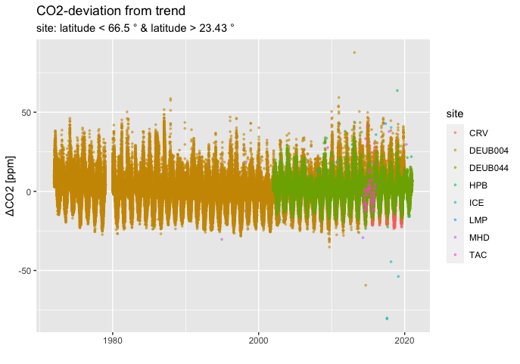
    - Mauna Loa (MLO) and Schauinsland (DEUB004):

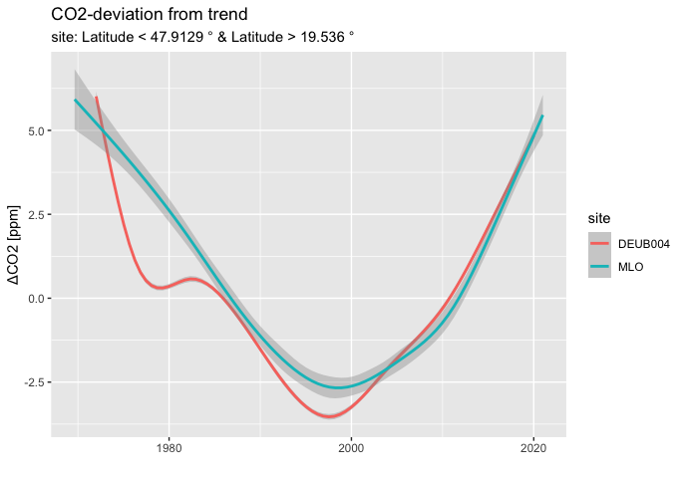

Note that the deviation from linear trend follows the pattern observed at South Pole site (SPO).

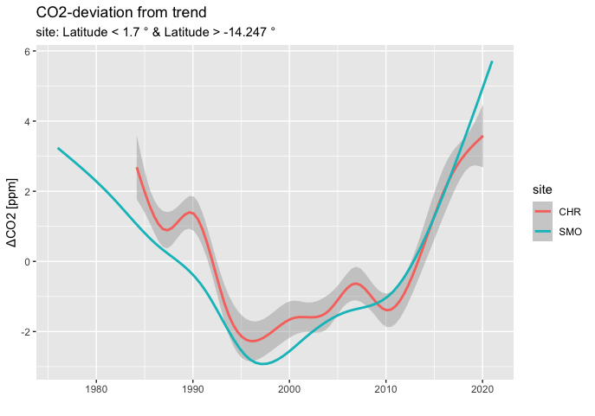
    - Equatorial sites (“SMO”,”CHR”) show similar pattern of deviations with distinct minimum around 1998:
    - Sites with observational time between 1995 and 2019:site start end site from to 1 BRW 1973-07-24 2020-12-31 2 CHR 1984-03-08 2020-01-25 3 ICE 1992-10-02 2020-12-30 4 MHD 1991-06-03 2020-12-30 5 MLO 1969-08-20 2020-12-31 6 PSA 1978-01-27 2020-12-25 7 SMO 1976-01-01 2020-12-31 8 SPO 1975-01-01 2020-12-01 9 ZEP 1994-02-11 2020-12-31

10- Smoothed deviations from sites with observational time between 1970-01-01 and 2020-01-01. Site Codes: "BRW, CHR, MLO, PSA, SMO, SPO"

