CO2 model fitting Mauna Loa CO2 time series

Plots from: Global Temp/ CO2_resd_mdl.R

Data fitted to liear trend and deviation:
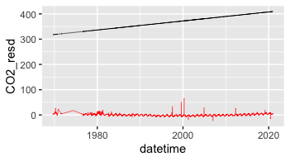
Deviation/residuals only:
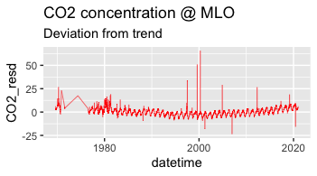
Longterm linear trend compared to fitting with 6 gauss functions:

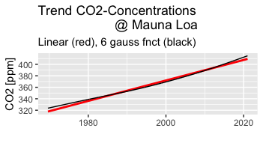
CO2- immission @ Mauna Loa deviance from linear regression (including outliers):

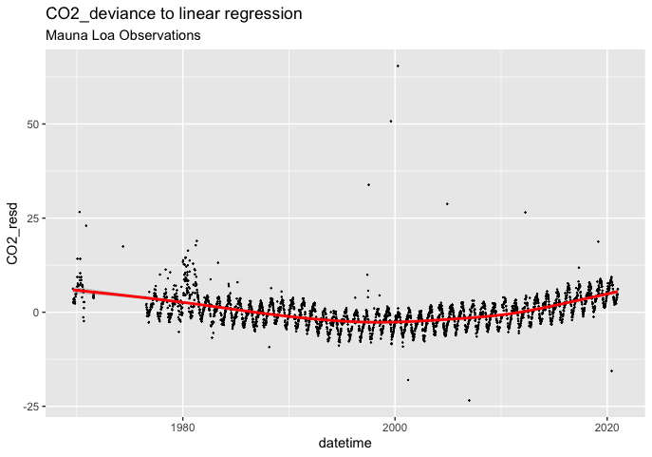
Residuals with respect to 6 gauss trend (fit) outliers deleted:

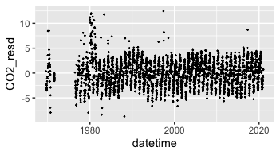

Residuals fitted with 108 gauss functions:

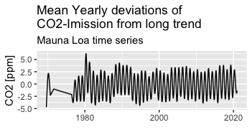

# Trend compared with 18 sites data from NOAA ESRL + 2 sites German UBA (Schauinsland, Zugspitze):

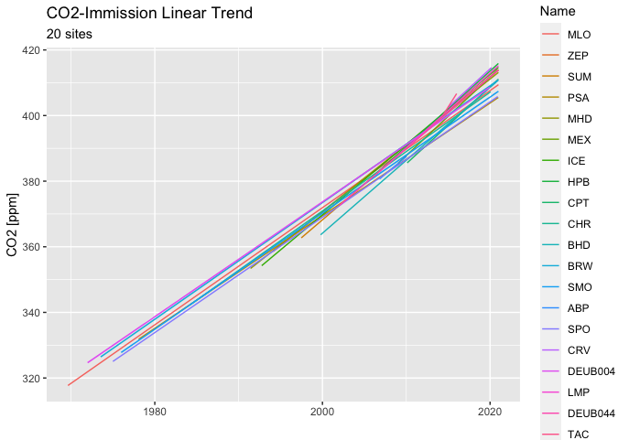
Comparing linear trend of 20 selected stations:
Note that trend was calculated on different time spans, shorter time at DEUB044 Zugspitze is the reason for much greater slope per annum.

Site | Intercept (1970) | Slope/a
DEUB044 | 221 | 4.04
BRW | 292 | 2.4
MEX | 297 | 2.34
MHD | 292 | 2.34
CPT | 298 | 2.3
BHD | 299 | 2.27
ZEP | 297 | 2.22
LMP | 303 | 2.18
HPB | 303 | 2.18
CHR | 306 | 2.14
MLO | 302 | 2.14
TAC | 309 | 2.06
SMO | 310 | 2.02
PSA | 317 | 1.81
ABP | 318 | 1.78
SUM | 320 | 1.78
CRV | 317 | 1.77
DEUB004 | 316 | 1.76
ICE | 321 | 1.75
SPO | 318 | 1.72

site | Intercept (1970) | Slope per Annum
DEUB044 | 221 | 4.04
BRW | 292 | 2.4
MEX | 297 | 2.34
MHD | 292 | 2.34
CPT | 298 | 2.3
BHD | 299 | 2.27
ZEP | 297 | 2.22
LMP | 303 | 2.18
HPB | 303 | 2.18
CHR | 306 | 2.14
MLO | 302 | 2.14
TAC | 309 | 2.06
SMO | 310 | 2.02
PSA | 317 | 1.81
ABP | 318 | 1.79
SUM | 320 | 1.78
CRV | 317 | 1.77
DEUB004 | 316 | 1.76
ICE | 321 | 1.75
SPO | 318 | 1.72

