CO2 Deviation from Linear Trend at 20 Sites (NOAA+UBA Data)
- Station sites Code:
  - „MLO" "ZEP" "SUM" "PSA" "MHD" "MEX" "ICE" "HPB" "CPT" "CHR" "BHD" "BRW" "SMO" "ABP" "SPO" "CRV" "DEUB004" "LMP" "DEUB044" "TAC"
- Program Code (github.com repo: Global_Temp)
  - CO2_trend_lin:gam.R
  - CO2_site_grouped.R
- Linear Trend observed at 29 sites . Annual increase between 1.7 and 4 ppm/a
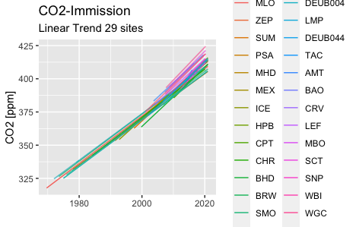
- Plot of deviation 29 obs sites:
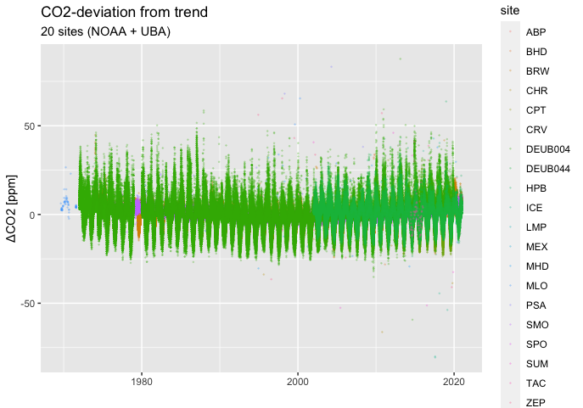
- Arctic sites selected latitude > 65°:
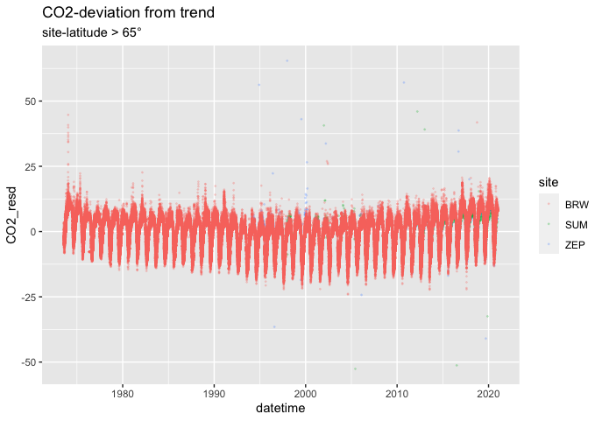

- South Pole (Latitude < -65°) elevation 2800m
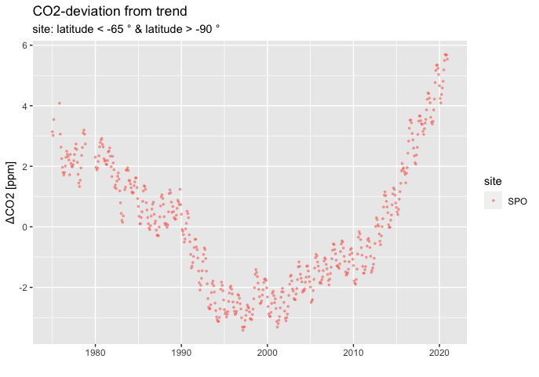
Deviation from linear trend has minimum around 1995 to 2002

  - Northern sites (Latitude > 23.43 ° and < 66.5° )

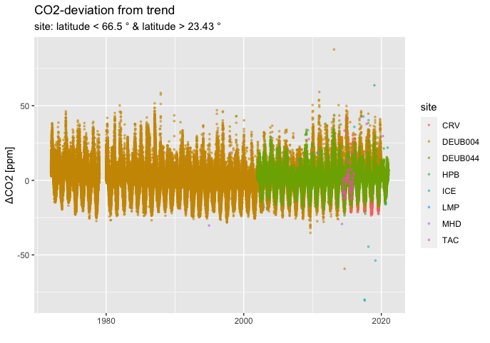
    - Mauna Loa (MLO) and Schauinsland (DEUB004):

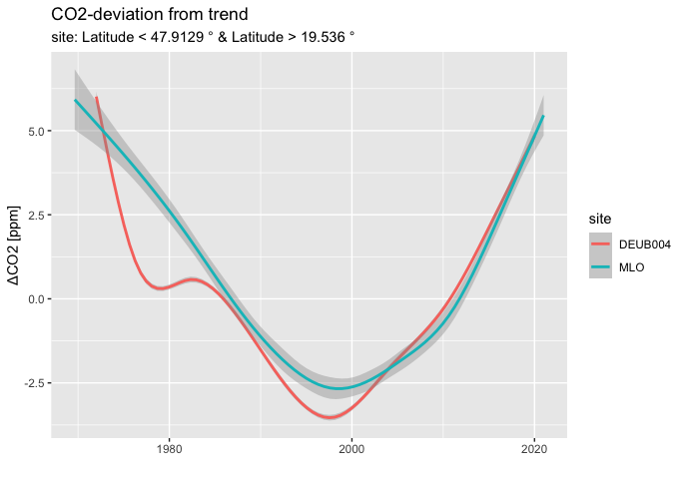
Note that the deviation from linear trend follows the pattern observed at South Pole site with a minimum around year 2000 (SPO,MLO, Schauinsland).

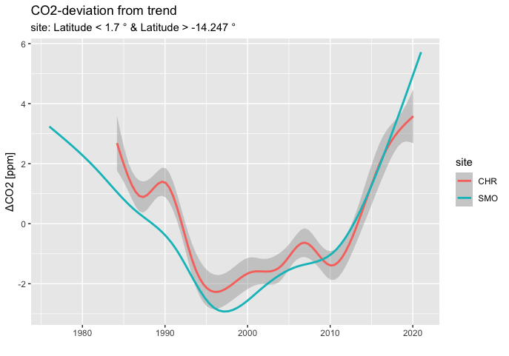
    - Equatorial sites (“SMO”,”CHR”) show similar pattern of deviations with distinct minimum around 1998 as observed with time series at MLO,SPO, DEUB004:
  - Sites with observational time between 1995 and 2019:site start end site from to 1 BRW 1973-07-24 2020-12-31 2 CHR 1984-03-08 2020-01-25 3 ICE 1992-10-02 2020-12-30 4 MHD 1991-06-03 2020-12-30 5 MLO 1969-08-20 2020-12-31 6 PSA 1978-01-27 2020-12-25 7 SMO 1976-01-01 2020-12-31 8 SPO 1975-01-01 2020-12-01 9 ZEP 1994-02-11 2020-12-31

10- Smoothed deviations from sites with observational time between 1970-01-01 and 2020-01-01. Site Codes: "BRW, CHR, MLO, PSA, SMO, SPO"

