Dr. Alf Löffler, Bergweg 6, D-71706 Markgröningen (alf.loeffler@icloud.com)
2022-03-20
Dependence of Central England Daily Temperatures on Sunspot Activity (Draft)
Data sources used:
Long time series can be used to study the dependence of temperatures on sun activity indicated by sunspots.
The longest instrumental record of daily mean temperatures is published and regular updated by the UK Meteorological service and can be downloaded from: https://www.metoffice.gov.uk/hadobs/hadcet/cetdl1772on.dat
A time series of counted daily sunspot data is available from SILSO " WDC-SILSO, Royal Observatory of Belgium, Brussels"
https://wwwbis.sidc.be/silso/datafiles/SN_d_tot_V2.0.csv

Long time series of temperature data (models)
As local measured temperatures vary heavily depending primarily on meteorological conditions proper average values (models) are needed to describe the climatic effects. This is visualized by using two different sets of 12 and 18 smoothing functions on the central England temperature dataset (CET):

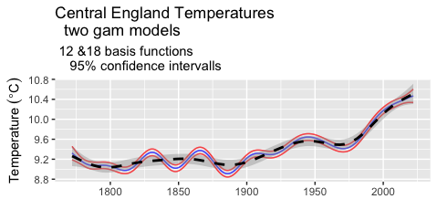
Note that the range of daily temperatures depends on the model. The range of mean daily temperatures from instrumental measurements in central England is -9.3 to 25.2 °C . The daily means show a strong variance. To allow reproducible interpretations models are needed. Such models may be moving averages. As much information is lost with simple moving averages fitting the data with splines looks more promising. Fitting is done by calculating the maximum likelihood of the fit iterating the calculation until a local maximum has been reached using the restricted maximum likelihood procedure available for generalized additive models. As example two fits with gaussian basis functions are shown with the plot.
Using 18 Gaussian basis functions results in more wriggly line (blue, 95% confidence interval “red”) as with only 12 Gaussian basis functions (black- dashed, confidence interval grey shade). Note that the selection of the smoothing procedure has great influence on the rate of change of the averaged temperatures. The steep increase of temperatures after 1825 and 1850 is not visible with 12 basis functions but very expressed with 18 and greater then the recent rise from1975 to 2000.
To demonstrate the dependence of conclusions on the selected model two other models are plotted with the next figure. The red line is the smooth with 48 basis functions (confidence interval shown with the black lines), the blue line calculated with 6 basis functions for comparison:
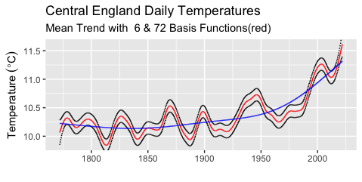

The blue line with 6 basis functions has a minimum around 1850, the red line with 72 basis functions.
The number of local maxima and minima depends on the number of gaussian basis functions selected for the fit. To judge the quality of the fit in a more objective way the Aiken information criterium can be used. (Other criteria to judge the goodness of the fit might be root sum square of the deviations from the fitted data)
The information loss according to Aiken with varied number of basis functions:

Number of Gaussian Basis Functions | AIC
6 | 374820.5
12 | 374810
24 | 374775.2
48 | 374760.3
60 | 374759.2
72 | 374756.7

As can be seen from the two examples plotted the potential interpretation depends on the amount of smoothing. A good fit is obtained with 48 basis functions. Increasing the number of basis functions results in a only slightly reduced AIC.

The interpretation of the smooth line (with 6 basis functions) would mean there is temperature increase since 1850 with an acceleration starting at 1950. However the AIC says this is not the best fit of the data.
Looking at wriggly red line (with 48 basis functions), the conclusion is, that there were temperature increases 1810 to 1825 , 1860 to 1870, 1880 to 1900, 1980 to 2000 and 2010 to 2021. But in between there were also strong declines between 1800 and 1810, 1825 and 1840,1870 and 1880.

This leads to the driving factors depend on a superposition of periodical changing variables, with periods greater than 2 or 3 years. Note that the difference with 36 or 72 basis functions on the change rate is barely visible with the plot.
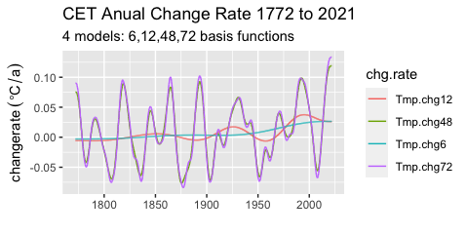
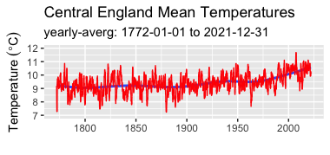
To get more insight the change rate of the temperature smoothing function is calculated:
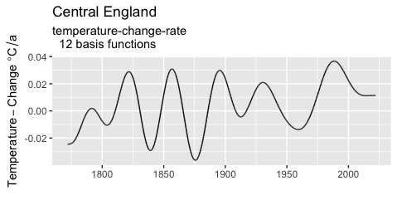
The maximum value is shown with ~ 0.036 °C/a at about 1980. Change rates of 0.03 °C/a in the years 1820 1860 and 1895.

Fitting the data with 24 basis functions the pattern changes. A maximum of change rate is at 1820 and a second in 2020 both with nearly 0.08 °C/a. The second - 200 years later - was not visible on the plot with 12 basis functions. The reason at the end of the smoothing interval there are no data to be fitted outside, but because of the bigger number of basis functions the peaks are considerable smaller:
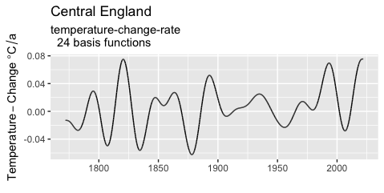

Keeping in mind: “All models are wrong, but some are useful” I decided to use the AIC criterion to select a temperature model for analysis of temperature dependence on solar activity.The conclusions drawn from the fitted data need to be discussed with respect to their dependence on the selected model.

Long time series of sunspot data (model)²⁾

The rate of temperature change is dependent on the difference of flux of energy coming from the sun at daytime and the infrared radiation leaving the earth. The net flow is the radiation balance. The
incoming heat-flow is also dependent on the distance of the earth from the sun. In addition heat with a constant flow is coming from below the earth crust out of the center of the earth.The temperatures measured depend also on local conditions and the exchange of energy between various heat storages (oceans, atmosphere, land surface, ice covered areas) and flows between these reservoirs. This means that a big number of other variables than the radiation on the sun have an influence on measured temperatures.

The energy radiated from the sun is not constant but depends on dynamical processes, some of them are observed from the earth. High activity of the sun correlates with sunspots, which are observed and recorded long time. These observations are recorded and published by the Belgium Royal Observatory, Brussels are plotted with this graph:
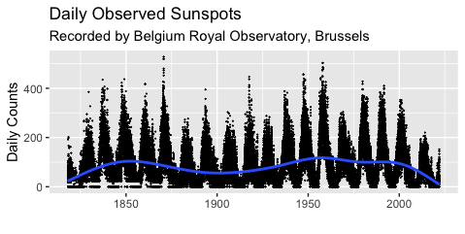
Note:
- the period of maximum sunspots observed which is close to 11 years.
- underlying is longterm period of about 100 years with maximum around 1850 and 1950
- there are phases with zero counts (recordings?)
- the recorded data are not complete ( 3246 daily data are missing out of a74509 days)
- Mean value of all published counts per day: 82

To get some understanding of the dynamics the data are fitted with 11 gaussian basis functions (blue line; AIC 814585.1)
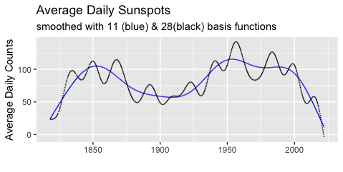

This shows maximum values around 1850 and 1950. However this fit does not show the 11 year cycle of the solar activity.

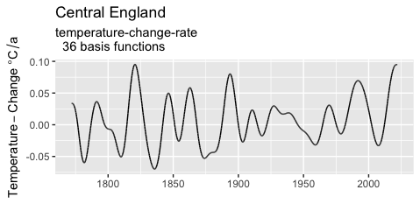

Note that the pattern changes but also the calculated maximum change rate is very much different:
- with 18 basis functions (AIC= 564849.2) change rate per annum is: from -0.036 °C/a and 0.037 °C/a
- with 36 basis functions ( AIC = 564792) change rate per annum is: from -0.070 °C/a and 0.095 °C/a

Increasing the number of basis functions increases not only the number of extremes but also the observed rate of change.
Smoothing with a 36 gaussian basis functions results in a much more detailed pattern (AIC 812168.6). The number of extremes is still less than expected from visual examination of the data.
Increasing the number of basis functions to 60 results in a better fit and a lower AIC (746832.9).

Counted Sunspots
The plot suggests a “good fit”. However the fitted data cover a range from -7.261 to 261.203 “counts” .

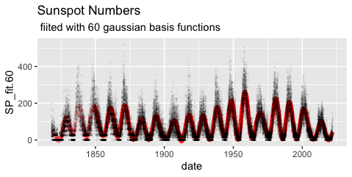

“Negative counts” for the fit is a consequence of the use of gaussian basis functions. As negative counts of unspots do not exist a better fit is obtained with negative binomial distribution.
Fitting with negative binomial functions from the MASS package in R with 60 basis functions and a log link function results in:
- intercept 4.033414 corresponding to an average of 56.5 counts
- a p value <2e-16
- an AIC 719405.3 (which is lower than with gaussian fit)
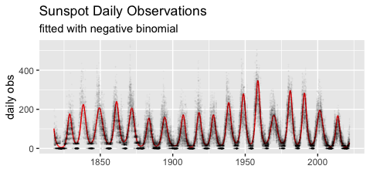

Interaction of Solar Radiation with Earth Surface.
The effect of the radiation imbalance is damped by heat capacity of various reservoirs on earth and influenced by the energy exchanged between. Especially the oceans which cover about 70% of earth surface reduce the extremes. In addition heat is exchanged by huge amounts transported by Ocean streams as Golf Stream or the various Pacific streams. ( Temperature variations are much less in maritime climate compared to continental climate).The measurements in central England can be taken as an approximation as England is surrounded with big oceans resulting in maritime climate. The question arises how many variables are needed to quantitative describe and predict future developments.

The change rate of daily temperature measurement at central England calculated from a function fitted to the instrumental record by 36 basis functions:

As 36 basis functions is still not sufficient to model the temperature changes: Model with 72 basis functions:

Temperature daily change rate using a model with 72 basis functions:
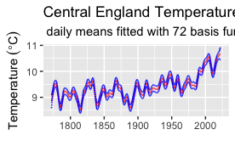
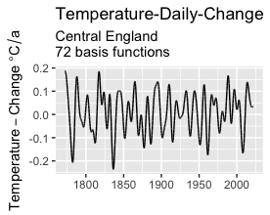

Somehow surprising: the daily change stays in a range between -0.2 and +0.2 °C and did not increase from 1772 to 2021. There are ~ 23 pikes. Considering that sunspots vary with a frequency of ~ 11 years and additional factors effecting solar radiation periodically the graph suggests a mayor influence of the number of sunspots on the temperature change rate in Central England.

Data sources:
1) Monthly mean Central England Temperatures (°C)
1659-1973 MANLEY (Q.J.R.METEOROL.SOC., 1974)
1974 _1992 PARKER ET AL. (INT.J.CLIM., 1992)
1992 on PARKER AND HORTON (INT.J.CLIM., 2005)
2) WDC-SISO, Royal Observatory of Belgium, Brussels

