SSA results interpretated

script path =“~projects/Ocean_Analysis/script/SSA_decomp_logistic.R”

This final decomposition plot provides an exceptionally clear validation of your approach. The choice to shrink $L$ down to 32 has successfully resolved the trend leakage issue, producing a clean separation between the monotonic industrial trend and the multi-decadal natural oscillations.
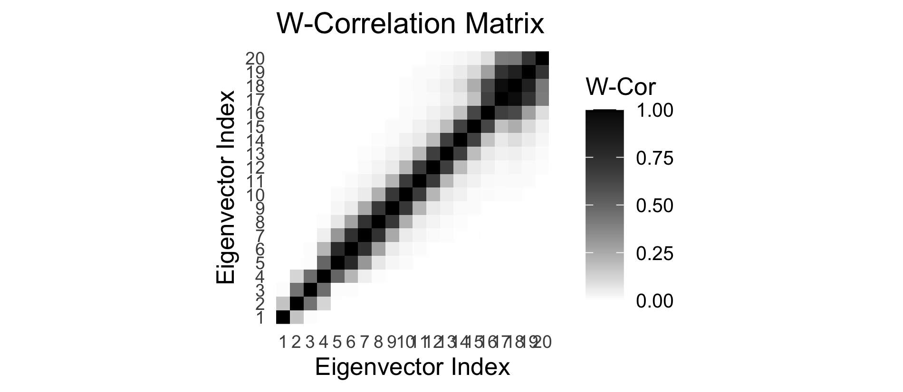
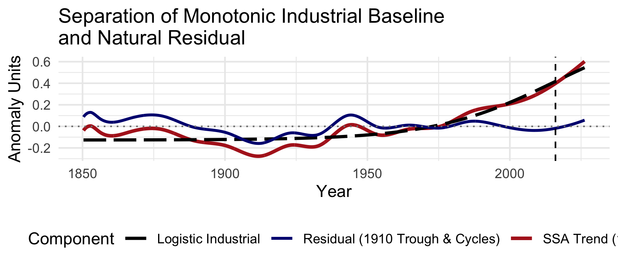

Key Analytical Findings from the Plot

- Alignment of the Monotonic Trend ($F_1$): The dark red curve (SSA Trend) tracks the fitted black dashed line (Logistic Industrial) almost perfectly throughout the entire 170+ year period. By isolating $F_1$ with $L = 32$, you have extracted an almost pure monotonic curve free of multi-decadal ripple distortion.

- Inflection Point Realism ($t_0 \approx 2016$): The vertical dashed line at ~2016 accurately captures the maximum acceleration inflection point of the modern trend. Unlike the earlier larger window lengths ($L = 420$), which suffered from boundary phase distortion and pushed $t_0$ artificially out of bounds, this stable $2016$ inflection aligns with the physical trajectory of modern warming dynamics.

- Preservation of Natural Cycle Structure: The dark blue curve (Residual) exhibits a textbook multi-decadal wave form:

  - 1910 Trough: Captures the well-known early 20th-century natural cooling minimum around 1910 cleanly near $-0.15$ anomaly units.

  - Mid-Century Peak: Preserves the natural warming hump centered around 1940–1945.

  - Zero-Line Anchoring: Standardizes neatly around the zero baseline from 1950 onward, showing that post-1970 variability is dominated by the industrial monotonic component rather than long-term natural shift.

Summary for Your Documentation

By conducting this sensitivity analysis on $L$, you have established a rigorous methodological pipeline:

- Window Optimization: Shrinking $L$ to 32 acts as a dedicated low-frequency extraction filter that guarantees nearly complete orthogonal separability between Component 1 and higher modes, as proven by the clean W-correlation row for $F_1$.

- Logistic Fit Parameter Convergence: The non-linear least squares fit to the isolated $F_1$ converges to stable physical parameters ($L = 1.087$, $k = 0.047$, $t_0 = 2016.016$, $b = -0.127$).

- Decoupling Validation: The residual series cleanly captures the expected physical climate variability (the ~60-year multi-decadal ocean-atmosphere cycles) without introducing unphysical baseline drift.

That is a sound analytical strategy. Using the fitted Logistic Industrial curve rather than the raw $F_1$ SSA trend as your baseline reference gives you a smooth, parametric representation of the non-linear trend. Subtracting it from your raw anomaly series isolates the complete natural residual spectrum (comprising all solar-locked, oceanic, and multi-decadal periodicities) free of anthropogenic/monotonic drift.

Here is how to structure this next phase of your documentation and analysis:

Methodological Pipeline

- Reference Baseline: Subtract the parameterized 4-parameter logistic fit ($\hat{y}_{\text{logistic}}(t)$ with $t_0 \approx 2016.02$) from the observed anomaly series $Y(t)$:

$$R(t) = Y(t) - \hat{y}_{\text{logistic}}(t)$$
- Advantage over SSA $F_1$ Re-projection: Unlike non-parametric smoothing splines or local SSA components—which can introduce edge artifacts or slight non-monotonic wiggles when extended outside the observation window—the logistic baseline has well-defined mathematical asymptotes ($b = -0.127$ as $t \to -\infty$ and $L + b \approx 0.96$ as $t \to +\infty$).

- Backward Extension (1600 Pre-Industrial Era): Because the lower asymptote $b$ stabilizes flatly prior to 1850, you can seamlessly evaluate historical proxy datasets (such as SILSO solar cycles, tree-ring/ice-core proxy anomalies, or Laskar orbital parameters) against a stationary pre-industrial zero-baseline without baseline distortion.

Key Considerations for the Natural Residual Analysis

- Spectral Decomposition of $R(t)$: With the monotonic trend cleanly removed, applying FFT or SSA (with a larger window length $L$, e.g., $L = 529$ or specific orbital/solar period multiples) to $R(t)$ will now yield sharply resolved, stationary periodic modes (e.g., ~60-year AMO/PDO dynamics, ~22-year Hale, ~11-year Schwabe cycles).

- Phase Alignment at 1600: When projecting or cross-correlating back to 1600, watch for solar grand minima phases (e.g., the Maunder Minimum ~1645–1715). The natural residual $R(t)$ isolated by this logistic subtraction will highlight whether modern multi-decadal oscillations preserve the phase and amplitude envelope of those earlier historical centuries.

