**TA Portal**

**Design Document**

10/30/2020

Version 1



**Team 10**

Logan Gorence Marcus Sagisi

Course: CptS 322 - Software Engineering Principles I

Instructor: Sakire Arslan Ay

# TABLE OF CONTENTS

**I**​**NTRODUCTION 3**

D​OCUMENT R​ ​EVISION H​ ​ISTORY 3

**A**​**RCHITECTURE D**​ ​**ESIGN 3**

O​VERVIEW 3

**D**​**ESIGN D**​ ​**ETAILS 4**

III.1. S​UBSYSTEM D​ ​ESIGN 4

III.1.1 M​ODEL (​ ​DATABASE)​ 4

III.1.2 C​ONTROLLER (​ ​ROUTER)​ 4

III.1.3 V​IEW (​ ​TEMPLATES)​ 5

III.2. D​ATA​ ​DESIGN 5

## III.2.1 U​SER 5

III.2.2. U​SER I​ ​NTERFACE D​ ​ESIGN 6

1. **P**​**ROGRESS R**​ ​**EPORT 6**
2. **T**​**ESTING P**​ ​**LAN 6**
3. **R**​**EFERENCES 6**

**A**​**PPENDIX:**​ **G**​**RADING R**​ ​**UBRIC 7**

# I. Introduction

This design document provides a number of high and medium level descriptions of the subsystems that make up our project. This is the initial revision of the document, which covers the basic subsystems, libraries that we use, URL routes, database schema, and a progress report. In iteration 2, this design document will be updated to include other information.

The goal of this project is to provide an easy-to-use application that will allow EECS students and faculty to easily find TA positions for classes. Prior to the beginning of the semester, a professor will enlist the courses that they are currently teaching on their profile. A student interested in being a TA will create a profile, and fill out a survey that will gather information from them and what classes they are interested in. The motivation of creating this application is to reduce the amount of labor required to manually collect survey results, validate them, and provide lists to professors to choose a TA.

Section II includes a high-level description of the subsystems and the architecture that was used to build our application. Section III includes implementation details of each subsystem and the components used in our application. Section IV contains a description of the progress in our project up until the end of the current iteration. Section V contains information about testing. Section VI contains any references that we need to include.

**Document Revision History**

Rev 1 2020-10-30 Initial version

# II. Architecture Design

## II.1. Overview

The architectural pattern that we adopted in our project is model-view-controller (MVC). MVC is typically used in applications that have a user interface and interface with some kind of persistence layer. Because our application provides a web-based user interface and persists data into a SQL database, MVC was an obvious choice for our project. MVC allows us to lower the coupling between units in our application, while increasing our cohesion to create components that are reusable and clean.

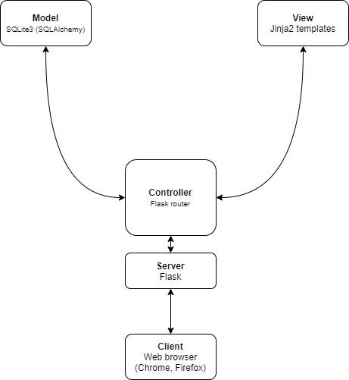

**Block diagram of our application architecture**

Because our application is utilizing MVC, we need a few different libraries to represent the different subsystems that we are building. Our model subsystem utilizes SQLAlchemy to create database tables, and uses SQLite3 as a backend, which is a flat file database. For our view, we utilize Jinja2 for a templating language, which Flask can render for us. Lastly, for our controller / router / web server, we use Flask. Additionally, we’re using wtforms for form generation and werkzeug for security and password hashing.

# III. Design Details

## III.1. Subsystem Design III.1.1 Model (database)

The model in our application persists all the relevant data that is required to run the application. For example, we store user profiles for students and professors, courses, applications, etc. This subsystem will not depend on any other subsystem to reduce coupling. For our application, we use SQLAlchemy that stores data in a SQLite3 flat file database. If we wanted to properly scale this application in the future, PostgreSQL or MySQL might be better choices to better handle failure and load. In a section below, we give rough descriptions of the tables that we are using to persist the data in our application.

### III.1.2 Controller (router)

The router is a part of Flask which will parse incoming requests and route them to specific locations (routes) that we have designated. For example, if you register the route */student/register*​ ​, and a web browser navigates to that URL, the web server will serve the designated content as per the route. Because our router takes incoming requests, we pass the requests onto their designated routes and those routes are part of our controller. Additionally, the controller creates the business logic that ties together the model and view.

|  |  |  |
| --- | --- | --- |
| Methods URL Description | | |
| GET | /, /index | Homepage of our application, provides links to all the various operations that a student or professor could perform. |
| GET, POST | /student/register,  /professor/register | Page to register as a student or professor, respectively. |
| GET, POST | /login | Page to login and create a session. |
| GET | /logout | Page to logout and destroy the existing user session. |
| GET, POST | /info | Edit currently logged in user’s information. |
| GET, POST | /student/experience | A student is able to edit their past TA experience. |
| GET | /student/positions | Student can view open TA positions for all courses. |
| GET | /student/position/{id} | Student can view the details about an open TA position. |
| GET, POST | /student/apply/{id} | Student can apply to an open TA position. |
| GET | /student/withdraw/{id} | Student can withdraw from a TA position that they have applied for. |
| GET | /professor/courses | View courses that a professor owns. |
| GET, POST | /professor/courses/add | Form for a professor to add a course with. |
| GET, POST | /professor/courses/edit/{i d} | Form for a professor to edit an existing course with. |
| GET | /professor/course/{id} | View information about a course and see students that have applied, with links to their information. |
| GET | /professor/student/{id} | Professor can view experience, contact information, etc for a student. |
| POST | /professor/course/{id}/ass ign/{studentId} | Assigns a student to a specific course. |

### III.1.3 View (templates)

In our application, we are utilizing Jinja2 templates with Flask to create reusable templates that will allow us to build our application frontend quickly. The view subsystem reduces coupling by only interacting with the models that are provided to it by the controller. Additionally, we are using wtforms in addition to Jinja2 and Flask to provide easily created forms for the frontend of the application.

**(iteration 2)** ​ Provide your class level design for the subsystem. You should include a UML class diagram​ visualizing your class level design. In addition, explain each class in detail, specify and explain their methods.

If you have considered alternative designs, please describe briefly your reasons for choosing the final design.

## III.2. Data design

### III.2.1 User

|  |  |  |
| --- | --- | --- |
| **Column** | **Type** | **Description** |
| id | Int | Primary key to identify the user by |
| name | String(70) | Name of the user |
| email | String(120) | Email address of this user |
| password_hash | String(128) | Password hash for this user (uses werkzeug security package to perform the hash and do checking) |
| is_professor | Boolean | Boolean flag that indicates whether this user is a professor or a student |
| phone | Integer | Phone number of the user |
| wsuID | Integer | WSU ID number of the user |
| gpa | Float | Cumulative GPA for a student |
| major | String | String representation for a student’s major |
| graduation | DateTime | String representation for a student’s graduation date |

**(iteration 2)** ​ Provide a UML diagram of your database model showing the associations and relationships​ among tables.

### III.2.2. User Interface Design

Use case: Create/Register account

For registering for both student and professor, the user only needs a valid email address, name, and password. Students and Professors have different URLS, so the software can differentiate if the user is a student or a professor

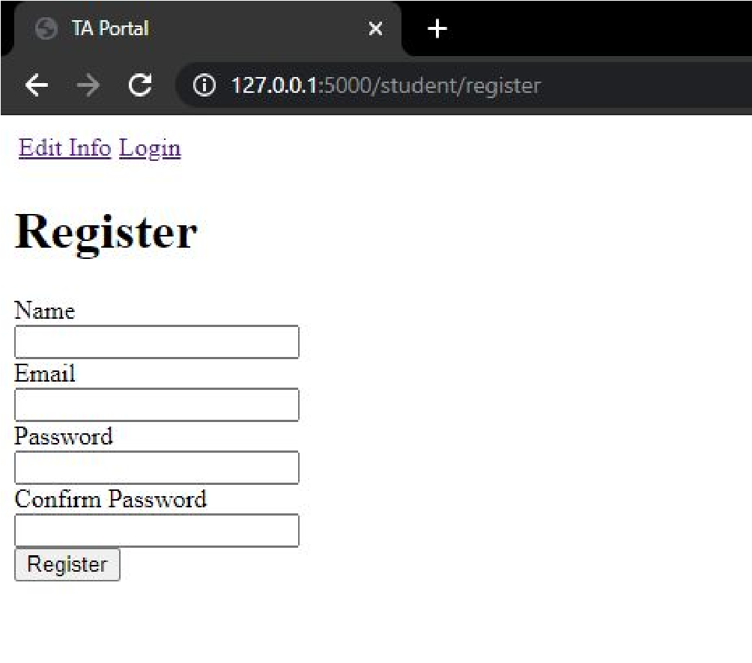

Use case: Login

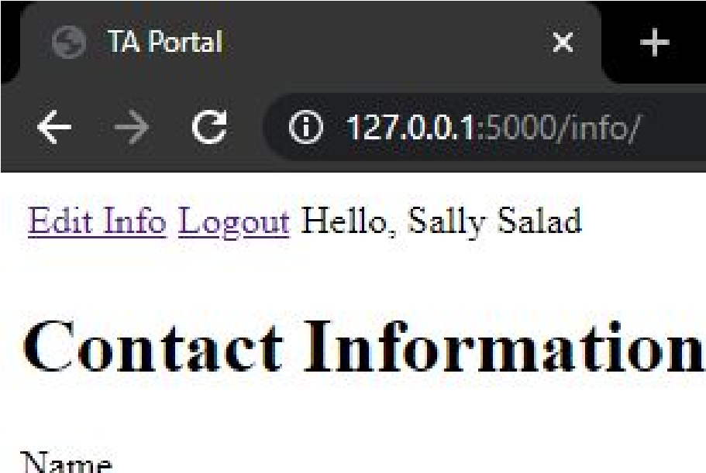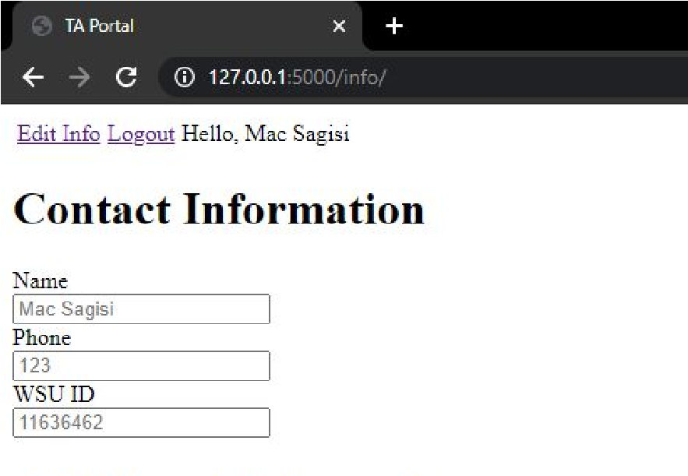The user needs to have an account and be logged in to that account in order to access the features of the app. The user only needs their email and password to log in. In the case the user does not have an account, the login page shows a student and professor registration links, that redirects the user to the registration page

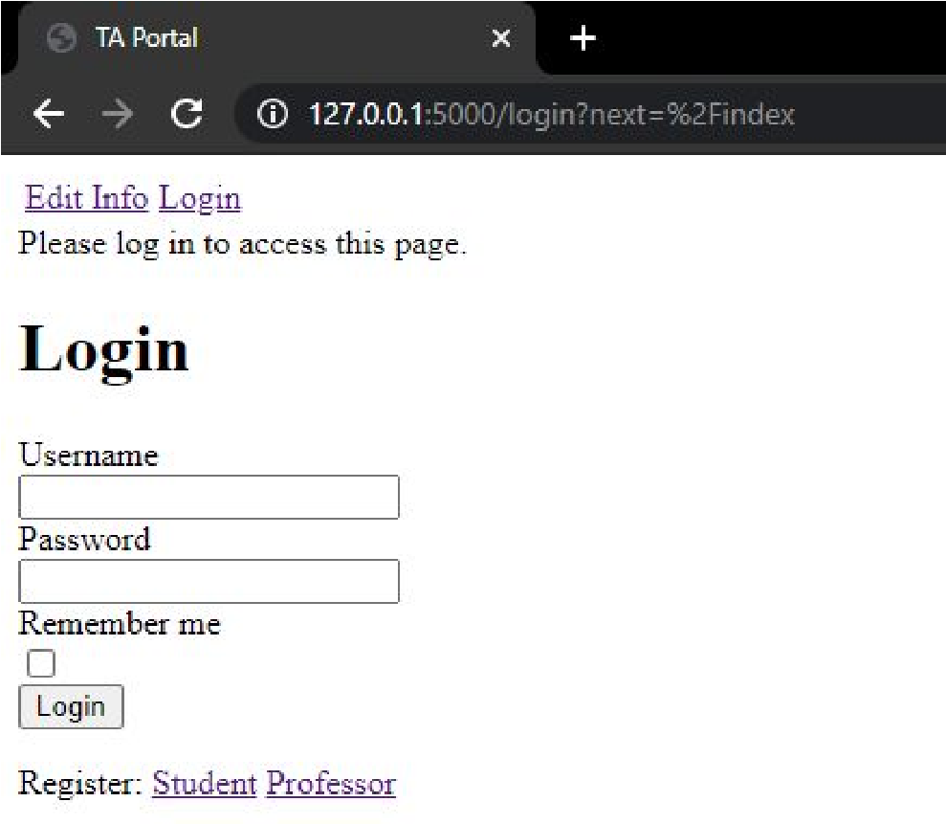

Use case: contact/additional information

For the student user, the student is able to input both contact and additional information, while the professor users can only input contact information. The form does have input placeholders so the user knows what their information already is. If they haven’t already edited their information, it shows None.

# IV. Progress Report

For iteration 1, we were primarily focused on having the user have an account and edit their information, both professors and students. The professors and students share the same User class, but the functionality of the user is based on the “is_professor” boolean value. For example, in our info page, both students and professors are able to change their contact information, but the students are able to see and edit their additional information, such as GPA or expected graduation. What we worked on, was to set up the foundation of our app.

# V. Testing Plan

## (iteration 2)

In this section goes a brief description of how you plan to test the system. Thought should be given to how mostly automatic testing can be carried out, so as to maximize the limited number of human hours you will have for testing your system. Consider the following kinds of testing:

* **Unit Testing:**​ Explain for what modules you plan to write unit tests, and what framework you plan to use. (Each team should write automated tests (at least) for testing the API routes)
* **Functional Testing:**​ How will you test your system to verify that the use cases are implemented correctly? (Manual tests are OK)
* **UI Testing**​: How do you plan to test the user interface? (Manual tests are OK) **VI. References**

None yet.

|  |  |  |
| --- | --- | --- |
| Max Points | **Your points** | **Design** |
| 10 | 10 | Are all parts of the document in agreement with the product requirements? |
| 15 | 15 | Is the architecture of the system described, with the major components and their interfaces? |
| 5 | 5 | Is the rationale for subsystem decomposition and the choice for the architectural pattern explained well? |
|  |  | Are all the external interfaces to the system (if any) specified in detail? |
| 15 | 15 | Are the major internal interfaces (e.g., client-server) specified in detail? |
| 15 | 10 | Are the subsystems that the team has started to implement are described in the document? |
| 10 | 10 | Is there sufficient detail in the design to start Iteration 2? |
|  |  | **Clarity** |
| 5 | 5 | Is the solution at a fairly consistent and appropriate level of detail? |
| 3 | 3 | Is the solution clear enough to be turned over to an independent group for implementation and still be understood? |
| 12 | 12 | Is the document making good use of semi-formal notation (UML, diagrams, etc) |
| 5 | 5 | Is the document identifying common architectural or design patterns, where appropriate? |
| 5 | 5 | Is the document carefully written, without typos and grammatical errors? |
| **Total** | 100 |  |