**TA Portal**

**Requirements Specifications**



**Team 10**

Logan Gorence Marcus Sagisi

Course: CptS 322 - Software Engineering Principles I

Instructor: Sakire Arslan Ay

# TABLE OF CONTENTS

**I**​**NTRODUCTION 3**

**R**​**EQUIREMENTS S**​ ​**PECIFICATION 3**

C​USTOMER, U​ ​SERS, ​ ​AND S​ ​TAKEHOLDERS 3

U​SE C​ ​ASES 3

N​ON-​ F​UNCTIONAL R​ ​EQUIREMENTS 10

**U**​**SER I**​ ​**NTERFACE 11**

V​IEW ​ ​STUDENT ​ ​APPLICANTS ​ ​PAGE 12

V​IEW ​ ​COURSES ​ ​PAGE 13

**R**​**EFERENCES 13**

**A**​**PPENDIX:**​ **G**​**RADING R**​ ​**UBRIC 14**

# Introduction

The goal of this project is to provide an easy-to-use application that will allow EECS students and faculty to easily find TA positions for classes. Prior to the beginning of the semester, a professor will enlist the courses that they are currently teaching on their profile. A student interested in being a TA will create a profile, and fill out a survey that will gather information from them and what classes they are interested in. The motivation of creating this application is to reduce the amount of labor required to manually collect survey results, validate them, and provide lists to professors to choose a TA.

In section II, we declare the requirements in terms of features, functionality, and specifications that we are required to implement in the product. In section III, we showcase sketches and mockups for the primary parts of the user interface.

**Document Revision History**

Rev 1.0 October 12th 2020 Initial version

# Requirements Specification

In this section you will describe the features, functions, and other specifications that are requirements for your product.

## Customer, Users, and Stakeholders

The customer is the school, since they would be the ones paying for the software for everyone to use. The stakeholders would be the instructors because they want a software that makes the TA finding process easier. The users are the students and teachers because the software was made for them to use.

## Use Cases

|  |  |
| --- | --- |
| Name | Create Account/Register |
| Users | Students |
| Rationale | In order to view and apply for open TA positions, a student needs to have an account with a WSU email. This would verify if the student is enrolled at WSU. |
| Triggers | “Register student” option |
| Preconditions | email has not been taken |
| Actions | 1. The user indicates the software they want to register 2. The software responds by opening a registration page 3. The user enters credentials (e.g wsu email, password) 4. The user clicks register when done 5. The software responds by saving the credentials into the database and redirecting user to sign-in page |
| Postconditions | The user’s account is registered into the database |
| Acceptance Tests | Make sure the user can sign-in after registering |
| Iteration | Iteration 1 |

|  |  |
| --- | --- |
| Rationale | A student and teacher needs to be signed in order to access the options of their position. This is also to make sure if the user is part of WSU so we do not get bot accounts. |
| Triggers | If not already signed in, the page will redirect to sign-in page |
| Preconditions | WSU email is registered  WSU email and password is right |
| Actions | 1. The software responds by opening sign-in page if the user is not already signed-in 2. The user enters their email and password 3. The software responds by checking if the email and password is correct 4. If login is not correct, the software will flash incorrect message in sign-in page 5. If login is correct, the software will redirect the user to the homepage and set the current user as the one that signed in. |
| Postconditions | The current user is the one that signed in |
| Acceptance Tests | The user’s account is in the home page if the login credentials are correct |
| Iteration | Iteration 1 |

|  |  |
| --- | --- |
| Name | Additional Information |
| Users | Students |
| Rationale | The user should enter additional information such as major, GPA, etc. in-order for the instructor viewing their application to tell if the user is best fit for the position |
| Triggers | “Additional information” option |
| Preconditions | The user has an account and is logged in |
| Actions | 1. The user tells the software that they want to add additional information 2. The software responds by opening the additional information page, which prompts the user for GPA, major, etc. 3. The user inputs the information they want to be displayed into the corresponding input boxes. 4. The software saves the given information into the database and flash a success message. 5. The software will stay in the “additional information” page in case the user still wants to edit their additional information |
| Postconditions | The additional information is saved in the database |
| Acceptance Tests | Ensure the user’s additional information is saved in the database |
| Iteration | Iteration 2 |

|  |  |
| --- | --- |
| Name | Enter past TAships |
| Users | Students |
| Rationale | The user should enter past experience as a TA (if any), in order for the instructor viewing their application to tell if the students is best fit for the position |
| Triggers | “Enter past TA experience” option |
| Preconditions | The user has an account and is logged in |
| Actions | 1. The user tells the software they want to enter their past TAships 2. The software responds by bringing up a form for the user to enter their experience 3. The user inputs the corresponding information about their experience such as which course, semester, etc. The user will be able to add more TAships if he/she had multiple 4. The software will store the given information into the database and flash a success message 5. The software will stay in the “past experience” page in case the user still wants to enter more TA experience |
| Postconditions | The “TA experience” is saved in the database |
| Acceptance Tests | Ensure the user’s TA experience is saved in the database |
| Iteration | Iteration 3 |

|  |  |
| --- | --- |
| Name | View open TA positions |
| Users | Students |
| Rationale | The user should be able to view the open TA positions in order for the user to apply to the position they want. The page will also show recommended openings to make the choosing process easier for the user. |
| Triggers | “View Open Positions” option |
| Preconditions | The user has an account and is logged in |
| Actions | 1. The user tells the software to view open positions 2. The software responds by bringing up a page that displays the TA openings. 3. The software will also show recommended TA positions for the user based on the user’s grade history on a course they have taken. 4. The user will be able to pick one of the positions. 5. The software will bring up a information on the position that the user chose to view |
| Postconditions | The user and software are on the “open positions” page |
| Acceptance Tests | The open positions page has open positions to view |
| Iteration | Iteration 1 |

|  |  |
| --- | --- |
| Name | Display Position Information |
| Users | Students |
| Rationale | The user should be able to view information on an open position in order for the user to see if they are best fit for the position and meet the requirements. |
| Triggers | Choosing a position from “open position” page |
| Preconditions | The user has an account and is logged in and is on the “open position” page |
| Actions | 1. The user tells the software they want to see information on an open position |
|  | 2. The software will bring up a page that shows information on the open position, such as course title, semester, instructor information, and qualifications |
| Postconditions | The user is on the position’s information page |
| Acceptance Tests | The position has a complete information page |
| Iteration | Iteration 1 |

|  |  |
| --- | --- |
| Name | Apply for position |
| Users | Students |
| Rationale | The user should be able to apply to a position they deem qualified for them to TA for. |
| Triggers | Choosing “apply” option on the position’s information page |
| Preconditions | The user has an account and is logged in and is on the position’s information page |
| Actions | 1. The user tells the software they want to apply for the open position 2. The software brings up a page with a form application for the position.   1. The user inputs corresponding information to form, such as grade for the class they are applying for, year and semester they took the course, and year and semester they are applying for. 2. The software saves the application to the database and sends the application to the instructor of that open position |
| Postconditions | The application is saved into the database and is sent to the instructor. The application should be pending for the student |
| Acceptance Tests | Check if the application has been sent to the instructor and is a pending application on the students end. |
| Iteration | Iteration 1 |

|  |  |
| --- | --- |
| Name | Withdraw Application |
| Users | Students |
| Rationale | The user should be able to withdraw from a pending application if they want to change their mind. |
| Triggers | Choosing the “withdraw” option |
| Preconditions | The user should have a pending application(s) |
| Actions | 1. The user tells the software they want to withdraw a pending application. 2. The software brings them to a page that shows all pending applications 3. The user tells the software to withdraw a specific application 4. The software then prompts the user if they really want to withdraw the application. 5. The user chooses either yes or no. 6. If no, the software will remain on the withdraw page with no changes 7. If yes, the software will withdraw the application from the instructor and delete it from the database. 8. After the application is withdrawn, the software will refresh the withdraw page and the specified application is no longer shown |
| Postconditions | The application is removed from the database |
| Acceptance Tests | Check if the application has removed from the database of the user and instructor |
| Iteration | Iteration 3 |

|  |  |
| --- | --- |
| Name | Create teacher account |
| Users | Teacher |
| Rationale | To be able to create courses, and review students which have applied to be a TA for a course, a teacher needs to be able to register their own account. |
| Triggers | “Register Teacher” option |
| Preconditions | Email has not already been used by another account (student or teacher) |
| Actions | 1. The teacher indicates the software they want to register 2. The software responds by opening a registration page 3. The teacher enters credentials (e.g WSU email, password) 4. The user clicks register when done 5. The software responds by saving the credentials into the database and redirecting user to sign-in page |
| Postconditions | The teacher’s account is registered into the database |
| Acceptance Tests | Make sure the teacher can sign-in after registering |
| Iteration | Iteration 1 |

|  |  |
| --- | --- |
| Name | Edit account contact information |
| Users | Students and teachers |
| Rationale | Students and teachers should be able to edit their account’s contact information. |
| Triggers | “Edit account” option |
| Preconditions | User has an account and is signed in |
| Actions | 1. The user indicates the software they want to edit account contact information 2. The software responds by opening contact information form with previous values filled into respective fields 3. The user edits one or more fields of contact information 4. The user submits the form 5. The software responds by editing the contact information and redirecting user to their profile |
| Postconditions | The user’s account is updated with the new information |
| Acceptance Tests | Ensure that the account information is persisted to the database |
| Iteration | Iteration 1 |

|  |  |
| --- | --- |
| Name | Add or edit current courses |
| Users | Teachers |
| Rationale | Teachers should be able to add a list of courses currently being taught for student users to show interest in TAship for a course. |
| Triggers | “Edit courses” option |
| Preconditions | Teacher has an account and is signed in |
| Actions | 1. The teacher indicates to the software that they want to add or edit their course list 2. The software responds by opening a form that will show them their current courses, if any and the form will allow teacher to add or remove courses 3. The teacher will add, edit, or remove courses 4. The teacher will submit the changes 5. The software responds by adding / editing / removing the courses in the database that the teacher has specified in the form |
| Postconditions | The courses are added to the teacher’s course profile |
| Acceptance Tests | Ensure that the course changes are persisted to the database |
| Iteration | Iteration 2 |

|  |  |
| --- | --- |
| Name | Edit course metadata |
| Users | Teachers |
| Rationale | Teachers should be able to edit metadata for a course that they are teaching. These are pieces of data like number of TAs required, minimum GPA, minimum grade earned, prior TA experience. |
| Triggers | “Edit course metadata” option on a course |
| Preconditions | Teacher has an account, is signed in, and has created at least one course |
| Actions | 1. The teacher indicates to the software that they want to edit the metadata for a course 2. The software responds by opening a form that will allow them to edit a course, and will populate any pre-existing data from the database 3. The teacher will edit the data that they need to 4. The teacher will submit the changes 5. The software responds by updating the course metadata in the database that the teacher has specified in the form |
| Postconditions | The courses metadata has been updated |
| Acceptance Tests | Ensure that the course metadata updates are persisted to the database |
| Iteration | Iteration 2 |

|  |  |
| --- | --- |
| Name | View students that have applied |
| Users | Teachers |
| Rationale | Teachers should be able to view students that have applied for TAship of a teacher’s course. |
| Triggers | “View applied students” option on a course |
| Preconditions | Teacher has an account, is signed in, has created one course  Student(s) has an account, has updated their profile, and has applied to the teacher’s course |
| Actions | 1. The teacher indicates to the software that they want to view the students that have applied to one of their courses, with some kind of selection for the course 2. The software responds by opening a list of students that have applied to the selected course |
| Postconditions | None |
| Acceptance Tests | Ensure that the students list contains the correct students |
| Iteration | Iteration 3 |

|  |  |
| --- | --- |
| Name | View qualifications of student |
| Users | Teachers |
| Rationale | Teachers should be able to view the qualifications of an individual student that has applied for TAship of a teacher’s course. |
| Triggers | “View student” option on the students applied page |
| Preconditions | Teacher has an account, is signed in, has created one course  Student(s) has an account, has updated their profile, and has applied to the teacher’s course |
| Actions | 1. The teacher indicates to the software that they want to view a student that has applied to one of their courses 2. The software responds by opening the student’s profile that the teacher has selected. |
| Postconditions | None |
| Acceptance Tests | Ensure that the student profile contains the correct qualification information |
| Iteration | Iteration 3 |

|  |  |
| --- | --- |
| Name | Assign student to course |
| Users | Teachers |
| Rationale | Teachers should be able to assign a student to their course that has not already been taken |
| Triggers | “Assign student” option on the students applied page |
| Preconditions | Teacher has an account, is signed in, has created one course  Student(s) has an account, has updated their profile, and has applied to the teacher’s course |
| Actions | 1. The teacher indicates to the software that they want to assign a student as a TA that has applied to one of their courses 2. The software will assign the student to the course ​**only if**​ there are still TA positions to fill, otherwise it will show an error. Also, if a student already has been assigned as a TA to another course, show an error to pick another student. |
| Postconditions | A student is assigned to the course |
| Acceptance Tests | Ensure that the student is assigned to the course in the database  Ensure that if there are no TA positions left for a course, that an error will show if another student is assigned |
| Iteration | Iteration 3 |

## Non-Functional Requirements

1. Browser Compatibility: The website should be compatible with all major browsers such as Google Chrome, Firefox, Safari, etc.
2. Throughput requirements: able to execute a given number (500 people) of transactions at a given time.
3. Response Times: An accepting time (<1 seconds)for the system to respond to requests on normal conditions
4. Security: The user’s information shall not be distributed outside it’s database

# User Interface

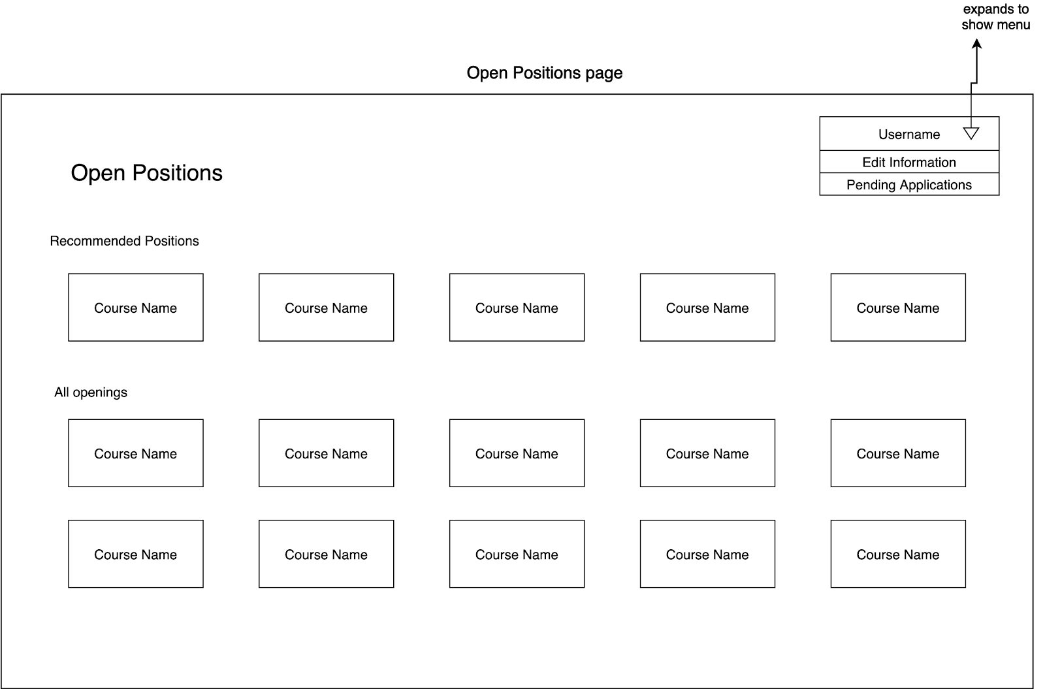

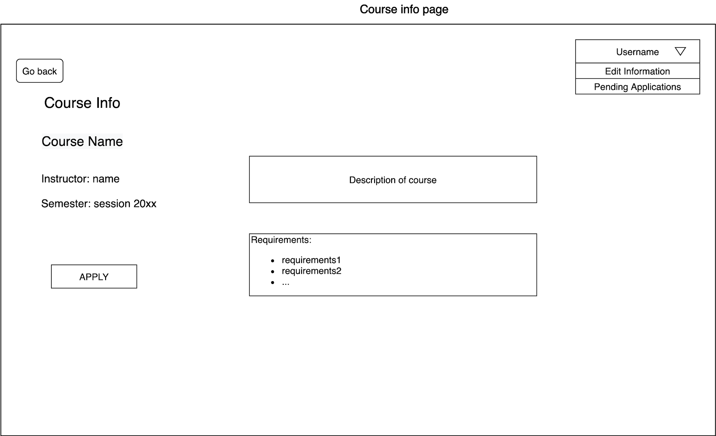

## View student applicants page

This page contains a table of students that have applied to the course selected. For this mockup, we have added eleven uniquely named students. For each student, you may view their qualifications, and additionally you may assign or remove the student as a TA for the course. If the student has been selected for TAship of another course already, the “Assign Student” button will be disabled. Finally, it also includes the core pieces of the page, like the logged in user, a logout button, and a back button.

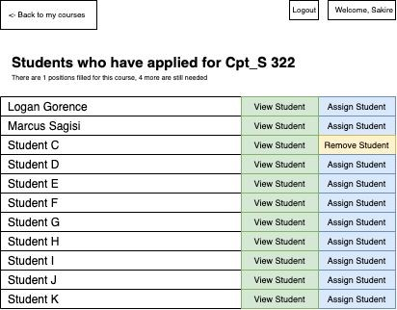

## View courses page

This page contains a table of courses that have been created by the logged in professor. For this mockup, we have added three courses, 322, 355, and 451. For each class, you may view the applicants for that course, and additionally you may edit the course required qualifications or metadata. From this page, you can also navigate to the “New Course” page. Finally, it also includes the core pieces of the page, like the logged in user, a logout button, and a back button.

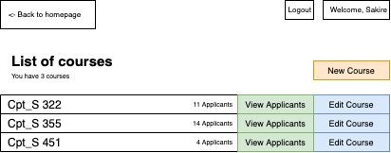

# References

Guru99. ​*What is Non-Functional Requirement? Types and Examples*​.

<https://www.guru99.com/non-functional-requirement-type-example.html>

|  |  |  |
| --- | --- | --- |
| Max Points | **Your Points** | **Content** |
| 10 | 10 | Do the requirements clearly state the customers’ needs? |
| 5 | 5 | Do the requirements avoid specifying a design (*note: customer-specified design elements are allowed; non-functional requirements may specify some major design requirements*)? |
|  |  |  |
|  |  | **Completeness** |
| 26 | 26 | Are use cases written in sufficient detail to allow for design and planning? |
| 4 | 4 | Do use cases have acceptance tests? |
| 5 | 5 | Do use cases mention error conditions and required behavior? |
| 20 | 20 | Is your use case model complete? Are all major use cases included in the document? |
| 10 | 10 | Are the User Interface Requirements given with some detail? Are there some sketches, mockups? |
|  |  |  |
|  |  | **Clarity** |
| 4 | 4 | Is the document carefully written, without typos and grammatical errors? |
| 3 | 3 | Is each part of the document in agreement with all other parts? |
| 3 | 3 | Are all items clear and not ambiguous? (Minor document readability issues should be handled off-line, not in the review, e.g. spelling, grammar, and organization). |
|  |  |  |
|  |  | **GitLab Issues** |
| 10 | 10 | Has the team setup their GitLab Issues page? Have they generated the list of use-cases, created milestones, assigned use-cases (issues) to milestones?  <https://about.gitlab.com/2018/03/05/gitlab-for-agile-software-development/>  Example GitLab repo (check the issues): <https://gitlab.eecs.wsu.edu/322-fall19-arslanay-warmup/sampletermprojectrepo/edit> |
| Total (100) | 100 |  |