RMIT University

School of Science, Engineering, and Technology

# 

**COSC2769**

**FURTHER WEB PROGRAMMING**

**Final Take-home Assignment Report**

**Member**

Do Hoang Quan – s3800978

Tran Vinh Tuong – s3878734

Tran Minh Nhat – s3877063

**Project** **demo**

https://youtu.be/2kE6wi6pJS8

# Table of Content

Application Topic 2

Goal and Motivation 3

Aim and Goal 3

Motivation 3

Key Features 4

1. Login/Signup 4

2. Website homepage 5

• First look at our website 5

3. Website Functionalities 5

• Assigning Section 6

• Adding assignments 6

• Adding cards 7

• Calendar 7

Tools and Technology 8

Security Measure 9

Project Progress 9

Scope 9

Progress 9

Testing 10

Risks 10

Conclusion 11

Group Distribution 12

# Application Topic

Since the twenty-first century, education has grown rapidly, bringing with it a plethora of new and intriguing courses. However, with numerous additional courses come extra assignments and homework, which students may forget or recall the incorrect due date. As a result, we want to develop a Trello clone and calendar hybrid tool to aid students in their studies. We planned for our software to help students keep track of their studies.

# Goal and Motivation

## Aim and Goal

This application's purpose is to provide the user with the most user-friendly and operable platform for effortlessly stimulating and interacting. Its goal is to assist students in their studies and to assist them in keeping track of their assignment due dates to decrease the incidence of late submission.

* To begin, to create a web app that helps students stay on top of their schoolwork, we must work on the left side of the website, where users will be able to create sections each of which will re-present a course and contain lists representing assignments and cards with functions such as Title, Description, Checklist, Due date, and so on. Users may quickly assign the list by entering the assignment's title, due date, and what steps must be taken during it. Users may also add assorted colors to each section to assist in distinguishing each course. Following that, we began working on the right side, which is where the calendar is located, and it will display which dates they have things due on, assisting them in staying on top of their schoolwork.
* We intend to build the user interface to be as user-friendly as possible because web applications aim to provide a smooth integration like native apps without the requirement for installation. Furthermore, many users now lead hectic lives, therefore spending less time on the site is always their top priority.

Motivation

The commonality of our group members' experiences inspired us to design this application. During our first meeting to discuss the group's topic, we discovered that each member had had the unpleasant experience of delivering their project late. There are two scenarios in such a situation. The first is when one member entirely forgets about a little task and does not work on it until it is past due. Another scenario is that one of the members recalled the incorrect due date and hence did not have enough time to complete the assignment or hurry the task and risk receiving a mediocre performance grade. To avoid history repeating itself and prevent other students from making the same mistake, we decided to build the Trello calendar hybrid to assist us and other students in keeping track of and staying on top of their work and assignments by allowing them to organize their tasks and display them on a calendar.

# Key Features

1. Graphical user interface, website

   Description automatically generated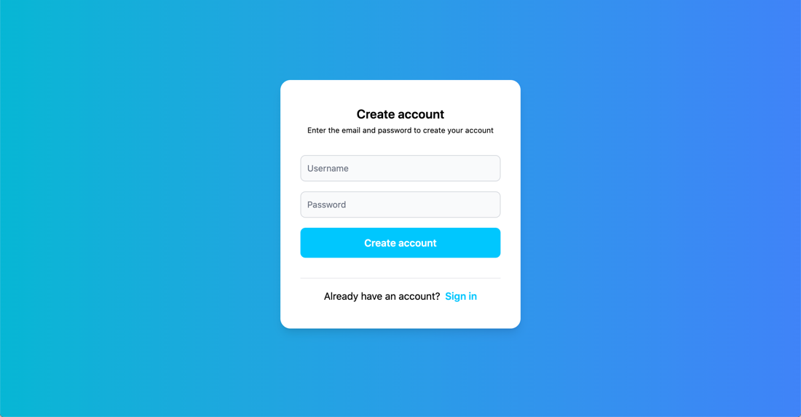**Login/Signup (not fully implemented)**

When you first open the website, you will be sent to the sign-up page, where you may provide the necessary knowledge to assist in creating an account before you can use the website efficiently. After successfully signing up, you will be sent to the Login page, from where you can verify your information and, if it is accurate, you will be directed to the homepage, where you can begin managing your account and assigning courses and assignments.

1. **Website homepage**

* First look at our website

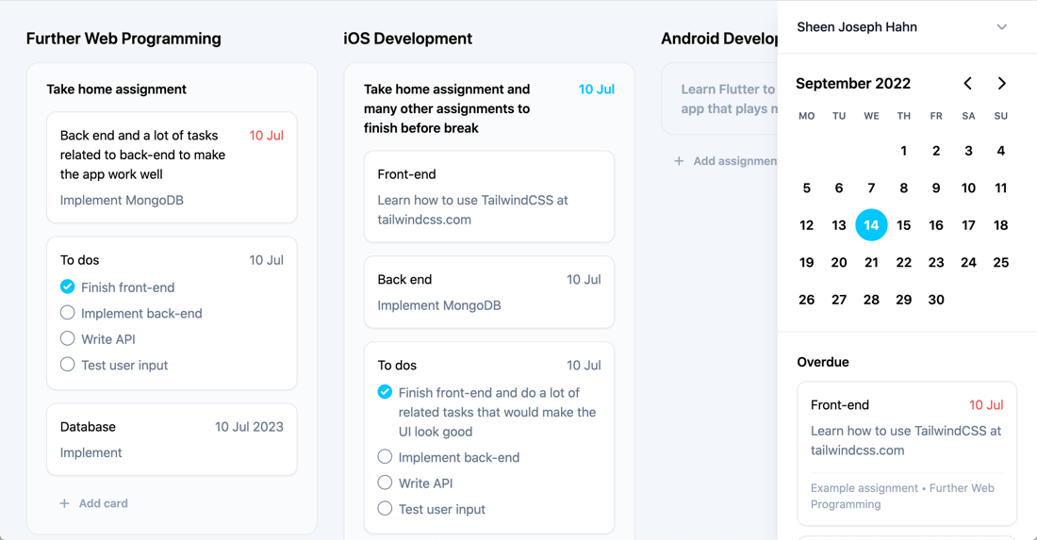

I have already registered and opened an account, and here is how our website will look while you are working with it. On the left side, you can see our board, sections, lists, and cards displaying our course name, the assignment, the number of tasks, and the due dates for each assignment. The calendar is located on the other side. It will assist in displaying the current date, and the due date of each assignment, and notifying us of any future assignments or tasks that are already past due.

1. **Website Functionalities**

* 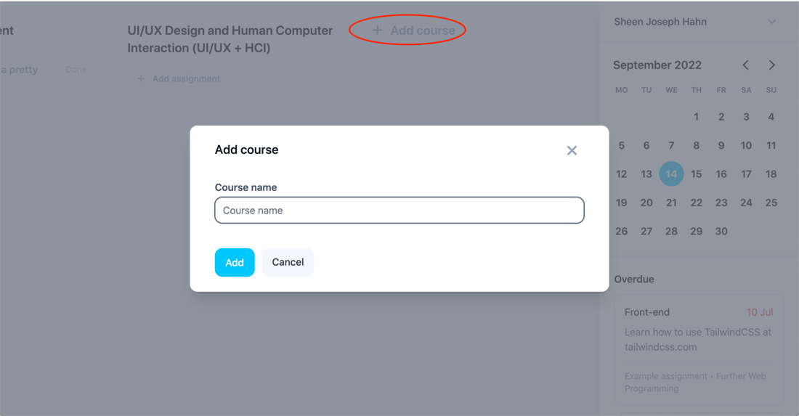Assigning Section

As shown in the images, you may begin working on your Trello calendar account by designating the area that reflects your course. Simply click the circular ADD COURSE icon to bring up a pop-up window. Simply enter the course name and hit Add, and you will be presented with a functioning list to utilize. You can add many courses at once to accommodate your study schedule.

* 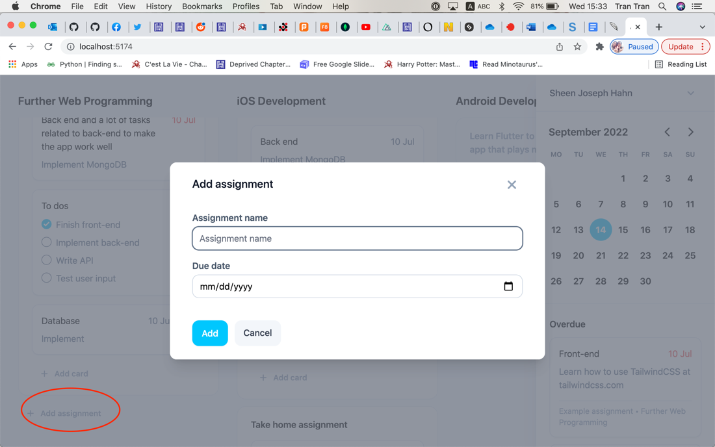Adding assignments

The following feature is a list where you may add any new task and its due date to help you keep track of time. It is as simple as filling in the assignment name and selecting the due date and you are done.

* 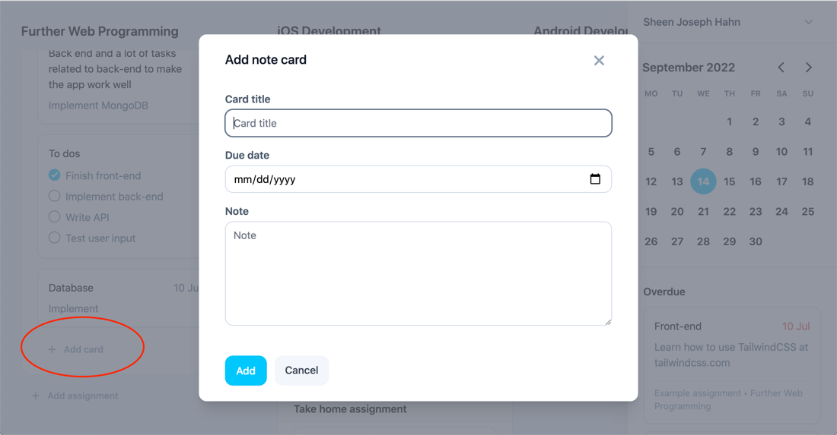Adding cards

When you have completed generating the list, go inside and start producing cards that illustrate your step-by-step procedure of what you should accomplish first, assigning yourself a due date for each stage to ensure you stay on track.

Each card can be a **note** or **checklist** card, letting users have both options to keep track of tasks or reminders.

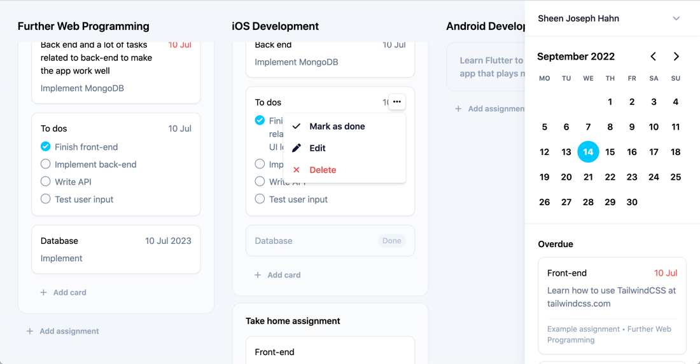

Furthermore, when you are through with any step or want to modify or remove a full card, you may accomplish all or one of those things by dragging your mouse to the "..." sign when you are finished with that card or want to edit or delete the card.

* Calendar

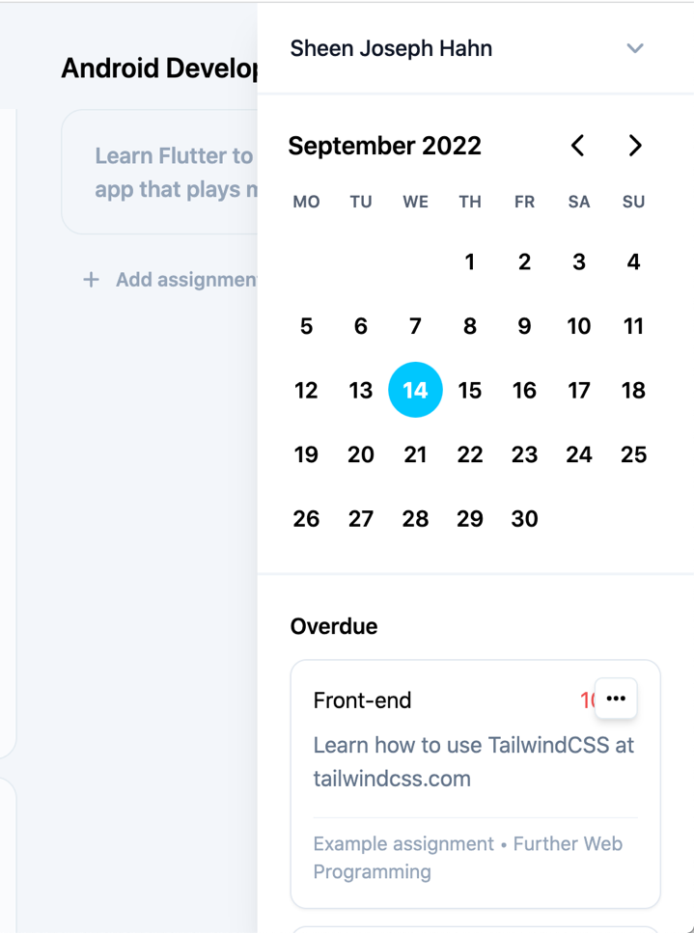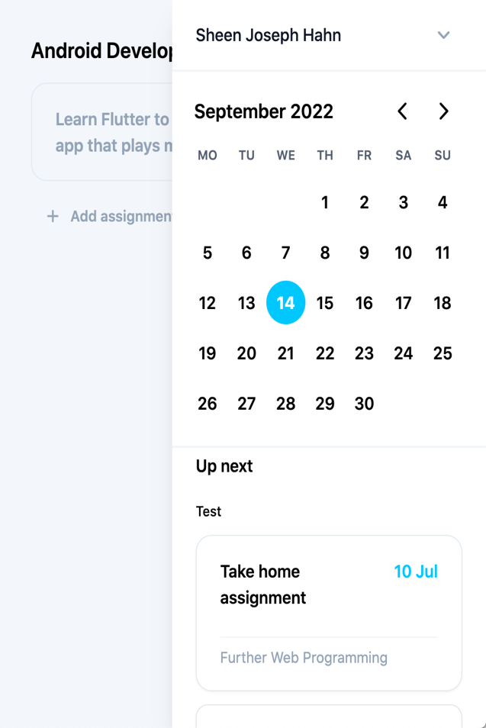

The two images above depict our website's calendar. Its purpose is to display the current date as well as any impending assignments. If you pay attention, there are alerts underneath the calendar that notify us which assignments are now past due and any impending assignments that need to be completed.

# Tools and Technologies

|  |  |
| --- | --- |
| **Tools/Technology** | **Objectives** |
| HTML5, CSS3, JavaScript, TailwindCSS, Vite | Building frontend |
| ReactJs, React Hook | Building backend |
| MongoDB, NodeJS, Express | Act as a database for future development. It is where you keep all your information, whether it be your login password and email or your lists and cards. It is also what keeps the server running and the websites operational. |
| Messenger, MS Team, GitHub | Help team members stay connected and support each other during the working process. |

# Security Measure

Although this website is solely for instructional purposes, personal privacy is still important, hence we have opted to employ JWT authentication to secure users' information from unwanted attention. A JWT is a means for determining who owns some JSON (JavaScript Object Notation) data. It is an encoded, URL-safe string that, unlike cookies, can include an endless amount of data and is cryptographically signed. When a server receives a JWT, it may be certain that the data it contains is trustworthy since it has been signed by the source. As a result, only the user or anybody they have authorized to know their password may access their account.

# Project Progress

Scope

Our project scope was aligned with the goal in the final report, and we used the technologies covered in the course: ReactJS, NodeJS, and Mongo DB. Other tools and technologies to consider are jwt authentications, tailwind CSS, Vite, and cloud deployment. We can state that we have reached the majority of our goals, with some space for improvement in the UX/UI.

Progress

The project will be finished after all the team meetings. The layout, login/registration page, modifying and creating the board, list, and cards according to the user's design, maintaining all those data using CRUD, and protecting the user's information using jwt authentication are all completed on time. But, unlike the other teams, ours was formed much later, and we even wasted a lot of time agreeing on a topic and waiting for the teacher's permission. As a result, we did not have much time, and the assignment still needed to be completed. As a result, we sped through the presentation to make way for other portions. In summation, each member attempts to fulfill his or her duty while also aiding others so that the entire team may effectively complete the project.

Testing

We performed some debugging and testing to determine whether there are any issues with jwt authentication and the CRUD in storing and managing user input in the board, list, and card. If there is an existing problem, group members will pay attention to it and endeavor to address it. When faced with a situation that was beyond their comprehension, a team member sought assistance from an online tutor supplied by RMIT University.

Due to time constraints, we did not complete the entire survey on Google Forms. Instead, we enlist the help of our friends and family as testers. We received feedback from them in vocal form, some are quite interested in the concepts, while others manage to uncover minor faults and make suggestions for what may be included to improve the website. However, many of them are delighted and advocate the continuation of this project.

Risks

There are always hidden dangers and challenges associated with web development; recognizing and analyzing such risks is crucial to avoid adverse consequences.

* The first and most important consideration is the amount of time we must spend on the project. Unlike other teams that were created during the second to fourth weeks. Because our members were unable to find a team to join, our team was formed late in week 6. Furthermore, despite having formed the team, we were unable to begin the project immediately since we needed to brainstorm to come up with a theme and then wait for the teacher's approval of this concept. Only then can we begin our project. As a result, we did not have enough time and had to rush through the job, risking making mistakes or underperforming our given responsibilities.
* Another topic worth considering is technological issues. Because two of the three members' computers are old, therefore several systems and modules are no longer supported or do not exist. So, until those machines are replaced, there will be a stop in the development of backend code since the computers outright refuse to execute the project. Thus, a significant amount of time was spent going to school to meet with an online tutor for assistance in resolving the problem, but that strategy does not always work because tutors are not always accessible, and we do not have the luxury of time on our hands.
* Finally, there was a scheduling issue. Along with starting work late, some outside causes may interrupt our planned timeline, causing the project to not advance as planned and forcing us to adjust the schedule unexpectedly.

Conclusion

After meeting and collaborating on this project, we can all agree that the end was excellent, but it could have been better. We could have refined and upgraded the project to be even more ideal if we had established the team earlier, and we would not have had to rush the project and stumble on the roadblocks. But, in the end, we liked the time we spent working together; the project was a success, and we were able to cover and apply all the needed technologies in the assignment, and the experience and knowledge that we have gained from working with each other is also a pleasure. Overall, even though the project was rushed, and numerous challenges were encountered during the creation process, the project was a success, and the experiences, knowledge, and friendships obtained while working together are all treasured by all members.

# Group Distribution

|  |  |
| --- | --- |
| **Members' names and IDs** | **Roles and deliverables** |
| **Do Hoang Quan**  **S3800978** | * Project ideation * UI/UX designs and userflow * All front-end components and pages * Course, assignment, cards API, and back-end * Linked front-end and back-end for home page and main content * Database structure * Visual touch-ups for report * Recorded demo and handled YouTube upload * Wrote README.txt |
| **Tran Vinh Tuong**  **S3878734** | * User, account, register, and logins API * Linked front-end and back-end for home page and main log-in and register * Wrote report |
| **Tran Minh Nhat**  **S3877063** | * User, account, register, and logins API * Linked front-end and back-end for home page and main log-in and register * Wrote report |

# Graphical user interface, text Description automatically generatedNo description available.