UNDERSTANDING WHATSAPP BUSINESS API
A plain-language guide, with pictures, for any customer-facing business
No technical background needed. If you talk to customers and they message you back, this is for you.
Powered by BTBIZ Group — Official Meta Tech Partner
ISO 9001 & ISO/IEC 27001 Certified

Let's start with what you already know
You already use WhatsApp. Your customers already use WhatsApp. That part doesn't change.
What changes is what happens behind your business's WhatsApp number — whether it's one person's personal phone, or a proper system your whole team can run. That system is called WhatsApp Business API, officially known as the WhatsApp Business Platform. This document explains what it actually does, using pictures instead of jargon.

Who this is for
Any business that talks to the people it serves, and gets messaged back. It doesn't matter what you sell or who you sell to:
- B2C — you sell directly to individual customers (a shop, a clinic, a restaurant, a service provider)
- B2B2C — you sell to other businesses, who then serve their own end customers (a distributor, a franchise, a platform with its own network of partners)
In both cases, someone at the end of the chain is a person with a phone, expecting a fast and clear answer. The diagrams below work the same way regardless of which one you are — replace “customer” with “client,” “patient,” “dealer,” or “end user” as fits your business.

The old way vs. the new way
Before anything technical — here's the simple picture.
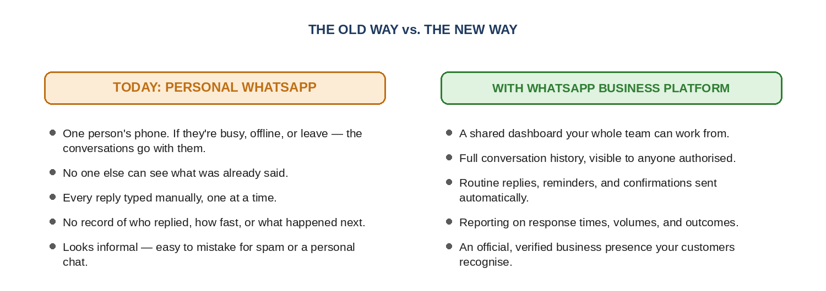

Picture 1: How a customer reaches you
This is what happens the moment someone messages your business on WhatsApp.
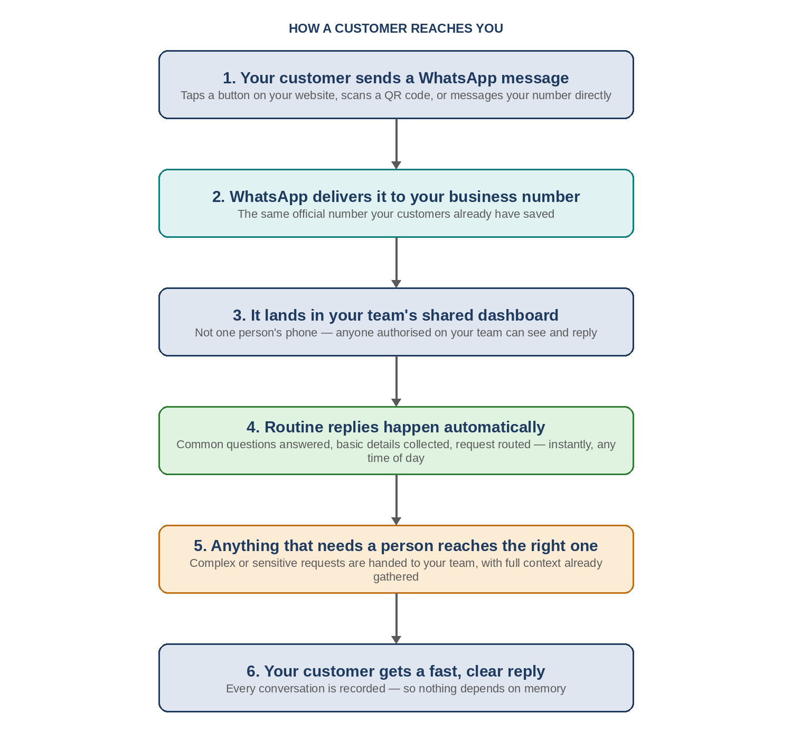
The important part: steps 3, 4, and 5 happen automatically and instantly — nothing here waits on a person to be free.

Picture 2: How you reach a customer
Sometimes you need to message the customer first — a booking confirmation, a payment reminder, a status update. This is how that works, and why it's not the same as sending a random text message.
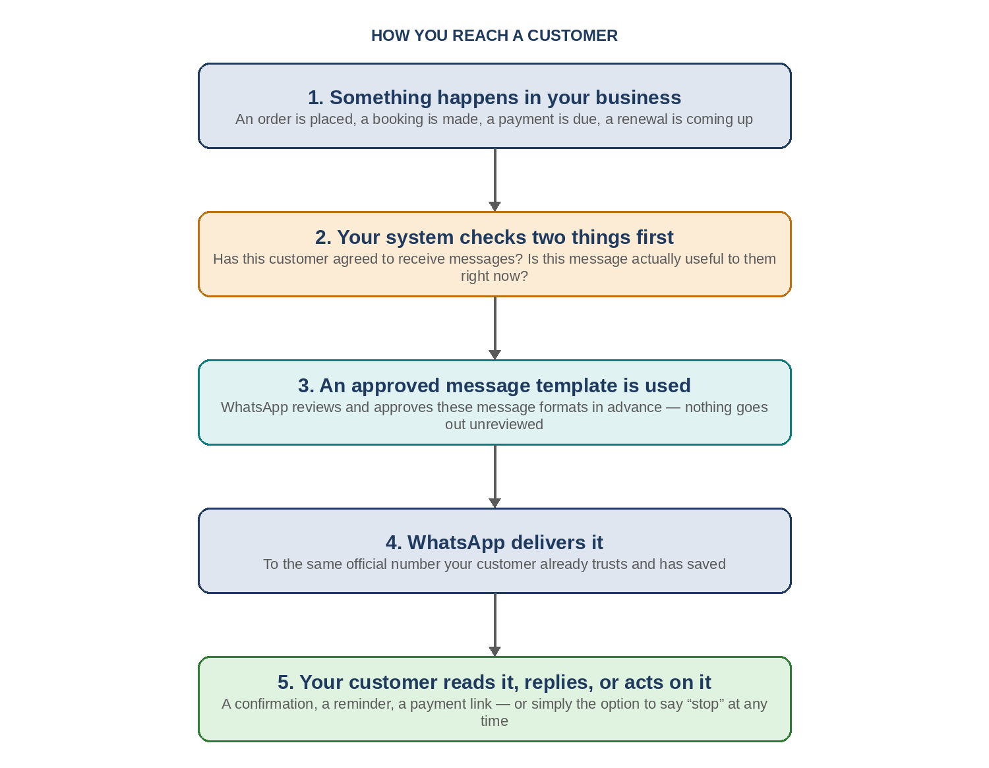
Step 2 exists for a reason: it stops your business from becoming a source of unwanted messages. Step 3 exists because WhatsApp itself checks and approves the wording in advance — you can't just send anything you like.

Picture 3: The full picture — automation and AI working together
The two pictures above show the message going in, and a reply coming out. This is what actually happens in between — how the system decides what to do with a request, and when it hands things over to a real person.
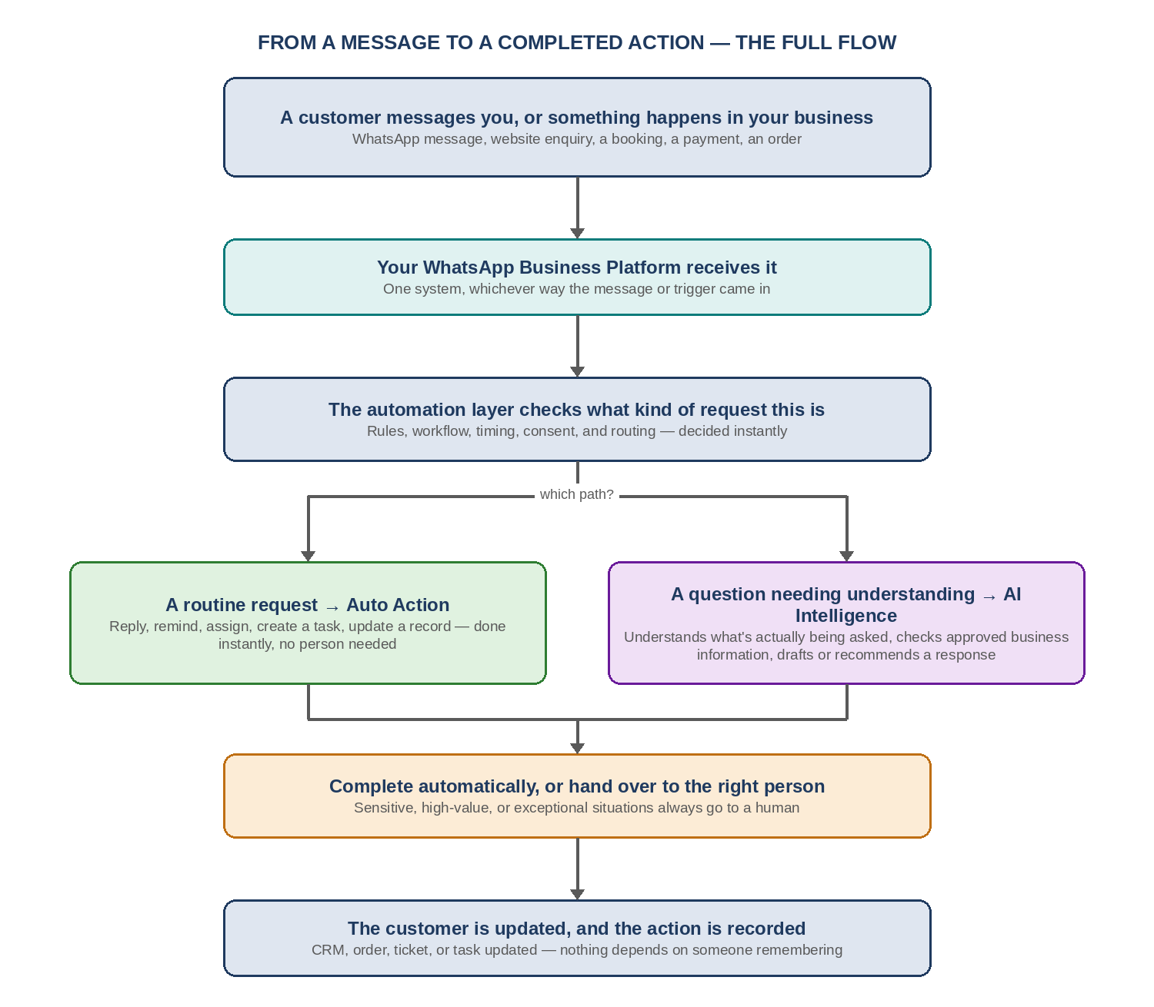
The key idea: routine, predictable requests are handled instantly by automation. Anything that needs real understanding — varied wording, context, judgement — goes through the AI layer instead. Either way, sensitive or high-value situations are always handed to a person, never completed automatically.

Picture 4: The one rule that actually matters — the 24-hour window
This is the single most important thing to understand, and it's simpler than it sounds.
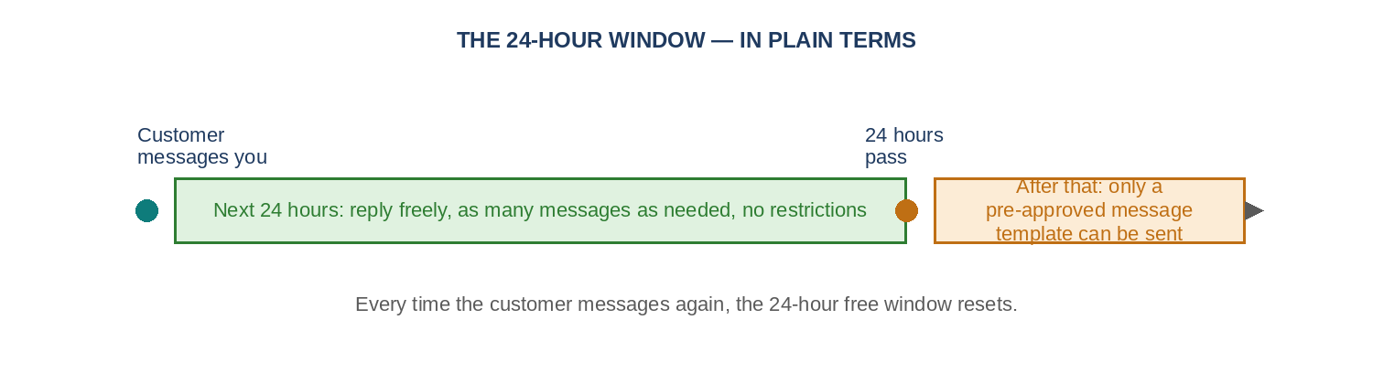
In plain terms: if your customer messages you, you have a full day to reply freely, however you like. If more than a day passes with no message from them, you can only send them a message that WhatsApp has already reviewed and approved in advance — called a template. The moment they message you again, the clock resets and you're back to replying freely.
This rule exists to stop businesses from messaging people endlessly without being invited to. It protects your customers — and it protects your business's reputation on the platform.

Why any customer-facing business should care
- You stop losing enquiries because one person was busy, asleep, or on leave.
- Your whole team works from one number — no one needs a customer's chat history explained to them from scratch.
- Routine, repetitive replies happen instantly, any time of day — without anyone typing them out.
- You get an actual record: who was messaged, when, what was said, what happened next.
- Your business looks like what it is — an official, verified presence — not an unofficial number that could be anyone.

If you run a B2B2C model specifically
The same three pictures apply one level up. Replace “your business” with “your head office” and “customer” with “your dealer, franchise, or partner” — the mechanics don't change. What often makes sense here is running one official WhatsApp presence at the top level, with conversations and chats assignable down to the right regional or partner team — so every downstream partner isn't setting up their own number and starting from zero.

What's included when you set this up
- Official onboarding of your business number onto WhatsApp Business Platform
- A shared dashboard your team logs into — no more personal phones
- Automated replies and reminders for the routine, repetitive parts
- Approved message templates prepared and submitted on your behalf
- Reporting so you can see response times and outcomes, not just guess

Trust, in plain terms
- This is set up by an official Meta Tech Partner — a direct, verified connection, not a chain of resellers
- ISO 9001 and ISO/IEC 27001 certified — independently audited quality and information-security practices
- Your customers only ever see your business name and number — nothing runs under anyone else's brand

The short version
“Your customers are already on WhatsApp. This just makes sure your business shows up there properly — fast, organised, and trustworthy — instead of relying on one phone and one person's memory.”

