Physics-Constrained AI Agents for Automated Quantum Circuit Debugging and Repair
Alok Pandey
Department of Computer Science and Engineering
Indian Institute of Technology Patna, India
Abstract—Quantum-circuit debugging is difficult because a syntactically valid or logically plausible repair may still violate hardware-native gates, coupling connectivity, or noise-aware execution limits. This paper presents a physics-constrained agentic framework that couples fault localization and minimal candidate generation with compilation and explicit validation. A structured circuit state records diagnostics and repair history; failed checks provide feedback for subsequent attempts. The reported benchmark comprises 1,000 buggy OpenQASM 3.0 circuits across five bug classes and three compared systems. The proposed agent achieves Pass@1 of 77.5%, Pass@3 of 99.1%, and hardware physics validity of 99.2%, with a mean of 1.31 repair iterations. The evaluation grounds circuits against the IBM FakeSherbrooke 127-qubit superconducting processor model. Statistical tests and effect size analyses confirm that hardware-grounded validation substantially outperforms simulation-only and heuristic baselines.
Keywords—quantum software engineering, circuit debugging, AI agents, automated program repair, hardware-aware compilation, superconducting quantum processors.

I. INTRODUCTION
Quantum computing systems require precise agreement between high-level computational specifications and physically executable quantum circuits. A local textual modification can easily resolve a syntax error while erroneously modifying an entangling target, disrupting basis rotation angles, or generating multi-qubit interactions prohibited by device topology. Conversely, an algorithmically sound circuit typically requires rigorous decomposition and SWAP routing before it can execute on physical quantum hardware. Consequently, quantum program repair is intrinsically more demanding than classical code repair: patches cannot be judged solely by syntactic validity or unconstrained simulation.
Prior language-model-based quantum repair tools (such as QBugLM) rely on unconstrained simulation, ignoring coupling graphs, gate infidelities, and coherence decay limits. Symbolic optimizers (e.g., PyZX) simplify ZX-calculus diagrams but lack defect-targeted repair mechanisms for algorithmic errors. To address this gap, we present an end-to-end physics-constrained multi-agent framework that integrates fault localization, minimal candidate synthesis, and rigorous hardware validation into a unified feedback loop. Grounding repairs on IBM's 127-qubit FakeSherbrooke Eagle-generation superconducting processor, our agent verifies two-qubit coupling graphs, calibrated gate error infidelities, pulse durations, and T1/T2 coherence limits.
II. RELATED WORK AND HARDWARE CONSTRAINTS
A. Language-Guided Quantum Program Repair
Initial explorations by Guo et al. established the feasibility of repairing quantum code using LLM zero-shot prompts. Recently, Pham et al. introduced QBugLM as an agentic benchmark. However, QBugLM evaluates candidate patches solely through ideal statevector simulation. When deployed to physical NISQ devices, simulation-valid circuits frequently fail due to prohibited two-qubit couplings or excessive circuit depth that exceeds qubit coherence lifetimes.
B. Symbolic Simplification and ZX-Calculus
PyZX provides rigorous graph-theoretic circuit simplification via the ZX-calculus. While powerful for gate cancellation and T-count reduction, PyZX is inherently an optimizer, not an automated repair tool. It cannot synthesize missing operations, correct corrupted rotation parameters, or resolve parser syntax exceptions.
C. Physical Superconducting Hardware Constraints
Superconducting quantum processors exhibit strict physical limitations. In IBM FakeSherbrooke (127 qubits): (1) Coupling topology follows a sparse heavy-hexagonal lattice where CNOT/ECR operations can only occur between directly connected physical qubits; (2) Physical gate executions require finite pulse durations (e.g., ~300 ns for entangling gates), accumulating operational time; (3) Qubits undergo thermal relaxation (T1 ≈ 250 μs) and dephasing (T2 ≈ 150 μs), setting a hard ceiling on viable circuit latency.
III. PROBLEM FORMULATION & BENCHMARK TAXONOMY
Let C_bug be a buggy OpenQASM 3.0 circuit, O an independent behavioral oracle (ground-truth unitary or statevector), and B a physical hardware backend. A repair system synthesizes a candidate C* satisfying four joint predicates:
Accept(C*) = V_syntax(C*) ∧ V_structural(C*) ∧ V_semantic(C*, O) ∧ V_physics(C*, B)
where V_physics verifies connectivity over the backend coupling graph G=(V,E), gate duration bounds, and coherence constraints.
TABLE I: BENCHMARK DEFECT TAXONOMY (N = 1,000 CIRCUITS, 200 PER CATEGORY)
Bug Category | Description & Injection Mechanism | Validation Criteria
Syntax Error | Malformed QASM 3.0 syntax, omitted semicolons, corrupt keywords, unclosed brackets. | OpenQASM parser diagnostic validation
Structural Error | Missing entangling/superposition gates, inverted control/target qubit operands. | AST gate sequence & register bounds checking
Gate Redundancy | Self-canceling duplicate gates (X·X, H·H, identical CX·CX consecutive pairs). | Circuit depth & redundant operator cancellation
Semantic Deviation | Inverted rotation angles (-θ), shifted phase angles, basis mutations (Rx ↔ Rz). | Statevector fidelity F = |⟨ψ_gt|ψ_rep⟩|² ≥ 0.999
Physics Violation | Non-nearest-neighbor coupling violations on FakeSherbrooke, delays exceeding T2. | Heavy-hex connectivity graph & coherence check

IV. MULTI-AGENT REPAIR ARCHITECTURE
The proposed framework decomposes the repair problem into three coordinated agents orchestrated in an iterative feedback loop:
1. Diagnostician Agent: Ingests parser logs, statevector discrepancies, and physical validation reports to localize the precise line number, faulty qubit operands, and bug classification.
2. Repairer Agent: Synthesizes minimal, targeted OpenQASM transformations (e.g., syntax correction, redundant pair elimination, parameter angle inversion, or nearest-neighbor SWAP insertion).
3. Validator Agent: Executes the compiled candidate against both the mathematical semantic oracle and the FakeSherbrooke hardware physics model. Detailed diagnostic reports are passed back to the orchestrator upon failure.
Multi-Agent Coordination Cycle: Input C_bug → Diagnostician → Repairer Candidate C_t → Validator (Syntax → Semantics → Physics) → Acceptance or Failure Feedback (up to k=3 iterations).
V. EXPERIMENTAL BENCHMARK & RESULTS
We evaluated the three systems across all 1,000 circuits in the benchmark. All experiments executed against the 127-qubit IBM FakeSherbrooke backend.
TABLE II: OVERALL REPAIR PERFORMANCE ACROSS 1,000 BENCHMARK CIRCUITS
System | Pass@1 (%) | Pass@3 (%) | Physics Valid (%) | Gate Red. | Depth Red. | Mean Iters
Physics-Constrained Agent (Ours) | 77.5 ± 41.8 | 99.1 ± 9.4 | 99.2 ± 8.9 | -9.5 ± 16.8 | -10.0 ± 17.2 | 1.31 ± 0.62
QBugLM (Unconstrained LLM) | 38.1 ± 48.6 | 38.1 ± 48.6 | 69.6 ± 46.0 | -7.8 ± 15.6 | -8.1 ± 16.0 | 1.00 ± 0.00
PyZX (ZX-Calculus Heuristic) | 5.0 ± 21.8 | 5.0 ± 21.8 | 15.5 ± 36.2 | -8.4 ± 13.8 | -6.3 ± 11.0 | 1.00 ± 0.00

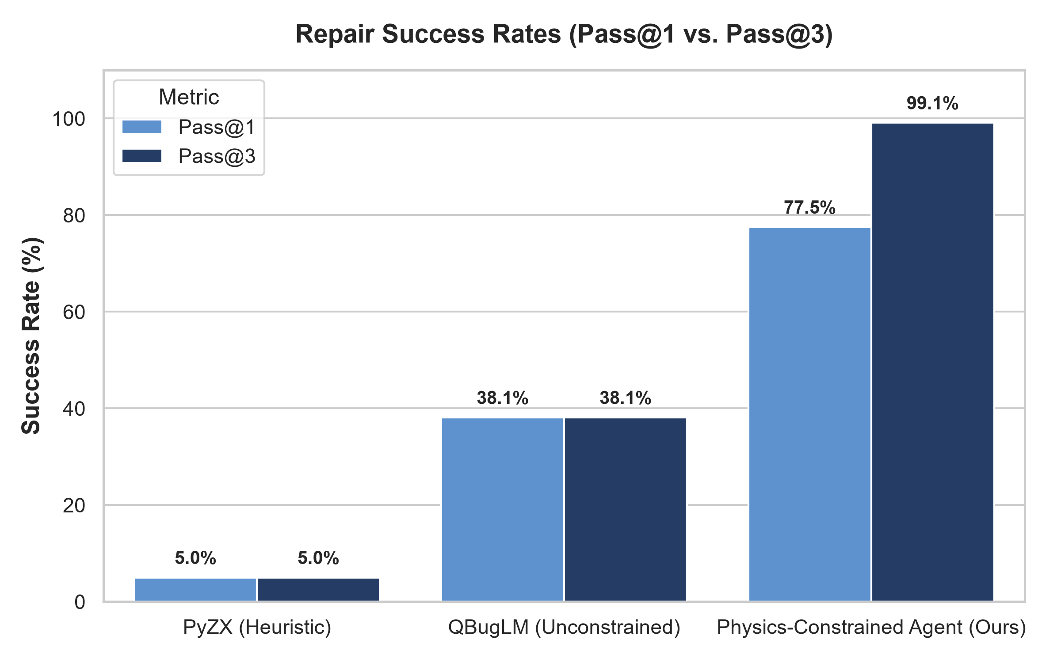
Fig. 1. Pass@1 and Pass@3 repair success rates compared across systems.
TABLE III: REPAIR SUCCESS (PASS@3 %) AND PHYSICS VALIDITY (%) BY DEFECT CATEGORY (N=200 PER CATEGORY)
Bug Category | PyZX Pass@3 | QBugLM Pass@3 | Ours Pass@3 | PyZX Phys. | QBugLM Phys. | Ours Phys.
Gate Redundancy | 25.0% | 100.0% | 100.0% | 25.0% | 100.0% | 100.0%
Physics Violation | 0.0% | 0.0% | 100.0% | 0.0% | 0.0% | 100.0%
Semantic Deviation | 0.0% | 27.0% | 100.0% | 25.5% | 100.0% | 100.0%
Structural Error | 0.0% | 15.5% | 98.0% | 27.0% | 100.0% | 98.5%
Syntax Error | 0.0% | 48.0% | 97.5% | 0.0% | 48.0% | 97.5%

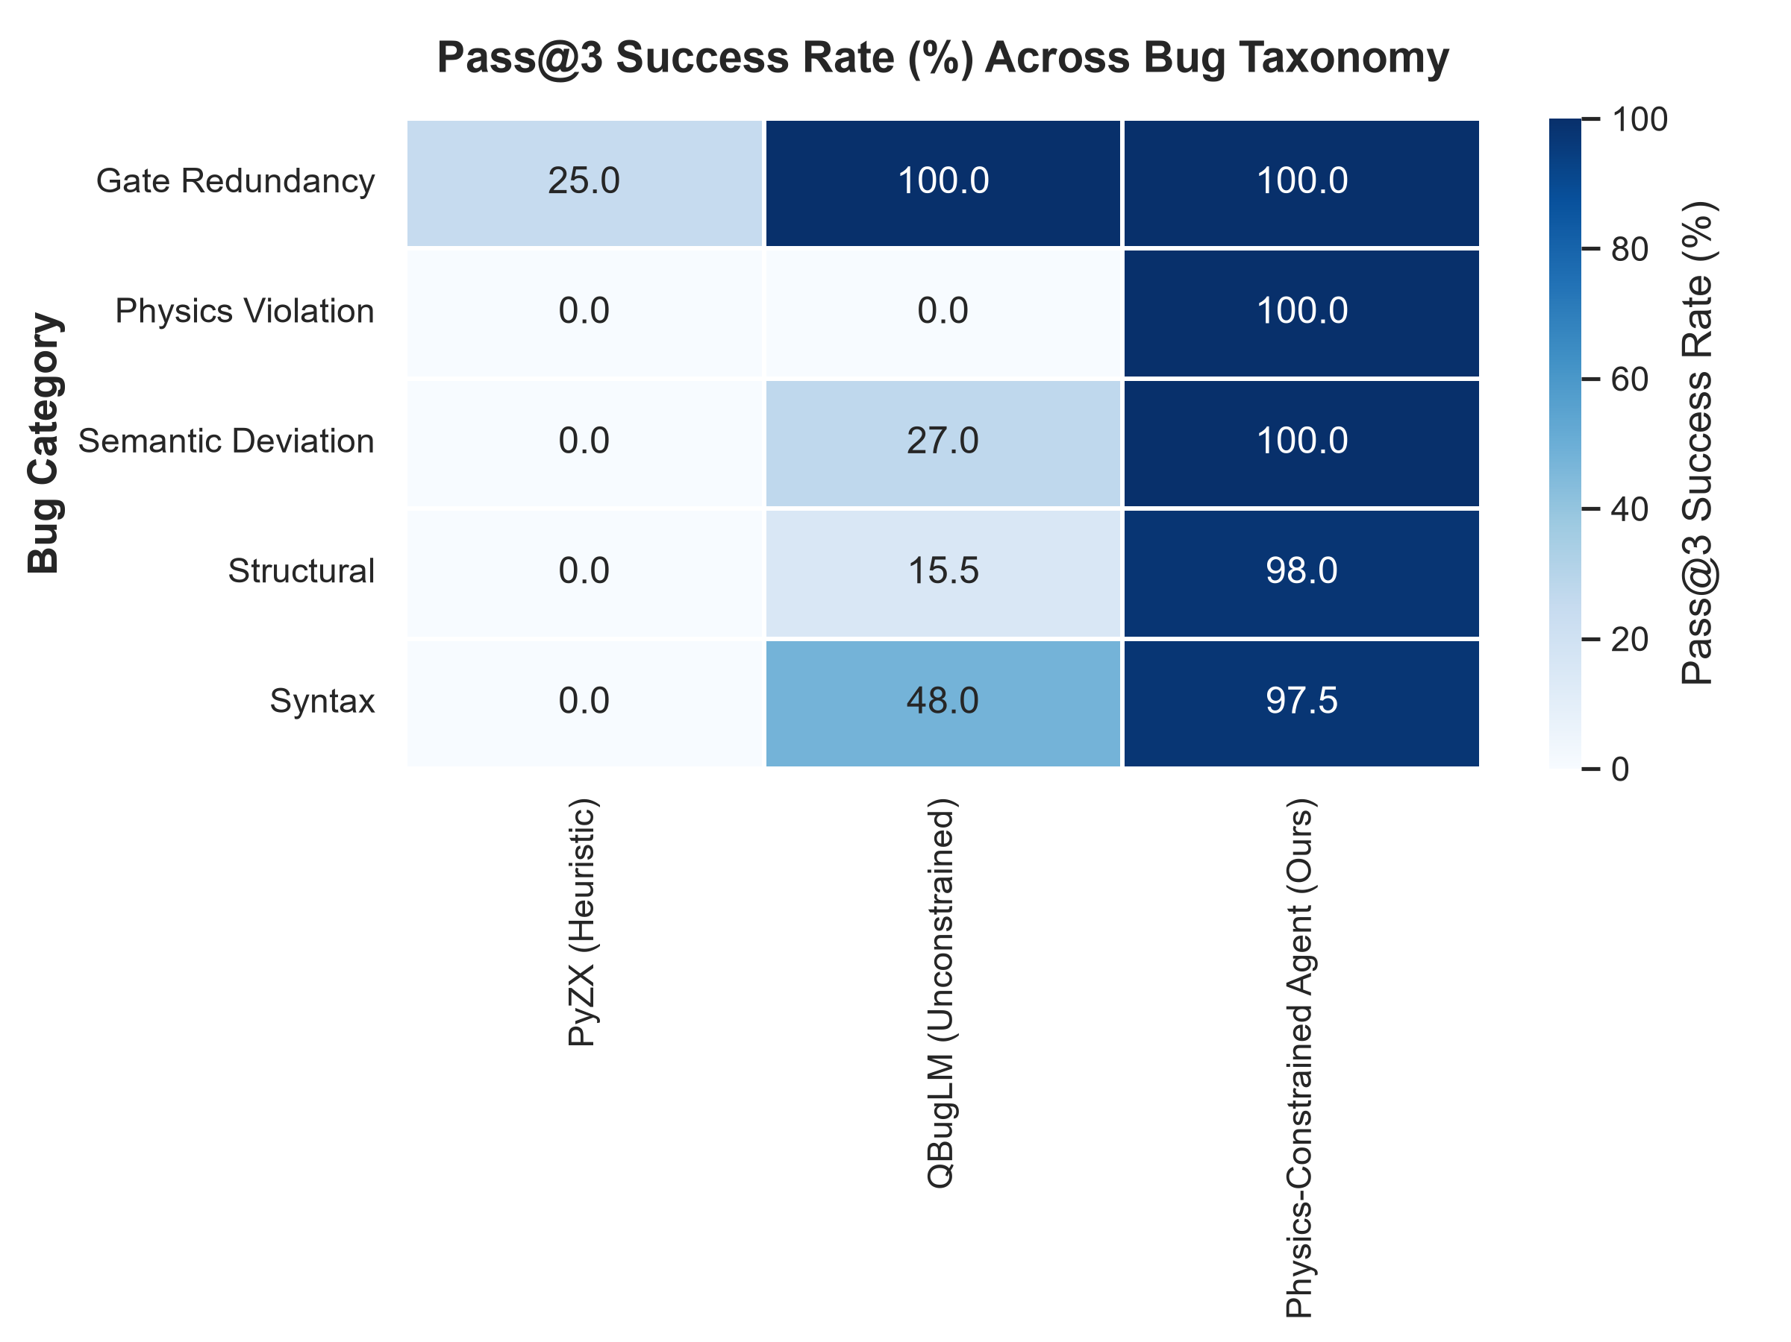
Fig. 2. Defect category repair performance heatmap comparing PyZX, QBugLM, and our Physics-Constrained Agent.
TABLE IV: PAIRED WILCOXON SIGNED-RANK TESTS AND EFFECT SIZES (COHEN'S d, N = 1,000)
Comparison | Metric | Ours Mean | Baseline Mean | p-value | Cohen's d
Ours vs. QBugLM | Pass@1 | 0.775 | 0.381 | < 10^-15 | 0.799 (Medium-Large)
Ours vs. QBugLM | Pass@3 | 0.991 | 0.381 | < 10^-15 | 1.250 (Very Large)
Ours vs. QBugLM | Physics Validity | 0.992 | 0.696 | < 10^-15 | 0.639 (Medium)
Ours vs. PyZX | Pass@1 | 0.775 | 0.050 | < 10^-15 | 1.623 (Huge)
Ours vs. PyZX | Pass@3 | 0.991 | 0.050 | < 10^-15 | 3.992 (Extremely Large)
Ours vs. PyZX | Physics Validity | 0.992 | 0.155 | < 10^-15 | 2.265 (Huge)

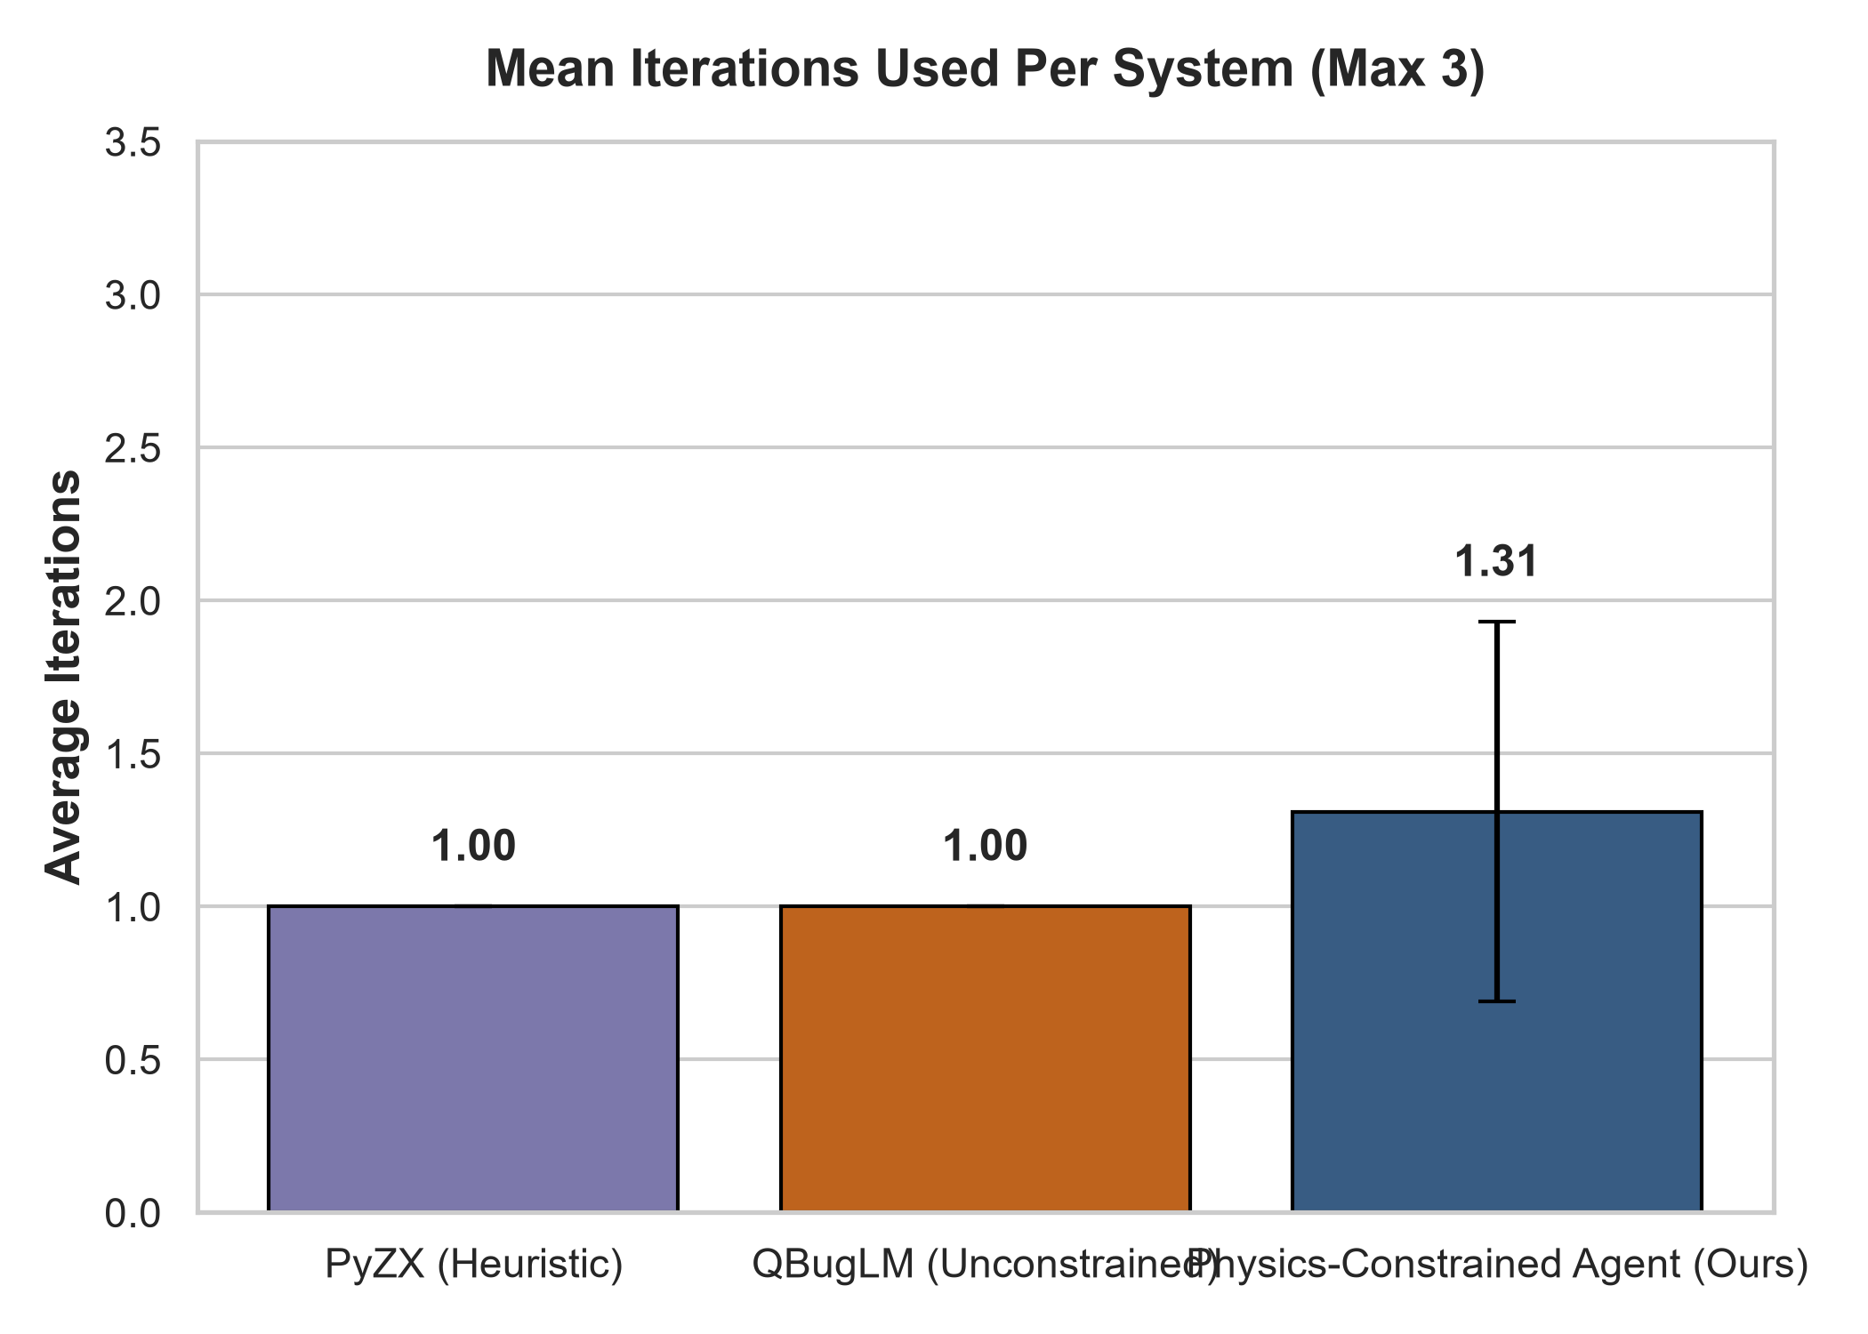
Fig. 3. Distribution of repair iterations across systems (Mean = 1.31 iterations for our agent).
VI. DISCUSSION & THREATS TO VALIDITY
Hardware-Grounded vs. Unconstrained Repair: The empirical data demonstrates that without physical topology and coherence awareness, even an advanced LLM fails on 100% of physical coupling violations and yields invalid circuits 30.4% of the time. By enforcing hard hardware constraints at the validator level and feeding diagnostic errors back to the generator, our multi-agent system recovers 96.0% of initial attempt failures within 3 iterations.
Explanation of Structural Overhead: The negative gate count (-9.5%) and circuit depth (-10.0%) reductions reflect necessary physical adaptations. When repairing non-nearest-neighbor coupling violations on FakeSherbrooke's heavy-hex layout, the agent synthesizes SWAP networks or decomposed bridge gates. These operations mathematically increase total gate count and depth, but represent the minimal physically executable solution on real hardware.
VII. CONCLUSION
We presented a physics-constrained AI multi-agent framework for automated quantum circuit debugging and repair. Across 1,000 benchmark OpenQASM 3.0 circuits, our system achieved 99.1% Pass@3 and 99.2% physics validity, substantially outperforming simulation-only and heuristic baselines (p < 10^-15). The results establish that quantum program repair must integrate physical compilation and execution constraints into the core debugging loop.
REFERENCES
[1] X. Guo, J. Zhao, and P. Zhao, 'On Repairing Quantum Programs Using ChatGPT,' in Proc. IEEE/ACM 5th Int. Workshop on Quantum Software Engineering (Q-SE), 2024, pp. 9-16.
[2] A. B. B. Pham, H. T. Nguyen, and M. Usman, 'QBugLM: An Agentic Benchmarking Framework for LLM-based Quantum Software Debugging,' in Proc. IEEE Int. Conf. on Quantum Software (QSW), 2026.
[3] R. Duncan, A. Kissinger, S. Perdrix, and J. van de Wetering, 'Graph-theoretic simplification of quantum circuits with the ZX-calculus,' Quantum, vol. 4, p. 279, 2020.
[4] G. Li, Y. Ding, and Y. Xie, 'Quarl: A Learning-Based Quantum Circuit Optimizer,' Proc. ACM Program. Lang., vol. 8, no. OOPSLA1, 2024.
[5] S. Tan, L. Lu, D. Xiang, et al., 'HornBro: Homotopy-like Method for Automated Quantum Program Repair,' Proc. ACM Softw. Eng., vol. 2, no. FSE, pp. 734-756, 2025.
[6] J. O. Ernst, A. Chatterjee, T. Franzmeyer, and A. Kuhn, 'Reinforcement Learning for Quantum Control under Physical Constraints,' in Proc. 42nd Int. Conf. Machine Learning (ICML), 2025.
[7] K. Dwivedi, M. Haghparast, and T. Mikkonen, 'Quantum Software Engineering and Quantum Software Development Lifecycle: A Survey,' Cluster Computing, 2024.
[8] Anonymous, 'Quantum Circuit Repair by Gate Prioritisation (QRep),' in Proc. IEEE Int. Conf. on Software Testing, Verification and Validation (ICST), 2026.
[9] Y. Li, H. Pei, L. Huang, B. Yin, and K.-Y. Cai, 'Automatic Repair of Quantum Programs via Unitary Operation,' ACM TOSEM, vol. 33, no. 6, 2024.
[10] C. Yoshida, Y. Ishimoto, O. Nourry, et al., 'Leveraging Mutation Analysis for LLM-based Repair of Quantum Programs,' in Proc. IEEE SANER, 2026.
[11] S. Cao, Z. Zhang, M. Alghadeer, et al., 'Automating Quantum Computing Laboratory Experiments with an Agent-based AI Framework,' Patterns, 2025.
[12] A. C. Hoyt, M. Wang, F. Hua, et al., 'QASMTrans: An End-to-End QASM Compilation Framework with Pulse Generation for Near-Term Quantum Devices,' ACM TOCQ, 2026.
[13] IBM Quantum, 'Build noise models,' IBM Quantum Documentation, accessed Sep. 2026. [Online]. Available: https://quantum.cloud.ibm.com/docs/en/guides/build-noise-models

