1.In the Search box type Spanner and choose the Spanner option from the list & click on Create a Provisioned Instance

(create instance is restricred when you do the lab, you can choose the existing instance to complete the activity, the below steps are for your understanding only no need to do it)

3. Choose the configuration as Regional if you want the instance to be managed in one region or you can choose multi region.

4. Configure the compute capacity required for the instance by providing the no of nodes or processing units 1 Node = 1000 Processing Units.

The scaling option can be selected as Manual by providing the no of nodes to be created in the instance or it can be selected as Auto Scale by providing min and max nodes based on the demand the nodes will be automatically increased or decreased based on the min and max values.

And click on Create.

On right side you can see the summary which will display the compute and storage cost for the instance

5.Once the instance created click on instance name, on this window you can Edit and Delete the instance.

You can create the database by clicking Create Database

6.Provide Database name, choose the dialect for the database either as Google Standard SQL or PostgreSQL

7.Once the database is created, table can be created by clicking Create Table option or you can manage the tables in the spanner studio

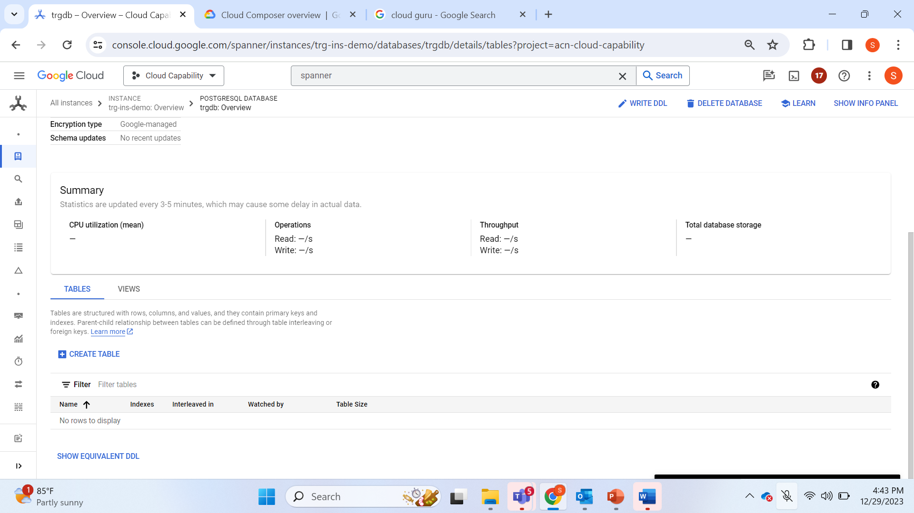

8.Click on Spanner Studio

9.In the Editor window, SQL queries can be written based the dialect we have selected during database creation

10.Using Import/Export, data can be imported/exported within the database.

11.Backup/Restore option will allows you to create the back up of the database. Click Create backup

12.Provide Backup name, set an expiration date and create the backup

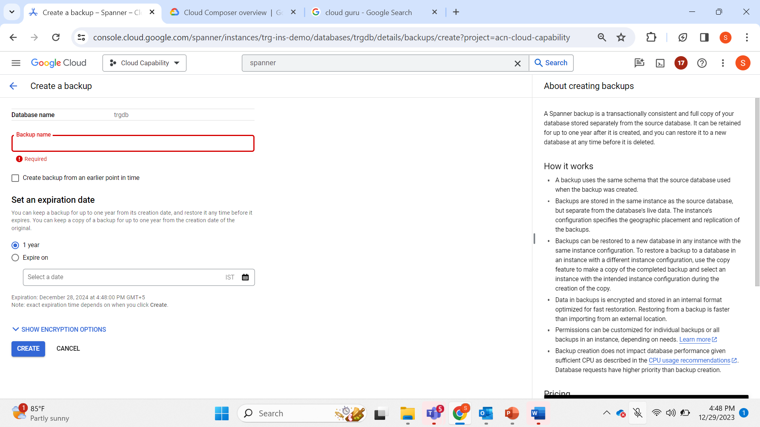

13.Once the back up is created click on three dots, other options to manage the backup will be available.

