**Aim**: Create a Bucket and add upload the file in the bucket

Step 1:- Open Console

Step 2:- Explore the Option under Storage 🡪 Storage 🡪 Browser and click on Browser

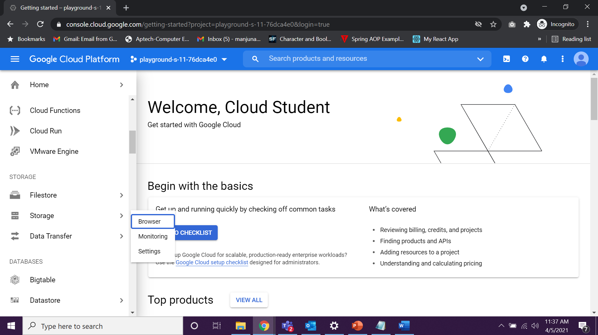

Output :- Here we can CREATE or DELETE the buckets

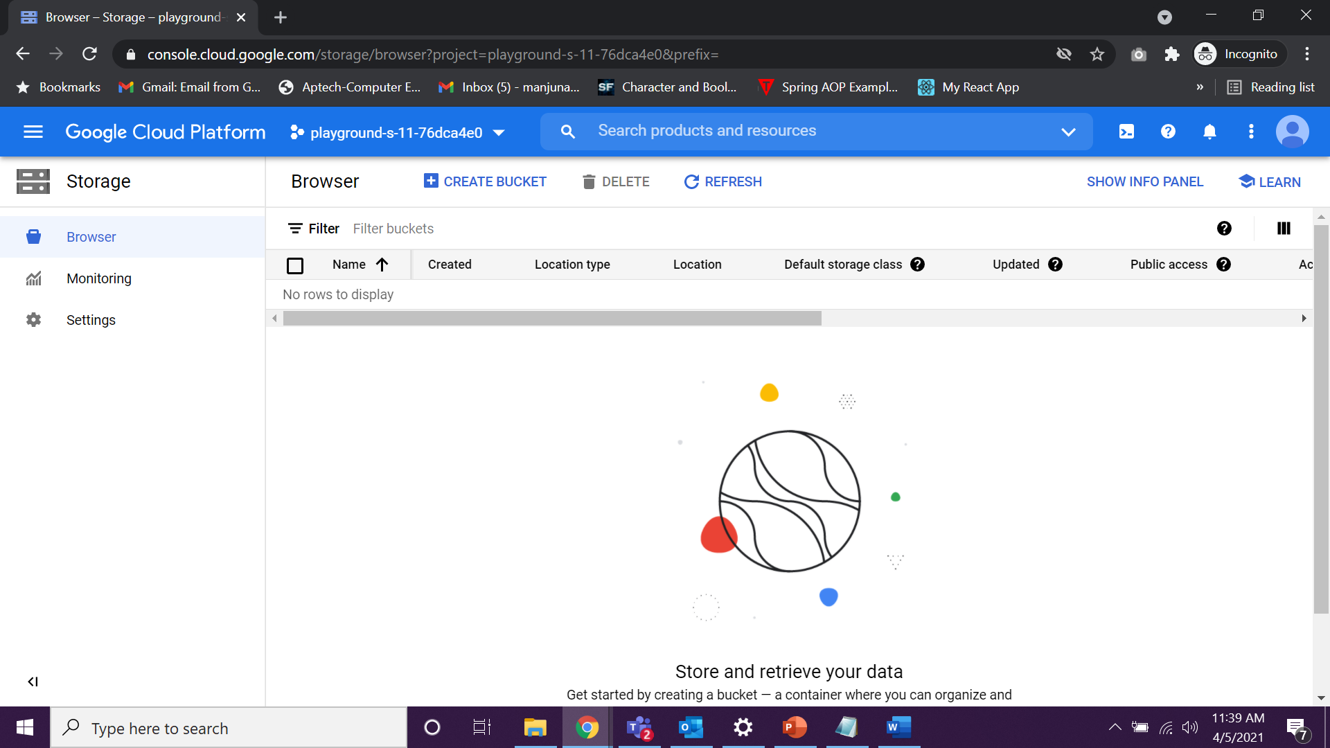

Step 3: Click on the **“CREATE BUCKET”** Button Option.

Step 4: Fill the Information about the bucket as follows

* **Name of the Bucket:** cloud-capablity-bkt-<your name> (Click on Continue)

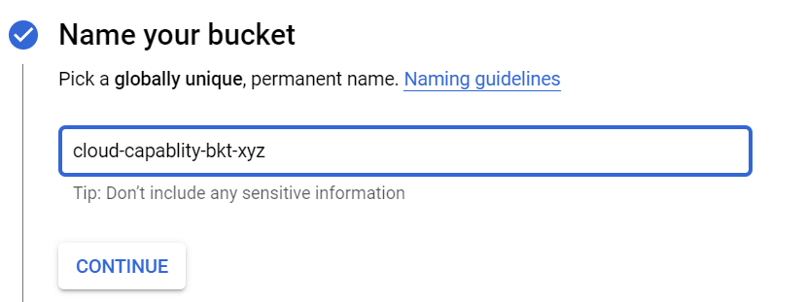

* **Choose where to store your data :** Region

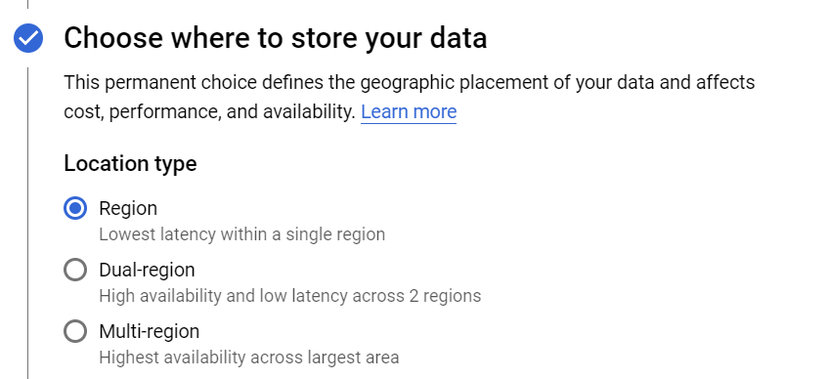

* **Location :**  asia-south1 (Mumbai) (Click on Continue)

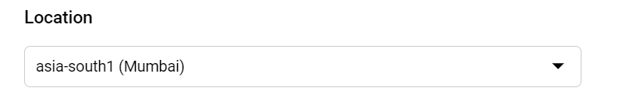

* **Choose a default storage class for your data :**  Standard (Click on Continue)

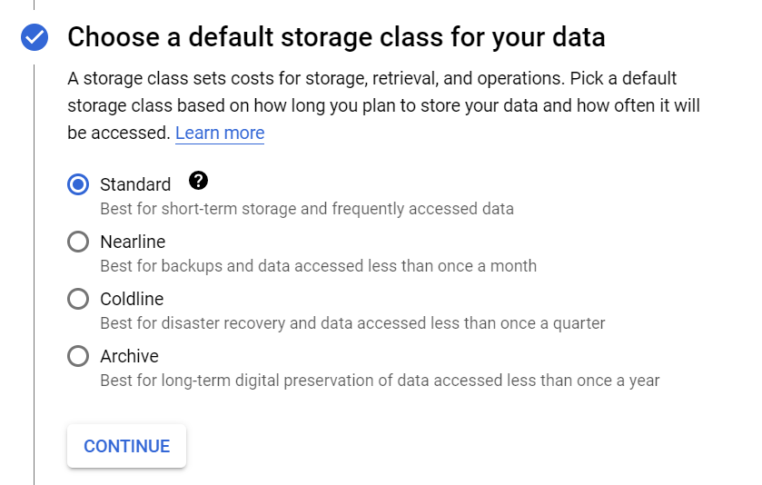

* **Choose how to control access to objects :** Fine-Grained

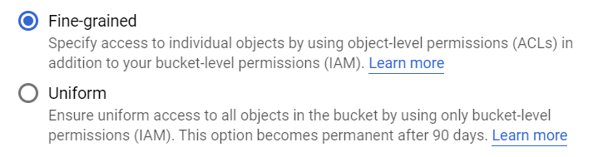

* **Advanced settings (optional):** Google-managed encryption key

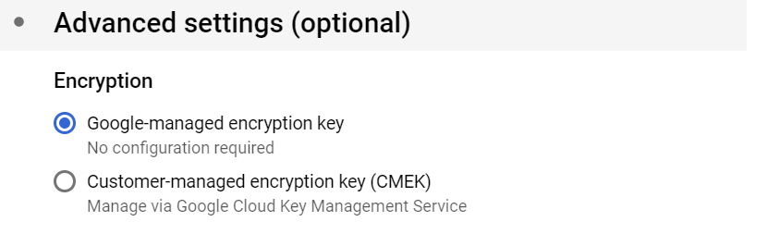

* **Retention policy:** Check the Option **“Set a retention policy”** and select the below option

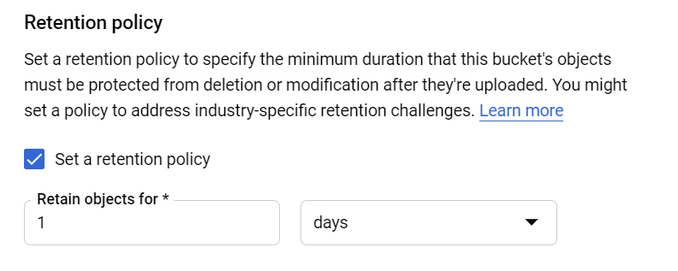

* **Label**

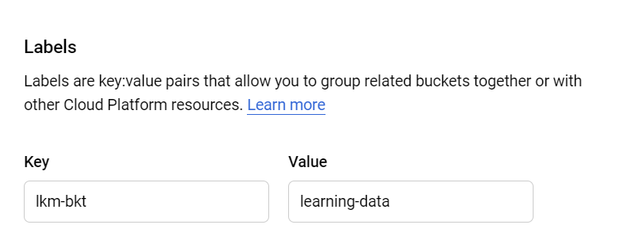

* Click on “**CREATE”** button



* Output: - Your bucket will be created with the Url
* Click on the “Configuration” to view the information of your bucket

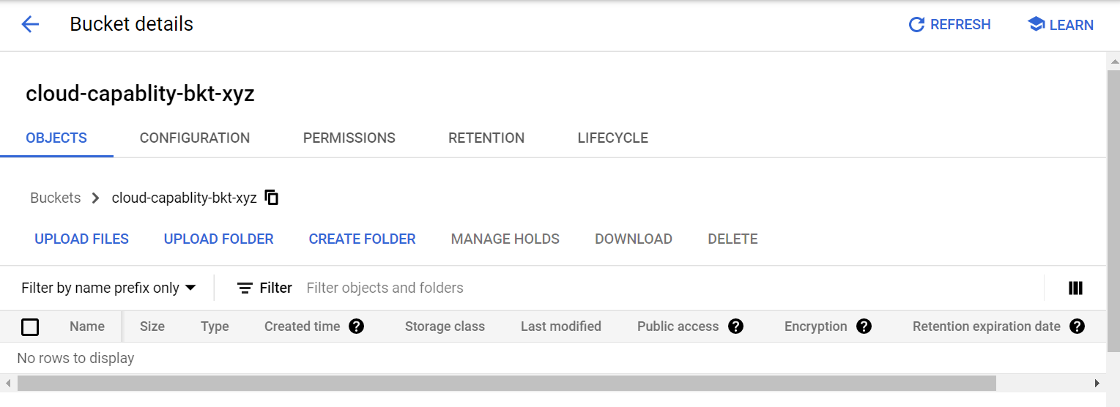

Step 5: Click on Create Folder and add the name cc-lkm-trng-data-<yourName>

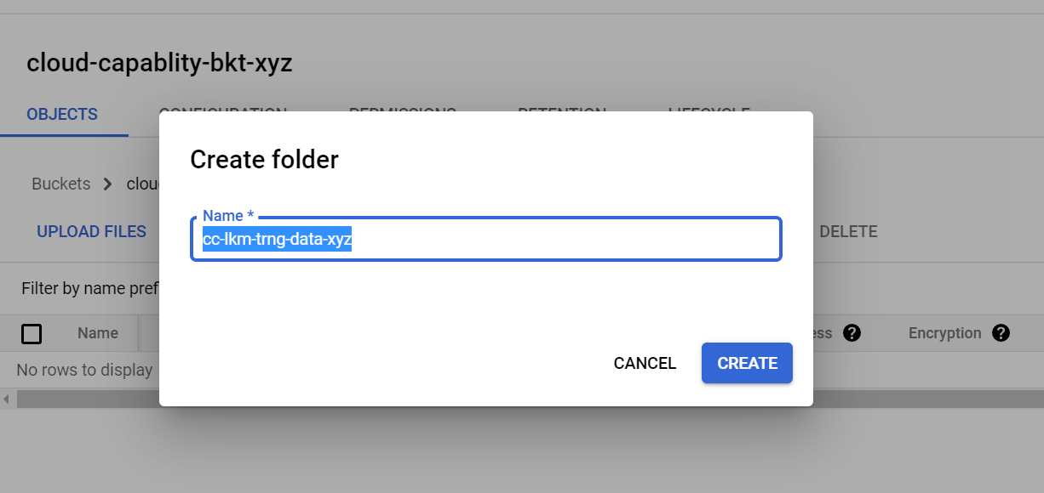

Step 6: Click on CREATE

Output:- your folder will be created ending with “/” which shows it is a folder

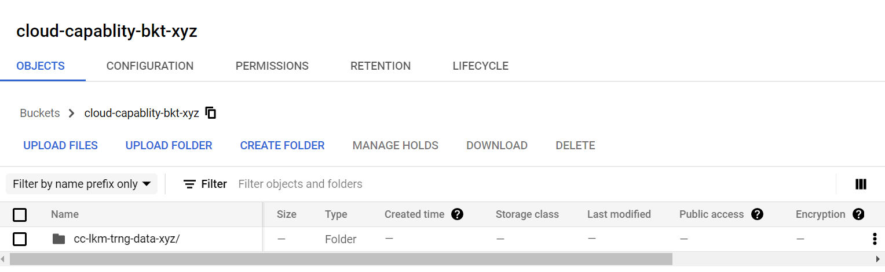

Step 7: Click on the Folder.

Step 8: Upload a file from your Computer by clicking a link “UPLOAD FILE”



