**For Setting up the lifecycle of the bucket**

**Step 1: -** Choose the Bucket of which you wants to set the lifecycle

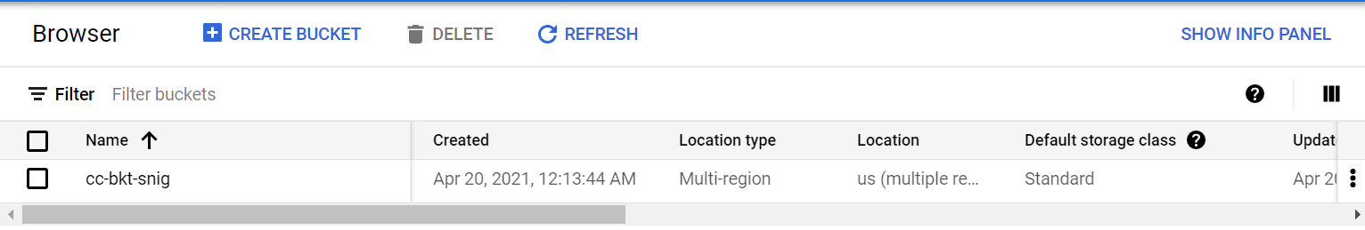

Step 2:- Click on the option lifecycle

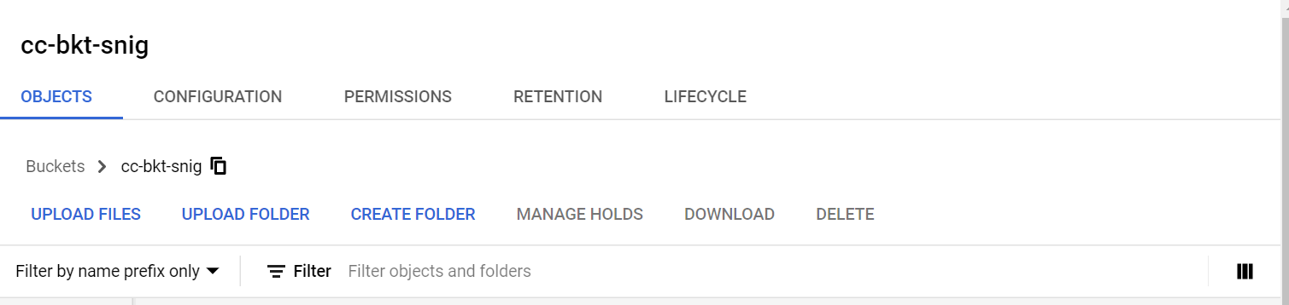

Step 3:- Click on the add Rule option

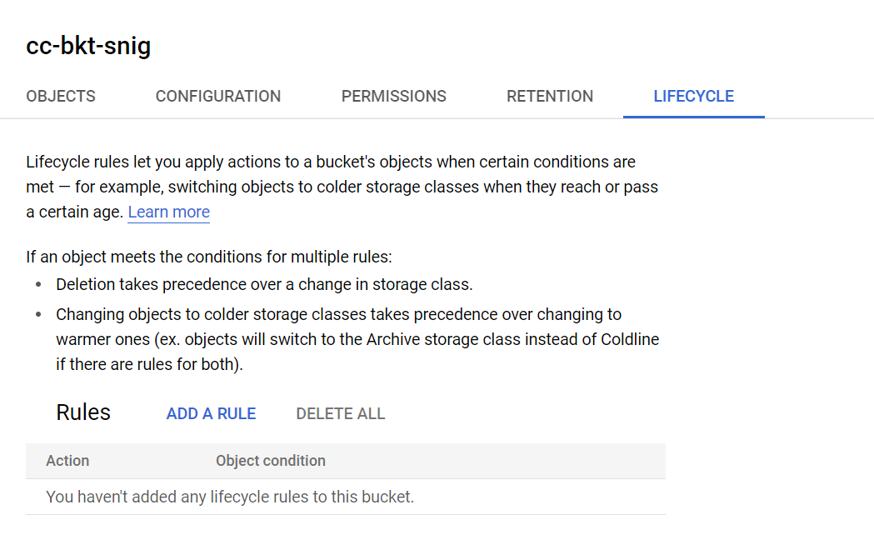

Step 4:- Add a new storage class or a deletion policy based on requirement and then click continue

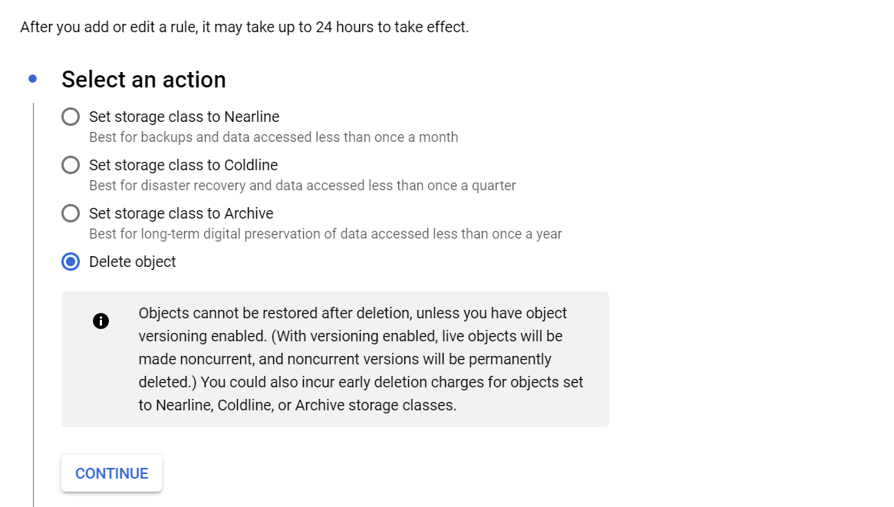

Step 5: Select one of the condition for the deletion policy (If deletion is selected)

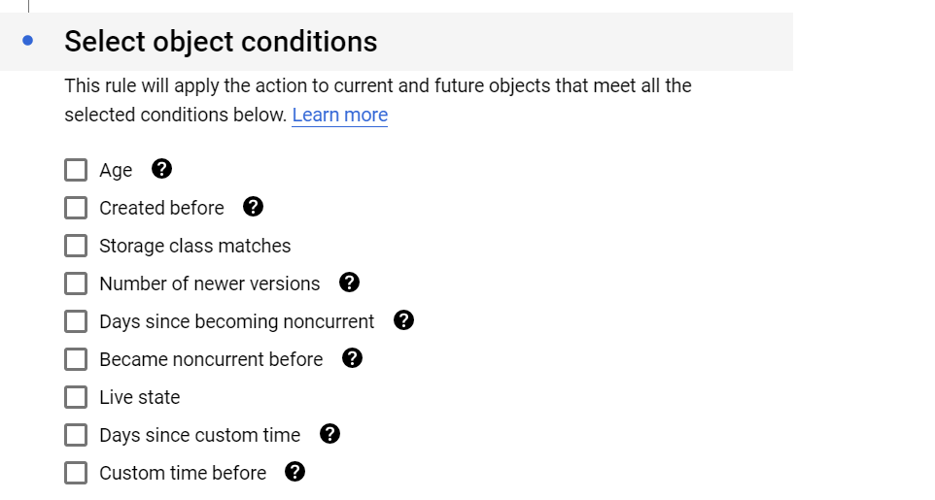

Step 6:- Add the rule on age which will delete object after a day

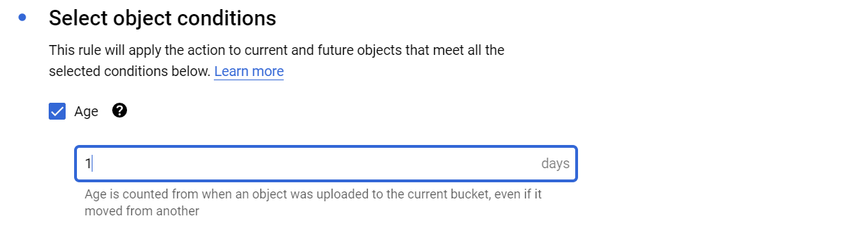

Step 7:- Click on the Create option

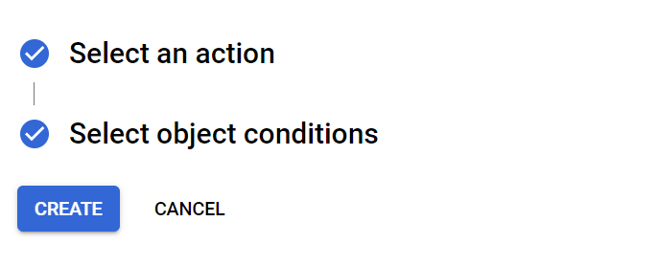

Outcome: -

Rule will be added to the bucket.

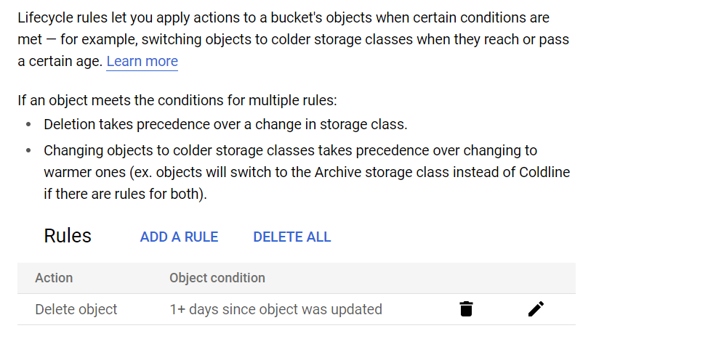

Note: try to delete the existing object or a newly added object from the bucket