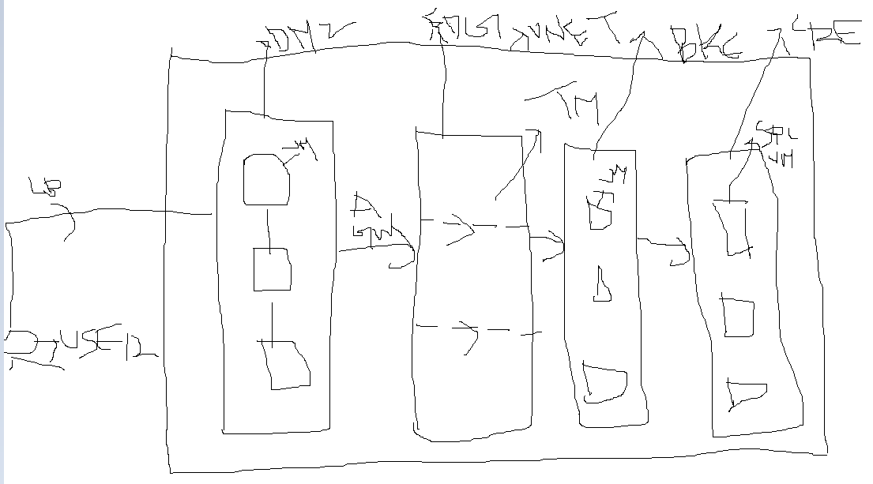

Explanation:

For three tier architecture, we require the following components

Vnet,subnet,traffic manager,application gateway,Virtual machine,NSG.

Initiall we have to be ready with the virtual machine deployment so just deploy 3-4 virtual machine in DMZ sunet where application is going to be installed and deploy all the networking component inside the EDG subnet as edg subnet take an example of internet facing where we need to deploy the Application Gateway and in core subnet just deploy the Pass component take an example of database vm.once you ready with this component then form the dr if reqire but better go for DR which will help you to run the business smoothly in case of disaster happen.