1.How are inline and block elements different from each other?

Inline elements don't start on new lines. It means that they'll line up right next to each other on the same line if there's enough space for them.

By default, block level elements take up the entire width of it’s parent container. After it's reached the edge of the container it'll drop below the other elements. So if you've just got a paragraph in the <body> then it will take up the entire width of the browser, unless you've set a width for the body.

2.Explain the difference between visibility:hidden and display:none

**display:none** means that the tag in question will not appear on the page at all (although you can still interact with it through the dom). There will be no space allocated for it between the other tags.

**visibility:hidden** means that unlike display:none, the tag is not visible, but space is allocated for it on the page. The tag is rendered, it just isn't seen on the page.

3. Explain the clear and float properties.

The float property is used for positioning and formatting content e.g. let an image float left to the text in a container.

The float property can have one of the following values:

* left - The element floats to the left of its container
* right - The element floats to the right of its container
* none - The element does not float (will be displayed just where it occurs in the text). This is default
* inherit - The element inherits the float value of its parent

Float is used to move contents left or right and to stop it we use clear as a barrier.

If an element can fit in the horizontal space next to the floated elements, **it will**;unless you apply the clear property to that element in **the same direction as the float**. Then the element will **move below** the floated elements.

4. explain difference between absolute, relative,fixed and static.

* **Static** - this is the default value, all elements are in order as they appear in the document.
* **Relative** - the element is positioned relative to its normal position.
* **Absolute** - the element is positioned absolutely to its first positioned parent.
* **Fixed** - the element is positioned related to the browser window.

5. Write the HTML code to create a table in which there are 4 columns( ID , Employee Name, Designation, Department) and at least 6 rows. Also do some styling to it.

<!DOCTYPE html>

<html>

<head>

<title>Q5 Table</title>

<style type="text/css">

td {

text-align: center;

}

</style>

</head>

<body>

<table border="1" style="width: 100%">

<thead>

<tr>

<th>ID</th>

<th>Employee Name</th>

<th>Designation</th>

<th>Department</th>

</tr>

</thead>

<tbody>

<tr>

<td style="color: blue; font-weight: bold;">001</td>

<td>alok</td>

<td>qe</td>

<td>cse</td>

</tr>

<tr>

<td style="color: blue; font-weight: bold;">002</td>

<td>shubham</td>

<td>android</td>

<td>ece</td>

</tr>

<tr>

<td style="color: blue; font-weight: bold;">003</td>

<td>prabhav</td>

<td>ame</td>

<td>mec</td>

</tr>

<tr>

<td style="color: blue; font-weight: bold;">004</td>

<td>mayank</td>

<td>react</td>

<td>civil</td>

</tr>

<tr>

<td style="color: blue; font-weight: bold;">005</td>

<td>akshat</td>

<td>game</td>

<td>unity</td>

</tr>

<tr>

<td style="color: blue; font-weight: bold;">006</td>

<td>lakshay</td>

<td>cyber</td>

<td>analyst</td>

</tr>

</tbody>

</table>

</body>

</html>

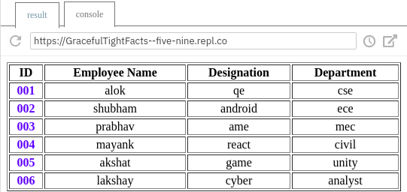

6. Why do we use meta tags?

**Meta tags are important to be passed in a webpage for machine accessibility or SEO. these tags do not appear on the webpage but are used by web crawlers while scraping or searching.**

**The meta tags are used to specify page description, keywords, author of the document, last modified, and other metadata. They are the first things that are searched when we type anything in any search engine.**

7. Explain box model.

**The CSS box model is basically a box that folds over each HTML component. It comprises of: margin, border, padding and content. The picture beneath delineates the crate model:**

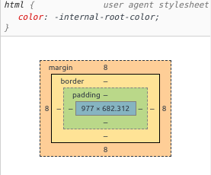

**Content: The content that has been entered in the element**

**Padding: The differentiating area or the space between the content and border**

**Border: The border that goes around padding and content**

**Margin: The area outside the border. This is transparent**

8. What are the different types of CSS Selectors?

1. CSS Element Selector

The element selector selects the HTML element by name.

1. CSS Id Selector

The id selector selects the id attribute of an HTML element to select a specific element. An id is always unique within the page so it is chosen to select a single, unique element.

1. CSS Class Selector

The class selector selects HTML elements with a specific class attribute. It is used with a period character . (full stop symbol) followed by the class name.

1. CSS Universal Selector

The universal selector is used as a wildcard character. It selects all the elements on the pages.

1. CSS Group Selector

The grouping selector is used to select all the elements with the same style definitions.

Grouping selector is used to minimize the code. Commas are used to separate each selector in grouping.

9. Define Doctype.

**Doctype is not an html language tag rather it instructs the web browser about what version of HTML will be used in the following code. This must be the very first thing that a developer must declare**

**Syntax: <!DOCTYPE HTML>**

10. Explain 5 HTML5 semantic tags.

1- The <article> element specifies independent, self-contained content.

2- The <section> element defines a section in a document.

3- The <header> element specifies a header for a document or section.

4- The <footer> element specifies a footer for a document or section.

5- The <nav> element defines a set of navigation links.

11. Create HTML for web-page.jpg (check resources, highest weightage for answers)

Codes are in the same folder in form of html and css files

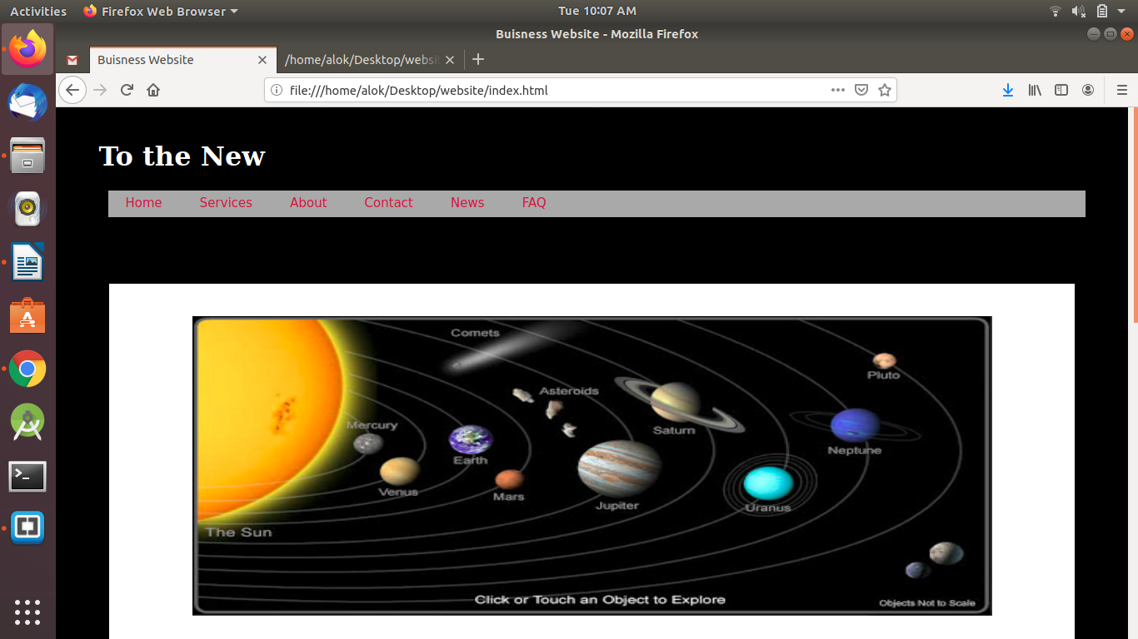

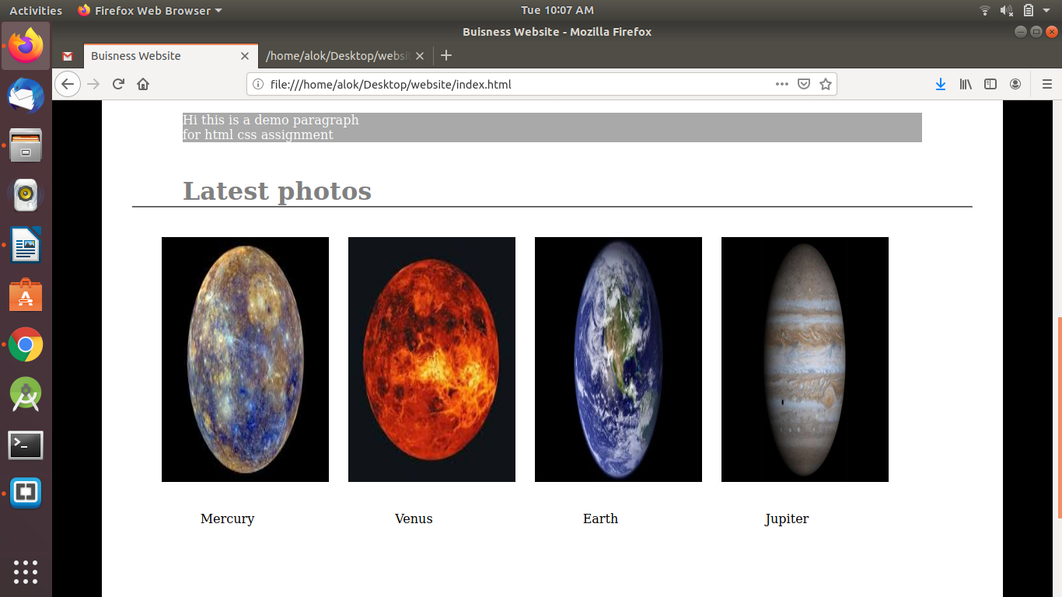

12. Create HTML for form.png (check resources, highest weightage for answers)

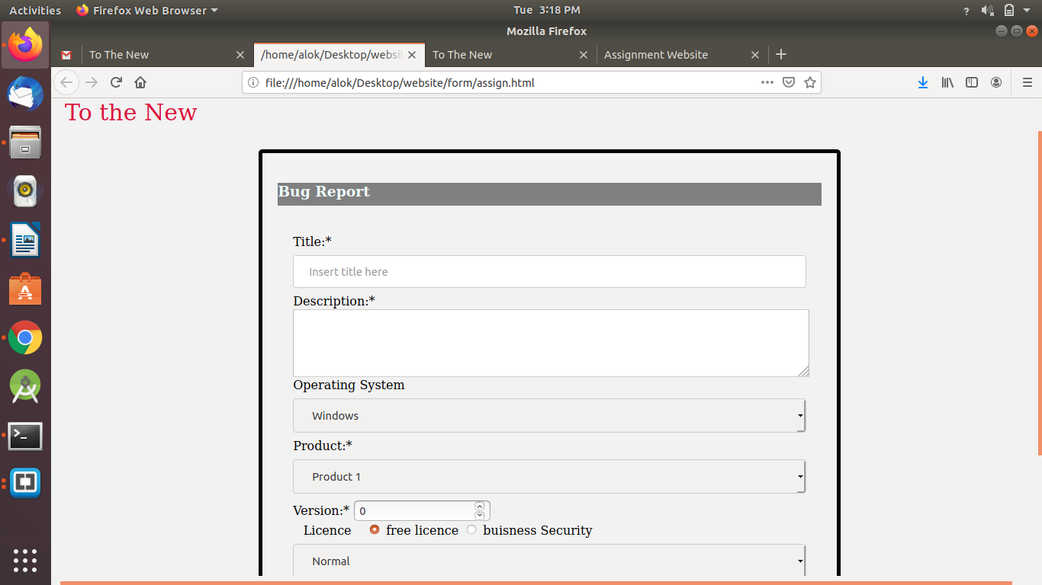

Note: 50% of marks are for last 2 exercises of creating html pages