PROJECT FRAMEWORK DOCUMENT
AI-Based Authentic Face Image Classification
and Verification System
LaunchED Global Internship — Capstone Project (Data Analytics Domain)
GitHub-First Development & Submission Framework
Prepared by | Alok
Program | MBA (Marketing & Business Analytics), Amity Business School
Domain | Data Analytics
Submission Deadline | 25th September 2026
Repository Strategy | Git & GitHub (version-controlled from Day 1)

1. Project Overview

1.1 Project Title
AI-Based Authentic Face Image Classification and Verification System

1.2 Problem Statement
Develop a Machine Learning / Deep Learning model that analyzes facial images and classifies them as Authentic (Real) or Manipulated (Fake), using a labeled dataset. The system leverages facial characteristics, demographic attributes, image quality indicators, and metadata to accurately identify authentic images, laying the groundwork for future deepfake-detection integration.

1.3 Dataset Description
The dataset consists of high-quality facial images (1080 × 1080 px) with the following associated metadata:
- Unique image identifiers and source URLs
- Classification labels (REAL / FAKE) and encoded numerical labels
- Gender information (Male, Female, Unknown)
- Age group categories
- Image quality indicators and detection difficulty levels
- Confidence scores
- Dataset split information (Training, Validation, Testing)

1.4 Objectives
- Preprocess and analyze the facial image dataset.
- Extract meaningful visual features from images.
- Train a classification model to identify image authenticity.
- Evaluate model performance using Accuracy, Precision, Recall, and F1-Score.
- Analyze the impact of demographic and image-quality attributes on classification performance.
- Develop a system capable of supporting future deepfake-detection and image-verification applications.

1.5 Expected Outcome
A system that accurately classifies facial images by authenticity and returns a confidence score per prediction — demonstrating practical application of AI and Computer Vision in digital image verification and security.

2. Project Workflow
The project follows a linear-with-feedback pipeline: each stage produces an artifact that is committed to GitHub before moving to the next stage, so the repository history mirrors the project's progress end-to-end.
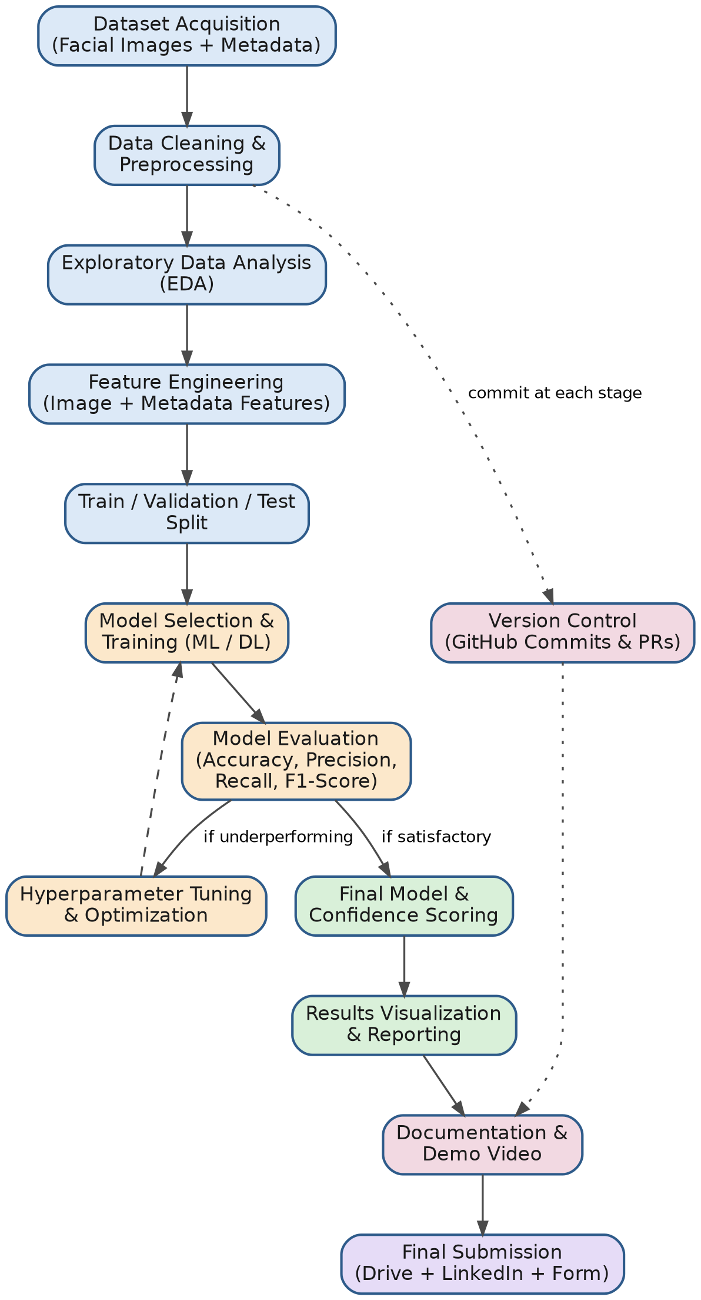
Figure 1 — End-to-end project workflow, from dataset acquisition to final submission

3. GitHub Repository Framework

3.1 Repository Structure
A single, well-organized repository holds the full project — data references, source code, notebooks, trained models, and documentation — matching the LaunchED submission requirement of one Google Drive / project folder with all related files.
face-authenticity-classifier/
├── data/
│ ├── raw/ # original dataset (git-ignored if large)
│ ├── processed/ # cleaned & preprocessed data
│ └── README.md # data dictionary & source notes
├── notebooks/
│ ├── 01_eda.ipynb
│ ├── 02_preprocessing.ipynb
│ ├── 03_feature_engineering.ipynb
│ ├── 04_model_training.ipynb
│ └── 05_evaluation.ipynb
├── src/
│ ├── data_loader.py
│ ├── preprocessing.py
│ ├── features.py
│ ├── model.py
│ ├── train.py
│ └── evaluate.py
├── models/
│ └── saved_models/ # trained model artifacts (.pkl / .h5)
├── reports/
│ ├── figures/ # charts, confusion matrices, plots
│ └── final_report.docx
├── docs/
│ ├── project_framework.docx (this document)
│ └── demo_video_script.docx
├── .gitignore
├── requirements.txt
├── README.md
└── LICENSE

3.2 Branching Strategy
A simple two-tier Git flow keeps main always in a clean, presentable state while active work happens on feature branches.
- main — stable, review-ready code only; this is what gets demoed and submitted.
- develop — integration branch where completed feature branches are merged and tested together.
- feature/<name> — one branch per pipeline stage (e.g. feature/data-preprocessing, feature/model-training), merged into develop via Pull Request.
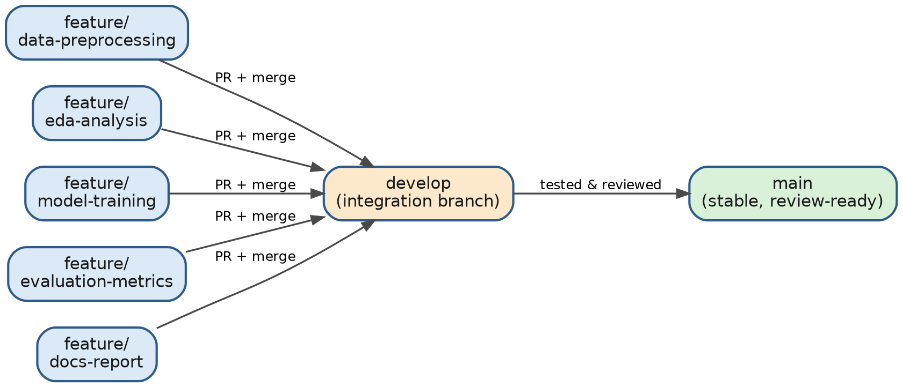
Figure 2 — Branching workflow: feature branches → develop → main

3.3 Commit Convention
Use short, prefixed, present-tense commit messages so the history itself documents progress:
data: add raw dataset and data dictionary
prep: clean missing values and normalize image metadata
eda: add class distribution and correlation plots
feat: implement CNN feature extraction pipeline
model: train baseline classifier and log metrics
eval: add confusion matrix and F1-score report
docs: update README with setup instructions

3.4 Suggested Commit Cadence
Commit at the end of every working session and always at the completion of each pipeline stage shown in Figure 1 — this gives the repository a clear, gradable timeline of effort rather than one large final upload.

3.5 README.md — Recommended Sections
- Project title and one-line overview
- Problem statement and objectives
- Dataset description and source
- Repository structure (folder tree)
- Setup instructions (environment, requirements.txt, how to run)
- Methodology summary (link to Figure 1 workflow)
- Results summary (key metrics, confusion matrix)
- Link to demo video and LinkedIn post
- Author and internship acknowledgment (LaunchED Global)

4. Tools & Technologies
Category | Tools / Libraries
Language | Python 3.x
Data Handling | Pandas, NumPy
Visualization | Matplotlib, Seaborn
Image Processing | OpenCV, Pillow
Modeling | Scikit-learn (baseline), TensorFlow / Keras or PyTorch (deep learning)
Evaluation | Scikit-learn metrics (Accuracy, Precision, Recall, F1, ROC-AUC)
Notebook Environment | Jupyter Notebook / Google Colab
Version Control | Git & GitHub
Documentation | Markdown (README), Word (reports)
Presentation | Screen recording tool for demo video, LinkedIn for publishing

5. Milestone Timeline
A suggested phased plan working backward from the 25th September 2026 deadline. Adjust dates once you set a start date.
Phase | Key Tasks | Deliverable
Week 1 | Repo setup, dataset acquisition, initial EDA, first commits | GitHub repo live + EDA notebook
Week 2 | Data cleaning, preprocessing, feature engineering | Processed dataset + feature set
Week 3 | Model selection, baseline training, initial evaluation | Baseline model + metrics
Week 4 | Hyperparameter tuning, final model, results visualization | Final model + report figures
Week 5 | README, final report, demo video script & recording | Complete documentation
Final Days | Upload to Drive, post video on LinkedIn, Google review, submit form | Full LaunchED submission

6. LaunchED Submission Checklist
Cross-referenced against the official Capstone Project Submission Guidelines.
- All project files (code, docs, resources) uploaded to a single Google Drive folder — "Anyone with the link can view"
- Project demonstration video recorded (5–10 minutes, MP4)
- Video introduction (mandatory, in English): name, college, course & branch, year, internship domain, internship experience mention, project title & overview
- Project walkthrough recorded (English or Hindi): problem statement, tools & tech, architecture/workflow, functionalities, live demo, challenges & solutions, final output
- Video uploaded to Google Drive with view access enabled
- Video posted on LinkedIn with detailed description; LaunchED and HOD tagged
- Google review submitted and screenshot captured
- Final Google Form submitted with: project folder link, video link, LinkedIn post link, review screenshot
- Deadline: 25th September 2026 — no extensions

