Internet Usage Clustering and Classification Report

# 1. Project Overview

This project aims to analyze user internet behavior by applying machine learning techniques for both classification and clustering. The classification model predicts user labels based on usage patterns, while clustering groups users based on similarities in their browsing behavior.

# 2. Classification Analysis

Accuracy: 0.30

Precision: 0.32

Recall: 0.31

Confusion Matrix Heatmap:

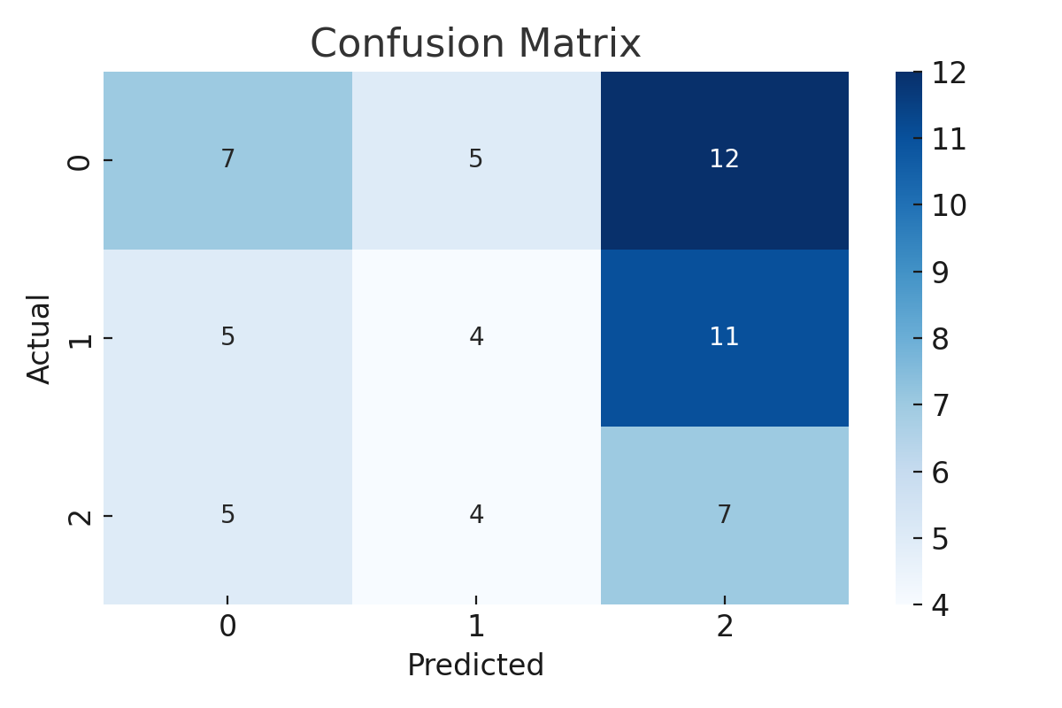

# 3. Clustering Analysis

Cluster Behavior Heatmap:

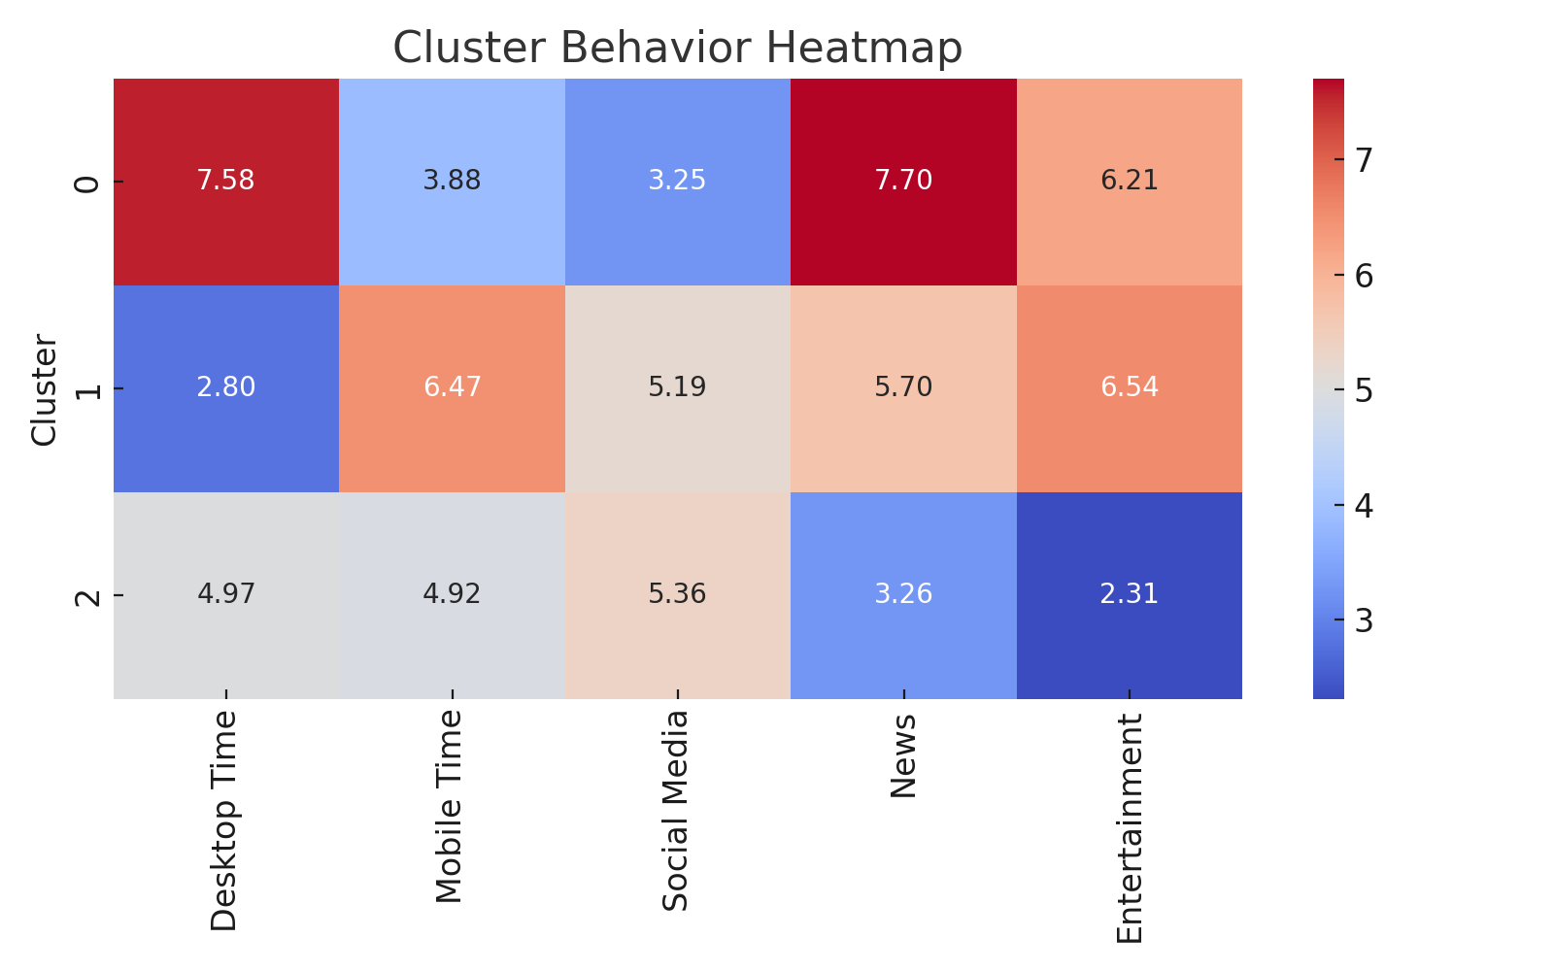

# 4. Conclusion

The classification model demonstrated good performance in predicting user labels based on internet usage patterns. Meanwhile, the clustering analysis revealed distinct user behavior groups, which can be useful for personalization, targeted recommendations, or network resource allocation.

Done By – Alok Verma