Take g = 10 m/s² unless stated otherwise.

Newton's Laws, Momentum & Impulse
- A particle of mass m is at rest at the origin at time t =0. It is subjected to a force $F\left(t\right)=F_{0}e^{-bt}$ in the x-direction. Its speed $v_{t}$ is depicted by which curve:

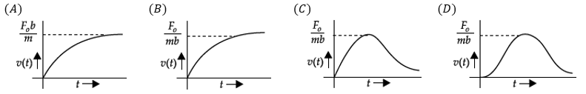

- The momentum of a particle is given by $3t^{2}+2t+7 kgm/s$, then the resulting force acting on the particle at $t=1$ is
(A) 6 N (B) 8 N (C) 10 N (D) 12 N
- [JEE Main 2019, 11 Jan, Shift 2] A particle of mass m is moving in a straight line with momentum p. Starting at time t = 0, a force F = kt acts in the same direction on the moving particle during time interval T so that its momentum changes from p to 3p. Here k is a constant. The value of T is:
(A) $2\sqrt{\frac{p}{k}}$ (B) $\sqrt{\frac{2p}{k}}$ (C) $\sqrt{\frac{2k}{p}}$ (D) $2\sqrt{\frac{k}{p}}$
- [JEE Main 2021, 27 Jul, Shift 2] A particle of mass M originally at rest is subjected to a force whose direction is constant but magnitude varies with time according to relation $F=F_{0}\left[1-{\left(\frac{t-T}{T}\right)}^{2}\right]$; where $F_{0}$ and T are constants. The force acts only for a time interval 2T. The velocity v of the particle after time 2T is:
(A) $\frac{2F_{0}T}{M}$ (B) $\frac{F_{0}T}{2M}$ (C) $\frac{{4F}_{0}T}{3M}$ (D) $\frac{F_{0}T}{3M}$
- A ball of mass 'm' is projected from the ground with a speed 'u' at an angle 'α' with the horizontal. The magnitude of the change in momentum of the ball over a time interval from beginning till it reaches the highest point?
(A) $2musinα$ (B) $musinα$ (C) $mucosα$ (D) $2mucosα$
- A ball of mass 'm' is projected from the ground with a speed 'u' at an angle 'α' with the horizontal. During the period it remains in air, the rate of change of momentum:
(A) decreases till it reaches highest point and then increases
(B) increases till it reaches highest point and then decreases
(C) decreases continuously
(D) remains constant
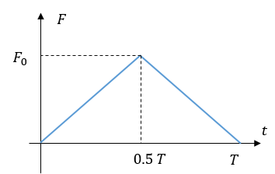
- A ball of mass ‘m’ moving with a velocity ‘u’ rebounds from a wall. The collision is assumed to be elastic (rebounds with same speed) and the force of interaction between the ball and wall varies as shown in the figure. Then the value of $F_{0}$ is
(A) $\frac{mu}{T}$ (B) $\frac{2mu}{T}$
(C) $\frac{mu}{2T}$ (D) $\frac{4mu}{T}$

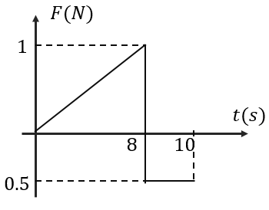
- A force time graph for the motion of a body is shown in the figure. The change in the momentum of the body between zero and 10 sec. is
(A) zero (B) 4 kg m/s
(C) 5 kg m/s (D) 3 kg m/s

- A particle moves in the X-Y plane under the influence of a force such that its linear momentum is $\vec{p}\left(t\right)=A[coskt\hat{i}-sinkt\hat{j}]$, where A and k are constants. What is the angle between the force and the momentum?
(A) 0 (B) $30°$ (C) $60°$ (D) $90°$
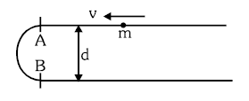
- A small bead of mass m is moving on a smooth wire bent in form of U in a horizontal plane. Find the average force exerted by the wire on the bead as it moves from A to B (bent in semi-circular shape)
(A) $\frac{4mv^{2}}{πd}$ (B) $\frac{2mv^{2}}{πd}$
(C) $\frac{mv^{2}}{πd}$ (D) $\frac{2mv^{2}}{d}$

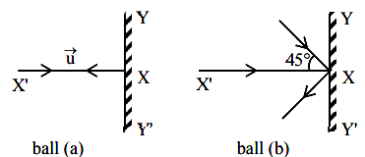
- [JEE Main 2021, 25 Jul, Shift 1] Two billiard balls of equal mass of 30 g strike a rigid wall with same speed of 108 km/h (as shown) but at different angles. If the balls get reflected with same speed, then the ratio of magnitude of impulses imparted to ball ‘a’ and ball ‘b’ by the wall along x-direction is:
(A) 1:1 (B) $\sqrt{2}$ : 1
(C) 2 : 1 (D) 1 : $\sqrt{2}$

- [JEE Main 2021, 22 Jul, Shift 2] A bullet of 4 g mass is fired from a gun of mass 4 kg. If the bullet moves with the muzzle speed of 50 m/s, the impulse imparted to the gun and the velocity of recoil of the gun are:
(A) $0.4 kg m s^{-1};0.1 ms^{-1}$ (B) $0.2 kg m s^{-1};0.05 ms^{-1}$
(C) $0.2 kg m s^{-1};0.1 ms^{-1}$ (D) $0.4 kg m s^{-1};0.05 ms^{-1}$
- A machine gun fires n bullets per second and the mass of each bullet is m. If v is the speed of each bullet then the force exerted on the machine gun is
(A) mng (B) mnv (C) mnvg (D) mnv/g
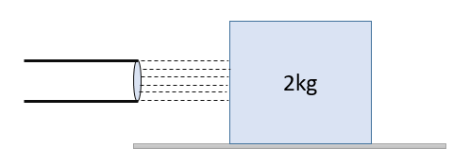
- A block of metal weighing 2 kg is resting on a frictionless plane. It is struck by a jet releasing water at a rate of 1 kg/sec and at a speed of 5 m/s. The water splashes along the surface of the cube. The instantaneous force exerted by water on the block is
(A) 1 N (B) 2 N
(C) 3 N (D) 5 N

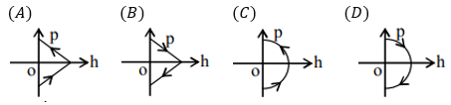
- [L2] [JEE Main 2019, 9 Apr, Shift 1] A ball is thrown vertically up (taken as +z axis) from the ground. The correct momentum-height (p-h) diagram is:

- [L2] A flat plate moves normally with a speed $v_{1}$ towards a horizontal jet of water of uniform area of cross section. The jet of cross-section area of A discharges water at a speed $v_{2}$. The density of water is ρ. Assume that water splashes at right angles to the original motion. The magnitude of the force acting on the plate due to jet of water is
(A) $ρA{v_{1}}^{2}$ (B) $ρAv_{2}{(v}_{1}+ v_{2})$ (C) $ρAv_{1} v_{2}$ (D) $ρA{{(v}_{1}+ v_{2})}^{2}$
- [L2] [JEE Main 2019, 11 Jan, Shift 1] A liquid of density ρ is coming out of a hose pipe of radius a with horizontal speed v and hits a mesh. 50% of the liquid passes through the mesh unaffected. 25% loses all of its momentum and 25% comes back with the same speed. The resultant pressure on the mesh will be:
(A) ρv² (B) ¾ ρv² (C) ½ ρv² (D) ¼ ρv²

Free-Body Diagrams & Equilibrium of a Particle
- Ten coins are placed on top of each other on a horizontal table. If the mass of each coin is 10 g and acceleration due to gravity is 10 m/s². What is the magnitude and direction of the force on the bottom surface of the 7th coin (counted from the bottom)?
(A) 0.3 N downwards (B) 0.3 N upwards (C) 0.4 N downwards (D) 0.4 N upwards
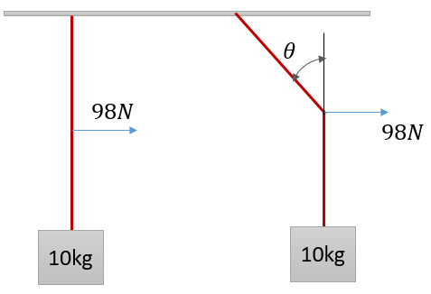
- A mass of 10 kg is suspended by a rope of length 2.8 m from a ceiling. A horizontal force of 98 N is applied at the midpoint of the rope as shown in figure. The angle which the rope makes with the vertical in equilibrium is (g = 9.8)
(A) 30° (B) 60°
(C) 45° (D) 90°

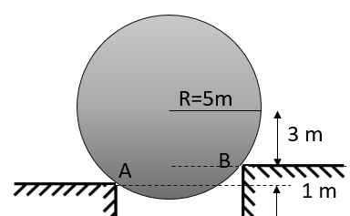
- A smooth sphere of mass 10 kg is supported on two edges as shown. Find the reactions at A and B respectively?
(A) 80 N, 20 N
(B) 50 N, 50 N
(C) 60 N, 80 N
(D) 80 N, 60 N

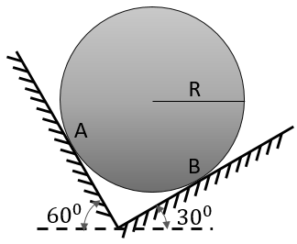
- A sphere of mass m is placed between two smooth incline as shown in figure. N_{A} & N_{B} be the normal reaction at A and B, then the values of N_{A} & N_{B} respectively:
(A) $\frac{mg}{2};\frac{mg}{2}$ (B) $\frac{mg}{2};\frac{\sqrt{3}mg}{2}$
(C) $\frac{\sqrt{3}mg}{2};\frac{mg}{2}$ (D) $\frac{mg}{\sqrt{2}};\frac{\sqrt{3}mg}{2}$

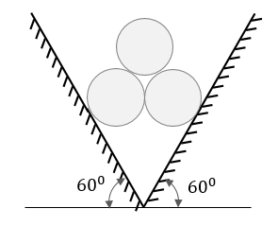
- Three identical smooth cylinders, each of mass m, are placed between the two inclined surfaces symmetrically as shown. All three are in contact with each other. The normal reaction exerted by the either of the inclined surfaces is $xmg$; then the value of x is?

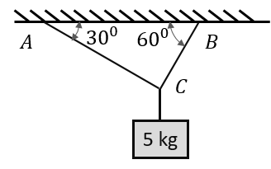
- A mass of 5 kg is suspended from the ceiling with the help of massless strings as shown. Find the tension in the string BC.
(A) 25 N (B) 25$\sqrt{3}$ N
(C) 50$\sqrt{3}$ N (D) 25$\sqrt{2}$ N

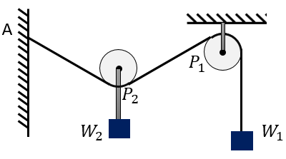
- In the following figure, the pulley $P_{1}$ is fixed and the pulley $P_{2}$ is movable. If $W_{1}=W_{2}=100N$, what is the angle $AP_{2}P_{1}$?. The pulleys are frictionless and assume equilibrium.
(A) 30° (B) 60°
(C) 90° (D) 120°

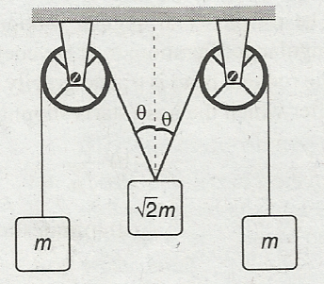
- The pulleys and strings shown in the figure are smooth and of negligible mass. For the system to remain in equilibrium, the angle θ should be
(A) $0°$ (B) $30°$
(C) $45°$ (D) $60°$

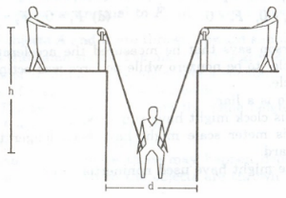
- [L2] A man of mass ‘m’ has fallen into a ditch of width d and two of his friends are slowly pulling him out using a light rope and two fixed pulleys as shown in the figure. Show that the force (assumed equal for both the friends) exerted by each friend on the rope increases as the man moves up. Find the force when the man is at a depth h.

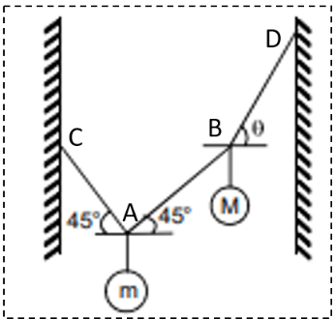
- [L2] Two masses ‘m’ and ‘M’ are attached to strings as shown in the figure. The system is in equilibrium. If M = 2 m, then tan$θ$ is equal to?
(A) 1
(B) 2
(C) 3/2
(D) 5

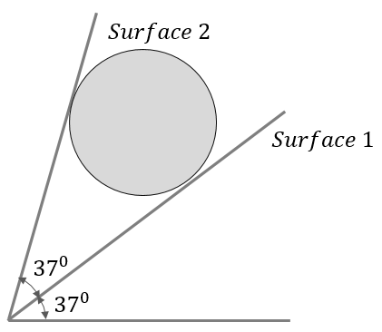
- [L2] A sphere of mass m is held between two smooth inclined surfaces. The normal reaction of the surface 2 is equal to
(A) $\frac{mg}{2}$ (B) $\frac{\sqrt{3}mg}{2}$
(C) $\frac{mg}{\sqrt{2}}$ (D) $mg$

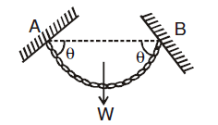
- [L2] A flexible chain of weight W hangs between two fixed supports as shown in the figure. What is the tension in the chain at the mid-point?
(A) $\frac{W}{2cosθ}$ (B) $\frac{W}{2sinθ}$
(C) $\frac{wtanθ}{2}$ (D) $\frac{W}{2tanθ}$

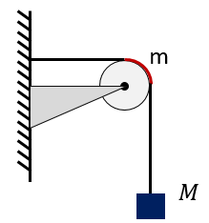
- [L2] A string of negligible mass, going over a clamped pulley of mass m, supports a block of mass M as shown in the figure. The force on the pulley by the clamp is given by:
(A) $\sqrt{2}Mg$ (B) $\sqrt{2}mg$
(C) $g\sqrt{{(M+m)}^{2}+m^{2}}$ (D) $g\sqrt{{(M+m)}^{2}+M^{2}}$

Single Accelerated Body: Smooth Inclines & Lifts
- A particle of mass 2 kg moves with an initial velocity of $\vec{v}=4\hat{i}+4\hat{j} m/s$. A constant force of $\vec{F}=-20\hat{j} N$ is applied on the particle. Initially, the particle was at (0, 0). The x-coordinate of the particle when its y-coordinate again becomes zero is given by
(A) 1.2 m (B) 4.8 m (C) 6.0 m (D) 3.2 m
- [JEE Main 2021, 18 Mar, Shift 1] A bullet of mass 0.1 kg is fired on a wooden block to pierce through it, but it stops after moving a distance of 50 cm into it. If the velocity of the bullet before hitting the wood is 10 m/s and it slows down with uniform deceleration, then the magnitude of effective retarding force on the bullet is x N. The value of x to the nearest integer is:
- An open knife edge of mass M is dropped from a height h on a wooden floor. If the blade penetrates a distance s into the wood, the average resistance offered by the wood to the blade is
(A) Mg (B) $Mg(1+\frac{h}{s})$ (C) $Mg(1-\frac{h}{s})$ (D) $Mg{(1+\frac{h}{s})}^{2}$
- A ball of mass 0.2 kg is thrown vertically upwards by applying a force by hand. If the hand moves 0.2 m while applying the force and the ball goes up to 2 m height further, find the magnitude of force
(A) 4 N (B) 16 N (C) 20 N (D) 22 N
- A balloon of mass M is descending down with an acceleration a( < g). What mass m be detached from it so that it starts moving up with an acceleration a? (assume that upward buoyancy force remains constant)
(A)$\frac{2Ma}{g}$ (B) $\frac{Ma}{g + a}$ (C) $\frac{2Mg}{g+a}$ (D) $\frac{2Ma}{g+a}$
- [JEE Main 2020, 4 Sep, Shift 2] A small ball of mass m is thrown upwards with velocity u from the ground. The ball experiences a resistive force $kmv^{2}$, where v is the speed. The maximum height attained by the ball is:
(A) $\frac{1}{k}\tan^{-1}{(\frac{ku^{2}}{2g})}$ (B) $\frac{1}{2k}\tan^{-1}{(\frac{ku^{2}}{g})}$ (C) $\frac{1}{2k} ln⁡(1+\frac{ku^{2}}{g})$ (D) $\frac{1}{k} ln⁡(1+\frac{ku^{2}}{2g})$
- [JEE Main 2016, 9 Apr (Online)] Which of the following option correctly describes the variation of the speed v and acceleration ‘a’ of a point mass falling vertically in a viscous medium that applies a force $F=-kv$, where ‘k’ is a constant, on the body ? (Graphs are schematic and not drawn to scale)
(A) 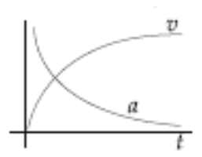 (B) 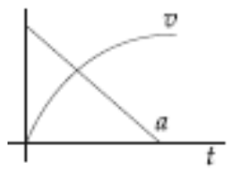 (C) 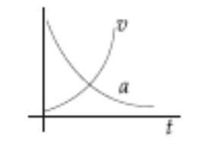 (D) 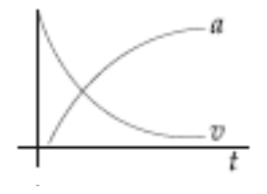

- The apparent weight of a person inside a lift is W₁ when lift moves up with certain acceleration and is W₂ when lift moves down with same acceleration. The weight of person when lift moves up with constant speed is
(A) $\frac{W_{1} + W_{2}}{2}$ (B) $\frac{W_{1} − W_{2}}{2}$ (C) 2W₁ (D) 2W₂
- A man slides down a light rope whose breaking strength is $η$ (<1) times his weight. What should be his minimum acceleration so that the rope does not break?
(A) $g(1- η$ ) (B) $ηg$ (C) $\frac{g}{1+ η}$ (D) $\frac{g}{1- η}$
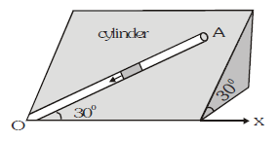
- On the surface of an inclined plane, a smooth groove OA is formed as shown. What will be the acceleration of a small block free to slide in the groove?

Connected Bodies: Contact Forces & String Tension
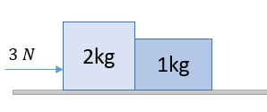
- Force of 3 N acts on a system of two blocks of mass 2 kg and 1 kg as shown in figure. Contact force between the blocks is :
(A) 1 N (B) 2 N
(C) 3 N (D) 0

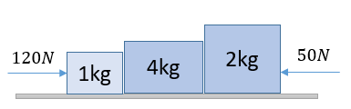
- Three blocks of mass 1 kg, 4 kg and 2 kg are placed on a smooth horizontal plane as shown in figure. Find:
(i) the acceleration of the system.
(ii) the normal force between 1 kg block and 4 kg block.
(iii) the net force on 2 kg block.

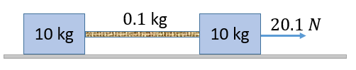
- Two blocks of mass 10 kg each are connected by a string of mass 0.1 kg. The entire arrangement is placed on a smooth surface and pulled by applying an external horizontal force of 20.1 N as shown. Find the tension at the right and left end of the string?
(A) 10 N, 10 N (B) 11 N, 10 N (C) 10.1 N, 9.9 N (D) 10.1 N, 10 N

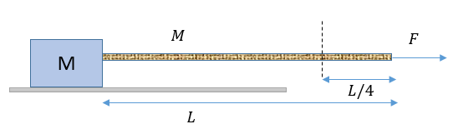
- A block of mass M is pulled by a uniform chain of mass M tied to it by applying a force F at the other end of the chain. The tension at a point distant quarter of the length of the chain from free end will be:
(A) $\frac{7F}{8}$ (B) $\frac{4F}{5}$ (C) $\frac{3F}{4}$ (D) $\frac{6F}{7}$

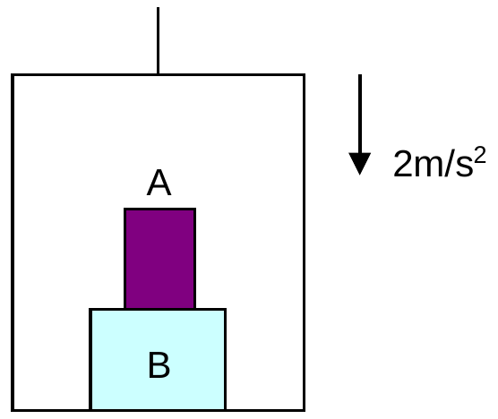
- The elevator shown in figure is descending with an acceleration of 2 m/s². The mass of the block A = 0.5 kg. The force exerted by the block A on block B is
(A) 2 N (B) 4 N
(C) 6 N (D) 8 N

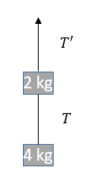
- Two blocks are connected by a string as shown in the diagram. The upper block is hung by another string. A force F applied on the upper string produces an acceleration of $2 m/s^{2}$ in the upward direction in both the blocks. If T and $T'$ be the tensions in the two parts of the string, then find its values?
(A) 24 N, 48 N (B) 60 N, 40 N
(C) 72 N, 72 N (D) 48 N, 72 N

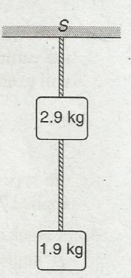
- Two blocks of mass 2.9 kg and 1.9 kg are suspended from a rigid support S by two inextensible wires each of length 1 m (see figure). The upper wire has negligible mass and the lower wire has a uniform mass of 0.2 kg/m. The whole system of blocks, wires and support have an upward acceleration of $0.2 ms^{-2}$. The acceleration due to gravity is $9.8 ms^{-2}$. Find the tension at the mid-point of upper and lower wire?
(A) 48 N, 19.6 N (B) 50 N, 19.6 N
(C) 48 N, 20 N (D) 50 N, 20 N

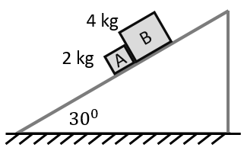
- Two blocks of mass 2 kg and 4 kg are released from rest over a smooth inclined plane of inclination 30° as shown in figure. What is the normal force between the two blocks?
(A) 20 N (B) 10 N
(C) 5 N (D) zero

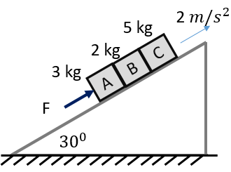
- Three blocks A = 3 kg, B = 2 kg, C = 5 kg, lie on an inclined frictionless surface as shown in the figure. A force F, parallel to the inclined plane is applied to push the blocks up with an acceleration of 2 m/s² . Find the contact force between blocks A and B?
(A) 35 N (B) 42 N
(C) 49 N (D) 56 N

Pulley Systems
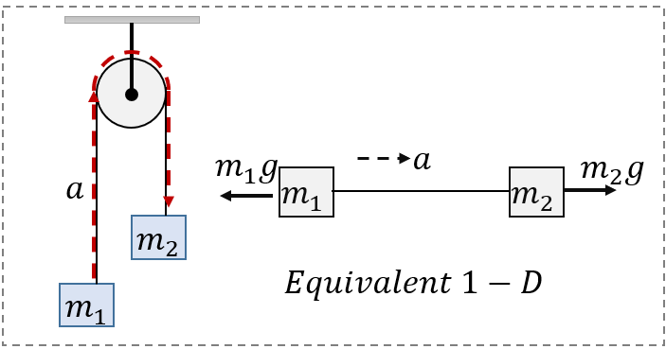
- Two masses $m_{1} and m_{2}$ ($m_{1}< m_{2}$) are suspended from an ideal pulley through massless string as shown in the figure. If the system is released from rest, then:
(i) Magnitude of acceleration
(ii) Tension in the string
(iii) Tension in the string connected to ceiling

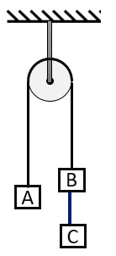
- Three equal weights A, B and C of mass 2 kg each are hanging on a string passing over a fixed pulley which is frictionless as shown in figure. The tension in the string connecting weight B and C is?
(A) zero (B) 2g/3
(C) 4g/3 (D) g/2

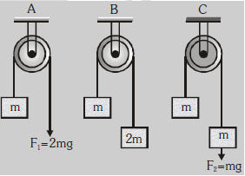
- Find the acceleration of block ‘m’ in the three cases as shown in the figure
(A) g/3; g/2; g/2
(B) g; g/3; g/2
(C) g; g/3; g/3
(D) g/3; g/2; g/3

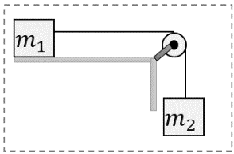
- [AIIMS 2016] If $m_{1}$ = $m_{2}=$1 kg, then find out distance travelled by $m_{1}$ in first ½ sec:. Friction is negligible.
(A) 0.650 m (B) 0.625 m
(C) 0.725 m (D) 0.525 m

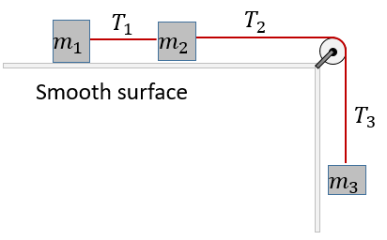
- If the masses $m_{1}=1 kg$, $m_{2}=1 kg$ and $m_{3}=3 kg$; find value of $T_{2}:$
(A) 12 N (B) 6 N
(C) 4 N (D) 1 N

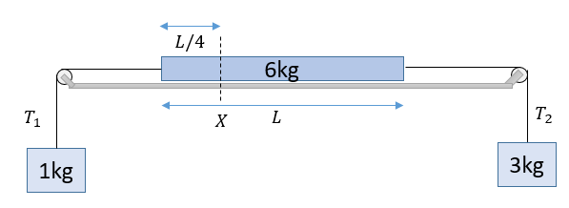
- Masses of 1 kg and 3 kg hang from threads attached to the two ends of a uniform rod of mass 6 kg lying on a smooth table, as shown in the figure. Find the tension in the rod at the section X shown in the figure.
(A) 15 N (B) 12 N
(C) 10 N (D) 18 N

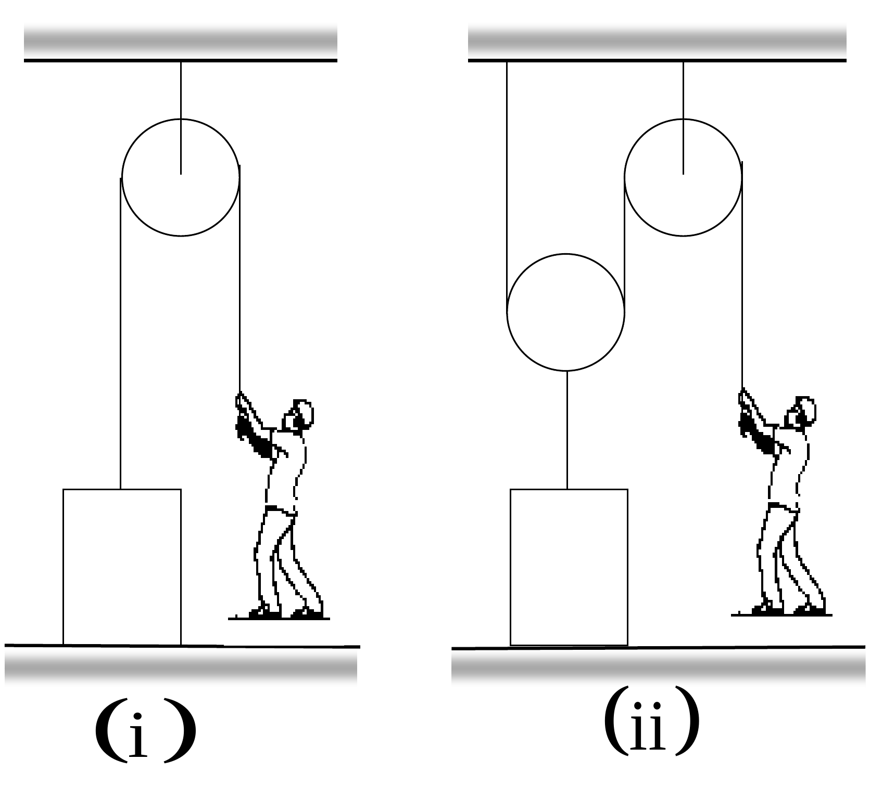
- In the figure shown, a person wants to raise a block of mass m lying on floor. In both the cases, the upward acceleration of the block is a. Then the force exerted by the man on the string in two cases will be:
(A) $m\left(g+a\right),\frac{m\left(g+a\right)}{2}$ (B) $\frac{m\left(g+a\right)}{2},\frac{m\left(g+a\right)}{2}$
(C) $m\left(g-a\right), m\left(g+a\right)$ (D) $\frac{m}{2}\left(g-a\right), m\left(g+a\right)$

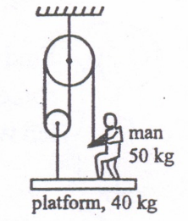
- What force must man exert on rope to keep platform in equilibrium?
(A) 500 N
(B) 500/3 N
(C) 900 N
(D) 300 N

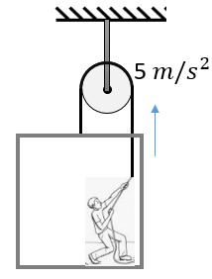
- A man is raising himself and the crate on which he stands with an acceleration of 5 $ms^{-2}$ by a massless rope-and-pulley arrangement. Mass of the man is 100 kg and that of the crate is 50 kg. The tension in the rope is?
(A) 2250 N (B) 1125 N
(C) 750 N (D) 375 N

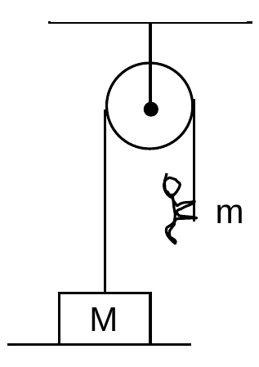
- The figure shows a block of mass M resting on a horizontal surface. The acceleration with which a boy of mass ‘m’ (< M) should climb the rope so as to lift the block should be greater than?
(A) $\frac{M}{m}g$ (B) $(\frac{M}{m}-1)g$
(C) $(\frac{M}{m} + 1)g$ (D) $\frac{mg}{M}$

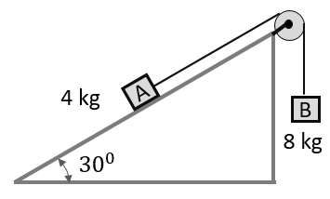
- Two masses of 8 kg and 4 kg are connected by a string as shown in figure over a frictionless pulley. The acceleration of the system is
(A)$g/2$ (B) $g/4$
(C) zero (D) $g/8$

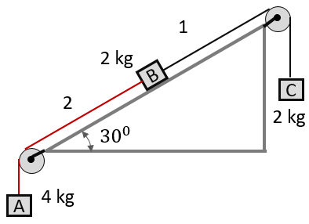
- Three blocks A, B and C are connected by inextensible strings, are placed on a fixed wedge of inclination 30°. The contact surfaces are frictionless and the pulleys are frictionless and massless. Then choose correct statements:
(A) The acceleration of block A is $\frac{3g}{8}$
(B) Tension in the string 1 is $\frac{11g}{4}$
(C) Tension in the string 2 is $\frac{5g}{2}$
(D) All are correct

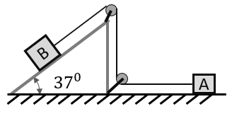
- Two blocks A and B, each having a mass of ‘m’ are placed as shown in the figure. The friction is negligible everywhere. The system is released from rest. Find the time taken for block A to have a displacement of 1 m?
(A) 1 s (B) $\sqrt{2/3} s$
(C) $\sqrt{3/2} s$ (D) $\sqrt{2} s$

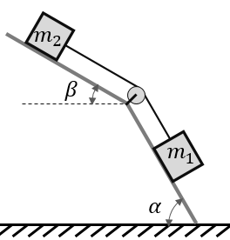
- Two blocks are connected by massless and inextensible string and placed on smooth surfaces as shown. Find the magnitude of acceleration if the released from rest:
(A) ${(m}_{1}sinα-m_{2}sinβ)g/(m_{1}+m_{2})$
(B) ${(m}_{1}sinα+m_{2}sinβ)g/(m_{1}+m_{2})$
(C) ${(m}_{1}sinα-m_{2}sinβ)g/{(m}_{1}cosα+m_{2}cosβ)$
(D) ${(m}_{1}sinα+m_{2}sinβ)g/{(m}_{1}cosα+m_{2}cosβ)$

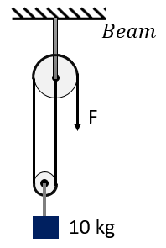
- [AIIMS 2018] A 10 kg mass is suspended from a combination of pulley as shown in the figure. If the mass is in equilibrium, then the find the force exerted by the string on the beam.
(A) 200 N (B) 100 N
(C) 150 N (D) 50 N

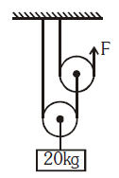
- A mass of 20 kg is connected to two pulleys arrangement as shown:. The axle of two pulleys are free to move vertically.
(i) Find the value of F is the system is in equilibrium
(ii) Find the acceleration of 20 kg block if F = 100 N

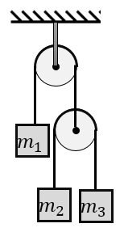
- [L2] In the arrangement shown in the figure, pulleys and strings are ideal. If the mass $m_{1}$remains at rest, then:
(A) $\frac{1}{m_{1}}=\frac{1}{m_{2}}+\frac{1}{m_{3}}$ (B) $m_{1}=m_{2}+m_{3}$
(C) $\frac{2}{m_{1}}=\frac{1}{m_{2}}+\frac{1}{m_{3}}$ (D) $\frac{4}{m_{1}}=\frac{1}{m_{2}}+\frac{1}{m_{3}}$

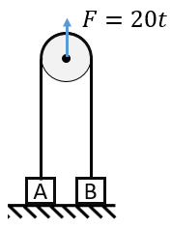
- [L2] Two blocks A and B of mass 1 kg and 2 kg respectively are connected by a string passing over a light frictionless pulley. Both the blocks are resting on a horizontal floor and the pulley is held such that string remains just taut. At moment t = 0, a time-dependent force F = 20 t newton starts acting on the pulley along vertically upward direction as shown in figure. Find the speed of block A at the instance block B leaves the ground.
(A) 1 m/s (B) 5 m/s
(C) 2 m/s (D) 3 m/s

Constraint Relations
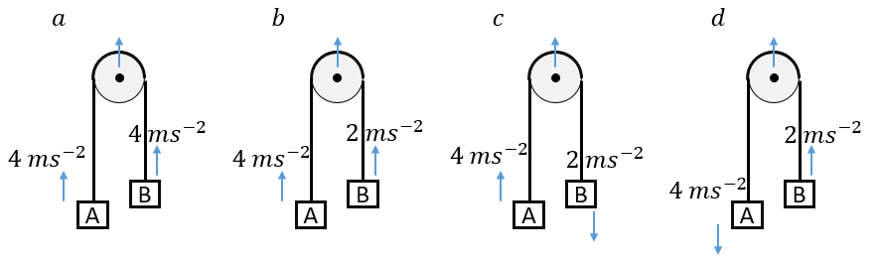
- Two blocks A and B are connected to an ideal pulley through inextensible string. In each of the four cases, the acceleration of two blocks is indicated in the figure. Find the acceleration of the pulley in case of (a), (b), (c), and (d) respectively:

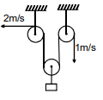
- Find the velocity of the hanging block, if the velocities of two free ends of the string are as shown in the figure?
(A) 3/2 m/s (up) (B) 3/2 m/s (down)
(C) ½ m/s (up) (D) ½ m/s (down)

- Choose the INCORRECT statement:
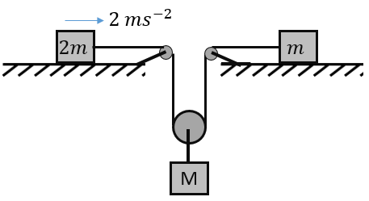
(A) Acceleration of block M is 3 $ms^{-2}$
(B) If m = 7 kg, then tension in the string is 28 N
(C) If m = 7 kg, then M = 8 kg
(D) If m = 7 kg, then M = 12 kg

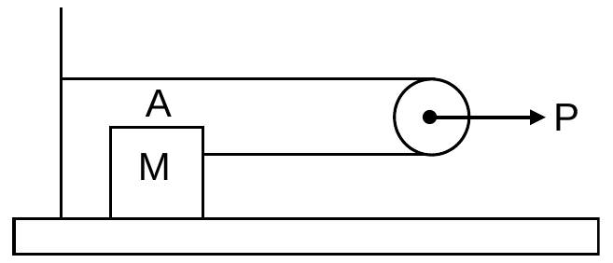
- In the following figure, the pulley is massless and frictionless. There is no friction between the body and the floor. If a constant force P is applied on the pulley as shown, find the acceleration of the block A and the pulley
(A) $\frac{P}{2M} \frac{P}{4M}$ (B) $\frac{P}{2M} \frac{P}{2M}$
(C) $\frac{P}{4M} \frac{P}{4M}$ (D) $\frac{P}{2M} \frac{P}{M}$

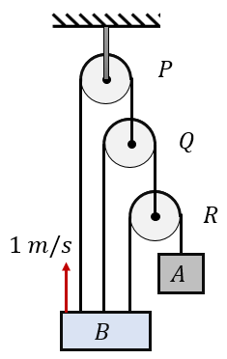
- [L2] Find the velocity of the blocks A if the block B is moving up with a velocity of 1 m/s. Assume that the block B remains horizontal during its motion.
(A) 3 m/s
(B) 5 m/s
(C) 7 m/s
(D) 9 m/s

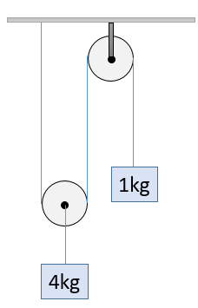
- [L2] In the system shown in the adjoining the figure, the acceleration of 1 kg mass is
(A) $\frac{g}{4} downwards$ (B) $\frac{g}{2} downwards$
(C) $\frac{g}{2} upwards$ (D) $\frac{g}{4} upwards$

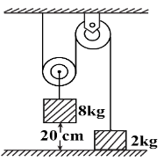
- [L2] [JEE Main 2021, 27 Aug, Shift 2] The boxes of mass 2 kg and 8 kg are connected by a massless string passing over smooth pulleys. Calculate the time taken by the box of mass 8 kg to strike the ground starting from rest.
(A) 0.34 s (B) 0.2 s
(C) 0.25 s (D) 0.4 s

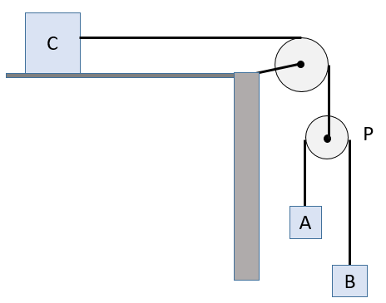
- [L2] In the arrangement shown in the figure $A=1 kg$, and $B=2 kg$. For what value of mass of block C will the block A move with a constant velocity. The friction on horizontal surface is negligible.

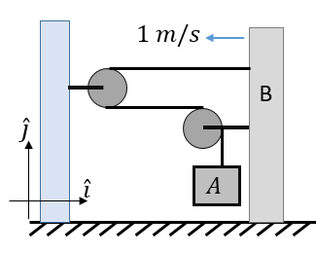
- [L2] The left side wall is fixed. The block B moves towards left with a velocity of $-\hat{i}$. Then what will be the velocity of block A?
(A) $-2 \hat{j}$ (B) $-\hat{i}- \hat{j}$
(C) $-2\hat{i}-2 \hat{j}$ (D) $-\hat{i}-2 \hat{j}$

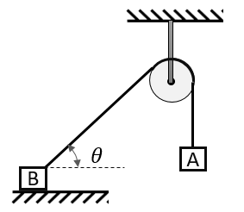
- [L2] Figure shows two blocks, each of mass ‘m’. The system is released from rest. If magnitude of accelerations of blocks A and B soon after release are $a_{A}$ and $a_{B}$respectively, then (the block B doesn’t take off the surface)
(A) $a_{A}$ = $a_{B}cosθ$ (B) $a_{A}$ = $a_{B}secθ$
(C) $a_{A}$ = $a_{B}$ (D) $a_{A}$ = $a_{B}sinθ$

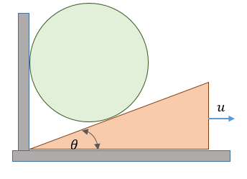
- [L2] A sphere is resting against a fixed vertical wall and an inclined plane as shown in the figure. If the inclined plane is given a horizontal velocity u as shown, then what will be the velocity of the sphere? (All surface are smooth)
(A) $usecθ$ (B) $utanθ$
(C) $ucosθ$ (D) $usinθ$

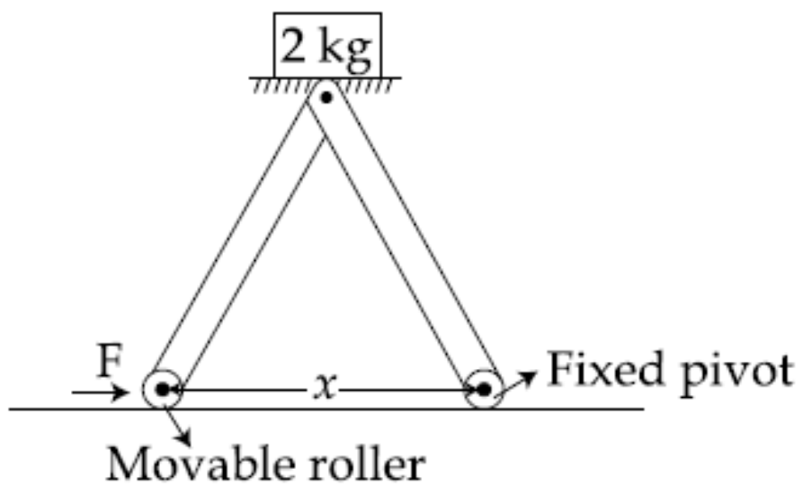
- [L2] [JEE Main 2017, 9 Apr (Online)] The machine as shown has 2 rods of length 1 m connected by a pivot at the top. The end of one rod is connected to the floor by a stationary pivot and the end of the other rod has a roller that rolls along the floor in a slot. As the roller goes back and forth, a 2 kg weight moves up and down. If the roller is moving towards right at a constant speed, the weight moves up with a :
(A) constant speed
(B) decreasing speed
(C) increasing speed
(D) speed which is 3/4th of that of the roller when the weight is 0.4 m above the ground

Spring Forces & Sudden Changes
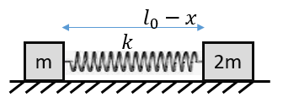
- Two blocks of mass ‘m’ and ‘2m’ are connected to ends of spring of spring constant ‘k’. The spring is compressed by a distance ‘x’ from its natural length of $l_{0}$and placed on a smooth horizontal surface and then gently released. Find acceleration of block ‘m’ and ‘2m’ respectively.
(A) $\frac{kx}{m};\frac{kx}{2m}$ (B) 0, 0 (C) $\frac{kx}{m};\frac{kx}{m}$ (D) $\frac{kx}{2m};\frac{kx}{2m}$

- A block of mass 4 kg is suspended through two light spring balances A and B. Then A and B will read respectively
4kg
B
A
(A) 4 kg and zero kg
(B) Zero kg and 4 kg
(C) 4 kg and 4 kg
(D) 2 kg and 2 kg

- Find the reading of the spring balance (in kgf) if the systems are in equilibrium:
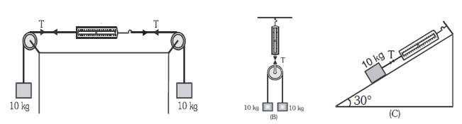

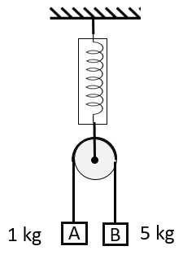
- Two masses of 1 kg and 5 kg are attached to the ends of a massless string passing over a pulley of negligible weight. The pulley itself is attached to a light spring balance as shown in Figure. The masses are released from rest. The reading of the spring balance will be:
(A) equal to 6 kgf (B) more than 6 kgf
(C) equal to $\frac{10}{3}$ kgf (D) equal to 3 kgf

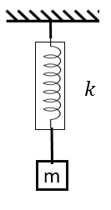
- The spring mass system shown in the figure is in equilibrium. If the mass m is pulled down by a distance mg/3k from the position of equilibrium and released, its instantaneous acceleration will be
(A) g/3 upward (B) 2g/3 downward
(C) g/3 downward (D) 2g/3 upward

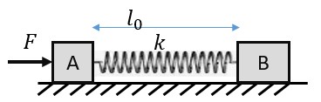
- Two blocks A and B, each of mass ‘m’ are connected to two ends of a spring of spring constant ‘k’. The system is placed on a smooth horizontal surface with spring in its natural length. At time t = 0, a force F is applied on block A as shown. Find the acceleration of block A and B soon after application of the force?
(A) $\frac{F}{2m};\frac{F}{2m}$ (B) $\frac{F}{m};\frac{F}{m}$ (C) $\frac{F}{m};0$ (D) $0;\frac{F}{2m}$

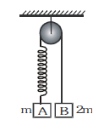
- Two blocks are held at rest such that the spring is in its natural length and the string is just taut. What will be the acceleration of blocks A and B soon after the release?
(A) 0, g (B) g, 0
(C) Both zero (D) both g

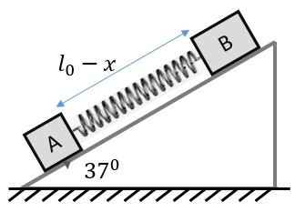
- Two blocks A and B, each of mass ‘m’ are connected to two ends of a spring of spring constant ‘k’. The spring is compressed by a distance ‘x’ from its natural length of $l_{0}$ such that $kx=mg$.The system is placed on smooth inclined plane as shown and released. Find the acceleration of block A and B soon after the release?
(A) 0.6g (down), 0 (B) 1.6g (down); 0.6g (down)
(C) 1.6g (down); 0.6g (up) (D) 1.6g (down); 0.4g (up)

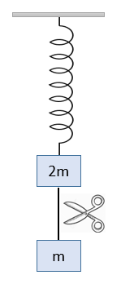
- System shown in figure is in equilibrium and at rest. The spring and string are massless. Now the string is cut. The acceleration of mass 2 m and m just after the string is cut will be?
(A) g/2 upwards, g downwards
(B) g upwards, g/2 downwards
(C) g upwards, 2g downwards
(D) 2g upwards, g downwards

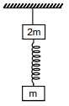
- Two masses are connected to an ideal spring and a string as shown. The system is at rest. If the string is cut, what will be the acceleration of ‘2m’ block soon afterwards?
(A) 0 (B) g
(C) g/2 (D) 3g/2

Pseudo Forces in Accelerated Frames
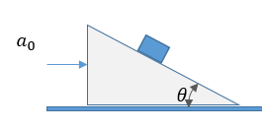
- A small block is placed on a smooth triangular prism with an inclination of $θ$ with the horizontal. If the large block is given an acceleration of $a_{0}$, the small block doesn’t slip with respect to the prism. What is value of $a_{0}$?
(A) $gsecθ$ (B) $gtanθ$
(C) $gcosθ$ (D) $gsinθ$

- A piece of wire is bent in the shape of a parabola $y=kx^{2}$ (y-axis vertical) with a bead of mass m on it. The bead can slide on the wire without friction. It stays at the lowest point of the parabola when the wire is at rest. The wire is now accelerated parallel to the x-axis with a constant acceleration a. The distance of the new equilibrium position of the bead, where the bead can stay at rest with respect to the wire, from the y-axis is
(A) $\frac{a}{gk}$ (B) $\frac{a}{2gk}$ (C) $\frac{2a}{gk}$ (D) $\frac{a}{4gk}$
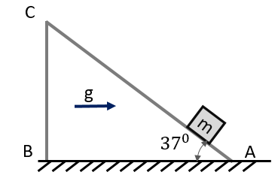
- A block ‘m’ is placed on a smooth inclined plane moving horizontally with an acceleration of ‘g’. If the inclined length AC = 1 m, find the time taken by the block to reach from A to C.
(A) 1 s B) 1.41 s
(C) 0.87 s D) 0.7 s

- [JEE Main 2021, 31 Aug, Shift 1] A car is moving on a plane inclined at $30°$ to the horizontal with an acceleration of 10 m$s^{-2}$ parallel to the plane upwards. A bob is suspended by a string from the roof of the car. The angle in degrees which the string makes with the vertical is?
- [JEE Main 2016, 9 Apr (Online)] A rocket is fired vertically from the earth with an acceleration of 2g, where g is the gravitational acceleration. On an inclined plane inside the rocket, making an angle θ with the horizontal, a point object of mass m is kept. The minimum coefficient of friction μ_{min} between the mass and the inclined surface such that the mass does not move is :
(A) tanθ (B) 2 tanθ (C) 3 tanθ (D) tan2θ
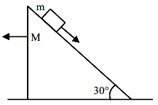
- [L3] [JEE Main 2021, 1 Sep, Shift 2] A block of mass m slides on a wooden wedge which in turn slides backwards on the horizontal surface. The acceleration of the block with respect to the wedge is? Given m = 8 kg and M = 16 kg. Assume all the surfaces to be frictionless.
(A) $\frac{4}{3}g$ (B) $\frac{6}{5}g$
(C) $\frac{3}{5}g$ (D) $\frac{2}{3}g$

Answer Key
Newton's Laws, Momentum & Impulse
Q1 | B | Q2 | B | Q3 | A
Q4 | C | Q5 | B | Q6 | D
Q7 | D | Q8 | D | Q9 | D
Q10 | $A$ | Q11 | B | Q12 | B
Q13 | B | Q14 | D | Q15 | D
Q16 | B | Q17 | B
Free-Body Diagrams & Equilibrium of a Particle
Q18 | D | Q19 | C | Q20 | D
Q21 | B | Q22 | 3 | Q23 | B
Q24 | D | Q25 | C | Q26 | $\frac{mg}{4h}\sqrt{d^{2} + 4h^{2}}$
Q27 | D | Q28 | D | Q29 | $D$
Q30 | D
Single Accelerated Body: Smooth Inclines & Lifts
Q31 | D | Q32 | 10 | Q33 | B
Q34 | D | Q35 | D | Q36 | C
Q37 | A | Q38 | A | Q39 | A
Q40 | g/4
Connected Bodies: Contact Forces & String Tension
Q41 | A | Q42 | (i) 10 m/s² (ii) 110 N (iii) 20 N | Q43 | D
Q44 | A | Q45 | B | Q46 | D
Q47 | D | Q48 | D | Q49 | C
Pulley Systems
Q50 | (i) $\frac{\left(m_{2}-m_{1}\right)g}{m_{1}+m_{2}}$ (ii) $\frac{\left(2m_{1}m_{2}\right)g}{m_{1}+m_{2}}$ (iii) $\frac{\left(4m_{1}m_{2}\right)g}{m_{1}+m_{2}}$ | Q51 | C | Q52 | B
Q53 | B | Q54 | A | Q55 | A
Q56 | A | Q57 | D | Q58 | B
Q59 | B | Q60 | A | Q61 | D
Q62 | B | Q63 | B | Q64 | C
Q65 | (i) 50 N; (ii) 10 $m/s^{2}$ | Q66 | D | Q67 | B
Constraint Relations
Q68 | 4 m$s^{-2}$ (up); 3 m$s^{-2}$ (up); 1 m$s^{-2}$ (up); 1 m$s^{-2}$ (down) | Q69 | A | Q70 | D
Q71 | $$A$$ | Q72 | C | Q73 | C
Q74 | D | Q75 | 8 kg | Q76 | D
Q77 | A | Q78 | B | Q79 | B
Spring Forces & Sudden Changes
Q80 | A | Q81 | C | Q82 | (A) 10 kgf; (B) 20 kgf; (C) 5 kgf
Q83 | C | Q84 | A | Q85 | C
Q86 | D | Q87 | D | Q88 | A
Q89 | D
Pseudo Forces in Accelerated Frames
Q90 | B | Q91 | B | Q92 | A
Q93 | 30 | Q94 | A | Q95 | D

Hints & Solutions
Newton's Laws, Momentum & Impulse
Q1 Hint
The force / acceleration is always $+$ve but decreasing and finally approaching zero, hence $v-t$ graph will have $+$ve but decreasing slope and finally tending to be horizontal
Q6 Hint
Rate of change of momentum = Net force = mg (constant)
Q7 Hint
Area under $F-t$ graph = Impulse which is equal to change in momentum $\frac{F_{0}T}{2}=2mu$
Q16 Think further
(If the water splashes along the surface of the plate, then the force will be? Answer: Option D)
Free-Body Diagrams & Equilibrium of a Particle
Q20 Solution
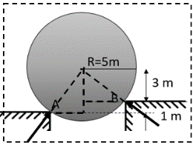
Key concept: Orientation (angle with horizontal) of the reactions at A and B;
As the surface is smooth, the forces will be normal to the point of contact, i.e., directed towards the centre;
Angles with horizontal for reactions at A and B are 53° and 37° respectively.
Alt: Three force vectors can be represented as sides of a triangle
Q22 Hint
Consider all three cylinders as the system; contact forces will act at an angle of $30°$ with the horizontal; the vertical component of each contact force $\frac{N}{2}$ = $3mg/2$
Q23 Solution
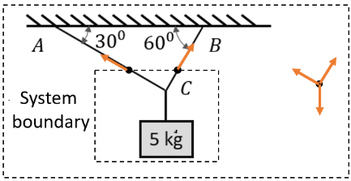
The choice of system boundary is important;
For the chosen system boundary, there are two contact points where external contact force will act;
Gravitational field force will act on the mass
The FBD will have three force along the indicated direction
Q24 Hint
The tension in the string on either side of pulley $P_{2}$ will be equal as it is frictionless = $W_{1}$;
hence the angles on either side will be equal as well (compare with Q23)
Q25 Hint
Two strings will have equal tensions (T) equal to weight of mass suspended = $mg$
Sum of vertical components will be equal to $\sqrt{2}mg$
Think further
Will the two strings make equal angle with vertical if the two masses are not equal? If the left mass were to be 1.2 m; how will the angles change?
Q26 Hint
Similar to Q25: the angle $θ=\tan^{-1}{\frac{\frac{d}{2}}{h}}$
Q27 Solution
Three parts of the string may have different tensions;
Here horizontal components of $T_{AC}$ and $T_{AB}$ are equal; and vertical components = $\frac{mg}{2}$
The horizontal components of $T_{AB}=\left(\frac{mg}{2}\right)=$ ${\left(T_{BD}\right)}_{H}$
Then ${\left(T_{BD}\right)}_{V}={\left(T_{BA}\right)}_{V}+2mg=\frac{5mg}{2}$
Q28 Solution
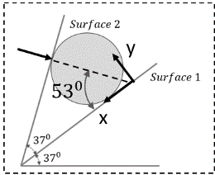
Key concept: The direction of contact force at Surface 2;
Makes an angle of $16°$ downwards with the horizontal;
Its angle with respect to Surface 1 is 53 which is easier;
Hence, choosing axes as shown simplifies the solution;
Reaction 1: $R\hat{j}$; Reaction 2: $-R^{'}cos53°\hat{i}-R^{'}sin53°\hat{j}$
And weight: $-mgcos37°\hat{i}+mgsin37°\hat{j}$
Q29 Solution
Full catenary: equating vertical components ${2T}_{Y}=2Tsinθ=W$
Half catenary: equating horizontal components $T_{0}=Tcosθ=\frac{W}{2tanθ}$
Part: horizontal component of tension = $T_{0}$ constant; Vertical component = Weight of part length
The slope of tangent keeps increasing with $x$
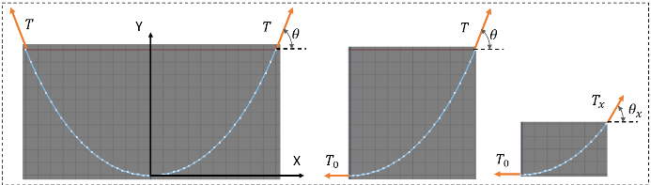
Q30 Solution
Key concept: choice of system
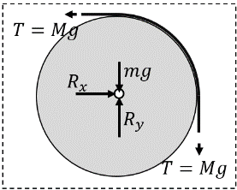
If pulley alone is considered as system, then the contact force between string and pulley becomes external force which will be acting normal to the contact points (different directions).
In order to avoid the pulley-string contact force, the system should include the string in contact with pulley and little beyond the last contact point;
Single Accelerated Body: Smooth Inclines & Lifts
Q33 Hint
Acceleration (g) for distance h and retardation (a) for distance s:
Then $\frac{g}{a}=\frac{s}{h}$ where $a=\frac{F-mg}{m}$
Q34 Solution
Here, the net accelerating force (acting in upward direction) is: $F-mg$
and retarding force (acting downwards) is $mg$
Then $\frac{F-mg}{mg}=\frac{2}{0.2}$
Q35 Hint
Initially: assuming downward $+ve$ $Mg-F=Ma$ (F: buoyancy force)
Later: assuming upward to be $+ve$ $F-\left(M-m\right)g=\left(M-m\right)a$
Q36 Hint
During ascent the deceleration is g + kv² (gravity and air resistance both oppose the motion): write a = v dv/dx = −(g + kv²) and integrate from v = u to v = 0.
Q40 Solution
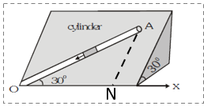
Let AN be perpendicular to OX (slope of $30°)$ having length L;
Height of A from x-y plane: $Lsin30°$; Length OA = $L/sin30°$;
hence $sinα=\frac{Ht of A}{OA}=sin^{2}30°$; $α$: angle of OA with horizontal
Connected Bodies: Contact Forces & String Tension
Q42 Solution
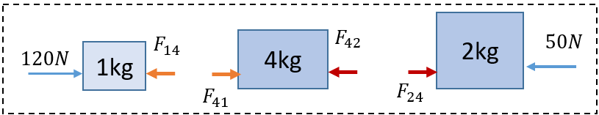
External forces (vertical forces not marked) if each block is considered as a system;
If 1 kg and 4 kg block were to considered as one system, the internal forces will cancel out
Here all block have equal acceleration = system acceleration $\vec{a_{1}}=\vec{a_{4}}=\vec{a_{2}}=\vec{a_{sys}}$
Q44 Hint
Choice of system: either the left part or the right part;
Ideally, the chain should be supported on smooth horizontal surface, else it takes catenary shape
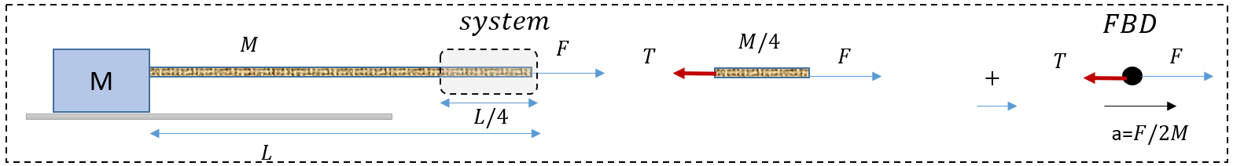
Q48 Hint
The contact force will act only if acceleration of B is greater than A without the contact force.
Q49 Solution
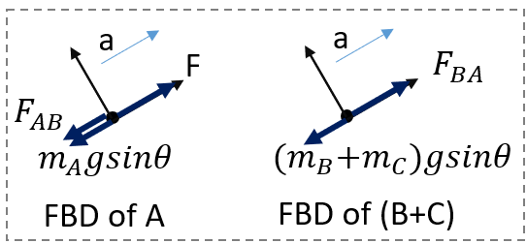
Choice of system: A or B or B&C
FBD shown here for two systems; note that F is an external force only on A;
Blocks B and C are being pushed up the contact exerted by A;
Pulley Systems
Q50 Hint
For string supporting the pulley, the effective mass: $\frac{\left(4m_{1}m_{2}\right)}{m_{1}+m_{2}}$
Q51 Hint
Block C will have downward acceleration of $g/3$; hence tension in the string supporting it: $2(g-\frac{g}{3})$
Think further
Will the magnitude of acceleration change if B and C are replaced with one 4 kg block?
(What is the tension in the string connecting pulley to the ceiling? Answer: 16g/3)
Q53 Hint
Two blocks will have equal magnitude of acceleration; equivalent 1-D motion with component of forces along the direction of motion: Net external force $m_{2}g$; hence $a=\frac{m_{2}g}{m_{1}+m_{2}}$
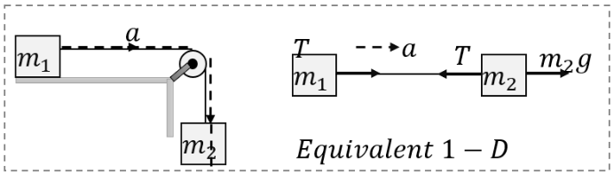
Q54 Hint
Using equivalent 1-D: $a=\frac{m_{3}g}{m_{1}+m_{2}+m_{3}}=6$;
Then considering $m_{1}$and $m_{2}$ together as system with $T_{2}$ as external force $T_{2}=2kg×6 m/s^{2}$ = 12 N
Q55 Hint
Acceleration a = 2; Tension in string connected to 1 kg: $1×\left(10+2\right)=12N$
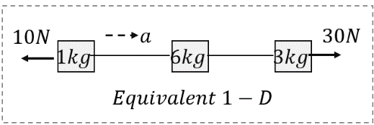
Net force on $L/4$ (of mass 1.5 kg) = 3 N; hence tension = (12 + 3) = 15 N
Q56 Hint
In case (ii), the force exerted by the person is half the tension in the string connected to the block
Q57 Think further
(What will be the tension in the string connecting the pulley to the ceiling? Answer: 900 N)
Q58 Hint
Tension in the string connected to the ceiling = total mass suspended$×(g+a)$
Q60 Hint
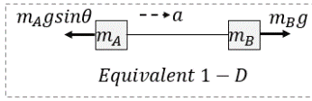
Considering two blocks with string as 1-D system:
$a=\frac{m_{B}g-m_{A}gsinθ}{m_{A}+m_{B}}$
Q61 Hint
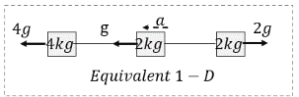
Note: weight of B and normal reaction are external forces;
$a=\frac{3g}{8}$; $T_{1}=m_{c}\left(g+a\right)$ $T_{2}=m_{A}(g-a)$
Q66 Hint
Effective mass to the string supporting lower pulley: $\frac{\left(4m_{2}m_{3}\right)}{m_{2}+m_{3}}$
Constraint Relations
Q68 Hint
Use $a_{P}=\frac{1}{2}(a_{1}+a_{2})$ with sign;
Assume up as $+$ve:
Q77 Hint
(Constraint equa: $a_{A}=a_{B}cosθ+v_{B}(-sinθ\frac{dθ}{dt})$ )
Spring Forces & Sudden Changes
Q81 Hint
In equilibrium, if springs were to be replaced with strings, then the tensions in strings will be same as tension in corresponding springs except that strings will have negligible elongation
Q83 Hint
Two masses connected to pulley are equivalent to $\frac{\left(4m_{1}m_{2}\right)}{m_{1}+m_{2}}=\frac{10}{3}kg$ as rest (as pulley is at rest)
Q85 Hint
Though block A will have acceleration, its displacement will be negligible in a very short interval of time. Hence, the spring force will be zero.
Q86 Hint
In a very short time interval after release, the blocks will have no time to move, the extension of the spring will be negligible and hence the spring force will be zero (same as at the time of release). The tension in string will be equal to tension in the spring and hence zero. The two objects will have instantaneous free fall.
Q87 Hint
Spring force of mg will act down the slope on A and up the slope on B.
Q88 Hint
Soon after the cut, the string force will be zero but the spring force will remain as before the cut (=3mg)
Pseudo Forces in Accelerated Frames
Q90 Think further
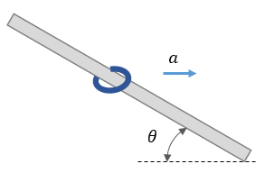
If a smooth rod, with a ring slipped on it, is an angle of $θ$ with horizontal. What is the horizontal acceleration it must be given for the ring not to slip?
(Same answer as above)

