Take g = 10 m/s² unless stated otherwise.

Work by a Constant Force
- A force $\vec{F}=5\hat{i}+3\hat{j}$ newton is applied over a particle which displaces it from its origin to the point $\vec{r}=(2\hat{i}-\hat{j})$ metres. The work done on the particle is
(A) – 7 joules (B) + 13 joules (C) + 7 joules (D) + 11 joules
- A uniform force of $3\hat{i}+\hat{j}$ newton acts on a particle of mass 2kg. The particle is displaced from position $2\hat{i}+\hat{k}$ meter to position (4$\hat{i}+3\hat{j}-\hat{k})$ meter. The work done by the force on the particle is:
(A) 15 J (B) 9 J (C) 6 J (D) 13 J
- [JEE Main 2021, 27 Aug, Shift 1] Two persons A and B perform same amount of work in moving a body through a certain distance d with application of forces acting at angle 45° and 60° with the direction of displacement respectively. The ratio of force applied by person A to the force applied by person B is $1/\sqrt{x}$. The value of x is:
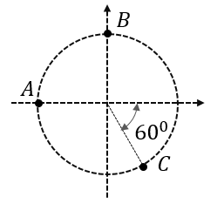
- A force $F=5\hat{i}$ is acting on a particle which moves in a circular path of radius of 2 m as shown in the figure. Find the work done when the particle moves from
(i) A to B
(ii) B to C

- A block of mass ‘m’ is lowered with the help of a rope of negligible mass through a distance d with a downward acceleration of g/3. The work done by the rope on the block is
(A) $\frac{2mgd}{3}$ (B) $\frac{mgd}{3}$ (C) $-\frac{2mgd}{3}$ (D) $-\frac{mgd}{3}$
- [JEE Main 2021, 22 Jul, Shift 2] A porter lifts a heavy suitcase of mass 80kg and at the destination lowers it down by a distance of 80 cm with a constant velocity. Calculate the work done by the porter in lowering the suitcase. (take g = 9.8 m/s²)
(A) -62720.0J (B) -627.2 J (C) +627.2 J (D) 784.0 J
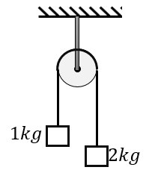
- Two unequal masses of 1 kg and 2 kg are attached at the two ends of a light inextensible string passing over a smooth pulley as shown in figure, if the system is released from rest the work done by string on 1 kg block in 1 sec is 200/α J. The value of α is

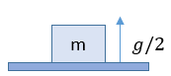
- [JEE Main 2019, 10 Jan, Shift 1] A block of mass m is kept on a platform which starts from rest with constant acceleration g/2 upward, as shown in fig. Work done by normal reaction on block in time t is:
(A) mg²t²/8 (B) 3mg²t²/4
(C) 3mg²t²/8 (D) 5mg²t²/8

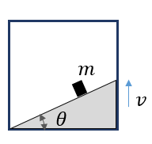
- A small block of mass m is kept on a rough wedge of inclination θ with the horizontal. The incline is fixed inside an elevator. The elevator goes up with a uniform velocity of v and the block does not slide. The work done by (i) the frictional force and (ii) the normal reaction on the block in time t is

- The work done by the frictional force on a pencil in drawing a complete circle of radius r = 1/π metre on the surface by a pencil of negligible mass with a normal pressing force of 5 N (μ = 0.5) is :
(A) 5J (B) 10J (C) -5J (D) -10J

Work by Variable Force; Chains & Ropes
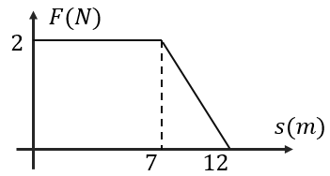
- Force F on a particle moving in a straight line varies with distance ‘s’ as shown in the figure. The work done on the particle during its displacement of 12 m is:
(A) 18 J (B) 21 J
(C) 26 J (D) 19 J

- A position dependent force $F=(7-2x+3x^{2})\hat{i}$ N acts on a small body of mass 2 kg and displaces it from $x=0$ to $x=5$m. The work done in joules is
(A) 70 (B) 270 (C) 35 (D) 135
- [JEE Main 2021, 25 Jul, Shift 2] A force $F=(5y+20)\hat{j}$ N acts on a particle. The work done by this force when the particle is moved from y = 0 to y = 10m is ….. J.
- [JEE Main 2014 (Offline)] When a rubber band of negligible length is stretched by a distance x, it exerts a restoring force of magnitude F = $ax+bx^{2}$where ‘a’ and ‘b’ are constants. The work done in stretching the unstretched rubber band by L is:
(A) ½($aL^{2}+bL^{3})$ (B) $\frac{1}{3}$($aL^{2}+bL^{3})$ (C) ($\frac{aL^{2}}{2}+\frac{bL^{3}}{6})$ (D) ($\frac{aL^{2}}{2}+\frac{bL^{3}}{3})$
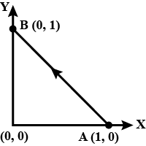
- [JEE Main 2020, 9 Jan, Shift 1] Consider force $\vec{F}=-x\hat{i}+y\hat{j}$. The work done by this force in moving a particle from A(1, 0) to B(0, 1) along the line segment is (all quantities are in SI units)
(A) 3/2 (B) 2
(C) 1 (D) ½

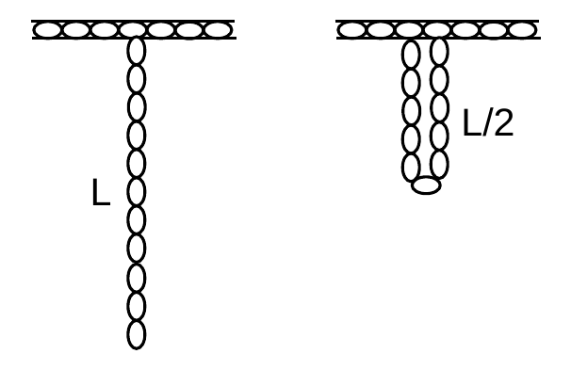
- A uniform chain of length L and mass m is hanging down vertically from a hook fixed to the roof. The work done by an external agent in slowly hooking the other end of the chain to the hook, as shown, is
(A) $\frac{mgL}{2}$ (B) $\frac{mgL}{4}$
(C) $-\frac{mgL}{2}$ (D) Zero

- A uniform flexible chain of mass m and length $2L$ hangs in equilibrium over a smooth horizontal pin of negligible diameter. One end of the chain is given a small vertical displacement so that the chain slips over the pin. The speed of the chain when it leaves the pin is:
(A) $\sqrt{2gL}$ (B) $\sqrt{gL}$ (C) $\sqrt{4gL}$ (D) $\sqrt{gL/2}$
- [JEE Main 2021, 26 Aug, Shift 1] A uniform chain of length 3 m and mass 3 kg overhangs a smooth table with 2 m lying on the table. If k is the kinetic energy of the chain in joules as it completely slips off the table, then the value of k is:
- [L2] A force F $=-k(y\hat{i}+x\hat{j})$ (where k is a positive constant) acts on a particle moving in the x-y plane. Starting from the origin, the particle is taken along the positive X-axis to the point (a, 0) and then parallel to the Y-axis to the point (a, a). The total work done by the force F on the particle is?
(A) $ka^{2}$ (B) $2ka^{2}$ (C) $-ka^{2}$ (D) $-2ka^{2}$
- [L2] A force F = $-y\hat{i}$ + $x\hat{j}$ acts on a particle as it moves in an anticlockwise circular motion in x-y plane. The centre of the circle is at the origin. If the work done by the force is 32$π$ in one complete revolution. The radius of the path is
- [L3] The work done on a particle of mass m by a force:
= K $\left\{\frac{x\hat{i}}{{(x^{2}+y^{2})}^{3/2}}+\frac{y\hat{j}}{{(x^{2}+y^{2})}^{3/2}}\right\}$,
(K is a constant of appropriate dimensions), when the particle is taken from the point (a, 0) to the point (0, a) along a circular path of radius a about the origin in the x - y plane is?

Spring Force: Work & Elastic PE
- [AIEEE 2002] A spring of force constant of 800 N/m has an extension of 5 cm. The work done in extending it from 5 cm to 15 cm is:
(A) 16J (B) 8J (C) 32J (D) 24J
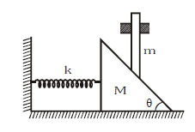
- A wedge of mass M fitted with a spring of stiffness 'k' is kept on a smooth horizontal surface. A rod of mass m is kept on the wedge as shown in the figure. The system is in equilibrium. Assuming that all surfaces are smooth, the potential energy stored in the spring is:
(A) ${\left(mgtanθ\right)}^{2}/k$ (B) ${\left(mgtanθ\right)}^{2}/2k$
(C) ${\left(mgsinθ\right)}^{2}/2k$ (D) ${\left(mgcosθ\right)}^{2}/2k$

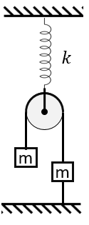
- A light pulley hangs from a spring of force constant k. Two blocks, each of mass m, hang from a light string passing over the pulley; the right block is tied to the floor by a string. The system is in equilibrium. The potential energy stored in the spring is
(A) $\frac{2m^{2}g^{2}}{k}$ (B) $\frac{m^{2}g^{2}}{2k}$
(C) $\frac{4m^{2}g^{2}}{k}$ (D) $\frac{m^{2}g^{2}}{4k}$

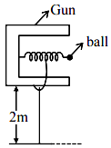
- [JEE Main 2021, 20 Jul, Shift 1] In a spring gun having spring constant 100 N/m, a small ball B of mass 100 g is put in its barrel by compressing the spring through 0.05m. There should be a box placed at a distance d on the ground so that the ball falls into it. If the ball leaves the gun horizontally at a height of 2m above the ground, then the value of d in m is

- [AIIMS 2008] A vertical spring with force constant k is fixed on a table. A ball of mass m at a height h above the free upper end of the spring falls vertically on the spring, so that the spring is compressed by a distance d. The sum of the work done by gravity and by the spring in the process is:
(A) $mg\left(h+d\right)+\frac{1}{2} kd^{2}$ (B) $mg\left(h+d\right)-\frac{1}{2} kd^{2}$
(C) $mg\left(h-d\right)-\frac{1}{2} kd^{2}$ (D) $mg\left(h-d\right)+\frac{1}{2} kd^{2}$
- A block of mass m moving with speed v compresses a spring through distance x before its speed is halved. The spring is placed on a smooth horizontal surface with other end fixed. What is the value of spring constant?
(A) $3mv^{2}/4x^{2}$ (B) $3mv^{2}/2x^{2}$ (C) $mv^{2}/4x^{2}$ (D) $mv^{2}/2x^{2}$
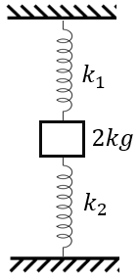
- A 2 kg block is connected with two springs of force constants k₁ = 100 N/m and k₂ = 300 N/m as shown in figure. The block is released from rest with the springs unstretched. The acceleration of the block in its lowest position is
(A) $g$ upwards (B) $g/2$ upwards
(C) $g/3$ upwards (D) $g/4$ upwards

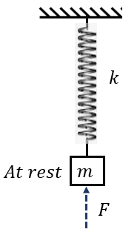
- A mass ‘m’ is suspended from a spring of stiffness ‘k’ and it is initially in the state of rest. A variable upward force ‘F’ is applied on the block such that it moves up slowly. The force keeps acting till the spring is compressed by an amount equal to its initial extension. The work done by this force F is
(A) $\frac{m^{2}g^{2}}{k}$ (B) $\frac{m^{2}g^{2}}{2k}$
(C) $\frac{{4m}^{2}g^{2}}{k}$ (D) $\frac{{2m}^{2}g^{2}}{k}$

- A mass is hung freely from the end of a spring. A boy then slowly pushes the mass upwards until the spring just becomes slack. The gain in gravitational potential energy of the mass during this process is:
(A) Equal to the work done by the boy on the mass.
(B) Greater than the work done by the boy on the mass.
(C) Less than the work done by the boy on the mass.
(D) Can be greater or less than the work done by the boy depending on the stiffness of spring
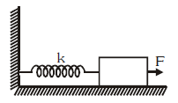
- A block attached to a spring, pulled by a constant horizontal force, is kept on a smooth surface as shown in the figure. Initially, the spring is in the natural state. Then the maximum extension of the spring will be?
(A) $2F/k$ (B) $F/k$
(C) $F/2k$ (D) It will keep expanding

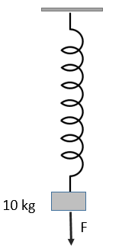
- A vertical spring of force constant 100 N/m is attached with a hanging mass of 10 kg. Now a variable external force is applied on the mass so that the spring is slowly stretched by additional 2m. The work done by the force F is :
(A) 400 J (B) 300 J
(C) 250 J (D) 200J

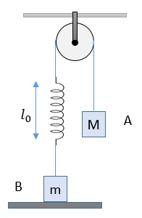
- In the arrangement shown in the figure, the block A is released from rest when the spring is in its natural length. For the block B of mass m to leave contact with ground at some stage what should be the minimum mass of block A?
(A) $2m$
(B) $m$
(C) $m/2$
(D) $m/3$

- [L2] [JEE Main 2021, 1 Sep, Shift 2] An engine is attached to a wagon through a shock-absorber of length 1.5 m. The system with a total mass of 40000 kg is moving with a speed of 72 km/h when the brakes are applied to bring it to rest. In the process of the system being brought to rest, the spring of the shock absorber gets compressed by 1.0 m. If 90% of energy of the wagon is lost due to friction, the spring constant is ….. $×{10}^{5}$ N/m.
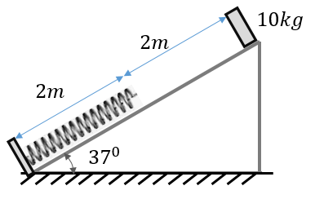
- [L2] A block of mass 10 kg is placed on a smooth plane inclined at 37° with the horizontal. A spring of natural length of 2m is placed on the inclined plane such that its lower end is fixed and the upper end is at an initial distance of 2m from the block. The block is released from rest and it comes to momentary rest after compressing the spring by 1m
(i) Find the spring constant
(ii) What will be the compression of spring when the kinetic energy of the block is maximum?
(iii) What is the maximum kinetic energy of the block?
(iv) What will be the maximum acceleration of the block?

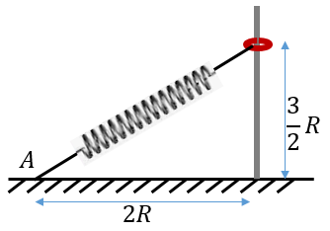
- [L2] A ring of mass m can slide over a smooth vertical rod. The ring is connected to a spring of force constant K = 4mg/R where 2R is the natural length of the spring. The other end of the spring is fixed to the ground at a horizontal distance 2R from the base of the rod. The mass is released at a height of 1.5R from ground. Find the velocity of the ring when it reaches the ground.
(A) $2\sqrt{gR}$ (B) $2\sqrt{2gR}$
(C) $\sqrt{2gR}$ (D) $\sqrt{gR}$

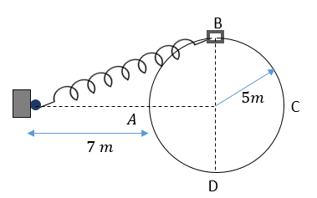
- [L2] A collar 'B' of mass 2 kg is constrained to move along a horizontal smooth and fixed circular track of radius 5m. The spring lying in the plane of the circular track and having spring constant 200 N/m is undeformed when the collar is at 'A'. The other end of the spring is fixed 7 m from A, on the line through A and the centre of the track. If the collar starts from rest at B the normal reaction exerted by the track on the collar when it passes through 'A' is:
(A) 1440 N (B) 1200 N
(C) 980 N (D) 1450 N

Work–Energy Theorem
- A particle of mass m at rest is acted upon by a force F for a time t. Its kinetic energy after an interval t is?
(A) $\frac{F^{2}t^{2}}{2m}$ (B) $\frac{F^{2}t^{2}}{m}$ (C) $\frac{Ft^{2}}{2m}$ (D) $\frac{F^{2}t}{2m}$
- [JEE Main 2019, 9 Jan, Shift 2] A force acts on a 2 kg object, so that its position is given as function of time as $x=3t^{2}+5$. What is the work done by this force in first 5 seconds?
(A) 850J (B) 900J (C) 950J (D) 875J
- [JEE Main 2019, 10 Jan, Shift 2] A particle which is experiencing a force, given by $\vec{F}=3\hat{i}-12\hat{j}$ undergoes a displacement of $\vec{d}=4\hat{i}$ . If the particle had a kinetic energy of 3 J at the beginning of the displacement, what is its kinetic energy at the end of the displacement?
(A) 12 J (B) 18 J (C) 15 J (D) 24 J
- [AIPMT 2015] A block of mass 10 kg, moving in x direction with a constant speed of 10 m/s, is subjected to a retarding force F = $0.1x$ J/m during its travel from x = 20 m to 30 m. Its final KE will be :
(A) 450 J (B) 275 J (C) 250 J (D) 475 J
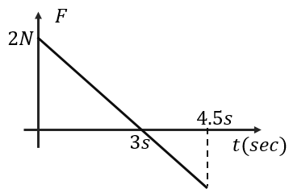
- A block of mass 2 kg is free to move along the x-axis. It is at rest and from t = 0 onwards it is subjected to a time-dependent force F(t) in the x-direction. The force F(t) varies with t as shown in the figure. The work done by the force in time interval of 4.5 s is?
(A) 9/4 J (B) 81/16J
(C) 81/64 J (D) 9/8 J

- [JEE Main 2017 (Offline)] A time dependent force F = 6t acts on a particle of mass 1 kg. If the particle starts from rest, the work done by the force during the first 1 s will be?
(A) 6 J (B) 3 J (C) 4 J (D) 4.5 J
- [JEE Main 2021, 1 Sep, Shift 2] A body of mass m dropped from height h reaches the ground with a speed of $0.8\sqrt{gh}$. The value of work done by air friction is:
(A) – 0.68mgh (B) mgh (C) 1.64 mgh (D) 0.64 mgh
- [JEE Main 2020, 3 Sep, Shift 1] A bowling machine projects a ball of mass 0.15kg in the vertically upward direction. The ball is displaced along with the bowling machine for 0.2m and released. After the release the ball achieves a maximum height of 20m, then find the average force exerted by the machine.
(A) 151.5 N (B) 150N (C) 165N (D) 135N
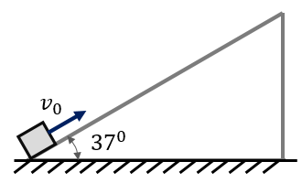
- A particle is projected vertically up with velocity $v_{0}$ and it reaches a maximum height of H. If a block is projected up a smooth slope inclined at an angle of 37° with the horizontal with speed $v_{0}$along the slope, then the distance it will travel before coming to a momentary rest for the first time?
(A) H (B) 0.6H
(C) $\frac{5H}{3}$ (D) $\frac{5H}{4}$

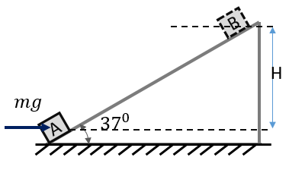
- A block of mass ‘m’ placed on smooth plane inclined at an angle of 37° with the horizontal, is pushed up the slope from initial position of rest. The external force acting on the block is constant and equal to $mg$ in magnitude and horizontal in direction. Find the kinetic energy of the block when it reaches B at a height of ‘H’ from the initial position?
(A) $\frac{1}{2}mgH$ (B) $\frac{1}{3}mgH$ (C) $\frac{4}{3}mgH$ (D) $mgH$

- [JEE Main 2020, 4 Sep, Shift 2] A person pushes a box on rough horizontal surface. He applies a force of 200N over a distance of 15m. Thereafter, he gets progressively tired and his applied force reduces linearly with distance to 100N over next 15m. What is the total work done by the person?
(A) 5000 J (B) 6000 J (C) 5500 J (D) 5250 J
- A rifle bullet loses 1/20th of its velocity in passing through a plank. The least number of such planks required just to stop the bullet is
(A) 5 (B) 10 (C) 11 (D) 20
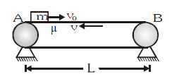
- With what minimum velocity $v_{0}$ should block be projected from left end A towards end B such that it reaches the other end B of conveyor belt which is moving with constant velocity v ? Friction coefficient between block and belt is μ.
(A) $2v$ (B) $\sqrt{2μgL}$
(C) $\sqrt{μgL}$ (D) $2\sqrt{μgL}$

- [JEE Main 2020, 6 Sep, Shift 2] A particle moving in the xy-plane experiences a velocity dependent force $\vec{F}=k(v_{y}\hat{i}+v_{x}\hat{j})$, where $v_{x}$ and $v_{y}$ are x and y components of velocity. If $\vec{a}$ is the acceleration of the particle, then which of the following statements is true for the particle?
(A) Quantity $\vec{v}×\vec{a}$ is constant in time (B) $\vec{F}$ arises due to magnetic field
(C) Kinetic energy is constant in time (D) Quantity $\vec{v}.\vec{a}$ is constant in time
- A small sphere starts falling from a very large height and after falling a distance of 100 m it attains the terminal velocity and continues to fall with this velocity. The magnitude of work done by the atmosphere during the first fall of 100m is?
(A) Greater than the work done for next fall of 100 m
(B) Less than the work done for next fall of 100 m
(C) Equal to 100 mg
(D) Greater than 100 mg
- A bullet of mass 10g is fired horizontally with a velocity of 1000m/s from the rifle situated at a height of 50m above the ground. If the bullet reaches the ground with a velocity of 500 m/s, the work done against air resistance is
(A) 3750 J (B) 3755J (C) 2500 J (D) 2555J
- A particle moves on a rough horizontal ground with some initial velocity say $v_{0}$. If 3/4th of its kinetic energy is lost due to friction in time $t_{0}$ ; then coefficient of friction between the particle and the ground is:
(A) 2$v_{0}/gt_{0}$ (B) 3$v_{0}/gt_{0}$ (C) $v_{0}/gt_{0}$ (D) $v_{0}/2gt_{0}$
- A particle is projected vertically upwards with a speed of 16 m/s, after some time, when it again passes through the point of projection, its speed is found to be 8 m/s. It is known that the work done by air resistance is same during upward and downward motion. Then the maximum height attained by the particle is?
(A) 12.8 m (B) 10m (C) 9 m (D) 8m
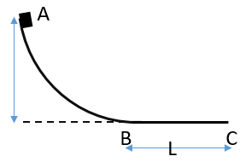
- A small ball of mass m starts at a point A at height ‘h’ with speed v₀ and moves along a frictionless track AB as shown. The track BC has coefficient of friction μ. The ball comes to stop at C after travelling a distance L which is?
(A) $\frac{h}{2μ}+\frac{v_{0}^{2}}{2μg}$ (B) $\frac{2h}{μ}+\frac{v_{0}^{2}}{2μg}$
(C) $\frac{h}{μ}+\frac{v_{0}^{2}}{2μg}$ (D) $\frac{h}{2μ}+\frac{v_{0}^{2}}{μg}$

- A body is moving up an inclined plane of angle $θ$ with an initial kinetic energy of E. The coefficient of friction between the plane and the body is μ. The work done against friction before the body comes to a stop is?
(A) $\frac{μsinθE}{µcosθ+sinθ}$ (B) $\frac{cosθE}{µcosθ+sinθ}$ (C) $\frac{μcosθE}{cosθ+μsinθ}$ (D)$\frac{μcosθE}{µcosθ+sinθ}$
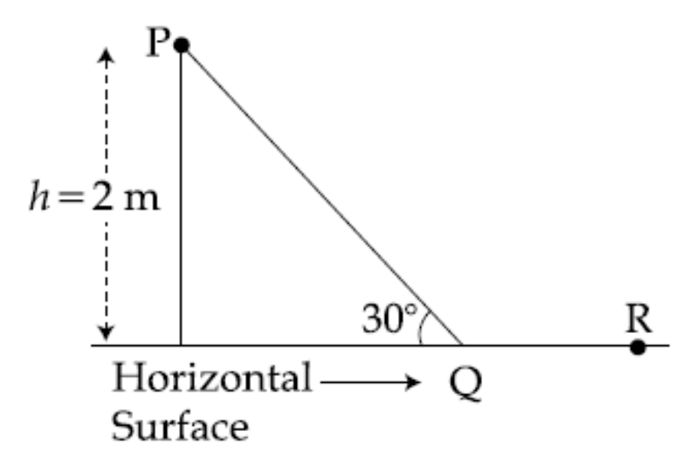
- [JEE Main 2016 (Offline)] A point particle of mass m, moves along the uniformly rough track PQR as shown in the figure. The coefficient of friction, between the particle and the rough track equals μ. The particle is released, from rest, from the point P and it comes to rest at a point R. The energies, lost by the ball, over the parts, PQ and QR, of the track, are equal to each other, and no energy is lost when particle changes direction from PQ to QR. The values of the coefficient of friction μ and the distance x(=QR), are, respectively close to :
(A) 0.2 and 6.5 m (B) 0.2 and 3.5 m
(C) 0.29 and 3.5 m (D) 0.29 and 6.5 m

- A block of mass 2 kg is initially at rest on a horizontal frictionless surface. A horizontal force F = (9 - $x^{2}$)$\hat{i}$ N acts on it. The maximum kinetic energy of the block between x =0, and x = 4m in Joules is?
(A) 18J (B) 44/3J (C) 36J (D) 27J
- A locomotive of mass m starts moving such that its velocity varies as $v=K\sqrt{s}$ , where K is a constant and s is the distance traversed. The total work done by all forces acting on the locomotive during the first t seconds after the start of motion is
(A) $\frac{1}{8}$m$K^{4}t^{2}$ (B) $\frac{1}{8}$m$K^{2}t^{2}$ (C) $\frac{1}{4}$m$K^{2}t^{2}$ (D) $\frac{1}{4}$m$K^{4}t^{2}$
- A body with zero initial velocity slips from the top of an inclined plane forming an angle $α$ with the horizontal. The coefficient of friction μ between the body and the plane increases with the distance ‘s’ from the top according to relation μ=bs. After what distance the body will stop?
(A) $2tanα$ (B) $2btanα$ (C) $\frac{2 tanα}{b}$ (D) $\frac{ tanα}{b}$
- [JEE Main 2017 (Offline)] A body of mass m = ${10}^{-2}$ kg is moving in a medium and experiences a frictional force $F=-kv^{2}$. Its initial speed is $v_{0}$ = 10 m/s. If after 10 s its energy is $\frac{1}{8}mv_{0}^{2}$, then the value of k is close to:
(A) ${10}^{-3}$kg/m (B) ${10}^{-4}$kg/m (C) ${10}^{-2}$kg/m (D) ${10}^{-1}$kg/m
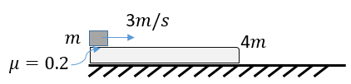
- A small block of mass ‘m’ is placed on a long plank of mass ‘4m’. The plank rests on a smooth floor, whereas the coefficient of friction between the block and the plank is 0.2. The small block is given a sudden impulse such that it acquires a velocity of 3 m/s. Find the work done by frictional force on the block and the plank during first one second?
(A) −4m, 4m (B) −4m, 2m (C) −4m, m (D) −4m, m/2

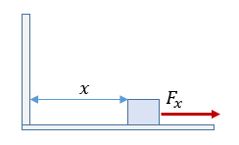
- [L2] The block of mass m initially at rest at x = 0 is acted upon by a horizontal force which, at position x, is given by $F=a-bx^{2}$ (where a > μmg), as shown in the figure. The co-efficient of friction between the surfaces of contact is μ. At what displacement will the mass ‘m’ be at momentary rest?
(A) $\sqrt{3(a-μmg)/b}$ (B) $\sqrt{2(a-μmg)/b}$
(C) $\sqrt{(a-μmg)/b}$ (D) Not possible

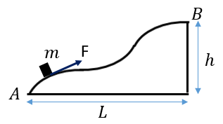
- [L3] A body of mass m is slowly hauled up the hill as shown by a force F of varying magnitude but always directed along the tangent to the trajectory. Find the work done by force F if coefficient of friction is μ.
(A) $mgh-μmgL$ (B) $-mgh+μmgL$
(C) $mgh+μmgL$ (D) $-(mgh+μmgL)$

Conservative Forces & Potential-Energy Curves
- [AIEEE 2006] The potential energy of a 1 kg particle free to move along the x-axis is given by $V\left(x\right)=\left(\frac{x^{4}}{4}-\frac{x^{2}}{2}\right).$The total mechanical energy of the particle is 2 J. Then, the maximum speed (in m$s^{-1}$) is:
(A) $3/\sqrt{2}$ (B) $\sqrt{2}$ (C) $\frac{1}{\sqrt{2}}$ (D) 2
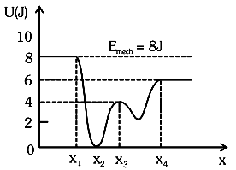
- [JEE Main 2021, 27 Jul, Shift 2] Given below is the plot of potential energy function U(x) for a system, in which a particle is in one-dimensional motion, while a conservative force F(x) acts on it. Suppose that $E_{mech}$= 8J, the incorrect statement for the system is:
(A) At $x>x_{4}$, KE is constant throughout the region
(B) At $x=x_{3}$, KE = 4J
(C) At $x=x_{2}$, KE is greatest
(D) At $x<x_{1}$, KE is smallest and the particle is moving at the slowest speed

- [AIPMT 2012 (Pre)] The potential energy of a particle in a force field is : U$=\frac{A}{r^{2}}-\frac{B}{r}$; where A and B are positive constants and r is the distance of particle from the centre of the field. For stable equilibrium, the distance of the particle is :
(A) A/B (B) B/A (C) B/2A (D) 2A/B
- [JEE Main 2020, 6 Sep, Shift 1] The potential energy between two molecules is $U=-\frac{A}{r^{6}}+\frac{B}{r^{12}}$. The equilibrium separation and the potential energy at equilibrium are:
(A) ${\left(\frac{B}{2A}\right)}^{1/6}$, $-\frac{A^{2}}{2B}$ (B) ${\left(\frac{B}{A}\right)}^{1/6}$, $0$ (C) ${\left(\frac{2B}{A}\right)}^{1/6}$, $-\frac{A^{2}}{4B}$ (D) ${\left(\frac{2B}{A}\right)}^{1/6}$, $-\frac{A^{2}}{2B}$
- The P.E of a particle oscillating on x–axis is given as U = 20 + (x – 2)² here U is in joules and x is in meters. Total mechanical energy of particle is 36 J.
(i) Find the mean position (ii) Find the amplitude of oscillation (iii) Find the maximum kinetic energy
- The potential energy of a particle of mass 5 kg, moving in x-y plane is given by $U=-7x+8.5y$ (SI units). Initially, the particle is at the origin and has velocity v = (14.4$\hat{i}$ + 5.1$\hat{j}$) m/s. The time at which the particle moves parallel to the x-axis is
(A) t =1s (B) t = 5s
(C) t = 4 s (D) t = 3 s
- Two particles of the same mass m are moving in circular orbits because of force, given by F(r) = $-\frac{16}{r}-r^{3}$. The first particle is at a distance r=1, and the second, at r=4. The best estimate for the ratio of kinetic energies of the first and the second particle is closest to:
(A) 6×10⁻² (B) 3×10⁻³ (C) 10⁻¹ (D) 6×10²
- A small object of mass m moves in a circular orbit under attractive central force $F=-kr^{3}\hat{r}$. The radius of the orbit is a. If the PE at the centre is zero, then the total mechanical energy of the object is?
(A) $\frac{ka^{4}}{4}$ (B) $\frac{ka^{3}}{4}$ (C) $\frac{3ka^{4}}{4}$ (D) $\frac{3ka^{3}}{4}$
- [JEE Main 2021, 18 Mar, Shift 2] A particle of mass m moves in a circular orbit under the central potential field $\left(r\right)=-\frac{C}{r}$ , where C is a positive constant. The correct radius-velocity graph of the particle motion is:

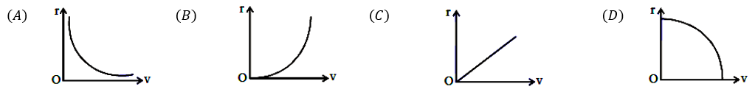

- [JEE Main 2018] A particle is moving in a circular path of radius a under the action of attractive potential $U=-\frac{k}{2r^{2}}$. Its total energy is:
(A) $-\frac{k}{4a^{2}}$ (B) $-\frac{k}{2a^{2}}$ (C) zero (D) $-\frac{3k}{2a^{2}}$

Conservation of Mechanical Energy
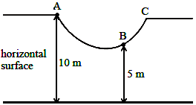
- [JEE Main 2021, 18 Mar, Shift 1] As shown in the figure, a particle of mass 10kg is placed at a point A, which is 10 m above the horizontal surface; point B is 5 m above it. When the particle is slightly displaced towards right, it starts moving and reaches the point B. The speed of the particle at B is x m/s. The value of x to the nearest integer is

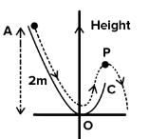
- [JEE Main 2020, 7 Jan, Shift 1] A particle (m = 1kg) slides down a frictionless track (AOC) starting from rest at point A (height 2m). After reaching C, the particle continues to move freely in air as projectile. When it reaches the highest point P (height 1m), the kinetic energy of the particle (in J) is:

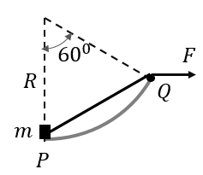
- [L2] A 10 kg block is pulled along a frictionless cylindrical surface of radius R = 10m. The applied force F is constant at 200N through a string passing over a smooth pulley Q of negligible size. P is the lowest point of the surface and OQ makes 60° with the vertical OP. If the block was initially at P, then what will be its kinetic energy when it reaches Q?
(A) 1500 J (B) 1800 J
(C) 2000 J (D) 2500 J

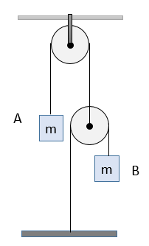
- [L2] In the figure shown, the system is released from rest. Find the velocity of block A when block B has fallen a distance '$l$'. Assume all pulleys to be massless and frictionless.
(A) $\sqrt{gl/7}$ (B) $\sqrt{gl/6}$
(C) $\sqrt{2gl/5}$ (D) $\sqrt{gl/5}$

Power
- A car of mass 2000 kg is moving up a smooth inclined plane with a velocity of 72 km/h utilizing its full power. If the rated power of the engine is 8 kW, the gradient of the incline is
(A) 1 in 100 (B) 1 in 50 (C) 1 in 33 (D) 1 in 25
- [AIEEE 2005] A body of mass m is accelerated uniformly from rest to a speed V in time T. The instantaneous power delivered to the body as a function of time is given by
(A) $\frac{mV^{2}t}{T^{2}}$ (B) $\frac{2mV^{2}t}{T^{2}}$ (C) $\frac{3mV^{2}t}{T^{2}}$ (D) $\frac{mV^{2}t}{2T^{2}}$
- Sand is falling on a conveyor belt at the rate of 5kg/s. The extra power required to keep the belt moving at 6 m/s is
(A) 30 W (B) 50 W (C) 90 W (D) 180 W
- [AIIMS 2017] A block of mass 20 kg is moved with constant velocity along an inclined plane of inclination 37° with help of a force of constant power 50 W. If the coefficient of kinetic friction between block and surface is 0.25, then what fraction of power is used against gravity?
(A) $¾$ (B) $¼$ (C) ½ (D) $\frac{1}{8}$
- [AIPMT 2012] A car of mass m starts from rest and accelerates so that the instantaneous power delivered to the car has a constant magnitude P₀. The instantaneous velocity of this car is proportional to:
(A) $t^{-1/2}$ (B) $\frac{t}{\sqrt{m}}$ (C) $t^{2}$ (D) $t^{1/2}$
- [JEE Main 2021, 27 Jul, Shift 2] An automobile of mass m accelerates from origin and initially at rest while the engine supplies constant power P. The position is given as function of time as:
(A) ${\left(\frac{9P}{8m}\right)}^{\frac{1}{2}}t^{\frac{3}{2}}$ (B) ${\left(\frac{8P}{9m}\right)}^{\frac{1}{2}}t^{\frac{2}{3}}$ (C) ${\left(\frac{9m}{8P}\right)}^{\frac{1}{2}}t^{\frac{3}{2}}$ (D) ${\left(\frac{8P}{9m}\right)}^{\frac{1}{2}}t^{\frac{3}{2}}$
- [JEE Main 2020, 3 Sep, Shift 2] Constant power P is being supplied to mass m initially at rest. Choose the correct s-t graph
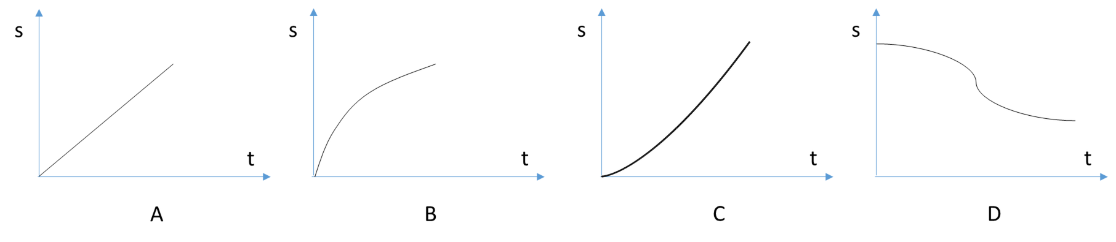
- [AIPMT 2015] A particle of mass m is driven by a machine that delivers a constant power k watts. If the particle starts from rest the force on the particle at time t is:
(A) $\sqrt{\frac{mk}{t}}$ (B) $\sqrt{\frac{2mk}{t}}$ (C) $\frac{1}{2}\sqrt{\frac{mk}{t}}$ (D) $\sqrt{\frac{mk}{2t}}$
- [NEET 2016] A body of mass 1 kg begins to move under the action of a time dependent force $\vec{F}=(2t\hat{i}+3t^{2}\hat{j})$N, where $\hat{i} and \hat{j}$ are unit vectors along x and y axis. What power will be developed by the force at the time t?
(A) $(2t^{2}+3t^{3})$W (B) $(2t^{2}+4t^{4})$W (C) $(2t^{3}+4t^{4})$W (D) $(2t^{3}+3t^{5})$W
- An engine pumps a liquid of density d continuously through a pipe of area of cross–section A. If the speed with which the liquid passes through a pipe is v, then the power being delivered to the liquid is
(A) $Adv^{2}$ (B) $\frac{1}{2}Adv^{2}$ (C) $\frac{1}{2}Adv^{3}$ (D) $Adv^{3}$
- [AIPMT 2010] An engine pumps water through a hose pipe. Water passes through the pipe and leaves it with a velocity of 2 m/s. The mass per unit length of water in the pipe is 100 kg/m. What is the power of the engine?
(A) 800 W (B) 400 W (C) 200 W (D) 100 W
- A wind-powered generator converts wind energy into electric energy. Assume that the generator converts a fixed fraction of the wind energy intercepted by its blades into electrical energy. For wind speed v, the electrical power output will be proportional to $v^{n}$. The value of n is
- Power supplied to a particle of mass 2 kg varies with time as $P=3t^{2}$ W. Here t is time in second. If the particle starts from rest at t = 0, its velocity at t = 2 s will be
(A) 2 m/s (B) $2\sqrt{2}$ m/s (C) 3 m/s (D) 4 m/s
- A particle of mass m is moving in a circle of radius R with speed $v=v_{0}(1+e^{-αt})$. The power delivered to the particle by the force at t = 0 is
(A) $-mv_{0}^{2}α$ (B) $-2mv_{0}^{2}α$ (C) $\frac{1}{2}mv_{0}^{2}α$ (D) 3$mv_{0}^{2}α$
- A particle of mass ‘m’ moves along a circle of constant radius R with radial acceleration changing with time as $a_{r}=kt^{n}$ where k is a constant and n > 1. What is the power required for this motion as a function of time?
(A) $\frac{1}{2}mnRkt^{n-1}$ (B) $\frac{1}{2k}mnRt^{n-1}$ (C) $\frac{1}{k}mnRkt^{n-1}$ (D) $mnRkt^{n-1}$
- [L2] A car of weight W is on an inclined road that rises by 10 m over a distance of 1 km. The road applies a constant frictional force W/20 on the car. While moving uphill on the road at a speed of 10 m/s, the car needs power P. If it needs power P/2 while moving downhill at speed v then the value of v is:
(A) 10 m/s (B) 7.5 m/s (C) 6 m/s (D) 5 m/s

Answer Key
Work by a Constant Force
Q1 | C | Q2 | B | Q3 | 2
Q4 | (i) +10 J (ii) +5 J | Q5 | C | Q6 | B
Q7 | 9 | Q8 | C | Q9 | (i) mg sin²θ vt (ii) mg cos²θ vt
Q10 | C
Work by Variable Force; Chains & Ropes
Q11 | D | Q12 | D | Q13 | 450
Q14 | D | Q15 | C | Q16 | B
Q17 | B | Q18 | 40 | Q19 | C
Q20 | 4 | Q21 | 0
Spring Force: Work & Elastic PE
Q22 | B | Q23 | B | Q24 | A
Q25 | 1 | Q26 | B | Q27 | A
Q28 | A | Q29 | D | Q30 | B
Q31 | A | Q32 | D | Q33 | C
Q34 | 16 | Q35 | (i) 360 N/m (ii) 1/6 m (iii) 125 J (iv) 30 m/s² | Q36 | A
Q37 | A
Work–Energy Theorem
Q38 | A | Q39 | B | Q40 | C
Q41 | D | Q42 | C | Q43 | D
Q44 | A | Q45 | A | Q46 | C
Q47 | B | Q48 | D | Q49 | C
Q50 | B | Q51 | A | Q52 | B
Q53 | B | Q54 | D | Q55 | D
Q56 | C | Q57 | D | Q58 | C
Q59 | A | Q60 | A | Q61 | C
Q62 | B | Q63 | D | Q64 | A
Q65 | C
Conservative Forces & Potential-Energy Curves
Q66 | A | Q67 | D | Q68 | D
Q69 | C | Q70 | (i) x = 2 m (ii) 4 m (iii) 16 J | Q71 | D
Q72 | A | Q73 | C | Q74 | A
Q75 | C
Conservation of Mechanical Energy
Q76 | 10 | Q77 | 10 | Q78 | A
Q79 | D
Power
Q80 | B | Q81 | A | Q82 | D
Q83 | A | Q84 | D | Q85 | D
Q86 | C | Q87 | D | Q88 | D
Q89 | D | Q90 | A | Q91 | 3
Q92 | B | Q93 | B | Q94 | A
Q95 | B

Hints & Solutions
Work by Variable Force; Chains & Ropes
Q19 Think further
What will be the work done if the particle is taken directly from (0, 0) to (a, a)?
Answer: −ka² (F is conservative)
Q20 Hint
$F=\sqrt{x^{2}+y^{2}}\left\{-\frac{y\hat{i}}{\sqrt{x^{2}+y^{2}}}+\frac{x\hat{j}}{\sqrt{x^{2}+y^{2}}}\right\}=R(\cos\left(\frac{π}{2}+θ\right)\hat{i}+\sin\left(\frac{π}{2}+θ\right)\hat{j})$
Q21 Think further
What will be the work done along the same path if force = $K\left\{-\frac{y\hat{i}}{{(x^{2}+y^{2})}^{3/2}}+\frac{x\hat{j}}{{(x^{2}+y^{2})}^{3/2}}\right\}$?
Answer: Kπ/2a
Work–Energy Theorem
Q47 Hint
Even for a path of varying slope, the KE at B will be the same.
Power
Q89 Think further
The kinetic energy given to the liquid per second is only ½Adv³. Where does the other half of the power go?
Answer: It is dissipated when the liquid is accelerated abruptly, as with the sand falling on the conveyor belt in Q82.
Q90 Think further
The kinetic energy carried away by the water per second is ½(100 × 2)(2²) = 400 W. Why is the engine power 800 W?
Answer: Half the power is dissipated when the water is accelerated abruptly to 2 m/s (compare Q82 and Q89).

